Appendix G2a. Household Eligibility Screener Web Screen Shot

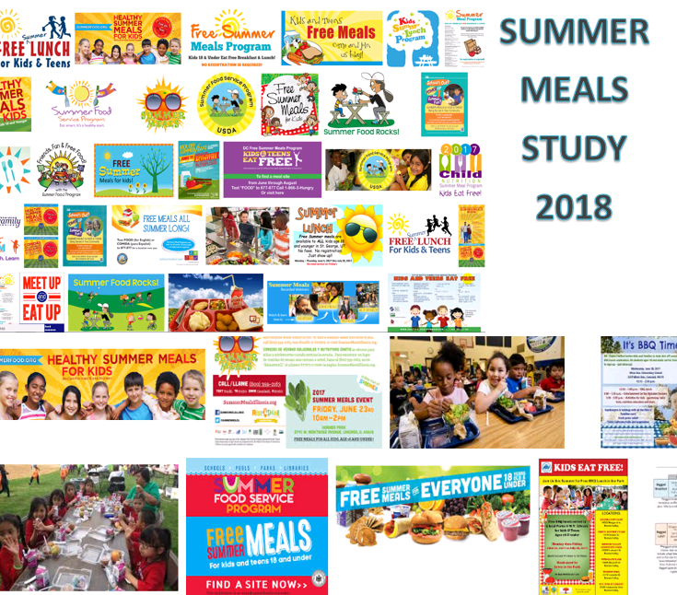 | Caregivers, please have your PIN ready to start the survey now.
Do any children 18 years or younger currently live in your home? Please include all children who currently live in your household for most of your time.

Yes PROGRAMMER GO TO NEXT QUESTION
No PROGRAMMER GO TO INELIGIBLE, FINAL SCREEN

This summer 2018, have any or will any of these children go to <SITE NAME> at <ADDRESS>, and get free meals there?

Yes PROGRAMMER – PROGRAMMER GO TO ELIGIBLE, FINAL SCREEN
No PROGRAMMER – PROGRAMMER GO TO NEXT QUESTION

This summer 2018, have any or will any of these children go somewhere else to get free meals? By free meals, we mean that you will not or did not pay a free or a reduced fee.

Yes PROGRAMMER GO TO INELIGIBLE, FINAL SCREEN
No PROGRAMMER GO TO ELIGIBLE, FINAL SCREEN

Public reporting burden for this collection of information is estimated to average 5 minutes per response, including the time for reviewing instructions, searching existing data sources, gathering and maintaining the data needed, and completing and reviewing the collection of information. An agency may not conduct or sponsor, and a person is not required to respond to, a collection of information unless it displays a currently valid OMB control number. Send comments regarding this burden estimate or any other aspect of this collection of information, including suggestions for reducing this burden, to: U.S. Department of Agriculture, Food and Nutrition Services, Office of Policy Support, 3101 Park Center Drive, Room 1014, Alexandria, VA 22302 ATTN: PRA (0584-xxxx*). Do not return the completed form to this address.

