**OMB # 0584-0624 Expiration xx/xx/xxxx**

**FNS-890**

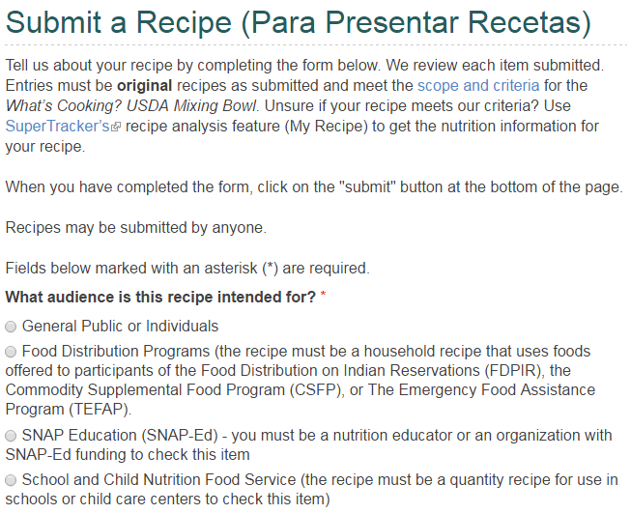

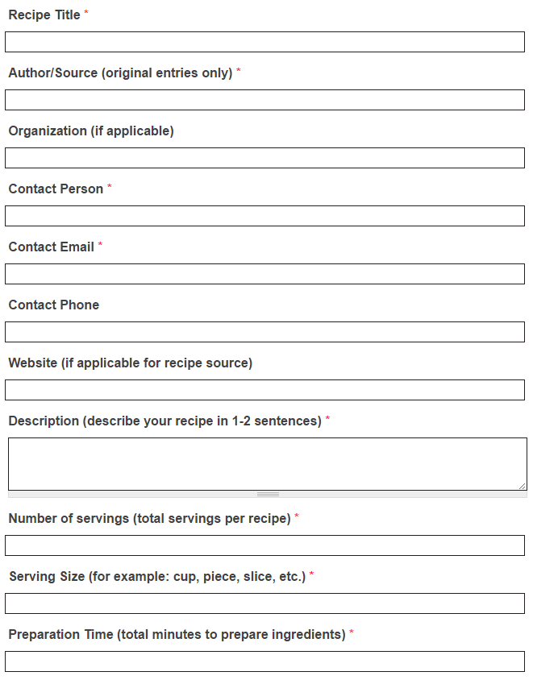

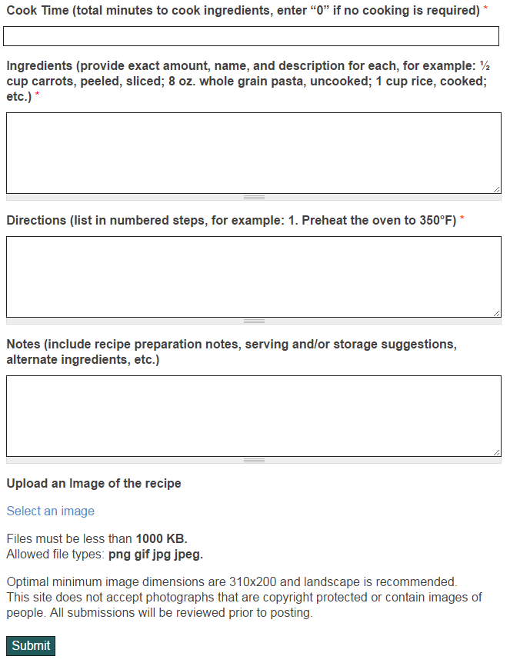

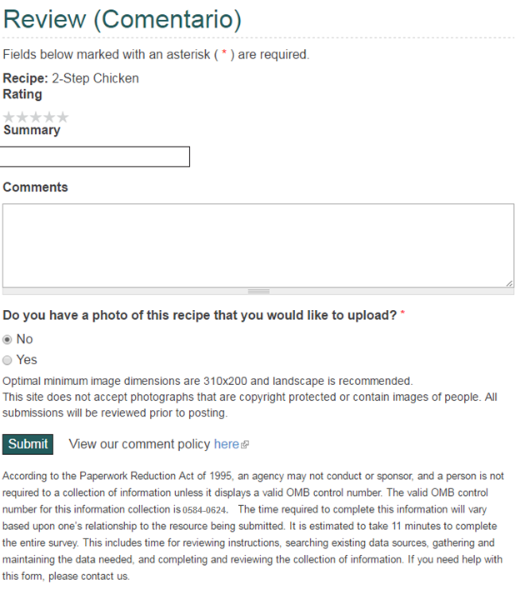

According to the Paperwork Reduction Act of 1995, an agency may not conduct or sponsor, and a person is not required to a collection of information unless it displays a valid OMB control number. The valid OMB control number for this information collection is 0584-0624. The time required to complete this information will vary based on one’s relationship to the resource being submitted. It is estimated to take 17 minutes to complete the entire survey. A respondent may also complete the Submit a Recipe selection separately, and it is estimated to take 11 minutes to complete this section of the form. A respondent may also complete the Review section separately, and it is estimated to take 6 minutes to complete this section of the form. This includes reviewing instructions, searching existing data sources, gathering and maintaining the data needed, and completing and reviewing the collection of information. If you need help with this form, please contact us.

Privacy Act Statement

**Authority:**Section 9 of the Food and Nutrition Act of 2008, as amended, (7 U.S.C. 2018); section 205(c)(2)(C) of the Social Security Act (42 U.S.C. 405(c)(2)(C)); and section 6109(f) of the Internal Revenue Code of 1986 (26 U.S.C. 6109(f)), authorizes collection of the information on this application.

**Purpose:**Information is collected primarily for use by the Food and Nutrition Service in the administration of the Supplemental Nutrition Assistance Program;

**Routine Use:**Information may be disclosed for any of the routine uses listed in the published System of Record  notice <https://www.federalregister.gov/documents/2010/12/27/2010-32457/privacy-act-revision-of-privacy-act-systems-of-records#p-30>