Attachment B1

BRDS-L1

(Draft)

A Message from the Directors
U.S. Census Bureau and National Center for Science and Engineering Statistics

The U.S. Census Bureau has selected your business to participate in the 2017 Business Research and Development Survey. This national survey collects information from businesses operating in the United States and is the single most important source of up-to-date information on business research and development (R&D) in the United States. Accurate information about R&D will help leaders in the public and private sectors make better decisions to strengthen American competitiveness.

Website:
Authentication Code:
Due Date:

- Sign in OR register at the website above.

- Add your authentication code.

- Report by clicking on “REPORT NOW.” You can return to your account over multiple sessions to complete.

YOUR RESPONSE IS REQUIRED BY LAW and will be kept strictly CONFIDENTIAL. We estimate this survey
will take an average of 3.3 hours to complete. Additional information about the authority, confidentiality, and burden of this data collection can be found on the back of this letter.

For assistance with completing this survey, please sign into your Census Bureau account or call our customer help line at 1-800-772-7851, Monday through Friday, 8:00 a.m. to 5:00 p.m. Eastern time.

Thank you in advance for your time and cooperation and for helping the U.S. Census Bureau measure America’s people, places, and economy. Your response makes a difference.

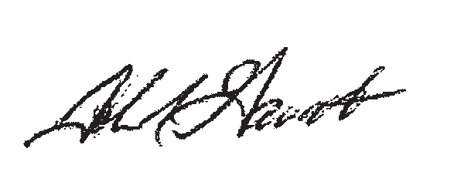

John R. Gawalt Director
Sincerely,
National Center for Science and Engineering Statistics National Science Foundation

OMB Number
This collection has been approved by the Office of Management and Budget (OMB). The eight-digit OMB approval number is 0607-0912 and appears in the upper right corner of each reporting screen. Without this approval we could not conduct this survey.

Authority and Confidentiality
Title 13 United States Code, Sections 8(b), 131, and 182, and Title 42 United States Code, Sections 1861-76 (National Science Foundation Act of 1950, as amended), authorize this collection. Sections 224 and 225 of Title 13 require your response. The U.S. Census Bureau is required by Section 9 of the same law to keep your information confidential and can use your responses only to produce statistics. The Census Bureau is not permitted to publicly release your responses in a way that could identify your business, organization, or institution. Per the Federal Cybersecurity Enhancement Act of 2015, your data are protected from cybersecurity risks through screening of the systems that transmit your data.

Burden Estimate Statement
We estimate this survey will take an average of 3.3 hours to complete, including the time for reviewing instructions, searching existing data sources, gathering and maintaining the data needed, and completing and reviewing the collection of information.

