SUPPORTING STATEMENT – ATTACHMENT A
MATERNAL AND CHILD HEALTH SERVICES BLOCK GRANT
APPLICATION/ANNUAL REPORT GUIDANCE

Published 60-Day and 30-Day Federal Register Notices

https://www.gpo.gov/fdsys/pkg/FR-2017-06-09/pdf/2017-12003.pdf
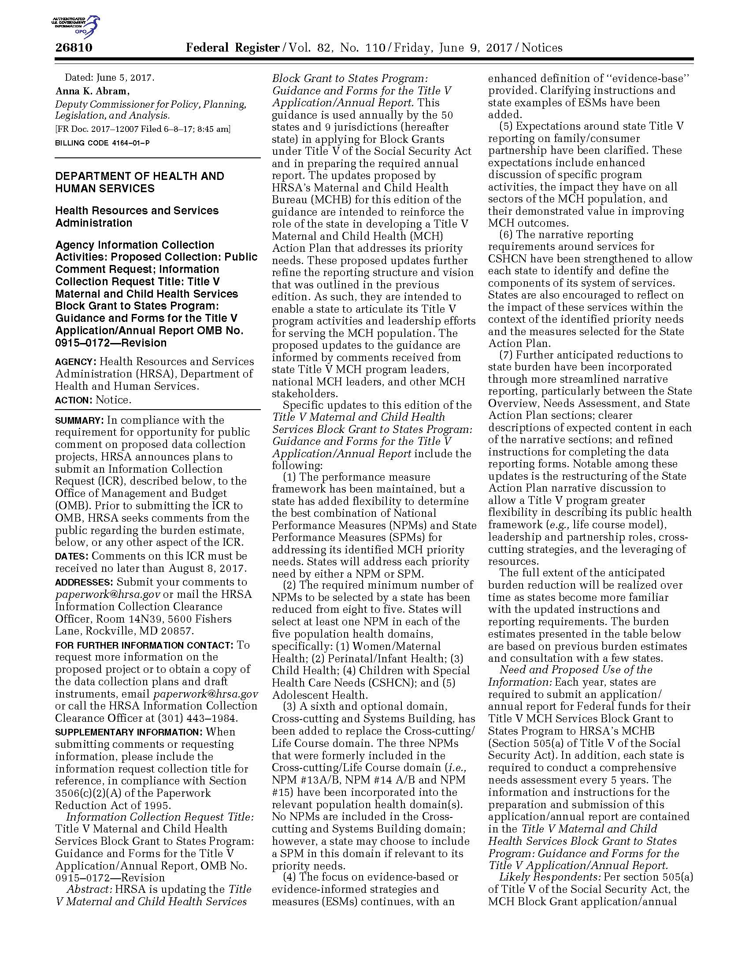
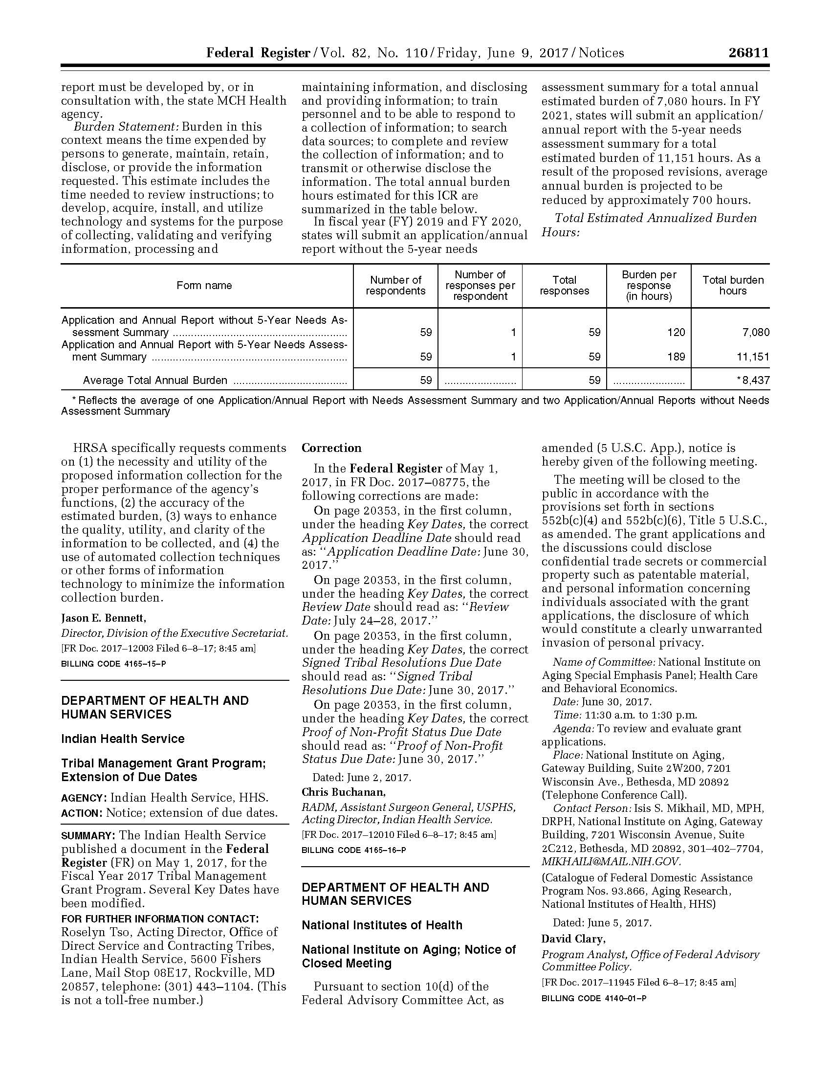

https://www.gpo.gov/fdsys/pkg/FR-2017-11-13/pdf/2017-24495.pdf
