Assessment of Ill Worker Policies Study
Attachment 11– Protocol

- Purpose
This study is designed to determine if an educational intervention will result in restaurants either developing or enhancing their ill worker management plans. We will administer an educational intervention in a random sample of restaurants, and assess ill worker management plans in those restaurants both before and after the intervention. We will also concurrently assess ill worker management plans in a group of control restaurants. If the data show that the intervention improved ill worker management plans, we will also administer the intervention in the control restaurants.
- Background
Sick food workers contribute to about a third of restaurant-related outbreaks, and to 70% of restaurant-related outbreaks caused by norovirus, the most common cause of outbreaks. Additionally, 20% of food workers report having worked with foodborne illness symptoms (vomiting and diarrhea) in the past year. Clearly, ill food workers are a significant public health problem.
In its model Food Code, The Food and Drug Administration (FDA) provides specific recommendations for restaurants on managing ill workers. For example, the Food Code states that workers should not work with foodborne illness symptoms and that workers need to tell their managers when they are sick with foodborne illness symptoms. There is some evidence that the adoption of these provisions is linked with fewer foodborne illness outbreaks (Kambhampati et al., 2016). However, not all states have adopted these provisions of the Food Code, and not all restaurants implement these provisions when they have been adopted in their state.
For this study, we designed an educational intervention for restaurant management. The goal of this intervention is to inform restaurant managers about the FDA Food Code provisions concerning ill workers, provide information on the reasons that food workers report for working while sick, to provide model ill worker management plans, and to encourage restaurant management to develop their own ill worker management plan for the restaurant. The goal of this study is to evaluate the effectiveness of this intervention. The primary outcome of interest is whether the intervention improves/enhances a restaurants’ ill worker management plans.
- Primary Research Questions

  - Does the educational intervention lead to either the development or enhancement of ill worker management plans?
Measure: change in plans from before and after intervention implementation.
  - Does having an ill worker management plan affect employees working while ill?
Measure: relationship between presence of ill worker management plans and worker reports of working while ill.
  - What is the frequency of food safety practices in restaurants to prevent the spread of illness from an ill worker?
Measure: frequency of restaurants with good food safety practices (e.g. limitations on bare hand contact with ready to eat food, cleaning policies, policies to respond to incidents of vomiting or diarrhea, etc.)
- Study Design
4.1 Summary
This study will use a quasi-experimental, non-equivalent group, pre/post-test design. The study will have two groups of restaurants (intervention and control). In both restaurant groups, we will conduct a baseline assessment of the restaurants’ ill worker management plans. Study personnel will assess the plans through manager interviews, food worker surveys and restaurant observations (Attachments 5, 7 and 8). For the intervention restaurants, study personnel will provide the educational intervention (see section 5.4 and using Attachment 9) at visit 1 or the same visit as the baseline observation. The intervention will consist of a visit from study personnel, who will provide verbal information about ill worker management plans (e.g., the need to exclude ill workers from working; the need for cleaning protocols for when employees become ill). Study personnel will also provide and review a written guide on ill worker management plans.
Approximately six months later at visit 2, study personnel will conduct another assessment in both restaurant groups (Attachment 5, 7 and 8). If the data indicates that the intervention is preliminarily effective, study personnel will then provide the intervention to the control restaurants. Approximately six months later, study personnel will then conduct the visit 3 in these control restaurants to determine the effectiveness of the intervention in these restaurants.
Participation in this study is voluntary and both restaurant managers and food workers will be made aware of its voluntary nature. If a restaurant decides to no longer participate following the baseline assessment (1st visit), the restaurant will be dropped from the study and recorded as a ‘loss to follow up’.

4.2 Study Sites
This study will occur within the Environmental Health Specialists Network (EHS-Net). EHS-Net is a collaborative project of the Centers for Disease Control and Prevention (CDC), the U.S. Food and Drug Administration (FDA), the U.S. Department of Agriculture (USDA), the U.S. Environmental Protection Agency (EPA), and eight state and local public health departments (California, New York, New York City, Minnesota, Rhode Island, Southern Nevada Health District, Harris County Texas, and Tennessee). The state and local partners work with CDC to design, collect, and analyze data from these studies. The federal partners provide funding and input into study design and data analysis.

4.3 Sample Size Determination
We anticipate recruiting twenty intervention and twenty control restaurants at each site (N=320). A power calculation was conducted assuming initial policy compliance rates of 20-50% and a power level of 80-90%. Based on these parameters, this study is sufficiently sized to detect if there is a difference between the intervention and control restaurants of approximately 15% or more (Figure 1).
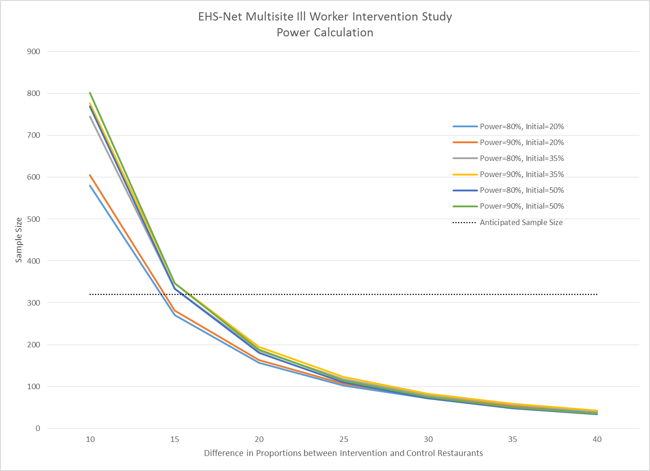
Figure 1. Power Calculation
4.4 Sample Selection
Restaurants will be randomly selected, with equal probability, within their respective site, independent of other sites. This process will give each restaurant in a particular sampling frame the same probability of being selected for study participation. There are three reasons for employing this sampling strategy: reducing sampling error, maintaining equal representation by site, and ensuring generalizability within a site. First, as stated previously, the total target population of restaurants from all EHS-Net sites combined constitutes a highly heterogeneous group. To control for such heterogeneity in the total sample, restaurants will be stratified by EHS-Net site so they can be grouped into more homogeneous strata and then sampled within stratum independently. This reduction in heterogeneity of the total sample will lead to reduction in sampling error, which can improve representativeness of the selected sample and provide estimates (e.g., means) that tend to have less variability than estimates produced from samples that were drawn using the un-stratified, simple random sampling method. Second, with equal allocation of samples (40 restaurants per site), each EHS-Net site will have equal representation in the parameter estimates of the combined sample. An additional benefit is that even sites with small sampling frames will have sufficient data points to support their site-specific analyses. Third, by ensuring that the sampling of restaurants is done by an entity (CDC) separate from the data collectors (EHS-Net sites) and employing a random selection method, we are able to minimize the potential for selection bias. Parameter estimates or study findings obtained from an unbiased study sample could be generalized to the entire EHS-Net target population.
The average response rate across EHS-Net studies that used methods similar to the proposed study is 45% (Brown et al., 2014; Radke et al., 2016). We expect a similar response rate for the proposed study. Thus, we will need to contact approximately 712 restaurants to meet our target of 320 participating restaurants.

- Implementation Plan
5.1 Visit– 1 (Baseline Visit)
Restaurants will be recruited into the study using a Manager Recruiting Script (Attachment 4) and randomly assigned to either receive the intervention initially or be in the control group. At the first visit, for the intervention and control restaurants, study personnel will obtain consent and interview the restaurant manager (Attachment 5) regarding existing ill worker management plans and their content. Study personnel will also ask the manager to provide a voluntary written survey (Attachment 7) to their food service workers (this will be in both English and Spanish). This survey will ask employees about their awareness and understanding of the existing practices of reporting and/or working while ill. During this visit, study personnel (health department environmental health specialists) will also document practices (Attachment 8) that are used to minimize the risk of disease transmission if an employee were working while ill (e.g. is handwashing occurring? Is bare hand contact with ready to eat foods occurring?). For intervention restaurants, study personnel will then provide the intervention to the restaurant manager. The intervention will explain the importance of restricting or excluding ill workers and having cleaning policies and supplies to address vomiting/diarrheal incidents (Section 5.4.1 for specific talking points). Additionally, they will provide and review the guide (Attachment 9) designed to assist in developing or modifying ill worker management plans. One month following the baseline visit/visit-1, study personnel will contact the intervention restaurants via phone or e-mail to determine if policies have been implemented and or modified, no information collection will be conducted. If they have not developed a plan, study personnel will encourage the restaurants to implement the changes to reduce the likelihood of ill workers continuing to work while ill. For the control restaurants, the manager interview, food worker survey, and restaurant observation will occur using the same format as for the intervention restaurants. No intervention will be administered for the control group in this visit.
5.2 Visit– 2
Approximately six months or longer (depending upon the study site capacity to do an assessment and restaurant manager availability) after the baseline visit, study personnel will reassess both groups of restaurants with the same instruments (Attachments 5 and 7) used on the initial visit. This will include interviewing the manager about the ill worker management plans and their content, and surveying employees about their knowledge of the plan and practices. An observation (Attachment 8) will again be conducted to document procedures that are used to minimize the risk of transmission if an employee were ill. If preliminary data analysis shows success with the intervention restaurants, the intervention will be provided to the control restaurants at visit 2, followed by an additional assessment described below.
5.3 Visit – 3
The third visit is dependent upon and will only be conducted in control restaurants where the intervention was provided. During this visit, an assessment of current conditions will be done using manager interview, food worker survey and restaurant observation (Attachments 5, 7, and 8). The purpose of this visit is to gather more evidence on the efficacy of the intervention in the control group.

The following table summarizes the study process.
 | Intervention Restaurants | Control Restaurants
Manager Recruiting Script
Visit -1
Manager Interview
Food Worker Survey
Restaurant Observation
Educational Intervention |  | –
Visit - 2
Manager Interview
Food Worker Survey
Restaurant Observation
Educational Intervention | –
Visit- 3 (Dependent on Visit – 2)
Manager Interview | –
Food Worker Survey | –
Restaurant Observation | –

5.4 Preliminary Measure of Success of Intervention
The control and intervention arms of this study will be conducted simultaneously. If three or more restaurants per study site within the intervention arm have either developed or changed their practices for managing ill workers, the intervention will then be provided to all control restaurants that have not yet had their follow up (visit – 2) visit. No attempt will be required of the study personnel to re-engage control restaurants that have already had their second visit performed.
5.5 Intervention Talking Points
The intervention will be conducted by study personnel, senior experienced environmental health specialists. Given the knowledge and experience of this group, and the diversity of restaurant managers, study personnel will customize their presentation of the materials to meet the needs of the restaurant managers. Prior to conducting the research, all study personnel will meet to discuss implementation techniques and ensure that all study personnel are using the same talking points.
5.5.1 Preliminary Talking Points
- Lots of outbreaks caused by ill food workers
- 1 in 5 Food workers reported working while sick with vomiting and diarrhea
- Infected food workers cause 70% of the reported norovirus outbreaks from contaminated food
- Humans are the reservoir for norovirus and may be asymptomatic
- Norovirus is spread from vomitus or fecal contamination from an infected person
- Excluding an ill worker is the best method to prevent contamination
- Good personal hygiene and limiting bare hand contact with food minimize the spread of contamination
- Contamination can persist on surfaces in the kitchen and dining room
- Different cleaners and sanitizers work for different types of contamination it is important to match them
- Employees report working while sick
  - Staff shortages
  - Not letting their co-workers down
  - Need the pay
  - Unable to find replacements
- All restaurants will eventually have an employee report that they are ill
- There are minimum code requirements that a restaurant is expected to meet, however they can do more to minimize the impact to their business and prevent foodborne illness
  - Introduce guide with various strategies and draft procedures.
- If technological capacity exists, a site may show or direct a restaurant manager to FDA video testimonials of victims of foodborne illness
- https://www.fda.gov/Food/GuidanceRegulation/RetailFoodProtection/IndustryandRegulatoryAssistanceandTrainingResources/ucm345399.htm?source=govdelivery

- References
Brown, L. G., Le, B., Wong, M. R., Reimann, D., Nicholas, D., Faw, B., . . . Selman, C. A. (2014). Restaurant manager and worker food safety certification and knowledge. Foodborne pathogens and disease, 11(11), 835-843.
Kambhampati, A., Shioda, K., Gould, L. H., Sharp, D., Brown, L. G., Parashar, U. D., & Hall, A. J. (2016). A State-by-State Assessment of Food Service Regulations for Prevention of Norovirus Outbreaks. J Food Prot, 79(9), 1527-1536. doi:10.4315/0362-028x.jfp-16-088
Radke, T. J., Brown, L. G., Hoover, E. R., Faw, B. V., Reimann, D., Wong, M. R., . . . Ripley, D. (2016). Food Allergy Knowledge and Attitudes of Restaurant Managers and Staff: An EHS-Net Study. J Food Prot, 79(9), 1588-1598. doi:10.4315/0362-028x.jfp-16-085

