Public Health in Indian Country Capacity Scan
Open [Date] to [Date]
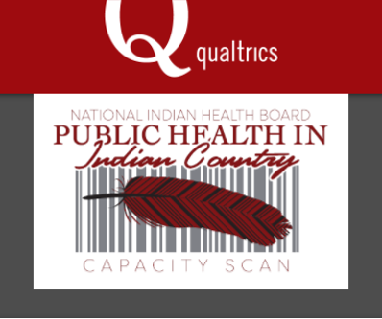
(PHICCS)

Request for Responses

The National Indian Health Board (NIHB), with support from the Centers for Disease Control and Prevention (CDC), is pleased to announce the Public Health in Indian Country Capacity Scan (PHICCS). The purpose of this scan is to increase the knowledge of Tribal and federal health leaders and advocates through the creation and dissemination of a national-level, comprehensive profile of the public health system and infrastructure in Indian Country. The profile will be informed by a national assessment of Tribal public health systems, functions, workforce, issues, gaps, strengths, and leadership.

This profile will help demonstrate the connections between the daily operations of individual Tribal health organizations and the collective efforts to improve the health status of American Indians and Alaska Natives taking place nationally. Such information will benefit Tribes in a number of ways, including but not limited to:
- Assess Tribal public health systems to identify their strengths and gaps
- Prioritize areas for development and resource allocation
- Identify opportunities for technical assistance and quality improvement needs
The information collected from the scan will be used to develop a report that will support and guide Tribal public health advocacy work in the areas of public health practice, technical support, and assessment of essential public health issues related to improving Indian health.

To support this work, we are asking 261 Tribal health directors from Tribal health departments/entities representing 573 federally recognized Tribes from 35 states and 12 Indian Health Service Areas in the United States to participate in this assessment to give us a more complete understanding of public health capacity in Indian Country. PHICCS is a web-based assessment, with other options for submission available if needed.

To learn more about this scan and to receive instructions on completing the web-based tool, please join us for a pre-launch webinar on [DATE OF PRE-LAUNCH WEBINAR]. Registration for this webinar can be accessed via the link below:
[Hyperlink to webinar registration]

Additional information may be found by contacting Stephen Valliere at svalliere@nihb.org

