**Attachment D – Web-Based Assessment Instrument, Web Version**

Page 1, Introduction Notice



Page 2, Introduction Notice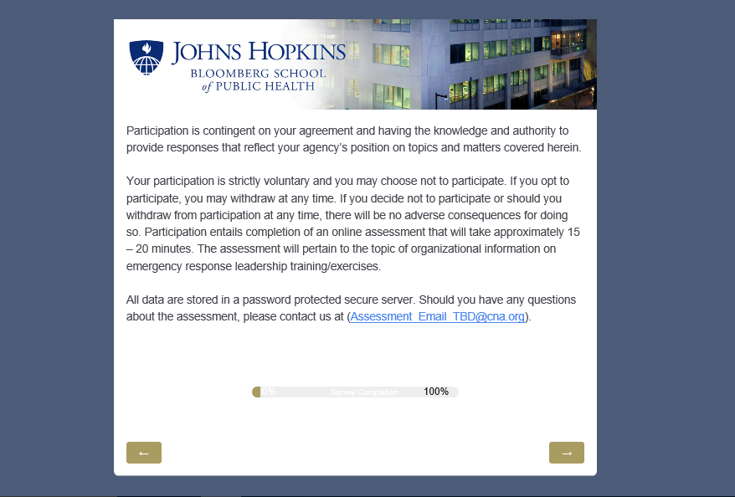

Page 3, Introduction Notice

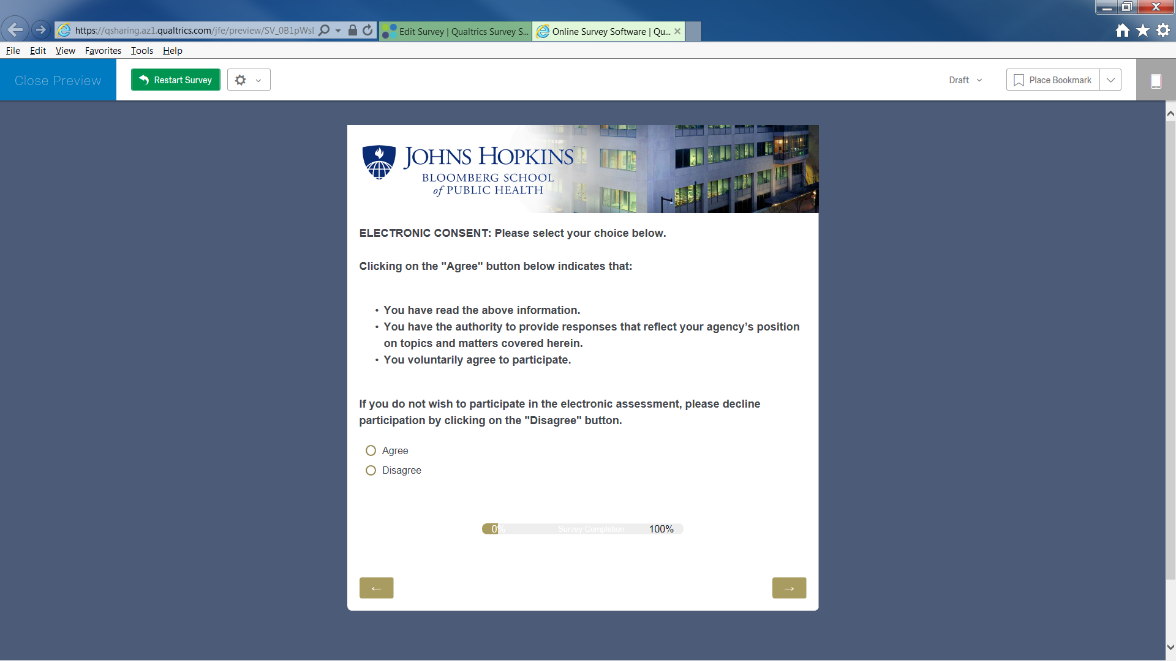

Page 4, Section 1 – Demographic Questions



Page 5, Section 1 – Demographic Questions

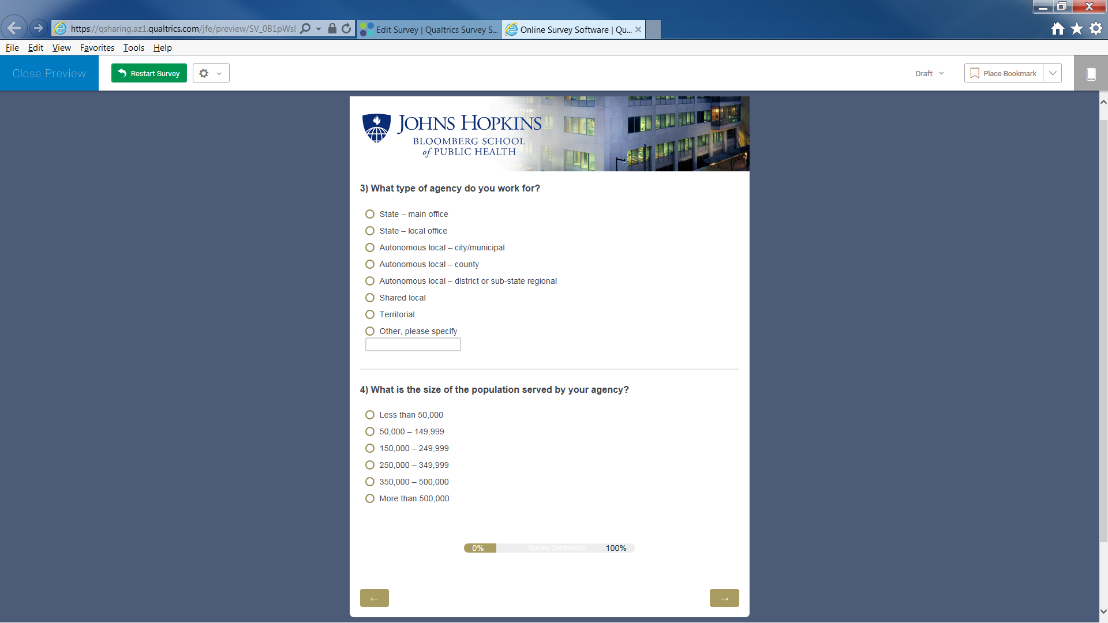

Page 6, Section 1 – Demographic Questions



Page 7, Section 1 – Demographic Questions

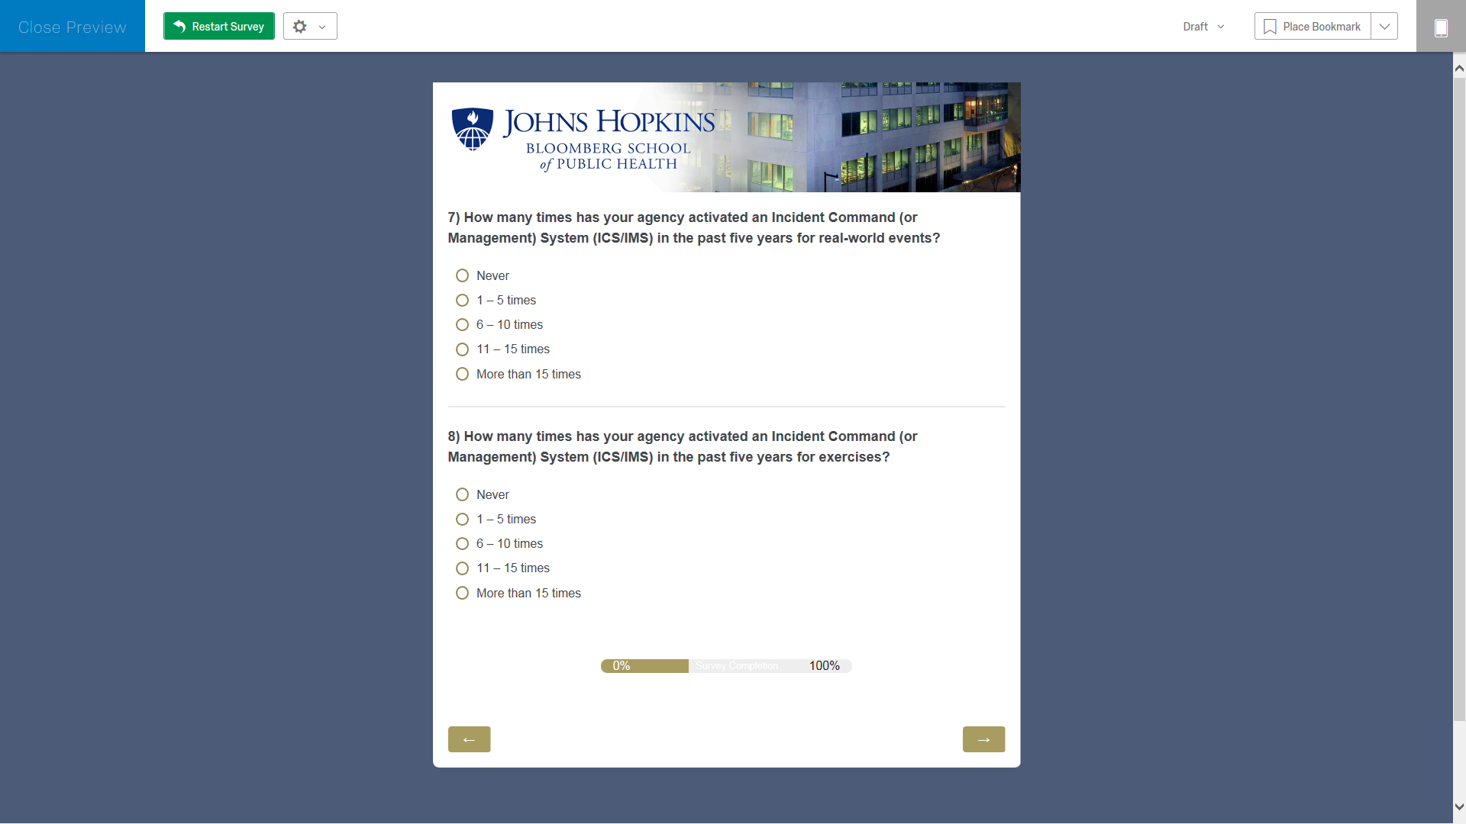

Page 8, Section 1 – Demographic Questions

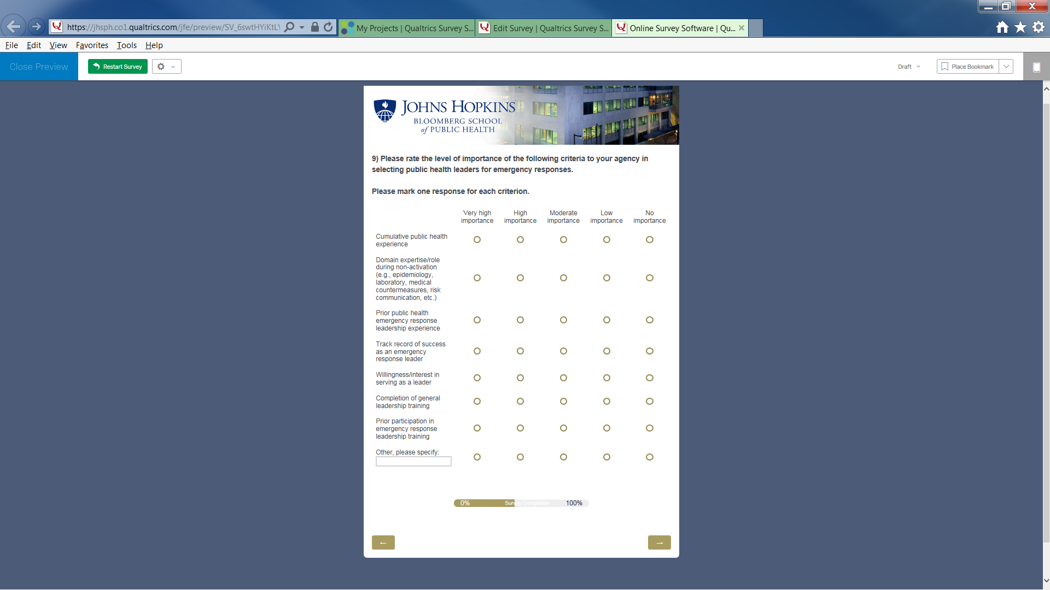

Page 9, Section 2 – Desired State of Training and Exercises Among State and Local Health Departments

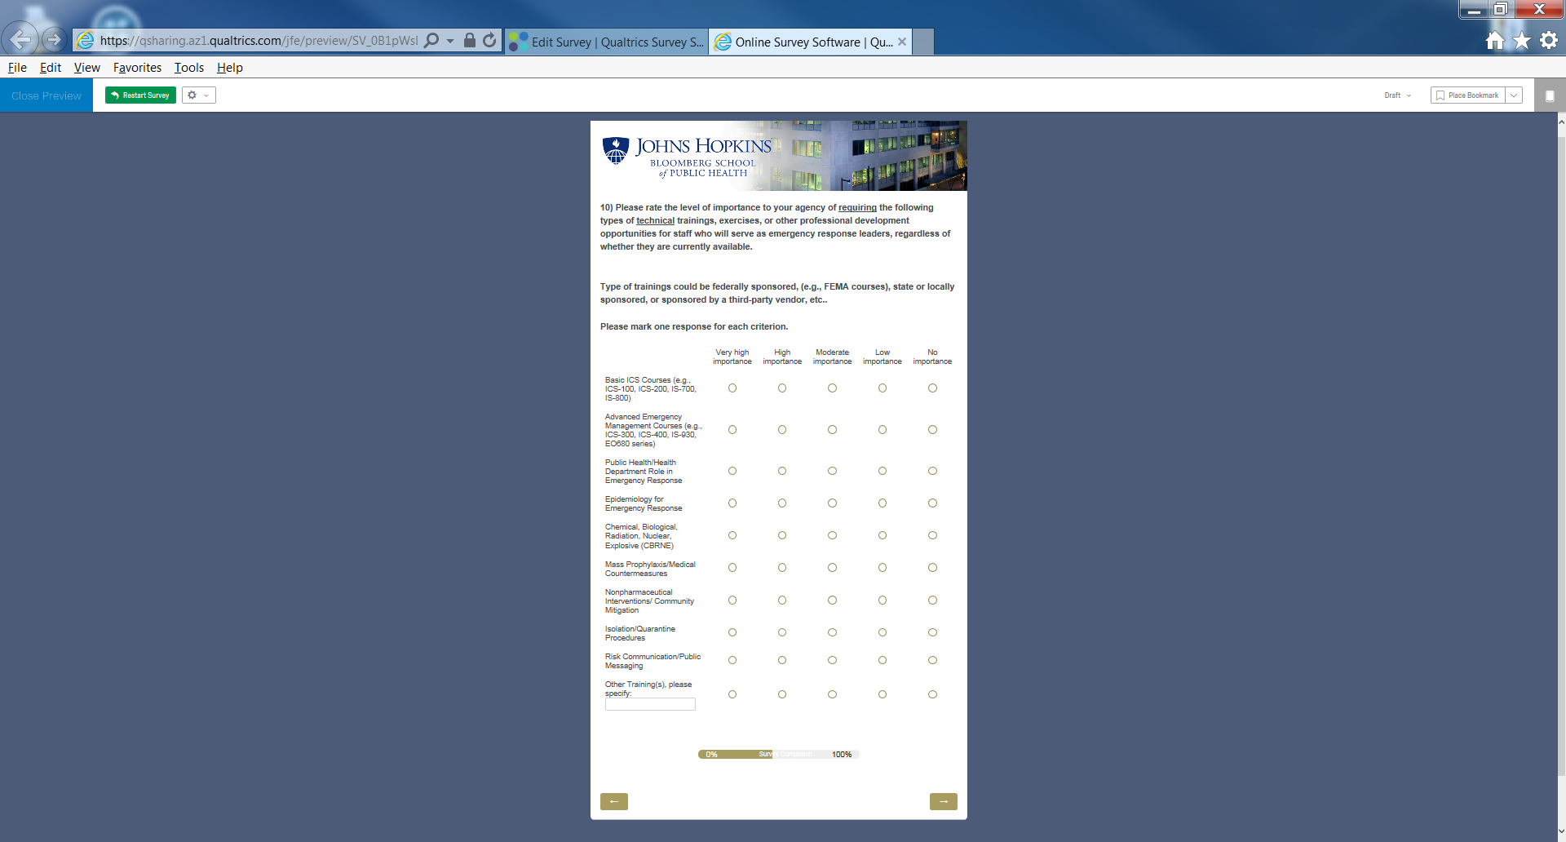

Page 10, Section 2 – Desired State of Training and Exercises Among State and Local Health Departments

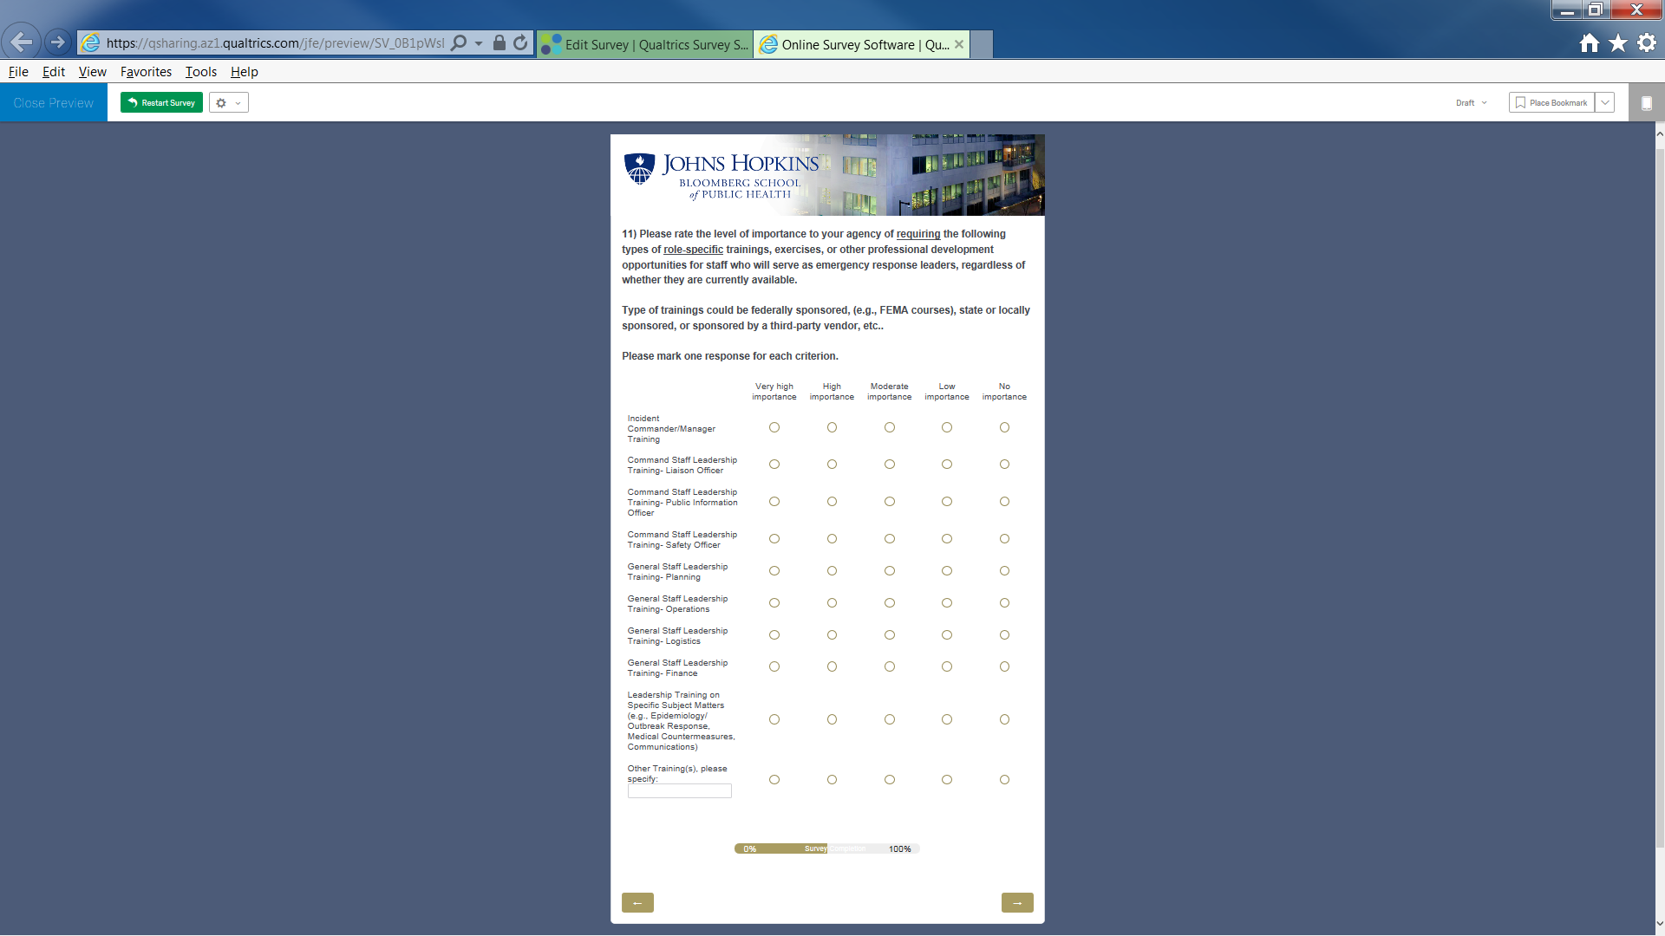

Page 11, Section 2 – Desired State of Training and Exercises Among State and Local Health Departments

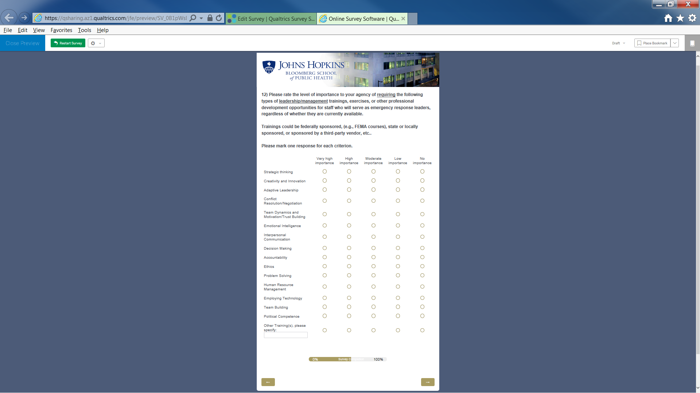

Page 12, Section 2 – Desired State of Training and Exercises Among State and Local Health Departments

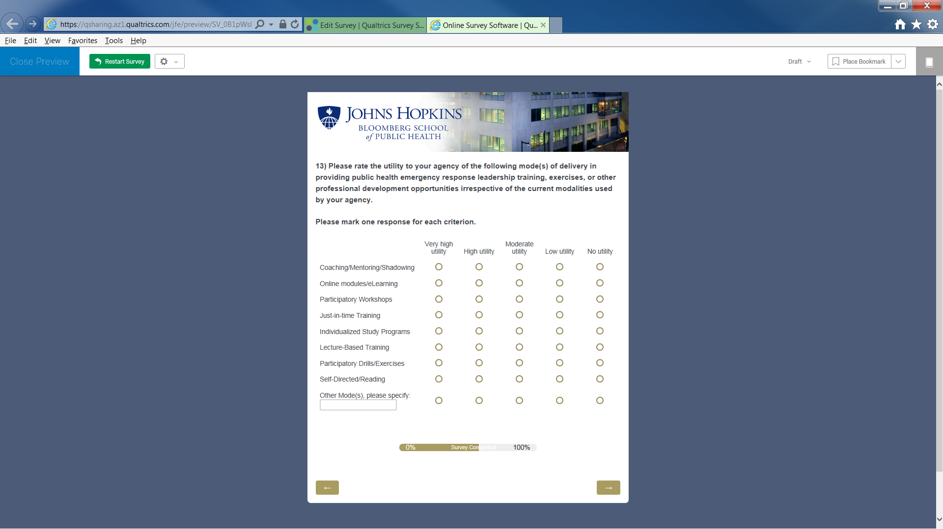

Page 13, Section 3 – Current State of Training and Exercises Among State and Local Health Departments

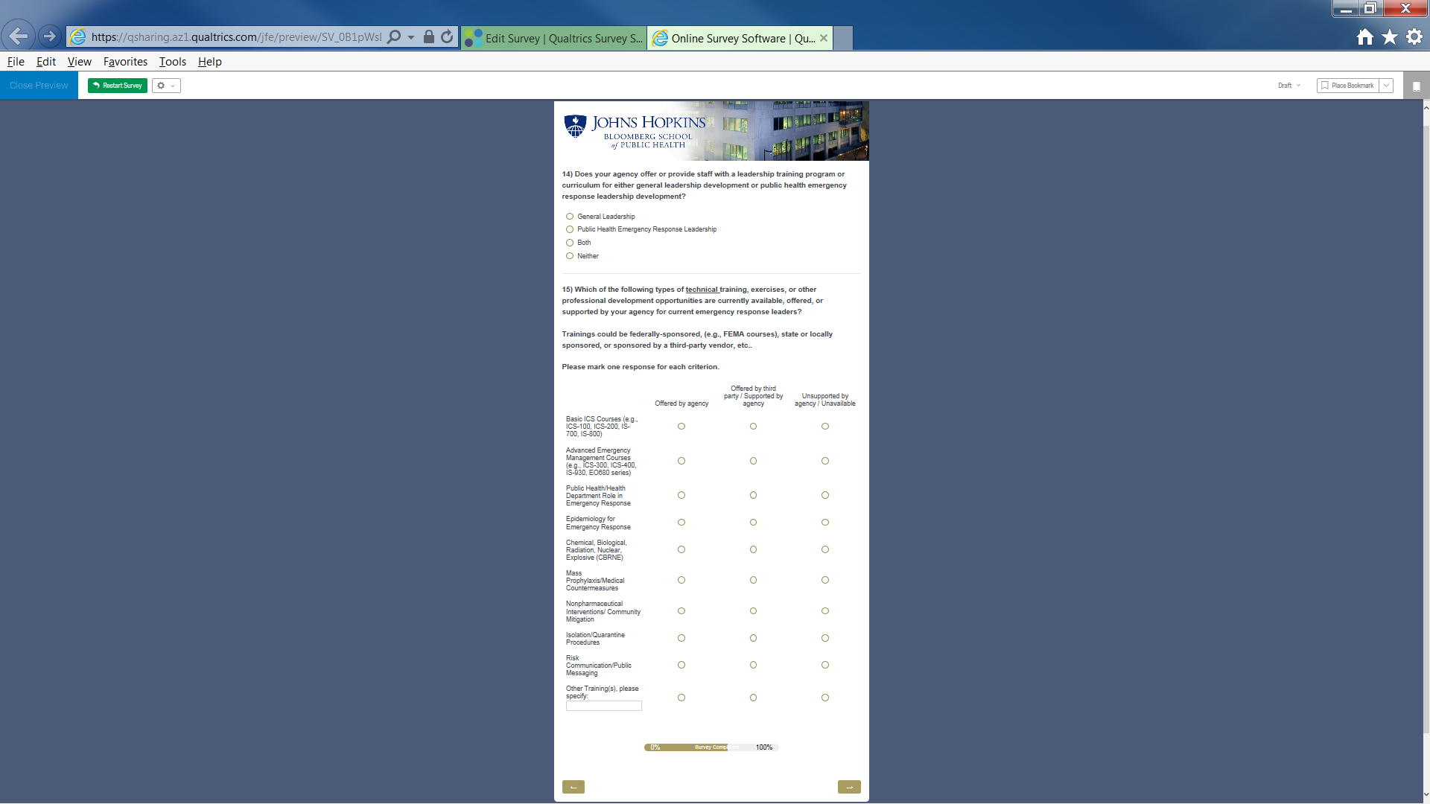

Page 14, Section 3 – Current State of Training and Exercises Among State and Local Health Departments

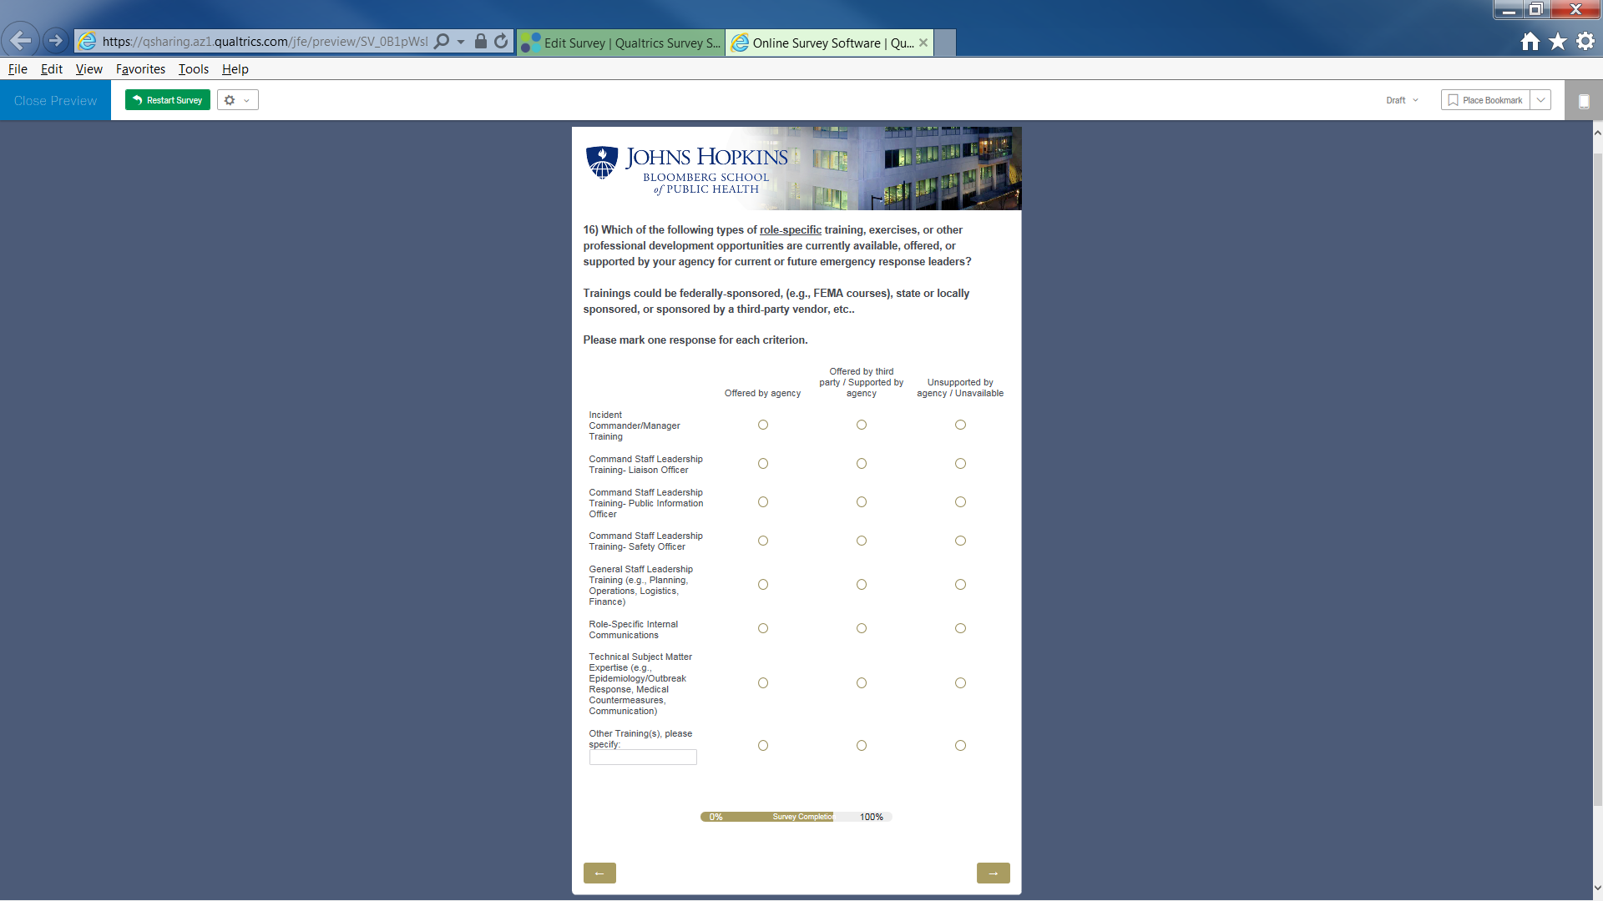

Page 15, Section 3 – Current State of Training and Exercises Among State and Local Health Departments

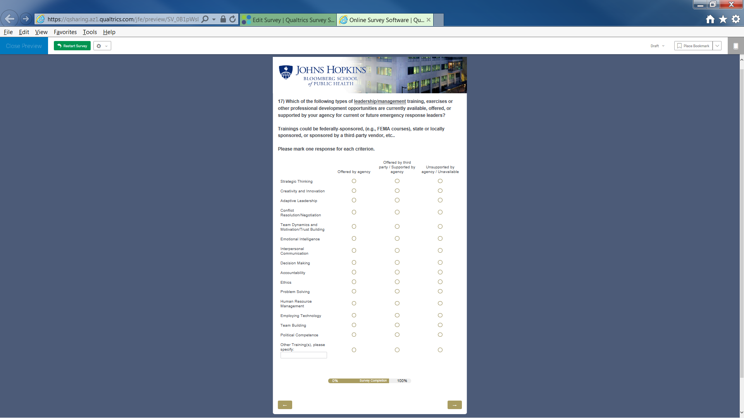

Page 16, Section 3 – Current State of Training and Exercises Among State and Local Health Departments

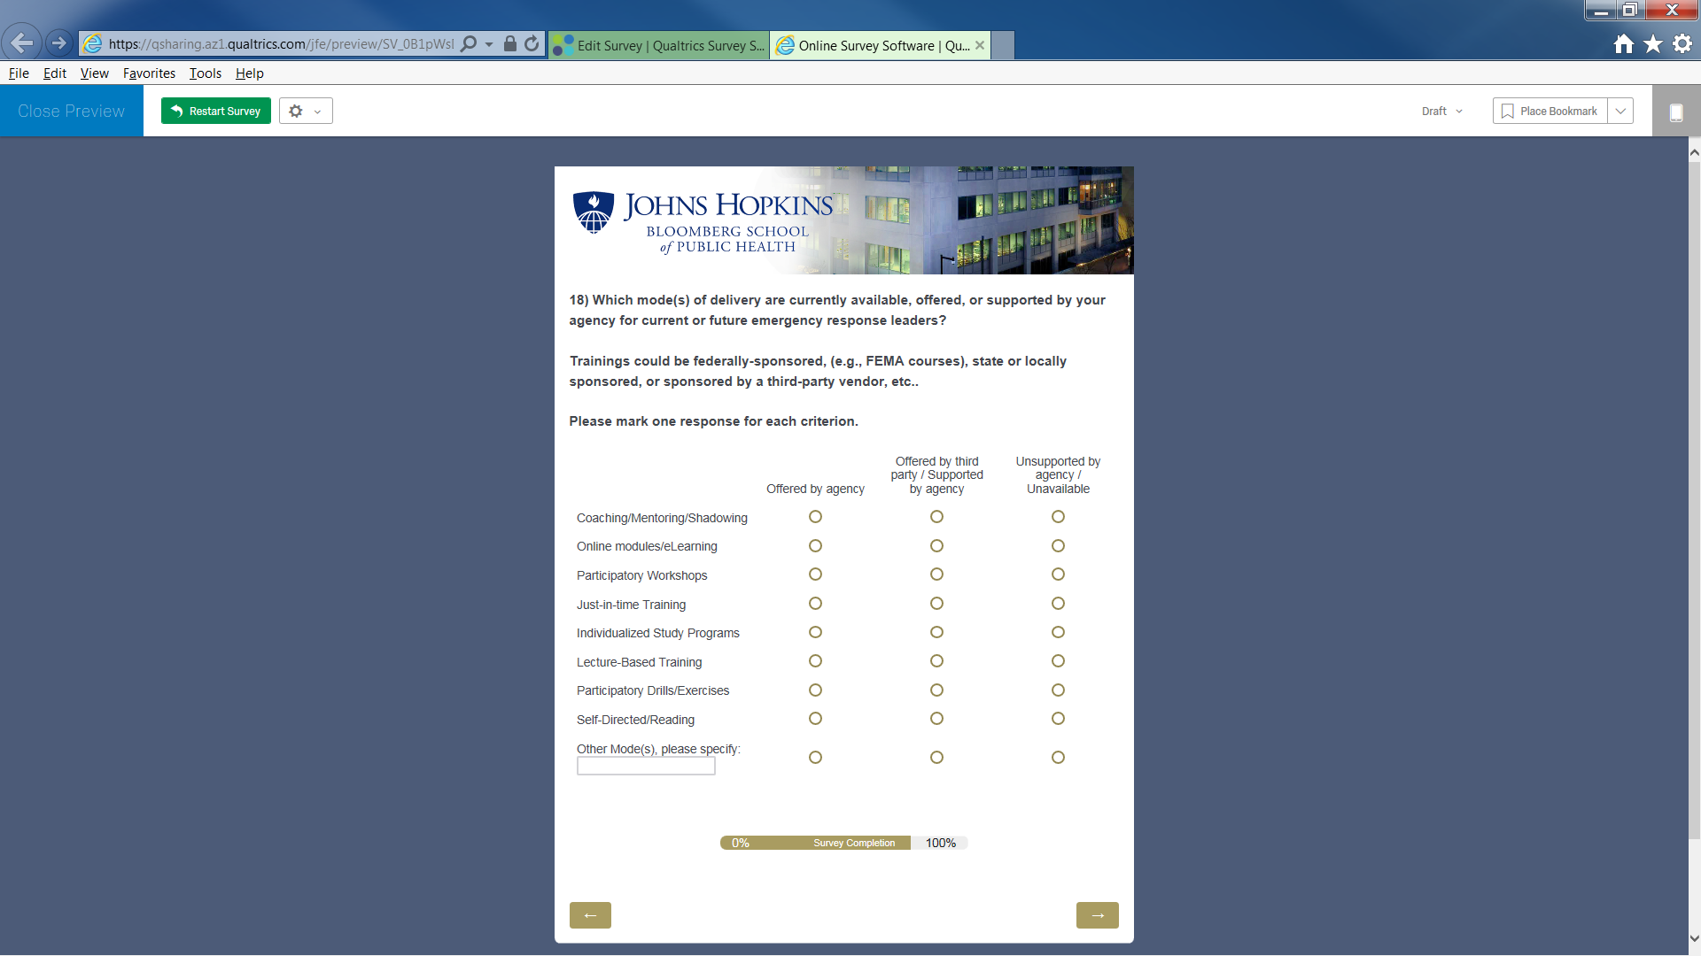

Page 17, Section 4 – Key Barriers to Training and Exercise for Developing Public Health Emergency Response Leaders

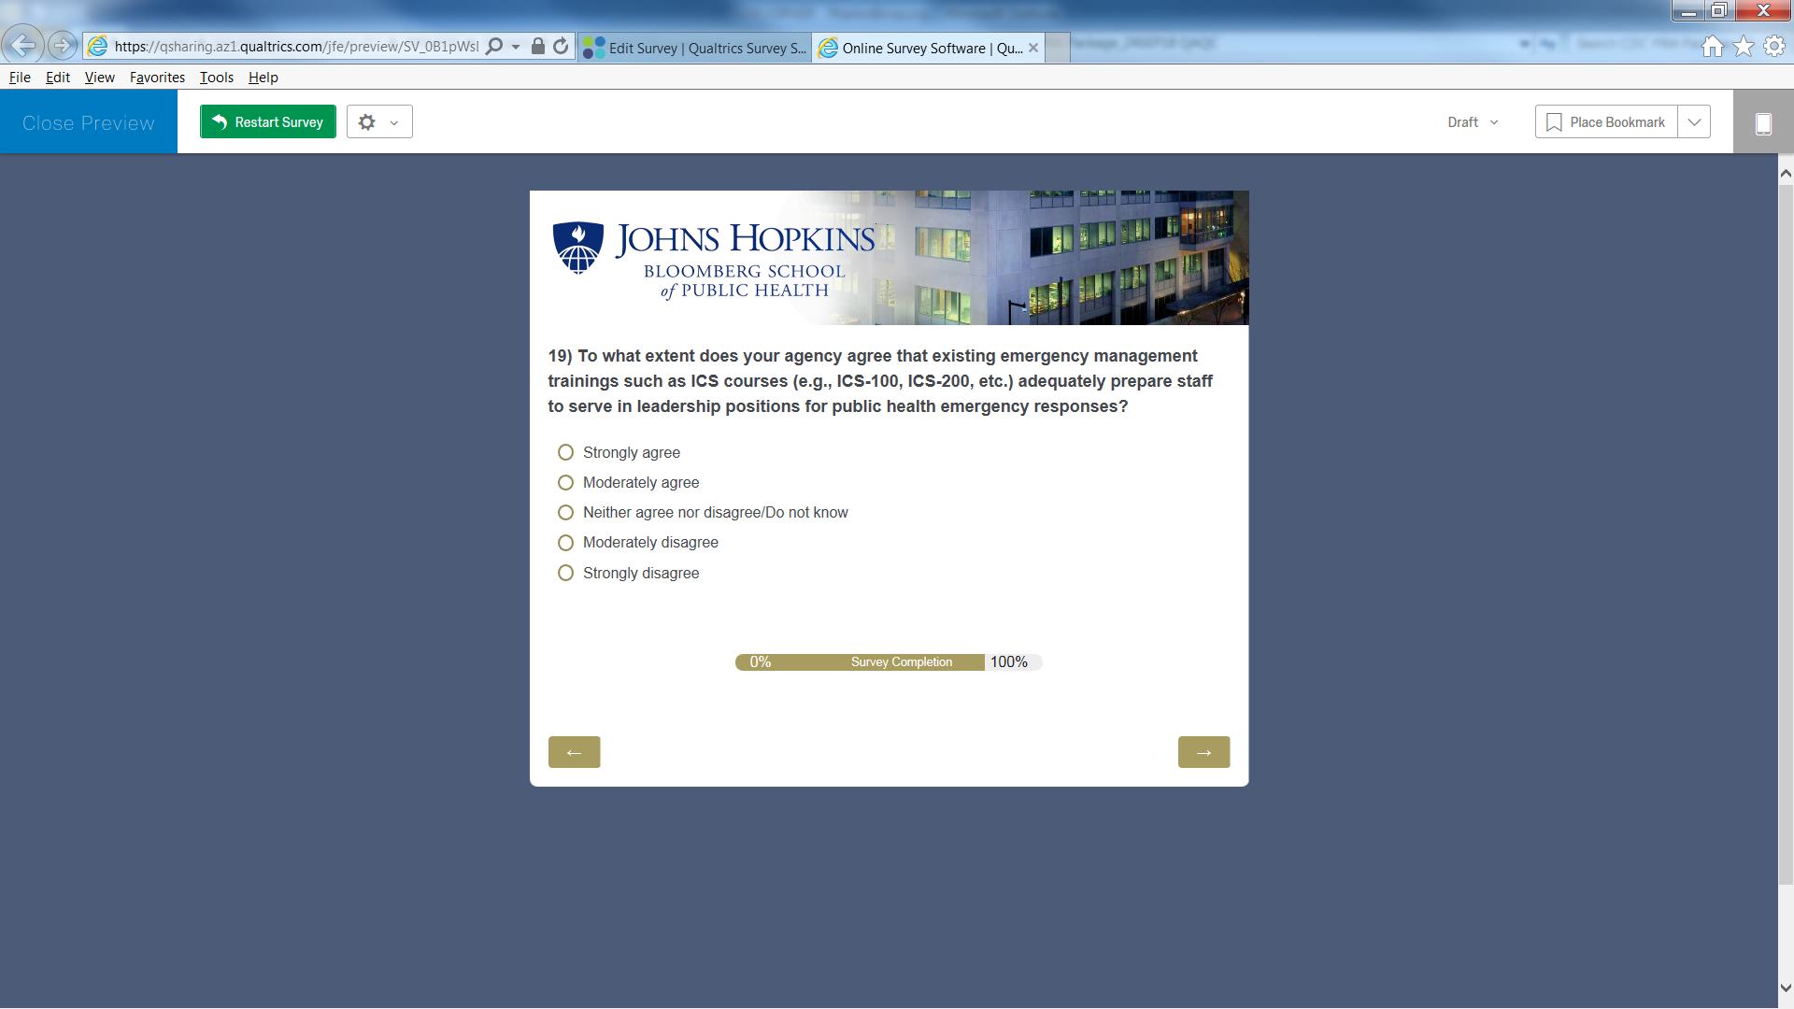

Page 18, Section 4 – Key Barriers to Training and Exercise for Developing Public Health Emergency Response Leaders

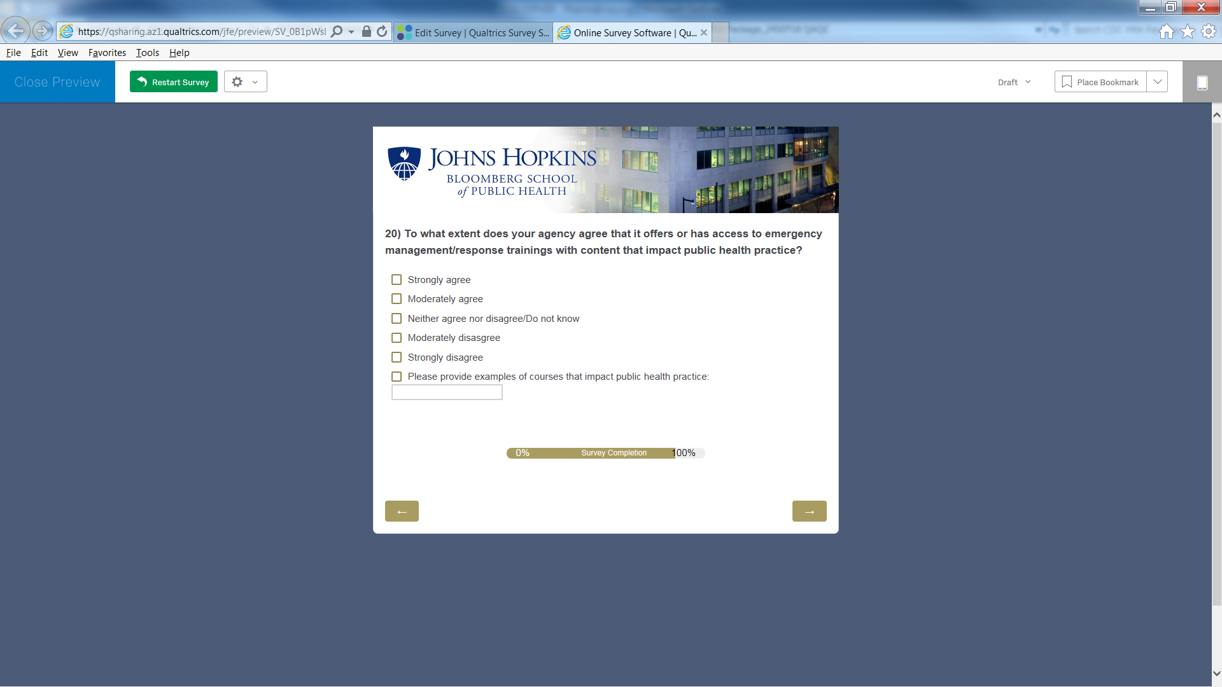

Page 19, Section 4 – Key Barriers to Training and Exercise for Developing Public Health Emergency Response Leaders



Page 20, Section 4 – Key Barriers to Training and Exercise for Developing Public Health Emergency Response Leaders

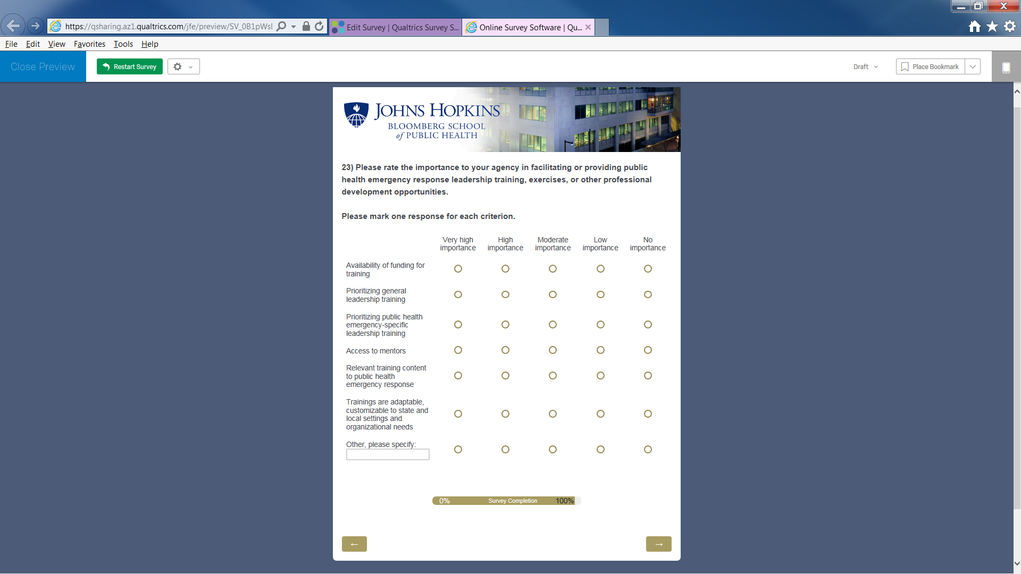

Page 21, Closing Remarks

