Attachment C: Web-based Version of Instrument

CDC Project Officer Effectiveness and Satisfaction Assessment: Instrument Guidance

Introduction

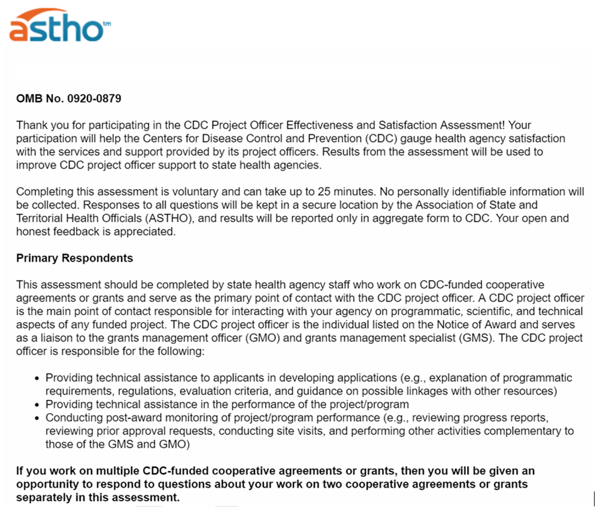
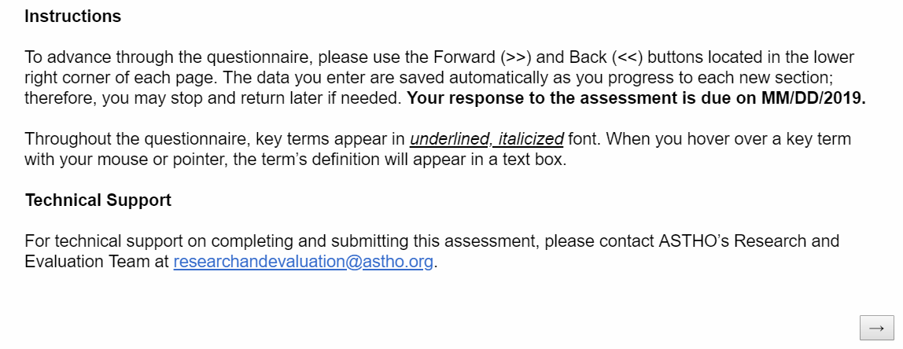

Part I: Demographics
Demographics – Selection of Cooperative Agreements and/or Grants
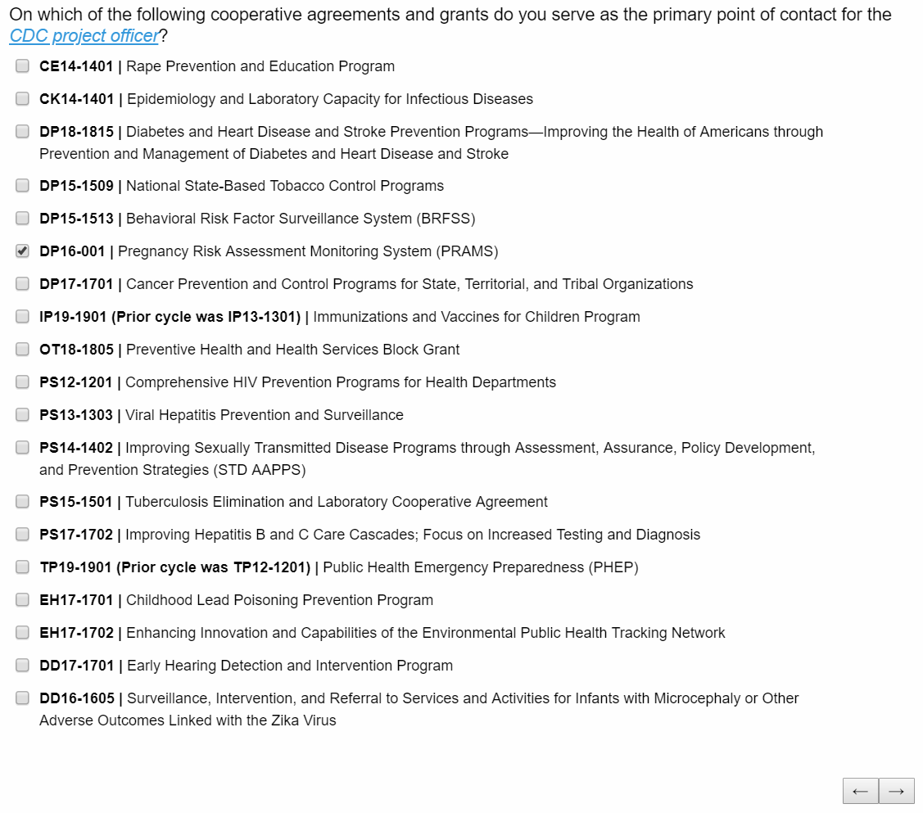
Select all that apply. If 3 or more are selected, the respondent will only be asked questions for 2 cooperative agreements.

Demographics – Respondent Experience with Cooperative Agreements and/or Grants
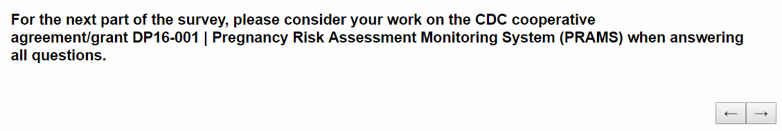
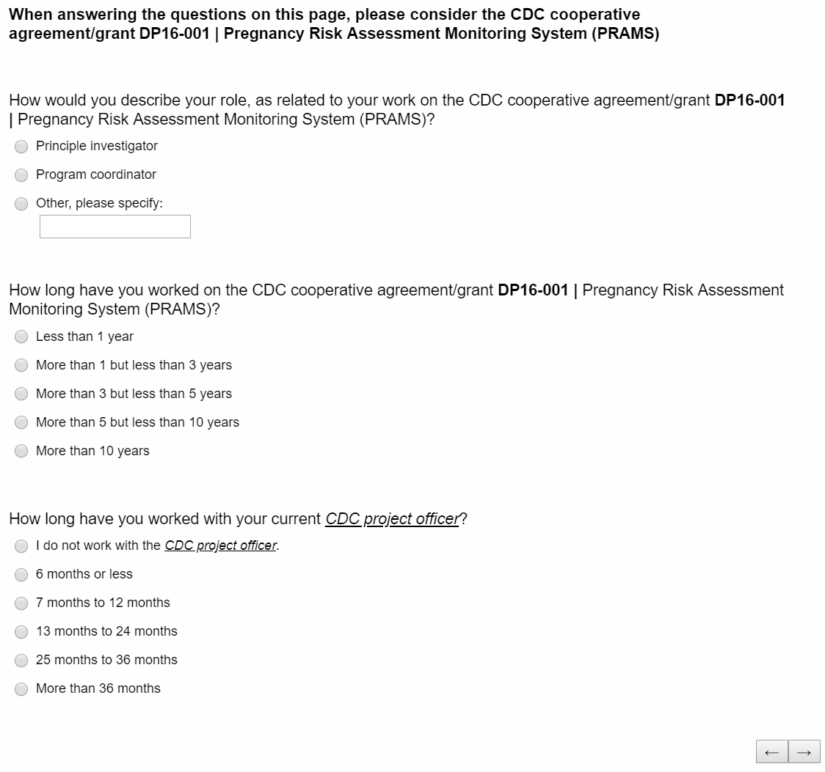
If “I do not work with the CDC project officer is selected,” respondent will be either sent to the final question in the instrument, or to the next series of questions for other selected CoAgs (if applicable).

IF respondent only leads one cooperative agreement and/or grant and selects “I do not work with CDC project officer” above, they will be directed to the end of the instrument:
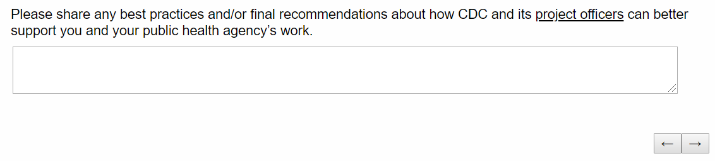
IF respondent selects any option other than “I do not work with CDC project officer” above, they will continue through the rest of the instrument:
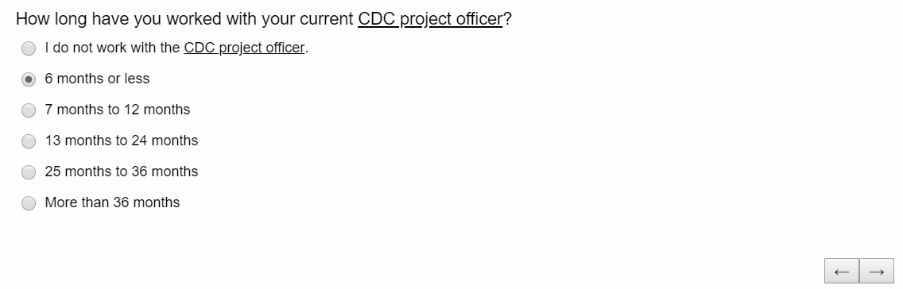
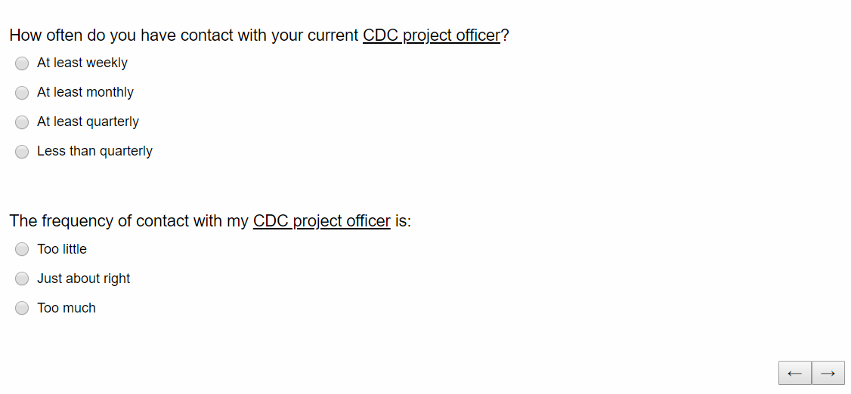
Part II: Satisfaction with Project Officer Support
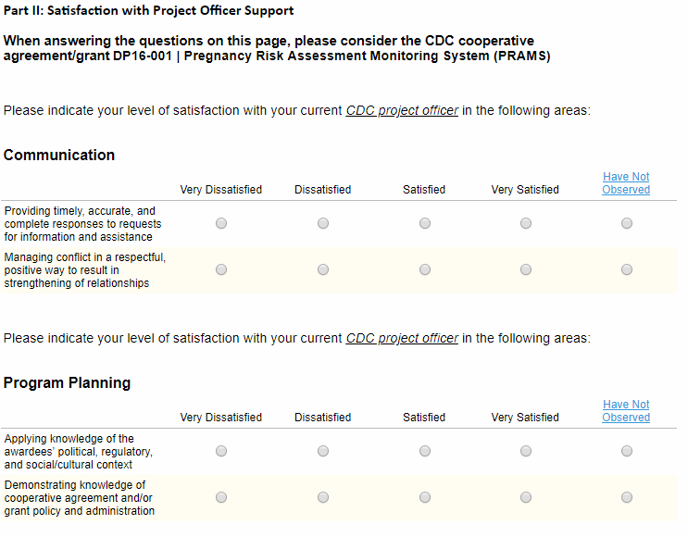
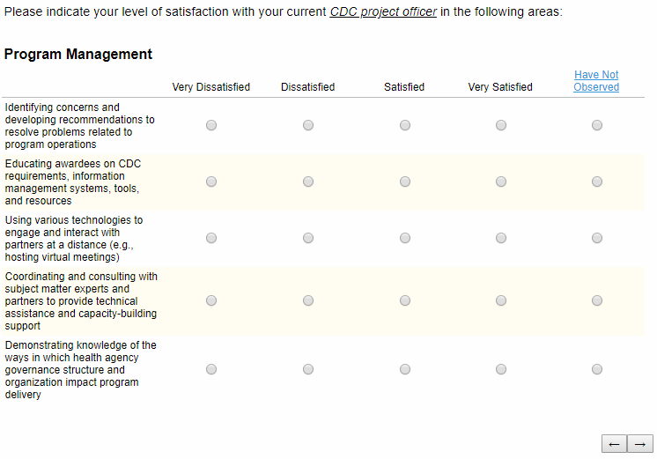
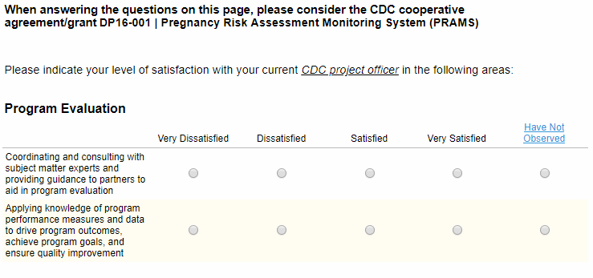
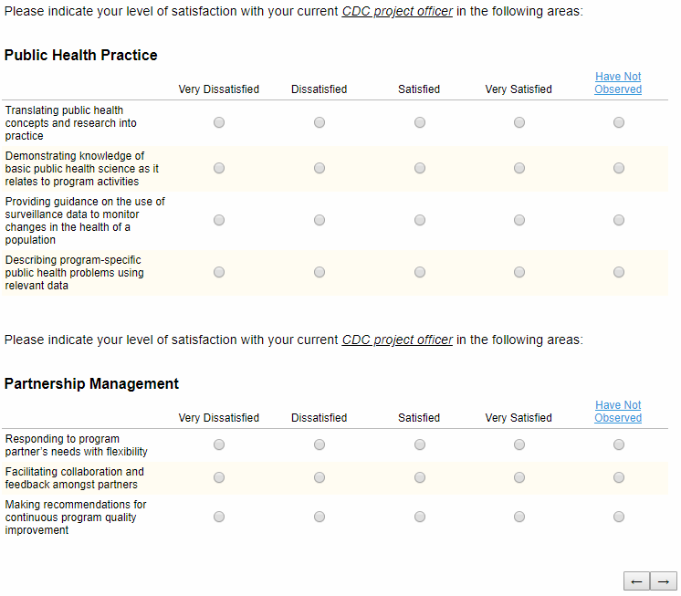
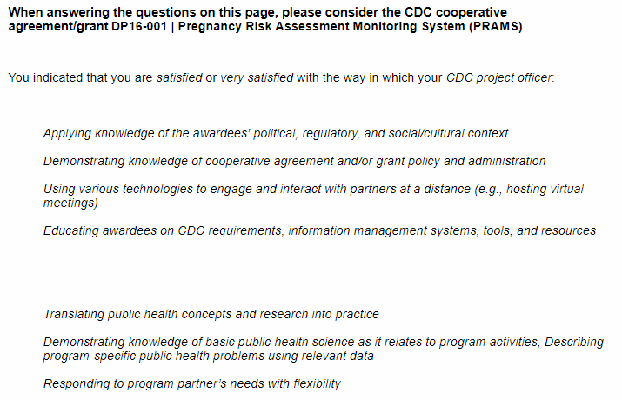
If “satisfied” or “very satisfied” is selected for any matrix item above, this question will be displayed. Each matrix item for which “satisfied” or “very satisfied” is selected is displayed in italics.

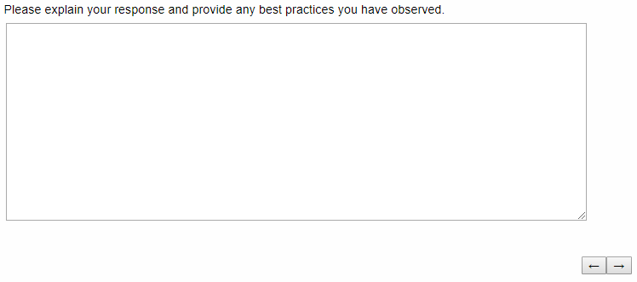

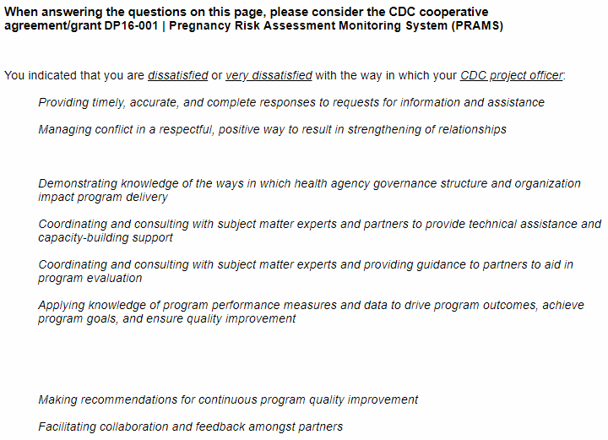
If “dissatisfied” or “very dissatisfied” is selected for any matrix item above, this question will be displayed. Each matrix item for which “dissatisfied” or “very dissatisfied” is selected is displayed in italics.

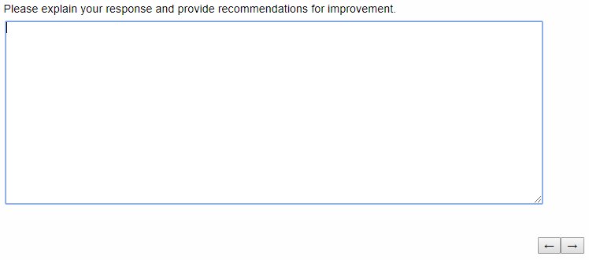
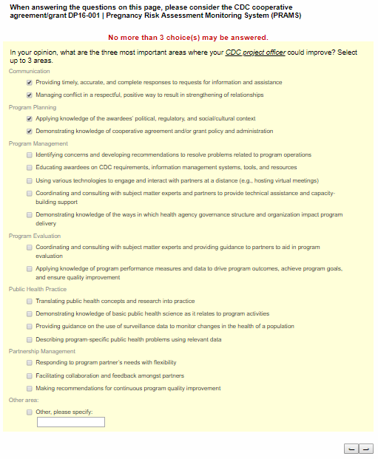
If respondents select more than 3 answers, they will be shown this error message and will not be able to continue within the instrument until 3 or less selections are made.
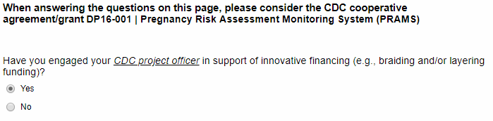
IF respondent selects “Yes” for the previous question, they will receive the question directly below:
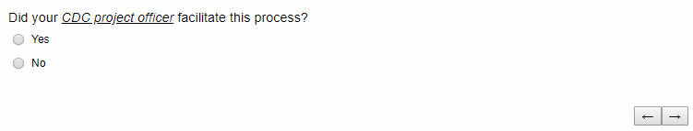
If “No” is selected, respondent will be shown question directly to the right.
If “Yes” is selected, respondent will be shown question directly below.
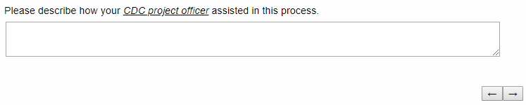
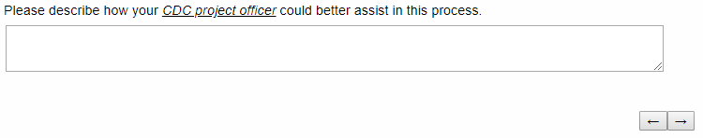
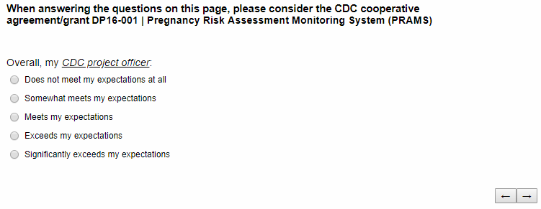
If “Exceeds my expectations” or “Significantly exceeds my expectations” is selected, respondent will be shown question directly to the right
If “Does not meet my expectations at all” or “Somewhat meets my expectations” is selected, respondent will be shown question directly below.

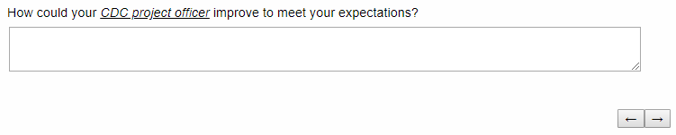

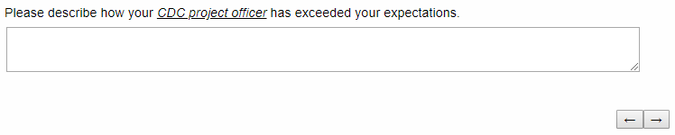

Part III: Site Visits
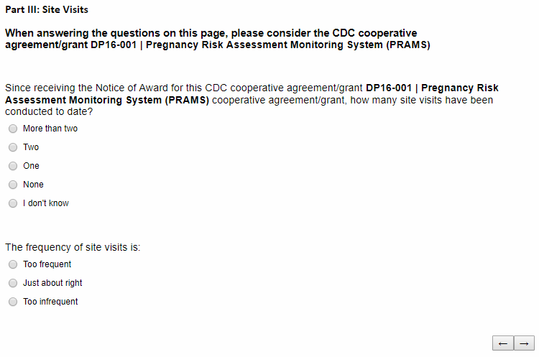
If “More than two, “Two,” or “One” is selected, respondent will be shown the matrix question below.
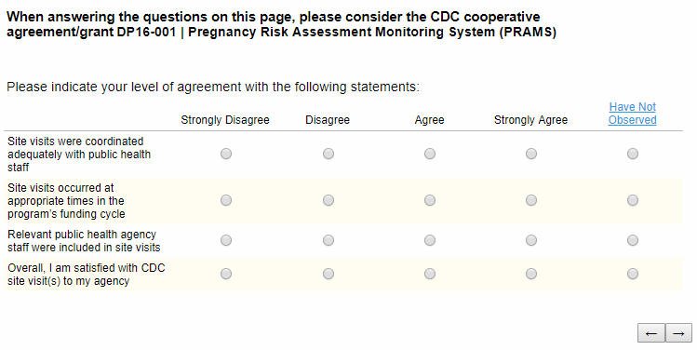

For each matrix for which the respondent selects “Strongly Disagree” or “Disagree,” they will be shown the corresponding text entry questions directly below:

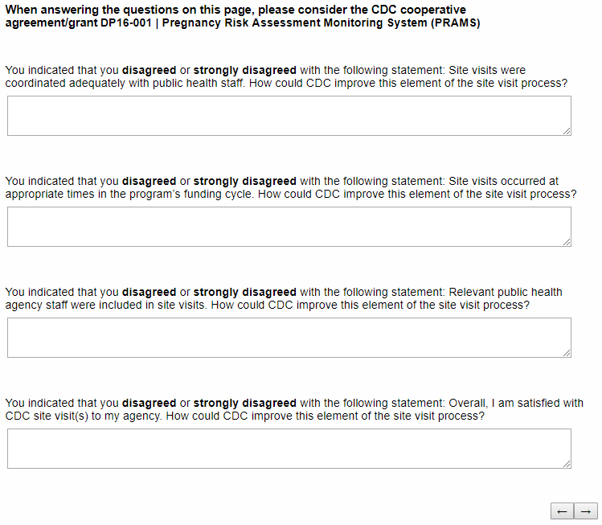

Part IV: Site Visits
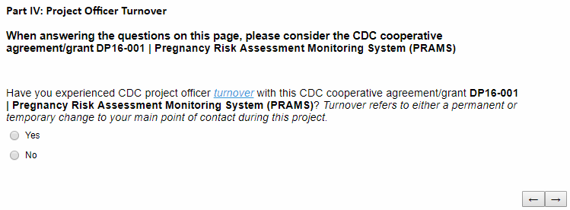
IF respondent selects “Yes” for the previous question, they will receive the question directly below:
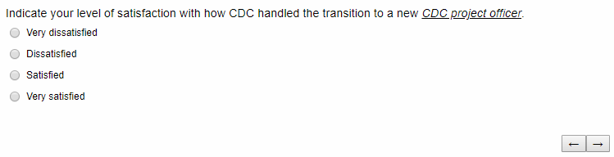
If “Satisfied” or “Very Satisfied” is selected, respondent will be shown question directly to the right
If “Very dissatisfied” or “Dissatisfied” is selected, respondent will be shown question directly below.
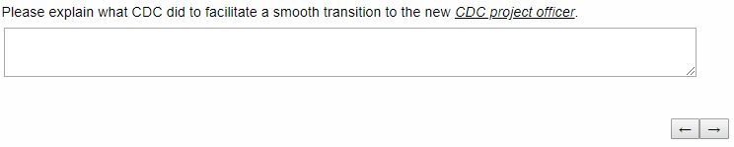
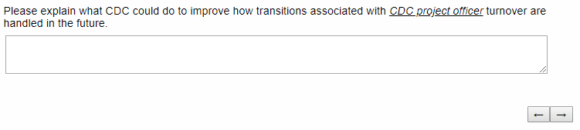

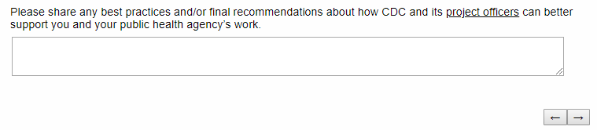
End of Instrument

