Attachment 4b: Summary of Proposed Changes to Facilitate Reporting and Searching Standardized Measures in the MIS for National Comprehensive Cancer Control Program Awardees

Table 1. Proposed Changes to Report Standardized Project Period Objectives and Annual Objectives
Current | Proposed
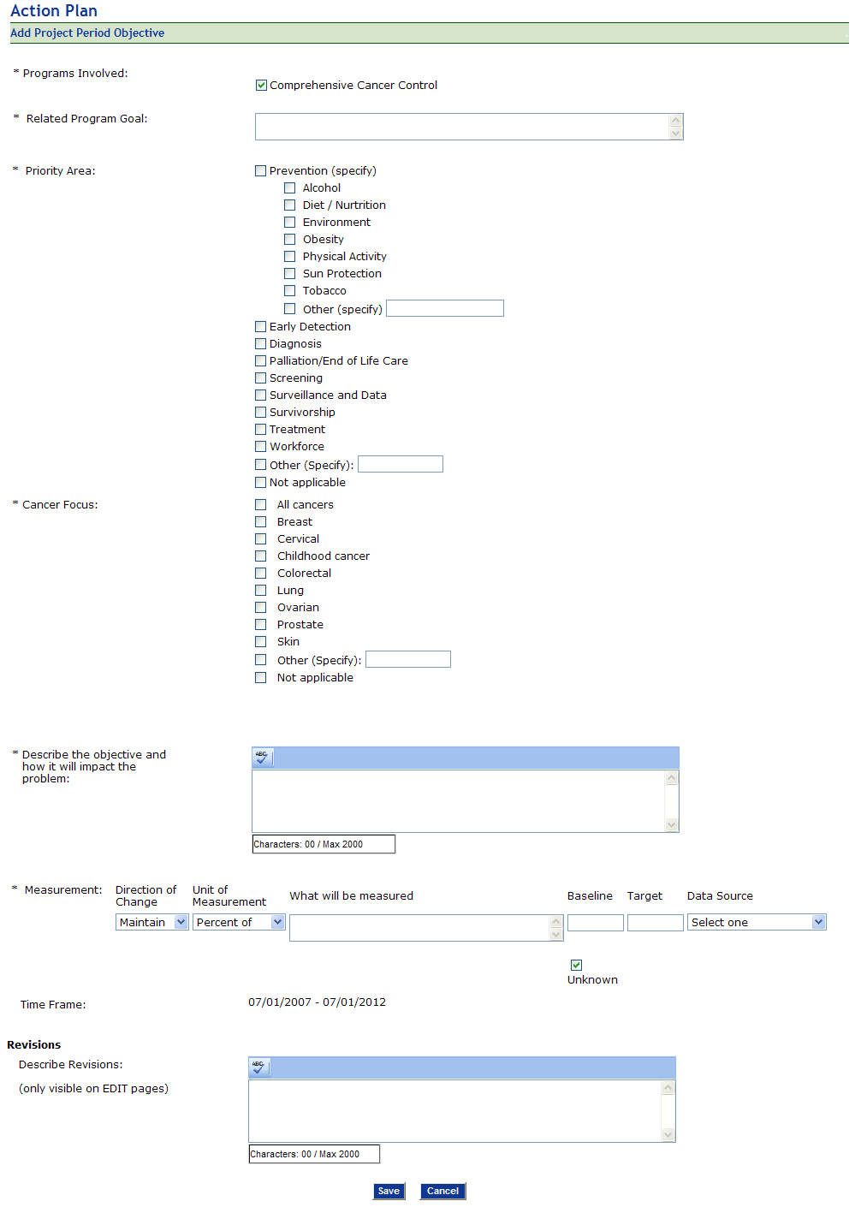 | 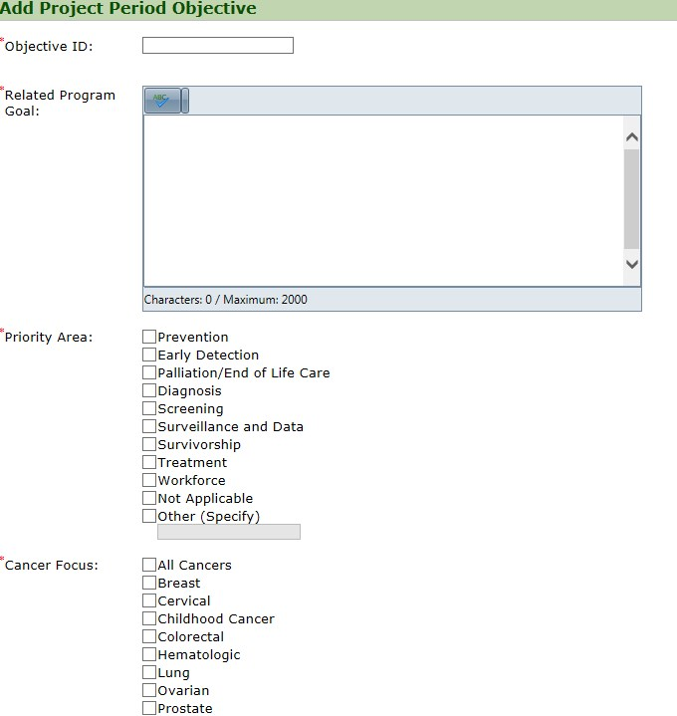  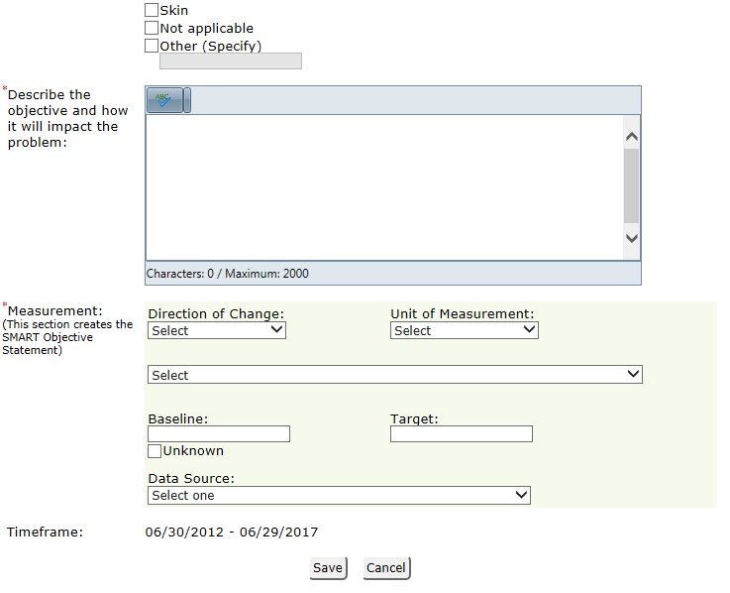  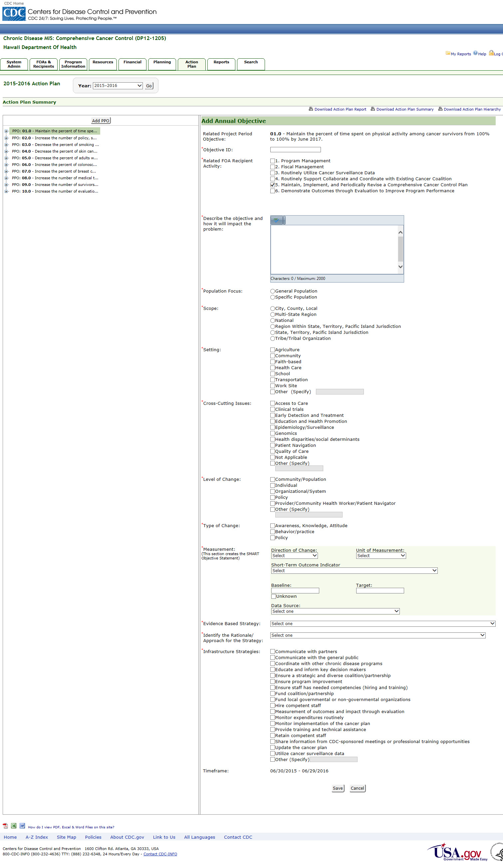

Table 2. Proposed Changes to Facilitate Searches for Standardized Measures
Current | Proposed
Search: New Search Criteria  Step 2: Select Response Options  *Topic: Action Plan  *Response Options:  Related FOA Recipient Activity  *Response Options: cont’d  Scope  Level of Change  Type of Change | 