DEPARTMENT OF HEALTH AND HUMAN SERVICES OMB control number: 0938-0931
CENTERS FOR MEDICARE & MEDICAID SERVICES _{Expiration Date: XX/2021}

NATIONAL PROVIDER IDENTIFIER (NPI) APPLICATION/UPDATE FORM

INSTRUCTIONS FOR COMPLETING THE NATIONAL PROVIDER IDENTIFIER (NPI) APPLICATION/UPDATE FORM
Please PRINT or TYPE all information so it is legible. Use only blue or black ink. Do not use pencil. Failure to provide pages 1, 2, and 3 with complete and accurate information may cause your application to be returned and delay processing of your application. In addition, you may experience problems being recognized by insurers if the records in their systems do not match the information you have furnished on this form. Please note: Social Security Number (SSN) or IRS Individual Taxpayer Identification Number (ITIN) information should only be listed in block 18 or block 19 of this form. DO NOT report SSN or ITIN information in any other section of this application form.
This application is to be completed by, or on behalf of, a health care provider or a subpart seeking to obtain an NPI. (See 45 CFR 162.408 and 162.410 (a) (1).
SECTION 1: BASIC INFORMATION (This section is to identify the reason for submittal of this form and the type of entity seeking to obtain an NPI.) A. Reason for Submittal of this Form
This section identifies the reason the health care provider is submitting this form. (Required)
1. Initial Application
If applying for a NPI for the first time check box #1, and complete appropriate sections as indicated in Section 1B for your entity type.

2. Change of Information
If changing information, check box #2, write your NPI in the space provided. See the instructions in Section 4, then sign and date the certification statement in Section 4A or 4B. All changes must be reported to the NPI Enumerator within 30 days of the change. Please ensure that your NPI is legible and correct. Complete Section 5 so that we may contact you in the event of problems processing this form. Please note that some changes, such as a change to a health care provider’s date of birth, require a photocopy of the health care provider’s U.S. driver’s license or birth certificate to be submitted along with the form for verification purposes.

3. Deactivation
If you are deactivating the NPI, check box #3. Record the NPI you want to deactivate, indicate the reason for deactivation, and complete
Section 2. Sign and date the certification statement in Section 4A or 4B, as appropriate. See instructions for Section 4. Use additional sheets of paper if necessary. Please note that deactivations due to death must be completed and signed in Section 4 by the Power of Attorney or Executor of the Will. In addition, a copy of the death certificate or obituary must accompany the completed signed form.

4. Reactivation
If you are reactivating the NPI, check box #4. Record the NPI you want to reactivate, provide the reason for reactivation, and complete Section 2. Sign and date the certification statement in Section 4A or 4B, as appropriate. See instructions for Section 4. Use additional sheets of paper if necessary.
B. Entity Type (Check only one box) (Required for initial applications)
- Entity Type 1: Individuals who render health care or furnish health care to patients; e.g., physicians, dentists, nurses, chiropractors, pharmacists, physical therapists. Incorporated individuals may obtain NPIs for themselves (Entity Type 1 Individual) if they are health care providers and may obtain NPIs for their corporations (Entity Type 2 Organization). A sole proprietorship is an Entity Type 1 (Individual). (A sole proprietorship is a form of business in which one person owns all the assets of the business and is solely liable for all the debts of the business in an individual capacity. Therefore, sole proprietorships are not organization health care providers.) Note that sole proprietorships may obtain only one NPI. Sole proprietorships must report their SSNs (not EINs even if they have EINs). Virtually any health care provider could be a sole proprietorship, including most of the examples listed in Entity Type 2.
DRAFT
- Entity Type 2: Organizations that render health care or furnish health care supplies to patients; e.g., hospitals, home health agencies, ambulance companies, group practices, health maintenance organizations, durable medical equipment suppliers, pharmacies. Solely owned corporations that are health care providers obtain NPIs as Entity Type 2. If the organization is a subpart, check yes and furnish the Legal Business Name (LBN) and Taxpayer Identification Number (TIN) of the “parent” organization health care provider. (A subpart is a component of an organization health care provider. A subpart may be a different location or may furnish a different type of health care than the organization health care provider. For ease of reference, we refer to that organization health care provider as the “parent”.)

SECTION 2: IDENTIFYING INFORMATION

A. Individual (includes Sole Proprietorships and Incorporated Individuals)
NOTE: An individual may obtain only one NPI, regardless of the number of taxonomies (specialties), licenses, or business practice locations he/she may possess. SSN or ITIN information should only be listed in block 18 or block 19, respectively, of this form. DO NOT report SSN and ITIN information in any other section of this form. A sole proprietorship is an individual.

Name Information
1–6. Provide your full legal name. (Required first and last name) Do not use initials or abbreviations. If you furnish your SSN in block 18, this name must match the name on file with the Social Security Administration (SSA). The date of birth must also match that on the file with SSA. Other name information
7–12. If you have used another name, including a maiden name, supply that “Other Name” in this area. (Optional) You may include multiple credentials. 13. Mark the check box to indicate the type of “Other Name” you used. (Required if 7–12 are completed)
14–16. Provide the date (Required), State (Required), and country (Required, if other than U.S.) of your birth. Do not use abbreviations other than United States (U.S.).
- Indicate your gender. (Required)
- Furnish your Social Security Number (SSN) for purposes of unique identification. (Optional) If you furnish your SSN, this name must match the name and date of birth on file with the Social Security Administration (SSA). If you do not furnish your SSN, processing of your application may be delayed because of the difficulty of verifying your identity via other means; you may also have difficulty establishing your proper identity with insurers from which you receive payments. If you are not eligible for an SSN, see item #19. If you do not furnish your SSN, you must furnish 2 proofs of identity with this application form. Acceptable forms include: valid passport, birth certificate, a photocopy of your U.S. driver’s license, State issued identification, or information requested in item 19. Visas and Employer Identification Cards are NOT acceptable.
- If you do not qualify for an SSN, furnish your IRS Individual Taxpayer Identification Number (ITIN) along with a photocopy of your U.S. driver’s license, State issued ID, birth certificate or passport. You may not report an ITIN if you have an SSN. Do not enter an Employer Identification Number (EIN) in the ITIN field. NOTE: Your valid passport, birth certificate, photocopy of the U.S. driver’s license or State issued identification must accompany your ITIN. If you do not furnish the information requested in blocks 18 or 19, you must furnish 2 proofs of identity with this application form: valid passport, birth certificate, a valid photocopy of your U.S. driver’s license or State issued identification. Visas and Employer Identification Cards are NOT acceptable.
Examples of individuals who need ITINs include:
  - Non-resident alien filing a U.S. tax return and not eligible for an SSN;
  - U.S. resident alien (based on days present in the United States) filing a U.S. tax return and not eligible for an SSN; • Dependent or spouse of a U.S. citizen/resident alien; and
  - Dependent or spouse of a non-resident alien visa holder.

B. Organizations (includes Groups, Corporations and Partnerships)
1–2. Provide your organization’s or group’s name (legal business name used to file tax returns with the IRS) and EIN (assigned by the IRS) (Required)
- If your organization or group uses or previously used another name, supply that “Other Name” in this area. (Optional)
- Mark the check box to indicate the type of “Other Name” used by your organization. (D/B/A Name=Doing Business As Name.) (Required if 3 is completed.)
NOTE: A sole proprietorship does not complete this section; he/she completes Section A.

SECTION 3: ADDRESSES AND OTHER INFORMATION

A. Business Mailing Address Information (Required)
This information will assist us in contacting you with any questions we may have regarding your application for an NPI or with other information regarding NPI. You must provide an address and telephone number where we can contact you directly to resolve any issues that may arise during our review of your application. Do not report your residential address in this section unless it is also your business mailing address.

B. Business Practice Location Information (Required)
If your Business Practice Location Information in this section is the same as your Correspondence Mailing Address in Section 3A, check here and continue to Section 3C. If the addresses are not the same, provide information on the address and telephone number of your primary practice location. If you have more than one practice location, select one as the “primary” location. Do not furnish information about additional locations on additional sheets of paper. Do not report your residential address in this section unless it is also your business practice location.

C. Other Provider Identification Numbers (Optional)
To assist health plans in matching your NPI to your existing health plan assigned identification number(s), you may wish to list the provider identification number(s) you currently use that were assigned to you by health plans. If you do not have such numbers, you are not required to obtain them in order to be assigned an NPI. Organizations should only furnish other provider identification numbers that belong to the organization; do not list identification numbers that belong to health care providers who are individuals who work for the Organizations. DO NOT report SSN, ITIN, EIN information, any Medicare number, or provider license number in this section of the form.

D. Provider Taxonomy Code (Provider Type/Specialty) (Required)
Provide your 10-digit taxonomy code. You must select a primary taxonomy code in order to facilitate aggregate reporting of providers by classification/specialization. If you need additional taxonomy codes to describe your type/classification/specialization, you may select additional codes. Information on taxonomy codes is available at www.wpc-edi.com/codes/taxonomy.
Furnish the provider’s health care license, registration, or certificate number(s) (if applicable). If issued by a State, show the State that issued the license/ certificate. The following individual practitioners are required to submit a license number. (If you are a resident or intern and do not have a license or certificate, you may select the Student in an Organization Health Care Education/Training Program taxonomy code.) (If you are one of the following and do not have a license or certificate, you must enclose a letter to the Enumerator explaining why not):
Certified Registered Nurse Anesthetist Clinical Psychologist Nurse Practitioner Physician/Osteopath
Chiropractor Dentist Optometrist Podiatrist
Clinical Nurse Specialist Licensed Nurse Pharmacist Registered Nurse
You may use the same license, registration, or certification number for multiple taxonomies; e.g., if you are a physician with several different specialties. Do not include SSN, ITIN, EIN or NPI in this section. Do not list credentials as a taxonomy description, be specific.
NOTE: A health care provider that is an organization, such as a hospital, may obtain an NPI for itself and for any subparts that it determines need to be assigned NPIs. In some cases, the subparts have Provider Taxonomy Codes that may be different from that of the hospital and of each other, and each subpart may require separate licensing by the State (e.g., General Acute Care Hospital and Psychiatric Unit). If the organization provider chooses to include these multiple Provider Taxonomy Codes in a request for a single NPI, and later determines that the subparts should have been assigned their own NPIs with their associated Provider Taxonomy Codes, the organization provider must delete from its NPPES record any Provider Taxonomy Codes that belong to the subparts who will be obtaining their own NPIs. The organization provider must do this by initiating the Change of Information option on this form.
DRAFT

SECTION 4: CERTIFICATION STATEMENT (Required)
This section is intended for the applicant to attest that he/she is aware of the requirements that must be met and maintained in order to obtain and retain an NPI. This section also requires the signature and date of signature of the “Individual” who is the type 1 provider, or the “Authorized Official” of the type 2 organization who can legally bind the provider to the laws and regulations relating to the NPI. See below to determine who within the provider qualifies as an Authorized Official. Review these requirements carefully. Authorized Official’s Information and Signature for the Organization
By his/her signature, the authorized official binds the organization provider/supplier to all of the requirements listed in the Certification Statement and acknowledges that the organization provider may be denied a National Provider Identifier if any requirements are not met. This section is intended for organization providers; not health care providers who are individuals. All signatures must be original. Stamps, faxed or photocopied signatures are unacceptable. You may include multiple credentials.
An authorized official is an appointed official with the legal authority to make changes and/or updates to the organization provider’s status (e.g., change of address, etc.) and to commit the organization provider to fully abide by the laws and regulations relating to the National Provider Identifier. The authorized official must be a general partner, chairman of the board, chief financial officer, chief executive officer, direct owner of 5 percent or more of the organization provider being enumerated, or must hold a position of similar status and authority within the organization.
Only the authorized official(s) has the authority to sign the application on behalf of the organization provider.
By signing this application for the National Provider Identifier, the authorized official agrees to immediately notify the NPI Enumerator if any information in the application is not true, correct, or complete. In addition, the authorized official, by his/her signature, agrees to notify the NPI Enumerator of any changes to the information contained in this form within 30 days of the effective date of the change.

SECTION 5: CONTACT PERSON (Required)
Please note that if a contact person is not provided, all questions about this application will be directed to the health care provider named in Section 2 or the authorized official named in Section 4, as appropriate. The contact person will receive the NPI notification once the health care provider has been assigned an NPI. You may include multiple credentials.
DEPARTMENT OF HEALTH AND HUMAN SERVICES CMS-10114 CENTERS FOR MEDICARE & MEDICAID SERVICES _{Expires: xx/xx}

NATIONAL PROVIDER IDENTIFIER (NPI) APPLICATION/UPDATE FORM
Please PRINT or TYPE all information so it is legible. Use only blue or black ink. Do not use pencil. Failure to provide pages 1, 2
and 3 with complete and accurate information may cause your application to be returned and delay processing. In addition, you may experience problems being recognized by insurers if the records in their systems do not match the information you have furnished on this form. Information submitted on this application (except for Social Security Number, IRS Individual Taxpayer Identification Number, and Date of Birth) may be made available on the internet.

SECTION 1: BASIC INFORMATION
- Reason for Submittal of this Form (Required) (Only provide one Reason for Submittal and/or NPI per form.

Use additional forms if necessary.)
1.Initial Application* 3. Deactivation (See Instructions)
(*Denotes required field for initial application only.) NPI: (Required)
2.Change of Information (See instructions) Deactivation Reason: (Check only one box) (Required)
NPI: (Required) Death Business Dissolved
Only complete the appropriate sections with the Other, Specify: (See Instructions) information that is changing. If removing information, 4. Reactivation (See Instructions) please indicate within the appropriate field(s) by NPI: (Required) writing ‘Remove’.
DRAFT
Reactivation Reason: (Required)

- Entity Type (Check only one box) (Required for initial applications only) (See Instructions)
1.An individual who renders health care. (Complete Sections 2A, 3, 4A and 5 only)
  - Is the individual a sole proprietor? (See Instructions) Yes No
2.An organization that renders health care. (Complete Sections 2B, 3, 4B and 5 only)
  - Is the organization a subpart? (See Instructions) Yes No
  - If yes, enter the Legal Business Name (LBN) and Taxpayer Identification Number (TIN) of the “parent” organization health care provider:
Parent Organization LBN:
Parent Organization TIN:

SECTION 2: IDENTIFYING INFORMATION
A. Individuals (includes Sole Proprietorships and Incorporated Individuals)
1. Prefix (e.g., Mr., Mrs.) | 2. First* | 3. Middle | 4. Last*
5. Suffix (e.g., Jr., Sr.) | 6. Credential (e.g., M.D., D.O.)
Other Name Information (If applicable. Use additional sheets of paper if necessary)
1. Prefix (e.g., Mr., Mrs.) | 2. First | 3. Middle | 4. Last
5. Suffix (e.g., Jr., Sr.) | 6. Credential (e.g., M.D., D.O.)
13. Type of Other Name
Former Name Professional Name Other
14. Date of Birth* (mm/dd/yyyy) | 15. State of Birth* (U.S. only) |  | 16. Country of Birth* (If other than U.S.) | 17. Gender* Male Female
18. Social Security Number (SSN) (See Instructions) |  | 19. IRS Individual Taxpayer Identification Number (ITIN) (See Instructions)
B. Organizations (includes Groups, Corporations and Partnerships) (Do not report an SSN in the EIN field.)
1. Name* (Legal Business Name) 2. Employer Identification Number* (EIN)
3. Other Name (if applicable see instructions) 4. Type of Other Name
Former Legal Business Name D/B/A Name Other

SECTION 3: BUSINESS ADDRESSES AND OTHER INFORMATION
A. Correspondence Mailing Address
(Do not report your residential address unless it is also your Correspondence Mailing Address.)
1. Correspondence Mailing Address Line 1* (Street Number and Name or P.O. Box)
2. Correspondence Mailing Address Line 2 (Address Information; e.g., Suite Number)
3. City/Town* | 4. State* | 5. ZIP or Foreign Postal Code* | 6. +4
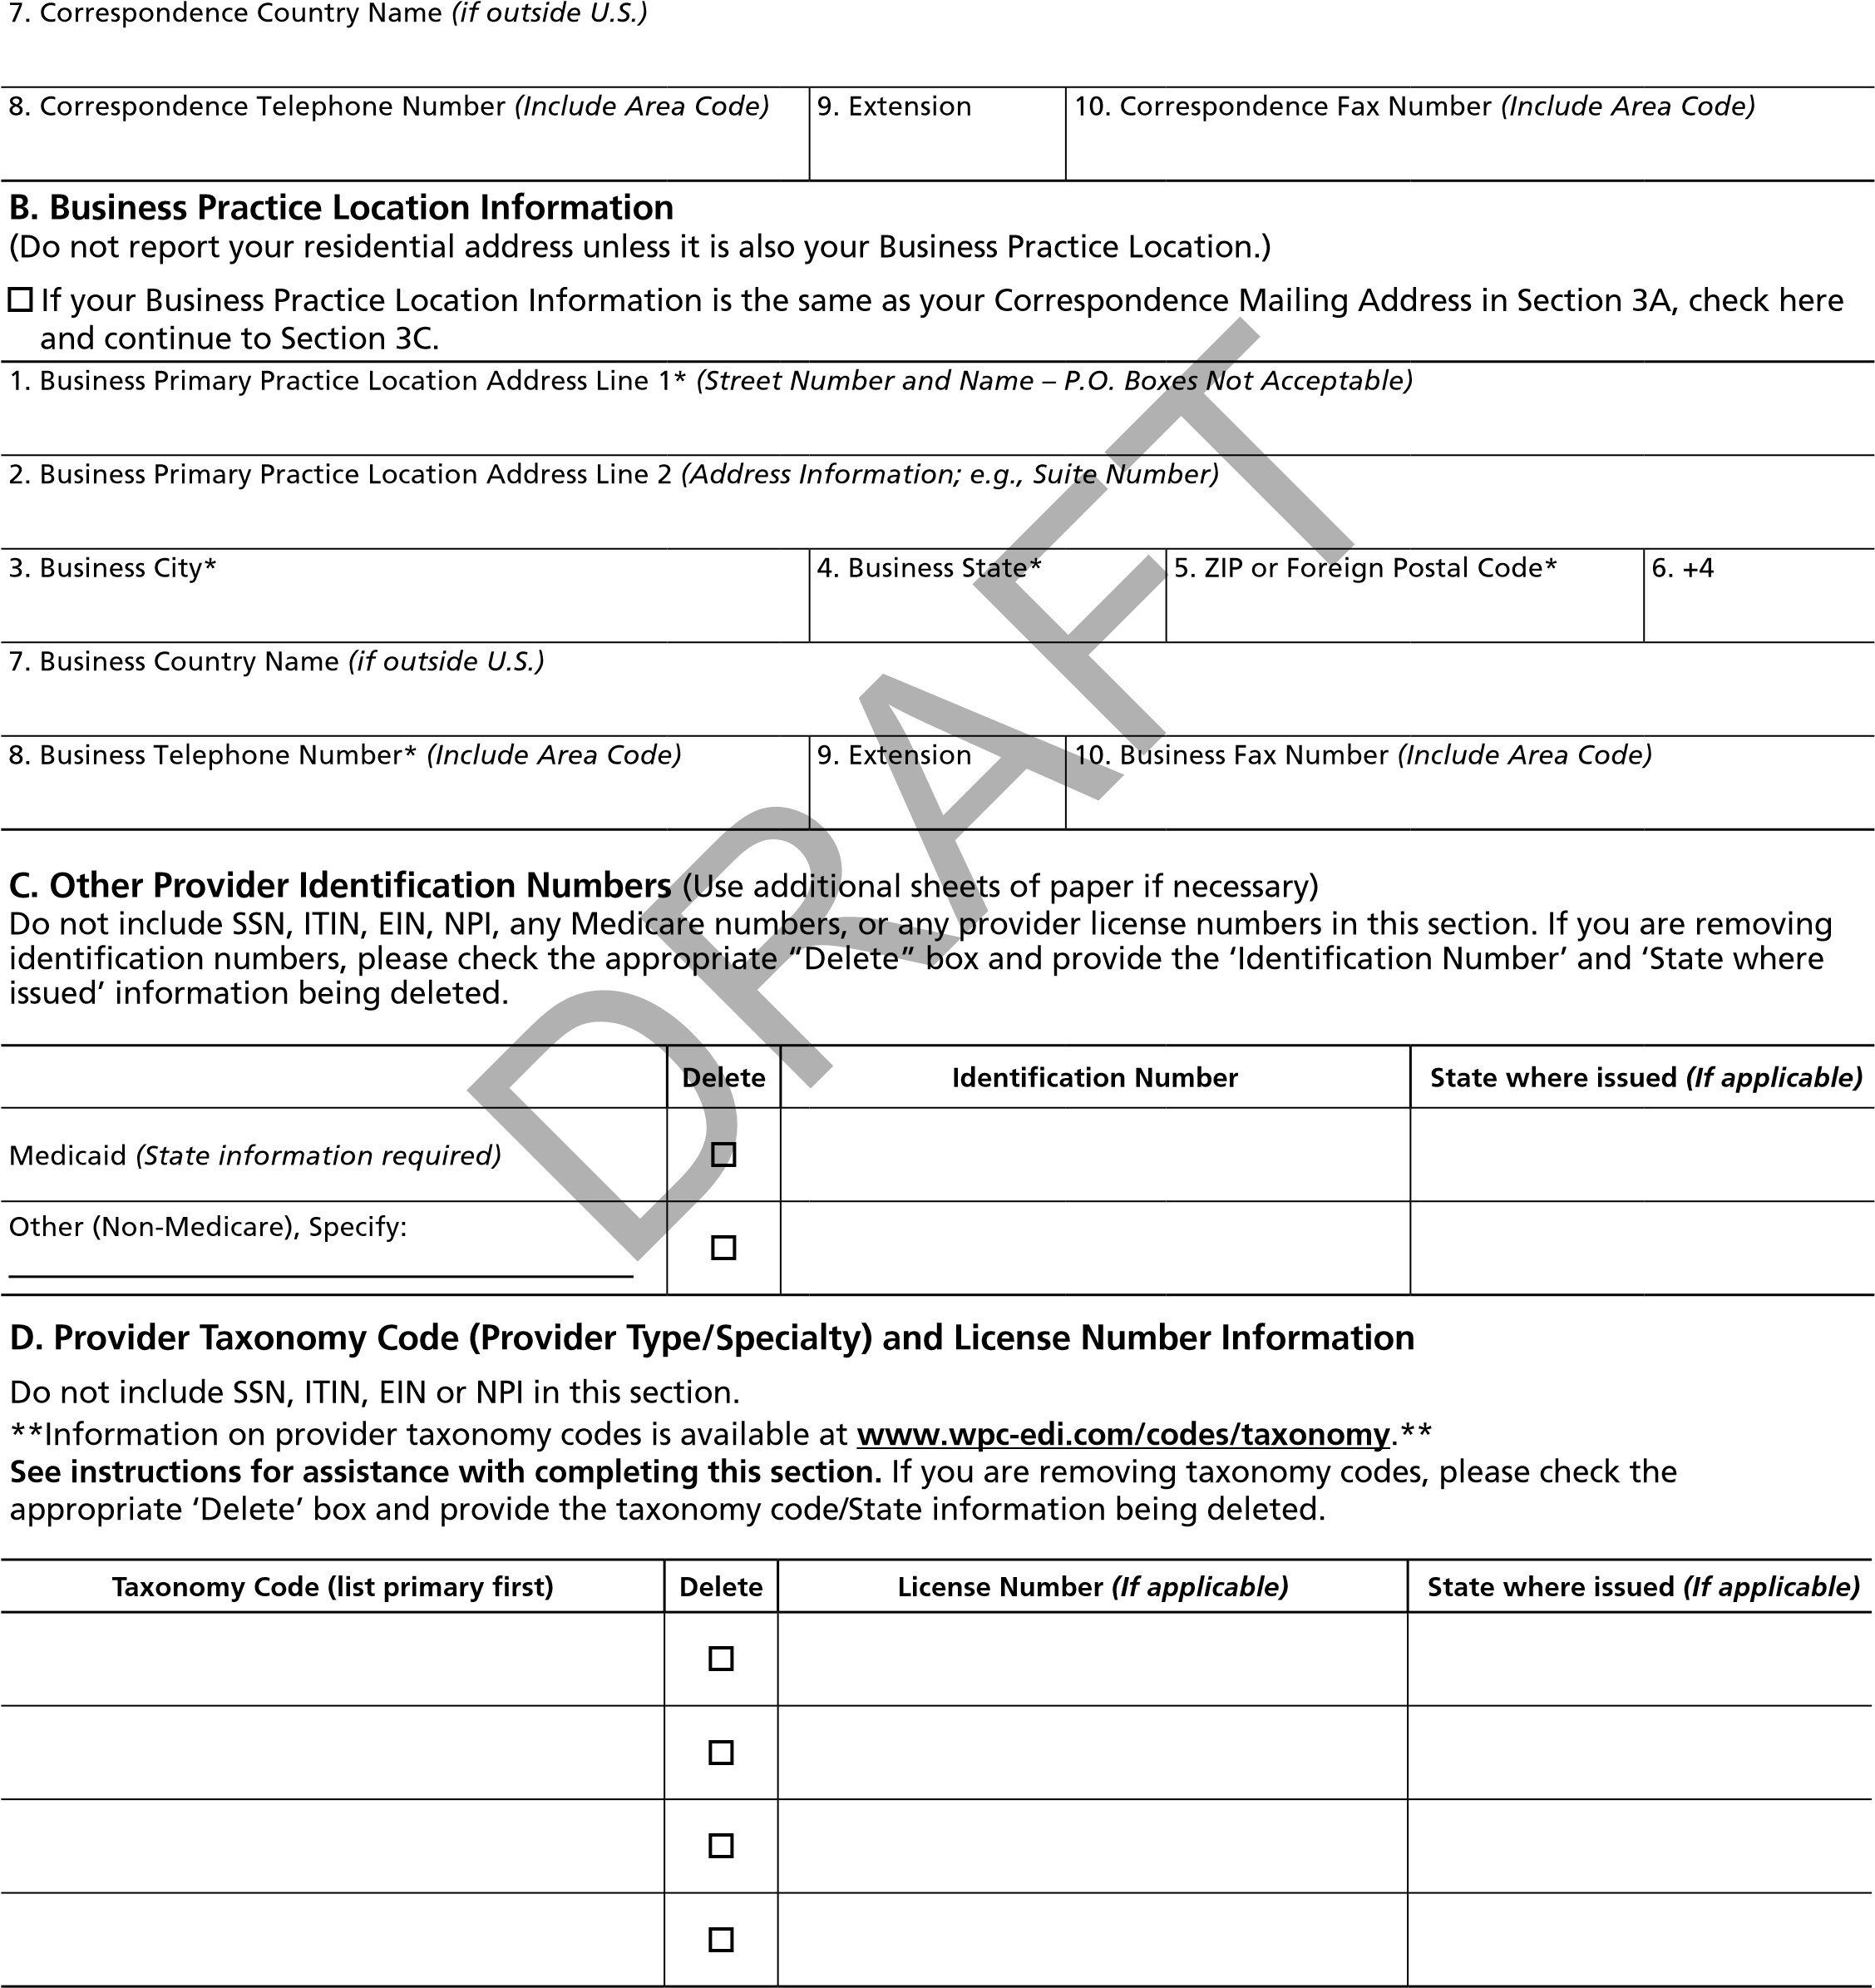

Penalties for Falsifying Information on the National Provider Identifier (NPI) Application/Update Form

18 U.S.C. 1001 authorizes criminal penalties against an individual who in any matter within the jurisdiction of any department or agency of the United States knowingly and willfully falsifies, conceals or covers up by any trick, scheme or device a material fact, or makes any false, fictitious or fraudulent statements or representations, or makes any false writing or document knowing the same to contain any false, fictitious or fraudulent statement or entry. Individual offenders are subject to fines of up to $250,000 and imprisonment for up to 5 years. Offenders that are organizations are subject to fines of up to $500,000. 18 U.S.C. 3571(d) also authorizes fines of up to twice the gross gain derived by the offender if it is greater than the amount specifically authorized by the sentencing statute.

SECTION 4: CERTIFICATION STATEMENT (See Instructions)
I, the undersigned, certify to the following:
- This form is being completed by, or on behalf of, a health care provider as defined at 45 CFR 160.103.
- I have read the contents of the application and the information contained herein is true, correct and complete. If I become aware that any information in this application is not true, correct, or complete, I agree to notify the NPI Enumerator of this fact immediately.
- I authorize the NPI Enumerator to verify the information contained herein. I agree to notify the NPI Enumerator of any changes in this form within 30 days of the effective date of the change.
- I have read and understand the Penalties for Falsifying Information on the NPI Application/Update Form as printed in this application. I am aware that falsifying information will result in fines and/or imprisonment.
- I have read and understand the Privacy Act Statement.
**All signatures must be original and signed in ink. Applications with signatures deemed not original will not be processed.
Stamped, faxed or copied signatures will not be accepted.**
A. Individual Practitioner’s Signature (Required for Type 1 Providers ONLY.)
1. Practitioner’s Signature (Required for Type 1 Organizations ONLY.)* (First, Middle, Last, Jr., Sr., M.D., D.O., etc.) 2. Date* (mm/dd/yyyy)

B. Authorized Official’s Signature for the Organization (Required for Type 2 Organizations ONLY.)
1. Authorized Official’s Signature (Required for Type 2 Organizations ONLY.)* (First, Middle, Last, Jr., Sr., M.D., D.O., etc.) |  |  |  |  | 2. Date* (mm/dd/yyyy)
3. Prefix (e.g., Mr., Mrs.) | 4. First* |  | 5. Middle | 6. Last*
7. Suffix (e.g., Jr., Sr.) | 8. Credential (e.g., M.D., D.O.)
9. Title/Position* |  | 10. Telephone Number* (Include Area Code) |  | 11. Extension

SECTION 5: CONTACT PERSON

Contact Person’s Information
Provide the name and telephone number of an individual who can be reached to answer questions regarding the information you furnished in this application. The contact person can be the health care provider. (See Instructions)
1. Prefix (e.g., Mr., Mrs.) | 2. First* | 3. Middle | 4. Last*
5. Suffix (e.g., Jr., Sr.) |  | 6. Credential (e.g., M.D., D.O.) | 7. Title/Position
8. E-Mail Address |  | 9. Telephone Number* (Include Area Code) |  | 10. Extension
For the most efficient and fast receipt of your NPI, please use the web-based NPI process at the following address: https:// nppes.cms.hhs.gov. NPI web is a quick and easy way for you to get your NPI. Or send the completed signed application to: NPI Enumerator, P.O. Box 6059, Fargo, ND 58108-6059
DRAFT
According to the Paperwork Reduction Act of 1995, no persons are required to respond to a collection of information unless it displays a valid OMB control number. The valid OMB control number for this information collection is 0938-0931. The time required to complete this information collection is estimated to average 10 minutes per response for new applications and 10 minutes for changes per response, including the time to review instructions, search existing data resources, gather the data needed, and complete and review the information collection. If you have comments concerning the accuracy of the time estimate(s) or suggestions for improving this form, please write to: CMS, 7500 Security Boulevard, Attn: PRA Reports Clearance Officer, Mail Stop C4-26-05, Baltimore, Maryland 21244-1850. Please do not send applications, claims, payments, medical records or any documents containing sensitive information to the PRA Reports Clearance Office. Please note that any correspondence not pertaining to the information collection burden approved under the associated OMB control number listed on this form will not be reviewed, forwarded, or retained. If you have questions or concerns regarding where to submit your documents, please contact the NPI Enumerator at 1-800-465-3203.

PRIVACY ACT STATEMENT

Section 1173 of the Social Security Act authorizes the adoption of a standard unique health identifier for all health care providers who conduct electronically any standard transaction adopted under 45 CFR 162. The purpose of collecting this information is to assign a standard unique health identifier, the National Provider Identifier (NPI), to each health care provider for use on standard transactions. The NPI will simplify the administrative processing of certain health information. Further, it will improve the efficiency and effectiveness of standard transactions in the Medicare and Medicaid programs and other Federal health programs and private health programs. The information collected will be entered into a new system of records called the National Provider System (NPS), HHS/HCFA/OIS No. 09-70-0008. In accordance with the NPPES Data Dissemination Notice (CMS- 6060), published May 30, 2007, certain information that you furnish will be publicly disclosed. The NPPES Data Dissemination Notice can be found at https://www.cms.gov/Regulations-and-Guidance/Administrative-Simplification/ NationalProvIdentStand/DataDissemination.html.
Failure to provide complete and accurate information may cause the application to be returned and delay processing. In addition, you may experience problems being recognized by insurers if the records in their systems do not match the information you furnished on the form. (See the instructions for completing the NPI application/update form to find the information that is voluntary or mandatory.)
Information may be disclosed under specific circumstances to:
- The entity that contracts with HHS to perform the enumeration functions, and its agents, and the NPS for the purpose of uniquely identifying and assigning NPIs to providers.
- Entities implementing or maintaining systems and data files necessary for compliance with standards promulgated to comply with title XI, part C, of the Social Security Act.
- A congressional office, from the record of an individual, in response to an inquiry from the congressional office made at the request of that individual.
- Another Federal agency for use in processing research and statistical data directly related to the administration of its programs.
- The Department of Justice, to a court or other tribunal, or to another party before such tribunal, when
  - HHS, or any component thereof, or
  - Any HHS employee in his or her official capacity; or
  - Any HHS employee in his or her individual capacity, where the Department of Justice (or HHS, where it is authorized todo so) has agreed to represent the employee; or
  - The United States or any agency thereof where HHS determines that the litigation is likely to affect HHS or any of its components is party to litigation or has an interest in such litigation, and HHS determines that the use of such records by the Department of Justice, the tribunal, or the other party is relevant and necessary to the litigation and would help in the effective representation of the governmental party or interest, provided, however, that in each case HHS determines that such disclosure is compatible with the purpose for which the records were collected.
DRA
F
T
- An individual or organization for a research, demonstration, evaluation, or epidemiological project related to the prevention of disease or disability, the restoration or maintenance of health, or for the purposes of determining, evaluating and/or assessing cost, effectiveness, and/or the quality of health care services provided.
- An Agency contractor for the purpose of collating, analyzing, aggregating or otherwise refining or processing records in this system, or for developing, modifying and/or manipulating automated data processing (ADP) software. Data would also be disclosed to contractors incidental to consultation, programming, operation, user assistance, or maintenance for ADP or telecommunications systems containing or supporting records in the system.
- An agency of a State Government, or established by State law, for purposes of determining, evaluating and/or assessing cost, effectiveness, and/or quality of health care services provided in the State.
- Another Federal or State agency
  - As necessary to enable such agency to fulfill a requirement of a Federal statute or regulation, or a State statute orregulation that implements a program funded in whole or in part with Federal funds.
  - For the purpose of identifying health care providers for debt collection under the provisions of the Debt Collection Information Act of 1996 and the Balanced Budget Act.

