Using Concept Mapping to Develop a Theory to Describe the Work of the
National Domestic Violence Hotline - Formative Data Collection

OMB Information Collection Request
0970 – 0356

Online Concept Mapping Directions

Submitted By:
Office of Planning, Research and Evaluation
Administration for Children and Families
U.S. Department of Health and Human Services

4th Floor, Mary E. Switzer Building
330 C Street, SW
Washington, D.C. 20201

September 2017

Project Officer:
Tia Zeno, Ph.D.
Social Science Research Analyst
Office of Planning, Research and Evaluation
Administration for Children and Families
U.S. Department of Health and Human Services
Table of Exhibits
Exhibit 1. (1a) Introduction to the SAF-T Concept Mapping Project 1
Exhibit 2. (1b) Informed Consent 2
Exhibit 3. (1c) Log-in Page 3
Exhibit 4. (1d) Home Page 5
Exhibit 5. (1di) Brainstorming 5
Exhibit 6. (1dii) Sorting 6
Exhibit 7. (1diii) Rating 7
Exhibit 8. (1e) Participant Questions 8
Exhibit 9. (1f) Project Completed Message 9
Exhibit 10. (2a) Brainstorming Activity Instructions 9
Exhibit 11. (2b) Brainstorming Activity Thank You 10
Exhibit 12. (3a) Sorting Activity Instructions 11
Exhibit 13. (3b) Sorting Activity Thank You 12
Exhibit 14. (4a) Rating Activity Instructions – Empowerment 12
Exhibit 15. (4b) Rating Activity Instructions – Support 13
Exhibit 16. (4c) Rating Activity Thank You 13

Online Concept Mapping Directions
NOTE: This document provides an overview of the information and directions to be given to participants via the online Concept Systems concept mapping program. Information below is organized by the way software administrators manage a concept mapping project, and except for General Project Areas, tasks and directions are sequenced below in the order that a participant will see them.

GENERAL PROJECT AREAS
Exhibit 1. (1a) Introduction to the SAF-T Concept Mapping Project
Safety Alert: If you are concerned about your safety related to this website, exit the webpage and clear your browser history. Computer use can be monitored and is impossible to be completely clear.
Welcome to the SAF-T Project Concept Mapping Process! We appreciate your input and value your participation. Your input will be used to better understand the factors that enable the National Domestic Violence Hotline (The Hotline) and loveisrespect (LIR) to empower and support those affected by relationship abuse. The results from this project will help inform a framework specific to the unique needs of domestic violence victims and survivors contacting The Hotline/LIR. The SAF-T Project Concept Mapping Process will include a variety of stakeholder groups, including The Hotline/LIR staff, users of The Hotline/LIR, intimate partner violence and domestic violence service providers, intimate partner violence and domestic violence policy advocates, and ACF or other federal staff.
Please be sure to save your responses frequently as you go by clicking the "save" icon that will appear near the top right portion of the page once you begin an activity.
To begin, please select "Participate Anonymously" if this is your first time here, or select "Login" to enter your username and password. Please remember to keep your username and password in a safe place to use for future sessions.
Participate Anonymously
Login

Exhibit 2. (1b) Informed Consent
Please read the following informed consent language and if you accept, click the button below.
What is the SAF-T project?
The National Domestic Violence Hotline Services Assessment Framework based on Theory (SAF-T) is a project funded by the Administration for Children and Families (ACF) on behalf of the Family and Youth Service Bureau’s Family Violence Prevention and Services Program and the Office of Planning, Research and Evaluation. The purpose of this project is to develop a framework that reflects the needs and outcomes of those who contact The National Domestic Violence Hotline (The Hotline) and loveisrespect (LIR; the helpline targeted towards young people) and the services that The Hotline and LIR provide. Using this framework, we will then develop an approach for performance measurement and evaluation. As part of this project we are seeking input from key stakeholders to help inform the development of the framework.
The SAF-T project will use concept mapping - a participatory qualitative research method that helps develop a conceptual framework for how a group views a topic or aspect of a topic. Concept mapping uses a structured data collection approach, which allows for the collection of a wide range of participant-generated ideas, and results are then used to produce illustrative maps that show the relationships of ideas shared.
The purpose of the SAF-T Project Concept Mapping Process is to elicit your perspective as a stakeholder on the factors that enable The Hotline/LIR to empower and support those affected by relationship abuse, how important the factors are with empowerment and safety, and guidance on the development of a framework specific to the unique needs of domestic violence victims and survivors contacting The Hotline/LIR.
What will participation involve?
If you choose to participate in this research project, you will be eligible to complete three online concept mapping data collection activities and one group webinar discussion. NOTE: Those referred to the project by The Hotline/LIR phone or chat advocates are being asked to complete a single concept mapping activity, but are welcome to return to participate in additional activities.
- Brainstorming Activity: You will be asked to contribute information and insight on factors that enable The Hotline/LIR to empower and support those affected by relationship abuse. This activity will take approximately 20 minutes to complete and will take place November 2017.
- Sorting Activity: You will be asked to sort responses into categories that make sense to you. This activity will take approximately 20 minutes to complete and will take place December 2017.
- Rating Activity: You will be asked to rate each response on a scale of importance in two areas: (1) empowering those affected by relationship abuse, and (2) supporting those affected by relationship abuse to take next steps towards becoming safer or remaining safe. This activity will take approximately 20 minutes to complete and will take place December 2017.
- Group Webinar Discussion: You will be asked to participate in a group webinar where we will share combined results and get feedback from all participants through discussion. This activity will take approximately 60 minutes to complete and will take place January 2018. If you are unable to participate in the webinar, you will be asked to independently review and respond to an emailed overview of the proposed framework.

While we are not able to provide financial incentives for participation, your input and perspective is really important and we greatly appreciate you contributing your time and insight to this project.

Before moving ahead, please remember that:
- You must be over the age of 18 years or older to participate in this study.
- There is the possible risk that you may feel some emotional discomfort when participating in the project activities. You do not have to answer any questions or provide any information that may make you uncomfortable.
- Computer use can be monitored and is impossible to be completely clear. If you are concerned about your safety related to this project, exit the webpage and clear your browser history.
- We will not use your name or any other personally identifiable information to identify your project records or any related documentation. Instead, we will assign you an identification code. Your responses will be kept private and no personally identifying information will be linked to your responses.
- Your participation is voluntary, and you can withdraw at any time without penalty.
- All records related to your involvement in this project will be stored on a password-protected computer only accessible by the project team.
- Once the data analyses are complete, all data will be destroyed according to institutional guidelines.
- This research is being conducted by Jessica Burke, PhD, from the University of Pittsburgh, Graduate School of Public Health. If you have any questions, she may be reached at jgburke@pitt.edu or (412) 624-3610.
To move ahead, please click on the "Accept" button below.
Accept
Reject
This collection of information is voluntary. Information will be kept private. An agency may not conduct or sponsor, and a person is not required to respond to, a collection of information unless it displays a currently valid OMB control number. The OMB number for this information collection is 0970-0356 and the expiration date is 03/31/2018.

Exhibit 3. (1c) Log-in Page
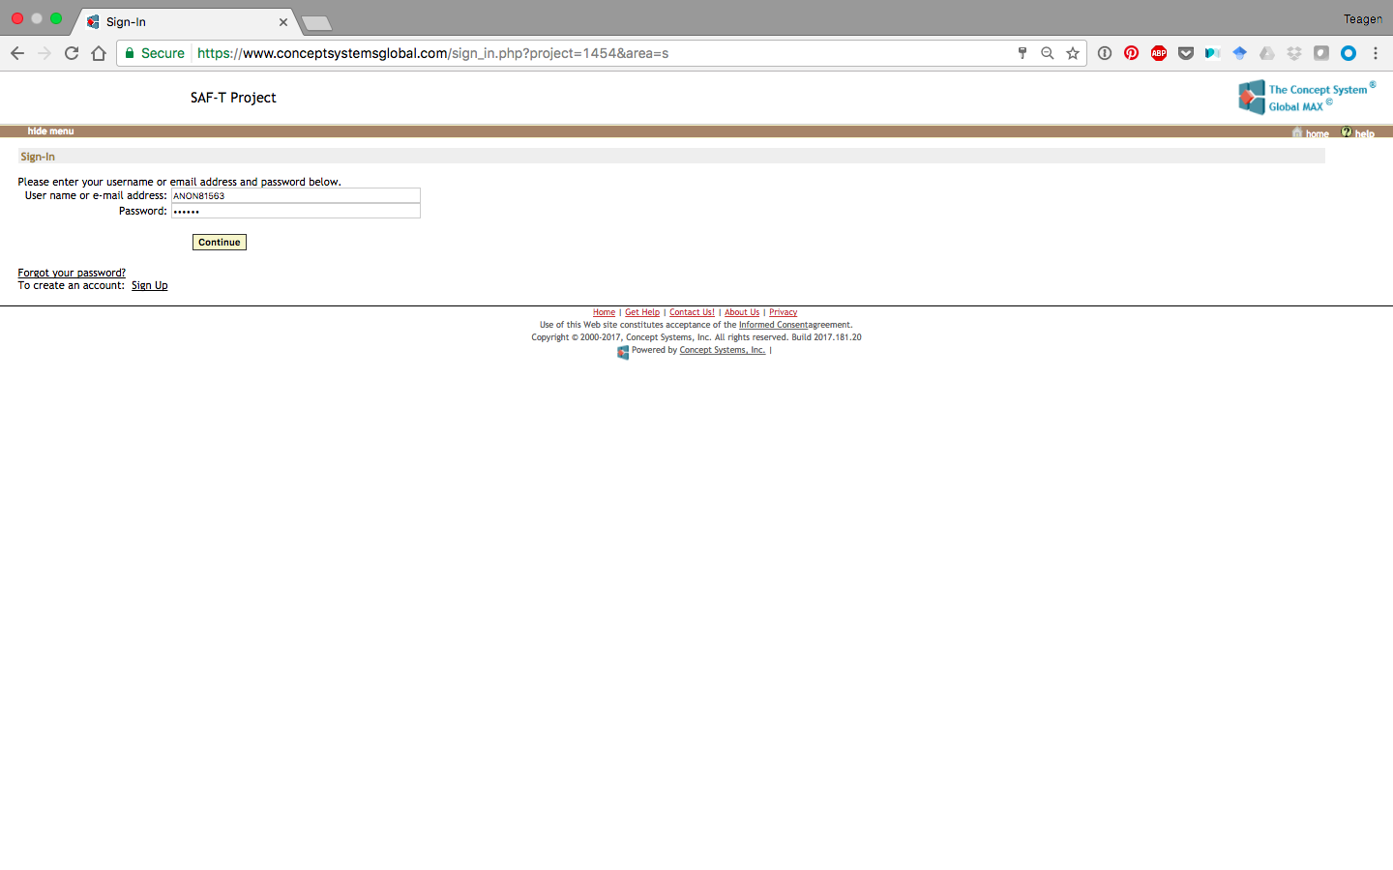

Exhibit 4. (1d) Home Page
NOTE: Text on the Home Page will change throughout the project to reflect which the specific activity (e.g., brainstorming, sorting, and rating) participants are being asked to complete at that time.

Exhibit 5. (1di) Brainstorming
IMPORTANT: Your username is ANON00099 and your password is ASDFJK. Please record this information so that you can log in for future sessions.
Thank you for participating in the SAF-T Project Concept Mapping Process! We appreciate your input and value your participation.
We are now in the brainstorming activity of the project. Instructions for activity completion are provided at each step. If you have any questions, please contact Jessica Burke at jgburke@pitt.edu or (412) 624-3610.
The brainstorming activity will be open for the next two weeks, from now through [INSERT END DATE WHEN KNOWN]. You may access and complete this activity at any time that is convenient for you within the next two weeks.
The sorting and rating activities will be open [INSERT DATE WHEN KNOWN]. Please feel free to return to complete this activity during this time. We will provide email reminders to all participants who were recruited through email.
We encourage you to participate in a group discussion of the results of these activities. It will take place by webinar on [INSERT DATE, TIME WHEN KNOWN]. Please note that this will take place online and that computer use carries associated risks. To participate in the webinar, please use the following link:
[INSERT LINK WHEN KNOWN]
Reminder: You may return to this home page or another activity at any time by clicking on the "home" icon, which you can find at the right side at the top of the page. Please be sure to save your responses frequently as you go by clicking the "save" icon that will appear near the top right portion of the page once you begin an activity.
Begin by clicking one of the activities listed in "NEXT STEPS" below.
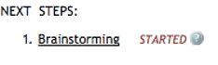
This collection of information is voluntary. Information will be kept private. An agency may not conduct or sponsor, and a person is not required to respond to, a collection of information unless it displays a currently valid OMB control number. The OMB number for this information collection is 0970-0356 and the expiration date is 03/31/2018.

Exhibit 6. (1dii) Sorting
IMPORTANT: Your username is ANON00102 and your password is SAFDKH. Please record this information so that you can log in for future sessions.
Thank you for participating in the SAF-T Project Concept Mapping Process! We appreciate your input and value your participation.
We are now in the sorting activity of the project. Instructions for activity completion are provided at each step. If you have any questions, please contact Jessica Burke at jgburke@pitt.edu or (412) 624-3610.
The sorting activity will be open for the next two weeks, from now through [INSERT END DATE WHEN KNOWN]. You may access and complete these activities at any time that is convenient for you within the next two weeks.
The rating activity will be open [INSERT DATE WHEN KNOWN]. Please feel free to return to complete this activity during this time. We will provide email reminders to all participants who were recruited through email.
We encourage you to participate in a group discussion of the results of these activities. It will take place by webinar on [INSERT DATE, TIME WHEN KNOWN]. Please note that this will take place online and that computer use carries associated risks. To participate in the webinar, please use the following link:
[INSERT LINK WHEN KNOWN]
Reminder: You may return to this home page or another activity at any time by clicking on the "home" icon, which you can find at the right side at the top of the page. Please be sure to save your responses frequently as you go by clicking the "save" icon that will appear near the top right portion of the page once you begin an activity.
Begin by clicking one of the activities listed in "NEXT STEPS" below.
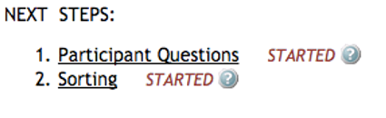

This collection of information is voluntary. Information will be kept private. An agency may not conduct or sponsor, and a person is not required to respond to, a collection of information unless it displays a currently valid OMB control number. The OMB number for this information collection is 0970-0356 and the expiration date is 03/31/2018.
Exhibit 7. (1diii) Rating
IMPORTANT: Your username is ANON00009 and your password is AJKLSD. Please record this information so that you can log in for future sessions.
Thank you for participating in the SAF-T Project Concept Mapping Process! We appreciate your input and value your participation.
We are now in the rating activity of the project. Instructions for activity completion are provided at each step. If you have any questions, please contact Jessica Burke at jgburke@pitt.edu or (412) 624-3610.
The rating activity will be open for the next two weeks, from now through [INSERT END DATE WHEN KNOWN]. You may access and complete these activities at any time that is convenient for you within the next two weeks.
We encourage you to participate in a group discussion of the results of these activities. It will take place by webinar on [INSERT DATE, TIME WHEN KNOWN]. Please note that this will take place online and that computer use carries associated risks. To participate in the webinar, please use the following link:
[INSERT LINK WHEN KNOWN]
Reminder: You may return to this home page or another activity at any time by clicking on the "home" icon, which you can find at the right side at the top of the page. Please be sure to save your responses frequently as you go by clicking the "save" icon that will appear near the top right portion of the page once you begin an activity.
Begin by clicking one of the activities listed in "NEXT STEPS" below.
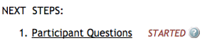

This collection of information is voluntary. Information will be kept private. An agency may not conduct or sponsor, and a person is not required to respond to, a collection of information unless it displays a currently valid OMB control number. The OMB number for this information collection is 0970-0356 and the expiration date is 03/31/2018.

Exhibit 8. (1e) Participant Questions
Cancel
These screens contain a series of questions that will be used as part of the project analysis. This information will not be used to personally identify you. Follow the instructions to respond to each question, then select the Continue button to continue or Cancel to exit.
- What stakeholder group do you best represent?
- The Hotline or LIR staff
- User of The Hotline or LIR
- Service provider
- Policy advocate
- ACF or other federal staff
Continue
Cancel

These screens contain a series of questions that will be used as part of the project analysis. This information will not be used to personally identify you. Follow the instructions to respond to each question, then select the Continue button to continue or Cancel to exit.

- What is your sex?
- Female
- Male
Cancel
Continue

These screens contain a series of questions that will be used as part of the project analysis. This information will not be used to personally identify you. Follow the instructions to respond to each question, then select the Continue button to continue or Cancel to exit.

- What is your age?

Cancel
Continue

These screens contain a series of questions that will be used as part of the project analysis. This information will not be used to personally identify you. Follow the instructions to respond to each question, then select the Continue button to continue or Cancel to exit.

- Which of the following best describes how you became involved with this project?
- Email recruitment
- Phone recruitment
- Chat recruitment
Continue
Cancel

Exhibit 9. (1f) Project Completed Message
You have completed all activities currently assigned to you. Thank you so much for your time and effort!
We encourage you to participate in a group discussion of the results of these activities. It will take place by webinar on [INSERT DATE, TIME WHEN KNOWN]. We will provide email reminders to all participants who were recruited through email. Please note that this will take place online and that computer use carries associated risks. To participate in the webinar, please use the following link:
[INSERT LINK WHEN KNOWN]
Thank you so much again for your important contribution to this project!
Return to Project Page

BRAINSTORMING ACTIVITY
Exhibit 10. (2a) Brainstorming Activity Instructions
The purpose of the SAF-T Project Concept Mapping Process is to elicit your perspective as a stakeholder on the factors that enable The Hotline/LIR to empower and support those affected by relationship abuse, how important the factors are with empowerment and safety, and contribute to the development of a framework specific to the unique needs of domestic violence victims and survivors contacting The Hotline/LIR.
In the text box below, type a statement that completes or answers the focus prompt. This prompt was developed by the SAF-T project team to solicit responses and information needed to develop a framework for The Hotline and LIR. Please keep each statement brief, and limit to just one thought per statement. Select "add this statement" after each statement or idea. Your statement will then be saved and added to the list of collected statements at the bottom of the page.
Factors identified through a literature review, analysis of existing The Hotline/LIR data, and interviews with The Hotline/LIR staff are already listed below. You may add as many statements to this list as you wish. Please review the other statements to see if your idea is already there. You may search this list of statements using the search function below. For reference, some definitions are included below.
When you are finished adding statements, please select “Brainstorming Complete”. To return to the main page, click the "home" icon at the top of the page.
A brief crisis intervention is when, during a short period of time, an advocate assesses a person's situation, focuses on what they're feeling in the moment, supports them, and helps create a plan of action.
To empower is to help a person who lacks power to set a personally meaningful goal oriented towards increasing their power, and take action and make progress towards that goal.
Relationship abuse is also called domestic violence, intimate partner violence (IPV), or domestic abuse. It is a pattern of behaviors used by one partner to maintain power and control over another partner in an intimate relationship. Relationship abuse includes behaviors that physically harm, arouse fear, prevent a partner from doing what they wish or force them to behave in ways they do not want. It includes the use of physical and sexual violence, threats and intimidation, emotional abuse and economic deprivation. Many of these different forms of domestic violence/abuse can be occurring at any one time within the same intimate relationship.
FOCUS PROMPT: What are the key components or factors necessary for effective brief crisis intervention to empower and support those affected by relationship abuse?
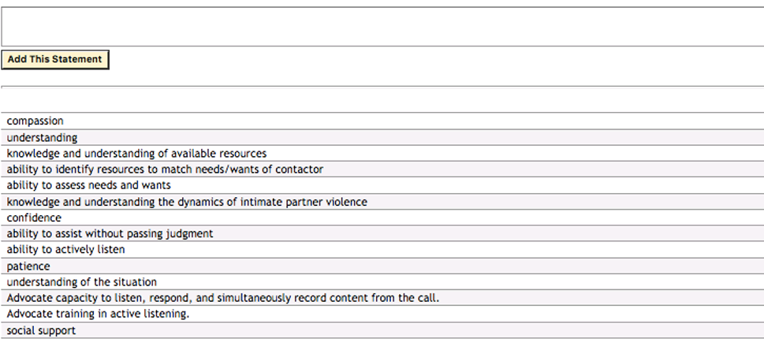

Exhibit 11. (2b) Brainstorming Activity Thank You
Thank you for participating in the brainstorming activity of this project! We appreciate your time and effort. You may return to the brainstorming page to add additional responses through [INSERT END DATE WHEN KNOWN].
Brainstorming Completed
The sorting and rating activities will be open [INSERT DATE WHEN KNOWN]. Please feel free to return to complete this activity during this time. We will provide email reminders to all participants who were recruited through email.
We encourage you to participate in a group discussion of the results of these activities. It will take place by webinar on [INSERT DATE, TIME WHEN KNOWN]. Please note that this will take place online and that computer use carries associated risks. To participate in the webinar, please use the following link:
[INSERT LINK WHEN KNOWN]
Return to Project Page
Return to Project Page

SORTING ACTIVITY
Exhibit 12. (3a) Sorting Activity Instructions
In this activity, you will categorize statements, according to your view of their meaning or theme. To do this, you will sort each statement into groupings that make sense to you. Group the statements for how similar in meaning or theme they are to one another. Give each group a name that describes its theme or contents. People vary in how many categories they create. Usually 5 to 20 categories work well to organize this number of statements.
Reminder - The statements were developed in response to the focus prompt listed below that was developed by the SAF-T project team to solicit responses and information needed to develop a framework for The Hotline and loveisrespect (LIR). These statements are the combined responses of all participants of the brainstorming activity, and also include statements identified in relevant literature, analysis of existing The Hotline/LIR data, and interviews with The Hotline/LIR staff.
“What are the key components or factors necessary for effective brief crisis intervention to empower and support those affected by relationship abuse?”
INSTRUCTIONS:
- Read through the statements in the Unsorted Statements column on the left.
- Drag statements from the column into the window on the right. If you drag a topic to any empty space in the window, the computer will prompt you to name a new group which that topic is going to be a part of. If you drag a topic into a group that's already there, it will become part of that group.
- Please note that the group names should reflect the reason that you sorted the responses together into the same pile (e.g., "citrus fruits" and "leafy vegetables" might be good pile names for a food-related concept mapping project). If you have a response that does not seem to relate to any others, please put it in its own group.
- Do NOT create categories according to priority, or value, such as "Important", or "Hard to do."
- Do NOT create categories such as "Miscellaneous" or "Other" that group together dissimilar statements. Put a statement alone in its own category if it is unrelated to all the other statements. Make sure every statement is put somewhere. Do not leave any statements in the Unsorted Statements column.
Remember: We are interested in seeing how you group the factors that empower and support those affected by relationship abuse who contact The Hotline/LIR.
To save your information, click the "save" image at the top of the screen. To return to the sorting and rating main page, click the "home" icon. You will be able to see your progress on the left side of the screen.

Exhibit 13. (3b) Sorting Activity Thank You
Thank you for participating in the sorting activity of this project! We appreciate your time and effort. Access to this page will be available to you until [INSERT DATE].
The rating activity is open [INSERT DATE WHEN KNOWN]. Please feel free to return to complete this activity during this time.
We encourage you to participate in a group discussion of the results of these activities. It will take place by webinar on [INSERT DATE, TIME WHEN KNOWN]. Please note that this will take place online and that computer use carries associated risks. To participate in the webinar, please use the following link:
[INSERT LINK WHEN KNOWN]
Return to Project Page
RATING ACTIVITY
Exhibit 14. (4a) Rating Activity Instructions – Empowerment
Please rate the following [NUMBER TO BE ADDED ONCE LIST IS FINALIZED] statements, in the range indicated below.
- How important is the item for empowering those affected by relationship abuse from 1 (not at all important) to 5 (extremely important)?
Reminder: The statements were developed in response to the focus prompt shown below that was developed by the SAF-T project team to solicit responses and information needed to develop a framework of The Hotline and loveisrespect (LIR). These statements are the combined responses of all participants of the brainstorming activity, and also include statements identified in relevant literature, analysis of existing The Hotline/LIR data, and interviews with The Hotline/LIR staff.
FOCUS PROMPT: What are the key components or factors necessary for effective brief crisis intervention to empower and support those affected by relationship abuse?
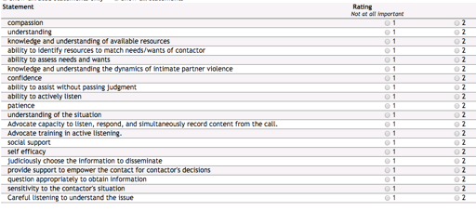
Save Rating Information
Save and Finish
Exhibit 15. (4b) Rating Activity Instructions – Support
Please rate the following [NUMBER TO BE ADDED ONCE LIST IS FINALIZED] statements, in the range indicated below.
- How important is the item for supporting those affected by relationship abuse to take the next step towards becoming safer or remaining safe from 1 (not at all important) to 5 (extremely important)?
Reminder: The statements were developed in response to the focus prompt shown below that was developed by the SAF-T project team to solicit responses and information needed to develop a framework for The Hotline and loveisrespect (LIR). These statements are the combined responses of all participants of the brainstorming activity, and also include statements identified in relevant literature, analysis of existing The Hotline/LIR data, and interviews with The Hotline/LIR staff.
FOCUS PROMPT: What are the key components or factors necessary for effective brief crisis intervention to empower and support those affected by relationship abuse?
Save Rating Information
Save and Finish

Exhibit 16. (4c) Rating Activity Thank You
Thank you for participating in the rating activity of this project! We appreciate your time and effort. Access to this activity will be available to you until [INSERT DATE].
We encourage you to participate in a group discussion of the results of these activities. It will take place by webinar on [INSERT DATE, TIME WHEN KNOWN]. Please note that this will take place online and that computer use carries associated risks. To participate in the webinar, please use the following link:
[INSERT LINK WHEN KNOWN]
Return to Project Page

