Home Page

Links to pop-up statements on public burden and privacy appear in consistent location on each page

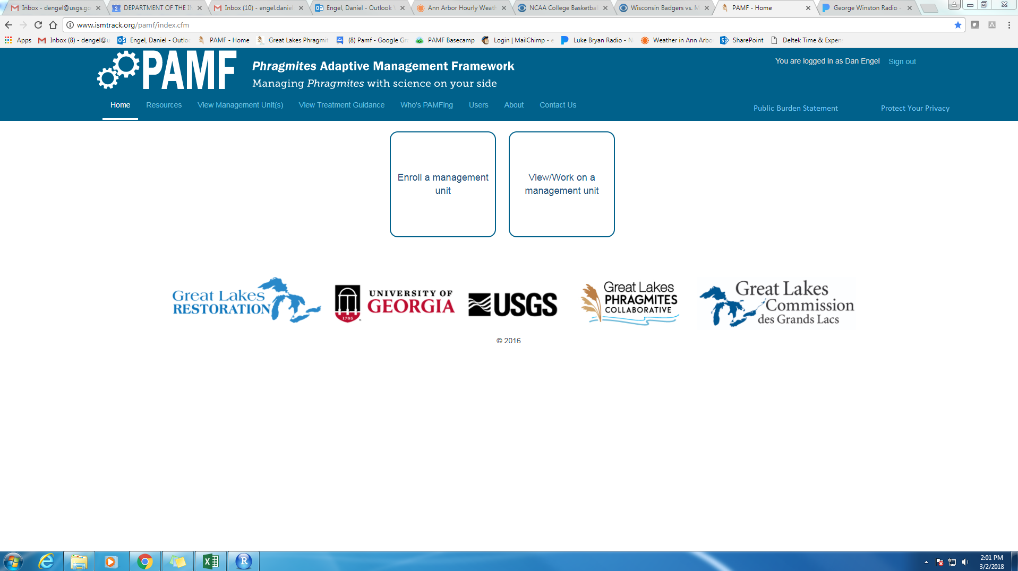

Management Unit Enrollment Page

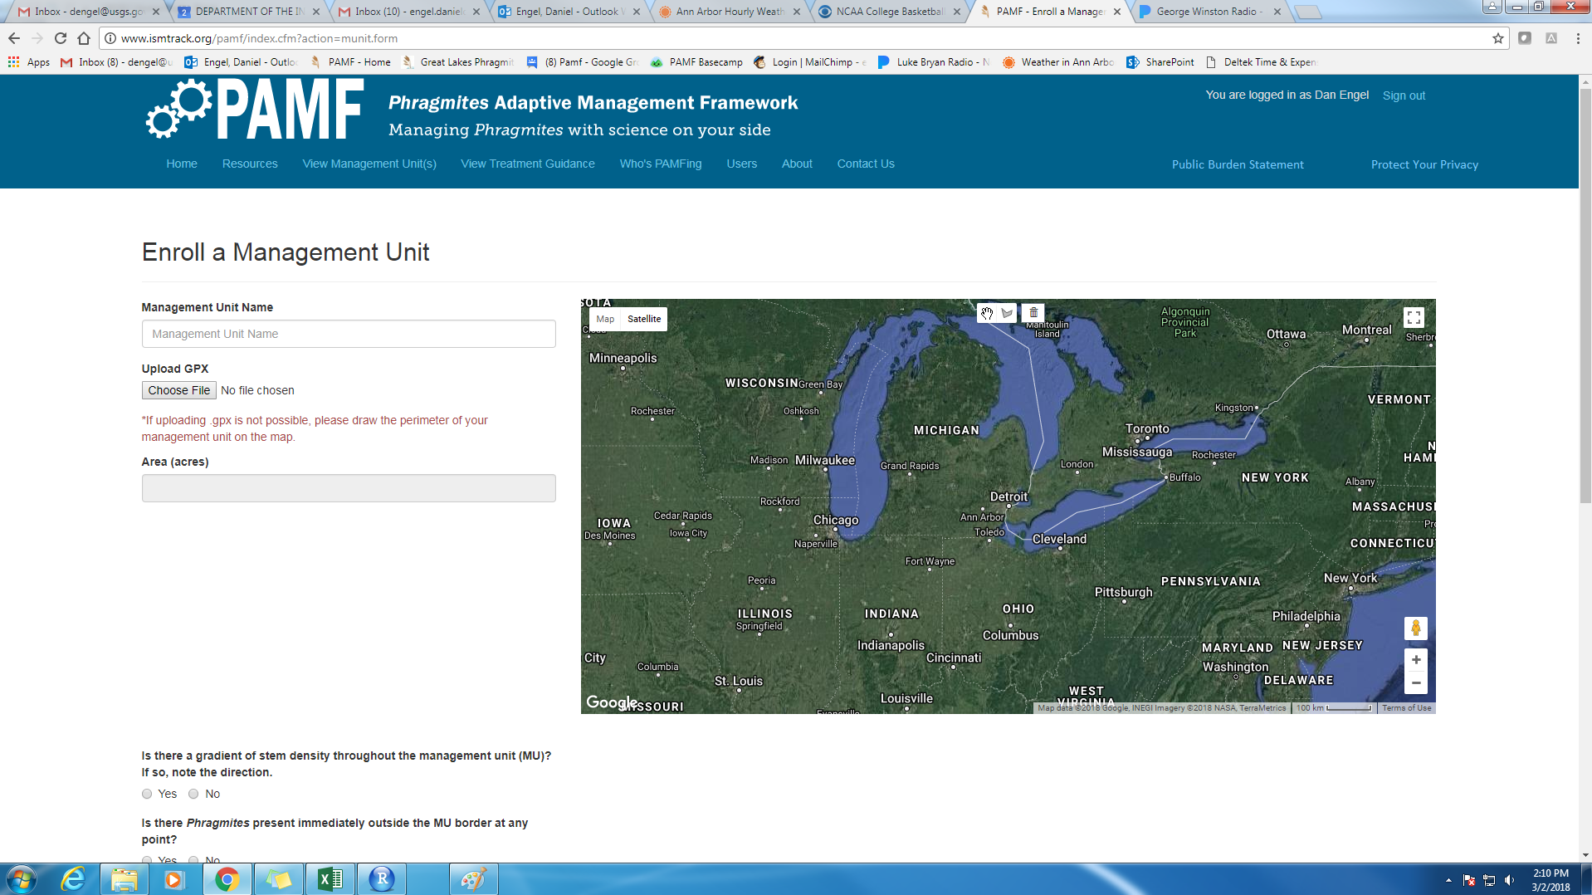

Monitoring Data Page

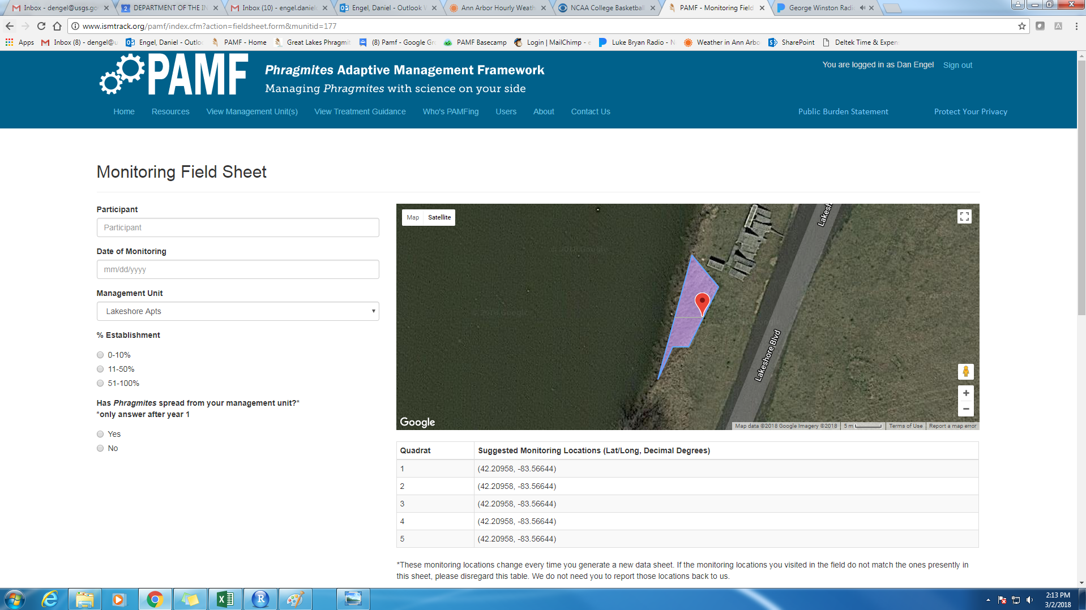

Treatment Report Page

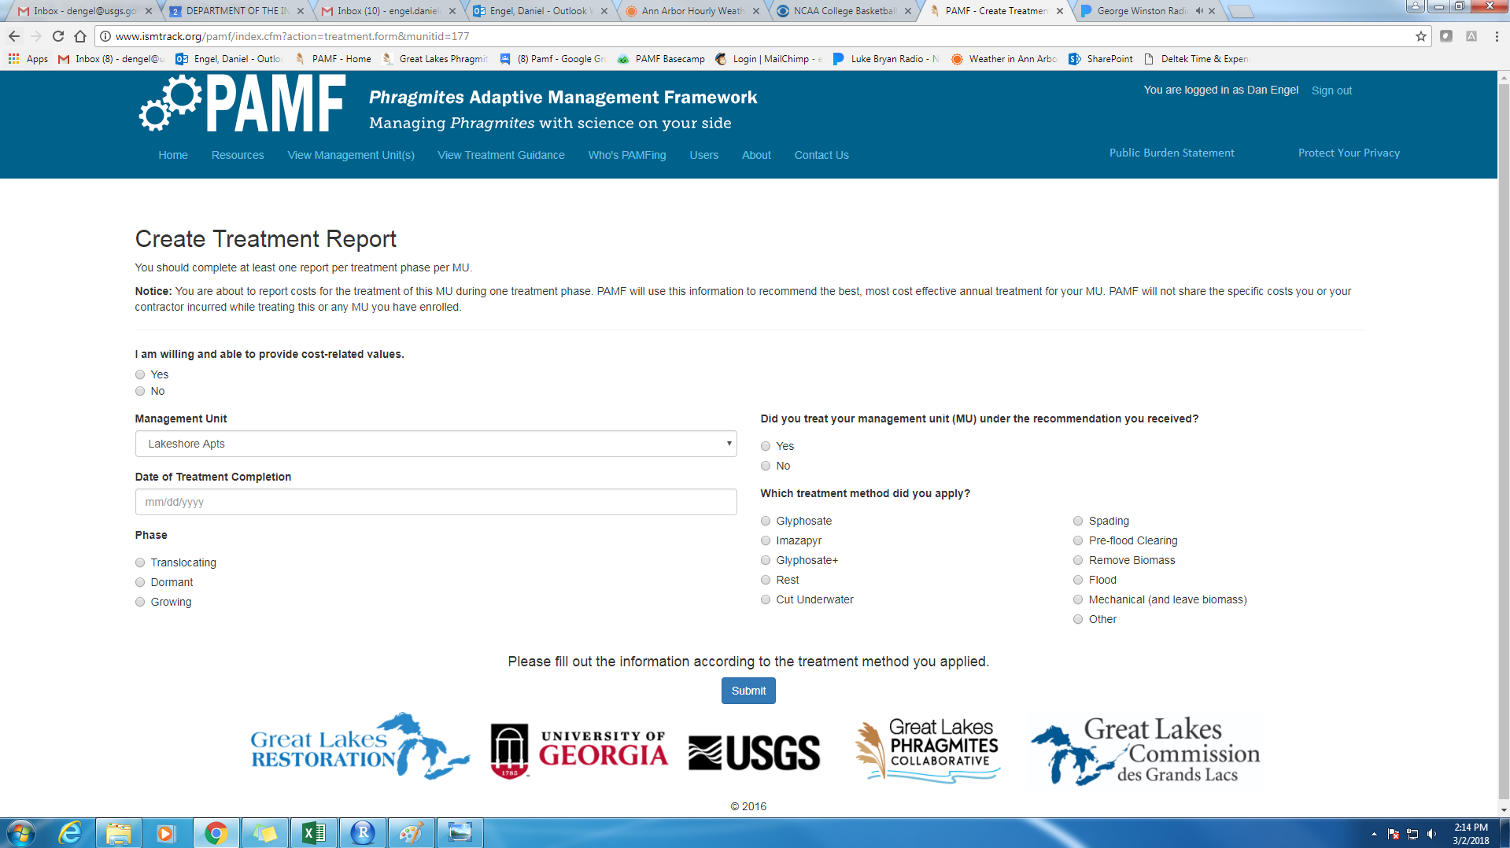

PRA statement appearing in pop-up box:

PAPERWORK REDUCTION ACT STATEMENT: A Federal agency may not conduct or sponsor, and a person is not required to respond to a collection of information unless it displays a currently valid OMB control number. Public burden for the collection of this information is estimated to average 1.5 hours over the year per respondent, inclusive of field measurements. Comments regarding this collection of information should be directed to the Bureau Clearance Officer, U.S. Geological Survey, 807 National Center, VA 20192. OMB NO. 1028-NEW Expiration date: MM/DD/YYYY.

Privacy Act statement appearing in pop-up box:

PRIVACY ACT STATEMENT: Collection and use is covered by Privacy Act System of Records OPM/GOVT-1 and USDA OP-1, and is consistent with the provisions of 5 USC 552a (Privacy Act of 1974), which authorizes acceptance of the information requested on this form. The data will be used to maintain official records of volunteers of the USDA and USDI for the purposes of tort claims and injury compensation. Furnishing this data is voluntary, however if this form is incomplete, enrollment in the program cannot proceed.