Select “501(c)(4)” from Organization dropdown
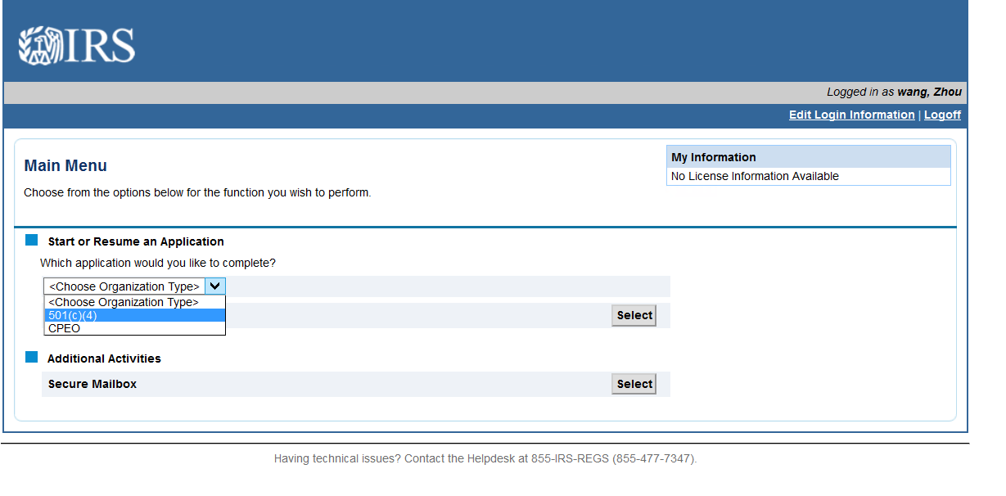

Select “Form 8976…” from the Application dropdown.
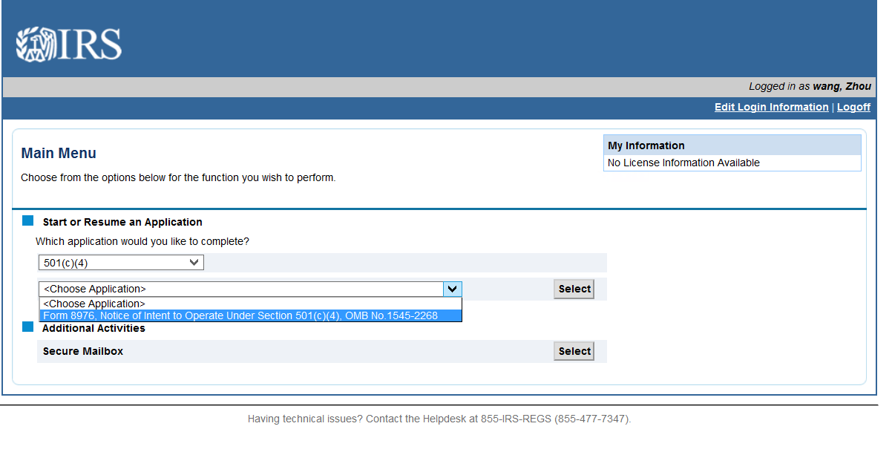

Screen which displays if a user has previously started a Form 8976 on this account. If the user has not previously begun this type of application, this screen will not display.
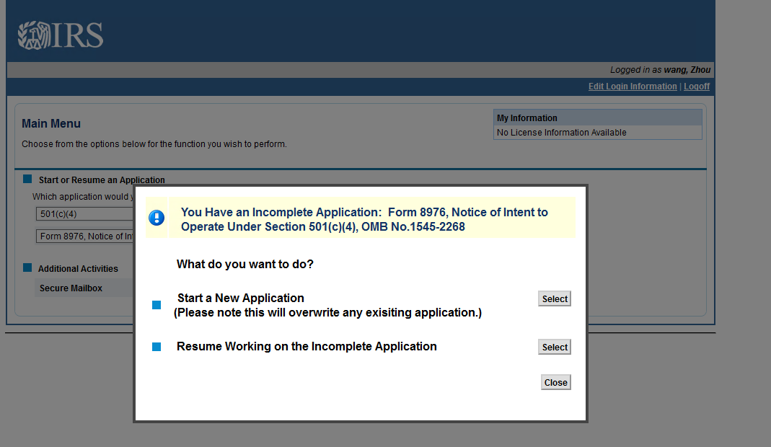
Gather Your Information screen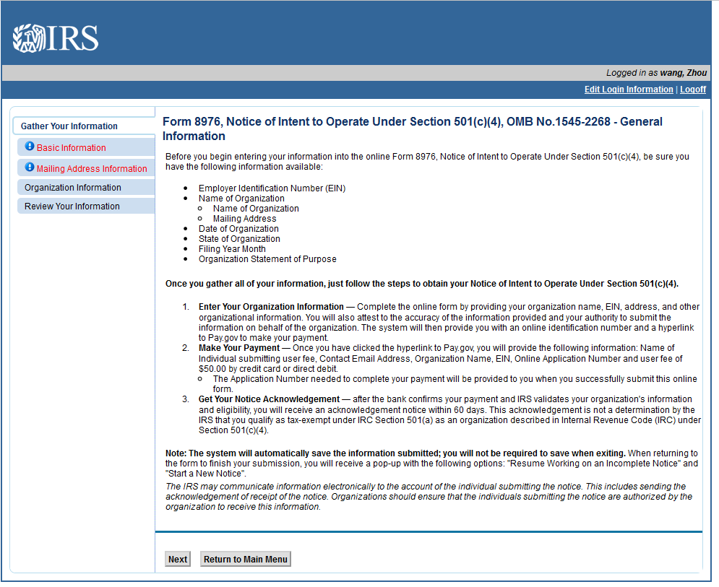
Basic Information screen
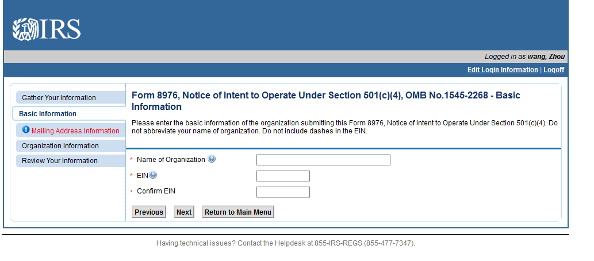
Mailing Address screen
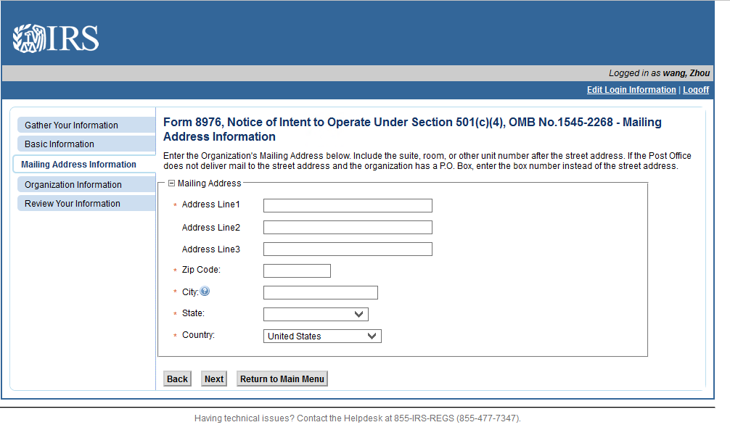

Organization Information screen
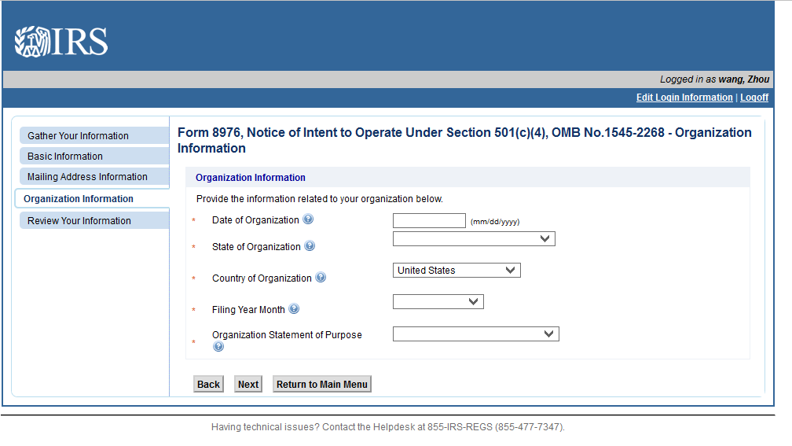
Review Your Information screen
(users may click the Edit button to jump to the screen to edit the information in that section)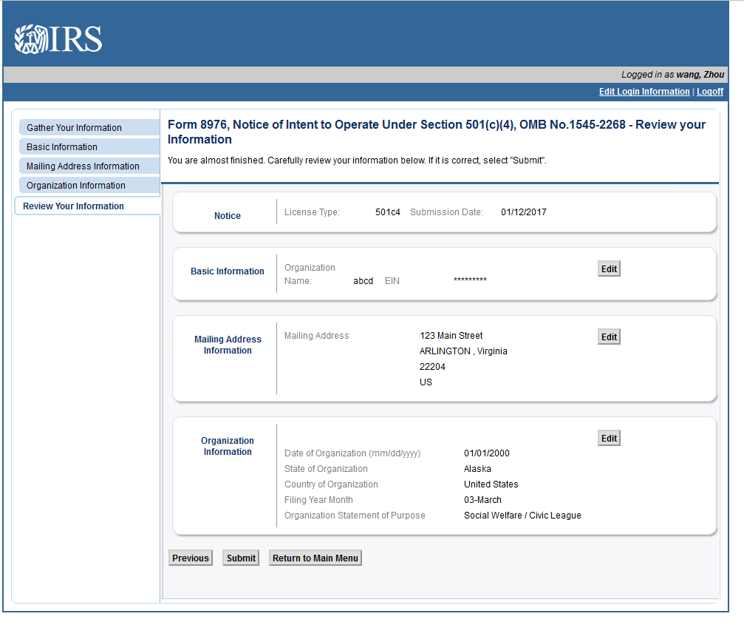

Clicking “Submit” on the Review Your Information screen bring the user to the Jurat page
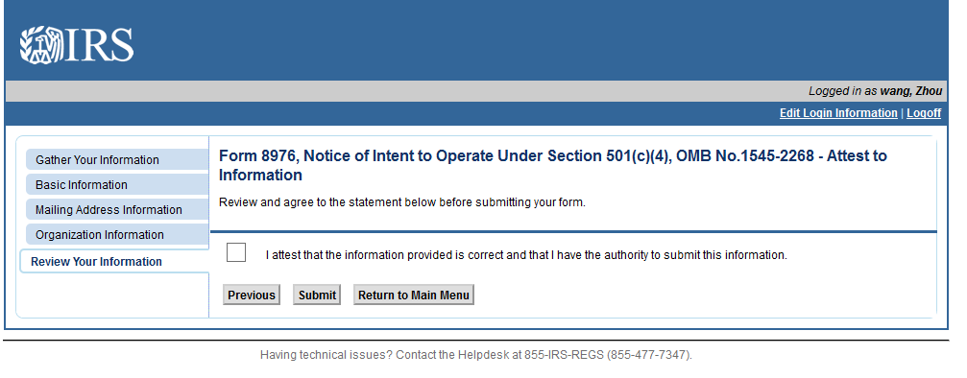

Screen that displays when the Form 8976 has been submitted without errors
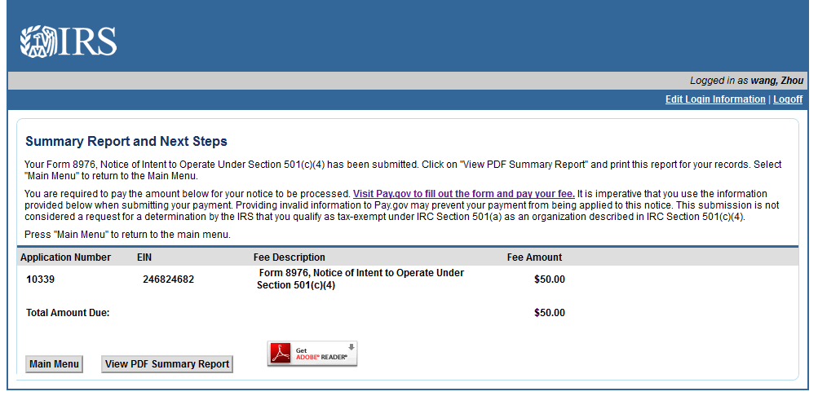

Upon returning to the Main Menu, the user will see the submitted Form 8976 under View Application Status.
