Memorandum United States Department of Education
Institute of Education Sciences

National Center for Education Statistics

DATE: July 24, 2017

TO: Robert Sivinski, OMB

THROUGH: Kashka Kubzdela, OMB Liaison, NCES

FROM: Ted Socha, B&B:16/17 Project Officer, NCES
Tracy Hunt-White, Team Lead, Postsecondary Longitudinal and Sample Surveys, NCES

SUBJECT: 2016-17 Baccalaureate and Beyond Longitudinal Study (B&B:16/17) Main Study Web Screens Change Request (OMB# 1850-0926 v.5)

The 2016/17 Baccalaureate and Beyond Longitudinal Study (B&B:16/17) is conducted by the National Center for Education Statistics (NCES), within the U.S. Department of Education (ED). B&B is designed to follow a cohort of students who completed the requirements for their bachelor’s degree during the same academic year. Data from B&B are used to help researchers and policymakers better understand the experiences of bachelor’s degree recipients in the years following their degree completion. The request to conduct the B&B:16/17 Main Study was approved in May with a change request in June 2017 (OMB# 1850-0926 v. 3-4). This request is to update the content and design of the B&B:16/17 survey entry screens that are part of the study’s confidentiality pledge experiment. Data collection will begin upon approval of this change request.
This request does not introduce changes to the approved survey items, estimated sample member burden, or the costs to the federal government. Updated Appendix F is included with this memorandum.

Changes to the Instrument Facsimile (Appendix F)

In the introduction to the approved Appendix F (OMB# 1850-0926 v. 4), we described a confidentiality pledge experiment being conducted as part of the B&B:16/17 full-scale data collection. Mock ups of the screens planned for that experiment were included to show the screens participants would see when entering the survey. Since that submission, the final screens have been programmed. One set of screens, in particular, has been modified significantly from the sample – the screen lay out for the “direct link from email” screens have been changed. The original screen and the revised screens for different experimental conditions are provided below in Exhibit 1. Pages F-2 to F-19 in the revised Appendix F included with this request show the order of the screens and their related follow-up screens.
As it was not apparent in the approved B&B:16/17 materials, we want to point out in this request that some sample members, depending on the device they will use to access the survey, will need to scroll down in order to see any part of the study’s required language, i.e., the authorization language and the confidentiality and/or the PRA statement. The B&B:16/17 website was developed according to U.S. web design standards (https://standards.usa.gov/), to be responsive to any display sizes. Hence, the amount of the website seen visible at entry varies depending on a person’s screen resolution. However, we utlize the ability to prioritize the information viewed so that the log in information is always displayed, regardless of the screen size. For a desktop computer with a monitor display resolution of 1680 by 1050, the users will see all of the screen, including the text in the screen’s lower portion which contains the authorization language and the confidentiality and the PRA statement or, for half of the experimental treatments, the authorization language and the PRA statement (see Exhibit 2 for entry view under 1680 by 1050 resolution on desktop computer). However, for lower display resolutions, scrolling will be necessary in order to see a portion or any of the required text. This is true to an even greater extent for mobile devices, on which the log-in information is displayed, but scrolling is necessary in order to see any of the required text. Consequently, while the required text does appear on the landing webpage of the B&B:16/17 survey, participants will need to scroll in order to see it on a mobile device (see Exhibit 3 for entry view on 360 by 640 mobile screen size) and on screens with lower resolution. However, to signal to participants that more information is below the image they see, we have added gray scroll bars to the side of all displays requiring scrolling.
In previous B&B studies, 28.7% of respondents used mobile devices to complete the survey. According to StatCounter (http://gs.statcounter.com/screen-resolution-stats), the most widely used screen resolution currently is 360 by 640, a mobile screen size. Specifically, StatCounter reports that this specific size is popular because it is the screen dimension of the most popular mobile device, Samsung, with its Android operating system. Exhibit 3 provides the approximate web site coverage of a 360 by 640 screen size.

Exhibit 1. Original and Revised Screen Layout for Direct Link Access to the B&B:16/17 Survey

Original: Screen 1 (direct link from email)-Control with Confidentiality Pledge
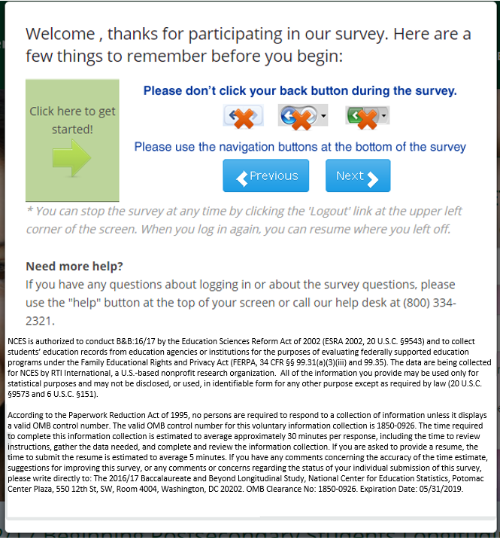

Revised: Screen 1 (direct link from email)- Control with Confidentiality Pledge
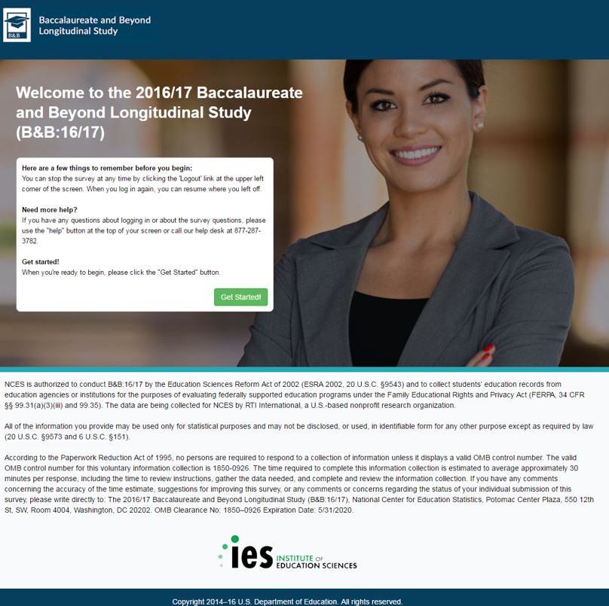

Original: Screen 1 (direct link from email)- Control – Confidentiality Pledge on 2nd screen
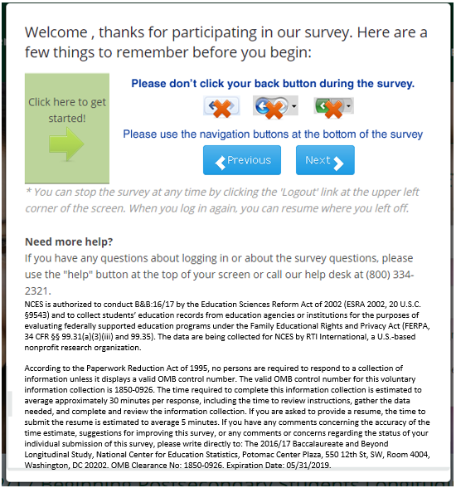

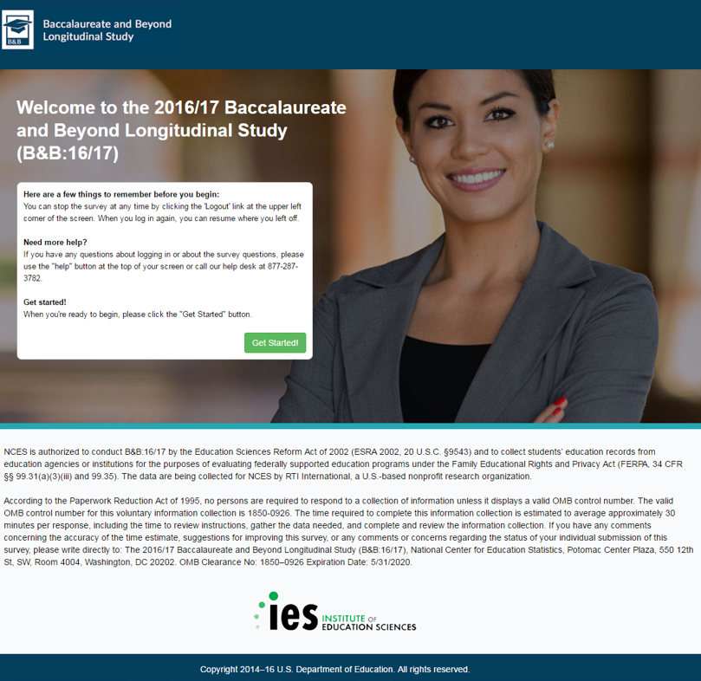
Revised: Screen 1 (direct link from email)- Control – Confidentiality Pledge on 2nd screen

Original: Screen 1 (direct link from email)- Homeland Security with Confidentiality Pledge
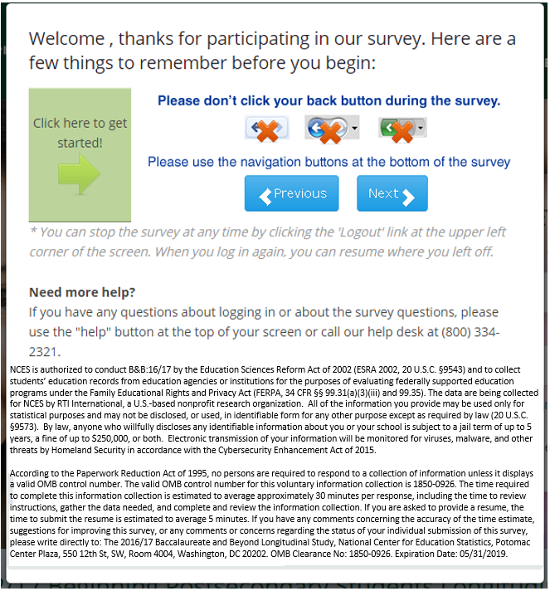

Revised: Screen 1 (direct link from email)- Homeland Security with Confidentiality Pledge
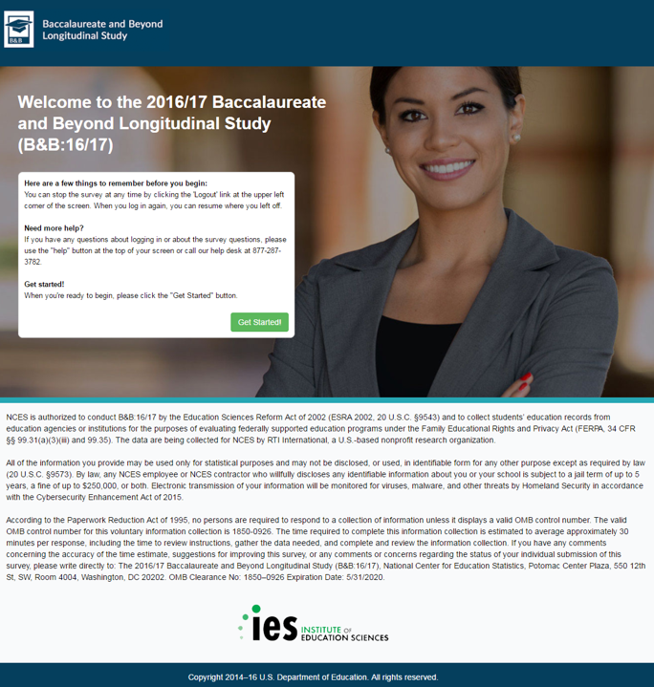

Original: Screen 1 (direct link from email)- Homeland Security – Confidentiality Pledge on 2nd screen
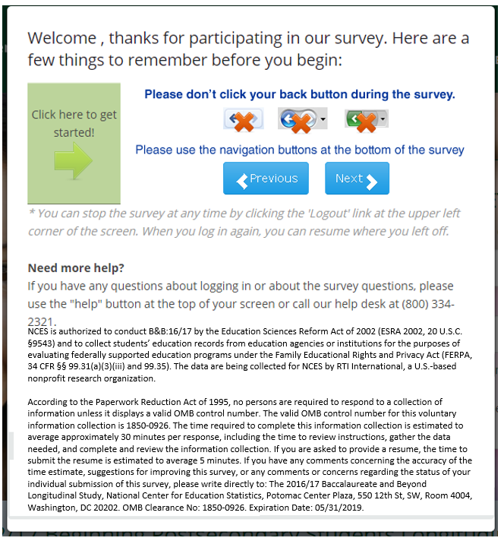

Revised: Screen 1 (direct link from email)- Homeland Security – Confidentiality Pledge on 2nd screen

Original: Screen 1 (direct link from email) - Federal Staff with Confidentiality Pledge
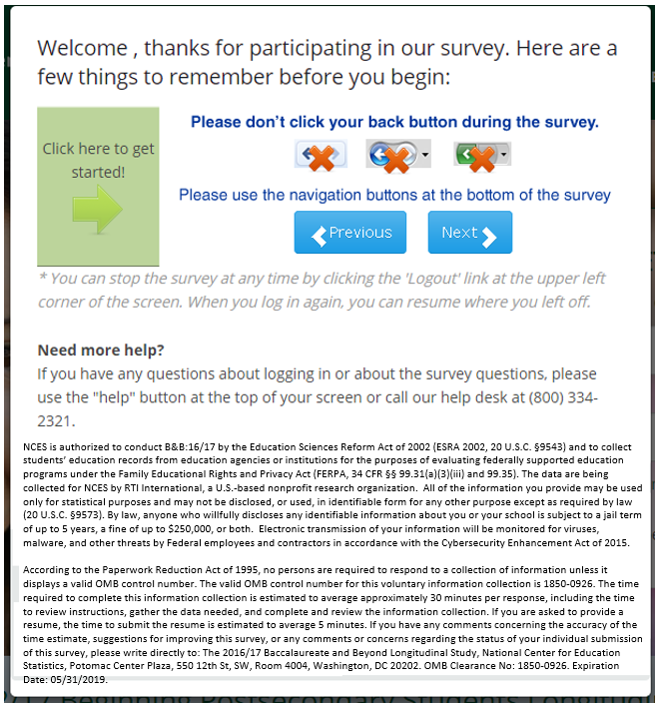

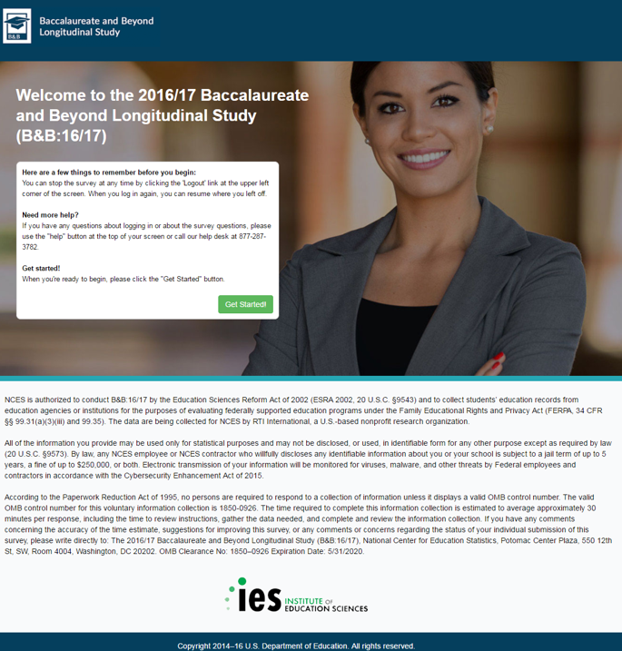
Revised: Screen 1 (direct link from email) - Federal Staff with Confidentiality Pledge

Original: Screen 1 (direct link from email)- Federal Staff – Confidentiality Pledge on 2nd screen
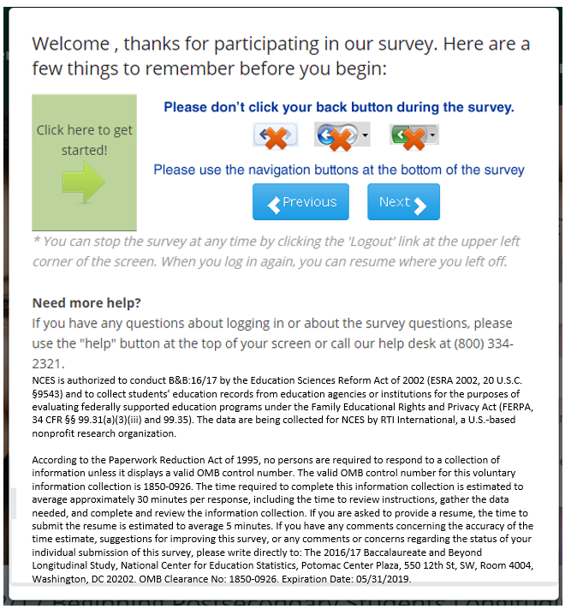

Revised: Screen 1 (direct link from email)- Federal Staff – Confidentiality Pledge on 2nd screen

Exhibit 2: Portion of B&B:16/17 Website Captured on a Desktop Computer Screen (1680 by 1050)

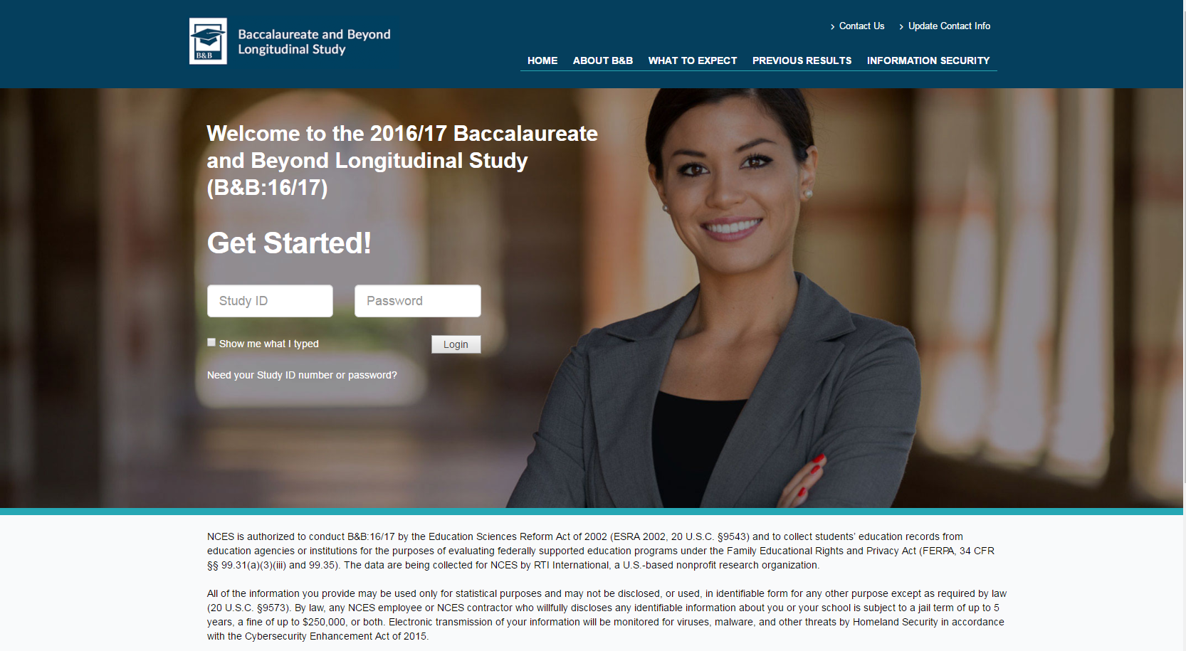

Exhibit 3. Portion of B&B:16/17 Website Captured within the Most Common Screen Size (360 by 640)

