2018 Teaching and Learning International Survey   
(TALIS 2018) Main Study Recruitment

Appendix A

OMB# 1850-0888 v.7

**(Carried over from the Approved Appendix A-2**, OMB# 1850-0888 v.6

with TALIS 2018 E-file instructions, school coordinator communication, and respondent reminders

added on pages 22-86**)**

December 2017

APPENDIX A-2: MAIN STUDY RECRUITMENT MATERIALS

TALIS 2018 State Letter 2

TALIS 2018 School District Letter 3

TALIS 2018 School Letter 4

TALIS 2018 Study Brochure 5

TALIS 2018 Study Brochure Timeline of Activities for Public and Private Schools 7

TALIS 2018 School FAQ 8

TALIS 2018 Teacher FAQ – Front Page 10

TALIS 2018 Teacher FAQ - Back Page 11

TALIS 2018 Summary of Activities for Public and Private School Coordinators 12

Teacher Invite Email 13

TALIS 2018 School Letter – Private Schools 14

TALIS 2018 Study Brochure – Private Schools 15

TALIS 2018 School FAQ – Private Schools – 17

TALIS 2018 Teacher FAQ – Private Schools – Front Page 19

TALIS 2018 Teacher FAQ – Private Schools – Back Page 20

Teacher Invite Email – Private Schools 21

TALIS 2018 E-file instructions 22

TALIS 2018 School Coordinator Communications 31

TALIS 2018 Respondent Reminders 36

TALIS 2018 School Coordinator Handbook 51

TALIS 2018 MyTALIS.us Website 69

TALIS 2018 School Coordinator WebEx 78

[Date]

[Title] [Name First] [Name Last]

# TALIS 2018 State Letter

[Title/Department]

[State]

[Address 1]

[City], [State] [Zip code]

Dear [Title] [Name Last]:

The United States is participating in an important international study in 2018: TALIS – the Teaching and Learning International Survey of principals and teachers at grades 7, 8, and 9. TALIS provides comparative information about teaching and the teaching profession around the world. This study is coordinated by the Organization for Economic Cooperation and Development (OECD), and more than 45 countries, including the United States, have committed to taking part in TALIS 2018. *Some schools in your state have been randomly selected to participate in TALIS 2018 this coming spring, and I am writing to ask your agency to support the participation of those schools*.

TALIS is the first and only international survey that focuses on the learning environment and the working conditions of teachers in middle schools and lower secondary schools. It fills important information gaps in the international comparisons of education systems and offers an opportunity for teachers and school principals to have a say in education analysis and policy development in key policy areas. TALIS allows countries to compare themselves with other education systems facing similar challenges, and to learn from other policy approaches.

TALIS is described in more detail in the enclosed materials. The study is conducted in the United States by the National Center for Education Statistics (NCES) in the U.S. Department of Education and is administered by Westat, a firm headquartered in Rockville, Maryland. The U.S. Office of Management and Budget has approved the data collection under OMB# 1850-0888. For information on the confidentiality of the data collected, please see the enclosed FAQ. While participation in this study is voluntary, we ask your agency to encourage the schools in your state to take part so that the United States has a representative sample of schools across the country.

Within the next few weeks, a representative of Westat will contact sampled school districts and schools to discuss participating in TALIS. We are in contact with your state assessment director and NAEP State Coordinator to try to ensure that we are not conflicting with other state efforts and that districts and schools understand how TALIS fits in with other data collections conducted by NCES. We also coordinate the administration of TALIS with NAEP and other NCES activities. In the meantime, if you have any questions, please do not hesitate to call 1-855-545-1163 or send an email to [TALISHELP@westat.com](mailto:TALISHELP@westat.com). You may also get more information about this study by contacting Mary Coleman at NCES at 202-245-8382 or [Mary.Coleman@ed.gov](mailto:Mary.Coleman@ed.gov) or by visiting the TALIS website at <http://nces.ed.gov/surveys/talis>.

Thank you for your time and support.

Sincerely,

Peggy Carr, Ph.D.

Acting Commissioner

cc: [State assessment coordinator name]

Enclosures

*The National Center for Education Statistics (NCES), within the U.S. Department of Education, conducts the Teaching and Learning International Survey (TALIS) in the United States as authorized by the Education Sciences Reform Act of 2002 (ESRA 2002, 20 U.S.C. §9543). All of the information you provide may be used only for statistical purposes and may not be disclosed, or used, in identifiable form for any other purpose except as required by law (20 U.S.C. §9573 and 6 U.S.C. §151).*

# TALIS 2018 School District Letter

[Date]

[Title] [Name First] [Name Last], [Title/Department]

[School District]

[Address 1]

[City], [State] [Zip code]

Dear [Title] [Name Last]:

The United States is participating in an important international study in 2018: TALIS – the Teaching and Learning International Survey of principals and teachers at grades 7, 8, and 9. TALIS provides comparative information about teaching and the teaching profession around the world. This study is coordinated by the Organization for Economic Cooperation and Development (OECD), and more than 45 44 countries, including the United States, have committed to taking part in TALIS 2018. *Some schools in your district have been randomly selected to participate in TALIS 2018 this coming spring, and I am writing to ask your agency to support the participation of those schools*.

TALIS is the first and only international survey that focuses on the learning environment and the working conditions of teachers in middle schools and lower secondary schools. It fills important information gaps in the international comparisons of education systems and offers an opportunity for teachers and school principals to have a say in education analysis and policy development in key policy areas. TALIS allows countries to compare themselves with other education systems facing similar challenges, and to learn from other policy approaches.

Participating schools will receive $200, and each school’s TALIS school coordinator (school staff person designated to liaise with TALIS staff) will receive $200 as a thank you for their time and effort. Selected teachers will receive $20 for completing the TALIS teacher questionnaire.

TALIS is described in more detail in the enclosed materials. The study is conducted in the United States by the National Center for Education Statistics (NCES) in the U.S. Department of Education and is administered by Westat, a firm headquartered in Rockville, Maryland. The U.S. Office of Management and Budget has approved the data collection under OMB# 1850-0888. For information on the confidentiality of the data collected, please see the enclosed FAQ. While participation in this study is voluntary, we ask your agency to encourage the schools in your district to take part so that the United States has a representative sample of schools across the country.

Within the next few days, a representative of Westat will contact the following school or schools in your district that have been selected for this study: [LIST SAMPLED SCHOOLS HERE…].

If you have any questions, please do not hesitate to call 1-855-545-1163 or send an email to [TALISHELP@westat.com](mailto:TALISHELP@westat.com). You may also get more information about this study by contacting Mary Coleman at NCES at 202-245-8382 or [Mary.Coleman@ed.gov](mailto:Mary.Coleman@ed.gov) or by visiting the TALIS website at <http://nces.ed.gov/surveys/talis>.

Thank you for your time and support.

Sincerely,

Peggy Carr, Ph.D.

Acting Commissioner

Enclosures

*The National Center for Education Statistics (NCES), within the U.S. Department of Education, conducts the Teaching and Learning International Survey (TALIS) in the United States as authorized by the Education Sciences Reform Act of 2002 (ESRA 2002, 20 U.S.C. §9543). All of the information you provide may be used only for statistical purposes and may not be disclosed, or used, in identifiable form for any other purpose except as required by law (20 U.S.C. §9573 and 6 U.S.C. §151).*

# 

# TALIS 2018 School Letter

[Date]

[Title] [Name First] [Name Last], [Title/Department]

[School District]

[Address 1]

[City], [State] [Zip code]

Dear [Title] [Name Last]:

The United States is participating in an important international study in 2018: TALIS – the Teaching and Learning International Survey of principals and teachers at grades 7, 8, and 9. TALIS provides comparative information about teaching and the teaching profession around the world. This study is coordinated by the Organization for Economic Cooperation and Development (OECD), and more than 45 countries, including the United States, have committed to participate in TALIS 2018. *Your school is one of only 220 across the United States that has been randomly selected to participate in TALIS 2018 this coming spring*.

TALIS is the first and only international survey that focuses on the learning environment and the working conditions of teachers in middle schools and lower secondary schools. It fills important information gaps in the international comparisons of education systems and offers an opportunity for teachers and school principals to have a say in education analysis and policy development in key policy areas. TALIS allows countries to compare themselves with other education systems facing similar challenges, and to learn from other policy approaches.

I’m writing to ask that you encourage the teachers in your school to participate in TALIS, as every teacher who completes the survey plays an important role in representing other teachers and schools that are similar. It’s vital that teachers participate in TALIS to ensure the U.S. sample is an accurate reflection of what teaching and learning looks like across the country. This information provides unique insight on the conditions of and activities relating to teaching in your school. But bigger than that, by taking part in TALIS, they will be contributing to a global, collaborative conversation about how factors like learning environments, professional development, school leadership, and job satisfaction impact teaching practice around the world.

Participating schools will receive $200, and each school’s TALIS school coordinator (school staff person designated to liaise with TALIS staff) will receive $200 as a thank you for their time and effort. Selected teachers will receive $20 for completing the TALIS teacher questionnaire.

TALIS is described in more detail in the enclosed materials. The study is conducted in the United States by the National Center for Education Statistics (NCES) in the U.S. Department of Education and is administered by Westat, a firm headquartered in Rockville, Maryland. The U.S. Office of Management and Budget has approved the data collection under OMB# 1850-0888. For information on the confidentiality of the data collected, please see the enclosed FAQ. I hope you will participate in this voluntary study because it is important that the United States has a nationally representative sample of schools and teachers.

Within the next few days, a representative of Westat will contact you to discuss your participation. If you have any questions, please do not hesitate to call 1-855-545-1163 or send an email to [TALISHELP@westat.com](mailto:TALISHELP@westat.com). You may also get more information about this study by contacting Mary Coleman at NCES at 202-245-8382 or [Mary.Coleman@ed.gov](mailto:Mary.Coleman@ed.gov) or by visiting the TALIS website at <http://nces.ed.gov/surveys/talis>.

Your participation in TALIS 2018 is vital. Thank you for your time and for supporting this important international study.

Sincerely,

Peggy Carr, Ph.D.

Acting Commissioner

Enclosures

*The National Center for Education Statistics (NCES), within the U.S. Department of Education, conducts the Teaching and Learning International Survey (TALIS) in the United States as authorized by the Education Sciences Reform Act of 2002 (ESRA 2002, 20 U.S.C. §9543). All of the information you provide may be used only for statistical purposes and may not be disclosed, or used, in identifiable form for any other purpose except as required by law (20 U.S.C. §9573 and 6 U.S.C. §151).*

TALIS 2018 Study Brochure

**What is TALIS?**

The Teaching and Learning International Survey (TALIS) is a survey about teachers, teaching, and learning environments. First conducted in 2008, its main objective is to provide international indicators that will help countries develop well-informed education policy. TALIS offers teachers and principals the opportunity to provide their perspectives on education in the United States. TALIS 2018 will be conducted in the spring of 2018.

**Why is TALIS important?**

TALIS is an effort by the United States and other countries to better understand the successes and challenges faced by teachers and school leaders. TALIS fills gaps in our knowledge of teacher and principal working conditions, an area that has been underrepresented in international studies of education. TALIS aims to inform policymakers and educators around the world about shared concerns and promising educational approaches.

**Why should schools participate?**

It’s vital that teachers in every kind of education system participate in TALIS to ensure the U.S. sample is an accurate reflection of what teaching and learning looks like across the country. The perspectives and opinions of educators provide unique and valuable insight on key factors like professional development opportunities, school leadership, mechanisms for feedback, and job satisfaction that are essential to the larger, global conversation about teaching practice and educational progress.

**Who will be surveyed?**

TALIS focuses on the middle and lower secondary levels: grades 7, 8, and 9 in the United States. Principals and teachers at U.S. schools have been randomly selected to participate.

**What will schools and teachers be asked to do?**

TALIS is composed of two questionnaires: one for school principals and another for teachers. The principal survey is designed to take approximately 45 minutes to complete and the teacher survey to take approximately 45 minutes. The online version of the questionnaire allows respondents to complete the survey at a single session or in multiple sessions. Both questionnaires cover the following topics:

● teacher and principal background and characteristics;

● school leadership and climate, including support for diversity;

● teachers’ instructional practices;

● teacher and principal professional development; and

● teacher appraisal and feedback.

**How will the study be coordinated?**

Data collection for this study will be carried out by staff from Westat, under contract with the U.S. Department of Education. Principals are asked to designate a School Coordinator who will liaise with TALIS staff and provide a list of 7th, 8th, and 9th grade teachers; distribute materials to the principal and selected teachers; and encourage the completion of surveys by the deadline.

**What will happen with the collected data?**

TALIS data will be used to describe the conditions of teaching and schooling across countries and to develop comparative education indicators. All of the information provided by school staff may be used only for statistical purposes and may not be disclosed, or used, in identifiable form for any other purpose except as required by law (20 U.S.C. §9573 and 6 U.S.C. §151). Reports of the findings from TALIS will not identify participating districts, schools, or individual staff. Individual responses will be combined to produce summary statistics and reports.

**TALIS 2013: Examples of key findings**

● Teachers who receive more professional development tend to believe they work more effectively.

● Teachers with stronger beliefs about teaching methods report, on average, more collaborative behavior with colleagues and more positive student teacher relations.

● Teachers who receive recognition for good performance from their principal or colleagues tend to feel they are more effective.

● Appraisal and feedback are associated positively with teachers’ job satisfaction and security, but only a minority of teachers reported that appraisal and evaluation affect professional development, career advancement, or pay.

SOURCE: Organization for Economic Cooperation and Development. (2014). *TALIS 2013 Results: An International Perspective on Teaching and Learning*. Paris: Author.

TALIS 2018: Participants

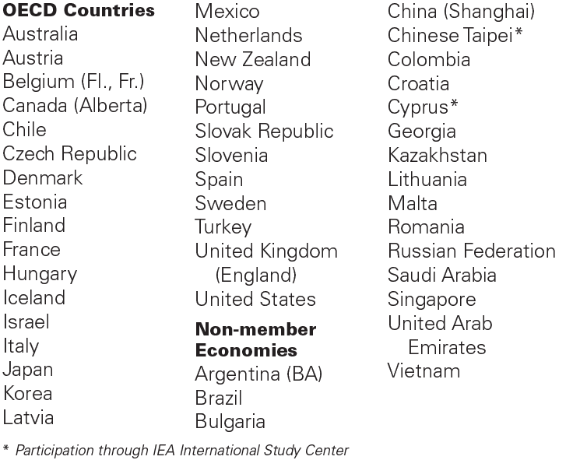

**For more information**

TALIS is sponsored by the Organization for Economic Co-operation and Development (OECD) and managed in the United States by the National Center for Education Statistics (NCES), part of the U.S. Department of Education.

To learn more about TALIS, visit <http://nces.ed.gov/surveys/talis> and <http://www.oecd.org/talis>. For questions about TALIS, contact the TALIS Information Hotline at 1-855-545-1163 or email [TALISHELP@westat.com](mailto:TALISHELP@westat.com).

*The National Center for Education Statistics (NCES), within the U.S. Department of Education, conducts the Teaching and Learning International Survey (TALIS) in the United States as authorized by the Education Sciences Reform Act of 2002 (ESRA 2002, 20 U.S.C. §9543). All of the information you provide may be used only for statistical purposes and may not be disclosed, or used, in identifiable form for any other purpose except as required by law (20 U.S.C. §9573 and 6 U.S.C. §151).The U.S. Office of Management and Budget has approved this data collection under OMB #1850-0888.*

TALIS 2018 Study Brochure Timeline of Activities for Public and Private Schools

|  |  |  |  |  |
| --- | --- | --- | --- | --- |
|  | Nov–Dec 2017 | Jan–Mar 2018 Pre-survey Contact | March-May 2018 | Benefits |
| Principal | * Identify a school coordinator. |  | * Complete an online Principal Questionnaire on the characteristics of your school | * Represent other similar U.S. schools. * Receive U.S. national report with TALIS 2018 results. * Schools will receive $200 for participating. |
| Teachers |  |  | * Complete an online Teacher Questionnaire on education and teaching experience. | * Teachers will receive $20 for completing the teacher questionnaire. |
| School  Coordinator |  | * Provide a list of eligible teachers to TALIS staff. * Notify selected teachers and inform them about the benefits of participating. | * Coordinate the principal’s completion of the school questionnaire. * Coordinate the teachers’ completion of the teacher questionnaire. | * Receive $200 for time and effort in coordinating the survey. |
| TALIS Staff | * Provide school with materials explaining TALIS and its importance. * Protect data collected from the school and teachers. | * Call the school coordinator to discuss survey and teacher participation. * Work with school coordinator to construct a list of eligible teachers. * Select random sample of eligible teachers to participate. * Provide online access information for the teacher and school questionnaires to the school coordinator. | * Meet with school coordinator after the assessment. * Help with any technical issues or other coordination that is required. |  |
| Find Out More | <http://nces.ed.gov/surveys/talis> | | | |

TALIS 2018 School FAQ - Front Page

Teaching and Learning International Survey

FREQUENTLY ASKED QUESTIONS

*Information for Schools*

**What is TALIS?**

TALIS is the Teaching and Learning International Survey of the teaching workforce, teaching as a profession, and the learning environments of schools based on questionnaire responses from nationally representative samples of teachers and their school principals in participating countries and education systems. TALIS’ main objective is to provide accurate and relevant international indicators on teachers and teaching towards the goal of helping countries review current conditions and develop informed education policy. TALIS offers an opportunity for teachers and school principals to provide their perspectives on the state of education in their own countries, allowing for a global view of teachers and the education systems in which they work. TALIS is being conducted in grades 7, 8, and 9 in the United States.

**Why was my school selected for participation?**

Schools with varying demographics and in different locales were randomly selected so that the U.S. sample is representative of the overall U.S. school population, both public and private. The random selection process is important for ensuring that a country’s sample accurately reflects its schools and therefore can be compared fairly with samples of schools from other countries.

**Why is it important for my school to take part?**

Every teacher who completes the TALIS survey plays an important role in representing other teachers and schools that are similar. The perspectives and opinions of educators provide unique and valuable insight that paints a comprehensive picture of what teaching and learning looks like in different classrooms and school environments across the United States.

**Will all teachers in the school be asked to participate?**

It depends on the number of teachers in the school. The study requires a random sample of up to 20 teachers who teach at least one class/course to 7th, 8th, or 9th graders in each school, regardless of subject matter. In schools with 20 or fewer eligible teachers, all teachers who teach at target grades will be asked to participate.

**Who conducts the study?**

The study will be undertaken by trained staff from Westat under contract to the National Center for Education Statistics (NCES) in the U.S. Department of Education. NCES is authorized to conduct this study by the Education Sciences Reform Act of 2002 (ESRA 2002, 20 U.S.C. §9543). The U.S. Office of Management and Budget has approved this data collection under OMB# 1850-0888.

**What are schools and teachers asked to do?**

TALIS is composed of two online questionnaires: one for the school principal and another for teachers. Both teacher and principal questionnaires include questions about the following core components:

• teacher and principal background and characteristics;

• teacher and principal professional development;

• school leadership and management;

• teacher appraisal and feedback;

• teachers’ instructional approaches and pedagogical practices;

• teacher efficacy and job satisfaction; and

• school climate, including support for diversity.

TALIS 2018 School FAQ - Back Page

**When will TALIS be conducted?**

The study will be conducted March-May, 2018. Both the principal and selected teachers will receive instructions on how to complete the questionnaires. To make responding easier, the questionnaires will be available online, although a paper-based version will also be available.

**How long do the questionnaires take to complete?**

The principal and teacher questionnaires are designed to be completed within 45 minutes, including the time it may take to read instructions and gather the needed information. The online version of the questionnaires will allow respondents to complete the survey questions at a single or over multiple sessions.

**What will happen with the collected data?**

The data from the questionnaires will be used to document the conditions of teaching and schooling that may be related to student learning and to develop comparative education indicators geared toward informing policy discussions about teachers and teaching. All of the information provided by school staff may be used only for statistical purposes and may not be disclosed, or used, in identifiable form for any other purpose except as required by law (20 U.S.C. §9573 and 6 U.S.C. §151). Reports of the findings from TALIS will not identify participating districts, schools, students, or individual staff. Individual responses will be combined with those from other participants to produce summary statistics and reports. For a recent example of how TALIS data are reported, please visit <http://nces.ed.gov/surveys/talis/talis2013/index.asp>.

**Is participation required by federal law?**

No. School and teacher participation is voluntary. However, we hope you will participate in this study so that the principal and teachers like those in your school are accurately and fairly represented.

**How will the study be coordinated in my school?**

Schools are asked to designate a *School Coordinator* to distribute materials and gather information. The School Coordinator will be the main contact at the school through whom Westat will communicate. There is no need for contractor staff to visit the school. The School Coordinator is asked to complete a sampling form listing eligible teachers of 7th, 8th, or 9th graders, distribute information materials to the selected teachers, provide the principal and teachers with the questionnaires or login/password information for the online surveys, and to encourage the completion of the surveys by the agreed upon deadline.

The School Coordinator can be a teacher or any school staff member (e.g., office administrator).

**Where can I find out more about TALIS?**

For more information on TALIS, including results from previous data collections, please visit the TALIS website at <http://nces.ed.gov/surveys/talis>.

If you have any questions or experience any difficulties, please contact the TALIS U.S. home office at

1-855-545-1163 or email [TALISHELP@westat.com](mailto:TALISHELP@westat.com).

# TALIS 2018 Teacher FAQ – Front Page

Teaching and Learning International Survey

FREQUENTLY ASKED QUESTIONS

*Information for Teachers*

**What is TALIS?**

TALIS is the Teaching and Learning International Survey of the teaching workforce, teaching as a profession, and the learning environments of schools based on questionnaire responses from nationally representative samples of teachers and their school principals in participating countries and education systems. TALIS’ main objective is to provide accurate and relevant international indicators on teachers and teaching towards the goal of helping countries review current conditions and develop informed education policy. TALIS offers an opportunity for teachers and school principals to provide their perspectives on the state of education in their own countries, allowing for a global view of teachers and the education systems in which they work. TALIS is being conducted in grades 7, 8, and 9 in the United States.

**What role do teachers have in TALIS?**

Teachers are the main source of information for TALIS. TALIS gives you an opportunity to provide information that is critical to understanding the conditions and activities of teaching in your school as well as to voice your perspectives on teaching and learning at your school. The teacher questionnaire asks about your background and teaching experience, teaching practices, the student body, and your views on school policies and evaluation.

**Why should I take the time to participate?**

Every teacher who completes the TALIS survey plays an important role in representing other teachers and schools that are similar. Your perspective and the perspective of your colleagues provides unique and valuable insight paints a more comprehensive picture of what teaching and learning looks like in different classrooms and school environments across the United States. Beyond that, by taking part in TALIS, you have the opportunity to share your perspective and contribute to a global conversation about how factors like learning environments, professional development, school leadership, and job satisfaction impact classroom experiences, and how educators and policymakers can work together to improve teaching practice around the world.

**How was I selected to take the TALIS teacher questionnaire?**

The TALIS school coordinator in your school (the person designated by your school principal to communicate with TALIS staff) provided a list of all teachers who teach any students in grades 7, 8, or 9. You are one of up to 20 teachers from your school who were selected to participate. Your participation in TALIS is vital to assure that your views are represented.

**How long will it take to complete the TALIS teacher questionnaire?**

The teacher questionnaire will take approximately 45 minutes to complete online, and you do not have to complete it all in a single session. The online software automatically saves your responses to each question as you navigate through the questionnaire so that if you wish to complete the questionnaire later, you may pick up right where you left off.

**How can I access the TALIS teacher questionnaire?**

To access the teacher questionnaire (https://portal.mytalis.usyou will need to have an internet connection, a suitable internet browser (see the list below), and your login credentials. You will be emailed a unique hyperlink that you can click on to access the questionnaire directly. The TALIS staff are ready to work with you to make access and completion of the teacher questionnaire as easy and efficient as possible.

The following browsers are supported by TALIS and can be downloaded for free if you do not already have them installed on the computer:

• *Firefox*: Version 19 and above

• *Internet Explorer*: Version 8 and above

• *Google Chrome*: Version 25 and above

• *Safari (Mac version)*: versions 6 and above

# TALIS 2018 Teacher FAQ - Back Page

**What will be done with the information you collect from me?**

Your responses to the TALIS teacher questionnaire will be combined with those from other participating teachers across the United States to produce summary statistics and reports. The data from the questionnaires will be used to document the conditions of teaching and schooling that may be related to student learning and to develop comparative education indicators geared toward informing policy discussions about teachers and teaching. All of the information provided by school staff may be used only for statistical purposes and may not be disclosed, or used, in identifiable form for any other purpose except as required by law (20 U.S.C. §9573 and 6 U.S.C. §151). Reports of the findings from TALIS will not identify participating districts, schools, students, or individual staff. Individual responses will be combined with those from other participants to produce summary statistics and reports. For a recent example of how TALIS data are reported, please visit <http://nces.ed.gov/surveys/talis/talis2013/index.asp>.

**Where can I go for help or technical support?**

If you have any questions or experience any difficulties, please contact the TALIS U.S. home office at

1-855-545-1163 or email [TALISHELP@westat.com](mailto:TALISHELP@westat.com).

For more information on TALIS, including results from previous data collections, please visit the TALIS website at <http://nces.ed.gov/surveys/talis>.

TALIS 2018 Summary of Activities for Public and Private School Coordinators

**Summary of TALIS Activities for School Coordinators**

**What will be asked of the School Coordinator?**

***Upon the school’s agreement to participate***, TALIS staff will work with the School Coordinator to:

* Provide a list of eligible teachers at grades 7, 8, and 9 (depending on the grades included in the school). The school coordinator will receive instructions for preparing and submitting the teacher listing form. The teacher listing form will be used to randomly select teachers for participation in the study.
* Distribute informational materials to the school principal and selected teachers, encouraging their participation in the study.
* Distribute the principal and teacher questionnaire logon forms. The school coordinator will be mailed the principal and teacher questionnaire logon forms and asked to distribute them to the school principal and selected teachers. Since the questionnaires will be made available online, TALIS staff will work with the school coordinator to determine the need for paper-based versions of the survey instruments.
* Encourage the participation of the school principal and selected teachers in the study. To thank everyone for their time and effort, the school will receive $200.00 upon completion of the Principal questionnaire, and each teacher will receive $20.00 upon completion of the Teacher questionnaire.
* As a thank you for his/her time and effort, the School Coordinator will receive $200 upon successful completion of the study in the school.

Please feel free to contact TALIS with any questions via e-mail at [TALISHELP@westat.com](mailto:TALISHELP@westat.com) or by

calling 1-855-545-1163.

# Teacher Invite Email

Month, Day, 2017

Dear [Teacher Name]:

Your school is one of 220 schools across the United States taking part in the 2018 Teaching and Learning International Study (TALIS). TALIS is an international survey of principals and teachers at grades 7, 8, and 9 that provides comparative information about teaching and the teaching profession around the world. More than 45 countries and other education systems are participating in 2018.

You’ve been selected to complete a TALIS online teacher questionnaire about the courses you teach, your teacher training and education, and your views on teaching. The questionnaire takes about 45 minutes to complete and can be completed in a single session or multiple sessions. If you have any questions about how you were selected for this survey, please contact your TALIS school coordinator, [SC name].

You will receive $20 as a thank you for completing the questionnaire, if allowed by your school’s policy.

Use the provided link and unique account information below to complete your questionnaire.

https://portal.mytalis.us

User ID: 999999

Password: 99999

Though your participation in TALIS is voluntary, every teacher who completes the survey plays an important role in representing other teachers and schools that are similar. It’s vital that teachers in every kind of education system—including public, private, and parochial schools—participate in TALIS to ensure the U.S. sample is an accurate reflection of what teaching and learning looks like across the country. The information you provide combined with responses from other teachers and principals provides unique insight on the conditions of and activities relating to teaching in your school. But bigger than that, by taking part in TALIS, you have the opportunity to share your perspective and contribute to a global conversation about how factors like learning environments, professional development, school leadership, and job satisfaction impact teaching practice around the world. Your participation is valuable and appreciated.

TALIS is conducted in the United States by the National Center for Education Statistics (NCES) in the U.S. Department of Education and is administered by Westat, a firm headquartered in Rockville, Maryland. The U.S. Office of Management and Budget has approved the data collection under OMB #1850-0888.

To get more information about this study visit the TALIS website at http://nces.ed.gov/surveys/talis.

If you need assistance accessing the survey, reach out to the TALIS help desk by phone between 8 a.m. and 8 p.m. Eastern Standard Time at 1-855-545-1163 or email TALISHelp@westat.com.

Sincerely,

The TALIS USA Team

Enclosures

*The National Center for Education Statistics (NCES), within the U.S. Department of Education, conducts the Teaching and Learning International Survey (TALIS) in the United States as authorized by the Education Sciences Reform Act of 2002 (ESRA 2002, 20 U.S.C. §9543). All of the information you provide may be used only for statistical purposes and may not be disclosed, or used, in identifiable form for any other purpose except as required by law (20 U.S.C. §9573 and 6 U.S.C. §151).*

# TALIS 2018 School Letter – Private Schools

[Date]

[Title] [Name First] [Name Last], [Title/Department]

[School District]

[Address 1]

[City], [State] [Zip code]

Dear [Title] [Name Last]:

The United States is participating in an important international study in 2018: TALIS – the Teaching and Learning International Survey of principals and teachers at grades 7, 8, and 9. TALIS provides comparative information about teaching and the teaching profession around the world. This study is coordinated by the Organization for Economic Cooperation and Development (OECD), and more than 45 countries, including the United States, have committed to participate in TALIS 2018. *Your school is one of only 220 across the United States that has been randomly selected to participate in TALIS 2018 this coming spring*.

TALIS is the first and only international survey that focuses on the learning environment and the working conditions of teachers in middle schools and lower secondary schools. It fills important information gaps in the international comparisons of education systems and offers an opportunity for teachers and school principals to have a say in education analysis and policy development in key policy areas. TALIS allows countries to compare themselves with other education systems facing similar challenges, and to learn from other policy approaches.

I’m writing to ask that you encourage the teachers in your school to participate in TALIS, as every teacher who completes the survey plays an important role in representing other teachers and schools that are similar. It’s vital that teachers in every kind of education system—including private schools—participate in TALIS to ensure the U.S. sample is an accurate reflection of what teaching and learning looks like across the country. This information provides unique insight on the conditions of and activities relating to teaching in your school. But bigger than that, by taking part in TALIS, they will be contributing to a global, collaborative conversation about how factors like learning environments, professional development, school leadership, and job satisfaction impact teaching practice around the world.

Participating schools will receive $200, and each school’s TALIS school coordinator (school staff person designated to liaise with TALIS staff) will receive $200 as a thank you for their time and effort. Selected teachers will receive $20 for completing the TALIS teacher questionnaire.

TALIS is described in more detail in the enclosed materials. The study is conducted in the United States by the National Center for Education Statistics (NCES) in the U.S. Department of Education and is administered by Westat, a firm headquartered in Rockville, Maryland. The U.S. Office of Management and Budget has approved the data collection under OMB# 1850-0888. For information on the confidentiality of the data collected, please see the enclosed FAQ. I hope you will participate in this voluntary study because it is important that the United States has a nationally representative sample of schools and teachers.

Within the next few days, a representative of Westat will contact you to discuss your participation. If you have any questions, please do not hesitate to call 1-855-545-1163 or send an email to [TALISHELP@westat.com](mailto:TALISHELP@westat.com). You may also get more information about this study by contacting Mary Coleman at NCES at 202-245-8382 or [Mary.Coleman@ed.gov](mailto:Mary.Coleman@ed.gov) or by visiting the TALIS website at <http://nces.ed.gov/surveys/talis>.

Your participation in TALIS 2018 is vital. Thank you for your time and for supporting this important international study.

Sincerely,

Peggy Carr, Ph.D.

Acting Commissioner

Enclosures

*The National Center for Education Statistics (NCES), within the U.S. Department of Education, conducts the Teaching and Learning International Survey (TALIS) in the United States as authorized by the Education Sciences Reform Act of 2002 (ESRA 2002, 20 U.S.C. §9543). All of the information you provide may be used only for statistical purposes and may not be disclosed, or used, in identifiable form for any other purpose except as required by law (20 U.S.C. §9573 and 6 U.S.C. §151).*

TALIS 2018 Study Brochure – Private Schools

**What is TALIS?**

The Teaching and Learning International Survey (TALIS) is a survey about teachers, teaching, and learning environments. First conducted in 2008, its main objective is to provide international indicators that will help countries develop well-informed education policy. TALIS offers teachers and principals the opportunity to provide their perspectives on education in the United States. TALIS 2018 will be conducted in the spring of 2018.

**Why is TALIS important?**

TALIS is an effort by the United States and other countries to better understand the successes and challenges faced by teachers and school leaders. TALIS fills gaps in our knowledge of teacher and principal working conditions, an area that has been underrepresented in international studies of education. TALIS aims to inform policymakers and educators around the world about shared concerns and promising educational approaches.

**Why should private schools participate?**

It’s vital that teachers in every kind of education system, including private and parochial schools, participate in TALIS to ensure the U.S. sample is an accurate reflection of what teaching and learning looks like across the country. The perspectives and opinions of educators in private school environments provide unique and valuable insight on key factors like professional development opportunities, school leadership, mechanisms for feedback, and job satisfaction that are essential to the larger, global conversation about teaching practice and educational progress.

**Who will be surveyed?**

TALIS focuses on the middle and lower secondary levels: grades 7, 8, and 9 in the United States. Principals and teachers at U.S. schools have been randomly selected to participate.

**What will schools and teachers be asked to do?**

TALIS is composed of two questionnaires: one for school principals and another for teachers. The principal survey is designed to take approximately 45 minutes to complete and the teacher survey to take approximately 45 minutes. The online version of the questionnaire allows respondents to complete the survey at a single session or in multiple sessions. Both questionnaires cover the following topics:

● teacher and principal background and characteristics;

● school leadership and climate, including support for diversity;

● teachers’ instructional practices;

● teacher and principal professional development; and

● teacher appraisal and feedback.

**How will the study be coordinated?**

Data collection for this study will be carried out by staff from Westat, under contract with the U.S. Department of Education. Principals are asked to designate a School Coordinator who will liaise with TALIS staff and provide a list of 7th, 8th, and 9th grade teachers; distribute materials to the principal and selected teachers; and encourage the completion of surveys by the deadline.

**What will happen with the collected data?**

TALIS data will be used to describe the conditions of teaching and schooling across countries and to develop comparative education indicators. All of the information provided by school staff may be used only for statistical purposes and may not be disclosed, or used, in identifiable form for any other purpose except as required by law (20 U.S.C. §9573 and 6 U.S.C. §151). Reports of the findings from TALIS will not identify participating districts, schools, or individual staff. Individual responses will be combined to produce summary statistics and reports.

**TALIS 2013: Examples of key findings**

● Teachers who receive more professional development tend to believe they work more effectively.

● Teachers with stronger beliefs about teaching methods report, on average, more collaborative behavior with colleagues and more positive student teacher relations.

● Teachers who receive recognition for good performance from their principal or colleagues tend to feel they are more effective.

● Appraisal and feedback are associated positively with teachers’ job satisfaction and security, but only a minority of teachers reported that appraisal and evaluation affect professional development, career advancement, or pay.

SOURCE: Organization for Economic Cooperation and Development. (2014). *TALIS 2013 Results: An International Perspective on Teaching and Learning*. Paris: Author.

TALIS 2018: Participants



**For more information**

TALIS is sponsored by the Organization for Economic Co-operation and Development (OECD) and managed in the United States by the National Center for Education Statistics (NCES), part of the U.S. Department of Education.

To learn more about TALIS, visit <http://nces.ed.gov/surveys/talis> and <http://www.oecd.org/talis>. For questions about TALIS, contact the TALIS Information Hotline at 1-855-545-1163 or email [TALISHELP@westat.com](mailto:TALISHELP@westat.com).

*The National Center for Education Statistics (NCES), within the U.S. Department of Education, conducts the Teaching and Learning International Survey (TALIS) in the United States as authorized by the Education Sciences Reform Act of 2002 (ESRA 2002, 20 U.S.C. §9543). All of the information you provide may be used only for statistical purposes and may not be disclosed, or used, in identifiable form for any other purpose except as required by law (20 U.S.C. §9573 and 6 U.S.C. §151).The U.S. Office of Management and Budget has approved this data collection under OMB #1850-0888.*

TALIS 2018 School FAQ – Private Schools – Front Page

Teaching and Learning International Survey

FREQUENTLY ASKED QUESTIONS

*Information for Schools*

**What is TALIS?**

TALIS is the Teaching and Learning International Survey of the teaching workforce, teaching as a profession, and the learning environments of schools based on questionnaire responses from nationally representative samples of teachers and their school principals in participating countries and education systems. TALIS’ main objective is to provide accurate and relevant international indicators on teachers and teaching towards the goal of helping countries review current conditions and develop informed education policy. TALIS offers an opportunity for teachers and school principals to provide their perspectives on the state of education in their own countries, allowing for a global view of teachers and the education systems in which they work. TALIS is being conducted in grades 7, 8, and 9 in the United States.

**Why was my school selected for participation?**

Schools with varying demographics and in different locales were randomly selected so that the U.S. sample is representative of the overall U.S. school population, both public and private. The random selection process is important for ensuring that a country’s sample accurately reflects its schools and therefore can be compared fairly with samples of schools from other countries.

**Why is it important for my school to take part?**

Every teacher who completes the TALIS survey plays an important role in representing other teachers and schools that are similar. The perspectives and opinions of educators in private schools provide unique and valuable insight that, when combined with contributions from public school teachers, paints a more comprehensive picture of what teaching and learning looks like in different classrooms and school environments across the United States.

**Will all teachers in the school be asked to participate?**

It depends on the number of teachers in the school. The study requires a random sample of up to 20 teachers who teach at least one class/course to 7th, 8th, or 9th graders in each school, regardless of subject matter. In schools with 20 or fewer eligible teachers, all teachers who teach at target grades will be asked to participate.

**Who conducts the study?**

The study will be undertaken by trained staff from Westat under contract to the National Center for Education Statistics (NCES) in the U.S. Department of Education. NCES is authorized to conduct this study by the Education Sciences Reform Act of 2002 (ESRA 2002, 20 U.S.C. §9543). The U.S. Office of Management and Budget has approved this data collection under OMB# 1850-0888.

**What are schools and teachers asked to do?**

TALIS is composed of two online questionnaires: one for the school principal and another for teachers. Both teacher and principal questionnaires include questions about the following core components:

• teacher and principal background and characteristics;

• teacher and principal professional development;

• school leadership and management;

• teacher appraisal and feedback;

• teachers’ instructional approaches and pedagogical practices;

• teacher efficacy and job satisfaction; and

• school climate, including support for diversity.

**When will TALIS be conducted?**

TALIS 2018 School FAQ – Private Schools – Back Page

The study will be conducted March-May, 2018. Both the principal and selected teachers will receive instructions on how to complete the questionnaires. To make responding easier, the questionnaires will be available online, although a paper-based version will also be available.

**How long do the questionnaires take to complete?**

The principal and teacher questionnaires are designed to be completed within 45 minutes, including the time it may take to read instructions and gather the needed information. The online version of the questionnaires will allow respondents to complete the survey questions at a single or over multiple sessions.

**What will happen with the collected data?**

The data from the questionnaires will be used to document the conditions of teaching and schooling that may be related to student learning and to develop comparative education indicators geared toward informing policy discussions about teachers and teaching. All of the information provided by school staff may be used only for statistical purposes and may not be disclosed, or used, in identifiable form for any other purpose except as required by law (20 U.S.C. §9573 and 6 U.S.C. §151). Reports of the findings from TALIS will not identify participating districts, schools, students, or individual staff. Individual responses will be combined with those from other participants to produce summary statistics and reports. For a recent example of how TALIS data are reported, please visit <http://nces.ed.gov/surveys/talis/talis2013/index.asp>.

**Is participation required by federal law?**

No. School and teacher participation is voluntary. However, we hope you will participate in this study so that the principal and teachers like those in your school are accurately and fairly represented.

**How will the study be coordinated in my school?**

Schools are asked to designate a *School Coordinator* to distribute materials and gather information. The School Coordinator will be the main contact at the school through whom Westat will communicate. There is no need for contractor staff to visit the school. The School Coordinator is asked to complete a sampling form listing eligible teachers of 7th, 8th, or 9th graders, distribute information materials to the selected teachers, provide the principal and teachers with the questionnaires or login/password information for the online surveys, and to encourage the completion of the surveys by the agreed upon deadline.

The School Coordinator can be a teacher or any school staff member (e.g., office administrator).

**Where can I find out more about TALIS?**

For more information on TALIS, including results from previous data collections, please visit the TALIS website at <http://nces.ed.gov/surveys/talis>.

If you have any questions or experience any difficulties, please contact the TALIS U.S. home office at

1-855-545-1163 or email [TALISHELP@westat.com](mailto:TALISHELP@westat.com).

# TALIS 2018 Teacher FAQ – Private Schools – Front Page

Teaching and Learning International Survey

FREQUENTLY ASKED QUESTIONS

*Information for Teachers*

**What is TALIS?**

TALIS is the Teaching and Learning International Survey of the teaching workforce, teaching as a profession, and the learning environments of schools based on questionnaire responses from nationally representative samples of teachers and their school principals in participating countries and education systems. TALIS’ main objective is to provide accurate and relevant international indicators on teachers and teaching towards the goal of helping countries review current conditions and develop informed education policy. TALIS offers an opportunity for teachers and school principals to provide their perspectives on the state of education in their own countries, allowing for a global view of teachers and the education systems in which they work. TALIS is being conducted in grades 7, 8, and 9 in the United States.

**What role do teachers have in TALIS?**

Teachers are the main source of information for TALIS. TALIS gives you an opportunity to provide information that is critical to understanding the conditions of and activities related to teaching in your school as well as to voice your perspectives and opinions. The teacher questionnaire asks about your background and teaching experience, teaching practices, the student body, and your views on school policies and evaluation.

**Why should I take the time to participate?**

Every teacher who completes the TALIS survey plays an important role in representing other teachers and schools that are similar. Your perspective and the perspective of your colleagues, as educators in a private school, provides unique and valuable insight that, when combined with contributions from other private, parochial, and public school teachers, paints a more comprehensive picture of what teaching and learning looks like in different classrooms and school environments across the United States. Beyond that, by taking part in TALIS, you have the opportunity to share your perspective and contribute to a global conversation about how factors like learning environments, professional development, school leadership, and job satisfaction impact classroom experiences, and how educators and policymakers can work together to improve teaching practice around the world.

**How was I selected to take the TALIS teacher questionnaire?**

The TALIS school coordinator in your school (the person designated by your school principal to communicate with TALIS staff) provided a list of all teachers who teach any students in grades 7, 8, or 9. You are one of up to 20 teachers from your school who were selected to participate. Your participation in TALIS is vital to assure that your views are represented.

**How long will it take to complete the TALIS teacher questionnaire?**

The teacher questionnaire will take approximately 45 minutes to complete online, and you do not have to complete it all in a single session. The online software automatically saves your responses to each question as you navigate through the questionnaire so that if you wish to complete the questionnaire later, you may pick up right where you left off.

**How can I access the TALIS teacher questionnaire?**

To access the teacher questionnaire (https://portal.mytalis.usyou will need to have an internet connection, a suitable internet browser (see the list below), and your login credentials. You will be emailed a unique hyperlink that you can click on to access the questionnaire directly. The TALIS staff are ready to work with you to make access and completion of the teacher questionnaire as easy and efficient as possible.

The following browsers are supported by TALIS and can be downloaded for free if you do not already have them installed on the computer:

• *Firefox*: Version 19 and above

• *Internet Explorer*: Version 8 and above

• *Google Chrome*: Version 25 and above

• *Safari (Mac version)*: versions 6 and above

# TALIS 2018 Teacher FAQ – Private Schools – Back Page

**What will be done with the information you collect from me?**

Your responses to the TALIS teacher questionnaire will be combined with those from other participating teachers across the United States to produce summary statistics and reports. The data from the questionnaires will be used to document the conditions of teaching and schooling that may be related to student learning and to develop comparative education indicators geared toward informing policy discussions about teachers and teaching. All of the information provided by school staff may be used only for statistical purposes and may not be disclosed, or used, in identifiable form for any other purpose except as required by law (20 U.S.C. §9573 and 6 U.S.C. §151). Reports of the findings from TALIS will not identify participating districts, schools, students, or individual staff. Individual responses will be combined with those from other participants to produce summary statistics and reports. For a recent example of how TALIS data are reported, please visit <http://nces.ed.gov/surveys/talis/talis2013/index.asp>.

**Where can I go for help or technical support?**

If you have any questions or experience any difficulties, please contact the TALIS U.S. home office at

1-855-545-1163 or email [TALISHELP@westat.com](mailto:TALISHELP@westat.com).

For more information on TALIS, including results from previous data collections, please visit the TALIS website at <http://nces.ed.gov/surveys/talis>.

# Teacher Invite Email – Private Schools

Month, Day, 2017

Dear [Teacher Name]:

Your school is one of 220 schools across the United States taking part in the 2018 Teaching and Learning International Study (TALIS). TALIS is an international survey of principals and teachers at grades 7, 8, and 9 that provides comparative information about teaching and the teaching profession around the world. More than 45 countries and other education systems are participating in 2018.

You’ve been selected to complete a TALIS online teacher questionnaire about the courses you teach, your teacher training and education, and your views on teaching. The questionnaire takes about 45 minutes to complete and can be completed in a single session or multiple sessions. If you have any questions about how you were selected for this survey, please contact your TALIS school coordinator, [SC name].

You will receive $20 as a thank you for completing the questionnaire, if allowed by your school’s policy.

Use the provided link and unique account information below to complete your questionnaire.

https://portal.mytalis.us

User ID: 999999

Password: 99999

Though your participation in TALIS is voluntary, every teacher who completes the survey plays an important role in representing other teachers and schools that are similar. It’s vital that teachers in every kind of education system—including private and parochial schools—participate in TALIS to ensure the U.S. sample is an accurate reflection of what teaching and learning looks like across the country. The information you provide combined with responses from other teachers and principals provides unique insight on the conditions of and activities relating to teaching in your school. But bigger than that, by taking part in TALIS, you have the opportunity to share your perspective and contribute to a global conversation about how factors like learning environments, professional development, school leadership, and job satisfaction impact teaching practice around the world. Your participation is valuable and appreciated.

TALIS is conducted in the United States by the National Center for Education Statistics (NCES) in the U.S. Department of Education and is administered by Westat, a firm headquartered in Rockville, Maryland. The U.S. Office of Management and Budget has approved the data collection under OMB #1850-0888.

To get more information about this study visit the TALIS website at http://nces.ed.gov/surveys/talis.

If you need assistance accessing the survey, reach out to the TALIS help desk by phone between 8 a.m. and 8 p.m. Eastern Standard Time at 1-855-545-1163 or email TALISHelp@westat.com.

Sincerely,

The TALIS USA Team

Enclosures

*The National Center for Education Statistics (NCES), within the U.S. Department of Education, conducts the Teaching and Learning International Survey (TALIS) in the United States as authorized by the Education Sciences Reform Act of 2002 (ESRA 2002, 20 U.S.C. §9543). All of the information you provide may be used only for statistical purposes and may not be disclosed, or used, in identifiable form for any other purpose except as required by law (20 U.S.C. §9573 and 6 U.S.C. §151).*

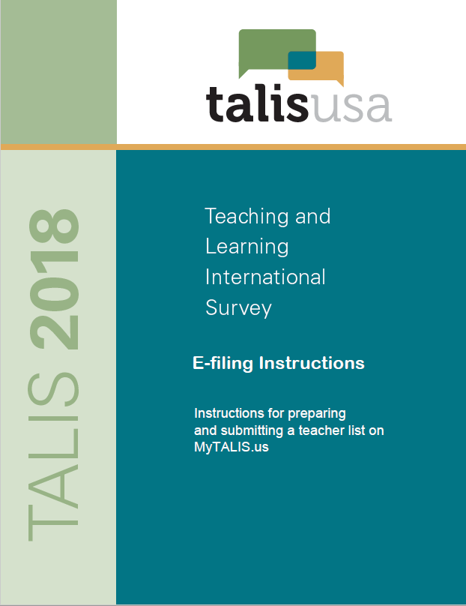

Table of Contents

Preparing the TALIS Electronic Teacher File (E-File) 1

Step 1: Identify ALL teachers eligible to teach students in grade 7, 8, or 9 1

Step 2: List each of the eligible teachers. 1

Submitting the TALIS Electronic Teacher File (E-File) 2

Step 1: Upload file. 2

Step 2: Map Columns 2

Step 3: Match Values to TALIS Codes 3

Step 4: Verify your E-file. 4

Online Teacher Data Checks 5

# Preparing the TALIS Electronic Teacher File (E-File)

Step 1: Identify ALL teachers eligible to teach students in grade 7, 8, or 9**.**

Criteria for TALIS teacher eligibility are:

* + - All teachers *who are eligible* to teach grade 7, 8, or 9 students.
    - Teacher-aides, assistants, and other school staff are not eligible.

TALIS needs accurate information about all teachers at your school who teach students in grades 7, 8, or 9. In addition to teacher name and email, TALIS needs you to identify which domain each teacher primarily teaches to students in grades 7, 8, or 9.

## Step 2: List each of the eligible teachers.

Using the electronic listing form template provided on the MyTALIS.us website ([www.MyTALIS.us](http://www.MyTALIS.us))

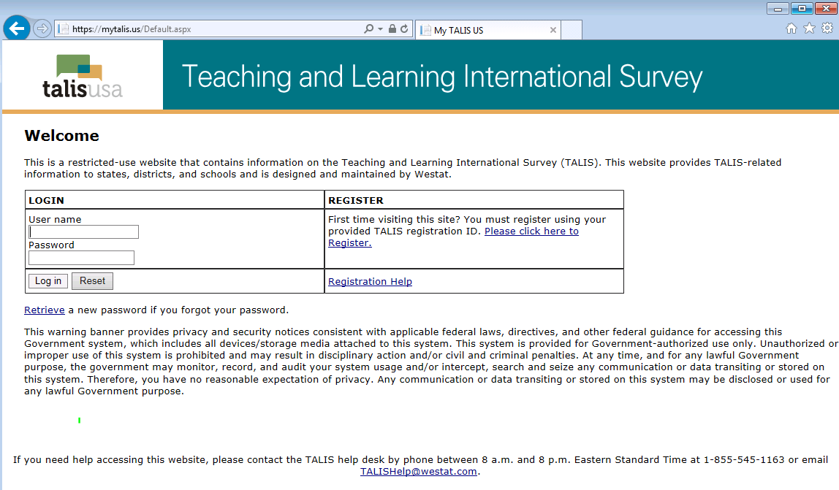

*The National Center for Education Statistics (NCES), within the U.S. Department of Education, conducts the Teaching and Learning International Survey (TALIS) in the United States as authorized by the Education Sciences Reform Act of 2002 (ESRA 2002, 20 U.S.C. §9543). All of the information you provide may be used only for statistical purposes and may not be disclosed, or used, in identifiable form for any other purpose except as required by law (20 U.S.C. §9573 and 6 U.S.C. §151).*

*According to the Paperwork Reduction Act of 1995, no persons are required to respond to a collection of information unless such collection displays a valid OMB control number. The valid OMB control number for this voluntary information collection is 1850-0888. The time required to complete the information collection requested on this site is provided at the start of each request. If you have any comments or concerns regarding the accuracy of the time estimate(s), suggestions for improving the form, or questions about the status of your individual submission of this form, write directly to: Teaching and Learning International Survey (TALIS), National Center for Education Statistics (NCES), Potomac Center Plaza, 550 12th Street, SW, 4th floor, Washington, DC 20202.*

*OMB No. 1850-0888, Approval Expires xx/xx/20xx*

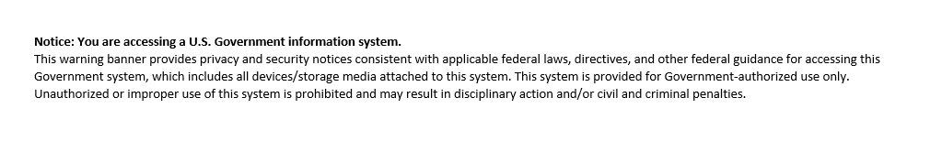

TEXT:

*The National Center for Education Statistics (NCES), within the U.S. Department of Education, conducts the Teaching and Learning International Survey (TALIS) in the United States as authorized by the Education Sciences Reform Act of 2002 (ESRA 2002, 20 U.S.C. §9543). All of the information you provide may be used only for statistical purposes and may not be disclosed, or used, in identifiable form for any other purpose except as required by law (20 U.S.C. §9573 and 6 U.S.C. §151).*

*According to the Paperwork Reduction Act of 1995, no persons are required to respond to a collection of information unless such collection displays a valid OMB control number. The valid OMB control number for this voluntary information collection is 1850-0888. The time required to complete the information collection requested on this site is provided at the start of each request. If you have any comments or concerns regarding the accuracy of the time estimate(s), suggestions for improving the form, or questions about the status of your individual submission of this form, write directly to: Teaching and Learning International Survey (TALIS), National Center for Education Statistics (NCES), Potomac Center Plaza, 550 12th Street, SW, 4th floor, Washington, DC 20202.*

*OMB No. 1850-0888, Approval Expires xx/xx/20xx*

**Notice: You are accessing a U.S. Government information system.**

This warning banner provides privacy and security notices consistent with applicable federal laws, directives, and other federal guidance for accessing this Government system, which includes all devices/storage media attached to this system. This system is provided for Government-authorized use only. Unauthorized or improper use of this system is prohibited and may result in disciplinary action and/or civil and criminal penalties.

List teachers in your school who are eligible for TALIS along with their other necessary information.

* + - Teacher first name
    - Teacher middle name (not required)
    - Teacher last name
    - Email address (this is needed to deliver their log in credentials electronically)
    - Main domain (1 – Language, 2 – Social Sciences, 3 – Math & Science, 4 – Other)

**Exhibit 1. Example Teacher listing Form**

|  |  |  |  |  |
| --- | --- | --- | --- | --- |
| **Teacher First Name** | **Teacher Middle Name** | **Teacher Last Name** | **Teacher email** | **Main Domain** |
| John |  | Simpson | JohnSimpson@nomail.com | 1 |
| Carol |  | White | CarolWhite@nomail.com | 1 |
| Jamie |  | Smith | JamieSmith@nomail.com | 1 |
| Loretta |  | Alexander | LorettaAlexander@nomail.com | 2 |
| Cindy |  | Tasker | CindyTasker@nomail.com | 2 |
| Bethel |  | Lane | BethelLane@nomail.com | 2 |
| Lin |  | Jing | LinJing@nomail.com | 3 |
| Jarrod |  | McElroy | JarrodMcElroy@nomail.com | 3 |
| Meghan |  | Taferishi | MeghanTaferishi@nomail.com | 4 |
| Tisha |  | Campbell | TishaCampbell@nomail.com | 3 |
| Tonya |  | Jackson | TonyaJackson@nomail.com | 4 |
| Monique |  | Smith | MoniqueSmith@nomail.com | 3 |
| Geoffery |  | Johnson | GeofferyJohnson@nomail.com | 4 |
| John |  | Candy | JohnCandy@nomail.com | 2 |
| Grady |  | White | GradyWhite@nomail.com | 2 |

# Submitting the TALIS Electronic Teacher File (E-File)

Step 1: Upload file. After you have created and saved your teacher E-File, proceed to [www.MyTALIS.us](http://www.mytalis.us/) . Once you have logged in, click the “Submit Teacher List” link on the left side of the page (box 1 below) underneath the “Submit Teacher Link.” Then click the “Browse” button to locate your file (box 2 below). Once you’ve located the file and clicked ok, click “Upload”(box 3 below).

**Exhibit 2. Submit Teacher List - initial screen**

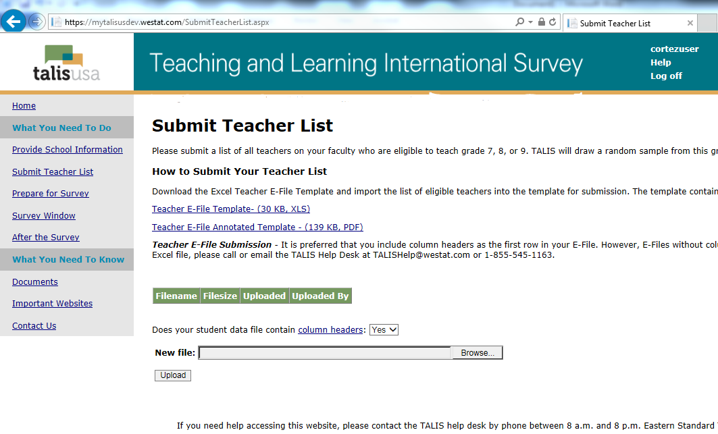

1

2

3

Step 2: Map Columns**.** The column headings in your file are shown in rows on the left side of the page. In each row, for each heading on the left, click on the down arrow next to the words in the table that read "Column Contains..." on the right. If there is no appropriate description in the drop-down list for your column heading, select N/A.

**Exhibit 3. Submit Teacher List – identify your columns**

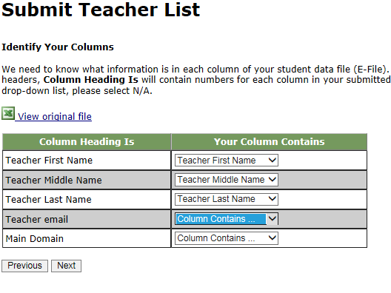

Step 3: Match Values to TALIS Codes**.** The next step is matching the values on your file to TALIS codes. The values in your column will again be displayed on the left. Select the corresponding TALIS code from the drop down list (see exhibit 4). If there is no appropriate description in the drop-down list for your column heading, select N/A. When you are finished matching your values to TALIS codes, click next.

**Exhibit 4. Submit Teacher List - Match your Values to TALIS Codes (Domain mapping)**

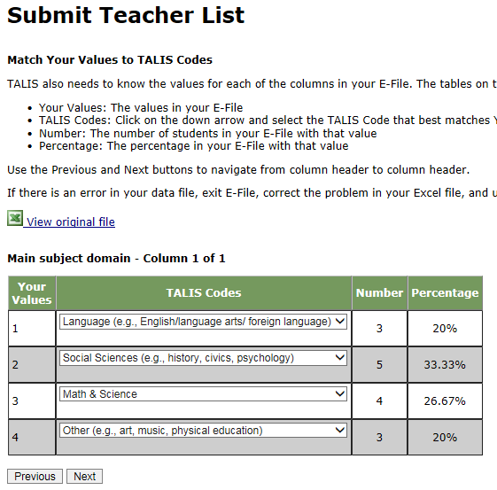

Step 4: Verify your E-file.The final step is to verify that the information is correct and submit your file. Check that the distribution of teachers by main subject domain match the total number of teachers you submitted. Indicate whether this information is correct and click “Submit.” If the information is incorrect click “Incorrect” and then click on the “Submit Teacher List” link on the left side of the screen. This will save your progress and exit the current e-file. You can access this file again or upload a new corrected file and start over using the same file upload process described in Step 1.

**Exhibit 5. Submit Teacher List –Verify your E-file**

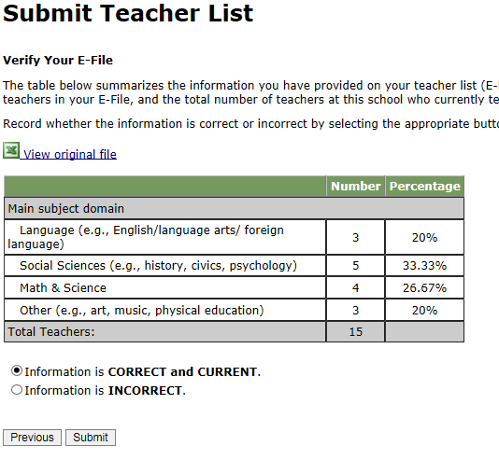

Online Teacher Data Checks **-** After you click “Submit” a number of online data validation checks are performed by our programs. These checks include checking the number of listed teachers against statistical estimates, checking for valid emails, and checking for any missing data. If the data fail these online checks, you will be presented with a screen that describes the issue, the location of the row(s) in your file that contains the errant data, and will need to correct the file and upload a new version. Exhibit 6 (below) provides an example of a file with missing data. Notice that the affected row is provided for each instance where the check failed. This is designed to help you efficiently locate and ameliorate any issues. Exhibit 7 provides an example of a file where an invalid email was provided.

**Exhibit 6. Online data check – missing data**

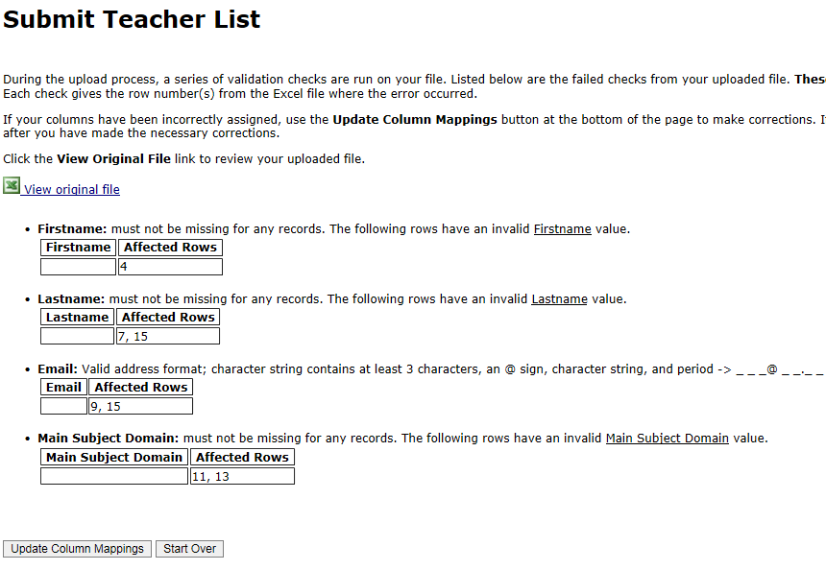

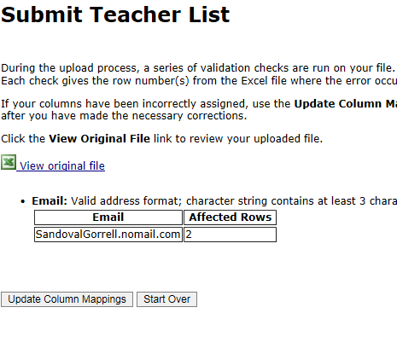**Exhibit 7. Online data check – invalid email**

If at any time you realize that every eligible teacher was not listed or needs to be corrected, you can exit e-filing, correct the file, and upload a new one by clicking on the “Submit Teacher List” link and uploading a new file. If you have any questions or would like to talk with someone about e-filing, please reach out to the TALIS help desk by phone between 8 a.m. and 8 p.m. Eastern Standard Time at

1-855-545-1163 or email [TALISHelp@westat.com](mailto:TALISHelp@westat.com).

**TALIS 2018 School Coordinator Communications**

1. **Email to register on MyTALIS**

Dear <title> <last name>:   
  
Thank you again for participating in the TALIS 2018 main study taking place this Spring. To keep you informed of new information about TALIS as well as steps for preparing for the study, we have developed a website for school coordinators called MyTALIS (<https://www.myTALIS.us>). This is a secure site with content tailored to each individual school.   
  
Below is your Registration ID. You will use this the first time you visit MyTALIS to create your own username and password.   
  
MyTALIS REGISTRATION ID: <Registration ID>  
  
The registration ID supports multiple users, though each user will need to provide their own registration information (e.g., name, email, phone, address).   
  
If you need technical assistance at any time, please do not hesitate to contact the TALIS help desk at 1-855-545-1163 or via email at [TALISHelp@westat.com](mailto:TALISHelp@westat.com).   
  
We look forward to working with you.   
  
Sincerely,   
  
The U.S. TALIS Team

**2. Cover letter to School Coordinator accompanying School Coordinator Handbook**

Hello!

Thank you for agreeing to serve as the TALIS School Coordinator for your school during TALIS 2018. Enclosed is a TALIS School Coordinator Handbook describing your role and the tasks you are asked to complete during the survey.

Please review the handbook and familiarize yourself with the survey procedures and your role. We will hold a short informational WebEx on [date]. You will be contacted through a separate email regarding the details of the WebEx.

If you have not already registered on [MyTALIS.us](http://www.MyTALIS.us) study website, please do so. If you need your registration credentials, call the TALIS Help Desk at 1-855-545-1163, or send an email to [TALISHELP@westat.com](mailto:TALISHELP@westat.com).

Thank you again!

The TALIS USA Team

*The National Center for Education Statistics (NCES), within the U.S. Department of Education, conducts the Teaching and Learning International Survey (TALIS) in the United States as authorized by the Education Sciences Reform Act of 2002 (ESRA 2002, 20 U.S.C. §9543). All of the information you provide may be used only for statistical purposes and may not be disclosed, or used, in identifiable form for any other purpose except as required by law (20 U.S.C. §9573 and 6 U.S.C. §151).*

1. **E-file instructions email to School Coordinator**

Dear School Coordinator,

Thank you for your time and effort working on TALIS 2018!

We are pleased to announce that [www.mytalis.us](http://www.mytalis.us) is now ready to receive teacher electronic listing files (e-files).

The instructions for preparing and submitting your school’s teacher listing file are attached to this email. The TALIS E-filing Instructions can also be accessed online from the website. Along with the instructions, we’ve prepared a formatted Excel template to make preparing the e-file more convenient.

If you have yet to register on [www.mytalis.us](http://www.mytalis.us), please let us know so we can send you the registration ID for your school.

Reach out to the TALIS help desk by phone between 8 a.m. and 8 p.m. Eastern Standard Time at 1-855-545-1163 or email [TALISHelp@westat.com](mailto:TALISHelp@westat.com).

Thanks again for your support.

All the best,

The TALIS USA Team

*The National Center for Education Statistics (NCES), within the U.S. Department of Education, conducts the Teaching and Learning International Survey (TALIS) in the United States as authorized by the Education Sciences Reform Act of 2002 (ESRA 2002, 20 U.S.C. §9543). All of the information you provide may be used only for statistical purposes and may not be disclosed, or used, in identifiable form for any other purpose except as required by law (20 U.S.C. §9573 and 6 U.S.C. §151).*

1. **TALIS E-file reminder email to School Coordinator**

Subject: TALIS E-File Reminder

Attachment: TALIS 2018 E-Filing Instructions

Dear School Coordinator:

Welcome and thank you for your efforts as the school coordinator for the Teaching and Learning International Survey (TALIS) 2018 at your school!

We are nearing the deadline for your teacher list to be submitted for sampling (**Friday, February 23, 2018**). Please upload your school’s list as soon as possible so that sampled teachers can be notified about the survey.

Detailed instructions for submitting your lists to TALIS are included in the enclosed document titled ***TALIS 2018 E-Filing Instructions***.

If you have any questions about the instructions, please contact the TALIS Help Desk at 1-855-545-1163, or send an email to [TALISHELP@westat.com](mailto:TALISHELP@westat.com). The e-filing instructions are also posted on the MyTALIS.us website (www.mytalis.us).

Sincerely,

The TALIS USA Team

*The National Center for Education Statistics (NCES), within the U.S. Department of Education, conducts the Teaching and Learning International Survey (TALIS) in the United States as authorized by the Education Sciences Reform Act of 2002 (ESRA 2002, 20 U.S.C. §9543). All of the information you provide may be used only for statistical purposes and may not be disclosed, or used, in identifiable form for any other purpose except as required by law (20 U.S.C. §9573 and 6 U.S.C. §151).*

1. **Email to School Coordinator when teacher samples are complete and Teacher Tracking**

**Form/School Logon Forms/Teacher Logon Invitations have been posted to MyTALIS.us**

Subject: TALIS Teacher Sampling Complete

Hello!

We have processed the list of teachers from your school and selected a sample of teachers for the Teacher Questionnaire. The following materials are now available on [www.MyTALIS.us](http://www.MyTALIS.us):

* Teacher Tracking Form
* School Questionnaire Invitation
* Teacher Questionnaire Invitations

To access the files:

1. Log into [www.MyTALIS.us](http://www.MyTALIS.us) with your username/password.

2. Click the Documents link in the “What you Need to Know” section.

3. Click on the link in the upper center of the page under "Download Your School's materials here:"

To open the files, use the password **[insert password]**

Please review and update the Teacher Tracking Form following the steps provided in chapter 3, section 3.3 of your School Coordinator Handbook. Please distribute the Principal and Teacher Questionnaire invitations, update the Teacher Tracking Form, and return the tracking form to Westat as described in section 3.5 of the School Coordinator Handbook.

Your TALIS Representative will contact you to make sure you have received the materials you need. He or she can assist you in answering any questions you may have.

If you have any questions in the meantime, please feel free to call the TALIS Help Desk at 1-855-545-1163, or send an email to [TALISHELP@westat.com](mailto:TALISHELP@westat.com)

Thank you again!

The TALIS USA Team

*The National Center for Education Statistics (NCES), within the U.S. Department of Education, conducts the Teaching and Learning International Survey (TALIS) in the United States as authorized by the Education Sciences Reform Act of 2002 (ESRA 2002, 20 U.S.C. §9543). All of the information you provide may be used only for statistical purposes and may not be disclosed, or used, in identifiable form for any other purpose except as required by law (20 U.S.C. §9573 and 6 U.S.C. §151).*

1. **Cover letter to hard copy materials package sent to School Coordinator when survey is ready to launch.**

Hello!

Enclosed please find the necessary materials for the launch of the TALIS survey. The following materials are included:

* Principal invitation
* Teacher invitations
* Return envelope
* Red security envelope
* Teacher Tracking Form

Please review the School Coordinator Handbook and familiarize yourself with the survey procedures and your role. If you missed the informational WebEx on February 13, you can access a recording of the presentation and the slides on the Documents page of [MyTALIS.us](http://www.MyTALIS.us).

If you have not already registered on [MyTALIS.us](http://www.MyTALIS.us) study website, please do so. If you need your registration credentials, or have other questions, call the TALIS Help Desk at 1-855-545-1163, or send an email to [TALISHELP@westat.com](mailto:TALISHELP@westat.com).

Thank you again!

The TALIS USA Team

*The National Center for Education Statistics (NCES), within the U.S. Department of Education, conducts the Teaching and Learning International Survey (TALIS) in the United States as authorized by the Education Sciences Reform Act of 2002 (ESRA 2002, 20 U.S.C. §9543). All of the information you provide may be used only for statistical purposes and may not be disclosed, or used, in identifiable form for any other purpose except as required by law (20 U.S.C. §9573 and 6 U.S.C. §151).*

**TALIS 2018 Respondent Communications**

TALIS 2018 – Teacher Questionnaire Invitation

Dear **«teacherFirstLast»**:

Your school is one of about 200 schools across the United States taking part in the Teaching and Learning International Study (TALIS) 2018. Conducted every 5 years since 2008, TALIS is an international survey of principals and teachers at grades 7, 8, and 9 and provides comparative information about teaching and the teaching profession around the world. More than 45 countries and other education systems are participating in 2018.

You’ve been selected to complete a TALIS online teacher questionnaire about the courses you teach, your teacher training and education, and your views on teaching. The questionnaire takes about 60 minutes and can be completed in a single session or multiple sessions. If you have any questions about how you were selected for this survey, please contact your TALIS school coordinator, «SCName» .

*You will receive $20 as a thank you for completing the questionnaire, if allowed by your school’s policy*.

Use the provided link and unique account information below to complete your questionnaire.

<https://portal.mytalis.us>

User ID: «IDTEACH»

Password: «T_ChkSum»

Your participation is valuable and appreciated. The information you contribute combined with responses from teachers and principals provides accurate and reliable data to teachers, principals, and policy makers around the world.

TALIS is conducted in the United States by the National Center for Education Statistics (NCES) in the U.S. Department of Education and is administered by Westat, a firm headquartered in Rockville, Maryland. The U.S. Office of Management and Budget has approved this data collection under OMB #1850-0888.

To get more information about this study visit the TALIS website at <http://nces.ed.gov/surveys/talis>

If you need assistance accessing the survey, reach out to the TALIS help desk by phone between 8 a.m. and 8 p.m. Eastern Standard Time at 1-855-545-1163 or email [TALISHelp@westat.com](mailto:TALISHelp@westat.com).

Sincerely,

The TALIS USA Team

*The National Center for Education Statistics (NCES), within the U.S. Department of Education, conducts the Teaching and Learning International Survey (TALIS) in the United States as authorized by the Education Sciences Reform Act of 2002 (ESRA 2002, 20 U.S.C. §9543). All of the information you provide may be used only for statistical purposes and may not be disclosed, or used, in identifiable form for any other purpose except as required by law (20 U.S.C. §9573 and 6 U.S.C. §151).*

TALIS 2018– Principal Questionnaire Invitation

Dear **«principal»**:

Your school is one of about 200 schools across the United States taking part in the Teaching and Learning International Study (TALIS) 2018. Conducted every 5 years since 2008, TALIS is an international survey of principals and teachers at grades 7, 8, and 9 and provides comparative information about teaching and the teaching profession around the world. More than 45 countries and other education systems are participating in 2018.

Each principal is asked to complete the TALIS online principal questionnaire about their school. The questionnaire takes about 45 minutes and can be completed in a single session or multiple sessions over time.

Use the provided link and unique account information below to complete your questionnaire.

<https://portal.mytalis.us>

User ID: «idschool»

Password: «Sch_ChkSum»

The information you contribute combined with responses from teachers and principals provides accurate and reliable data to teachers, principals, and policy makers around the world. Your participation is valuable and appreciated.

TALIS is conducted in the United States by the National Center for Education Statistics (NCES) in the U.S. Department of Education and is administered by Westat, a firm headquartered in Rockville, Maryland. The U.S. Office of Management and Budget has approved this data collection under OMB #1850-0888.

To get more information about this study visit the TALIS website at <http://nces.ed.gov/surveys/talis>

If you need assistance accessing the survey, reach out to the TALIS help desk by phone between 8 a.m. and 8 p.m. Eastern Standard Time at 1-855-545-1163 or email [TALISHelp@westat.com](mailto:TALISHelp@westat.com).

Sincerely,

The TALIS USA Team

*The National Center for Education Statistics (NCES), within the U.S. Department of Education, conducts the Teaching and Learning International Survey (TALIS) in the United States as authorized by the Education Sciences Reform Act of 2002 (ESRA 2002, 20 U.S.C. §9543). All of the information you provide may be used only for statistical purposes and may not be disclosed, or used, in identifiable form for any other purpose except as required by law (20 U.S.C. §9573 and 6 U.S.C. §151).*

TALIS 2018– Teacher Questionnaire Hard-Copy Invitation

Front side

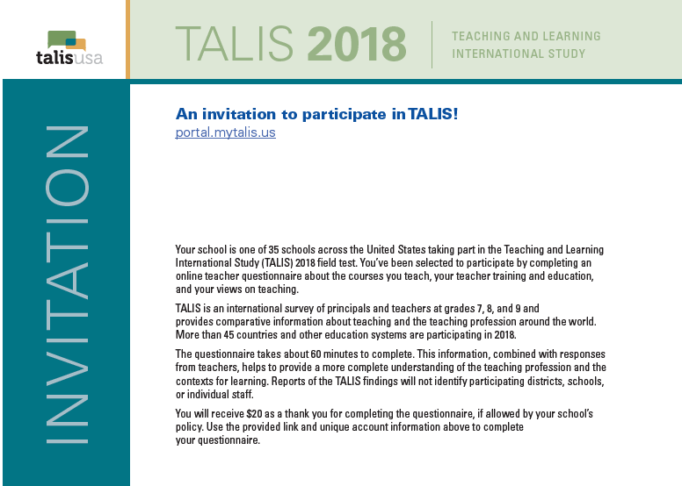

**Text for main study (to replace text from field test in the above image)**

Your school is one of 200 schools across the United States taking part in the Teaching and Learning International Study (TALIS) 2018. You’ve been selected to participate by completing an online teacher questionnaire about the courses you teach, your teacher training and education, and your views on teaching.

TALIS is an international survey of principals and teachers at grades 7, 8, and 9 and provides comparative information about teaching and the teaching profession around the world. More than 45 countries and other education systems are participating in 2018.

The questionnaire takes about 60 minutes to complete. This information, combined with responses from other teachers, helps to provide a more complete understanding of the teaching profession and the contexts for learning. Reports of the TALIS findings will not identify participating districts, schools, or individual staff.

You will receive $20 as a thank you for completing the questionnaire, if allowed by your school’s policy. Use the provided link and unique account information above to complete your questionnaire.

TALIS 2018– Teacher Questionnaire Hard-Copy Invitation

Back side

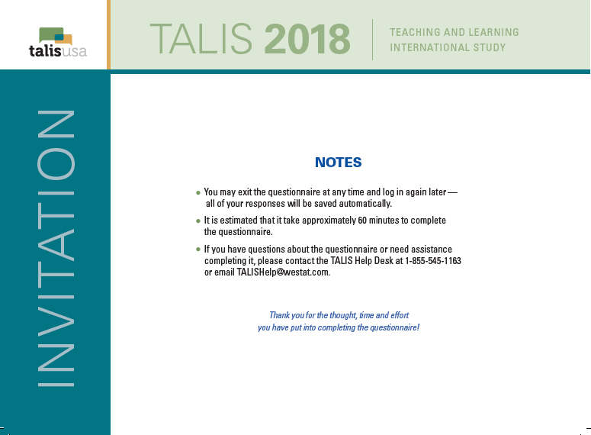

**Text for main study (to replace text from field test in the above image)**

NOTES

● You may exit the questionnaire at any time and log in again later —all of your responses will be saved automatically.

● It is estimated that it takes approximately 60 minutes to complete this questionnaire.

● If you have questions about this survey or need assistance completing it, please contact the TALIS Help Desk at 1-855-545-1163 or email TALISHelp@westat.com.

Thank you for the thought, time, and effort you have put into completing this questionnaire!

*The National Center for Education Statistics (NCES), within the U.S. Department of Education, conducts the Teaching and Learning International Survey (TALIS) in the United States as authorized by the Education Sciences Reform Act of 2002 (ESRA 2002, 20 U.S.C. §9543). All of the information you provide may be used only for statistical purposes and may not be disclosed, or used, in identifiable form for any other purpose except as required by law (20 U.S.C. §9573 and 6 U.S.C. §151).*

TALIS 2018– Principal Questionnaire Hard-Copy Invitation

Front side

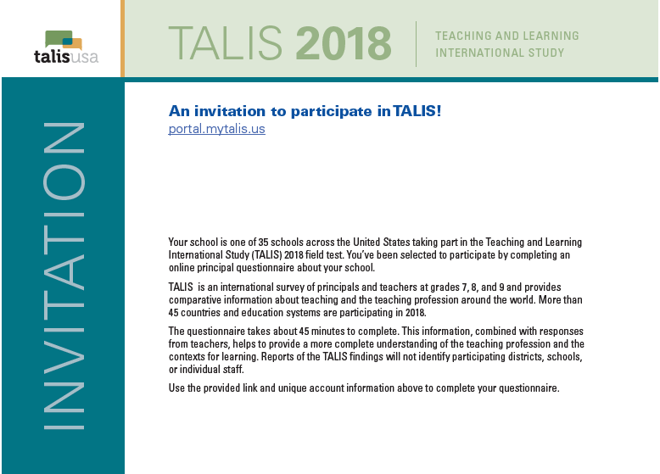

**Text for main study (to replace text from field test in the above image)**

Your school is one of 200 schools across the United States taking part in the Teaching and Learning International Study (TALIS) 2018. You’ve been selected to participate by completing an online principal questionnaire about your school.

TALIS is an international survey of principals and teachers at grades 7, 8, and 9 and provides comparative information about teaching and the teaching profession around the world. More than 45 countries and education systems are participating in 2018.

The questionnaire takes about 45 minutes to complete. This information, combined with responses from other principals and teachers, helps to provide a more complete understanding of the teaching profession and the contexts for learning. Reports of the TALIS findings will not identify participating districts, schools, or individual staff.

Use the provided link and unique account information above to complete your questionnaire.

TALIS 2018– Principal Questionnaire Hard-Copy Invitation

Back side

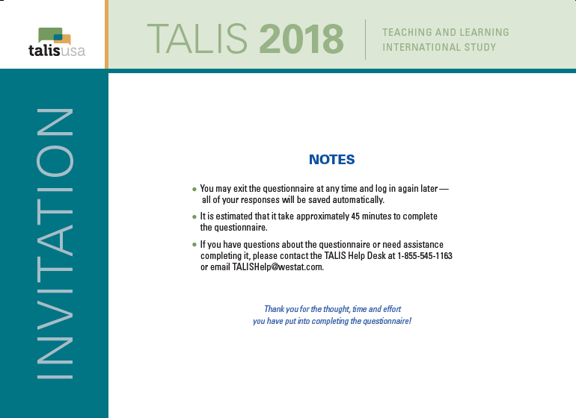

**Text for main study (to replace text from field test in the above image)**

NOTES

● You may exit the questionnaire at any time and log in again later —all of your responses will be saved automatically.

● It is estimated that it takes approximately 45 minutes to complete this questionnaire.

● If you have questions about this survey or need assistance completing it, please contact the TALIS Help Desk at 1-855-545-1163 or email TALISHelp@westat.com.

Thank you for the thought, time, and effort you have put into completing this questionnaire!

*The National Center for Education Statistics (NCES), within the U.S. Department of Education, conducts the Teaching and Learning International Survey (TALIS) in the United States as authorized by the Education Sciences Reform Act of 2002 (ESRA 2002, 20 U.S.C. §9543). All of the information you provide may be used only for statistical purposes and may not be disclosed, or used, in identifiable form for any other purpose except as required by law (20 U.S.C. §9573 and 6 U.S.C. §151).*

**TALIS Questionnaire Login Pages - Principal**

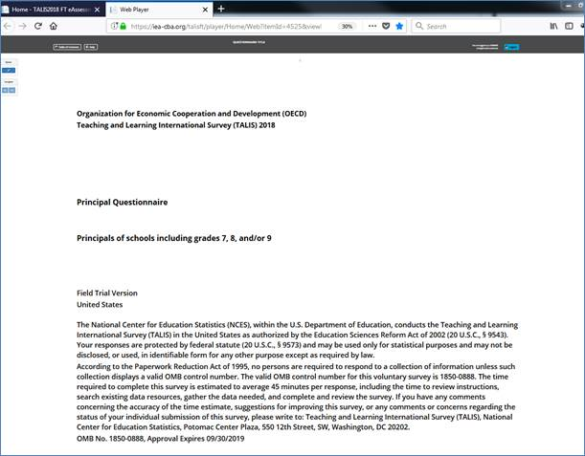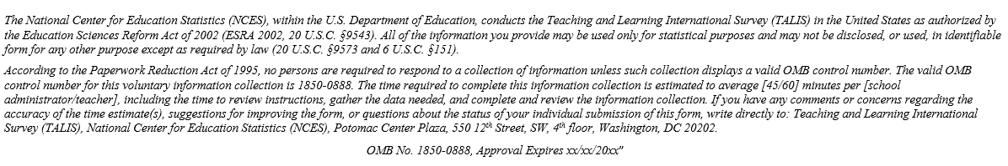

**Text for main study (to replace text from field test in the above image)**

*The National Center for Education Statistics (NCES), within the U.S. Department of Education, conducts the Teaching and Learning International Survey (TALIS) in the United States as authorized by the Education Sciences Reform Act of 2002 (ESRA 2002, 20 U.S.C. §9543). All of the information you provide may be used only for statistical purposes and may not be disclosed, or used, in identifiable form for any other purpose except as required by law (20 U.S.C. §9573 and 6 U.S.C. §151).*

*According to the Paperwork Reduction Act of 1995, no persons are required to respond to a collection of information unless such collection displays a valid OMB control number. The valid OMB control number for this voluntary information collection is 1850-0888. The time required to complete this information collection is estimated to average 45 minutes per school administrator, including the time to review instructions, gather the data needed, and complete and review the information collection. If you have any comments or concerns regarding the accuracy of the time estimate(s), suggestions for improving the form, or questions about the status of your individual submission of this form, write directly to: Teaching and Learning International Survey (TALIS), National Center for Education Statistics (NCES), Potomac Center Plaza, 550 12th Street, SW, 4th floor, Washington, DC 20202.*

*OMB No. 1850-0888, Approval Expires xx/xx/20xx*

**TALIS Questionnaire Login Page - Teachers**

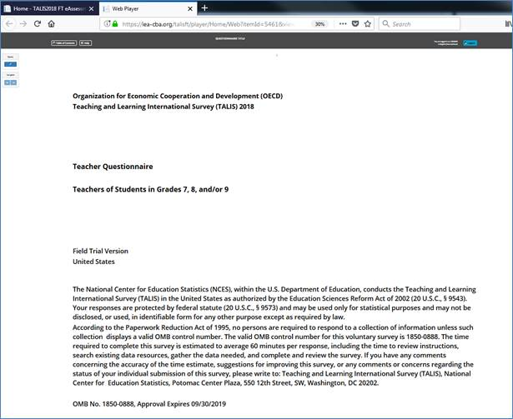

**Text for main study (to replace text from field test in the above image)**

The *U.S. Department of Education, conducts the Teaching and Learning International Survey (TALIS) in the United States as authorized by the Education Sciences Reform Act of 2002 (ESRA 2002, 20 U.S.C. §9543). All of the information you provide may be used only for statistical purposes and may not be disclosed, or used, in identifiable form for any other purpose except as required by law (20 U.S.C. §9573 and 6 U.S.C. §151).*

*According to the Paperwork Reduction Act of 1995, no persons are required to respond to a collection of information unless such collection displays a valid OMB control number. The valid OMB control number for this voluntary information collection is 1850-0888. The time required to complete this information collection is estimated to average 60 minutes per teacher, including the time to review instructions, gather the data needed, and complete and review the information collection. If you have any comments or concerns regarding the accuracy of the time estimate(s), suggestions for improving the form, or questions about the status of your individual submission of this form, write directly to: Teaching and Learning International Survey (TALIS), National Center for Education Statistics (NCES), Potomac Center Plaza, 550 12th Street, SW, 4th floor, Washington, DC 20202.*

*OMB No. 1850-0888, Approval Expires xx/xx/20xx*

TALIS 2018– Teacher Reminder 1

Dear «NAME»:

Thanks to you and your school for participating in the Teaching and Learning International Survey (TALIS) 2018. This email is a reminder that you have been selected to represent your school’s teacher body in TALIS by completing the online teacher questionnaire.

Please know that your participation is important and valued. If you have any questions about how you were selected for this survey, please contact your TALIS school coordinator, «SCFNAME» «SCLNAME».

*You will receive $20 as a thank you for completing this questionnaire, if allowed by your school’s policy*.

Use the provided link and unique account information below to complete your questionnaire.

<https://portal.mytalis.us>

**User ID: «IDTEACH»**

**Password: «T_CHKSUM»**

TALIS is conducted in the United States by the National Center for Education Statistics (NCES) in the U.S. Department of Education and is administered by Westat, a firm headquartered in Rockville, Maryland. The U.S. Office of Management and Budget has approved the data collection under OMB #1850-0888.

To get more information about this study visit the TALIS website at <http://nces.ed.gov/surveys/talis>

If you need assistance accessing the survey, reach out to the TALIS help desk by phone between 8 a.m. and 8 p.m. Eastern Standard Time at 1-855-545-1163 or email [TALISHelp@westat.com](mailto:TALISHelp@westat.com).

Sincerely,

The TALIS USA Team

*The National Center for Education Statistics (NCES), within the U.S. Department of Education, conducts the Teaching and Learning International Survey (TALIS) in the United States as authorized by the Education Sciences Reform Act of 2002 (ESRA 2002, 20 U.S.C. §9543). All of the information you provide may be used only for statistical purposes and may not be disclosed, or used, in identifiable form for any other purpose except as required by law (20 U.S.C. §9573 and 6 U.S.C. §151).*

TALIS 2018– Principal Reminder 1

Dear Principal:

The Teaching and Learning International Survey (TALIS) data collection period ends **Friday, March 17.** This email is a reminder to login and complete the online principal questionnaire at your earliest convenience.

Please know that your participation is important and valued. This week your school’s TALIS School Coordinator will receive a hard-copy questionnaire with a pre-paid return envelope for you to complete, in case you’ve had difficulties completing the questionnaire online or prefer to complete it on paper.

You can *still* complete the survey online! Use the information below to access the website and get started:

<https://portal.mytalis.us>

**User ID: <IDSCHOOL>**

**Password: <sch_chksum>**

TALIS is conducted in the United States by the National Center for Education Statistics (NCES) in the U.S. Department of Education and is administered by Westat, a firm headquartered in Rockville, Maryland. The U.S. Office of Management and Budget has approved the data collection under OMB #1850-0888.

To get more information about this study visit the TALIS website at <http://nces.ed.gov/surveys/talis>

If you need assistance accessing the survey, reach out to the TALIS help desk by phone between 8 a.m. and 8 p.m. Eastern Standard Time at 1-855-545-1163 or email [TALISHelp@westat.com](mailto:TALISHelp@westat.com).

Sincerely,

The TALIS USA Team

*The National Center for Education Statistics (NCES), within the U.S. Department of Education, conducts the Teaching and Learning International Survey (TALIS) in the United States as authorized by the Education Sciences Reform Act of 2002 (ESRA 2002, 20 U.S.C. §9543). All of the information you provide may be used only for statistical purposes and may not be disclosed, or used, in identifiable form for any other purpose except as required by law (20 U.S.C. §9573 and 6 U.S.C. §151).*

TALIS 2018– Teacher final reminder

Dear Teacher:

The Teacher and Learning International Survey (TALIS) data collection period ends **<DATE>.**

Remember to complete your TALIS questionnaire by this Friday night, or let your TALIS school coordinator, <SC NAME>, know that you don’t want to participate so we stop sending you reminder messages.

**To complete the questionnaire online**, use the provided link and unique account information below:

<https://portal.mytalis.us>

**User ID: <IDTEACH>**

**Password: <T_checksum>**

If you log in and complete *any portion* of the questionnaire you are eligible to receive the $20 incentive, if allowed by your school, even if you can’t find time to complete it all before Friday night.

This week your TALIS School Coordinator received a shipment of hard-copy questionnaires with pre-paid return envelopes, in case you’ve had difficulties completing the questionnaire online or prefer to complete it on paper. If you plan to complete on paper, please reply to this email and let us know so we stop sending email messages to you.

TALIS is conducted in the United States by the National Center for Education Statistics (NCES) in the U.S. Department of Education and is administered by Westat, a firm headquartered in Rockville, Maryland. The U.S. Office of Management and Budget has approved the data collection under OMB #1850-0888.

To get more information about this study visit the TALIS website at <http://nces.ed.gov/surveys/talis>

If you need assistance accessing the survey, reach out to the TALIS help desk by phone between 8 a.m. and 8 p.m. Eastern Standard Time at 1-855-545-1163 or email [TALISHelp@westat.com](mailto:TALISHelp@westat.com).

Sincerely,

The TALIS USA Team

*The National Center for Education Statistics (NCES), within the U.S. Department of Education, conducts the Teaching and Learning International Survey (TALIS) in the United States as authorized by the Education Sciences Reform Act of 2002 (ESRA 2002, 20 U.S.C. §9543). All of the information you provide may be used only for statistical purposes and may not be disclosed, or used, in identifiable form for any other purpose except as required by law (20 U.S.C. §9573 and 6 U.S.C. §151).*

TALIS 2018– Principal final reminder

Dear Principal:

Thanks to you and your colleagues for participating in the Teaching and Learning International Survey (TALIS) 2018! In the next few weeks your school will receive its $200.00 incentive check as a thank you for your participation if allowed by school policy.

This is a reminder to complete your TALIS principal questionnaire by this Friday night. The data collection period ends **<DATE>.**

To complete the questionnaire online, use the provided link and unique account information below:

<https://portal.mytalis.us>

**User ID: <IDSCHOOL>**

**Password: <SCH_Checksum>**

TALIS is conducted in the United States by the National Center for Education Statistics (NCES) in the U.S. Department of Education and is administered by Westat, a firm headquartered in Rockville, Maryland. The U.S. Office of Management and Budget has approved the data collection under OMB #1850-0888.

To get more information about this study visit the TALIS website at <http://nces.ed.gov/surveys/talis>

If you need assistance accessing the survey, reach out to the TALIS help desk by phone between 8 a.m. and 8 p.m. Eastern Standard Time at 1-855-545-1163 or email [TALISHelp@westat.com](mailto:TALISHelp@westat.com).

Sincerely,

The TALIS USA Team

*The National Center for Education Statistics (NCES), within the U.S. Department of Education, conducts the Teaching and Learning International Survey (TALIS) in the United States as authorized by the Education Sciences Reform Act of 2002 (ESRA 2002, 20 U.S.C. §9543). All of the information you provide may be used only for statistical purposes and may not be disclosed, or used, in identifiable form for any other purpose except as required by law (20 U.S.C. §9573 and 6 U.S.C. §151).*

TALIS 2018 – Teacher last-day reminder

Dear Teacher:

The Teacher and Learning International Survey (TALIS) data collection period ends ***today***.

Remember to complete your TALIS questionnaire by tonight, or let your TALIS school coordinator, David Lewis, know that you don’t want to participate so we can assign proper close-out codes.

To complete the questionnaire online, use the provided link and unique account information below:

<https://portal.mytalis.us>

**User ID: <IDTEACH>**

**Password: <T_Checksum>**

If you log in and complete ***any portion*** of the questionnaire you are eligible to receive the $20 incentive, if allowed by your school, even if you can’t find time to complete it all before Friday night.

This week your TALIS School Coordinator received a shipment of hard-copy questionnaires with pre-paid return envelopes, in case you’ve had difficulties completing the questionnaire online or prefer to complete it on paper. **If you plan to complete on paper**, please reply to this email and let us know so we can make sure we have the proper participation code assigned for you. You can still send them today!

To get more information about this study visit the TALIS website at <http://nces.ed.gov/surveys/talis>

If you need assistance accessing the survey, reach out to the TALIS help desk by phone between 8 a.m. and 8 p.m. Eastern Standard Time at 1-855-545-1163 or email [TALISHelp@westat.com](mailto:TALISHelp@westat.com).

Sincerely,

The TALIS USA Team

*The National Center for Education Statistics (NCES), within the U.S. Department of Education, conducts the Teaching and Learning International Survey (TALIS) in the United States as authorized by the Education Sciences Reform Act of 2002 (ESRA 2002, 20 U.S.C. §9543). All of the information you provide may be used only for statistical purposes and may not be disclosed, or used, in identifiable form for any other purpose except as required by law (20 U.S.C. §9573 and 6 U.S.C. §151).*

TALIS 2018 – Principal last-day reminder

Dear Principal:

The Teacher and Learning International Survey (TALIS) data collection period ends ***today***.

Remember to complete your TALIS questionnaire by tonight, or let your TALIS school coordinator, [name], know that you don’t want to participate so we can assign proper close-out codes.

To complete the questionnaire online, use the provided link and unique account information below:

<https://portal.mytalis.us>

**User ID: <IDSCHOOL>**

**Password: <SCH_Checksum>**

If you log in and complete ***any portion*** of the questionnaire your data will contribute to the national database.

This week your TALIS School Coordinator received a hard-copy questionnaire with a pre-paid return envelope, in case you’ve had difficulties completing the questionnaire online or prefer to complete it on paper. **If you plan to complete on paper**, please reply to this email and let us know so we can make sure we have the proper participation code assigned for you. You can still send them today!

To get more information about this study visit the TALIS website at <http://nces.ed.gov/surveys/talis>

If you need assistance accessing the survey, reach out to the TALIS help desk by phone between 8 a.m. and 8 p.m. Eastern Standard Time at 1-855-545-1163 or email [TALISHelp@westat.com](mailto:TALISHelp@westat.com).

Sincerely,

The TALIS USA Team

*The National Center for Education Statistics (NCES), within the U.S. Department of Education, conducts the Teaching and Learning International Survey (TALIS) in the United States as authorized by the Education Sciences Reform Act of 2002 (ESRA 2002, 20 U.S.C. §9543). All of the information you provide may be used only for statistical purposes and may not be disclosed, or used, in identifiable form for any other purpose except as required by law (20 U.S.C. §9573 and 6 U.S.C. §151).*

TALIS 2018 – Teacher Deadline Extension Email

Subject: TALIS online survey **extended till <insert date>**!

Dear <SP first name>

As you may know, the TALIS survey was scheduled to end on *<previous end date>*. However, we are making every effort to include all the sampled teachers, so it is being extended **until <Insert date>**. The TALIS team is really counting on you!

Without your contribution the study could be in jeopardy. Teachers like you are busy people and we recognize that. If you could find time to complete the survey it would go a long way toward helping the study be successful.

Click the link below, enter your login information (also below), and complete Part A:

Website: [www.Portal.MyTALIS.us](http://www.Portal.MyTALIS.us)

Username: <IDTEACH>

Initial password: <T_checksum>

Don’t let this to opportunity to provide valuable contributions to research that shapes education policy for future generations pass you by. **The survey is now scheduled to close <Insert date>.**

Go online and complete the questionnaire as soon as possible. Thank you for your time.

Sincerely,

The U.S. TALIS Team

*The National Center for Education Statistics (NCES), within the U.S. Department of Education, conducts the Teaching and Learning International Survey (TALIS) in the United States as authorized by the Education Sciences Reform Act of 2002 (ESRA 2002, 20 U.S.C. §9543). All of the information you provide may be used only for statistical purposes and may not be disclosed, or used, in identifiable form for any other purpose except as required by law (20 U.S.C. §9573 and 6 U.S.C. §151).*

TALIS 2018 – Principal Deadline Extension Email

Dear Principal

As you may know the TALIS survey was scheduled to end on *<previous end date>*. However, we are making every effort to include all of the Principals from participating schools, so the deadline is being extended **until <Insert date>**. The TALIS team is really counting on you!

If you could find time to complete the survey it would go a long way toward helping the study be successful.

Click the link below, enter your login information (also below), to complete the survey:

Website: [www.portal.mytalis.us](http://www.portal.mytalis.us)

Username: <IDSCHOOL>

Initial password: <sch_checksum>

Don’t let this to opportunity to provide valuable contributions to research that shapes education policy for future generations pass you by. **The survey is now scheduled to close <Insert date>.**

Go online and complete the questionnaire as soon as possible. Thank you for your time.

Sincerely,

The U.S. TALIS Team

*The National Center for Education Statistics (NCES), within the U.S. Department of Education, conducts the Teaching and Learning International Survey (TALIS) in the United States as authorized by the Education Sciences Reform Act of 2002 (ESRA 2002, 20 U.S.C. §9543). All of the information you provide may be used only for statistical purposes and may not be disclosed, or used, in identifiable form for any other purpose except as required by law (20 U.S.C. §9573 and 6 U.S.C. §151)*

|  |  |
| --- | --- |
| **Organization for Economic Cooperation and Development (OECD)** | |
|  | **Teaching and Learning International Survey  (TALIS) 2018** |
|  | School Coordinator Handbook |
|  | United States: Grades 7, 8, and 9  January 2018 |
|  | **Consortium** |
| D:\Projects\TALIS 2018\Project\General\Templates\Logos\IEA.JPG | International Association for the Evaluation of Educational Achievement (IEA)  (Amsterdam, The Netherlands and Hamburg, Germany) |
| Canadian Flag.png | Statistics Canada  (Ottawa, Canada) |
|  | Australian Council for Educational Research (ACER) (Melbourne, Australia) |

The National Center for Education Statistics (NCES), within the U.S. Department of Education, conducts the Teaching and Learning International Survey (TALIS) in the United States as authorized by the Education Sciences Reform Act of 2002 (ESRA 2002, 20 U.S.C. §9543). All of the information you provide may be used only for statistical purposes and may not be disclosed, or used, in identifiable form for any other purpose except as required by law (20 U.S.C. §9573 and 6 U.S.C. §151).

According to the Paperwork Reduction Act of 1995, no persons are required to respond to a collection of information unless such collection displays a valid OMB control number. The valid OMB control number for this voluntary information collection is 1850-0888. The time required to complete this information collection and participate in study activities is estimated to average 240 minutes per school coordinator, including the time to review instructions, gather the data needed, and complete and review the information collection. If you have any comments or concerns regarding the accuracy of the time estimate(s), suggestions for improving the form, or questions about the status of your individual submission of this form, write directly to: Teaching and Learning International Survey (TALIS), National Center for Education Statistics (NCES), Potomac Center Plaza, 550 12th Street, SW, 4th floor, Washington, DC 20202.

OMB No. 1850-0888, Approval Expires xx/xx/2021

Table of Contents

1 Introduction 1

1.1 Overview of the survey and study background 1

1.2 Your Role as School Coordinator 1

2 Preliminary Tasks 4

2.1 Preparing the teacher list 4

2.2 Prepare for the survey 4

2.3 Checking the materials on arrival 5

3 administering the questionnaires 10

3.1 Overview 10

3.2 Accessing the online principal and teacher questionnaires 10

3.3 Monitoring participation and questionnaire completion 10

3.4 Completing the Teacher Tracking Form 12

3.5 Returning materials to the TALIS Home Office 12

Return the Teacher Tracking Form 12

Return paper questionnaires 12

4 Quality control during the Main study 13

APPENDIX a: Example of a teacher tracking form 14

APPENDIX B: Explanation of Teaching Domains 15

1. **Introduction**

Thank you for agreeing to be a school coordinator during the Teaching and Learning International Survey (TALIS) 2018. Your work as a school coordinator will contribute tothe U.S. efforts to obtain accurate and useful information about the work of teachers and principals. We appreciate your willingness to help. Your efforts and support contribute to the TALIS objective of improving the quality of schooling in the United States.

* 1. **Overview of the survey and study background**

The Teaching and Learning International Survey (TALIS) is the first international OECD survey to focus on the learning environment and the working conditions of teachers in schools. TALIS was first administered in 2008 with 24 countries and other education systems. The second cycle of the survey was conducted in 2013 with 34 education systems. The United States first participated in TALIS in 2013 and is one of more than 45 countries and other education systems participating in 2018.

TALIS aims to fill key international and national data gaps in understanding of teachers, teaching, and the impact that teachers can have on student learning. It provides an opportunity for teachers and school principals to give their input into education analysis and policy development in key policy areas. Cross-country analyses from TALIS provide opportunities to identify other countries facing similar challenges and to learn from other policy approaches.

Your school is participating in the TALIS in spring 2018. In the United States, TALIS will collect data from schools and teachers who teach students in grades 7, 8 and 9. The survey will launch on March 5 and run through April 27, 2018.

Please note that this survey is in no way an attempt to evaluate the performance of individual schools, teachers, or principals No individual results will be produced. Analyses will only report aggregate country or system level results. The data we will ask you to collect will enable us to draw a picture of the working conditions of teachers and principals in the participating schools while respecting the confidentiality rights and identity of the respondents.

To find out more about TALIS, visit the U.S. TALIS site at <https://nces.ed.gov/surveys/talis/> or the international OECD site at [www.oecd.org/talis](http://www.oecd.org/talis).

**If you have any questions or concerns please contact us:**

TALIS Help Desk

Phone: 1-855-545-1163

FAX: 240-314-2334

Email: TALISHELP@westat.com

* 1. **Your Role as School Coordinator**

As a school coordinator you act as the liaison between your school and the TALIS Home Office. You help to facilitate the survey to teachers in your school. In order to assist you, a TALIS representative, assigned to your school, will contact you at various points during the field period to make sure you have what you need and that any questions you have are answered. Exhibit 1.1 provides a summary of the key activities for the School Coordinator.

Please be aware that School Coordinators have to treat all survey information, especially personally identifying information and responses, as confidential at all times.

Administering TALIS involves two components:

* *Principal Questionnaire* to be completed by the school principal. If your school does not have a principal but, for example, a school management team, the Principal Questionnaire should be filled in by the highest ranking person of this team. If in doubt please contact the TALIS Help Desk and identify the best person to complete the questionnaire.
* *Teacher Questionnaire* to be completed by up to 20 randomly sampled teachers in your school.

As School Coordinator for TALIS, we ask you to assist us in the identification and sampling of teachers, and to ensure the correct distribution and collection of all survey materials. In this role, you are responsible for overseeing the survey administration in your school. It is essential that you carefully follow the procedures described in this handbook to ensure that the correct teachers are identified for sampling and that the survey is administered similarly in all participating countries. **Failure to do so might invalidate the results of the study.**

As a thank you for your help with facilitating TALIS in your school, you will receive $200 if allowed by your school’s policy.

**Exhibit 1.1. Key Activities for TALIS School Coordinators**

|  |  |  |  |  |
| --- | --- | --- | --- | --- |
| **Step** | **Activity** | **Handbook Section** | **Schedule** | **Completed** |
| 1 | Receive E-filing instructions from TALIS Home Office. Prepare *Teacher Listing Form* and submit it via MyTALIS.us. | 2.1 | 4 weeks prior to start of the survey | 🞏 |
| 2 | Download and print the *Teacher Tracking Form* from MyTALIS.us*.* Receive hardcopy of the principal invitation, and teacher invitations, and storage envelope via FedEx. Check if the number of teacher invitations matches the number of teachers listed on the form. | 2.3 | 1 to 2 weeks prior to the start of the survey | 🞏 |
| 3 | Distribute the principal invitations and the *teacher invitations* according to the *Teacher Tracking Form*. | 2.3 | Shortly before the start of the survey | 🞏 |
| 4 | TALIS ADMINISTRATION |  | March 5- April 27, 2018 | 🞏 |
| 5 | Record teacher participation information on the *Teacher Tracking Form and in the Participation Table on MyTALIS.us.* | 3.3 - 3.4 | During the survey administration period | 🞏 |
| 6 | Return the completed *Teacher Tracking Form* and any completed paper versions of the questionnaire to the TALIS Home Office at Westat. | 3.5 | At the end of the survey administration period | 🞏 |
| 7 | Securely store the *Teacher Tracking Form* for a period of at least six months. | 3.5 | At the end of the survey administration period | 🞏 |
| 8 | Complete school debriefing call with TALIS Representative | 4 | At the end of the survey administration period | 🞏 |

1. **Preliminary Tasks**
   1. **Preparing the teacher list**

You should have received a separate set of E-filing instructions detailing how to prepare the teacher list and should be preparing that list if it has not already been submitted. If you have questions regarding the preparation of the list, please contact the TALIS Help Desk.

* 1. **Prepare for the survey**

As the school coordinator you are the liaison for TALIS in your school.

Please visit the “Prepare for Survey” link on MyTALIS.us for information about preparing your school for TALIS. Here you will find tips for engaging staff, enlisting teacher support and motivating teachers. Exhibit 2.1 shows the page and its location.

**Exhibit 2.1. Prepare for Survey page on MyTALIS.us**

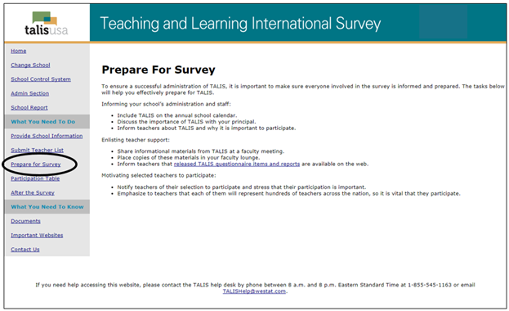

* 1. **Checking the materials on arrival**

After the teacher list is submitted and the TALIS Home Office selects a sample of teachers, you will receive a FedEx package containing:

* Principal Questionnaire Invitation – provides the principal/designee with the information needed to access the online Principal Questionnaire.
* Teacher Questionnaire Invitations (in general 20) – provide the selected teachers with the information needed to access the online Teacher Questionnaires.
* Red storage envelope
* FedEx return envelope

In addition, the *Teacher Tracking Form* and electronic versions of the principal and teacher invitations will be posted electronically to MyTALIS.us in a zip file.

When the materials are available, you will be notified via email *with instructions and a password for the zip file*. *To download, go to the “Documents” link. See Exhibit 2.2 below to showing where to find the link on MyTALIS.us.*

You should download and print a copy of the tracking form and keep it securely stored in the storage envelope when not in use. The electronic versions of the invitations are provided for you as a backup should the hard copy invitations get misplaced or damaged. They are provided for your convenience should you need them.

Your TALIS representative will contact you prior to the start of data collection to ensure that you have all the materials and to answer any questions.

**Exhibit 2.2. Documents page on MyTALIS.us**

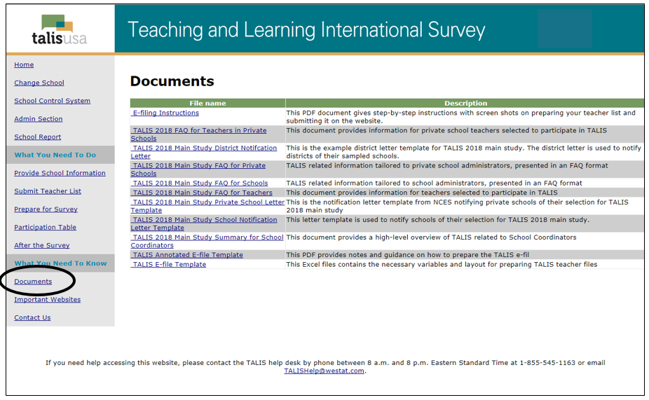

Distribute the principal and teacher questionnaire invitations to the principal/designee and the teachers listed on the *Teacher Tracking Form*.

Please notify the TALIS Help Desk if you have difficulty accessing or receiving this information. Examples of the principal and teacher questionnaire invitations are shown in exhibit 2.3 and 2.4 below.

Important! Under no circumstances may a sampled teacher be replaced with any other teacher who was not selected to participate in TALIS.

**Exhibit 2.3. Principal Questionnaire Invitation**

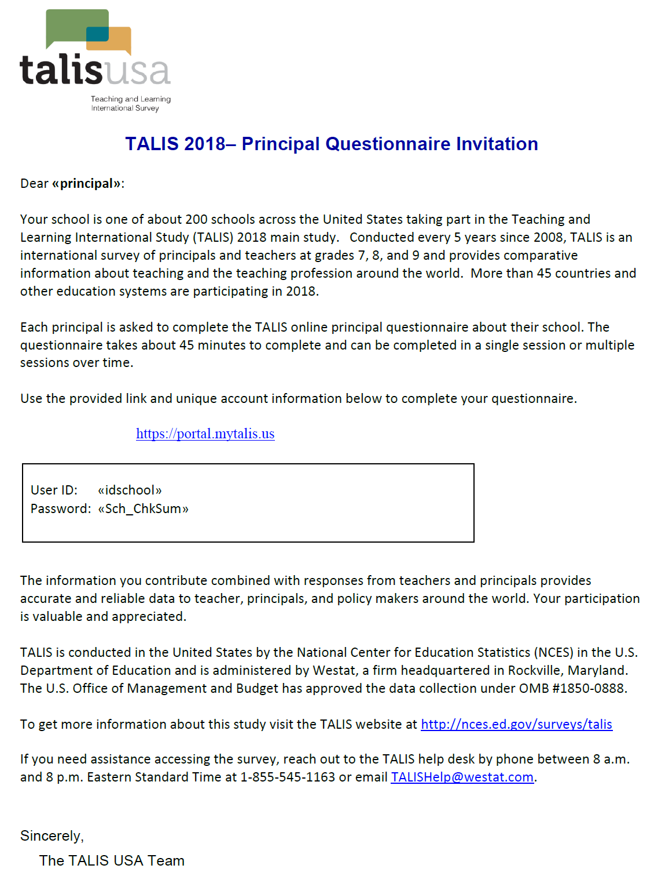

**Exhibit 2.4. Teacher Questionnaire Invitation**

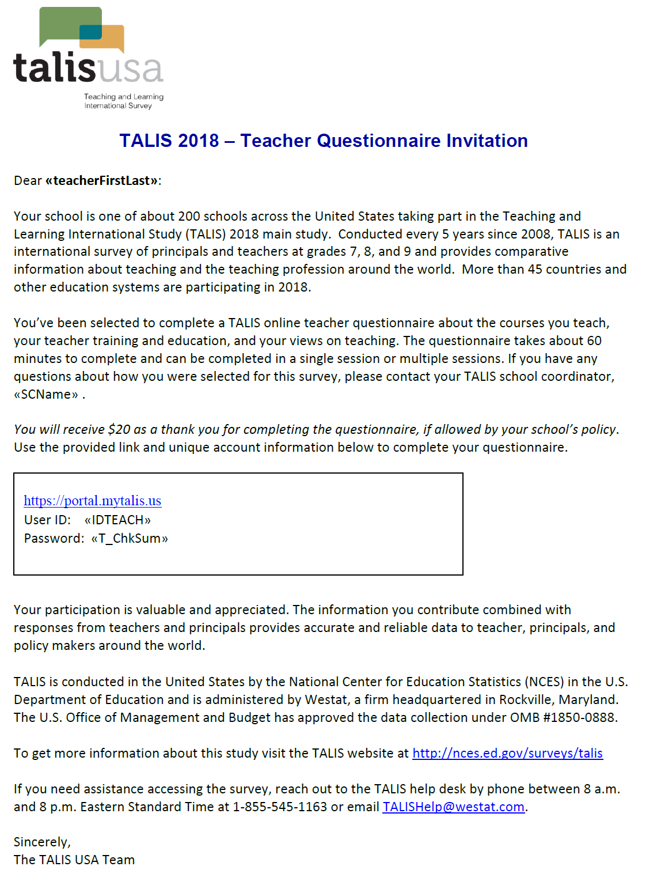

1. **administering the questionnaires**
   1. **Overview**

Monitoring participation and completion of the TALIS questionnaires is one of the main tasks for you as school coordinator. This requires close cooperation between you and your TALIS representative.

**TALIS WEEK!**

Schools and teachers participating in TALIS in the United States are encouraged to complete their questionnaires during the week of **March 5 - March 8!**

The field period for TALIS is March 5- April 27, 2018

It is important that you adhere to the timeline so that your school’s data can be used for international analysis.

* 1. **Accessing the online principal and teacher questionnaires**

Our ultimate goal is to achieve a participation rate of 100 percent. This will ensure that the information from the United States is comparable at the international level. **It is not permitted to use printouts of the online questionnaires under any circumstances!**

The web pages for the online questionnaires have been designed to work with minimum browser requirements. The online questionnaires do **not** require JavaScript to work and ‘cookies’ will not be used.

Please advise teachers and the principal that school and respondent identities are never included in any reports. All of the provided information may be used only for statistical purposes and may not be disclosed, or used, in identifiable form for any other purpose except as required by law (20 U.S.C. §9573 and 6 U.S.C. §151). Responses are saved as people go from question to question. They may leave the questionnaire at any time and log in again later (for example, on the next day).

On average, the Principal Questionnaire will take about 45 minutes to complete. The Teacher Questionnaire should take approximately 60 minutes to complete, on average.

* 1. **Monitoring participation and questionnaire completion**

You will need to monitor and code the participation of teachers during the survey. To do this you will use the “Participation Table” on MyTALIS.us. The Participation Table provides questionnaire status by teacher ID as listed on the Teacher Tracking Form. It also provides information on incentive status.

All teachers will begin with a status of “Not Started.” As teachers complete the questionnaires online change in completion status will be reflected in the table as either “Started” or “Finished.” You should check the Participation Table daily during the data collection period and update participation. Throughout the survey period, periodic email reminders will be sent from the TALIS Home Office to the teachers whose questionnaires are not finished. You should also follow-up with these teachers and encourage them to complete their questionnaire.

You will need to enter the participation status of each teacher on the Participation Table and on your copy of the *Teacher Tracking Form*. Record the following codes in TTF Participation Code column:

* Use **“1”** for “Returned - paper”
* Use **“2”** for “Returned - online”
* Use **“3”** for “Not Returned”
* Use **“4”** for “left school permanently”, i.e. if the teacher left the school after being listed but before the administration of the survey started.
* Use **“5”** for “Exclusion” if a teacher has been listed but does not teach students in grades 7, 8, or 9; if the teacher is also the principal; or he/she is in a position that was not to be according to E-file instructions.
* Use **“6”** for “Refused” if the teacher refuses to participate in TALIS.

In the Participation Table, set the participation codes by selecting the relevant code from a drop down list. Exhibit 3.1 shows an example of the Participation Table list. You should also record these codes in the column 5 of the *Teacher Tracking Form*. See Appendix A for an example of the tracking form.

**Exhibit 3.1. Participation Table on MyTALIS.us**

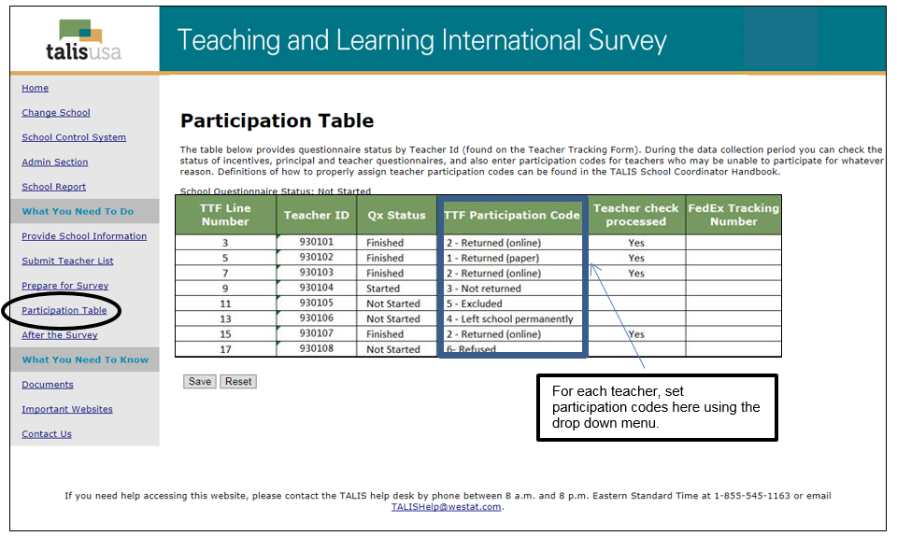

The TALIS Home Office will send email reminders to teachers with statuses of “Not Started” or “Started” and participation code of “**3**”. Please also prompt teachers that have not completed the survey to do so before April 27.

On **April 16**, two weeks before the end of the survey, you will receive a FedEx package with paper versions of the questionnaire for those teachers that have yet to complete the questionnaire. Each questionnaire will have a label with the Teacher ID and an accompanying postage paid return envelope. Please distribute the paper questionnaires to the correct teachers and ask that they complete the questionnaire – either with the paper copy or online – before **April 27**. If teachers are electing to use paper, you will need to confirm that they have returned the questionnaire to the TALIS Home Office and set their participation code to 1 – Returned (paper).

* 1. **Completing the Teacher Tracking Form**

Check the *Teacher Tracking Form* and ensure that all teachers have a participation code and that these are complete and accurate. The participation code for each teacher on the tracking form should match the code that was set in the Participation Table. Ensure that any corrections to the main subject domain in column 3 are clearly indicated.

* 1. **Returning materials to the TALIS Home Office**

***Return the Teacher Tracking Form***

Once the *Teacher Tracking Form* is complete, make a copy of the form. Store the original version in the red storage envelope that came with your materials.

Using the copy of the *Teacher Tracking Form*, separate the form along the dashed line between two teacher ID fields (the column 2’s). Place the portion with the teacher name and teacher ID (columns 1 and 2) in the storage envelope along with the original form.

Store this envelope securely until June 2019, at which time these materials should be destroyed.

Send the copy of the completed *Teacher Tracking Form* without teacher names to the TALIS Home Office using the FedEx return envelope provided with your materials.

***Return paper questionnaires***

As mentioned, you should update the teacher participation online in the Participation Table on MyTALIS.us. If the principal or any teachers completed the questionnaire on paper they should return the questionnaire to the TALIS Home Office using the return envelope they received with the paper version. However, if any completed paper questionnaires were given to you, please return them to the TALIS Home Office.

1. **Quality control during the mAIN STUDY**

Quality control takes place at numerous stages in the course of questionnaire preparation and also during data processing. This is one of the reasons why it is important that you adhere to all of the above described procedures at all times.

Your TALIS representative will conduct a final call with you at the end of the administration period to complete a School Coordinator debriefing that will gather information about your experience in administering the survey in your school. The debriefing interview will be done over the phone. In addition, International Quality Monitors hired by the International Project Team will contact a small number of schools across the country and hold a short, in-person visit with the schools to understand how the survey went in the school. The TALIS Home Office will work with you to schedule a convenient time to hold this visit, should it be necessary. The Home Office will work to ensure that the implementation of the survey in schools has been undertaken according to the TALIS Technical Standards, such as checking that the anonymity and confidentiality of respondents has been respected and that the *Teacher Listing Form* and the *Teacher Tracking Form* have been filled in correctly and stored securely.

**Your help with TALIS is very important to its success in ensuring that data collected in the United States is of the highest quality.**

**The U.S. TALIS and International Project Team appreciate your time and effort.**

**Thank you!**

**APPENDIX A: Example of a teacher tracking form**

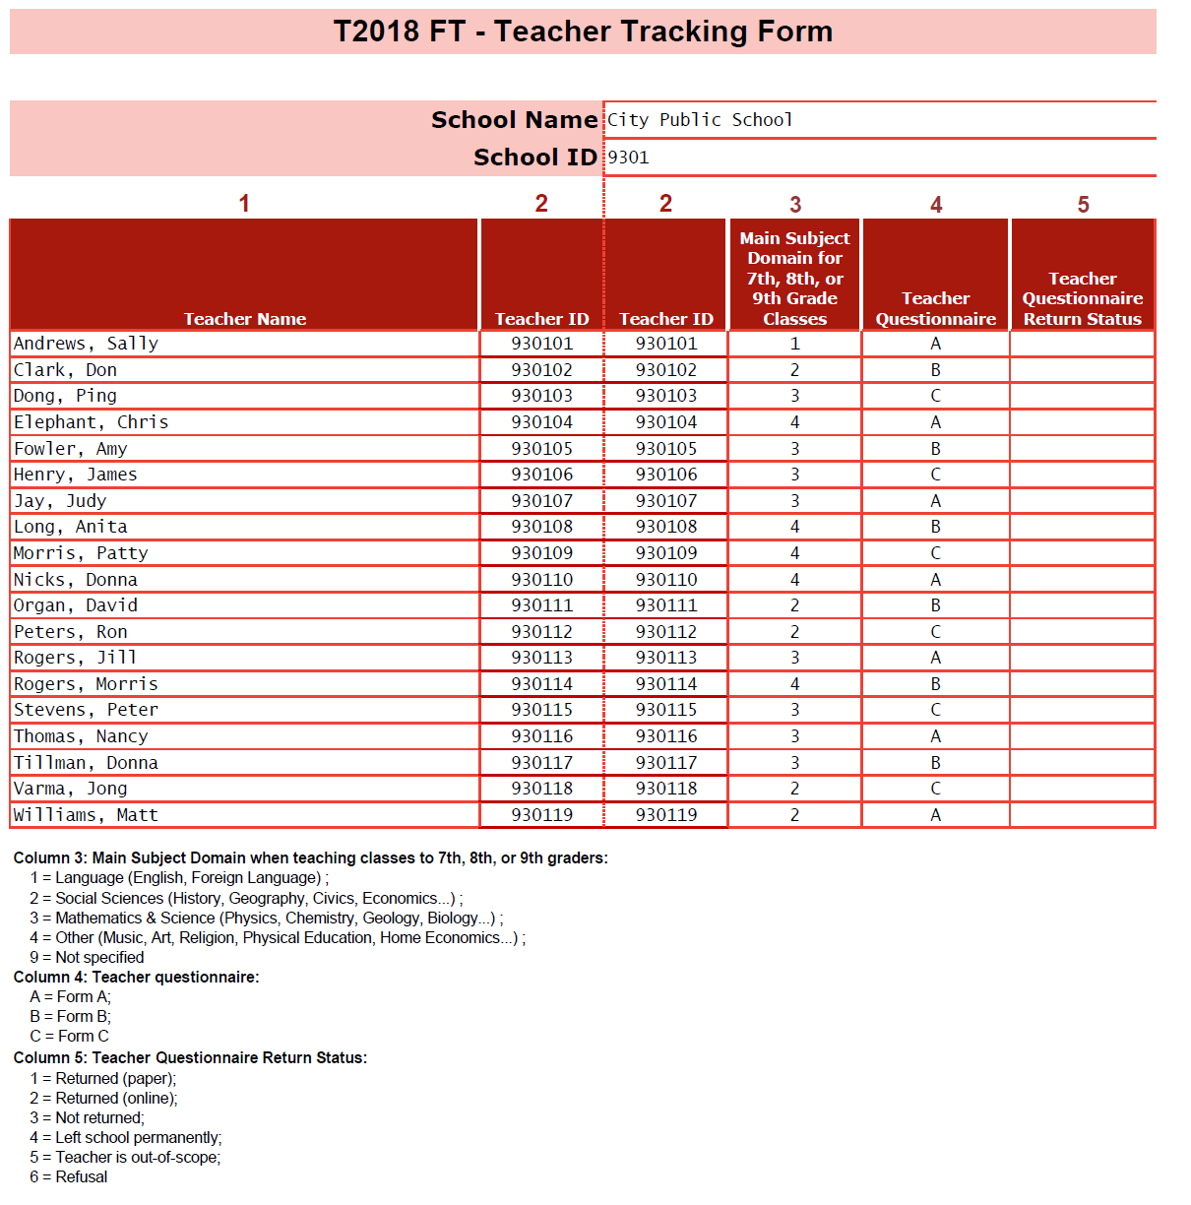

**APPENDIX B: Explanation of Teaching Domains**

**1 = Language** includes:

* Reading and writing (and literature) in the mother tongue, reading and writing (and literature) in the language of instruction, reading and writing in the tongue of the country (region) as a second language (for non-natives), language studies, public speaking, literature
* Modern and Foreign languages
* Ancient Greek and/or Latin

**2 = Social Sciences** includes:

* Social studies, community studies, contemporary studies, economics, environmental studies, geography, history, humanities, legal studies, studies of the own country, social sciences, ethical thinking, philosophy

**3 = Mathematics & Science** includes:

* Mathematics, mathematics with statistics, geometry, algebra etc.
* Physics, physical science, chemistry, biology, human biology, environmental science, agriculture/horticulture/forestry, astronomy

**4 = Other** includes:

* Orientation in technology, including information technology, computer studies, construction/surveying, electronics, graphics and design, keyboard skills, word processing, workshop technology / design technology
* Arts, music, visual arts, practical art, drama, performance music, photography, drawing, creative handicraft, creative needlework
* Physical education, gymnastics, dance, health
* Religion, history of religions, religion culture, ethics

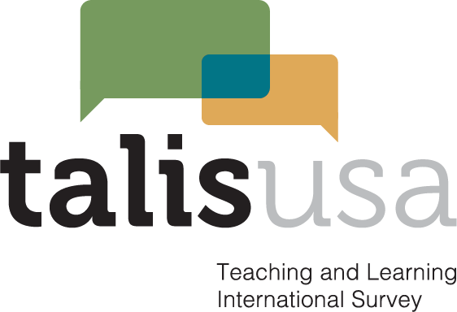

**MyTALIS project website for School Coordinators and schools**

The following screens shots show the web content of MyTALIS.us for schools and school coordinators. MyTALIS.us is described in Part B of the main study package.

**MyTALIS.us – Home**

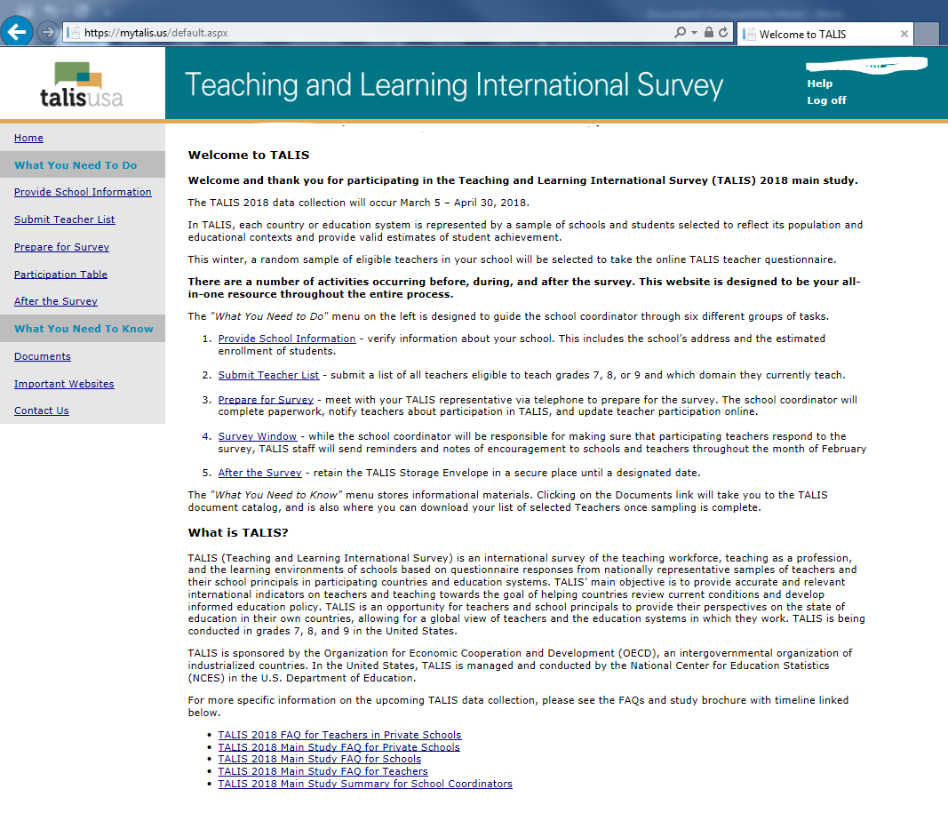

This screen is the Welcome page for the MyTALIS.us site. It provides overview information about the survey and navigation to specific areas of the site.

The following text will replace the final sentence of the final full paragraph:

In the United States, TALIS is conducted by the National Center for Education Statistics (NCES) in the U.S. Department of Education and administered by Westat, a firm located in Rockville, MD.

**MyTALIS.us – Provide School Information**

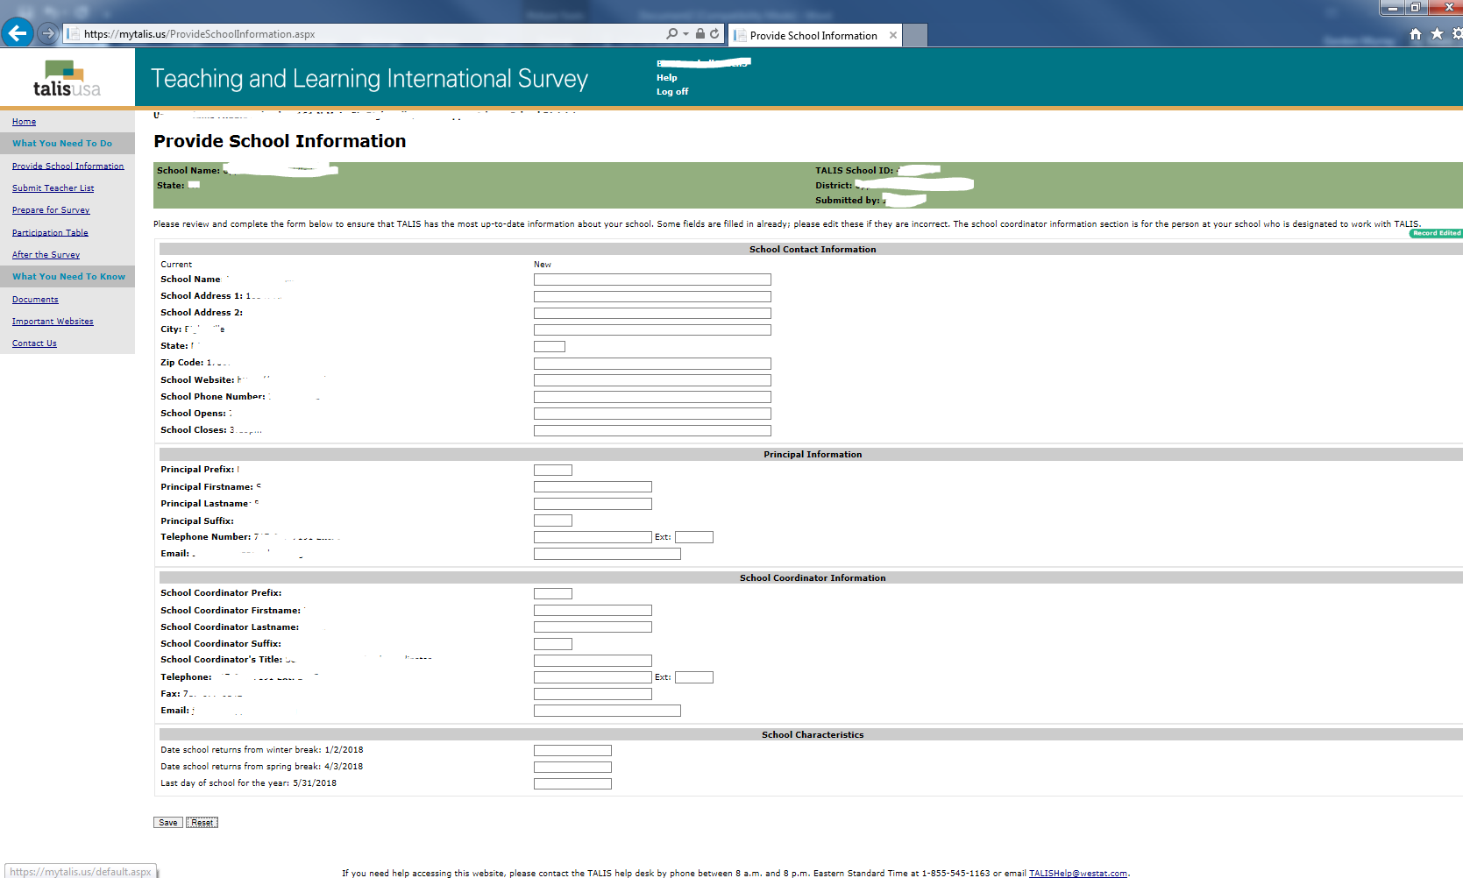

This screen provides information about the school. This information is already populated first from the sampling information and then updated by the NAEP State Coordinators or TALIS Recruiters.

**MyTALIS.us – Submit Teacher List**

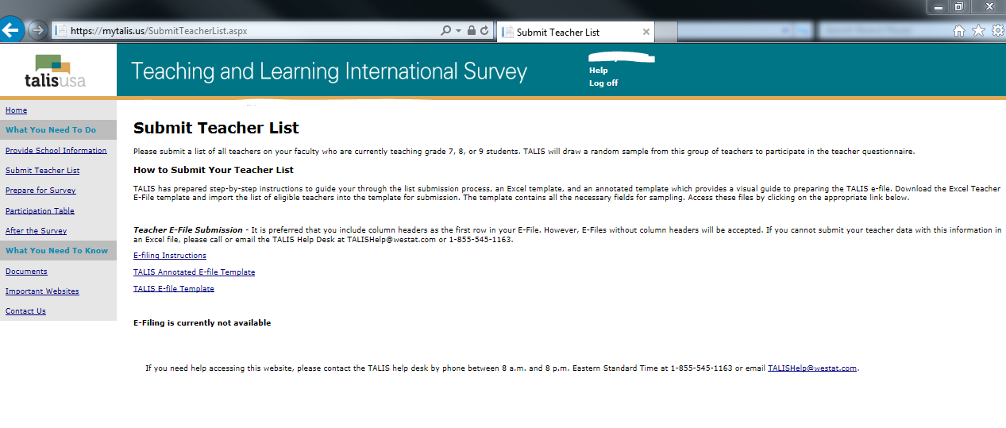

This screen provides the E-file instructions and template and is where the school coordinator will securely upload the completed teacher list.

The following statement will be added to the screen above to state the estimated time to complete and submit the teacher list.

*According to the Paperwork Reduction Act of 1995, no persons are required to respond to a collection of information unless such collection displays a valid OMB control number. The valid OMB control number for this voluntary information collection is 1850-0888. The time required to complete this information collection is estimated to average 45 minutes per school coordinator, including the time to review instructions, gather the data needed, and complete and review the information collection. If you have any comments or concerns regarding the accuracy of the time estimate(s), suggestions for improving the form, or questions about the status of your individual submission of this form, write directly to: Teaching and Learning International Survey (TALIS), National Center for Education Statistics (NCES), Potomac Center Plaza, 550 12th Street, SW, 4th floor, Washington, DC 20202.*

**MyTALIS.us – Prepare for Survey**

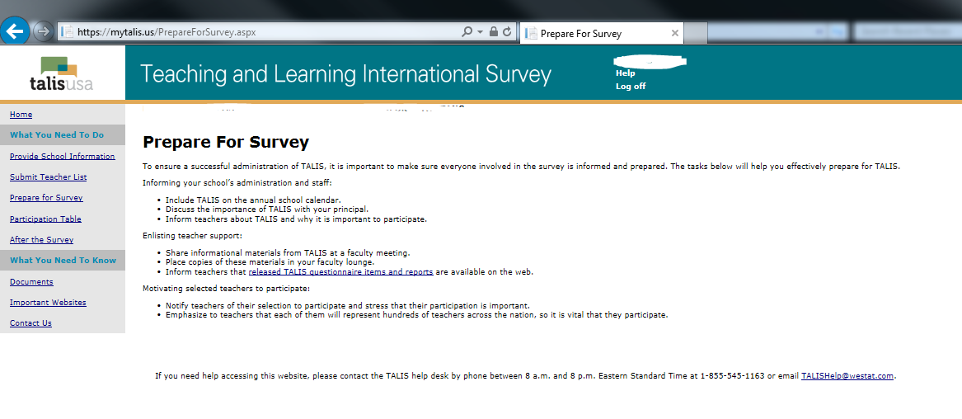

This screen provides information and suggestions for preparing for the survey including discussing the survey with school staff, providing materials, and notifying teachers of their selection to participate.

The following statement will be added to the screen above to state the estimated time for Survey preparation and communication activities including receiving and distributing hard copy invitations and paper questionnaires, as well as contact with the TALIS home office.

*According to the Paperwork Reduction Act of 1995, no persons are required to respond to a collection of information unless such collection displays a valid OMB control number. The valid OMB control number for this voluntary information collection is 1850-0888. The time required to complete this activity is estimated to average 100 minutes per school coordinator, including the time to review instructions, gather any data needed, and complete and review this activity. If you have any comments or concerns regarding the accuracy of the time estimate(s), suggestions for improving the form, or questions about the status of your individual submission of this form, write directly to: Teaching and Learning International Survey (TALIS), National Center for Education Statistics (NCES), Potomac Center Plaza, 550 12th Street, SW, 4th floor, Washington, DC 20202.*

**MyTALIS.us – Participation table**

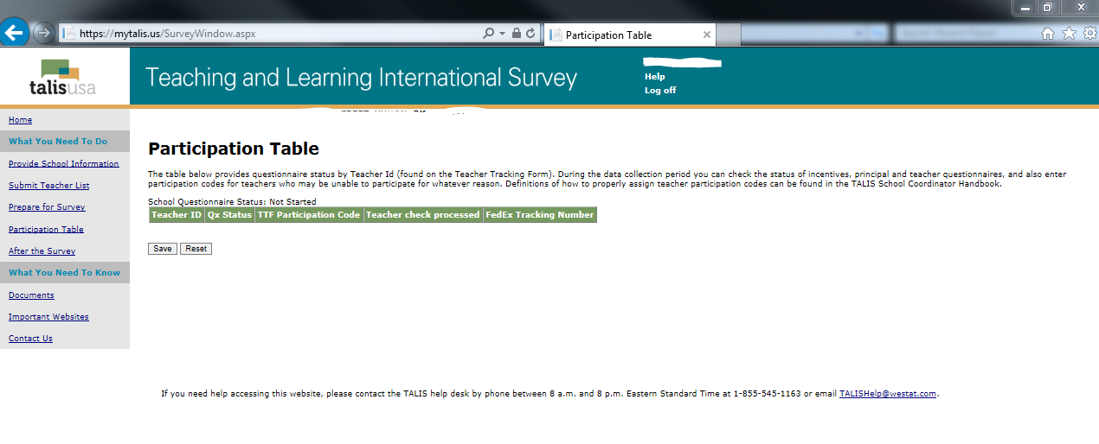

This screen provides the Participation table showing the status of each questionnaire by teacher id. The school coordinator updates the participation codes for the teachers throughout the survey administration period.

The following statement will be added to the screen above to state the estimated time for tracking participation.

*According to the Paperwork Reduction Act of 1995, no persons are required to respond to a collection of information unless such collection displays a valid OMB control number. The valid OMB control number for this voluntary information collection is 1850-0888. The time required to complete this information collection is estimated to average 45 minutes per school coordinator, including the time to review instructions, gather the data needed, and complete and review the information collection. If you have any comments or concerns regarding the accuracy of the time estimate(s), suggestions for improving the form, or questions about the status of your individual submission of this form, write directly to: Teaching and Learning International Survey (TALIS), National Center for Education Statistics (NCES), Potomac Center Plaza, 550 12th Street, SW, 4th floor, Washington, DC 20202.*

**MyTALIS.us – After the Survey**

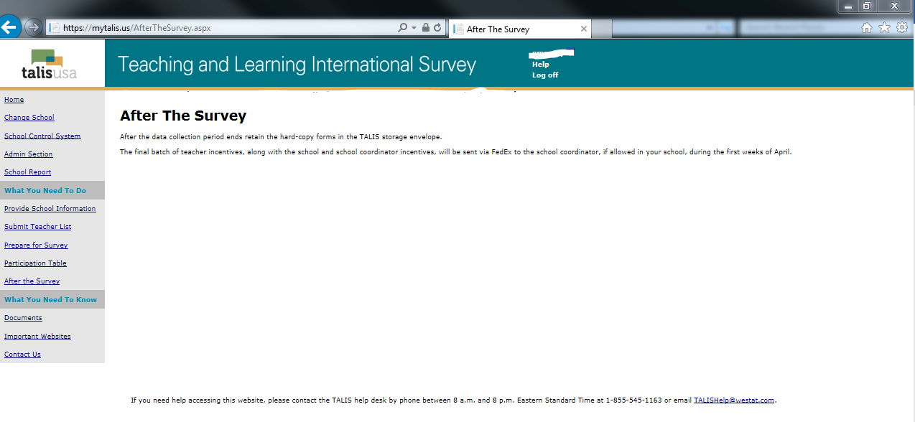

This screen provides information about storing teacher tracking forms and distributing incentives.

The following statement will be added to the screen above to state the estimated time for tracking participation.

*According to the Paperwork Reduction Act of 1995, no persons are required to respond to a collection of information unless such collection displays a valid OMB control number. The valid OMB control number for this voluntary information collection is 1850-0888. The time required to complete this activity is estimated to average 50 minutes per school coordinator, including the time to review instructions, gather any data needed, and complete and review this activity. If you have any comments or concerns regarding the accuracy of the time estimate(s), suggestions for improving the form, or questions about the status of your individual submission of this form, write directly to: Teaching and Learning International Survey (TALIS), National Center for Education Statistics (NCES), Potomac Center Plaza, 550 12th Street, SW, 4th floor, Washington, DC 20202.*

**MyTALIS.us – Documents**

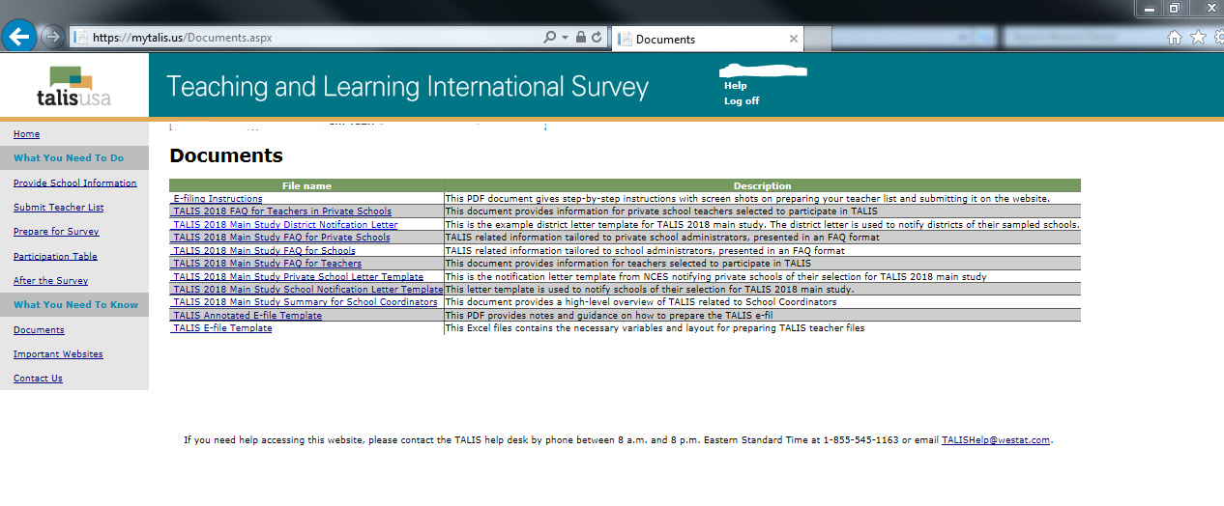

**MyTALIS.us – Important Websites**

`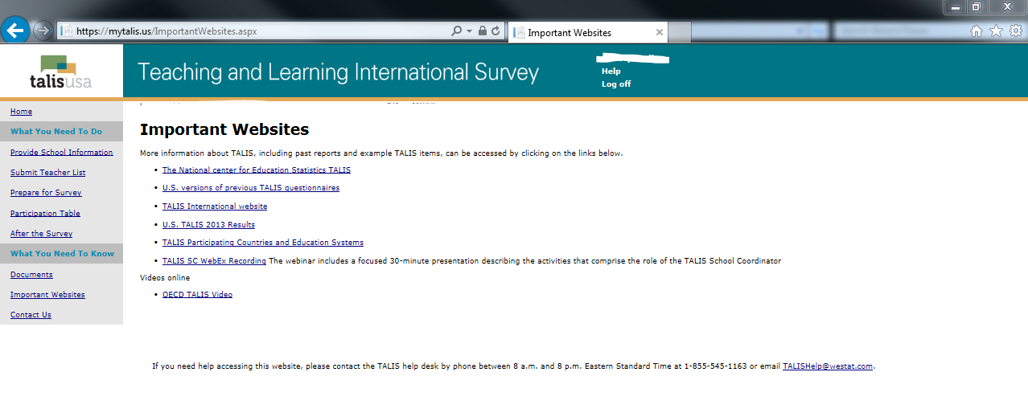

**MyTALIS.us – Contact Us**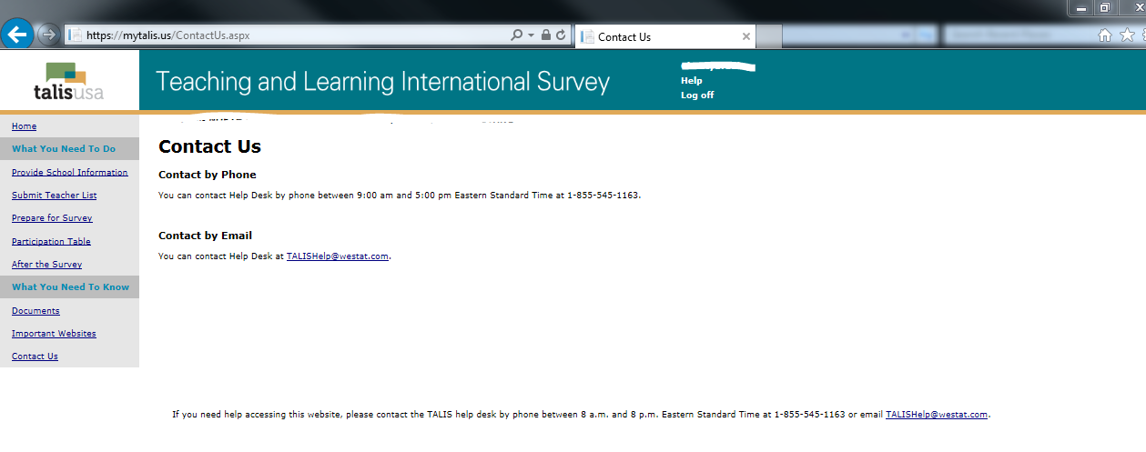

**TALIS School Coordinator WebEx presentation**

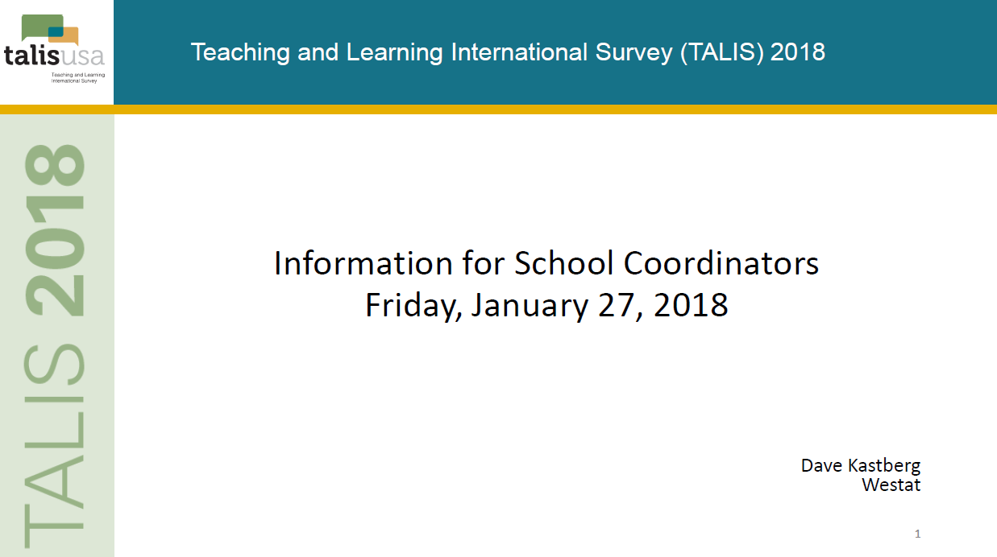

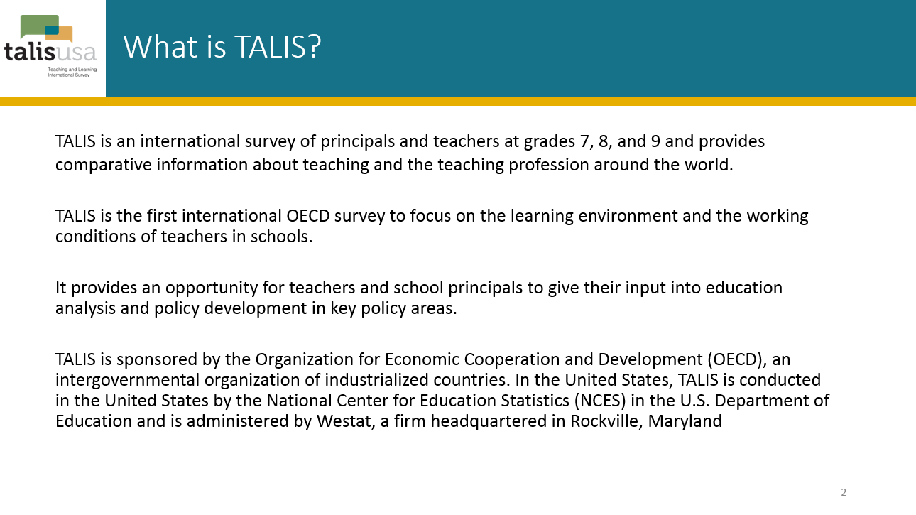

The last sentence in the slide above will read:

In the United States, TALIS is conducted by the National Center for Education Statistics (NCES) in the U.S. Department of Education and is administered by Westat, a firm headquartered in Rockville, Maryland.

