Request for Approval under the “Generic Clearance for the Collection of Routine Customer Feedback” (OMB Control Number: 2010-0042)
TITLE OF INFORMATION COLLECTION:
Evaluating Diesel Emissions Reduction Act (DERA) Program Customer Satisfaction in EPA Regions 9 and 10.

PURPOSE:
Requesting information from EPA Region 9 and 10 grantees, sub-grantees, and prospective applicants regarding customer satisfaction with DERA funding assistance programs.

DESCRIPTION OF RESPONDENTS:
EPA with the assistance of a contractor has developed a short survey requesting feedback from relevant grantees, sub-grantees, and prospective applicants regarding their satisfaction with DERA funding assistance programs (e.g., state, local and tribal governments, eligible non-profit organizations, and medium and heavy-duty fleet operators).

TYPE OF COLLECTION: (Check one)

[ ] Customer Comment Card/Complaint Form [X] Customer Satisfaction Survey
[ ] Usability Testing (e.g., Website or Software [ ] Small Discussion Group
[ ] Focus Group [ ] Other: ______________________

CERTIFICATION:

I certify the following to be true:
- The collection is voluntary.
- The collection is low-burden for respondents and low-cost for the Federal Government.
- The collection is non-controversial and does not raise issues of concern to other federal agencies.
- The results are not intended to be disseminated to the public.
- Information gathered will not be used for the purpose of substantially informing influential policy decisions.
- The collection is targeted to the solicitation of opinions from respondents who have experience with the program or may have experience with the program in the future.

Name: John Mikulin, Environmental Protection Specialist, EPA R9

To assist review, please provide answers to the following question:

Personally Identifiable Information:
- Is personally identifiable information (PII) collected? [ ] Yes [X] No
- If Yes, will any information that is collected be included in records that are subject to the Privacy Act of 1974? [ ] Yes [ ] No
- If Yes, has an up-to-date System of Records Notice (SORN) been published? [ ] Yes [ ] No

Gifts or Payments:
Is an incentive (e.g., money or reimbursement of expenses, token of appreciation) provided to participants? [ ] Yes [X] No

BURDEN HOURS

Category of Respondent | No. of Respondents | Participation Time | Burden
EPA R9 and 10 DERA awardees | 45 | 10 | 450
Prospective DERA applicants | 45 | 10 | 450
Totals |  |  | 900

FEDERAL COST: The estimated total cost to the Federal government is $40,000. This is based on the EPA FY20 DERA management and oversight contract assignment issued to ERG for survey composition, data gathering, and data synthesis.

If you are conducting a focus group, survey, or plan to employ statistical methods, please provide answers to the following questions:

The selection of your targeted respondents
- Do you have a customer list or something similar that defines the universe of potential respondents and do you have a sampling plan for selecting from this universe? [X] Yes [ ] No

If the answer is yes, please provide a description of both below (or attach the sampling plan)? If the answer is no, please provide a description of how you plan to identify your potential group of respondents and how you will select them?

The targeted survey respondents include existing EPA R9 and R10 DERA grantees and West Coast Collaborative Communicator Newsletter recipients (~1000 email recipients, <10% response rate expected).

Administration of the Instrument
- How will you collect the information? (Check all that apply)
[X] Web-based or other forms of Social Media
[ ] Telephone
[ ] In-person
[ ] Mail
[ ] Other, Explain
- Will interviewers or facilitators be used? [ ] Yes [X] No

Please make sure that all instruments, instructions, and scripts are submitted with the request.

See subsequent pages for survey screenshots.

OMB Control Number: 2010-0042
Expiration Date: 3/31/21
Form Number: 5800-0012

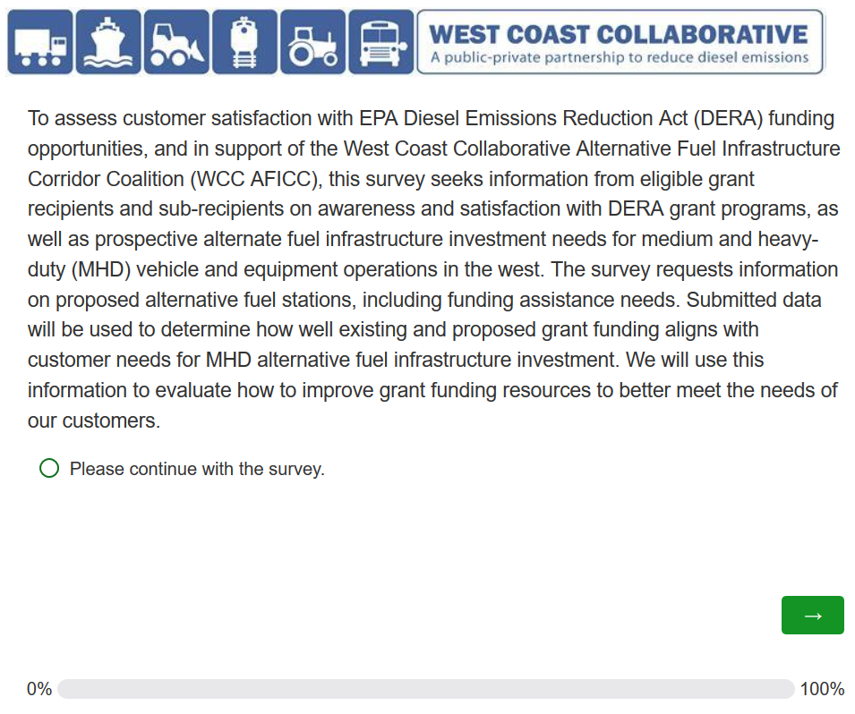
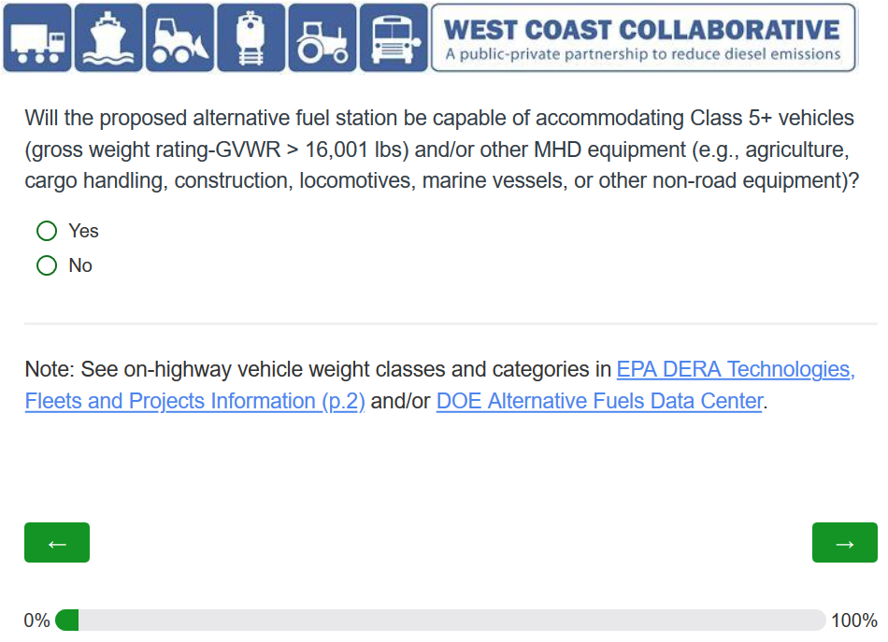
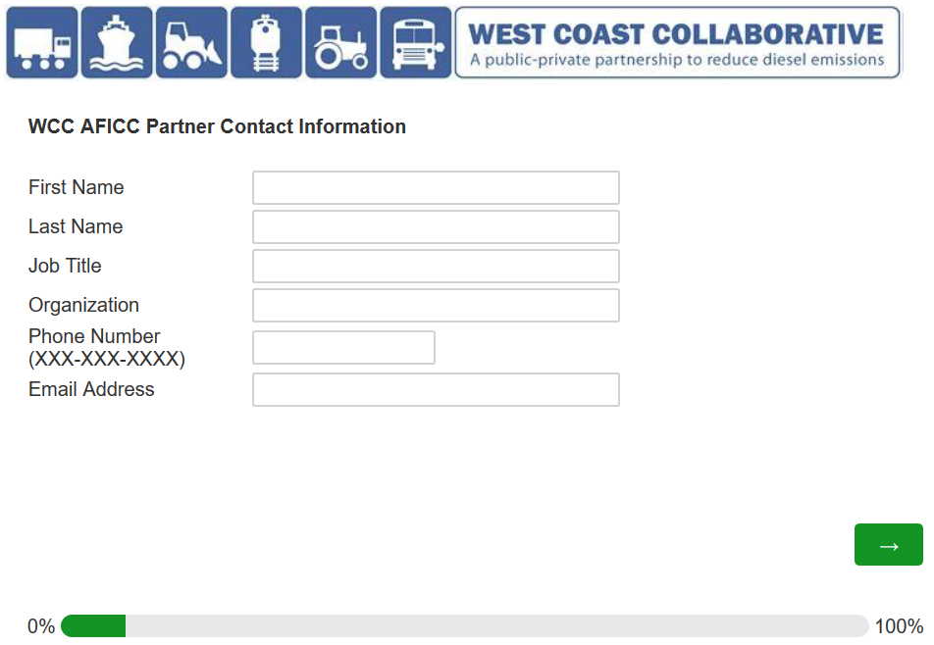

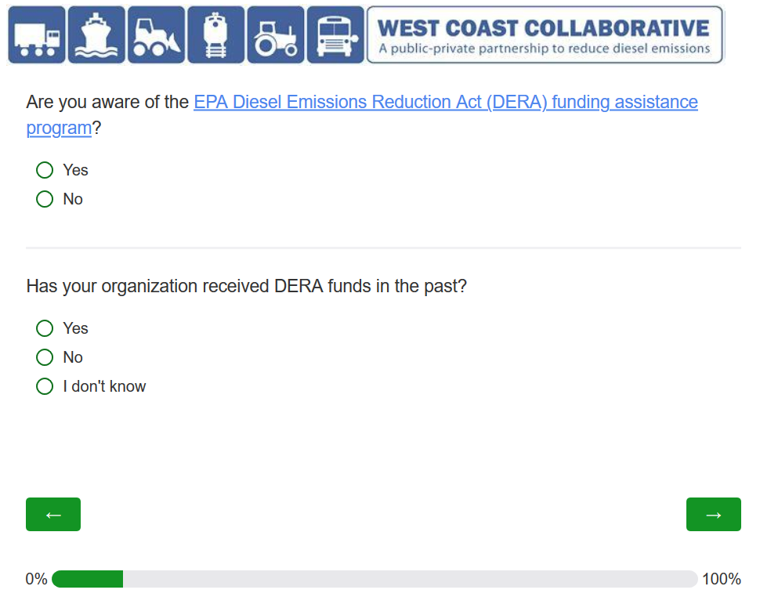
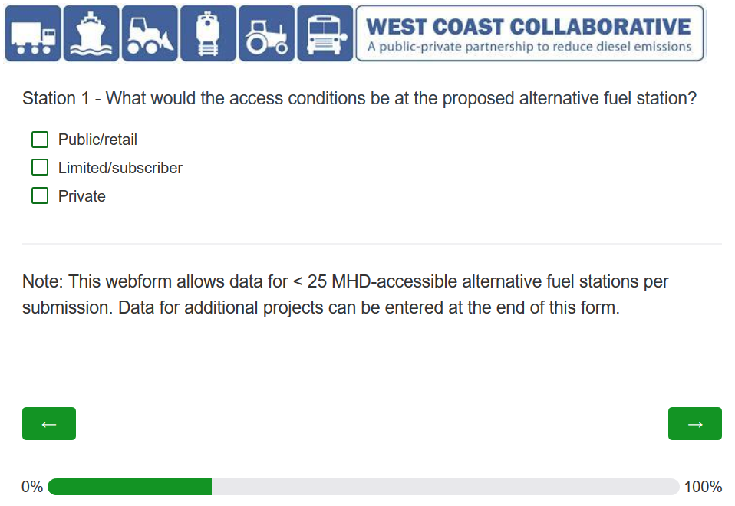
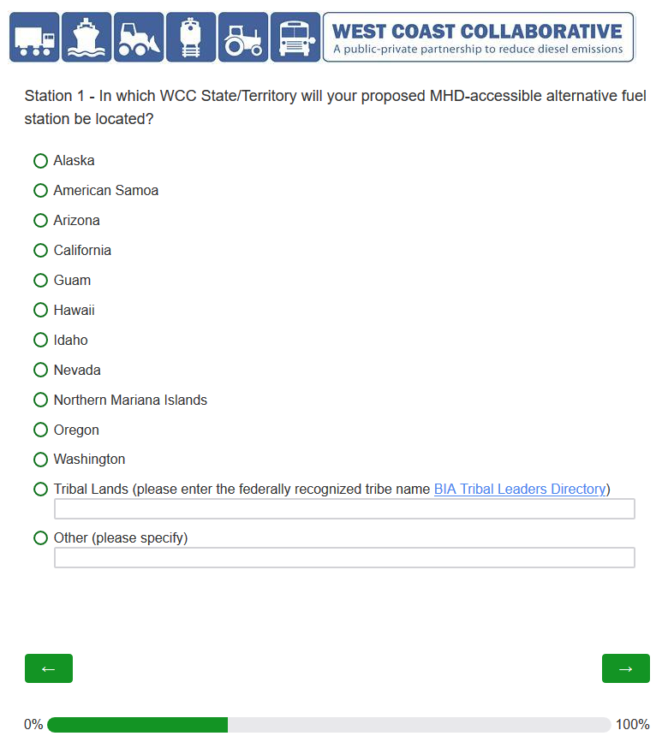

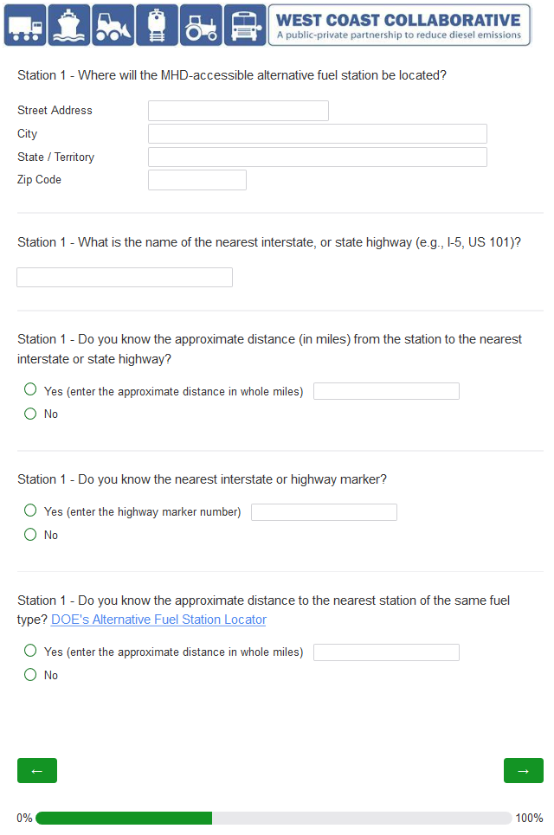
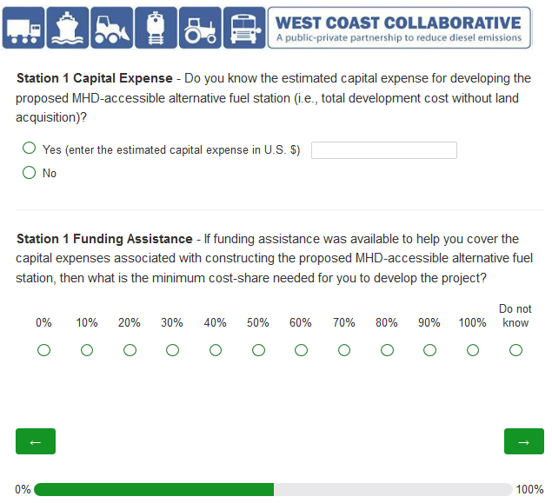

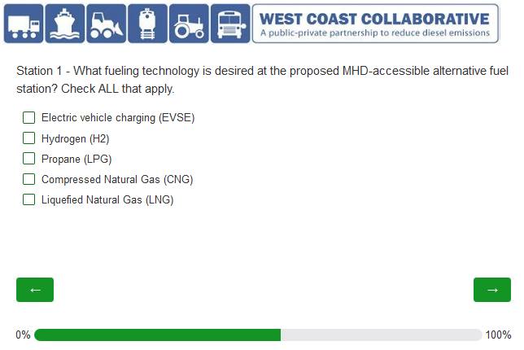
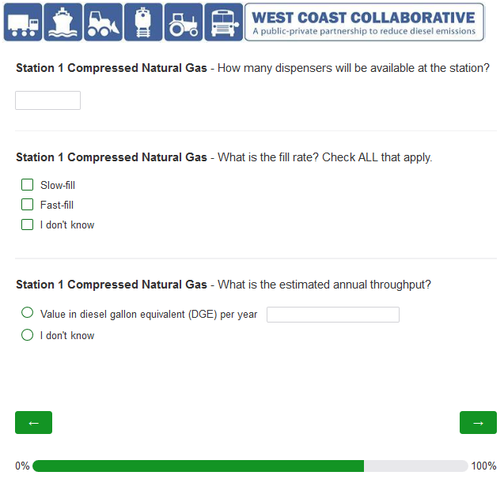
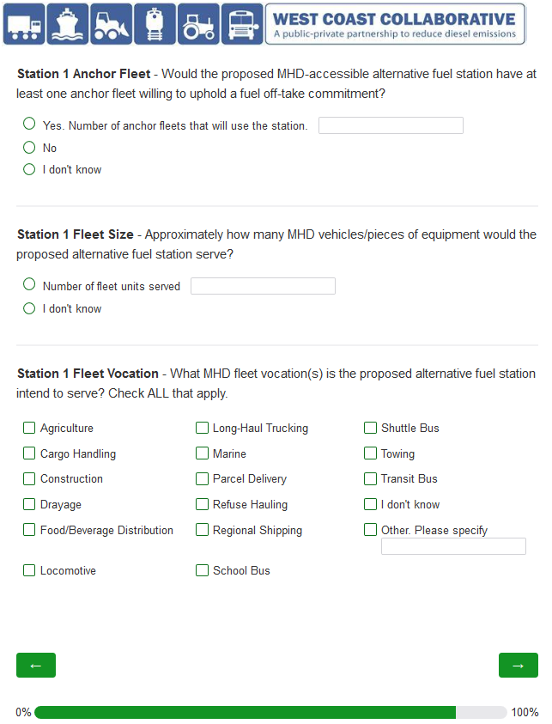
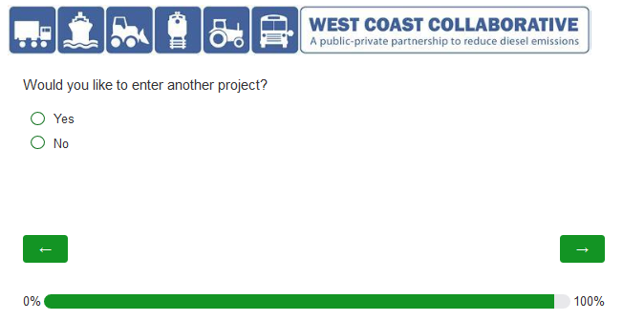
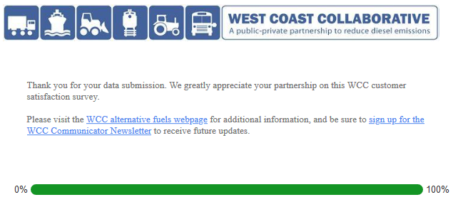
This collection of information is approved by OMB under the Paperwork Reduction Act, 44 U.S.C. 3501 et seq. (OMB Control No. 2010-0042). Responses to this collection of information are voluntary. An agency may not conduct or sponsor, and a person is not required to respond to, a collection of information unless it displays a currently valid OMB control number. The public reporting and recordkeeping burden for this collection of information is estimated to 10 minutes per response. Send comments on the Agency’s need this formation, the accuracy of the provided burden estimates and any suggested methods for minimizing respondent burden including through the use of automated collection techniques to the Director, Regulatory Support Division, U.S. Environmental Protection Agency (2821T), 1200 Pennsylvania Ave., NW, Washington, D.C. 20460. Include the OMB control number in any correspondence. Do not send the completed form to this address.

