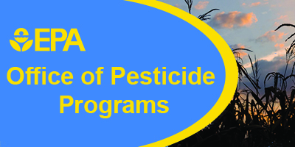

Evaluation: EPA Region 5 Advanced Worker Protection Standard Inspector Training

1. Affiliation:

State

2. Which webinar did you monitor? (select appropriate drop down)
- Part I
- Part II

3. After viewing this webinar, I will use the information learned to conduct WPS inspections.
Yes
No (why?)
(please specify)

4. Which part of WPS inspection training was most helpful?

5. Which part of the WPS inspection training was least helpful?

6. Which regulatory elements of the WPS do you consider the most difficult to verify for compliance?

7. What regulatory elements of the WPS do you hear from agricultural employers that are the most difficult to comply with? Why?

8. In your opinion, what are the biggest obstacles in conducting WPS inspections?

9. Are there any tools, references, or documents that EPA could develop that would be helpful to you in conducting WPS inspections? [please describe]

10. How many other people are in the room with you for this webinar?
No others, just me
Myself plus one
Myself plus 2 others
Myself plus 3 or 4 others
Myself plus 5 or more others

11. What additional WPS training would you like EPA to offer?

12. What other additional pesticide inspector training would you like EPA to offer?

Submit

