2017 TRI Website Satisfaction Survey
The Environmental Protection Agency would like to give you the opportunity to help improve the Toxics Release Inventory (TRI) Program website and its tools and resources to better meet your needs.
Your responses to the following questions will help us continue to improve access to and understanding and use of TRI data.
- How often do you use the TRI website at www.epa.gov/tri ?
- More than once a week
- Once a week
- Once a month
- Several times per year
- Once a year
- I have never visited the TRI website

- Please rate the usefulness of the following features/webpages:
 | Have not used | Not Useful | Somewhat Useful | Neutral | Very Useful | Extremely Useful
General information about the program
Explore a TRI Facility
Definitions of Common TRI Terms
TRI Data in Action paper and webpage
TRI Pollution Prevention Search Tool
TRI Explorer
My Right-to-Know (myRTK) Tool
TRI for Communities
Spanish content
Risk information
What You Can Do
Reporting for Facilities “portal”
Guide-ME (tool containing reporting guidance and FAQs)
Threshold Screening Tool

Other: (Please specify) _________________________________________
- What other information/features would you like to see added to the TRI website? Please specify.

- What are your primary reasons for visiting the TRI website? Please select all that apply.
- Getting reporting guidance and other information needed to fill out and submit TRI reporting forms
- Getting information on toxic chemicals in local community or another geographic location
- Getting information about a particular facility’s compliance with environmental regulations
- Getting information on proposed or finalized TRI Program regulations
- Getting information about how companies are preventing pollution at facilities
- Getting information on a specific chemical or industry
- Learning how to use TRI data
- Other (please specify)

- How do you expect to use the information on the TRI website? Please select all that apply.
- To comply with TRI reporting requirements
- To identify pollution prevention practices that may be replicable
- For discussion with community leaders
- For use at community meetings
- For academic or other research
- For emergency planning
- To inform facility citing processes
- To support public policymaking
- To inform financial investment decisions
- Other (please specify)

- Please rate the following attributes of our website:
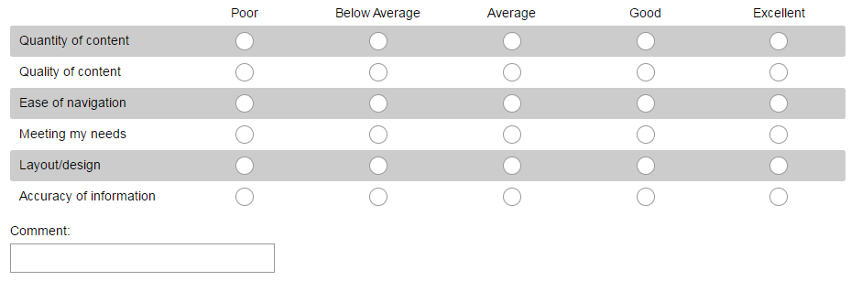

- Consider the online TRI Data and Tools webpage at https://www.epa.gov/toxics-release-inventory-tri-program/tri-data-and-tools that includes TRI Explorer, myRTK, the Risk Screening Environmental Indicators (RSEI), etc. If you have used any of these tools, did they meet your needs? What would you change about them? Please be specific as to the tool and a desired change, and include any other desired comments about your experience using the tool.

- Please rate the quality of support you received when contacting the support options listed on the TRI "Contact Us" webpage.

 | Have not used/only used to provide a comment | Very dissatisfied | Somewhat dissatisfied | Neutral | Somewhat satisfied | Very satisfied
TRI Information Center Hotline
Central Data Exchange (CDX) Helpdesk
TRI Data Processing Center
EPA Regional TRI Coordinators
State TRI Coordinators
TRI Tribal Contracts
TRI Webmaster
tri.help@epa.gov

Additional comments: ________________________________________________

- How did you find out about the Toxics Release Inventory? Select all that apply.
- Internet search engine
- News article
- Email bulletin sent by the TRI Program
- Workshop, presentation or other event
- EPA press release
- Other (please specify)
10) How satisfied are you with the TRI website?
- Very satisfied
- Somewhat satisfied
- Neutral
- Somewhat dissatisfied
- Very dissatisfied

11) Please identify your affiliation:
  - State government
  - Local government
  - Tribal government
  - Federal government, non-EPA
  - EPA employee
  - Community or non-profit organization
  - Individual community member
  - Consulting practice
  - Facility required to report to the TRI Program
  - Trade or professional association
  - News media
  - Student/teacher/professor
  - Prefer not to identify affiliation
Please specify institution/company, if desired: ________________________

12) Please include any other comments you have on the TRI website:

