APHIS/CDC Form 1 (Application for Registration for Possession, Use, and Transfer of Select Agents and Toxins)

For the previous system NSAR, the system captured Section 1A, Section 4, and Section 6A as shown below. The rest of the information was saved into the system as pdf for the submitted APHIS/CDC Form 1.

For Section 1,

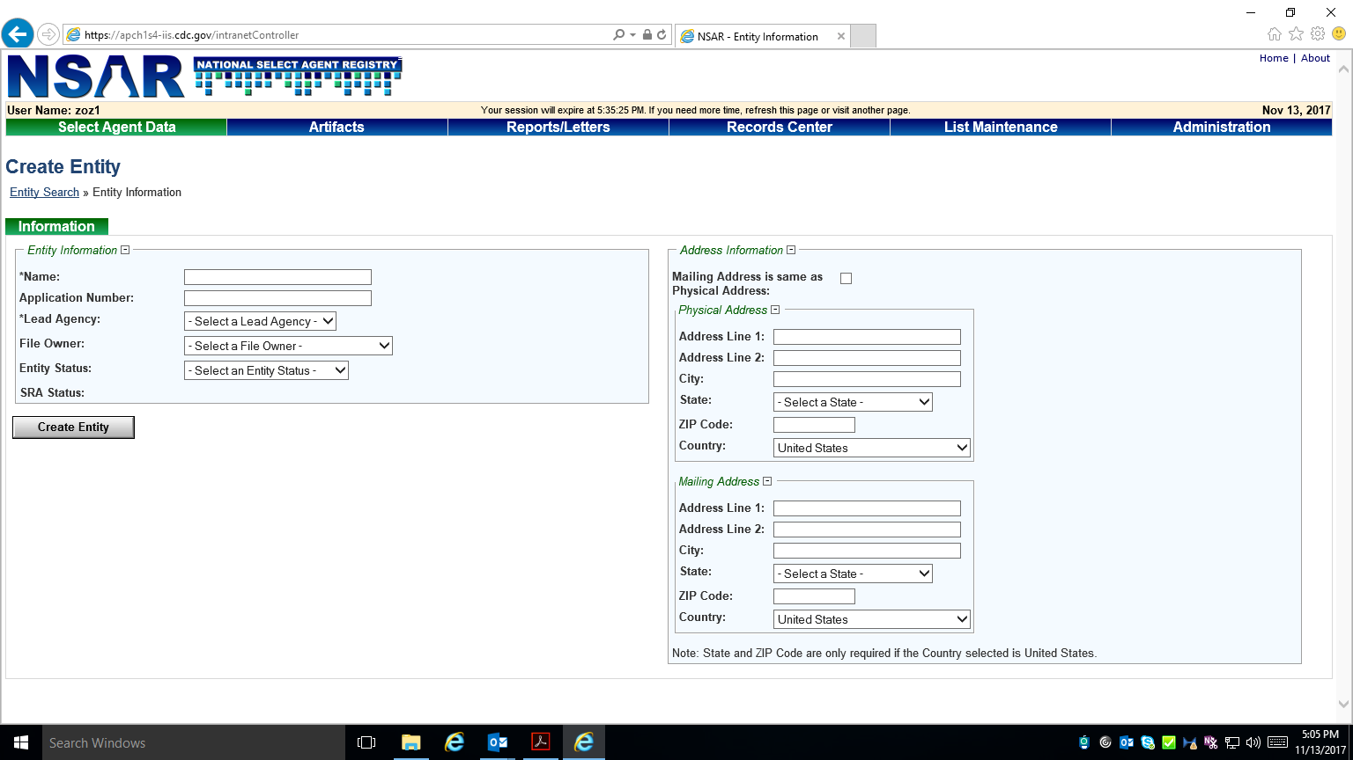

For Section 4,

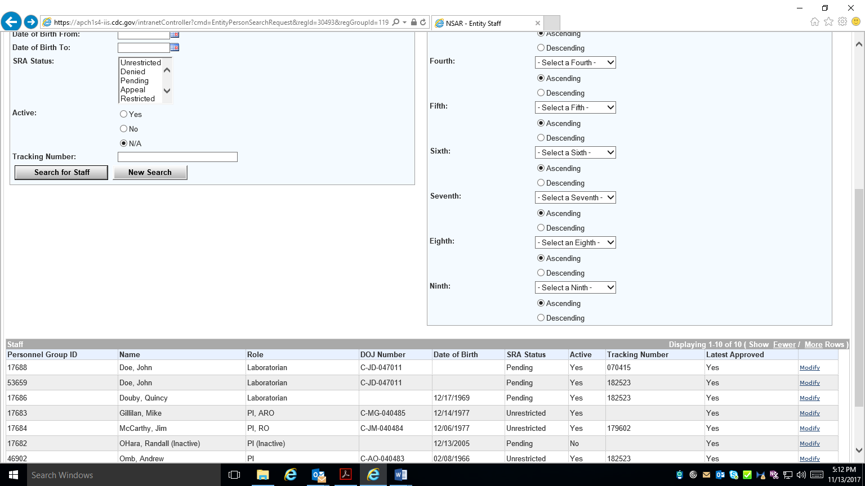

For Section 6A,
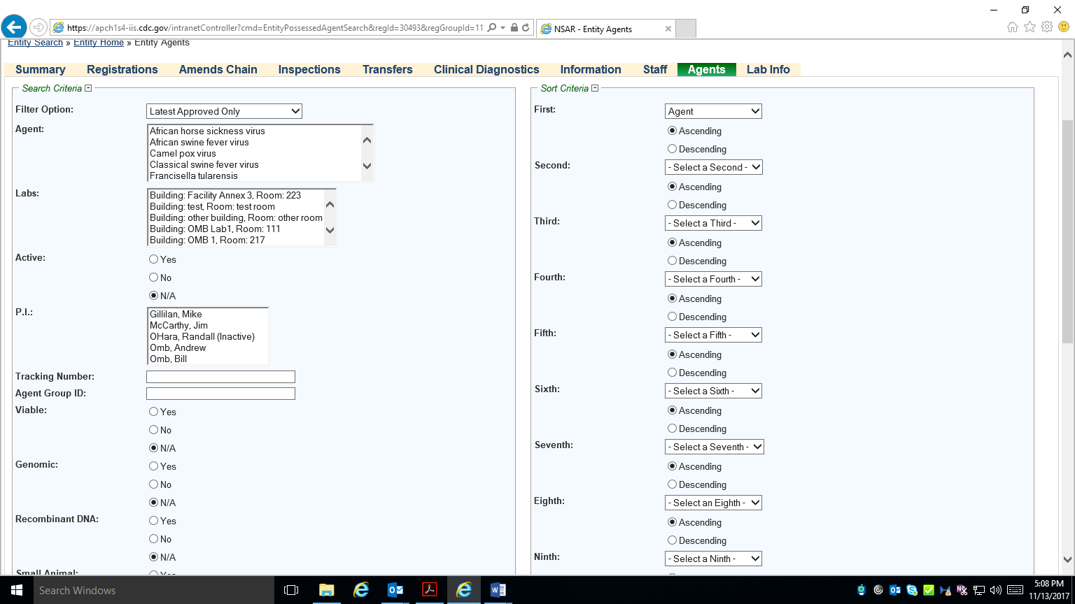

For eFSAP, the new system will capture all information from the APHIS/CDC Form 1 as noted below in the screenshots.

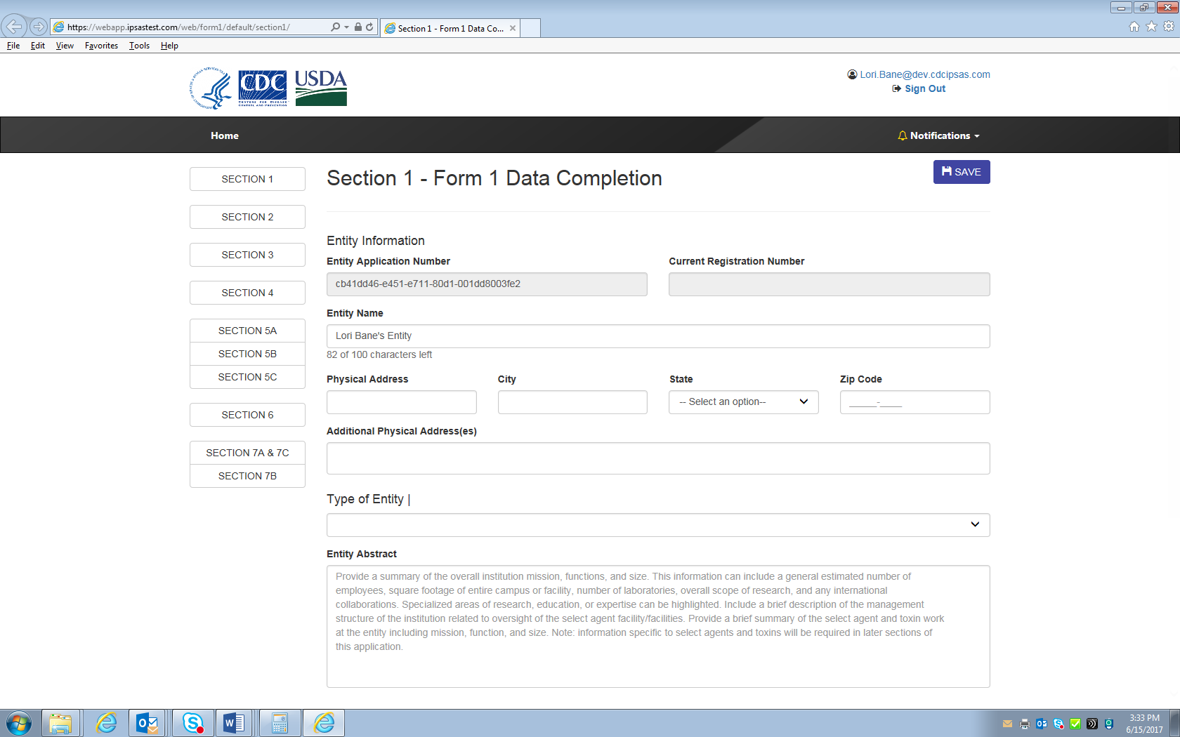
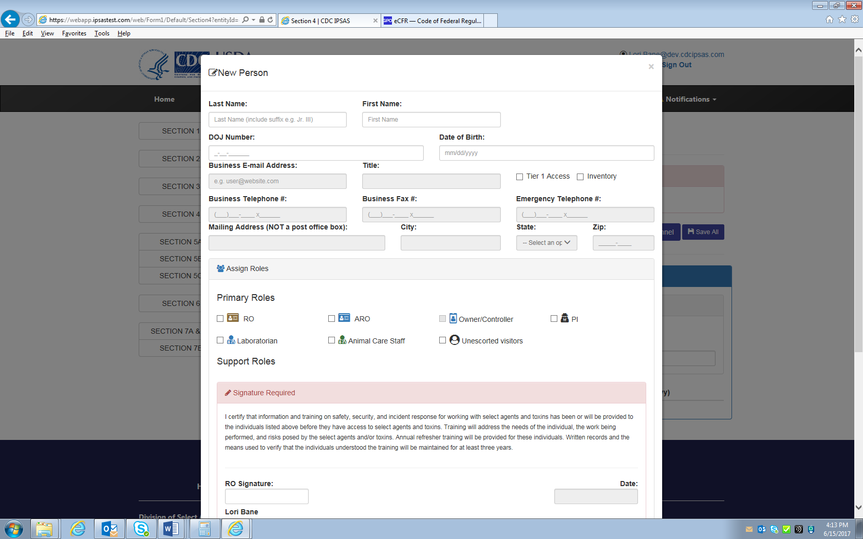

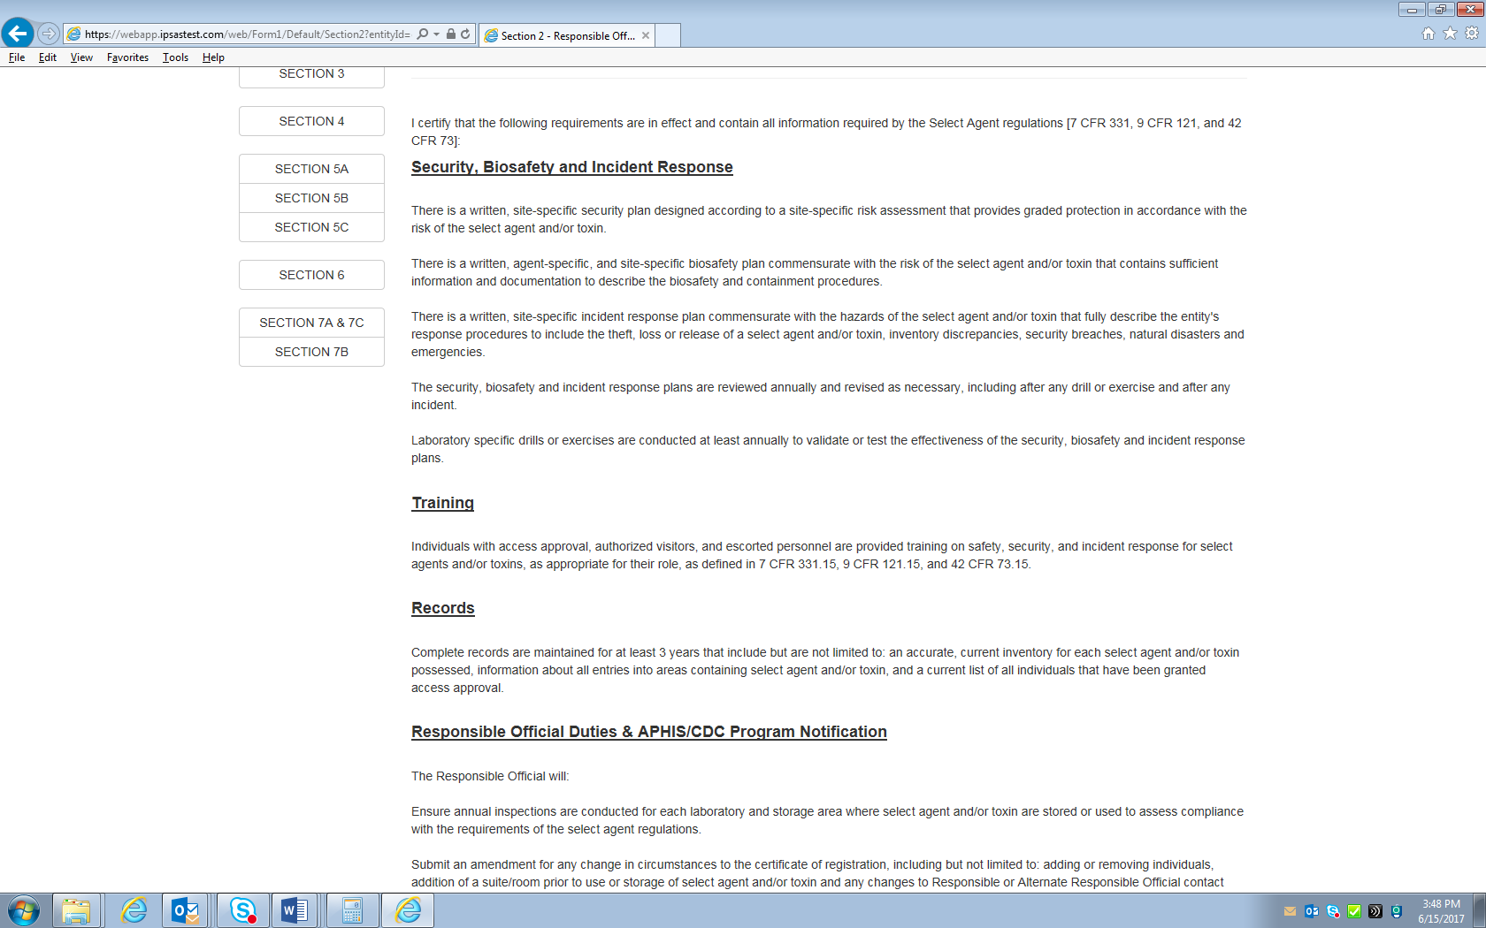

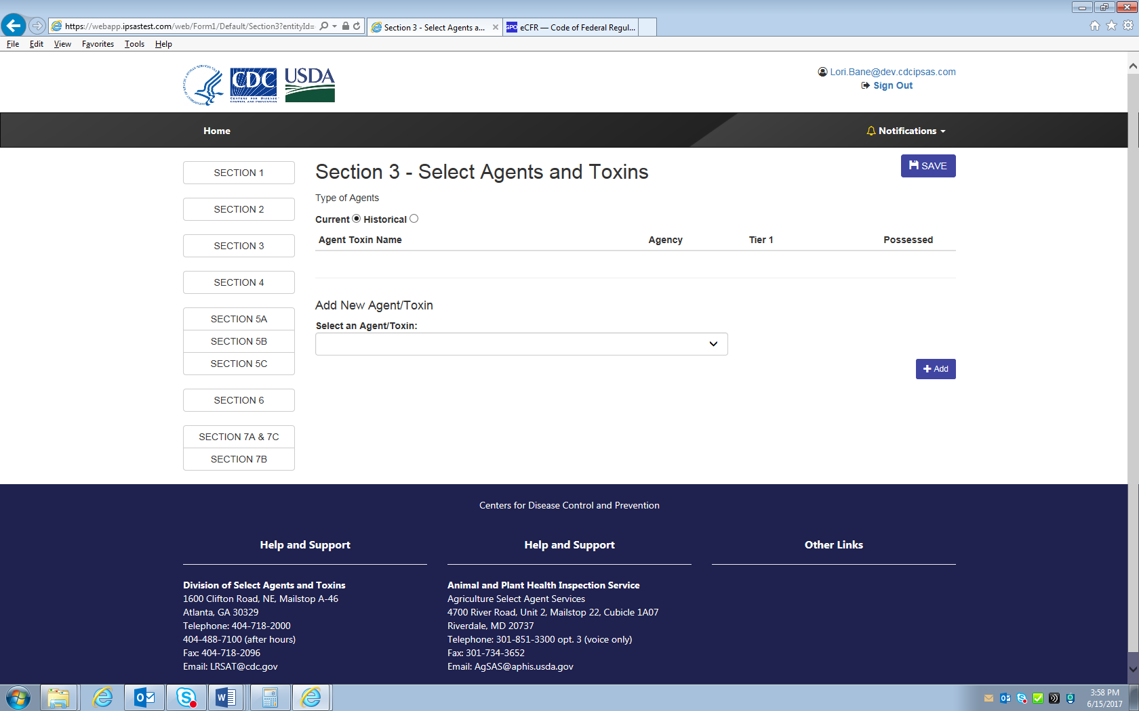

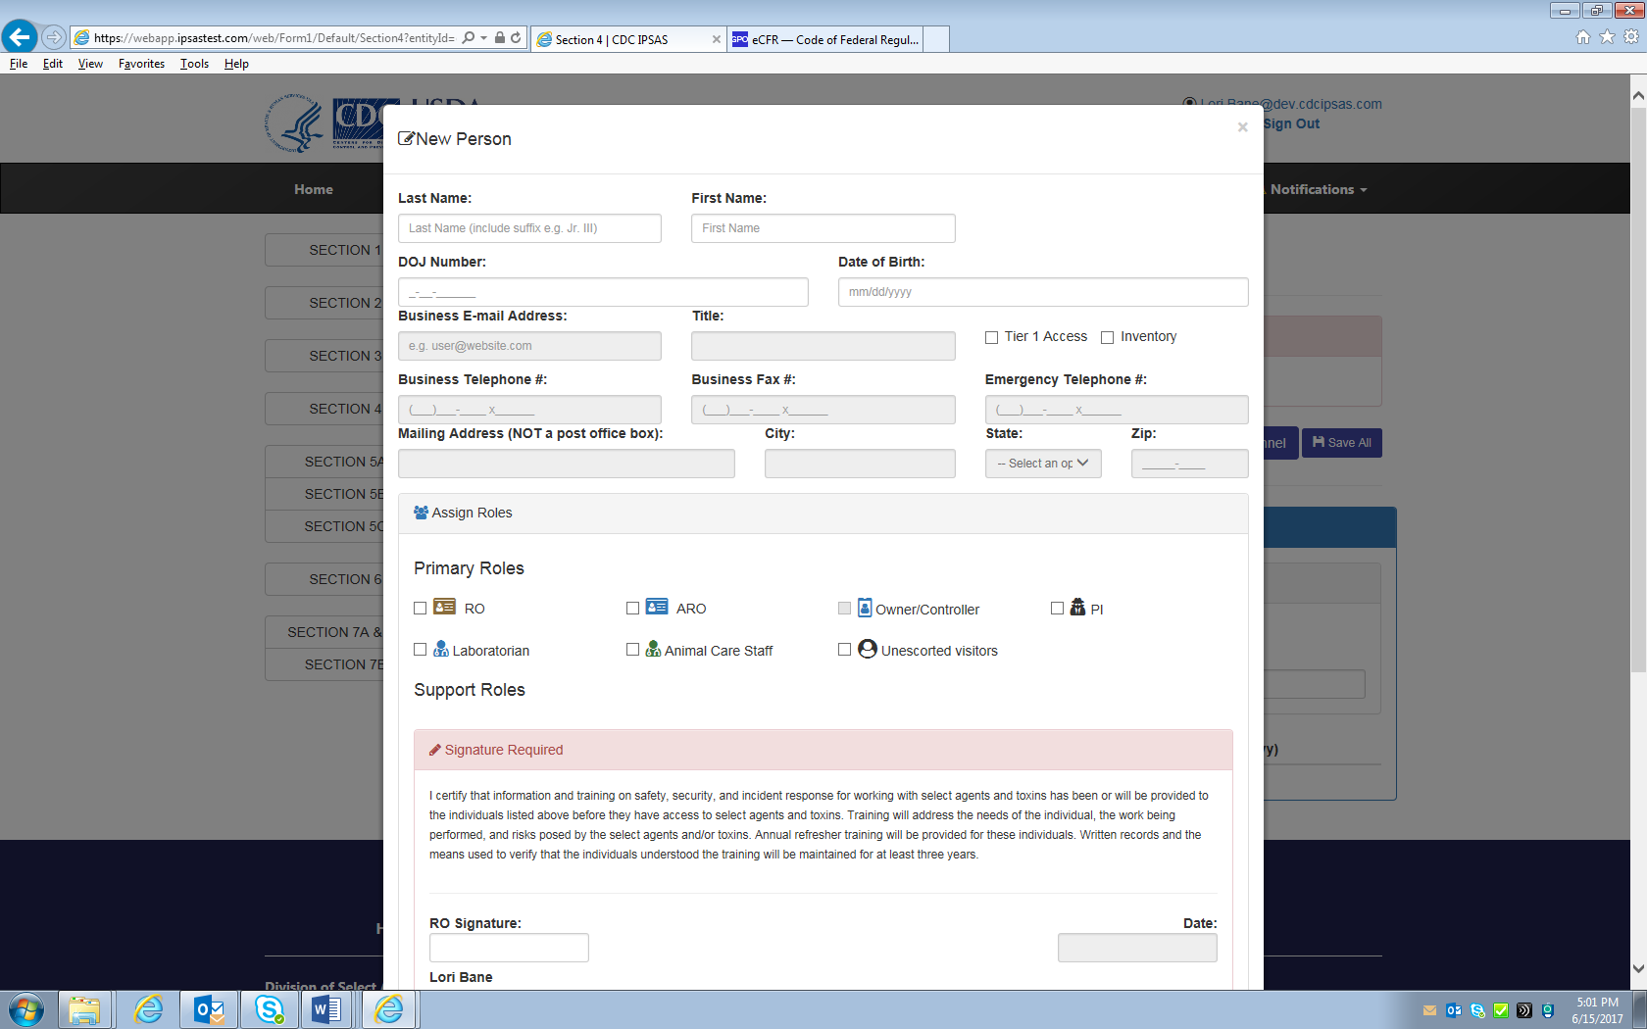
The fields are grayed out for Section 4.
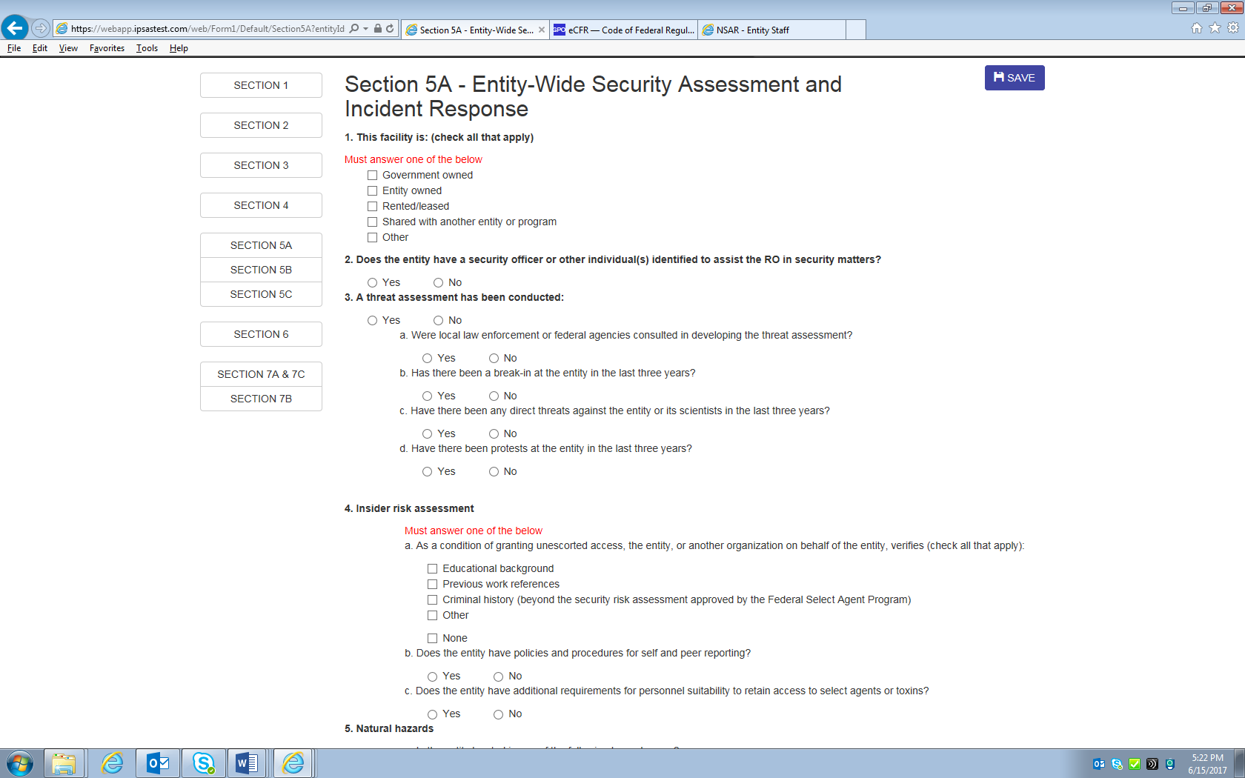
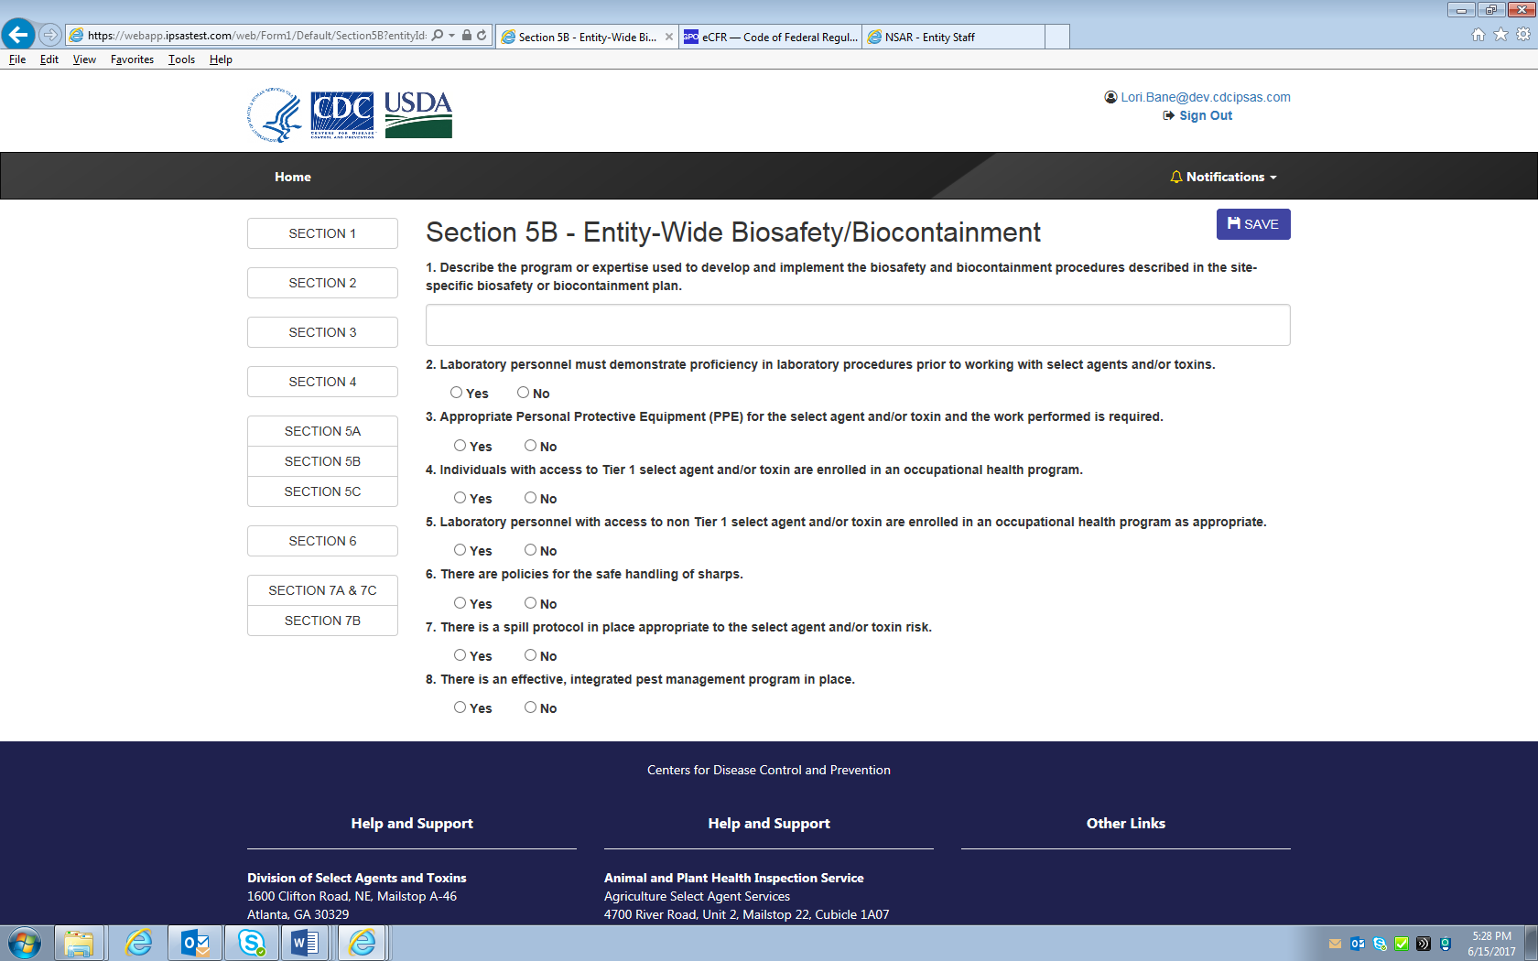
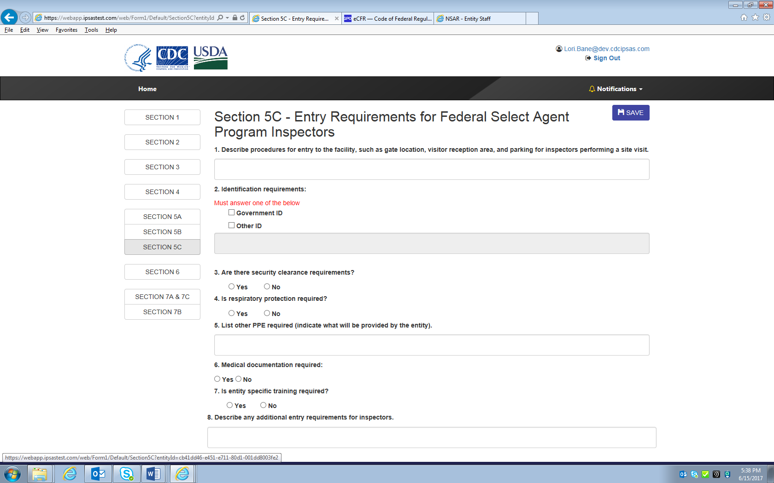

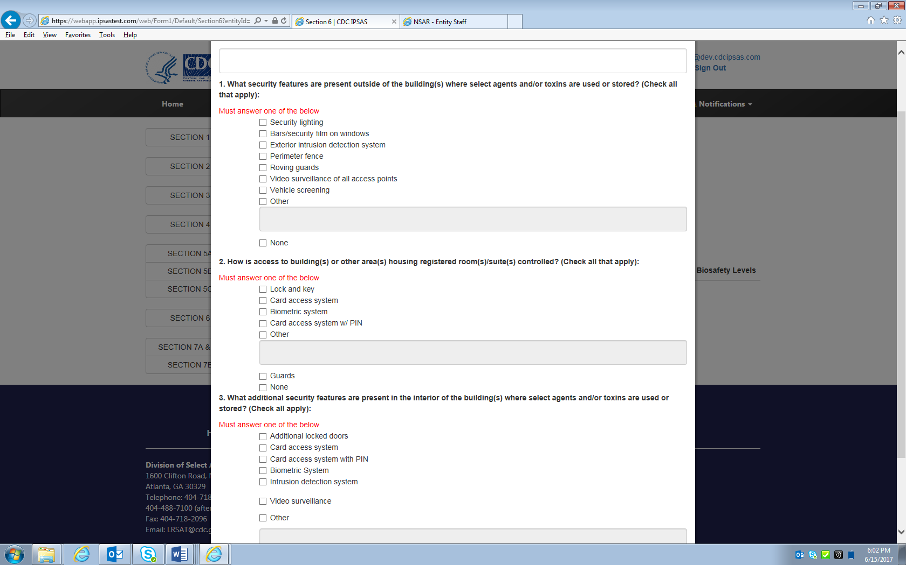
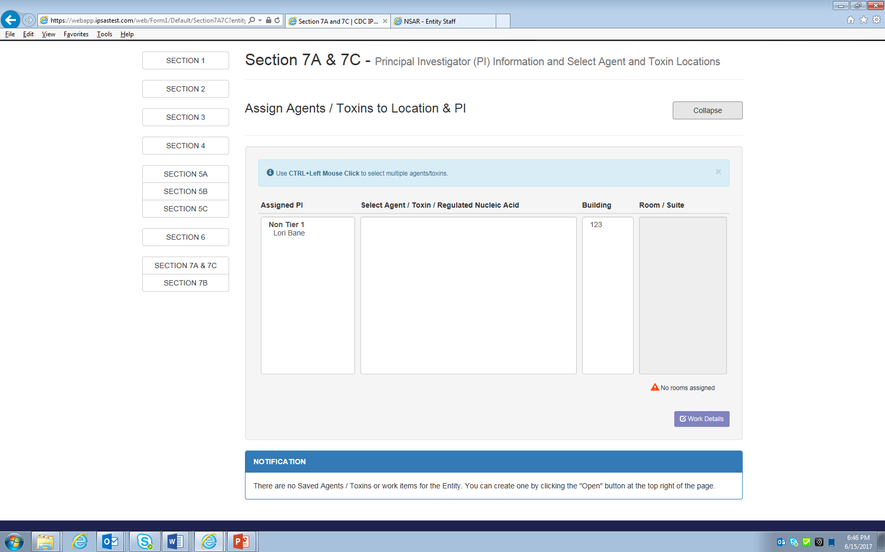

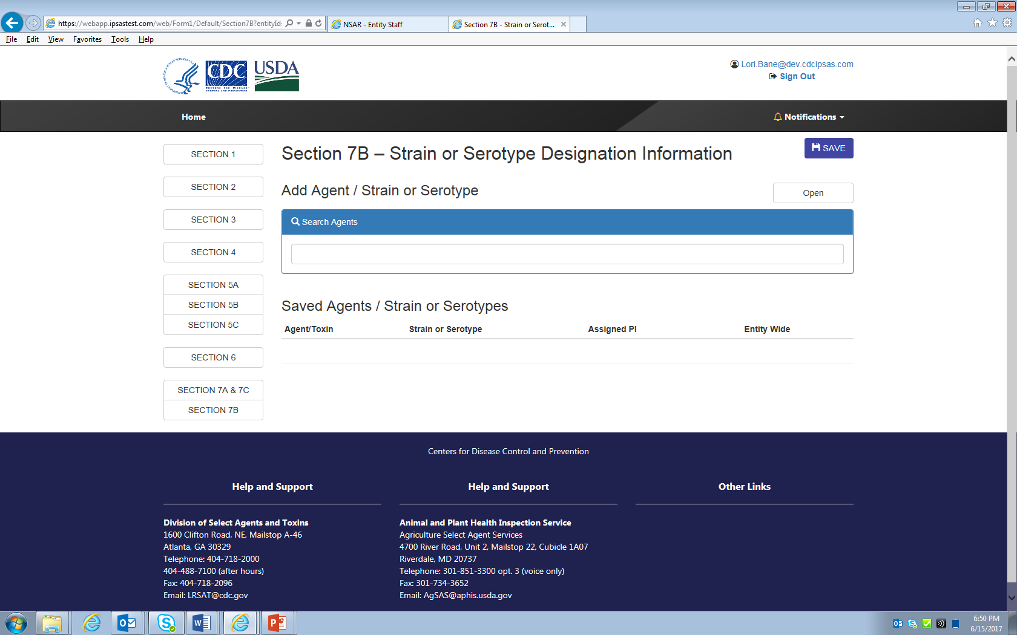
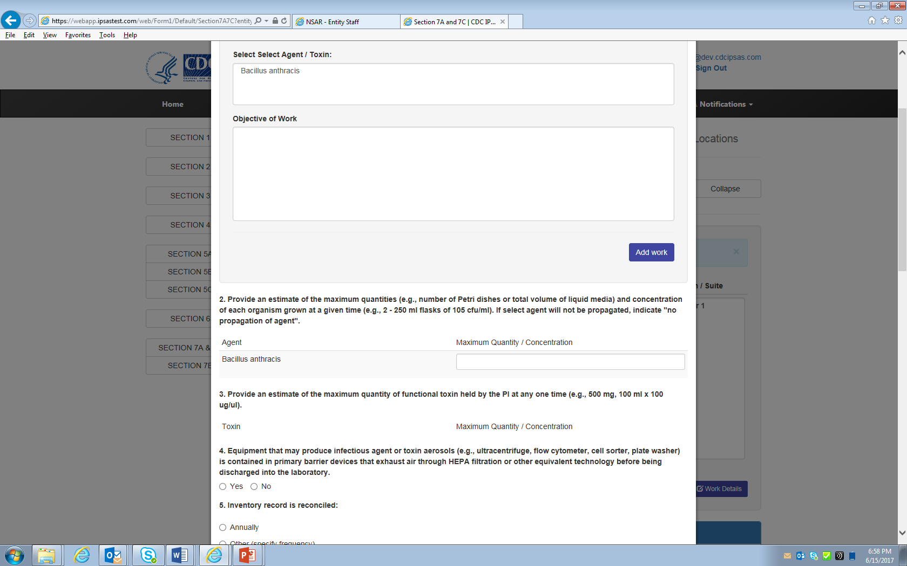

APHIS/CDC Form 2: Request to Transfer Select Agents and Toxins

The same information that is collected in NSAR is same information being collected in eFSAP. There were no changes in the IT structure.

APHIS/CDC Form 3, Report of Theft, Loss, or Release of Select Agents and Toxins

Data for the APHIS/CDC Form 3 were not collected in NSAR. The pdf of the form was scanned into the system. The below screen prints show what will be collected in eFSAP.
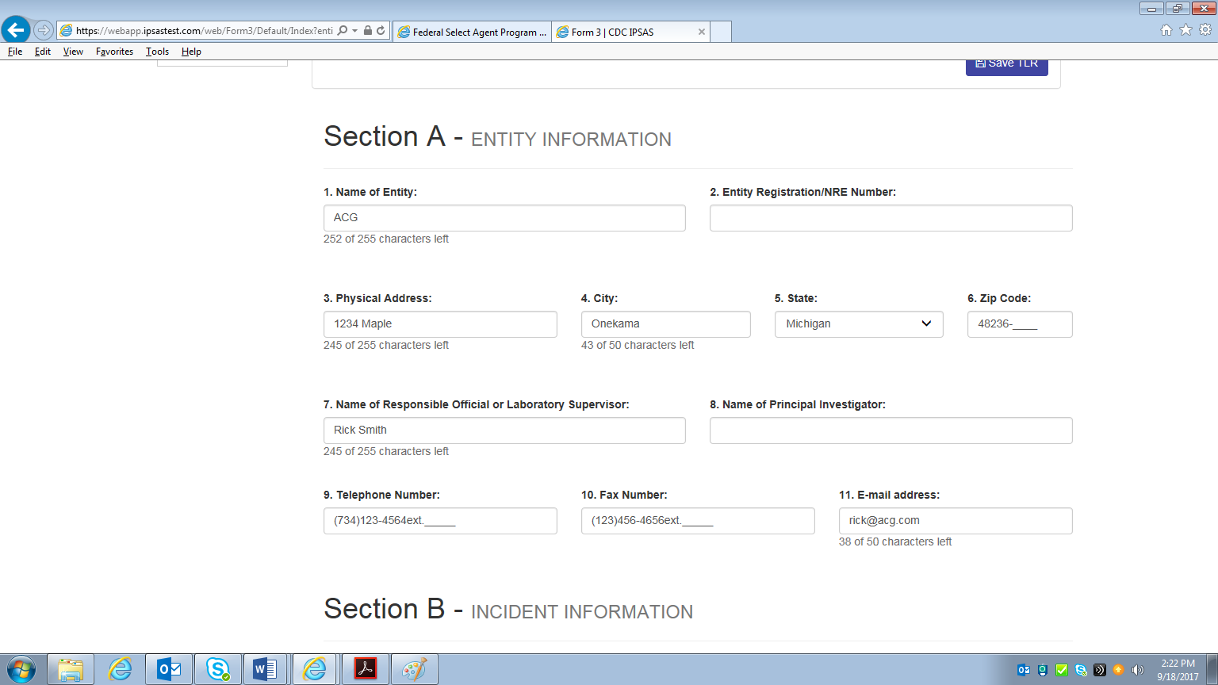

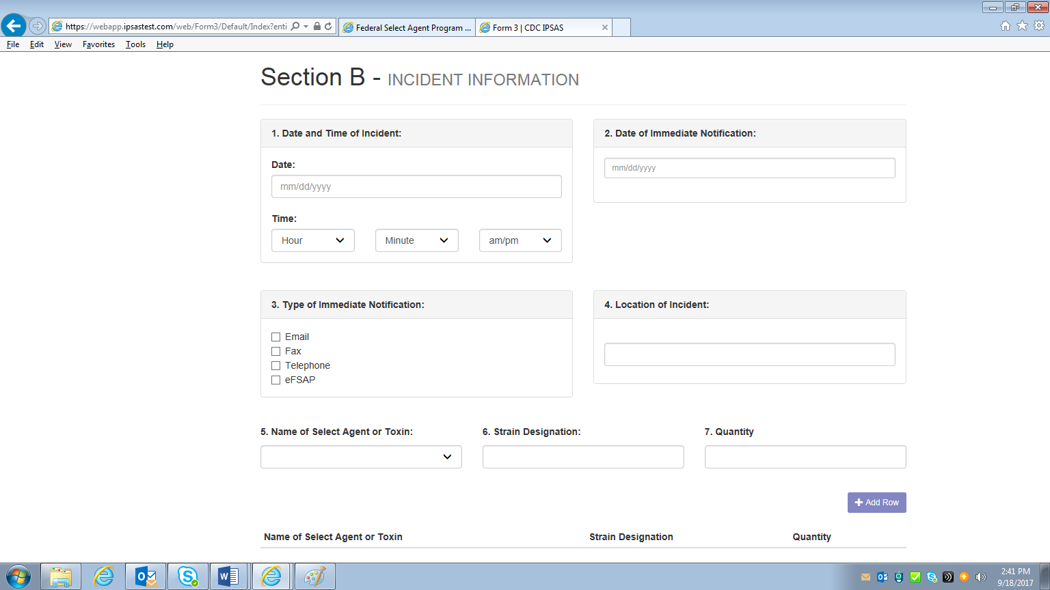
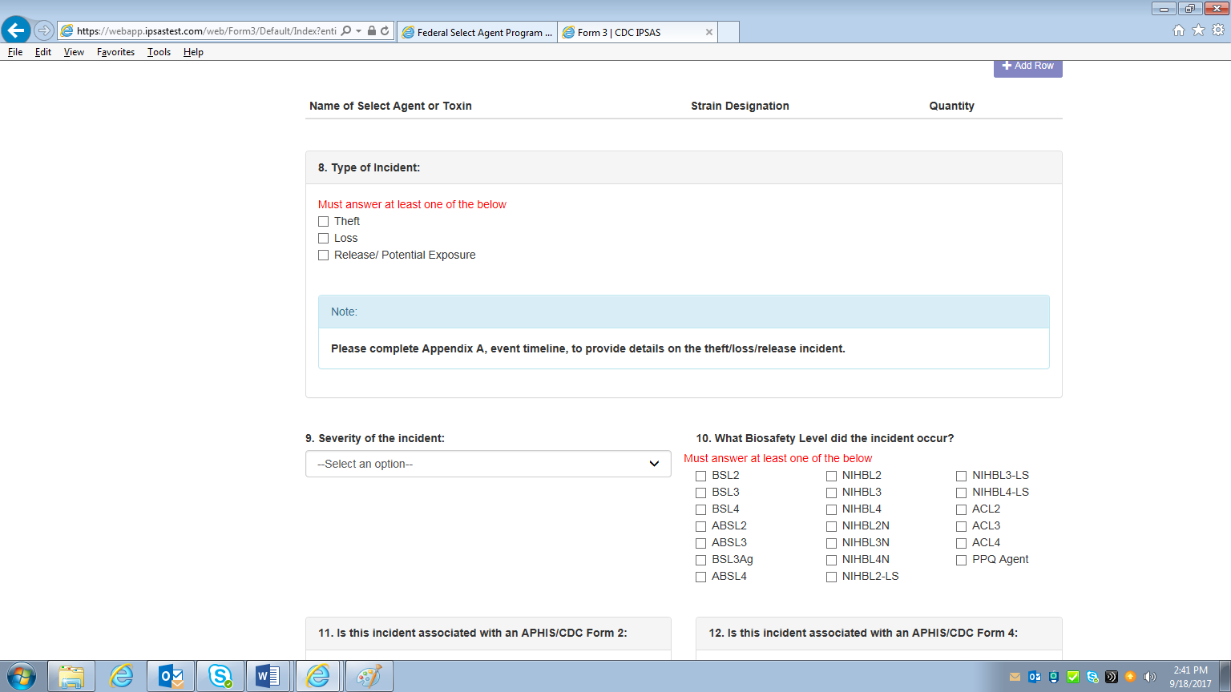
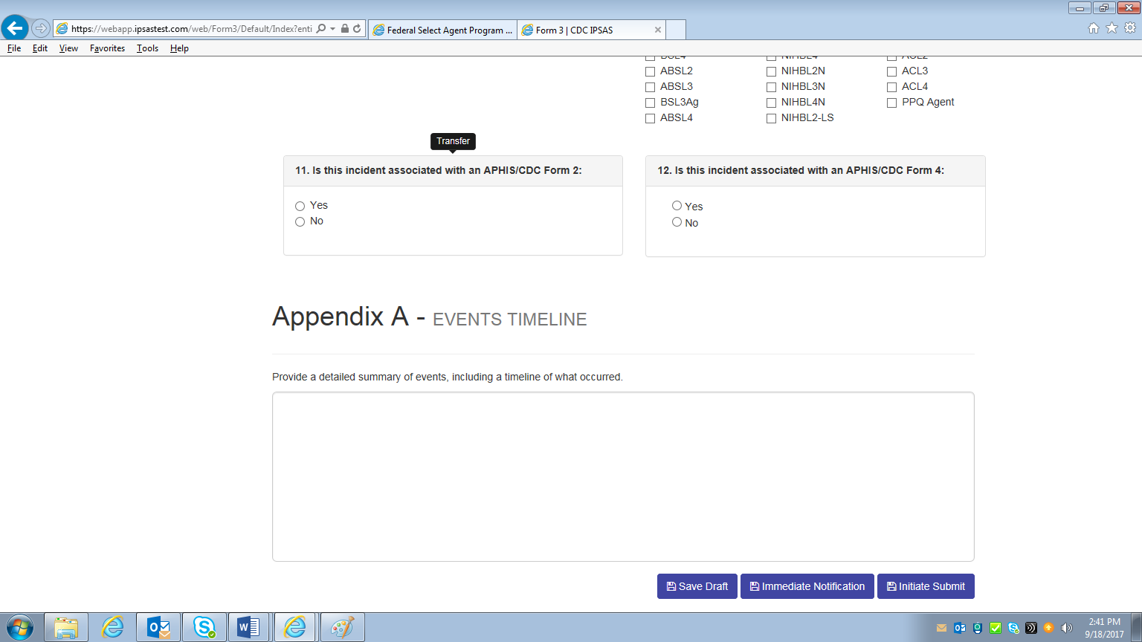

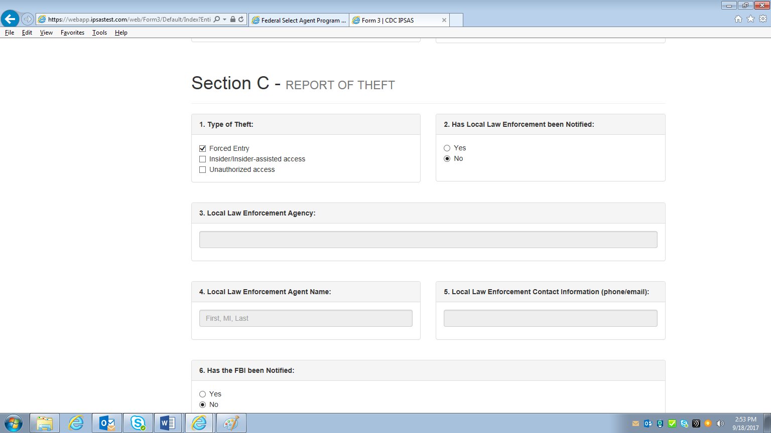
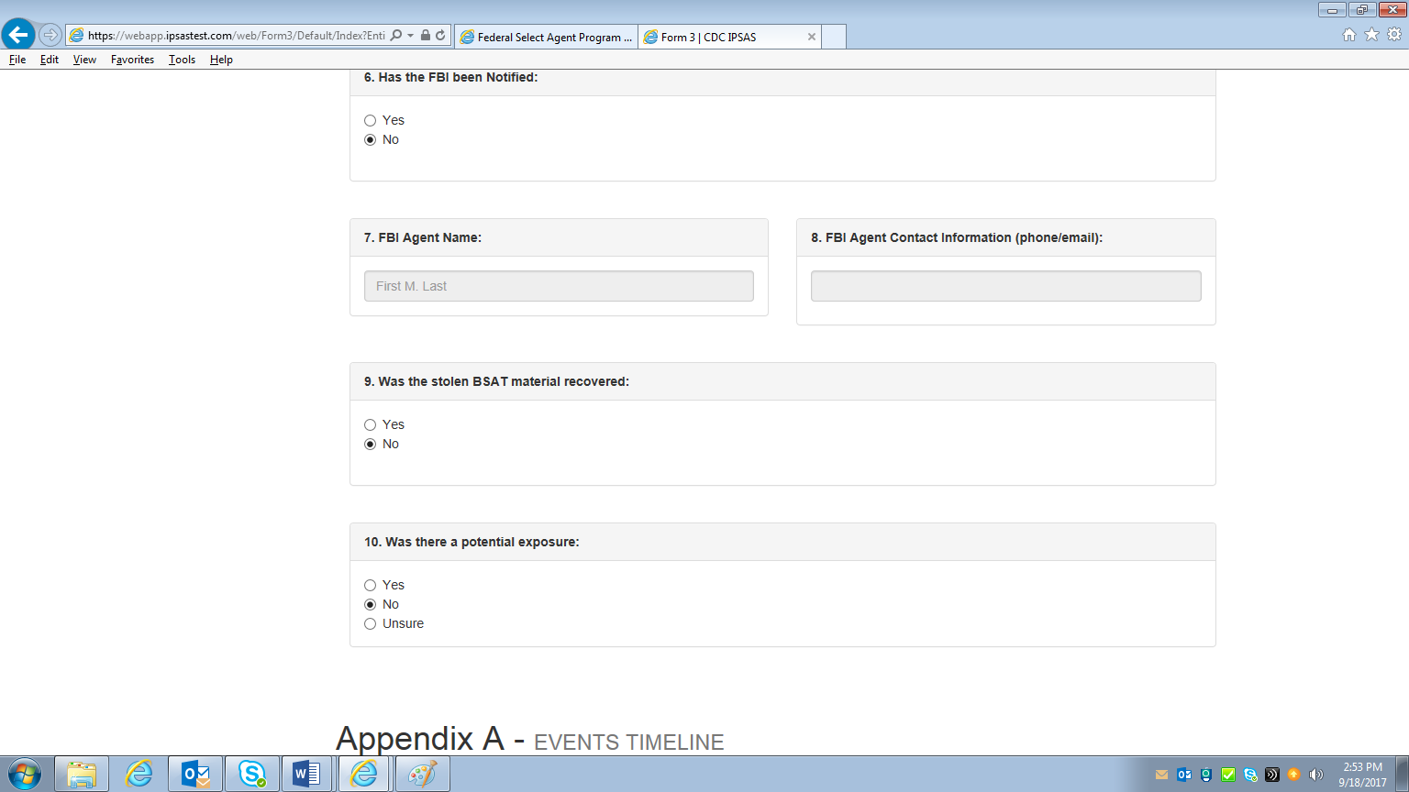

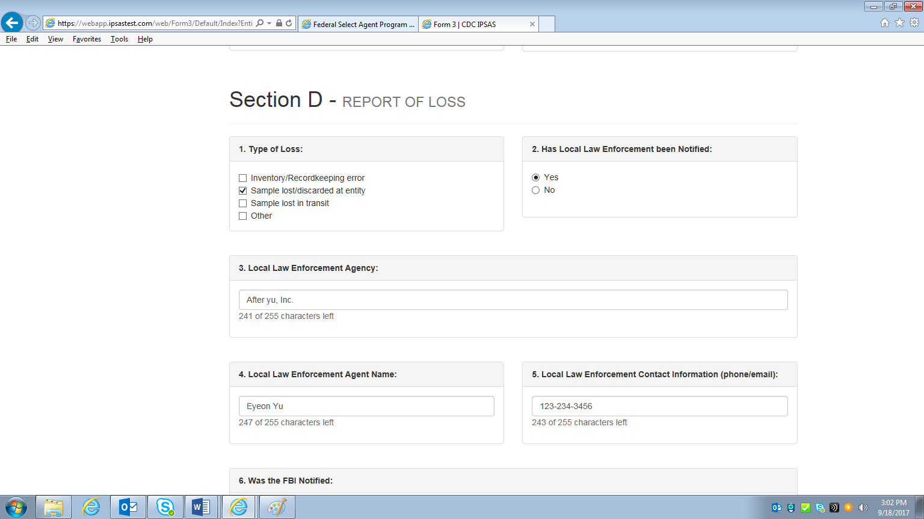
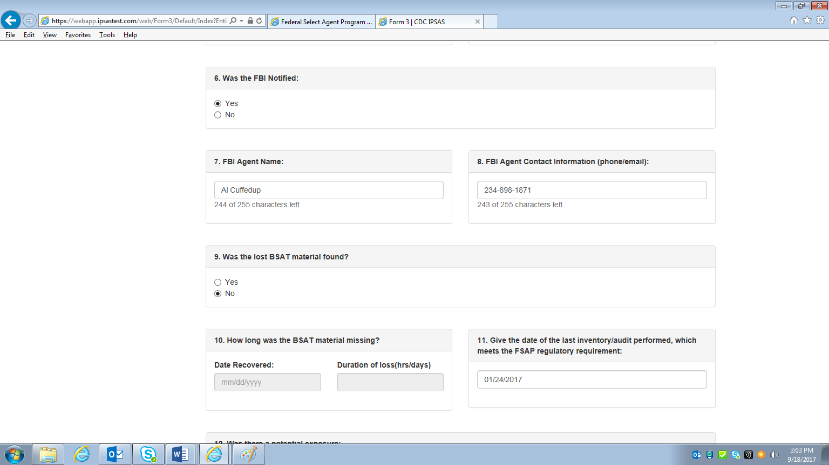
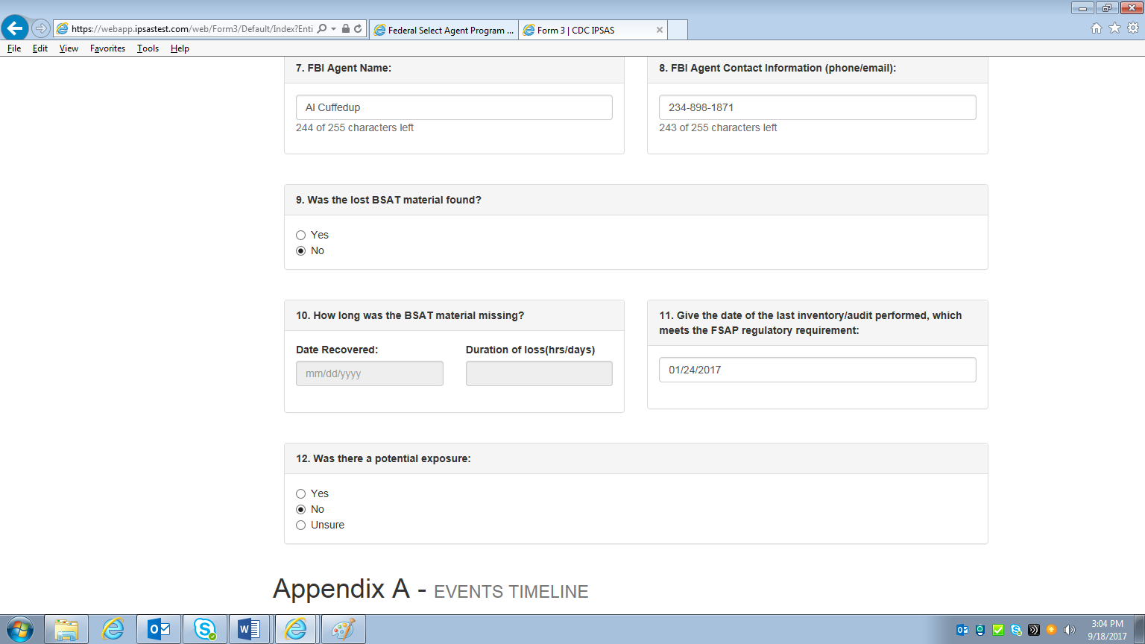

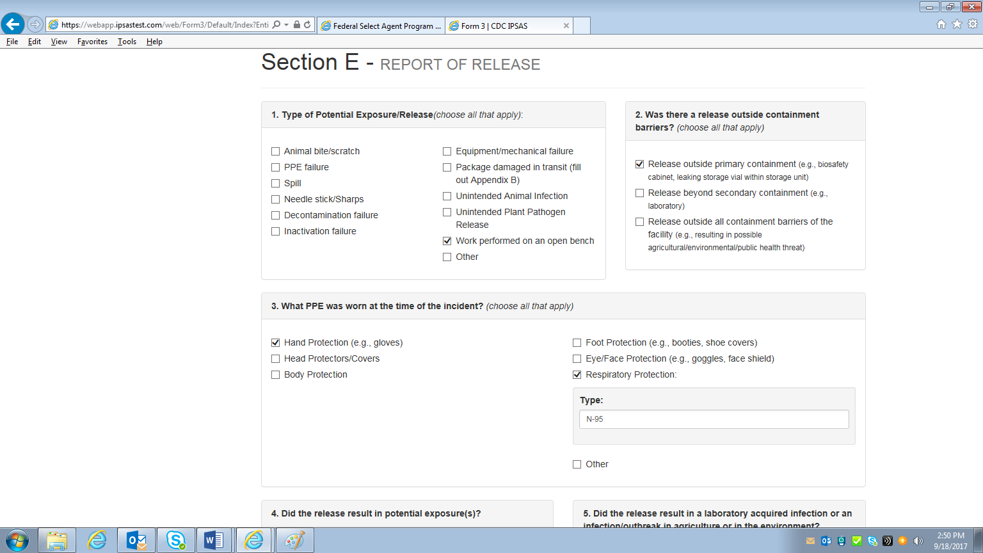
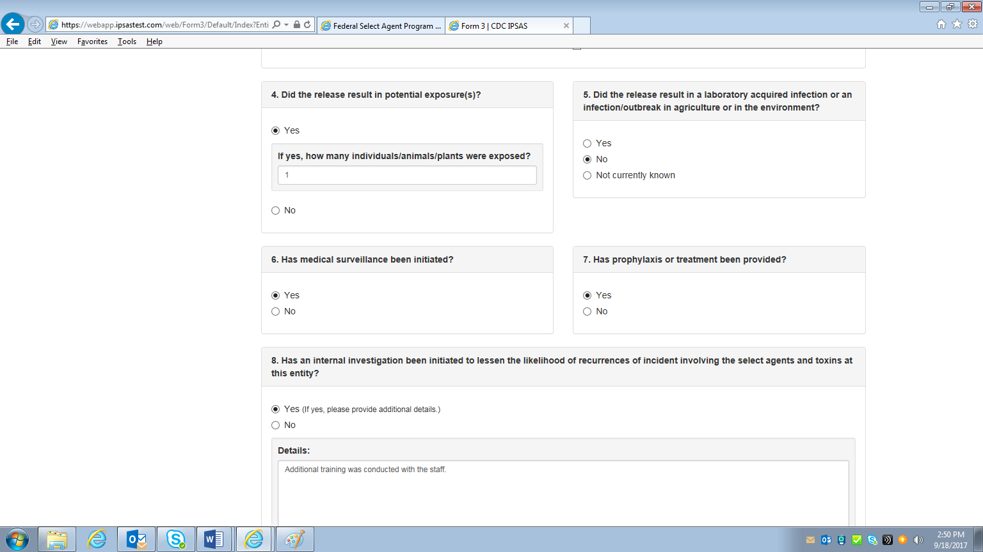
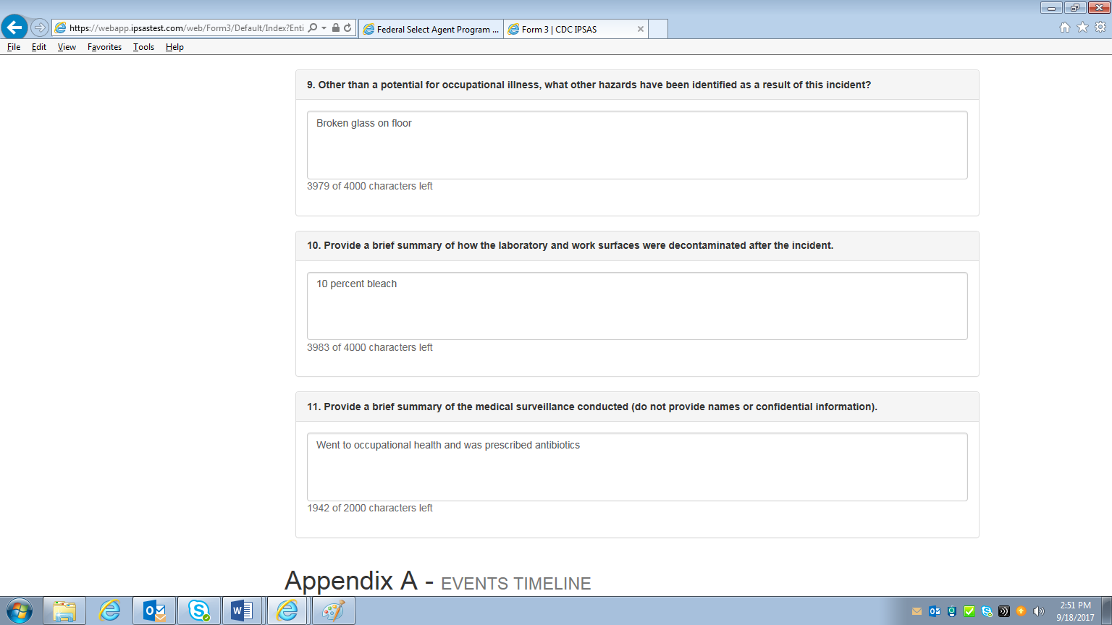

APHIS/CDC Form 4: Report of the Identification of a Select Agent or Toxin

Outside the entity information and select agent identified, data for the APHIS/CDC Form 4 were not collected in NSAR. The pdf of the form was scanned into the system. The below screen prints show what will be collected in eFSAP.
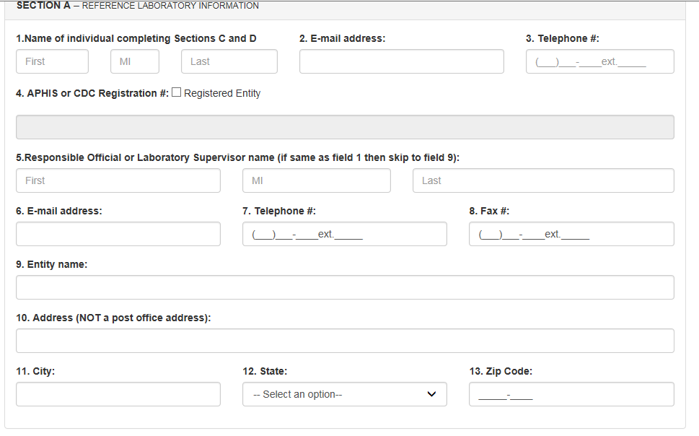

For the below screen print, this is found in Section B of the form.
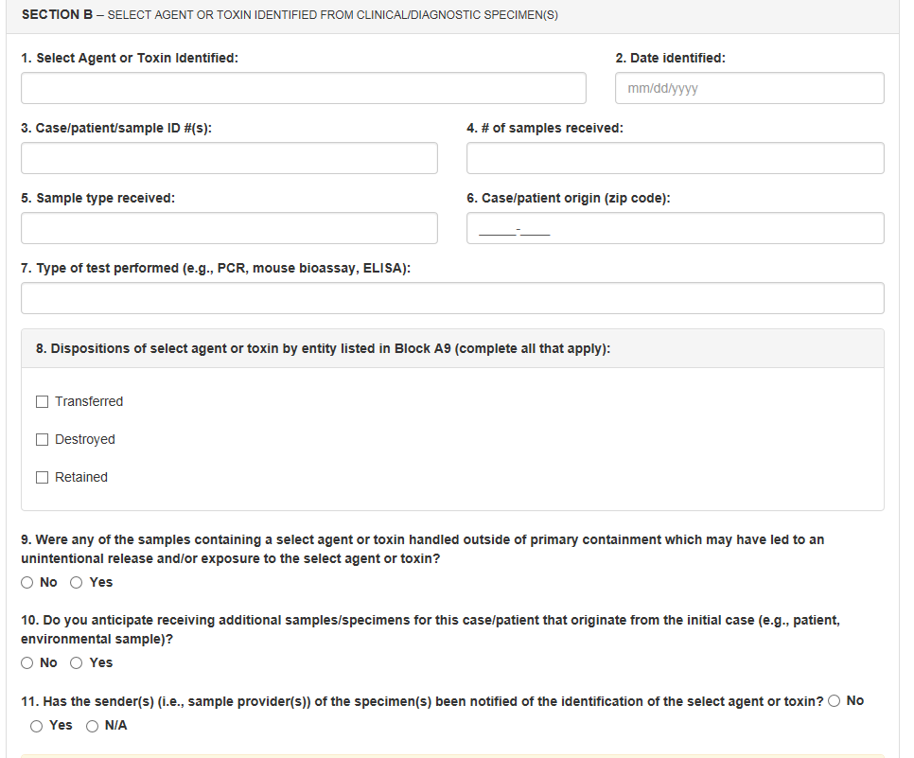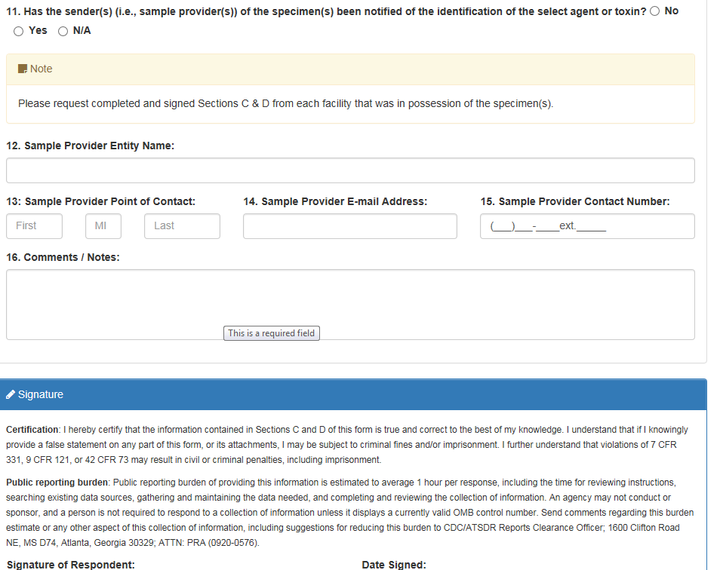

For the below screen print, this is found in Section C of the form.
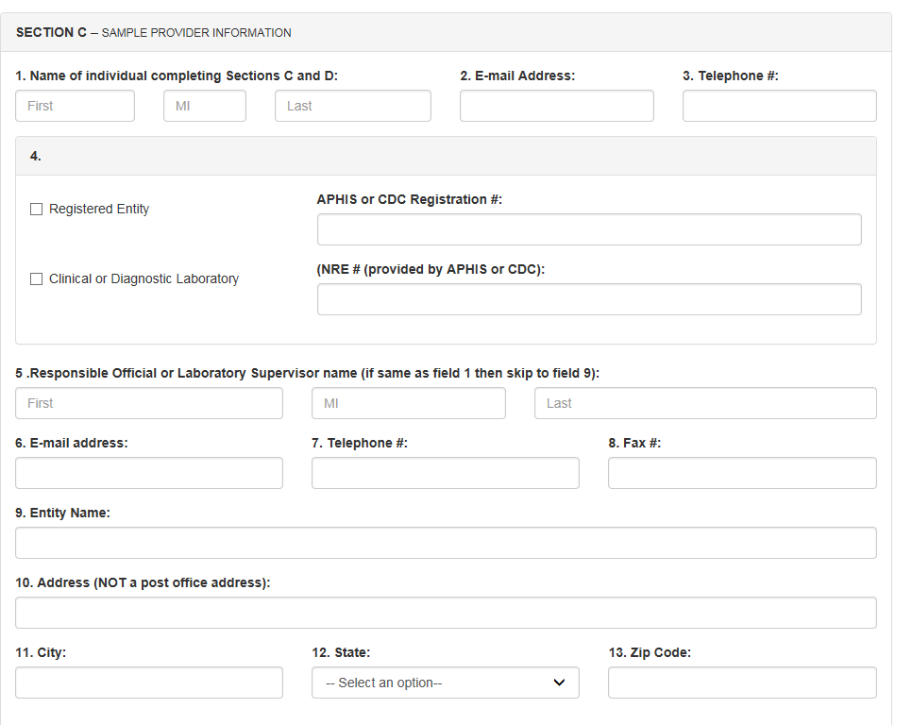

For the below screen prints, this is found in Section D of the form.
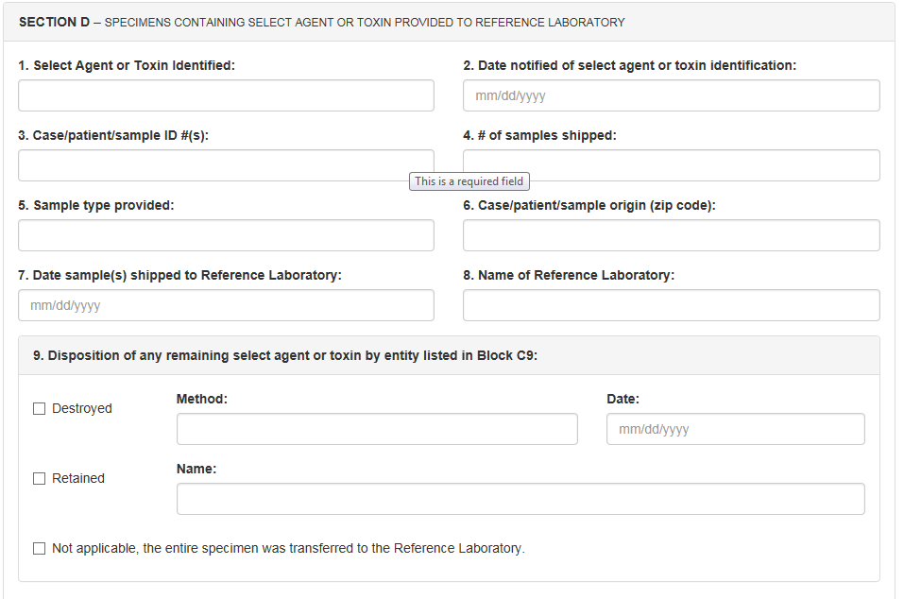

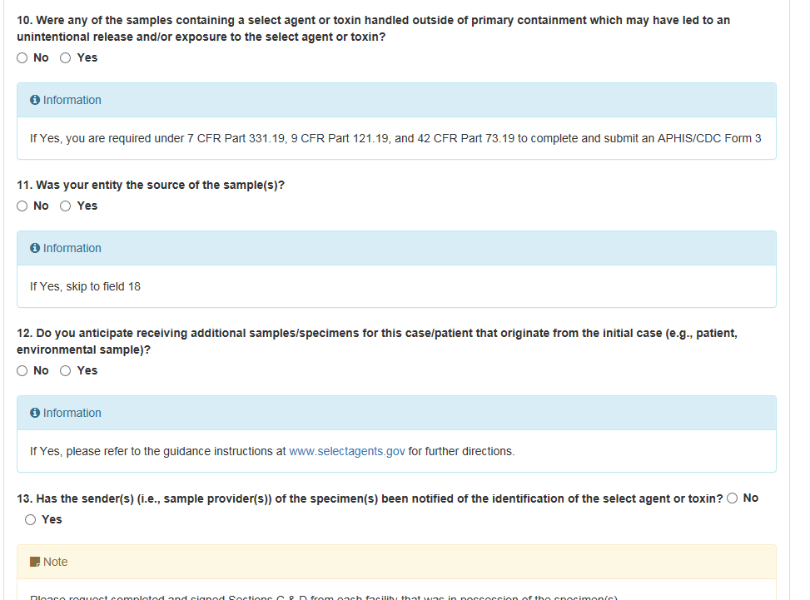
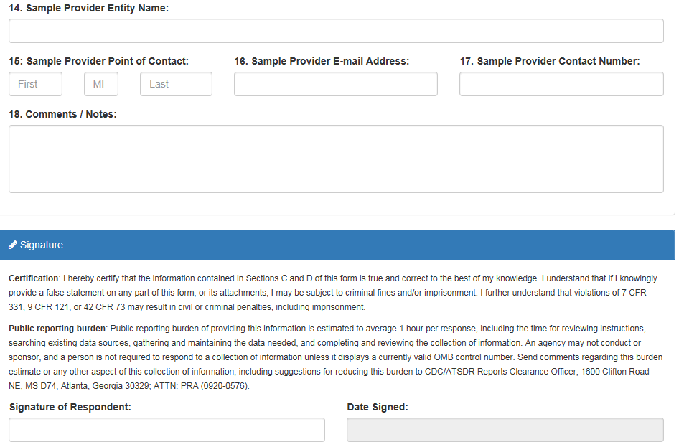

APHIS/CDC Form 5: Request for Exemption of Select Agents and Toxins for an Investigational Product

Similar to NSAR, the form will not be available in the new system. Applicants will still complete the pdf available on the Federal Select Agent Program website.

