Telephone Follow-up Survey Introductory Letter (English Version)

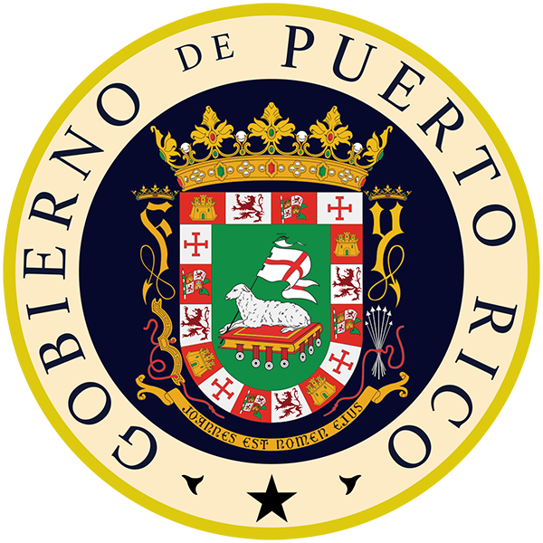

Department of Health

<DATE>

Ms. «MotherNAME1»
«MotherPostalAdress1»
«MotherPostalAdress2»
«MotherPostalAdress3»
«MotherPostalCounty» «MotherPostalAdressZipCode»

Dear Ms. «MotherName_» «MotherLastNames»,

Recently we asked for your help with the Zika Postpartum Emergency Response Survey (ZPER for short). As you may recall, you, and possibly the father of your new baby, filled out a questionnaire in the hospital shortly after the delivery of your new baby. We are very grateful for your participation. Your answers provided valuable information that the Puerto Rico Department of Health is using to improve programs that will help other pregnant women during the Zika virus outbreak.

In fact, the information you provided was so important, we would like to invite you to participate in a follow-up telephone survey to learn more about you and your baby’s health. We would like to know some information regarding your experiences since the delivery of your baby. You don’t have to do anything now. We will call you by telephone in the next few weeks.

If you do not want to be contacted, please call us at 787-764-5915. The call is free, so there is no cost to you.

We thank you very much for your consideration and commitment with Puerto Rico’s health, and we look forward to talking with you soon.

Sincerely,

Beatriz Salvesen von Essen,
Puerto Rico PRAMS-ZPER Project Coordinator
Puerto Rico Department of Health
Division of Maternal, Child and Adolescent Health
787-765-2929, x. 4672

