**OBSOLETE**

**MSSICS 008.022  Law Enforcement (ALEF)**

A.              INTRODUCTION

This section describes the **Law Enforcement (ALEF) screen**.  ALEF lets you record the claimant's status as a fugitive felon or parole or probation violator.  This screen appears in the Initial Claims and Redeterminations claims path.

B.              FACSIMILE:  ALEF - LAW ENFORCEMENT

MSSICS                    LAW ENFORCEMENT                         ALEF

[[1-O]](http://policynet.ba.ssa.gov/msom.nsf/sectionlist/MSSICS_008.022#commonfields#commonfields)

SSS-SS-SSSS                                               TRANSFER TO: XXXX

[[2-M]](http://policynet.ba.ssa.gov/msom.nsf/sectionlist/MSSICS_008.022#field2M#field2M)

ACCUSED OR CONVICTED OF A FELONY OR AN ATTEMPT TO COMMIT A FELONY  (Y/N): X

[[3-C]](http://policynet.ba.ssa.gov/msom.nsf/sectionlist/MSSICS_008.022#field3C#field3C)                          [[4-C]](http://policynet.ba.ssa.gov/msom.nsf/sectionlist/MSSICS_008.022#field4C#field4C)

  IF YES, IN WHICH STATE: XX     OR COUNTRY: XXXXXXXXXXXXXXXXXXXXXX

[[5-D]](http://policynet.ba.ssa.gov/msom.nsf/sectionlist/MSSICS_008.022#field5D#field5D)             [[6-C]](http://policynet.ba.ssa.gov/msom.nsf/sectionlist/MSSICS_008.022#field6C#field6C)

  SINCE SS/SS/SSSS, FELONY OR ARREST WARRANT (Y/N): X

[[7-M]](http://policynet.ba.ssa.gov/msom.nsf/sectionlist/MSSICS_008.022#field7M#field7M)

ON PAROLE OR PROBATION UNDER FEDERAL OR STATE LAW (Y/N): X

[[8-C]](http://policynet.ba.ssa.gov/msom.nsf/sectionlist/MSSICS_008.022#field8C#field8C)

      IF STATE LAW, WHICH STATE: XX

[[9-D]](http://policynet.ba.ssa.gov/msom.nsf/sectionlist/MSSICS_008.022#field9D#field9D)             [[10-C]](http://policynet.ba.ssa.gov/msom.nsf/sectionlist/MSSICS_008.022#field10C#field10C)

      SINCE SS/SS/SSSS, FEDERAL OR STATE ARREST WARRANT FOR PAROLE OR

      PROBATION VIOLATION(Y/N): X

[[11-O]](http://policynet.ba.ssa.gov/msom.nsf/sectionlist/MSSICS_008.022#commonfields#commonfields)

                                                               REMARKS (Y): X

**OBSOLETE**

**MSSICS 008.023  Felony Warrant (AWRF)**

A.              INTRODUCTION

This section describes the **Felony Warrant (AWRF) screen**.  This screen documents the information obtained from the felony warrant issued for the claimant.

B.              FACSIMILE:  AWRF - FELONY WARRANT

MSSICS                    FELONY WARRANT                            AWRF

[[1-O]](http://policynet.ba.ssa.gov/msom.nsf/sectionlist/MSSICS_008.023#commonfields#commonfields)

SSS-SS-SSSS                                           TRANSFER TO: XXXX

[[2-M]](http://policynet.ba.ssa.gov/msom.nsf/sectionlist/MSSICS_008.023#field2M#field2M)

DATE WARRANT ISSUED (MMDDYY):  999999

[[3-O]](http://policynet.ba.ssa.gov/msom.nsf/sectionlist/MSSICS_008.023#field3O#field3O)

DATE FLED (MMDDYY): 999999

[[4-M]](http://policynet.ba.ssa.gov/msom.nsf/sectionlist/MSSICS_008.023#field4M#field4M)

WARRANT SELECTED/ISSUED IN ERROR (Y/N):  X

[[5-C]](http://policynet.ba.ssa.gov/msom.nsf/sectionlist/MSSICS_008.023#field5C#field5C)

     WARRANT SATISFIED (Y/N):  X

[[6-C]](http://policynet.ba.ssa.gov/msom.nsf/sectionlist/MSSICS_008.023#field6C#field6C)

         IF YES, DATE WARRANT SATISFIED (MMDDYY):  999999

[[7-C]](http://policynet.ba.ssa.gov/msom.nsf/sectionlist/MSSICS_008.023#field7C#field7C)

GOOD CAUSE: 9 1=ESTABLISHED

              2=NOT ESTABLISHED

[[8-O]](http://policynet.ba.ssa.gov/msom.nsf/sectionlist/MSSICS_008.023#field8O#field8O)                        [[9-O]](http://policynet.ba.ssa.gov/msom.nsf/sectionlist/MSSICS_008.023#field9O#field9O)                            [[10-O]](http://policynet.ba.ssa.gov/msom.nsf/sectionlist/MSSICS_008.023#commonfields#commonfields)

ANOTHER WARRANT (Y): X       DELETE THIS SOURCE (Y): X        REMARKS (Y): X

**OBSOLETE**

**MSSICS 008.024  Parole Or Probation Violation Warrant (AWRP)**

A.              INTRODUCTION

This section describes the **Parole or Probation Violation Warrant (AWRP) screen**.  This screen documents the information obtained from the parole or probation violation warrant issued for the claimant.

B.              FACSIMILE:  AWRP - PAROLE OR PROBATION VIOLATION WARRANT

MSSICS                 PAROLE OR PROBATION VIOLATION WARRANT         AWRP

[[1-O]](http://policynet.ba.ssa.gov/msom.nsf/sectionlist/MSSICS_008.024#commonfields#commonfields)

SSS-SS-SSSS                                               TRANSFER TO: XXXX

[[2-M]](http://policynet.ba.ssa.gov/msom.nsf/sectionlist/MSSICS_008.024#field2M#field2M)

DATE WARRANT ISSUED (MMDDYY):  999999

[[3-O]](http://policynet.ba.ssa.gov/msom.nsf/sectionlist/MSSICS_008.024#field3O#field3O)

DATE VIOLATED PAROLE OR PROBATION (MMDDYY):  999999

[[4-M]](http://policynet.ba.ssa.gov/msom.nsf/sectionlist/MSSICS_008.024#field4M#field4M)

WARRANT SELECTED/ISSUED IN ERROR (Y/N):  X

[[5-C]](http://policynet.ba.ssa.gov/msom.nsf/sectionlist/MSSICS_008.024#field5C#field5C)

     WARRANT SATISFIED (Y/N):  X

[[6-C]](http://policynet.ba.ssa.gov/msom.nsf/sectionlist/MSSICS_008.024#field6C#field6C)

          IF YES, DATE WARRANT SATISFIED (MMDDYY):  999999

[[7-C]](http://policynet.ba.ssa.gov/msom.nsf/sectionlist/MSSICS_008.024#field7C#field7C)

GOOD CAUSE: 9 1=ESTABLISHED

              2=NOT ESTABLISHED

[[8-O]](http://policynet.ba.ssa.gov/msom.nsf/sectionlist/MSSICS_008.024#field8O#field8O)                         [[9-O]](http://policynet.ba.ssa.gov/msom.nsf/sectionlist/MSSICS_008.024#field8O#field8O)                           [[10-O]](http://policynet.ba.ssa.gov/msom.nsf/sectionlist/MSSICS_008.024#commonfields#commonfields)

ANOTHER WARRANT (Y): X        DELETE THIS SOURCE (Y): X       REMARKS (Y): X

**NEW**

Warrants - Felony Warrant Page with State/territory selected

(Both screen shots below replace the old AWRF)

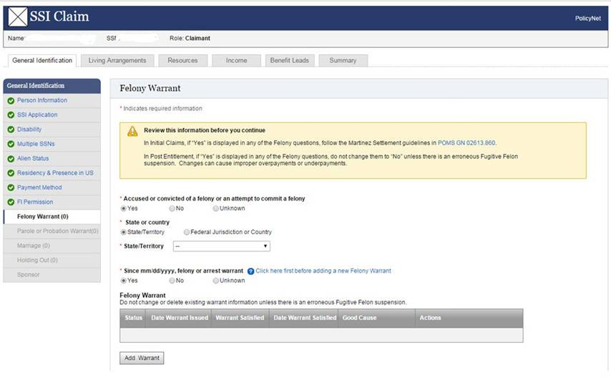Note: We incorporated ALEF questions into the AWRP & AWRF screens.

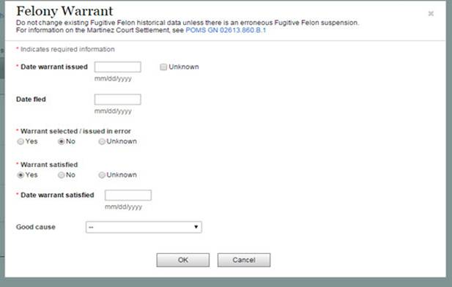Warrants - Felony Warrant Pop-up Window - NEW

**NEW**

Parole/Probation Violation Warrant w/State/Territory selected

(Both screen shots below replaced the old AWRP)

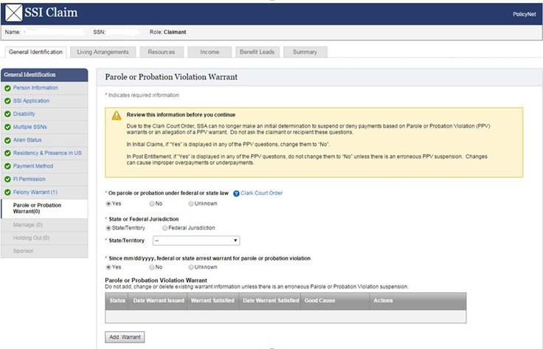

Note: We incorporated ALEF questions into the AWRP & AWRF screens.

Warrants- Parole or Probation violation pop-up window - NEW

