OMB Control No. 1035-####
Expiration Date ##/##/####

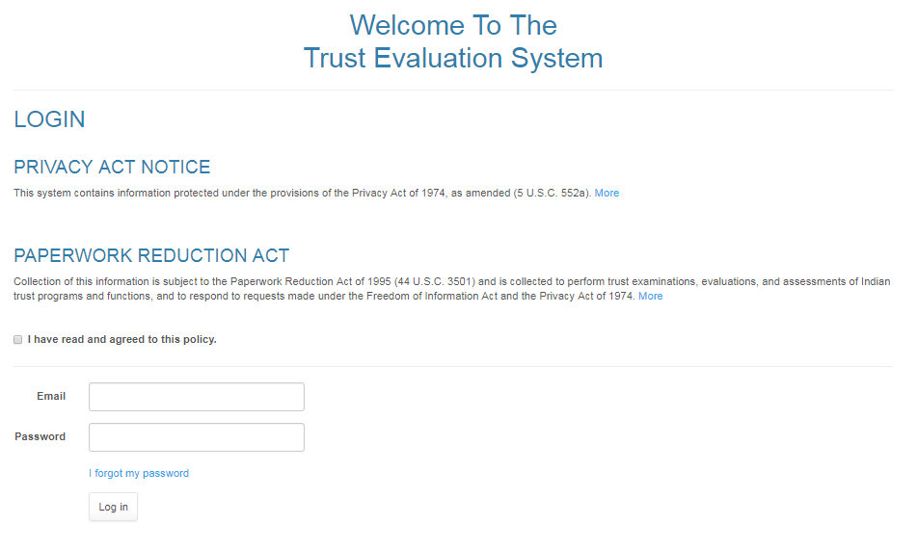

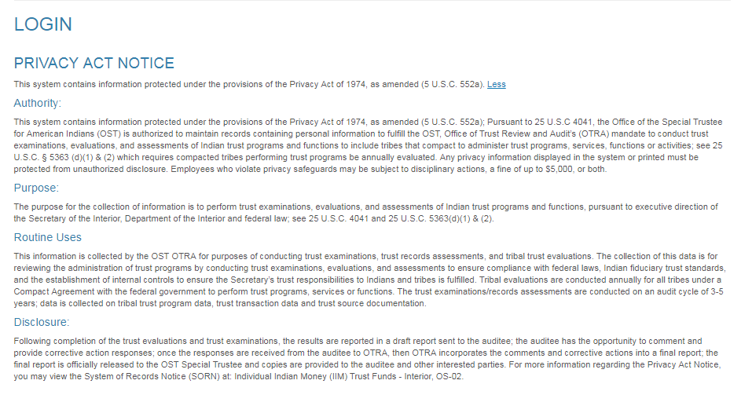

PAPERWORK REDUCTION ACT STATEMENT

We are collecting this information subject to the Paperwork Reduction Act (44 U.S.C. 3501) in order to oversee the implementation of trust reforms, trust accounting and coordination of trust policies intra-bureau-wide related to the management of Indian trust assets, and to respond to requests made under the Freedom of Information Act and the Privacy Act of 1974. Your response is mandatory; however, failure to respond for P.L. 93-638 Compact Tribes will result in non-compliance with the terms, conditions and requirements of the Compact Agreement, 25 U.S.C. 5363 (d)(1), and 25 CFR 1000.350. According to the Paperwork Reduction Act of 1995, no persons are required to respond to a collection of information unless such collection displays a valid OMB control number. OMB has approved this collection of information and assigned Control No. 1035-####.

ESTIMATED BURDEN STATEMENT

Public reporting for this collection of information varies with the convenient availability of the requested information. The relevant burden associated with this collection of information averages 2 hours for reporting and 1 hour for recordkeeping. This burden estimate includes time for reviewing instructions, searching existing data sources, gathering and maintaining the data needed, and completing and reviewing the collection of information. Send comments regarding this burden estimate or any other aspect of this collection of information, including suggestions for reducing this burden, to the Agency Information Clearance Officer, Department of the Interior, Office of the Special Trustee for American Indians, Office of Information Resources, 4400 Masthead Street NE, Albuquerque, NM 87109.

