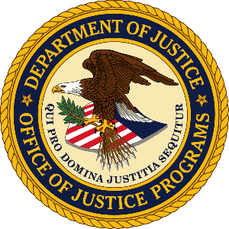

U.S. Department of Justice

Office of Justice Programs

Bureau of Justice Statistics

Washington, D.C. 20531

MEMORANDUM TO: Robert Sivinski
Office of Management and Budget

THROUGH: Jeri M. Mulrow, Acting Director, Bureau of Justice Statistics
Gerard F. Ramker, Deputy Director
Elizabeth Ann Carson, Acting Corrections Unit Chief

FROM: Mary Cowhig
Statistician

SUBJECT: Nonsubstantive change request to the name of Deaths in Custody Reporting Program (Jails): OMB Control No: 1121-0094

DATE: December 7, 2017

The Bureau of Justice Statistics (BJS) is requesting a nonsubstantive change to the name of Deaths in Custody Reporting Program (Jails), one of three data collections under OMB Control No: 1121-0094 (expiration 01/31/2019), “Annual Survey of Jails, Survey of Jails in Indian Country, Deaths in Custody Reporting Program (Jails).” BJS requests to change the name of the “Deaths in Custody Reporting Program (Jails)” to “Mortality in Correctional Institutions (Jails).” The new name better describes the data BJS collects, and allows for respondents to more easily distinguish it from BJS’s arrest-related deaths collection.

We will change the name on the following forms:

CJ-9, Death Report on Inmates under Jail Jurisdiction
CJ-9A, Annual Summary on Inmates under Jail Jurisdiction
CJ-10, Death Report on Inmates in Private and Multi-Jurisdictional Jails
CJ-10A, Annual Summary on Inmates in Private and Multi-Jurisdictional Jails

There is no change in the burden estimates associated with this collection at this time.

