https://www.uscis.gov/i-765-addresses

Direct Filing Addresses for Form I-765, Application for Employment Authorization
If you are filing Form I-765 with another form, file both forms at the location specified by the other form. For example, if you are filing Form I-765 with a Form I-539, file both forms according to the Form I-539 instructions. Use addresses below only when you are NOT submitting Form I-765 with another form.
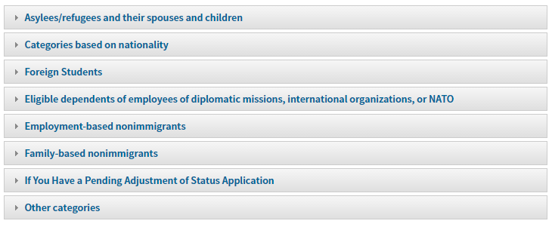
Eligibility Category 8 CFR  274a.12  This is the category you selected in question 20 on Form I-765 | Category Description | Filing Location
(c)(34) | Spouse of an International Entrepreneur Parolee | See IER webpage

E-Notification: If you want to receive an email and/or a text message that USCIS has accepted your Form I-765, complete Form G-1145, E-Notification of Application/Petition Acceptance, and attach it to the first page of your application.

