https://www.uscis.gov/i-131-addresses

Direct Filing Addresses for Form I-131, Application for Travel Document
Use the chart below to determine where you must file your Form I-131.
E-Notification: If you want to receive an email or a text message that a USCIS Lockbox facility has accepted your Form I-131, complete Form G-1145, E-Notification of Application/Petition Acceptance and attach it to the first page of your application.
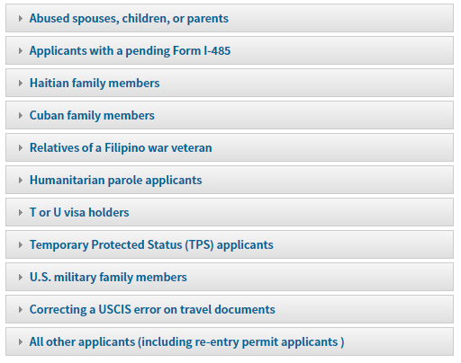
If you are… | Send your form to…
Applying for an Advance Parole Document for Dependent Spouse/Child of an Entrepreneur Parolee or Applicant for Entrepreneur | See IER webpage

