Trends in International mathematics and science study (TIMSS 2019)

field test and Main study Recruitment and Parent Materials

OMB# 1850-0695 v.11

AppendiCes A1, A2 and B1, B2

Field Test and Main Study Recruitment and Parent Materials

Submitted by:

National Center for Education Statistics

U.S. Department of Education

Institute of Education Sciences

Washington, DC

June 2017

revised December 2017

Master Table of Contents

**Detailed List of Contents for TIMSS 2019 Field Test**

Appendix A-1: TIMSS 2019 Field Test Recruitment Materials 3

Appendix B-1: TIMSS 2019 Field Test Notification Letters and Supporting Materials 64

**Detailed List of Contents for TIMSS 2019 Main Study**

Appendix A-2: TIMSS 2019 Main Study Recruitment Materials 76

Appendix B-2: TIMSS 2019 Main Study Notification Letters and Supporting Materials 137

**Appendix A-1: TIMSS 2019 Field Test Recruitment Materials**

Contents

State TIMSS Field Test Letter 4

School District TIMSS Field Test Letter 5

School TIMSS Field Test Letter 6

Teacher TIMSS Field Test Letter 8

TIMSS 2019 FT Study Brochure Content: 8 ½ X 11in Tri-fold 9

TIMSS 2019 Field Test FAQ 12

Summary of School Activities: TIMSS 2018 Field Test 14

Email to School Coordinator (SC) for MyTIMSS Registration and to Provide School Information (PSI) 16

MyTIMSS Registration and Provide School Information (PSI) Guide 18

Automated Email for all MyTIMSS registrants 22

Automated Email for MyTIMSS School Coordinator registrant 23

MyTIMSS Login Page 24

MyTIMSS Home Page 26

MyTIMSS Provide School Information (PSI) Page 27

Email to School Coordinator (SC) to Submit Class and Student Lists—Grade 4 28

Instructions for Submitting Class Lists—Grade 4 29

Submit Class List Page – Grade 4 31

Instructions for Submitting Student Lists—Grade 4 32

Submit Student List Page – Grade 4 36

Email to School Coordinator (SC) to Submit Class and Student Lists—Grade 8 37

Instructions for Submitting Class Lists—Grade 8 38

Submit Class List Page – Grade 8 40

Instructions for Submitting Student Lists—Grade 8 41

Submit Student List Page – Grade 8 45

MyTIMSS Prepare for Assessment Page 46

Student-Teacher Linkage Form (STLF) Email 47

Student Tracking Form (STF) and Teacher Tracking Form (TTF) Email 48

Instructions for Student Tracking Form (STF) and Teacher Tracking Form (TTF) 49

Student-Teacher Linkage Form (STLF) Template 51

Student Tracking Form (STF) Template 52

Teacher Tracking Form (TTF) Template 53

MyTIMSS Documents Page 54

MyTIMSS Important Websites and Contact Us Pages 55

School Principal Questionnaire Login Card/Email 56

Teacher Questionnaire Login Card/Email 57

Online Questionnaire Login Screen Text 58

Student Appointment Card for TIMSS 2018 FT: Grade 8 only 59

Student Login Card 61

Student Certificate of Completion 62

School Certificate of Completion 63

# State TIMSS Field Test Letter

[Date]

[Title] [Name First] [Name Last]

[Title/Department]

[State]

[Address 1]

[Address 2]

[City], [State] [Zip code]

Dear [Title] [Name Last]:

The United States is participating in an important international study in 2019: the Trends in International Mathematics and Science Study (TIMSS). TIMSS is the longest ongoing international student assessment. Since 1995, TIMSS has measured trends in academic achievement at grades 4 and 8 in countries around the world, including the United States. Results from TIMSS are used by researchers and policymakers to chart national progress against international standards and other countries around the world, informing national discussions about international competitiveness. For the first time, in 2019, TIMSS will be administered digitally. The electronic version of TIMSS, sometimes called “eTIMSS,” will be on the same scale and comparable to the previous paper versions of TIMSS.

In preparation for the full study in 2019, TIMSS will administer a field test in 2018. Some schools in your state have been randomly selected to participate in this international field test for TIMSS in the spring of 2018. I am writing to ask your agency to support the participation of those selected schools in the TIMSS field test. The purpose of the field test is to determine whether TIMSS questions are valid and fair for U.S. students and to help ensure that the TIMSS field operations will be effective for the main study in 2019

TIMSS is described in more detail in the enclosed materials. In the United States, TIMSS is conducted by the National Center for Education Statistics (NCES), part of the U.S. Department of Education, and its data collection is administered by Westat in Rockville, Maryland. The U.S. Office of Management and Budget has approved the data collection under OMB#1850-0695. For information on the confidentiality of the data collected, please see the enclosed FAQ. While participation in this study is voluntary, your support of school participation in your state is invaluable so that the United States has a representative sample of schools across the country.

We are in contact with your state assessment director and NAEP State Coordinator to keep them informed about the TIMSS field test, and how TIMSS fits in with other national data collections conducted by NCES. We also coordinate the administration of TIMSS with NAEP and other NCES activities. In the meantime, if you have questions about the study, please do not hesitate to call Dr. Chris Averett at (240) 314-2492 or send an email to TIMSS@westat.com. You may also get more information about these studies by contacting Dr. Stephen Provasnik at NCES at (202) 245-6442 or stephen.provasnik@ed.gov, or by visiting the TIMSS website at <http://nces.ed.gov/surveys/timss>.

Thank you for your time and support.

Sincerely,

Peggy Carr, Ph.D.

Acting Commissioner, NCES

cc: [State assessment director]

[NAEP State Coordinator]

Enclosures

*NCES is authorized to conduct this study under the Education Sciences Reform Act of 2002 (ESRA 2002, 20 U.S.C. §9543). All of the information provided by school staff and students may be used only for statistical purposes and may not be disclosed, or used, in identifiable form for any other purpose except as required by law (20 U.S.C. §9573 and 6 U.S.C. §151).*

# School District TIMSS Field Test Letter

[Date]

[Title] [Name First] [Name Last], [Title/Department]

[School District]

[Address 1]

[City], [State] [Zip code]

Dear [Title] [Name Last]:

I am writing to notify you that [number] schools in your district have been randomly selected to participate in the 2018 field test for an important international study: the Trends in International Mathematics and Science Study (TIMSS). TIMSS is the longest ongoing international student assessment. Since 1995, TIMSS has measured trends in academic achievement at grades 4 and 8 in countries around the world, including the United States. Results from TIMSS are used by researchers and policymakers to chart national progress against international standards and other countries around the world, informing national discussions about international competitiveness. For the first time, in 2019, TIMSS will be administered digitally. The electronic version of TIMSS, sometimes called “eTIMSS,” will be on the same scale and comparable to the previous paper versions of TIMSS.

In preparation for the 2019 assessment, TIMSS will administer a field test in 2019. The purpose of the field test is to determine whether TIMSS questions are valid and fair for U.S. students and to help ensure that the TIMSS field operations will be effective for the main study in 2019

Selected schools are notified in advance so that principals can place the assessment date on their calendars and incorporate TIMSS into the planned school program. I am writing to ask for your support of the participation of those selected schools. Selected students will take the TIMSS assessment on supplied tablets. Participating schools will receive $200, and each school’s TIMSS school coordinator (the school staff person designated to work with TIMSS staff) will receive $100 as a thank you for his or her time and effort. A school administrator and teachers of the selected students will each be asked to complete a questionnaire. Teachers will receive $20 as a thank you for completing the questionnaire. Each student who participates will receive a small gift as a token of appreciation.

TIMSS is described in more detail in the enclosed materials. In the United States, TIMSS is conducted by the National Center for Education Statistics (NCES), part of the U.S. Department of Education, and its data collection is administered by Westat in Rockville, Maryland. The U.S. Office of Management and Budget has approved the data collection under OMB#1850-0695. For information on the confidentiality of the data collected, please see the enclosed FAQ. While participation in this study is voluntary, your support of school participation in your district is invaluable so that the United States has a representative sample of schools across the country. The schools will be contacted soon with more information about the assessment.

The list of selected schools in your district is attached. Please include the TIMSS assessment window (3/5-4/13 2018) on your district test calendar. [Name], our NAEP State Coordinator, will contact your staff with additional information.

If you have any questions, please do not hesitate to call 1-(855)-445-5604 or send an email to TIMSS@westat.com. You may also get more information about this study by contacting Dr. Stephen Provasnik at NCES at (202) 245-6442 or stephen.provasnik@ed.gov, or by visiting the TIMSS website at <http://nces.ed.gov/surveys/timss>.

I know that I can count on you to help accomplish our goal of 100 percent participation. Thank you for your time and support.

[Name of Chief State School Officer]

Enclosures

cc: [State Testing Director]

[District Test Coordinator]

[NAEP State Coordinator]

*NCES is authorized to conduct this study under the Education Sciences Reform Act of 2002 (ESRA 2002, 20 U.S.C. §9543). All of the information provided by school staff and students may be used only for statistical purposes and may not be disclosed, or used, in identifiable form for any other purpose except as required by law (20 U.S.C. §9573 and 6 U.S.C. §151).*

# School TIMSS Field Test Letter

[Date]

[Title] [Name First] [Name Last], [Title/Department]

[School District]

[Address 1]

[City], [State] [Zip code]

Dear [Title] [Name Last]:

I am writing to inform you that [school name] has been selected to represent schools across the United States by participating in an import international study in 2018: the Trends in International Mathematics and Science Study (TIMSS). TIMSS is the longest ongoing international student assessment. Since 1995, TIMSS has measured trends in academic achievement at grades 4 and 8 in more than 60 countries around the world, including the United States. Results from these assessments are used by researchers and policymakers to chart national progress against international standards and other countries around the world, informing national discussions about international competitiveness. For the first time, in 2019, TIMSS will be administered digitally. The electronic version of TIMSS, sometimes called “eTIMSS,” will be on the same scale and comparable to the previous paper versions of TIMSS.

Your school has been randomly selected to participate in a TIMSS field test in spring 2018. The purpose of the field test is to determine whether TIMSS questions are valid and fair for U.S. students and to help ensure that the TIMSS field operations will be effective for the main study in 2019. Students will take the assessment on supplied tablets. Students who participate in the field test will receive a small token of appreciation.

NCES recognizes the burden of assessments on schools and works to reduce that burden as much as possible both in terms of time and resources. Under contract to NCES, Westat is responsible for all aspects of the assessment administration and will work with you to make TIMSS a success in your school. TIMSS will sample two classes of fourth-graders [or two math classes of eighth-graders] in your school. A school administrator and teachers of the selected students will be asked to complete a questionnaire.

As a token of appreciation for participating in TIMSS, your school will receive $200. Your school’s TIMSS school coordinator (a staff person you designate to liaise with TIMSS staff) will receive $100 for his or her time and effort coordinating TIMSS in the school. Teachers of selected students will receive $20 for completing a brief questionnaire about themselves.

TIMSS is described in more detail in the enclosed materials. In the United States, TIMSS is conducted by the National Center for Education Statistics (NCES), part of the U.S. Department of Education, and its data collection is administered by Westat in Rockville, Maryland. The U.S. Office of Management and Budget has approved the data collection under OMB#1850-0695. For information on the confidentiality of the data collected, please see the enclosed FAQ. I hope you will participate in this voluntary study because it is important that the United States has a nationally representative sample of schools.

For now, I am writing only to notify you of the assessment. The assessment window is 3/05-4/13, 2018. Within the next few weeks I will send you an assessment date. Should there be a conflict on that date, a TIMSS representative will work with you to identify an alternate. Please put this date on your 2017-2018 school calendar. In January, I will send you detailed information about the assessment and will ask you to identify a school coordinator. TIMSS representatives will provide significant support to schools, bring all necessary materials, including tablets and all equipment, and administer the assessment.

If you have any questions, please do not hesitate to call 1-(855)-445-5604 or send an email to TIMSS@westat.com. You may also get more information about this study by contacting Dr. Stephen Provasnik at NCES at (202) 245-6442 or stephen.provasnik@ed.gov, or by visiting the TIMSS website at <http://nces.ed.gov/surveys/timss>.

Your participation in the 2018 TIMSS field test to help us prepare for TIMSS 2019 is very important to its success. We need to ensure that students in schools like yours are represented in our evaluation of assessment items and questionnaires. Thank you for your time and for supporting this important international study.

Name of Coordinator

NAEP State Coordinator

cc: [District Test Coordinator]

Enclosures

*NCES is authorized to conduct this study under the Education Sciences Reform Act of 2002 (ESRA 2002, 20 U.S.C. §9543). All of the information provided by school staff and students may be used only for statistical purposes and may not be disclosed, or used, in identifiable form for any other purpose except as required by law (20 U.S.C. §9573 and 6 U.S.C. §151).*

# Teacher TIMSS Field Test Letter

[Date] Web Address:

[Title] [Name First] [Name Last] Your Study ID:

[Teacher] Your Password:

[School Name]

[Address 1]

[City], [State] [Zip code]

Dear [Title] [Name Last]:

[School Name] is participating in an important international study in 2019: the Trends in International Mathematics and Science Study (TIMSS). TIMSS is the longest ongoing international student assessment. Since 1995, TIMSS has measured trends in academic achievement at grades 4 and 8 in more than 60 countries around the world, including the United States. Results from these assessments are used by researchers and policymakers to chart national progress against international standards and in comparison to other countries around the world, informing national discussions about international competitiveness. For the first time, in 2019, TIMSS will be administered digitally. The electronic version of TIMSS, sometimes called “eTIMSS,” will be on the same scale and comparable to the previous paper versions of TIMSS.

In preparation for the 2019 assessment, [School Name] is participating in a field test in the spring of 2018. The purpose of the field test is both to try out new questions and to help ensure that operational procedures will be effective in the 2019 assessment.

We are asking you to complete a 30-minute questionnaire to provide insight into school and classroom contexts for mathematics and/or science learning, your teaching experience and available resources and instructional practices at your school. You may complete the questionnaire online using a secure website. To access the questionnaire online, please use the web address and unique study ID and password provided on this letter. If you prefer to complete the questionnaire by hardcopy, please use the enclosed business reply envelope to return the completed questionnaire to us. You may also let your school’s TIMSS coordinator, [school coordinator name], know and a hardcopy questionnaire will be provided for you. You will receive a check for $20 within a few weeks of completing the questionnaire as a token of our appreciation.

In the United States, TIMSS is conducted by the National Center for Education Statistics (NCES), part of the U.S. Department of Education, and the data are being collected by Westat. The U.S. Office of Management and Budget has approved the data collection under OMB# 1850-0695. For information on the confidentiality of the data collected, please see the enclosed FAQ. While participation in this questionnaire is voluntary, your participation is invaluable.

If you have any questions, please do not hesitate to call 1-(855)-445-5604 or send an email to TIMSS@westat.com. You may also get more information about this study by contacting Dr. Stephen Provasnik at NCES at (202) 245-6442 or stephen.provasnik@ed.gov, or by visiting the TIMSS website at <http://nces.ed.gov/surveys/timss>.

Your participation in the 2018 TIMSS field test to help us prepare for TIMSS 2019 is very important to its success. We need to ensure that students in schools like yours are represented in our evaluation of assessment items and questionnaires. Thank you for your time and for supporting this important international study.

Peggy Carr, Ph.D.

Acting Commissioner, NCES

Enclosures

*NCES is authorized to conduct this study under the Education Sciences Reform Act of 2002 (ESRA 2002, 20 U.S.C. §9543). All of the information you provide may be used only for statistical purposes and may not be disclosed, or used, in identifiable form for any other purpose except as required by law (20 U.S.C. §9573 and 6 U.S.C. §151).*

# TIMSS 2019 FT Study Brochure Content: 8 ½ X 11in Tri-fold

***Title page:***

TIMSS USA Logo

Trends in International Mathematics and Science Study (TIMSS) 2019

***Inside panels:***

**What is TIMSS?**

The Trends in International Mathematics and Science Study (TIMSS) is an international assessment and research project designed to measure trends in mathematics and science achievement at the fourth- and eighth-grade levels as well as school and teacher practices related to instruction. Since 1995, TIMSS has been administered every 4 years. TIMSS 2019, the seventh study in the series, will involve students from more than 60 countries, including the United States.

TIMSS is sponsored by the International Association for the Evaluation of Educational Achievement (IEA) and conducted in the United States by the National Center for Education Statistics (NCES), part of the U.S. Department of Education.

**Why is TIMSS important?**

TIMSS provides a unique opportunity to compare U.S. students’ math and science knowledge and skills at the fourth- and eighth-grade levels with that of their peers in countries around the world. TIMSS complements what we learn from national assessments by identifying the strengths and weaknesses of student performance relative to students around the world. The results inform national discussions about education as well as international competitiveness.

TIMSS provides valuable benchmark information on how U.S. students compare to students around the world, allows educators and policymakers to examine other educational systems for practices that could have application to the United States, and contributes to ongoing discussions of ways to improve the quality of education of all students.

**What type of assessment is TIMSS?**

The TIMSS mathematics and science assessment is developed through an international consensus building process involving input from U.S. and international experts in mathematics, science, and measurement. In a final step, the assessment is endorsed as suitable by all participating countries. The assessment contains a mix of questions: some require students to select appropriate responses, while others require that students solve problems and provide written answers. Examples of released TIMSS items are available at <http://nces.ed.gov/timss/educators.asp>. For the first time, in 2019, TIMSS includes a digitally-based assessment administered on supplied tablets.

**How does the United States compare internationally? Results from TIMSS 2015**

*Mathematics*

* U.S. fourth-graders’ average score in mathematics was 539, which was higher than the average scores of students in 34 education systems and lower than the average scores of students in 10 education systems. U.S. fourth-grade students have, on average, shown long-term improvement on the TIMSS mathematics assessments. At the fourth grade, U.S. students’ average mathematics scores increased from 1995, 2003, and 2007 to 2015. The average mathematics score in 2015, however, was not measurably different from the most recent assessment in 2011. Over 20 years, U.S. fourth graders’ average mathematics score increased from 518 points in 1995 to 539 points in 2015.
* U.S. eighth-graders’ average score in mathematics was 518, which was higher than the average scores of students in 24 education systems and lower than the average scores of students in 8 education systems. At the eighth grade, U.S. students’ average mathematics scores increased from all prior time points (1995, 1999, 2003, 2007, and 2011) to 2015. Over 20 years, U.S. eighth-graders’ mathematics scores increased from 492 points in 1995 to 518 points in 2015.

*Science*

* U.S. fourth-graders’ average score in science was 546, which was higher than the average scores of students in 38 education systems and lower than the average scores of students in 7 education systems. U.S. fourth-grade students have shown improvement on the TIMSS science assessments over some time periods: average scores in 2015 were higher than in 2003 and 2007. However, there was no measurable difference between the average science score in 2015 and the average science score in 1995 or 2011. The apparent difference between the average score in 1995 and in 2015 (542 vs. 546 points) was not statistically significant.
* U.S. eighth-graders’ average score in science was 530, which was higher than the average scores of students in 26 education systems and lower than the average scores of students in 7 education systems. At the eighth grade, U.S. students’ average science scores increased from 1995, 1999, and 2007 to 2015, but there were no measurable differences from 2003 or the most recent time point (2011) to 2015. Over 20 years, U.S. eighth-graders’ science scores increased from 513 points in 1995 to 530 points in 2015.

Additional TIMSS 2015 results can be found at <http://nces.ed.gov/surveys/timss>.

***Back panels:***

**Other information collected by TIMSS**

TIMSS is more than an assessment of student knowledge in mathematics and science. TIMSS also considers the context in which learning occurs. Students, teachers, and schools are asked about a variety of aspects of the environments in which content is taught, learned, practiced, and applied. In this way, TIMSS provides each country with a rich source of information on the factors influencing mathematics and science achievement.

**Participating education systems in TIMSS 2015**

**Countries**

|  |  |  |
| --- | --- | --- |
| **North and South America**  Canada  Chile  United States  **Europe**  Austria  Belgium (Flemish)  Bulgaria  Croatia  Cyprus  Czech Republic  Denmark  England  Finland  France  Georgia  Germany  Hungary  Ireland  Italy  Lithuania  Macedonia  Malta  The Netherlands  Norway  Poland  Portugal  Romania  Russian Federation  Serbia  Slovak Republic  Slovenia  Spain  Sweden  Turkey | **Asia and Middle East**  Armenia  Azerbaijan  Bahrain  Chinese Taipei  Hong Kong SAR  Iran, Islamic Rep. of  Israel  Japan  Jordan  Kazakhstan  Korea, Rep. of  Kuwait  Lebanon  Malaysia  Oman  Palestinian Nat’l Auth.  Qatar  Saudi Arabia  Singapore  Thailand  United Arab Emirates  Yemen | **Africa**  Botswana  Morocco  South Africa  Tunisia  **Australia and Oceania**  Australia  New Zealand |
| **Benchmarking participants** | | |
| Abu Dhabi, UAE  Alberta, Canada | Buenos Aires, Argentina  Dubai, UAE | Ontario, Canada  Quebec, Canada |

NCES is authorized to conduct TIMSS under the Education Sciences Reform Act of 2002 (ESRA 2002, 20 U.S.C. §9543). Information collected will help the U.S. Department of Education’s ongoing efforts to benchmark student achievement in the United States. Participation is voluntary. All of the information provided by school staff and students may be used only for statistical purposes and may not be disclosed, or used, in identifiable form for any other purpose except as required by law (20 U.S.C. §9573 and 6 U.S.C. §151). The U.S. Office of Management and Budget has approved the data collection under OMB# 1850-0695. Individual responses will be combined with those from other participants to produce summary statistics and reports.

TIMSS USA logo

IES / NCES logo

For questions about TIMSS 2019, contact the TIMSS Information Hotline at 1-855-445-5604 or email [TIMSS@westat.com](mailto:TIMSS@westat.com).

# TIMSS 2019 Field Test FAQ

Trends in International Mathematics and Science Study

**Frequently Asked Questions**

Spring 2018 Field Test for TIMSS 2019

**What is TIMSS?**

The Trends in International Mathematics and Science Study (TIMSS) is an international assessment and research project designed to measure trends in mathematics and science achievement at the fourth- and eighth-grade levels as well as school and teacher practices related to instruction. Since 1995, TIMSS has been administered every 4 years. TIMSS 2019, the seventh study in the series, will involve students from more than 60 countries, including the United States. For the first time, in 2019, TIMSS will be administered digitally. The electronic version of TIMSS, sometimes called “eTIMSS,” will be on the same scale and comparable to the previous paper versions of TIMSS. ”

**What is the field test for?**

Field tests are a critical part of the development of assessments like TIMSS. Field tests (small-scale, trial runs of an assessment) allow assessment developers to try out new questions to determine their performance when administered to students around the world. The results of the U.S. field test will help assessment developers to determine specific wording or content that may put U.S. students at a disadvantage relative to students in other countries. It will also allow the United States to fine tune operational procedures for the 2019 assessment.

**Why was my school selected for participation?**

Your school was randomly selected so that the overall U.S. field test sample will be representative of the overall U.S. school population. Field-testing on a diverse sample of students from a variety of schools, locations, and backgrounds ensures that the assessment wording and concepts are not regionally, culturally, or socially biased, and to evaluate performance among students with a variety of digital skills.

**Why should my school and students participate?**

TIMSS informs national discussions about education policy as well as international competitiveness. By participating, students ensure fairness in the questions that will be used in the main study in 2019. Field-testing the assessment questions will identify specific wording and content that could disadvantage U.S. students in the main study. Their participation helps ensure that students in schools like theirs are represented in our evaluation of assessment content and the transition to eTIMSS. Students’ efforts in the field test help ensure that the achievement of our nation’s grade 4 and 8 students can be accurately and fairly reported.

**Will all our fourth- or eighth-grade students be asked to participate?**

It depends on the number of fourth- or eighth-grade classrooms in the school. In schools with only one or two such classrooms, all students will be asked to participate. In schools with more than two such classrooms, only students in two randomly selected classrooms will be asked to participate. In addition, some students with special needs or limited English proficiency may be excused from the assessment.

**Who conducts the TIMSS assessment?**

The National Center for Education Statistics (NCES), within the U.S. Department of Education, is authorized to conduct this study under the Education Sciences Reform Act of 2002 (ESRA 2002, 20 U.S.C. §9543), and approval of the U.S. Office of Management and Budget under OMB# 1850-0695. The entire assessment process will be administered on behalf of NCES by trained staff from Westat, a research organization under contract with NCES.

**How are the school and teacher questionnaires administered?**

The teacher, school, and parent/guardian questionnaires are administered online from a secure website. Teacher questionnaires take about 30 minutes to complete, and ask teachers questions about their experience, available resources, and instructional practices. School questionnaires take about 20 minutes to complete, and ask about school practices and resources.

**Do teachers need to help administer the assessment?**

No, Westat field staff will visit the school on the day of the assessment, bringing with them all the materials required. These field staff will administer the assessments to students.

**Do schools need to provide computer equipment for the field test?**

No, Westat field staff will bring all the equipment needed for the field test, including tablets, styluses, and keyboards.

**When will the field test be conducted?**

The field test will be conducted in March and April 2018. Westat will work with schools to identify an assessment date convenient for the school in that time period.

**Where will the field test be conducted?**

The assessment will be conducted in the schools that are selected to participate.

**How long does the field test take?**

The field test will take approximately 2 ½ hours to complete. This includes time for directions, the assessment, and a brief questionnaire that students complete about themselves.

**What will happen with the collected data?**

The field test data will be used to evaluate whether the assessment fairly and accurately measures students’ knowledge and skills in all participating countries. All of the information provided by school staff and students may be used only for statistical purposes and may not be disclosed, or used, in identifiable form for any other purpose except as required by law (20 U.S.C. §9573 and 6 U.S.C. §151). Reports of the findings from the field test will not identify participating districts, schools, students, parent/guardians, or individual staff. Individual responses will be combined with those of other participants to produce summary statistics and reports.

**Where can I find more information about TIMSS?**

Visit the TIMSS website at <http://nces.ed.gov/timss>.

For additional information about TIMSS 2019, contact the TIMSS U.S. home office at 1-(855)-445-5604 or email TIMSS@westat.com.

# Summary of School Activities: TIMSS 2018 Field Test

|  |  |  |  |  |
| --- | --- | --- | --- | --- |
| **Summary of School Activities: TIMSS 2018 Field Test** | | | | |
|  | **November-December 2017** | **January-February 2018**  **Prior to assessment day** | **March-April 2018**  **Assessment day** | **Benefits** |
| **Principal** | * Designate a school coordinator | * Complete a brief School Questionnaire on the characteristics of the school, its enrollment, resources, policies, and learning environment (available online)Share the importance of participation in the study with school staff | * Support assessment day activities * Encourage students to participate and do their best on the assessment | * Represent other similar U.S. schools * Receive a $200 check for the school |
| **School coordinator** | * Confirm an assessment date convenient for your school | * Arrange assessment day location * Confirm date and location with TIMSS assessment staff * Provide class lists and student lists through online MyTIMSS portal * Notify teachers, selected students, and students’ parents of the study and benefit of participating * Work with assessment staff to identify students with special needs * Coordinate the principal’s completion of the school questionnaire and teacher’s completion of teacher questionnaires (online) * Collect parental consent forms where required and submit to TIMSS staff | * Confirm space for assessment is problem-free * Ensure all sampled students attend the assessment session * Meet with assessment staff and provide feedback about the assessment process | * Receive a $100 personal check |
| **Selected Students** |  |  | * Attend the assessment sessions, complete the assessment and student questionnaire | * Receive a small thank-you gift * Represent the United States in preparations for the international study |
| **Westat assessment staff** | * Work with the school to set an assessment date * Help school coordinator with assessment details and logistics * Protect school and student information | * Call the school coordinator to discuss assessment day location and student participation * Select classroom sample and notify school of selected classes | * Administer assessment from start to finish * Furnish all assessment equipment or materials: e.g., tablets, styluses, and keyboards. * Administer a brief debriefing interview with the school coordinator at the end of the assessment * Maintain security of all materials | * Ensure quality and uniformity of data collected across the United States |

For additional information, go to <http://nces.ed.gov/timss>.

**Back Cover**

For additional information, go to [http://nces.ed.gov/timss](http://nces.ed.gov/timss%20) or the TIMSS international website at <http://timss.bc.edu>.

For questions about TIMSS 2018, contact the toll-free TIMSS information hotline at 855-445-5604 or email TIMSS@westat.com.

OMB# 1850-0695 (Expires 01/31/2021)

Department of Education logo

IEA logo

IEA logo

# Email to School Coordinator (SC) for MyTIMSS Registration and to Provide School Information (PSI)

(Yellow highlight for merge data fields; red font for customization)

Dear SC:

We hope that this finds you well and enjoying another terrific school year! We are following up with you to remind you to put the *Trends in International Mathematics and Science Study (TIMSS) 2018* field test assessment date, [date], on your school calendar at [school name]. We appreciate your commitment to TIMSS, and we know your students will be excited and proud to represent U.S. students in this important international assessment. The TIMSS 2018 team looks forward to working with you to coordinate TIMSS in your school.

A sample of your grade [grade 4 or 8] classes will be taking TIMSS. In most schools, TIMSS will randomly select about two [math classes if grade 8] classes to participate in the assessment.

You will have a number of responsibilities critical to making TIMSS a success. Please review the attached *Summary of School Activities: TIMSS 2018* for an overview of these responsibilities. The MyTIMSS website ([www.MyTIMSS.com](http://www.MyTIMSS.com)) will assist you with these responsibilities and provide information about the assessment. You can refer to the attached *MyTIMSS Registration and Provide School Information (PSI) Guide* to assist you through the immediate next steps. Please register on MyTIMSS using this **registration ID**: [MyTIMSS school registration ID].

Once you have registered, please make sure to complete the questions on the **Provide School Information** page on the MyTIMSS website.

The timeline below provides an overview of these activities:

•  **Today** – Register on MyTIMSS and answer the questions on the MyTIMSS **Provide School Information** page.

•  **January** – Prepare and submit a list of classes on the Submit Class List. Once classes are submitted, TIMSS staff will inform you of the selected classes and will email you to submit the list of students in selected classes on the Student List page of MyTIMSS. The TIMSS 2018 team will contact you in January with directions for submitting the class and student lists.

• **January through March** –

* Receive a packet of TIMSS materials, including a TIMSS 2018 Parent FAQ, sample parent/guardian notification letters, and student appointment cards [student appt cards for grade 8 only]. These materials will also be available on the MyTIMSS website.
* Review lists of students and teachers.
* An assigned TIMSS representative will contact you to discuss assessment logistics and accommodations for students with disabilities or English language learners.
* Notify parents/guardians that their children have been selected for the assessment. A sample parent/guardian notification letter will be available on the MyTIMSS website for you to customize and print on your school letterhead.
* **One week before the assessment** – Distribute student appointment cards [student appt cards for grade 8 only] (mailed to you prior to assessment) and notify teachers in advance so they know when to release students, and remind them to complete an online TIMSS Teacher Questionnaire, which should have been emailed to them by the TIMSS Team. Request that the school principal complete the TIMSS School Questionnaire as well.

Thank you in advance for your cooperation and effort in helping to coordinate this important assessment. If you have any questions, please feel free to contact the TIMSS information hotline at 1-(855)-445-5604 or TIMSS@westat.com. You may also get more information about this study by visiting the TIMSS website at <https://nces.ed.gov/timss/>.

Sincerely,

[NAEP State Coordinator]

Attachment: *Summary of School Activities: TIMSS 2018*

*MyTIMSS Registration and PSI Guide*

*NCES is authorized to conduct TIMSS under the Education Sciences Reform Act of 2002 (ESRA 2002, 20 U.S.C. §9543). All of the information provided by school staff and students may be used only for statistical purposes and may not be disclosed, or used, in identifiable form for any other purpose except as required by law (20 U.S.C. §9573 and 6 U.S.C. §151). The U.S. Office of Management and Budget has approved the data collection under OMB# 1850-0695. Individual responses will be combined with those from other participants to produce summary statistics and reports.*

# MyTIMSS Registration and Provide School Information (PSI) Guide

**Registration + Username/Password**

In order to prepare for the TIMSS 2018 field test in grades 4 or 8, you must log in to the MyTIMSS website (www.mytimss.com). If you have never logged in to the website for the 2018 field test and cannot find the registration ID number provided to you by your state coordinator, please contact your state coordinator or the TIMSS Help desk at [TIMSS@westat.com](mailto:TIMSS@westat.com) / 1-855-445-5604.

1. Once you have your registration ID number, go to the [www.mytimss.com](http://www.mytimss.com) website and click “Please register.”
2. Enter your registration ID and click “Continue.”
3. Make sure to confirm the district and school name shown at the top of the page are correct. Then follow the instructions to enter your name and other contact info. If you will be handling most of the TIMSS tasks at your school, make sure to click “Are you the school coordinator for?”

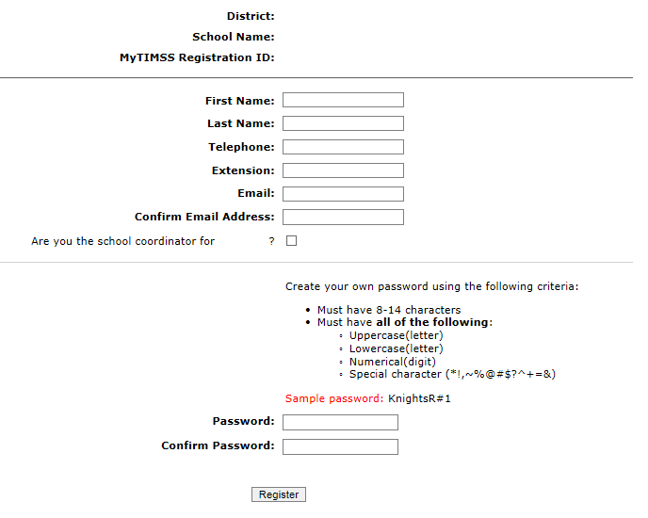

1. Then create a password that meets the password criteria and click **Register.**
2. Once created, your username will be emailed to you. Your username is **not** your email address. Usually the username convention will be LastNameFirstinitialofFirstName, e.g. *JohnsonB*
3. If you check the “Are you the school coordinator for?” box, you will get an additional email with a Summary of upcoming activities.

**Site Home Page**

When you first log in, you will see your school name, grade, and assessment date at the top banner. Please make sure those fields are accurate. If not, contact [TIMSS@westat.com](mailto:TIMSS@westat.com).

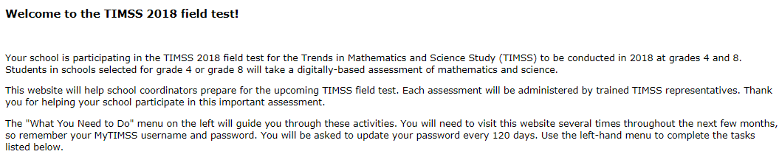

The **“What You Need to Do”** menu on the left will guide you through the upcoming TIMSS activities. You will need to visit this website several times throughout the next few months, so remember your MyTIMSS username and password. You will also be asked to update your password every 120 days. The change password link is at the top right of the page.

To get started, use the left-hand menu to complete the tasks listed below.

* Provide School Information—Now
* Submit Class List—January
* Submit Student List—January
* Prepare for Assessment—January-March

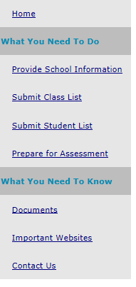

**Provide School Information (PSI)**

The first step in MyTIMSS is to complete the **Provide School Information** page. Click the **Provide School Information** link at the left-hand menu to access this page.

On the PSI page, the information on the left is the current information available for your school. Please make updates in the fields on the right if the current information on the left is blank or incorrect. Make sure to complete both the **“School Contact Information**” and **“School Characteristics”** sections. Then click Save.

Note: You will see this red text banner below until all required fields are filled out completely:



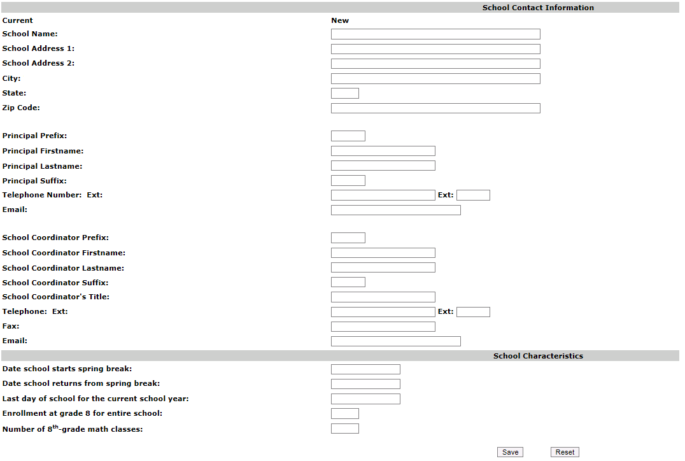

**If you are selected for grade 8, then the last two fields will ask about grade 8 (see pic above). For grade 8 schools, count all math classes **with at least one** 8th-grade student.

If you are selected for grade 4, then the last two fields will ask about grade 4. (see pic below).

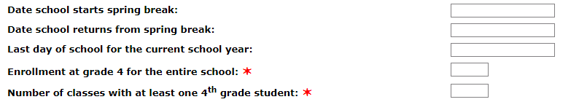

Once complete, you will see this blue text bar shown below at the top of the page.



In January, 2018, we will email to you instructions for submitting class and student lists.

Thank you for you school’s participation in TIMSS 2018!

The TIMSS 2018 Team

855-445-5604

[TIMSS@westat.com](mailto:TIMSS@westat.com)

# Automated Email for all MyTIMSS registrants

(Yellow highlight for merge data fields)

Thank you for creating a MyTIMSS account for the Trends in International Mathematics and Science Study (TIMSS). To access MyTIMSS, go to <https://www.MyTIMSS.com> and enter your username and password.

**Username: [username]**

**Password information:** You created your own password upon registering. Use the **"Forgot Password"** links on MyTIMSS login page if needed. You will be prompted to change your password after 120 days.

MyTIMSS is a secure site that contains confidential information, so it is important to remember your username and password. If you choose to write down this information, store it in a secure place.

If you have questions or need help accessing the website, please contact the TIMSS Help Desk at [TIMSS@westat.com](mailto:TIMSS@westat.com) or at 1-855-445-5604 Monday through Friday between 9 a.m. and 5:00 p.m. ET.

Sincerely,

The TIMSS Team

*NCES is authorized to conduct TIMSS under the Education Sciences Reform Act of 2002 (ESRA 2002, 20 U.S.C. §9543). All of the information provided by school staff and students may be used only for statistical purposes and may not be disclosed, or used, in identifiable form for any other purpose except as required by law (20 U.S.C. §9573 and 6 U.S.C. §151). The U.S. Office of Management and Budget has approved the data collection under OMB# 1850-0695. Individual responses will be combined with those from other participants to produce summary statistics and reports.*

# Automated Email for MyTIMSS School Coordinator registrant

(Yellow highlight for merge data fields; red font for customization)

Dear [school coordinator],  
  
Thank you for creating a MyTIMSS account for the Trends in International Mathematics and Science Study (TIMSS) on <https://www.MyTIMSS.com>. MyTIMSS is a secure website for sharing information and files related to your school’s participation in the TIMSS 2018 Field Test. The website’s **"What You Need to Do"** menu will guide you through the upcoming TIMSS activities.  
  
The first step is to complete the **Provide School Information** page. If you have not already done so, please go to <https://www.MyTIMSS.com/ProvideSchoolInformation.aspx>.   
  
In January, you will need to provide a complete and current list of **all of your school’s fourth-grade/eighth-grade mathematics classes** for the TIMSS team to randomly select two classes to participate in the TIMSS Field Test. You will then be asked to submit lists of **all students in the selected classes**. TIMSS also needs a list of **all of your school’s eighth-grade science teachers** and the courses they teach to assign teacher questionnaires that will be used to link information about science teachers to the assessed students. We will email you in early January with instructions about how to submit the class list, student list, and teacher list through <https://www.MyTIMSS.com>.   
  
Please see the **attached** Summary of School Activities for a complete list of activities associated with your school’s participation in the TIMSS 2018 Field Test.  
  
Thank you very much for participating in TIMSS, and for playing a key role in making the assessment a success in [school name]!  
  
Sincerely,  
  
The TIMSS Team  
  
*NCES is authorized to conduct TIMSS under the Education Sciences Reform Act of 2002 (ESRA 2002, 20 U.S.C. §9543). All of the information provided by school staff and students may be used only for statistical purposes and may not be disclosed, or used, in identifiable form for any other purpose except as required by law (20 U.S.C. §9573 and 6 U.S.C. §151). The U.S. Office of Management and Budget has approved the data collection under OMB# 1850-0695. Individual responses will be combined with those from other participants to produce summary statistics and reports.*

# MyTIMSS Login Page

TIMSS USA LOGO

MyTIMSS

**Login**

MyTIMSS is a restricted-use website that contains information on the Trends in International Mathematics and Science Study (TIMSS).

**Existing User Login** First time visiting the MyTIMSS 2018 site?

Schools can register now!

User Name: Please register

Password:

Forgot Password | Having trouble logging in?

Log In

The National Center for Education Statistics (NCES), within the U.S. Department of Education, conducts TIMSS in the United States as authorized by the Education Sciences Reform Act of 2002 (ESRA 2002, 20 U.S.C. §9543). All of the information you provide may be used only for statistical purposes and may not be disclosed, or used, in identifiable form for any other purpose except as required by law (20 U.S.C. §9573 and 6 U.S.C. §151).

According to the Paperwork Reduction Act of 1995, no persons are required to respond to a collection of information unless such collection displays a valid OMB control number. The valid OMB control number for this voluntary information collection is 1850-0695. The time required to complete this information collection and participate in study activities is estimated to average 240 minutes per school coordinator, including the time to review instructions, search existing data resources, gather the data needed, and complete and review the information collection. If you have any comments or concerns regarding the accuracy of the time estimate(s), suggestions for improving the form, or questions about the status of your individual submission of this form, write directly to: Trends in International Mathematics and Science Study (TIMSS), National Center for Education Statistics, Potomac Center Plaza (PCP), 550 12th St., SW, 4th floor, Washington, DC 20202.

OMB No. 1850-0695, Approval Expires 01/31/2021.

**Notice: You are accessing a U.S. Government information system.**

This warning banner provides privacy and security notices consistent with applicable federal laws, directives, and other federal guidance for accessing this Government system, which includes all devices/storage media attached to this system. This system is provided for Government-authorized use only. Unauthorized or improper use of this system is prohibited and may result in disciplinary action and/or civil and criminal penalties.

(MyTIMSS Login Page screenshot)

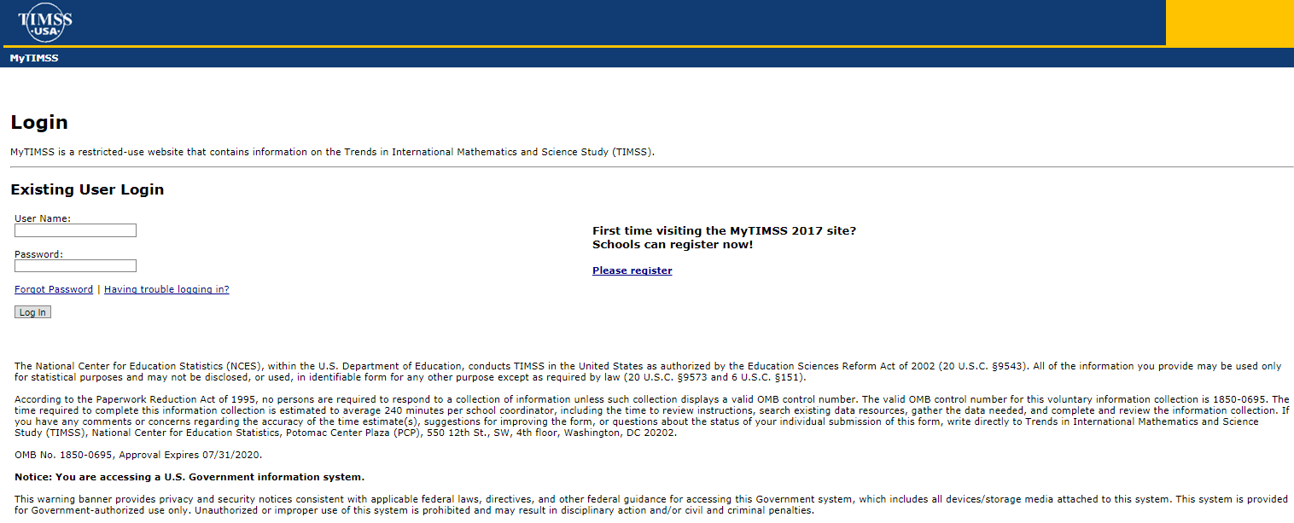

# MyTIMSS Home Page

Welcome to the TIMSS 2018 field test!

Your school is participating in the TIMSS 2018 field test for the Trends in International Mathematics and Science Study (TIMSS) to be conducted in 2018 at grades 4 and 8. Students in schools selected for grade 4 or grade 8 will take a digitally-based assessment of mathematics and science.

This website will help school coordinators prepare for the upcoming TIMSS field test. Each assessment will be administered by trained TIMSS representatives. Thank you for helping your school participate in this important assessment.

The "What You Need to Do" menu on the left will guide you through these activities. You will need to visit this website several times throughout the next few months, so remember your MyTIMSS username and password. You will be asked to update your password every 120 days. Use the left-hand menu to complete the tasks listed below.

* Provide School Information—Fall, 2017
* Submit Class List—January, 2018
* Submit Student List—January, 2018
* Prepare for Assessment—January-February, 2018

(MyTIMSS Home Page screenshot)

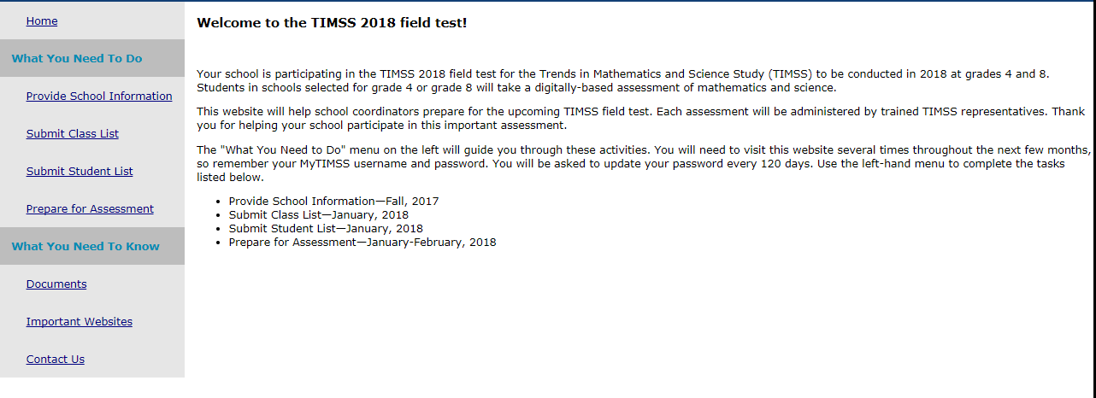

# MyTIMSS Provide School Information (PSI) Page

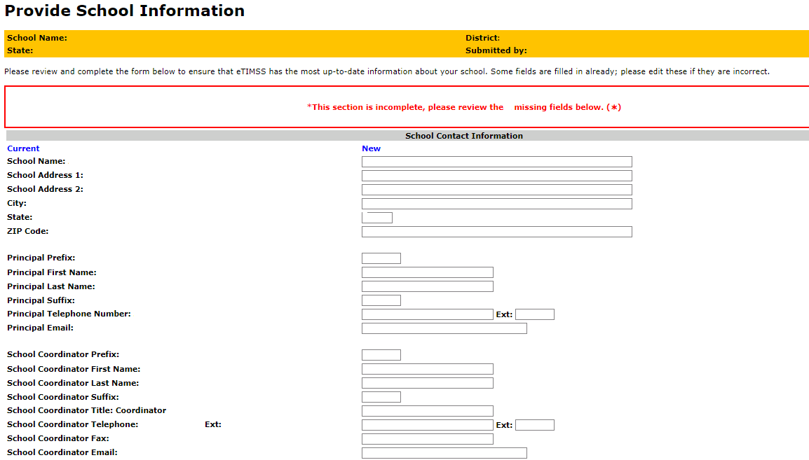

[Grade 4 schools]

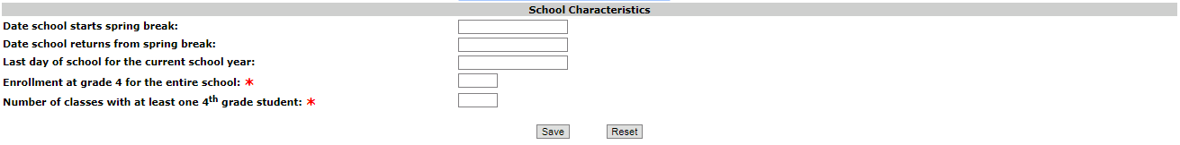

[Grade 8 schools]

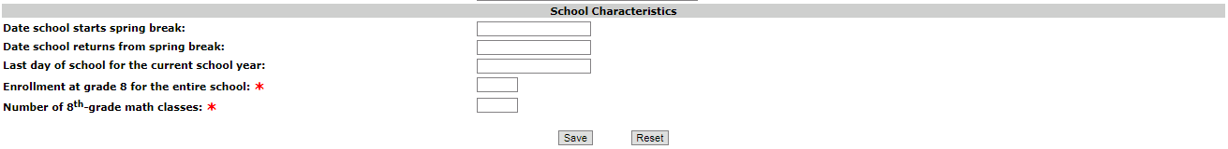

# Email to School Coordinator (SC) to Submit Class and Student Lists—Grade 4

Dear [School Coordinator],

TIMSS needs a complete and current list of **all of your school’s fourth-grade classes** and **all the fourth-grade students in those classes** in order to randomly select classes to participate in the TIMSS Field Test.

Please go to [https://www.mytimss.com](http://www.mytimss.com) to submit your class and student lists. If you have forgotten your login ID please contact the TIMSS hotline at [timss@westat.com](mailto:timss@westat.com) or 1-(855)-445-5604. If you have forgotten your password, you can request a new password on the MyTIMSS login page.

After logging in, select **Submit Class List** from the left hand panel to provide information about your fourth-grade classes. Once you have provided information about all fourth-grade classes, select **Submit Student List** to provide an electronic list of currently enrolled fourth-grade students in your school.

Instructions for **Submit Class List** and **Submit Student List** are attached. These tip sheets and Excel templates can also be found in the **Documents** section of MyTIMSS.

If you have any questions about submitting your list, please email or call the TIMSS E-File Help Desk at [TIMSSefile@westat.com](mailto:TIMSSefile@westat.com) or 1-(855)-445-5604. ​

Please submit your student E-File by **2/7/18.** TIMSS will process your submission and select the sample of fourth-grade classes to be assessed. You will be informed of the classes selected within a few weeks of submitting your lists.

Thank you very much for participating in TIMSS, and for submitting your school's class and student lists!

Sincerely,

TIMSS Field Test Team

Attachments: Grade 4 Submit Class List Tip Sheet; Grade 4 Submit Student List Tip Sheet

*NCES is authorized to conduct this study under the Education Sciences Reform Act of 2002 (ESRA 2002, 20 U.S.C. §9543). All of the information you provide may be used only for statistical purposes and may not be disclosed, or used, in identifiable form for any other purpose except as required by law (20 U.S.C. §9573 and 6 U.S.C. §151).*

# Instructions for Submitting Class Lists—Grade 4

**TIMSS Field Test: Instructions for Grade 4 Submit Class List**

TIMSS needs a complete and current list of all of your school’s fourth-grade classes in order to randomly select classes to be assessed. Typically, two classes are sampled in each school, and all students in the selected classes will be assessed.

On [www.mytimss.com](http://www.mytimss.com/), select **Submit Class List** from the navigation menu on the left. Enter information for each fourth-grade class in the web form. After you have entered information for each class, click on the *Save* button, and another row will appear for you to enter information about another class.

Continue until you have entered information for all classes that contain fourth-grade students. Include the following information for each class:

• *Class Name*

• *Class Group or Track* (If applicable)

• *Number of Students*

• *Class Exclusion Status* (If applicable)

• *Name of Mathematics Teacher*

• *Name of Science Teacher*

When you have entered information for fourth-grade classes in your school, click on the *Finished* button.

**Example 1: Small school with the same Mathematics and Science Teacher for each class**

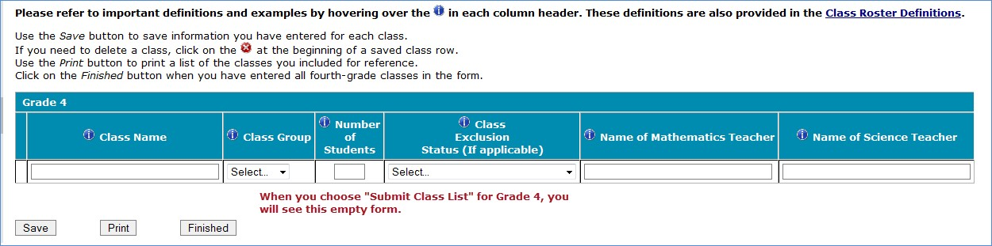

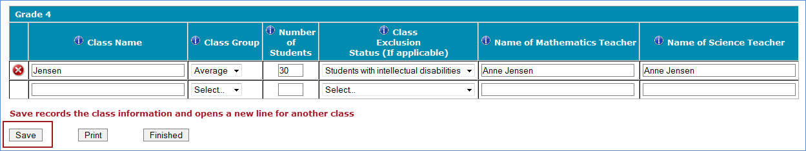

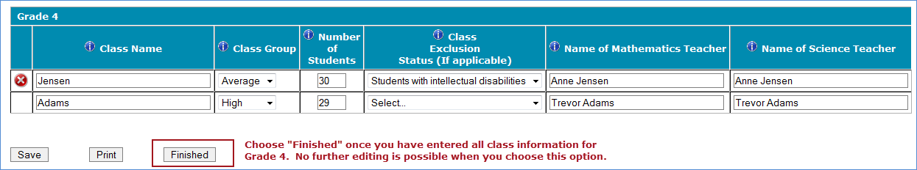

**Example 2: Larger school with multiple Grade 4 classes**

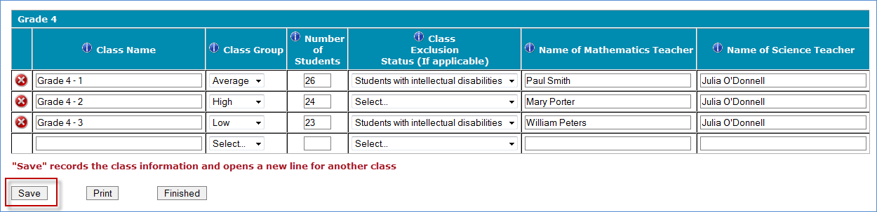

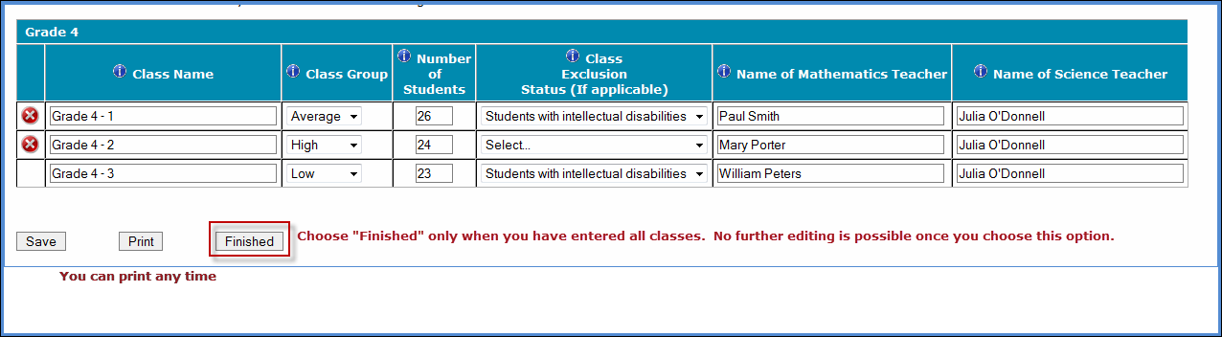

**Additional tips for submitting information about your fourth-grade classes:**

• Refer to the important definitions in the **Class Roster Definitions** document in the **Documents** section of MyTIMSS.

• Record the Class Name that is typically used by your school to refer to the class.

• For classes with students from more than one grade level, include in *Number of Students* only those students in grade 4. For example, if the class has 5 third-graders, 6 fourth-graders, and 4 fifth-graders, enter “6” as the *Number of Students* in this class.

• Use the most current enrollment information.

• Include all classes, even if they typically are excluded from your state testing program, or all students take alternate assessments. You can indicate information about the class in *Class Exclusion Status*.

• Name of mathematics teacher and name of science teacher may be the same.

• Print a list of the classes you included for your future reference using the *Print* button.

**If you need assistance, email** [**TIMSSefile@westat.com**](mailto:TIMSSefile@westat.com) **or call 1-**1-(855)-445-5604**.**

Submit Class List Page – Grade 4 **(screenshot)**

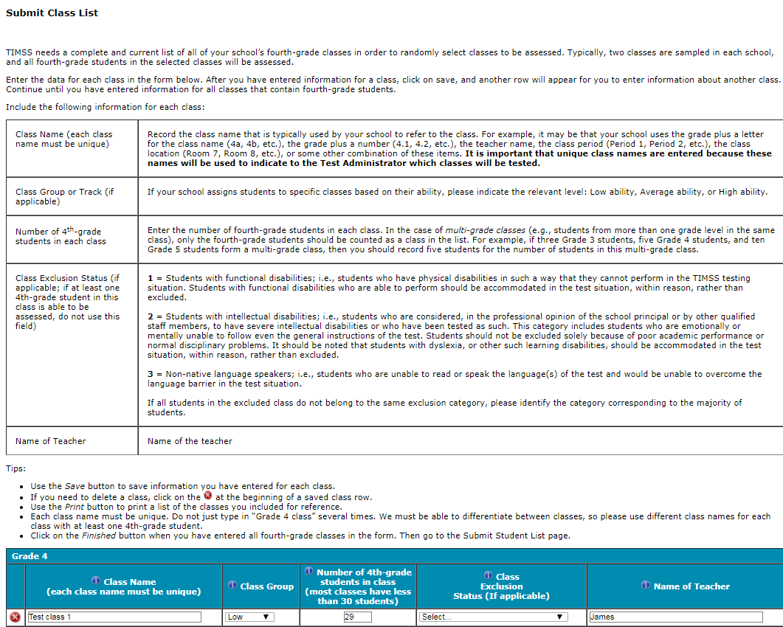

# Instructions for Submitting Student Lists—Grade 4

**TIMSS Field Test: Instructions for Grade 4 Submit Student List**

Along with the list of classes, TIMSS needs a complete and current list of **all students** in grade 4 in order to draw a random sample of classes (and therefore students) to participate in the assessment. Your student data electronic file (E-File) must be submitted as a Microsoft Excel file.

You may use one of the **TIMSS Grade 4 Excel Templates** (located in **Documents** on [www.mytimss.com](http://www.mytimss.com/) and described below) or you may provide an Excel file with the same information. If you cannot submit your student data with this information in an Excel file, please call or email the TIMSS E-File Help Desk at [TIMSSefile@westat.com](mailto:TIMSSefile@westat.com) or 1-(855)-445-5604.

**Step 1 – Compile Data in an Excel File**

Prepare an Excel file with the following data elements for all students in grade 4.

|  |  |
| --- | --- |
| **Data Element** | **Description** |
| Class | The fourth-grade class the student is enrolled in. Please use the  same class names you used in **Submit Class List.** |
| Teacher Name | Teacher of the above named class |
| Student Name | The preferred format is First Name, Middle Name (or Initial), and  Last Name in separate columns. However, TIMSS will accept student names in one column. |
| Sex | Codes (numeric or text) for Male/Female |
| Date of Birth | The preferred format is Month of Birth and Year of Birth in  separate columns. However, TIMSS will accept Date of Birth in one column. |
| Student with a Disability  (SD) Status | School-defined codes for:  • Yes, IEP: Student has an Individualized Education Plan (IEP).  Students with 504 plans that need accommodations can be coded this value as well.  • No, not SD:  • Information unavailable at this time. |
| English Language  Learner (ELL) Status | School-defined codes for:  • Yes, ELL  • No, not ELL  • Information unavailable at this time. |

You may use one of the templates provided or create your own Excel file with these data for each student. It is preferred that you include column headers as the first row in your E-File, as in these templates. However, E-Files without column headers will be accepted.

*Template 1* has student name in three separate columns, and month of birth and year of birth in two separate columns.



*Template 2* has student name in one column, and date of birth in one column.



Tips for ensuring the E-File process goes smoothly:

• Use the template or provide column headers. Student information should begin on the second row. There should be no empty rows within the student data.

• Be sure to give your file a unique, descriptive name. Within Excel, click on *File*, then *Save As*,

and give your file a name such as “Your School Name Grade 4.xls.”

• The first row of data in your file will be read as the column header unless you indicate otherwise on the **Submit Student List** webpage. Each succeeding row will be considered a student record.

• There should be only one worksheet with data in the Excel file. If there are other worksheets, they must not contain any data.

**Step 2 – Upload Your Excel File**

Once your file is prepared and checked for accuracy and completeness, login to [www.mytimss.com](http://www.mytimss.com/) and

select “Submit Student List” from the left-hand menu.

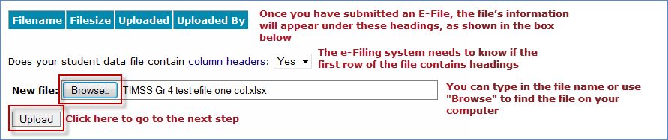

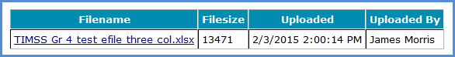

**Step 3 – Identify Your Columns**

We need to know what information is in each column of your student data file (E-File). If you provided column headers in your E-File (preferred), they are displayed in **Column Heading Is** in the table. If you did not provide column headers, **Column Heading Is** will contain numbers for each column in your submitted E-File. Click on the down arrows in **Your Column Contains** to select descriptions for each column header. If there is no appropriate description in the drop-down list, please select N/A.

Select *Next* after all columns have been identified.

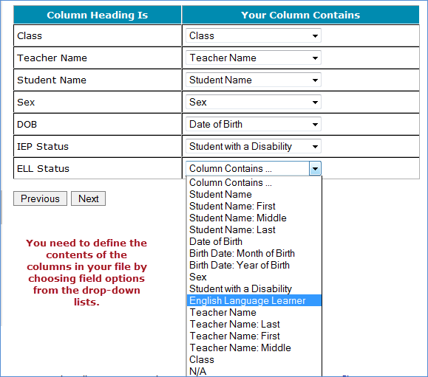

**Step 4 – Match Your Values to TIMSS Codes**

TIMSS also needs to know the values for some of the columns in your E-File. The tables contain the following information for each column:

• Your Values: The values in your E-File

• TIMSS Codes: Click on the down arrow and select the TIMSS Code that best matches Your Values

• Number: The number of students in your E-File with that value

• Percentage: The percentage in your E-File with that value

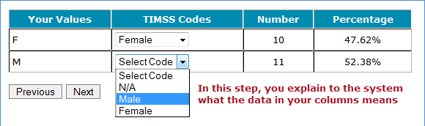

Use the *Previous* and *Next* buttons to navigate from column header to column header.

If there is an error in your data file, exit E-File, correct the problem in your Excel file, and upload the file again.

**Step 5 – Verify Your E-File**

The table in this section summarizes the information you have provided on your student list (E-File). Please review this summary and verify that the information is correct. *Total Enrollment* at the bottom of the table should match the number of students in your E-File, and the total number of students currently enrolled in grade 4.

Record whether the information is correct or incorrect by selecting the appropriate button at the bottom of the page. Then click the *Submit* button. If you select INCORRECT, you will need to correct your E-File and resubmit it.

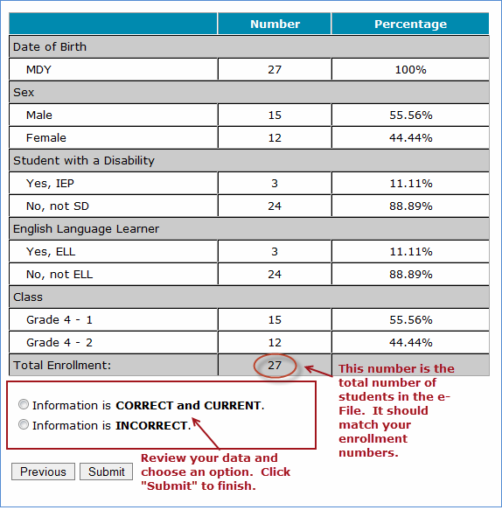

**If you need assistance, please contact the TIMSS E-File Help Desk at** [**TIMSSefile@westat.com**](mailto:TIMSSefile@westat.com) **or 1-(855)-445-5604.**

Submit Student List Page – Grade 4 **(screenshot)**

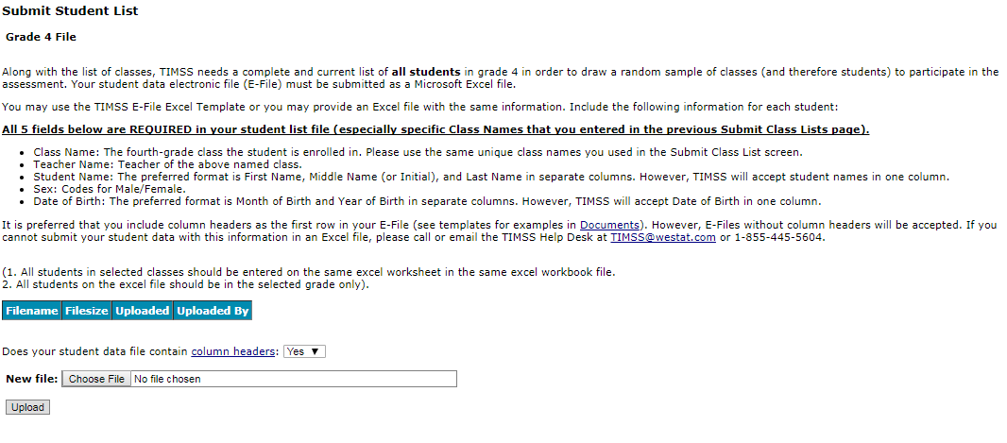

# Email to School Coordinator (SC) to Submit Class and Student Lists—Grade 8

Dear [School Coordinator],

TIMSS needs a complete and current list of **all of your school’s eighth-grade mathematics classes** and **all the eighth-grade students in those classes** in order to randomly select classes to participate in the TIMSS Field Test. TIMSS also needs a list of your school’s eighth-grade science teachers and the courses they teach in order to link information about science teachers to the assessed students.

Please go to [https://www.mytimss.com](http://www.mytimss.com/) to submit your class and student lists. If you have forgotten your login ID please contact the TIMSS hotline at [timss@westat.com](mailto:timss@westat.com) or 1-(855)-445-5604. If you have forgotten your password, you can request a new password on the MyTIMSS login page.

After logging in, select **Submit Class List** from the left hand panel to provide information about your eighth-grade mathematics classes and science teachers. Once you have provided information about all eighth-grade mathematics classes and science teachers, select **Submit Student List** to provide an electronic list of currently enrolled eighth-grade students in your school.

Instructions for **Submit Class List** and **Submit Student List** are attached. These tip sheets and Excel templates can also be found in the **Documents** section of MyTIMSS. An optional webinar will be held on XXXXXXXX to review the Submit Class and Submit Student procedures. Registration information for the webinar will be sent to you in a separate mail. The webinar will be recorded for viewing at a later time as well.

If you have any questions about submitting your list, please email or call the TIMSS E-File Help Desk at [TIMSSefile@westat.com](mailto:TIMSSefile@westat.com) or 1-(855)-445-5604. ​

Please submit your student E-File by **2/7/18.** TIMSS will process your submission and select the sample of eighth-grade mathematics classes to be assessed. You will be informed of the classes selected within a few weeks of submitting your lists.

Thank you very much for participating in TIMSS, and for submitting your school's class and student lists!

Sincerely,

TIMSS Field Test Team

Attachments: Grade 8 Submit Class List Tip Sheet; Grade 8 Submit Student List Tip Sheet

*NCES is authorized to conduct this study under the Education Sciences Reform Act of 2002 (ESRA 2002, 20 U.S.C. §9543). All of the information you provide may be used only for statistical purposes and may not be disclosed, or used, in identifiable form for any other purpose except as required by law (20 U.S.C. §9573 and 6 U.S.C. §151).*

# Instructions for Submitting Class Lists—Grade 8

**TIMSS Field Test: Instructions for Grade 8 Submit Class List**

TIMSS needs a complete and current list of all of your school’s eighth-grade mathematics classes in order to randomly select classes to be assessed. Typically, two classes are sampled in each school, and all students in the selected classes will be assessed.

**Step 1 – Enter information about all eighth-grade mathematics classes**

On [www.mytimss.com](http://www.mytimss.com/), select **Submit Class List** from the navigation menu on the left. Enter information for each eighth-grade mathematics class in the web form. After you have entered information for each mathematics class, click on the *Save* button, and another row will appear for you to enter information about another mathematics class. Continue until you have entered information for all mathematics classes that contain eighth-grade students.

Include the following information for each class:

• *Class Name*

• *Class Group or Track* (If applicable)

• *Number of Students*

• *Class Exclusion Status* (If applicable)

• *Name of Mathematics Teacher*

**Example:**

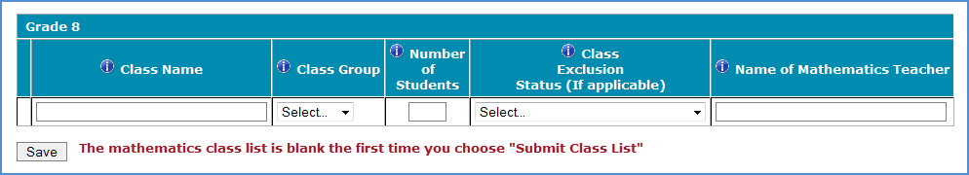

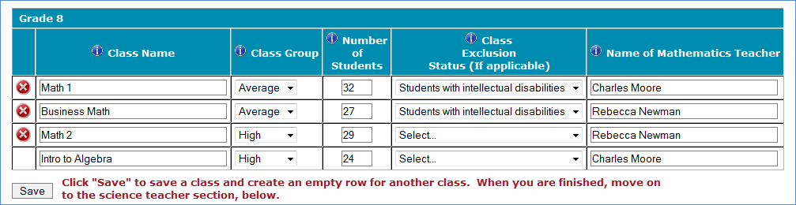

**Step 2 – Enter information about your eighth-grade science teachers**

TIMSS also needs a complete and current list of all of your school’s eighth-grade science teachers in order to link information about science teachers to the assessed students. Enter each teacher’s name and the course the teacher teaches (e.g. biology, integrated science) into the form. Click *Save* after entering each teacher. Continue until you have entered information about all science teachers who teach eighth-grade students.

**Example:**

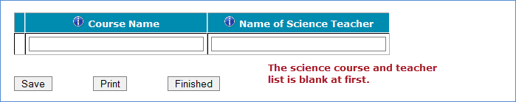

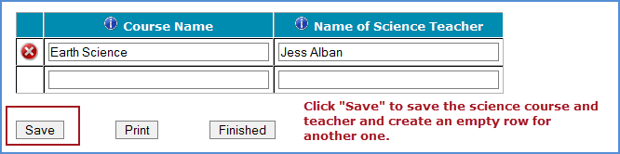

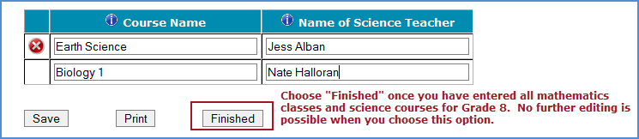

When you have entered information for eighth-grade mathematics classes, and eighth-grade science teachers, in your school, click on the *Finished* button.

**Additional tips for submitting information about your eighth-grade mathematics classes:**

• Refer to the important definitions in the **Class Roster Definitions** document in the **Documents** section of MyTIMSS.

• Record the Class Name that is typically used by your school to refer to the class.

• For math classes with students from more than one grade level, include in *Number of Students* only those students in grade 8. For example, if the class has 5 seventh-graders, 6 eighth- graders, and 4 ninth-graders, enter “6” as the *Number of Students* in this class.

• Use the most current enrollment information.

• Include all classes, even if they typically are excluded from your state testing program, or all students take alternate assessments. You can indicate information about the class in *Class Exclusion Status*.

• Examples of science courses include: general science, integrated science, biology, physical science. Use the course names that you use in your school.

• Print a list of the mathematics classes and science teachers you included for your future reference using the *Print* button.

**If you need assistance, email** [**TIMSSefile@westat.com**](mailto:TIMSSefile@westat.com) **or call 1-(855)-445-5604.**

Submit Class List Page – Grade 8 **(screenshot)**

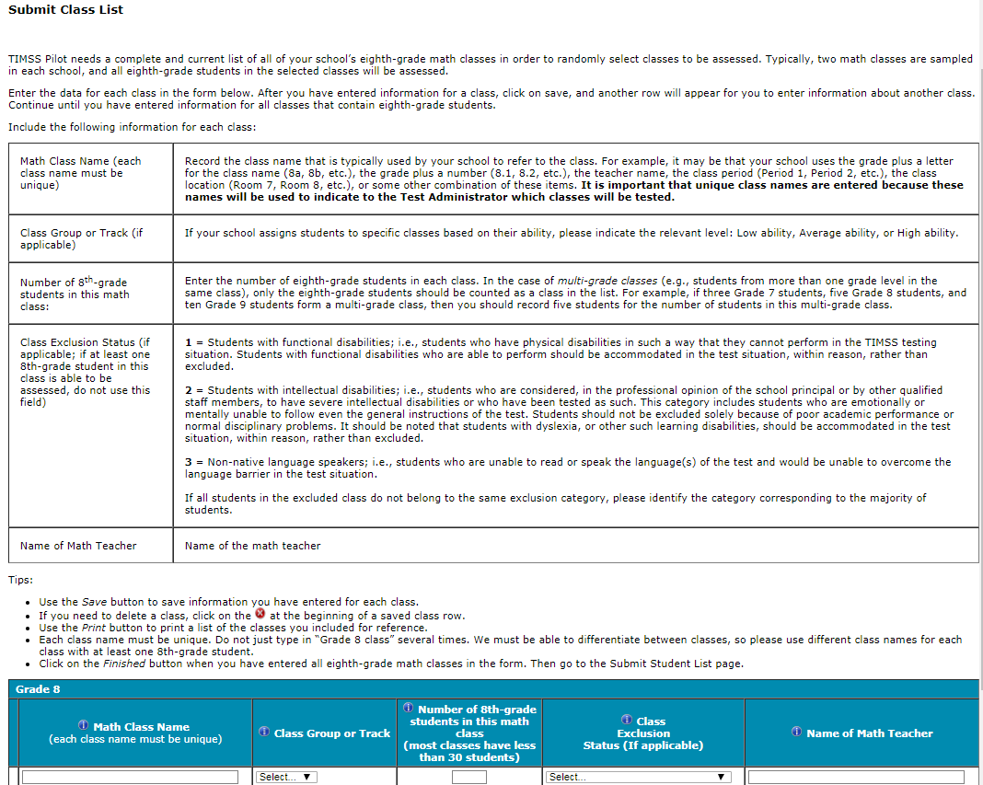

# Instructions for Submitting Student Lists—Grade 8

**TIMSS Field Test: Instructions for Grade 8 Submit Student List**

Along with the list of classes, TIMSS needs a complete and current list of **all students** in grade 8 in order to draw a random sample of mathematics classes (and therefore students) to participate in the assessment. Your student data electronic file (E-File) must be submitted as a Microsoft Excel file.

You may use one of the **TIMSS Grade 8 Excel Templates** (located in **Documents** on [www.mytimss.com](http://www.mytimss.com/) and described below) or you may provide an Excel file with the same information. If you cannot submit your student data with this information in an Excel file, please call or email the TIMSS E-File Help Desk at [TIMSSefile@westat.com](mailto:TIMSSefile@westat.com) or 1-(855)-445-5604.

**Step 1 – Compile Data in an Excel File**

Prepare an Excel file with the following data elements for all students in grade 8.

|  |  |
| --- | --- |
| **Data Element** | **Description** |
| Mathematics Class | The mathematics class the student is enrolled in. Please use the  same class names you used in **Submit Class List.** |
| Mathematics Teacher | Teacher of the above named mathematics class that the student is  taking |
| Science Teacher | Name of science teacher who teaches science to each student |
| Student Name | The preferred format is First Name, Middle Name (or Initial), and  Last Name in separate columns. However, TIMSS will accept student names in one column. |
| Sex | Codes (numeric or text) for Male/Female |
| Date of Birth | The preferred format is Month of Birth and Year of Birth in  separate columns. However, TIMSS will accept Date of Birth in one column. |
| Student with a Disability  (SD) Status | School-defined codes for:  • Yes, IEP: Student has an Individualized Education Plan (IEP).  Students with 504 plans that need accommodations can be  coded this value as well.  • No, not SD:  • Information unavailable at this time. |
| English Language  Learner (ELL) Status | School-defined codes for:  • Yes, ELL  • No, not ELL  • Information unavailable at this time. |

You may use one of the templates provided or create your own Excel file with these data for each student. It is preferred that you include column headers as the first row in your E-File, as in these templates. However, E-Files without column headers will be accepted.

*Template 1* has student name in three separate columns, and month of birth and year of birth in two separate columns.



*Template 2* has student name in one column, and date of birth in one column.



Tips for ensuring the E-File process goes smoothly:

• Use the template or provide column headers. Student information should begin on the second row. There should be no empty rows within the student data.

• Be sure to give your file a unique, descriptive name. Within Excel, click on *File*, then *Save As*,

and give your file a name such as “Your School Name Grade 8.xls.”

• The first row of data in your file will be read as the column header unless you indicate otherwise on the **Submit Student List** webpage. Each succeeding row will be considered a student record.

• There should be only one worksheet with data in the Excel file. If there are other worksheets, they must not contain any data.

**Step 2 – Upload Your Excel File**

Once your file is prepared and checked for accuracy and completeness, login to [www.mytimss.com](http://www.mytimss.com/) and select “Submit Student List” from the left-hand menu.

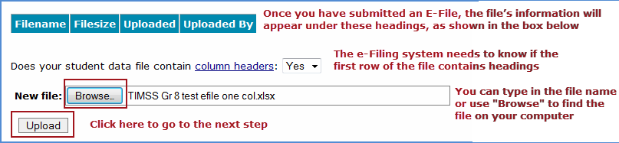

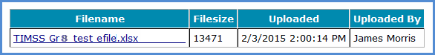

**Step 3 – Identify Your Columns**

We need to know what information is in each column of your student data file (E-File). If you provided column headers in your E-File (preferred), they are displayed in **Column Heading Is** in the table. If you did not provide column headers, **Column Heading Is** will contain numbers for each column in your submitted E-File. Click on the down arrows in **Your Column Contains** to select descriptions for each column header. If there is no appropriate description in the drop-down list, please select N/A.

Select *Next* after all columns have been identified.

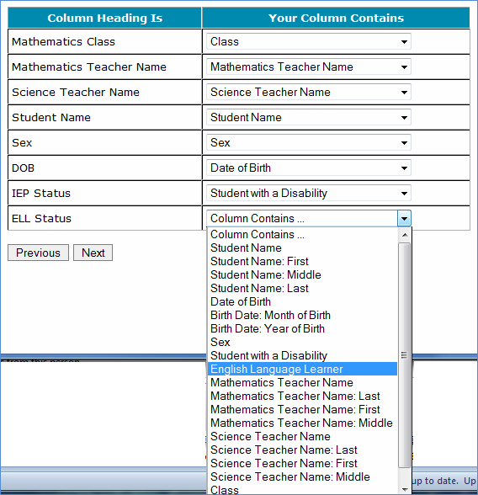

**Step 4 – Match Your Values to TIMSS Codes**

TIMSS also needs to know the values for some of the columns in your E-File. The tables contain the following information for each column:

• Your Values: The values in your E-File

• TIMSS Codes: Click on the down arrow and select the TIMSS Code that best matches Your Values

• Number: The number of students in your E-File with that value

• Percentage: The percentage in your E-File with that value



Use the *Previous* and *Next* buttons to navigate from column header to column header.

If there is an error in your data file, exit E-File, correct the problem in your Excel file, and upload the file again.

**Step 5 – Verify Your E-File**

The table in this section summarizes the information you have provided on your student list (E-File). Please review this summary and verify that the information is correct. *Total Enrollment* at the bottom of the table should match the number of students in your E-File, and the total number of students currently enrolled in grade 8.

Record whether the information is correct or incorrect by selecting the appropriate button at the bottom of the page. Then click the *Submit* button. If you select INCORRECT, you will need to correct your E-File and resubmit it.

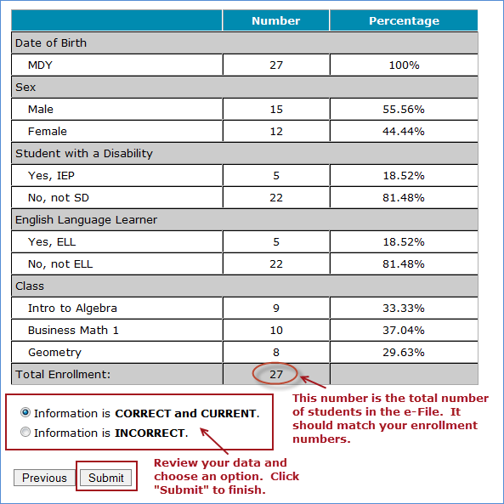

**If you need assistance, please contact the TIMSS E-File Help Desk at** [**TIMSSefile@westat.com**](mailto:TIMSSefile@westat.com) **or 1-(855)-445-5604.**

Submit Student List Page – Grade 8 (screenshot)

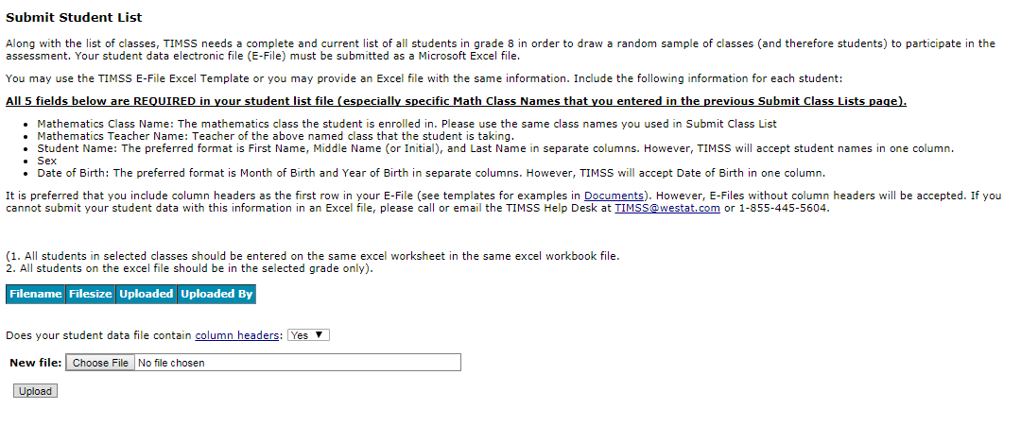

# MyTIMSS Prepare for Assessment Page

(red font is customized depending on grade school was selected for)

**Prepare For Assessment**

Thank you for providing information about all the fourth-grade classes / eighth-grade math classes in your school! In a few days you will receive an email informing you that your sample of classes has been selected. Return to this webpage when you receive the email from TIMSS@westat.com: “The list of students selected to participate in TIMSS is available in the Student-Teacher Linkage Form (STLF)”

**Please note the following:**

**Student-Teacher Linkage Forms (STLF)** –The forms list the students who have been selected to participate in the assessment at your school. You will get an email when this form is ready.

**Student Tracking Form (STF)–**The forms list the students who have been selected to participate in the assessment at your school. Instructions on how to access and review the forms are in the Documents section on this website. The STF and TTF will become available about a week after the STLF has been posted.

**Teacher Tracking Form (TTF)** –The forms list the teachers who have been selected to participate in the online teacher questionnaire at your school. Instructions on how to access and review the forms are in the Documents section on this website. The STF and TTF will become available about a week after the STLF has been posted.

**Sample Parent Notification Letter and Facts for Parents about TIMSS**. Starting mid-February and after you submit student lists, your school will receive a FedEx packet of TIMSS materials including a TIMSS Parent FAQ, a sample hardy copy parent/guardian notification letter, and student appointment cards.

A sample parent/guardian notification letter is in the Documents section for you to customize and print on your school letterhead. Please distribute the parent notification letter and the Parent FAQ (from our FedEx mailing to you) to the parents of the selected students prior to the assessment. Additionally, a Spanish version of the letter is available in the Documents page. You can also share the Parent FAQ link available here: https://nces.ed.gov/timss/parents/.

As your assessment date approaches, your Test Administrator will be contacting you to finalize the assessment day activities.

**Prepare for Assessment page** (Screenshot below and will be updated with text above)

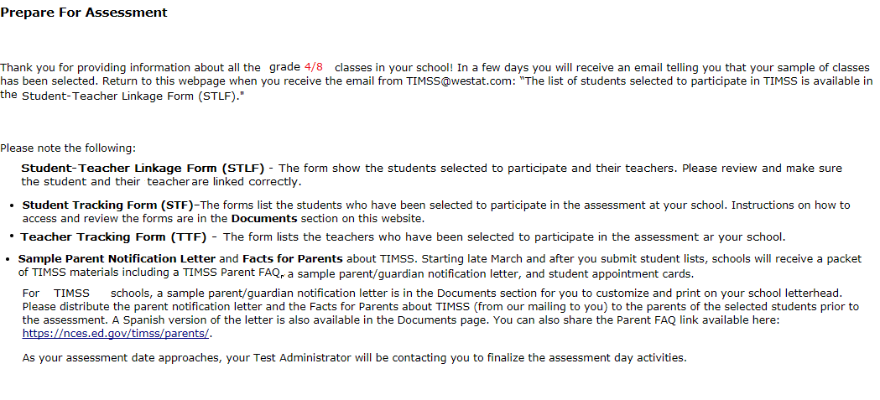

# Student-Teacher Linkage Form (STLF) Email

(yellow highlight for mail merge)

Dear [school coordinator],

The list of students selected to participate in TIMSS is available in the Student-Teacher Linkage Form (STLF)!

The **Student-Teacher Linkage Form (**STLF) lists the students who have been selected to participate in the assessment at your school. This list is based on the class and student information you submitted. To access the STLF, please login at www.mytimss.com, then go to **Prepare for Assessment** and select **“Click here to download the STLF.”** In that one STLF excel file, there is a worksheet for each set of classes or students selected, so please make sure to review each worksheet in the STLF excel file. Most schools will have two worksheets, one for each class.



For the Student-Teacher Linkage Form (STLF), you will only need to make sure the students on that list match the teachers to the selected students in the header of Column 6. If you see any errors, please contact the TIMSS Hotline at [TIMSS@westat.com](mailto:TIMSS@westat.com) or 855-445-5604. Please do not email the list back to us.

In a week of the STLF posting, you will receive an email informing you that the final list of selected students and teachers are available. These lists, called the Student Tracking Forms (STF) and Teacher Tracking Forms (TTF) will be posted on this same **Prepare for Assessment** page.

Thank you very much for participating in TIMSS, and for submitting your school's class and student lists!

Sincerely,

The TIMSS Team

*NCES is authorized to conduct this study under the Education Sciences Reform Act of 2002 (ESRA 2002, 20 U.S.C. §9543). All of the information you provide may be used only for statistical purposes and may not be disclosed, or used, in identifiable form for any other purpose except as required by law (20 U.S.C. §9573 and 6 U.S.C. §151).*

# Student Tracking Form (STF) and Teacher Tracking Form (TTF) Email

(yellow highlight for mail merge; red for customization)

Dear [School Coordinator],

Thank you for providing information about all the fourth-grade/eighth-grade classes in your school! The list of students and teachers selected to participate in TIMSS is now available in the Student Tracking Forms (STF) and Teacher Tracking Forms (TTF) available on the MyTIMSS website. Please see below for more details about the forms and parent notification.

* Student Tracking Form (STF) –The forms list the students who have been selected to participate in the assessment at your school. Instructions on how to access and review the forms are attached.
* Teacher Tracking Form (TTF) –The forms list the teachers who have been selected to participate in the online teacher questionnaire at your school. Instructions on how to access and review the forms are attached.
* Sample Parent Notification Letter and Facts for Parents about TIMSS 2018 (Parent FAQ) – A sample parent/guardian notification letter is attached for you to customize and print on your school letterhead. Please distribute the parent notification letter and the *Facts for Parents about TIMSS 2018* to the parents of the selected students prior to the assessment. A Spanish version of the letter is available on the MyTIMSS site under **Documents.**
* FedEx Shipment
  + Within a week, a FedEx shipment of hard-copies of the *Facts for Parents* *about TIMSS 2018 (Parent FAQ)* will be delivered to you. You can also distribute them electronically or share the Parent FAQ link available here: <https://nces.ed.gov/timss/parents/>
  + Student Appointment/invitations cards to give to selected students will be sent to you as well.

As your assessment date approaches, your Test Administrator will be contacting you to finalize the assessment day activities and discuss accommodations, if necessary.

If you have any questions, please do not hesitate to call 855-445-5604 or send an email to [TIMSS@westat.com](mailto:TIMSS@westat.com). You may also get more information about this study by visiting the TIMSS website at <http://nces.ed.gov/timss>.

Thank you for your assistance with this study!

Sincerely,

The TIMSS Team

Attachments:

Sample Parent Notification Letter

Facts for Parents about TIMSS 2018 (Parent FAQ)

STF and TTF Instructions

*NCES is authorized to conduct this study under the Education Sciences Reform Act of 2002 (ESRA 2002, 20 U.S.C. §9543). All of the information you provide may be used only for statistical purposes and may not be disclosed, or used, in identifiable form for any other purpose except as required by law (20 U.S.C. §9573 and 6 U.S.C. §151).*

# Instructions for Student Tracking Form (STF) and Teacher Tracking Form (TTF)

**Reviewing the Student Tracking Form (STF)**

The **Student Tracking Form** (STF) lists the students who have been selected to participate in the assessment at your school. This list is based on the student information you submitted. You can take notes on this form in preparation for the pre-assessment call in which the Test Administrator will ask you about any updates to this form over the phone. To access the STF, please login at www.mytimss.com, then go to **Prepare for Assessment** and select **“Click here to download the STF.”** Student Appointment/invitations cards to give to selected students will be sent to you in a FedEx delivery.

As the first step in reviewing the Student Tracking Form, please verify the student information for accuracy after you open the excel file you just downloaded. See below for what should be reviewed. Please also make sure the school name and students match what you expect.

* Student’s name is listed in **Column 1**.
* Date of birth is listed in **Column 3.**
* Gender (using codes—1 for female and 2 for male) is listed in **Column 4**.
* Exclusion status in **Column 5.**
* Participation status in **Column 6.**

**Student Exclusions and Accommodations**

If a student is to be excluded from the assessment because he or she requires an accommodation, please make a note in column 7 using the codes at the bottom of the STF.

**Participation Status + Newly-enrolled or no-longer-enrolled students**

If many of the students listed in the STF are not enrolled in the school, please contact TIMSS@westat.com ASAP, but you do not need to contact TIMSS@westat.com if only 1 to 3 students are no longer enrolled or are newly enrolled. These new or no-longer-enrolled students can be discussed with your Test Administrator when they call you for the pre-assessment call (usually 1-2 weeks before assessment date). You can make a note on the form regarding these students in the first column in column 7 using the status codes shown at the bottom of the STF. You can also use status codes 1 through 4 to provide more information about a student.

**Updates and Questions**

If you have updates to the STF, please have the form ready for the pre-assessment call. You can also provide the hardcopy to the Test Administrator when they come to your school on assessment day. If you have any questions about completing this form, please address them with your Test Administrator when they contact you. For urgent questions on the STF, you can also contact the TIMSS Help Desk (TIMSS@westat.com). The STF is just for you to take notes on in preparation for the pre-assessment call so you know parents of which students should be notified. Please do not send the STF or TTF back to us. You can however give it to the Test Administrator in person, if you would like, when they come on the assessment day. Instructions for reviewing the Teacher Tracking Form (TTF) are on the next page.

**Reviewing the Teacher Tracking Form (TTF)**

The **Teacher Tracking Form** (TTF) lists the teachers who have been selected to complete the teacher questionnaire at your school. This list is based on the teacher information you submitted. You can take notes on this form in preparation for the pre-assessment call in which the Test Administrator will ask you about any updates to this form over the phone. To access the TTF, please login at www.mytimss.com, then go to **Prepare for Assessment** and select **“Click here to download the TTF.”**

As the first step in reviewing the TTF, please verify the teacher information for accuracy after you open the excel file you just downloaded. See below for what should be reviewed. Please also make sure the school name and teachers match what you expect.

* Teacher’s name is listed in **Column 1**.
* Year of birth is listed in **Column 3**.
* Gender (using codes—1 for female and 2 for male) is listed in **Column 4**.
* Main subject in **column 5.**
* Questionnaire status is listed in **Column 6.**

**If a selected teacher is no longer at the school, please make a note of this on the TTF. You do not need to contact us about new teachers not already listed on the TTF.**

Teachers will be emailed login access to complete the teacher questionnaire prior to assessment day.

**Updates and Questions**

If you have updates to the TTF, please have the form ready for the pre-assessment call. You can also provide the hardcopy to the Test Administrator when they come to your school on assessment day. If you have any questions with completing this form, please address them with your Test Administrator when they contact you. For urgent questions on the TTF, you can also contact the TIMSS Help Desk (TIMSS@westat.com). The TTF is just for you to take notes on in preparation for the pre-assessment call. Please do not send it back to us. You can however give it to the Test Administrator in person, if you would like, when they come on assessment day.

Thank you for your assistance with this study!

The TIMSS 2018 Team

[TIMSS@westat.com](mailto:ICILS@westat.com);

855-445-5604

# Student-Teacher Linkage Form (STLF) Template

(Template below is an example from 2015. Does not include real names. Will be updated for 2018 when IEA provides 2018 STLF templates).

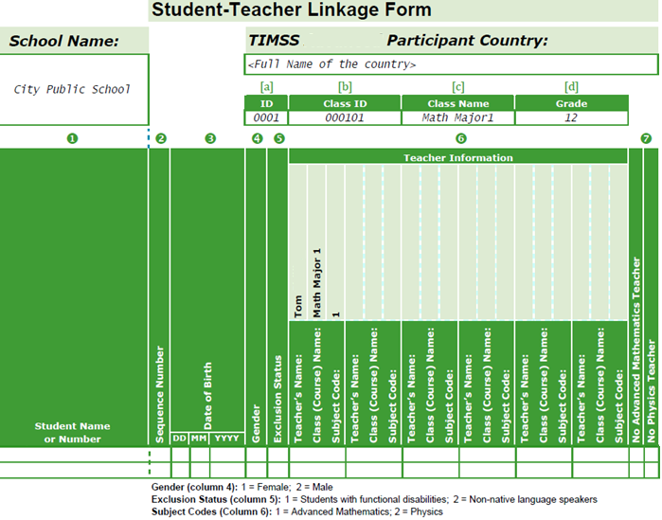

# Student Tracking Form (STF) Template

(Below is a blank template from 2015. Will be updated when the IEA provides updated STF templates).

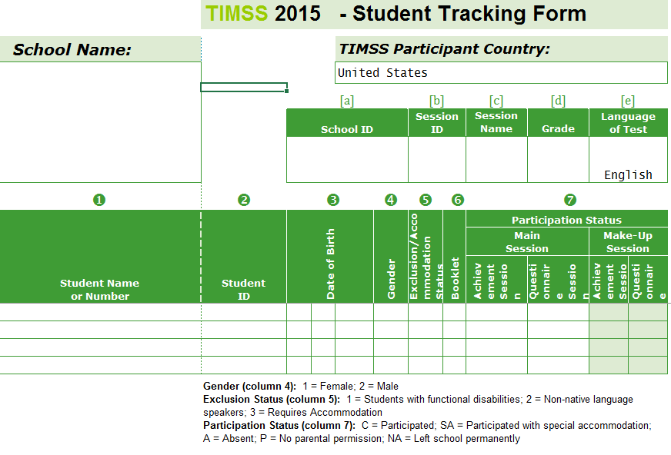

# Teacher Tracking Form (TTF) Template

(Below is a blank template from 2015. Will be updated when the IEA provides updated TTF templates).

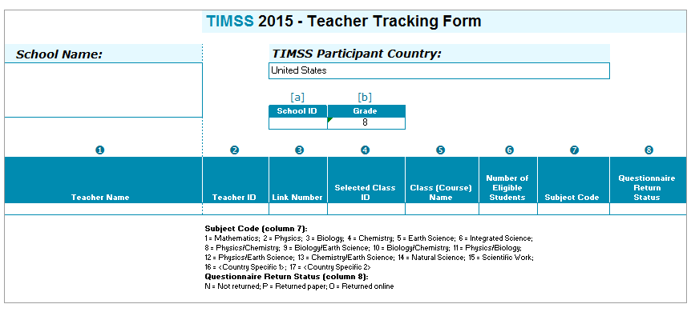

# MyTIMSS Documents Page

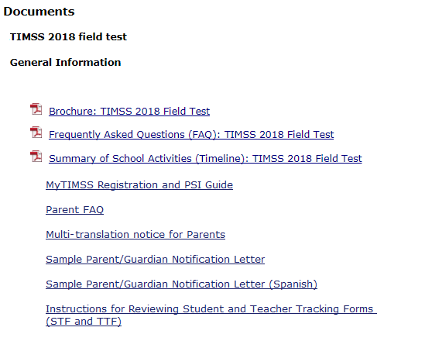

# MyTIMSS Important Websites and Contact Us Pages

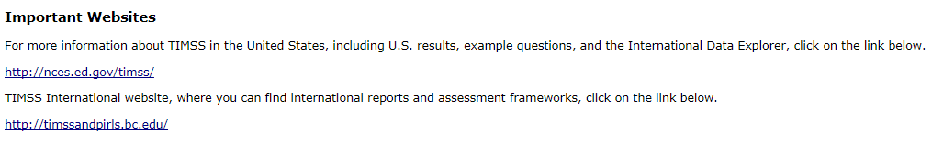

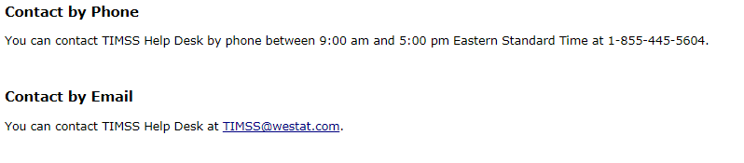

# School Principal Questionnaire Login Card/Email

**Front of Card:**

Welcome to TIMSS!

Your school is participating in the field test for Trends in International Mathematics and Science Study (TIMSS) 2018. This online questionnaire seeks information about schools and provides important context to understanding the achievement of students taking the assessment.

Please go to the web address (URL) given below and log in to the online questionnaire with your “School ID” and “Password”, which are printed on the label attached below. Please contact the TIMSS Help Desk (TIMSS@westat.com) if you have problems logging on.

The website link is: <https://portal.myTIMSS.us/>

[Insert Label]

The online questionnaire does NOT require JavaScript or cookies to work. Responses are saved automatically as you go from question to question. The “Table of Contents” link on the bottom of each page provides an overview of all questions and whether you have completed them. You may leave the questionnaire at any time and log in again later. See notes on the back of this card.

OMB# 1850-0695 (expires 01/31/2021).

**Back of Card:**

NOTES

* Please use the Previous and Next buttons to navigate backward and forward
* You may exit the questionnaire at any time and log in again later— all of your responses will be saved automatically.
* The Table of Contents provides an overview of all questions and shows whether you have completed all questions.
* To exit the Table of Contents, click on any question link or section header.
* If you would like a printed copy of the online questionnaire, click on the “Prepare Printer Version” link on the Table of Contents page.
* It is estimated that it will take approximately 20 minutes to complete the questionnaire.
* If you have problems accessing the online questionnaire or need assistance, please contact the TIMSS help desk at 1-855-445-5604 or email TIMSS@westat.com.
* If you would prefer to complete a paper questionnaire, please contact your TIMSS School Coordinator.

Thank you for the thought, time, and effort you have put into completing the questionnaire!

*NCES is authorized to conduct TIMSS under the Education Sciences Reform Act of 2002 (ESRA 2002, 20 U.S.C. §9543). All of the information provided by school staff and students may be used only for statistical purposes and may not be disclosed, or used, in identifiable form for any other purpose except as required by law (20 U.S.C. §9573 and 6 U.S.C. §151). The U.S. Office of Management and Budget has approved the data collection under OMB# 1850-0695. Individual responses will be combined with those from other participants to produce summary statistics and reports.*

# Teacher Questionnaire Login Card/Email

**Front of Card:**

Welcome to TIMSS!

Your school is participating in the field test for Trends in International Mathematics and Science Study (TIMSS) 2018. This online questionnaire seeks information about teachers’ academic and professional backgrounds, classroom resources, instructional practices, and attitudes toward teaching.

Please go to the web address (URL) given below and log in to the online questionnaire with your “Teacher ID” and “Password”, which are printed on the label attached below. Please contact the TIMSS Help Desk (TIMSS@westat.com) if you have problems logging on.

The website link is: <https://portal.myTIMSS.us/>

[Insert Label]

The online questionnaire does NOT require JavaScript or cookies to work. Responses are saved automatically as you go from question to question. The “Table of Contents” link on the bottom of each page provides an overview of all questions and whether you have completed them. You may leave the questionnaire at any time and log in again later. See notes on the back of this card.

OMB# 1850-0695 (expires 01/31/2021).

**Back of Card:**

NOTES

* Please use the Previous and Next buttons to navigate backward and forward
* You may exit the questionnaire at any time and log in again later— all of your responses will be saved automatically.
* The Table of Contents provides an overview of all questions and shows whether you have completed all questions.
* To exit the Table of Contents, click on any question link or section header.
* If you would like a printed copy of the online questionnaire, click on the “Prepare Printer Version” link on the Table of Contents page.
* It is estimated that it will take approximately 30 minutes to complete the questionnaire.
* If you have problems accessing the online questionnaire or need assistance, please contact the TIMSS help desk at 1-855-445-5604 or email TIMSS@westat.com.
* If you would prefer to complete a paper questionnaire, please contact your TIMSS School Coordinator.
* After you complete the questionnaire, please email the TIMSS@westat.com and provide an email address where we can send your $20 Amazon gift card code as a token of appreciation for your participation.

Thank you for the thought, time, and effort you have put into completing the questionnaire!

*NCES is authorized to conduct TIMSS under the Education Sciences Reform Act of 2002 (ESRA 2002, 20 U.S.C. §9543). All of the information provided by school staff and students may be used only for statistical purposes and may not be disclosed, or used, in identifiable form for any other purpose except as required by law (20 U.S.C. §9573 and 6 U.S.C. §151). The U.S. Office of Management and Budget has approved the data collection under OMB# 1850-0695. Individual responses will be combined with those from other participants to produce summary statistics and reports.*

# Online Questionnaire Login Screen Text

(for the Principal, Teachers, and Students)

TIMSS2018FT - English (United States)

You are not logged in.

Welcome to the IEA - DPC SurveySystem

Online Questionnaires

Please enter your user ID and password (Checksum).

User ID:

Password:

The National Center for Education Statistics (NCES), within the U.S. Department of Education, conducts TIMSS in the United States as authorized by the Education Sciences Reform Act of 2002 (ESRA 2002, 20 U.S.C. §9543). All of the information you provide may be used only for statistical purposes and may not be disclosed, or used, in identifiable form for any other purpose except as required by law (20 U.S.C. §9573 and 6 U.S.C. §151).

According to the Paperwork Reduction Act of 1995, no persons are required to respond to a collection of information unless such collection displays a valid OMB control number. The valid OMB control number for this voluntary information collection is 1850-0695. The time required to complete this information collection is estimated to average 20 minutes per principal, 30 minutes per teacher, and 30 minutes per student, including the time to review instructions, search existing data resources, gather the data needed, and complete and review the information collection. If you have any comments or concerns regarding the accuracy of the time estimate(s), suggestions for improving the form, or questions about the status of your individual submission of this form, write directly to: Trends in International Mathematics and Science Study (TIMSS), National Center for Education Statistics, Potomac Center Plaza (PCP), 550 12th St., SW, 4th floor, Washington, DC 20202.

OMB No. 1850-0695, Approval Expires 01/31/2021.

© IEA Online SurveySystem 2018 - Help

# Student Appointment Card for TIMSS 2018 FT: Grade 8 only

**Front**

(TIMSS USA Graphic and Logo)

Welcome to the U.S. TIMSS Team!

___________________________________

(student name)

Congratulations, you have been selected to be part of a special group of students representing the United States in the TIMSS (Trends in International Mathematics and Science Study) 2018 Field Test.

See back for details.

**Back**

This spring, selected students from the United States will try out new questions to help assessment developers prepare for the main study in 2019.

Join us on....

TIMSS Date:

TIMSS Time:

TIMSS Location:

Please bring your own scientific or graphic calculator to the TIMSS 2018 field test.

During the assessment, you are not permitted to use devices that can connect to the Internet. Aside from the testing equipment, you cannot use a laptop or other portable computer, pocket organizer, device with a typewriter-style keyboard, electronic writing pad, pen input device, or a cell phone.

See front for details.

(TIMSS USA and IES logos)

(Below is a student appointment card example from the 2017 Pilot. It will be updated for the 2018 Field Test with the language listed on the previous page of this document.)

**Front**

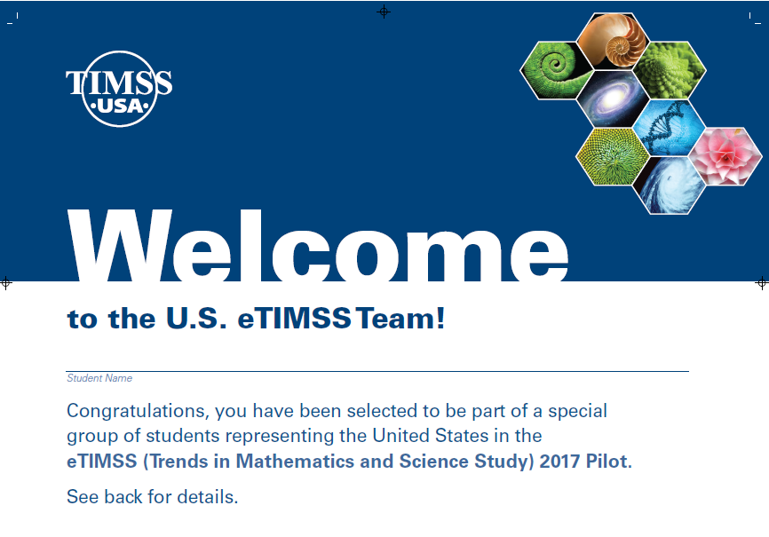

**Back**

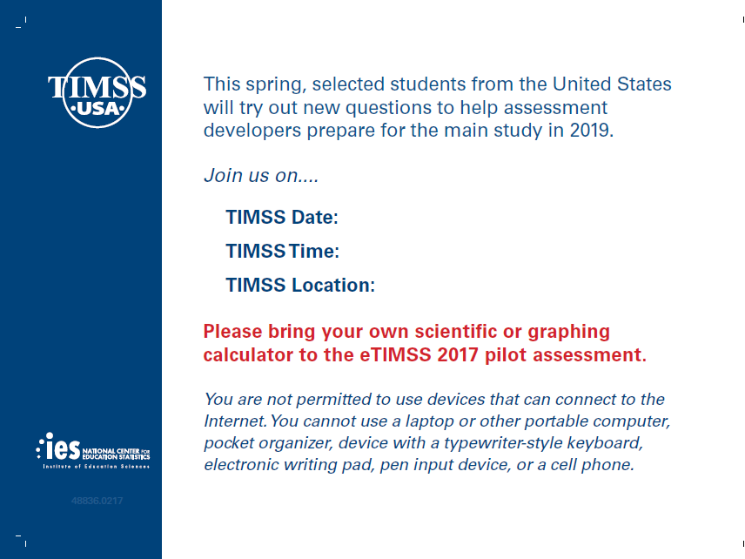

Student Login Card (label with login information will be affixed to the card)

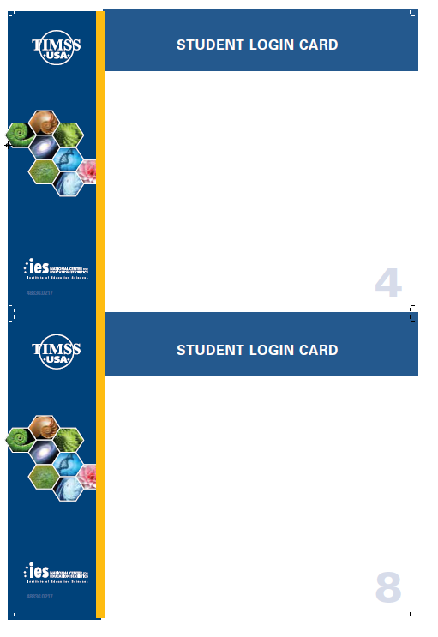

# Student Certificate of Completion

# 

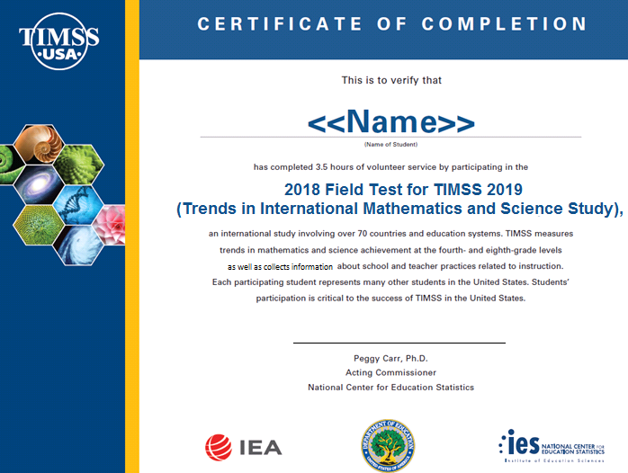

# School Certificate of Completion

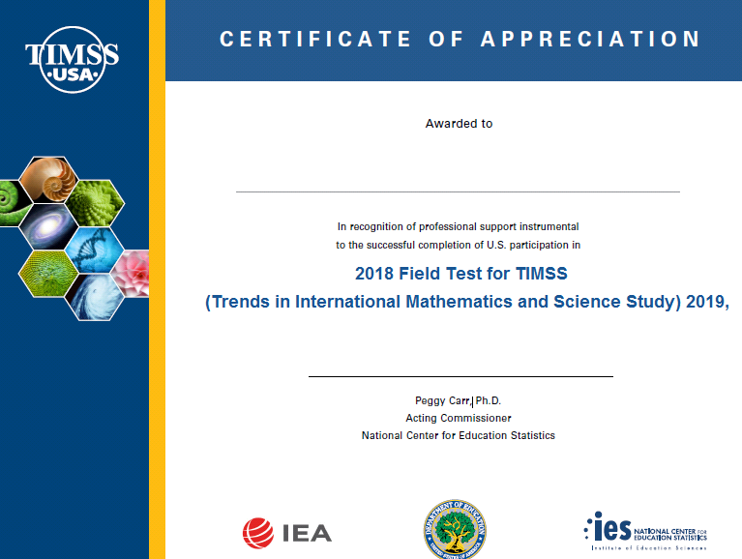

# Appendix B-1: TIMSS 2019 Field Test Notification Letters and Supporting Materials

Contents

TIMSS Field Test Sample Notification Letter: Grade 4 65

TIMSS Field Test Sample Notification Letter: Grade 8 66

TIMSS Field Test Sample Implicit Consent Letter: Grade 4 67

TIMSS Field Test Sample Implicit Consent Letter: Grade 8 68

TIMSS Implicit Consent Form: Grades 4 and 8 69

TIMSS Field Test Sample Explicit Consent Letter: Grade 4 70

TIMSS Field Test Sample Explicit Consent Letter: Grade 8 71

TIMSS Explicit Consent Form: Grades 4 and 8 72

TIMSS Facts for Parents About the Field Test: Grade 4 73

TIMSS Facts for Parents About the Field Test: Grade 8 74

Multi-translation Notice for Parents 75

## TIMSS Field Test Sample Notification Letter: Grade 4

SCHOOL LETTERHEAD

Dear Parent or Guardian,

This letter is to inform you about an important international study of student learning being conducted in our school this spring. The Trends in International Mathematics and Science Study (TIMSS) provides important information for benchmarking student performance in mathematics and science at grades 4 and 8 in the United States against countries around the world. Since 1995, TIMSS has measured worldwide trends in student knowledge of mathematics and science. The next TIMSS assessment will be in the spring of 2019.

Each time the study is done, new test questions need to be developed and tested to ensure that those questions accurately measure the knowledge and skills of students. In spring 2018, new questions will be piloted in an electronic format in approximately 35 schools in the United States that include 4th grade. This field test will allow test developers to modify or delete questions that are not reliable and fair across participating countries.

Our school has accepted an invitation from the National Center for Education Statistics (NCES), part of the U.S. Department of Education, to participate in the TIMSS field test. {Insert number} of our 4th-grade classes will take part. {This/One of these} is your child’s class. The enclosed summary sheet provides some background information about TIMSS, explains what is involved for each student selected to participate in the study, and gives a contact phone number and email address where you can find answers to any questions you might have.

To have an accurate picture of what U.S. 4th graders can do in mathematics and science, it is important that each student selected take part in the study. In addition to answering mathematics and science questions, students will be asked to complete a brief questionnaire about themselves. I urge you to support this effort by encouraging your child to take part; however, participation in this study is entirely voluntary. Previous experience suggests that students actually enjoy taking part, and participating students will receive a small gift, which we think they will like.

All of the information collected is safeguarded, as required by law. NCES is authorized to conduct this study under the Education Sciences Reform Act of 2002 (ESRA 2002, 20 U.S.C. §9543). All of the information provided by school staff and students may be used only for statistical purposes and may not be disclosed, or used, in identifiable form for any other purpose except as required by law (20 U.S.C. §9573 and 6 U.S.C. §151). Students and schools are never identified in any reports. All reported statistics refer to the United States as a whole.

Thank you for taking the time to learn about this important study.

Sincerely,

[School official]

Enclosures:

Facts for Parents about the TIMSS Field Test

## TIMSS Field Test Sample Notification Letter: Grade 8

SCHOOL LETTERHEAD

Dear Parent or Guardian,

This letter is to inform you about an important international study of student learning being conducted in our school this spring. The Trends in International Mathematics and Science Study (TIMSS) provides important information for benchmarking student performance in mathematics and science at grades 4 and 8 in the United States against countries around the world. Since 1995, TIMSS has measured worldwide trends in student knowledge of mathematics and science. The next TIMSS assessment will be in the spring of 2019.

Each time the study is done, new test questions need to be developed and tested to ensure that those questions accurately measure the knowledge and skills of students. In spring 2018, new questions will be piloted in an electronic format in approximately 35 schools in the United States that include 8th grade. This field test will allow test developers to modify or delete questions that are not reliable and fair across participating countries.

Our school has accepted an invitation from the National Center for Education Statistics (NCES), part of the U.S. Department of Education, to participate in the TIMSS field test. {Insert number} of our 8th-grade classes will take part. {This/One of these} is your child’s class. The enclosed summary sheet provides some background information about TIMSS, explains what is involved for each student selected to participate in the study, and gives a contact phone number and email address where you can find answers to any questions you might have.

To have an accurate picture of what U.S. 8th graders can do in mathematics and science, it is important that each student selected take part in the study. In addition to answering mathematics and science questions, students will be asked to complete a brief questionnaire about themselves. I urge you to support this effort by encouraging your child to take part; however, participation in this study is entirely voluntary. Previous experience suggests that students actually enjoy taking part, and participating students will receive a small gift, which we think they will like.

All of the information collected is safeguarded, as required by law. NCES is authorized to conduct this study under the Education Sciences Reform Act of 2002 (ESRA 2002, 20 U.S.C. §9543). All of the information provided by school staff and students may be used only for statistical purposes and may not be disclosed, or used, in identifiable form for any other purpose except as required by law (20 U.S.C. §9573 and 6 U.S.C. §151). Students and schools are never identified in any reports. All reported statistics refer to the United States as a whole.

Thank you for taking the time to learn about this important study.

Sincerely,

[School Official]

Enclosures:

Facts for Parents about the TIMSS Field Test

## TIMSS Field Test Sample Implicit Consent Letter: Grade 4

SCHOOL LETTERHEAD

Dear Parent or Guardian,

This letter is to inform you about an important international study of student learning being conducted in our school this spring. The Trends in International Mathematics and Science Study (TIMSS) provides important information for benchmarking student performance in mathematics and science at grades 4 and 8 in the United States against countries around the world. Since 1995, TIMSS has measured worldwide trends in student knowledge of mathematics and science. The next TIMSS assessment will be in the spring of 2019.

Each time the study is done, new test questions need to be developed and tested to ensure that those questions accurately measure the knowledge and skills of students. In spring 2018, new questions will be piloted in an electronic format in approximately 35 schools in the United States that include 4th grade. This field test will allow test developers to modify or delete questions that are not reliable and fair across participating countries.

Our school has accepted an invitation from the National Center for Education Statistics (NCES), part of the U.S. Department of Education, to participate in the TIMSS field test. {Insert number} of our 4th-grade classes will take part. {This/One of these} is your child’s class. The enclosed summary sheet provides some background information about TIMSS, explains what is involved for each student selected to participate in the study, and gives a contact phone number and email address where you can find answers to any questions you might have.

To have an accurate picture of what U.S. 4th graders can do in mathematics and science, it is important that each student selected take part in the study. In addition to answering mathematics and science questions, students will be asked to complete a brief questionnaire about themselves. I urge you to support this effort by encouraging your child to take part; however, participation in this study is entirely voluntary. Previous experience suggests that students actually enjoy taking part, and participating students will receive a small gift, which we think they will like.

All of the information collected is safeguarded, as required by law. NCES is authorized to conduct this study under the Education Sciences Reform Act of 2002 (ESRA 2002, 20 U.S.C. §9543). All of the information provided by school staff and students may be used only for statistical purposes and may not be disclosed, or used, in identifiable form for any other purpose except as required by law (20 U.S.C. §9573 and 6 U.S.C. §151). Students and schools are never identified in any reports. All reported statistics refer to the United States as a whole.

If you have any objection to your child joining in the TIMSS activities, please let us know by completing the attached consent form and returning it to the school.

Thank you for taking the time to learn about this important study.

Sincerely,

[School Official]

Enclosures:

Facts for Parents about the TIMSS Field Test

Parent/Guardian Consent Form

## TIMSS Field Test Sample Implicit Consent Letter: Grade 8

SCHOOL LETTERHEAD

Dear Parent or Guardian,

This letter is to inform you about an important international study of student learning being conducted in our school this spring. The Trends in International Mathematics and Science Study (TIMSS) provides important information for benchmarking student performance in mathematics and science at grades 4 and 8 in the United States against countries around the world. Since 1995, TIMSS has measured worldwide trends in student knowledge of mathematics and science. The next TIMSS assessment will be in the spring of 2019.

Each time the study is done, new test questions need to be developed and tested to ensure that those questions accurately measure the knowledge and skills of students. In spring 2018, new questions will be piloted in an electronic format in approximately 35 schools in the United States that include 8th grade. This field test will allow test developers to modify or delete questions that are not reliable and fair across participating countries.

Our school has accepted an invitation from the National Center for Education Statistics (NCES), part of the U.S. Department of Education, to participate in the TIMSS field test. {Insert number} of our 8th-grade classes will take part. {This/One of these} is your child’s class. The enclosed summary sheet provides some background information about TIMSS, explains what is involved for each student selected to participate in the study, and gives a contact phone number and email address where you can find answers to any questions you might have.

To have an accurate picture of what U.S. 8th graders can do in mathematics and science, it is important that each student selected take part in the study. In addition to answering mathematics and science questions, students will be asked to complete a brief questionnaire about themselves. I urge you to support this effort by encouraging your child to take part; however, participation in this study is entirely voluntary. Previous experience suggests that students actually enjoy taking part, and participating students will receive a small gift, which we think they will like.

All of the information collected is safeguarded, as required by law. NCES is authorized to conduct this study under the Education Sciences Reform Act of 2002 (ESRA 2002, 20 U.S.C. §9543). All of the information provided by school staff and students may be used only for statistical purposes and may not be disclosed, or used, in identifiable form for any other purpose except as required by law (20 U.S.C. §9573 and 6 U.S.C. §151). Students and schools are never identified in any reports. All reported statistics refer to the United States as a whole.

If you have any objection to your child joining in the TIMSS activities, please let us know by completing the attached consent form and returning it to the school.

Thank you for taking the time to learn about this important study.

Sincerely,

[School Official]

Enclosures:

Facts for Parents about the TIMSS Field Test

Parent/Guardian Consent Form

## TIMSS Implicit Consent Form: Grades 4 and 8

**Trends in International Mathematics and Science Study (TIMSS)**

**Field Test**

**Parent/Guardian Consent Form**

Your child has been asked to participate in a field test of an international study of student learning called the Trends in International Mathematics and Science Study (TIMSS). Each student who participates will receive a small gift. This assessment will be administered by a team of researchers from Westat, who are operating under contract on behalf of the National Center for Education Statistics (NCES), with the U. S. Department of Education. In spring 2018, 4th and 8th grade questions in electronic formats will be tested on tablet computers in approximately 70 schools in the United States in preparation for the 2019 international study (35 schools that include 4th grade and 35 that include 8th grade). This field test will allow test developers to modify or delete questions that are not reliable or fair for students in the United States.

**If you grant permission for your child to participate in the TIMSS Field Test, you do not need to return this form.**

**If you do not consent to your child’s participation in the TIMSS Field Test, please return this form to your child’s school as soon as possible.**

**I do not grant permission** for my child, _______________________________, to participate in the Trends in International Mathematics and Science Study Field Test.

**__________________________________________________________________**

(Signature of parent or guardian)

Date of signature: _______/_______/____________

PLEASE PRINT:

**Student name: _____________________________________________**

School name: ______________________________________________

FOR OFFICE USE ONLY:

Student ID: ________________________________________________

*NCES is authorized to conduct TIMSS under the Education Sciences Reform Act of 2002 (ESRA 2002, 20 U.S.C. §9543). All of the information provided by school staff and students may be used only for statistical purposes and may not be disclosed, or used, in identifiable form for any other purpose except as required by law (20 U.S.C. §9573 and 6 U.S.C. §151).*

## TIMSS Field Test Sample Explicit Consent Letter: Grade 4

SCHOOL LETTERHEAD

Dear Parent or Guardian,

This letter is to inform you about an important international study of student learning being conducted in our school this spring. The Trends in International Mathematics and Science Study (TIMSS) provides important information for benchmarking student performance in mathematics and science at grades 4 and 8 in the United States against countries around the world. Since 1995, TIMSS has measured worldwide trends in student knowledge of mathematics and science. The next TIMSS assessment will be in the spring of 2019.

Each time the study is done, new test questions need to be developed and tested to ensure that those questions accurately measure the knowledge and skills of students. In spring 2018, new questions will be piloted in an electronic format in approximately 35 schools in the United States that include 4th grade. This field test will allow test developers to modify or delete questions that are not reliable and fair across participating countries.

Our school has accepted an invitation from the National Center for Education Statistics (NCES), part of the U.S. Department of Education, to participate in the TIMSS field test. {Insert number} of our 4th-grade classes will take part. {This/One of these} is your child’s class. The enclosed summary sheet provides some background information about TIMSS, explains what is involved for each student selected to participate in the study, and gives a contact phone number and email address where you can find answers to any questions you might have.

To have an accurate picture of what U.S. 4th graders can do in mathematics and science, it is important that each student selected take part in the study. In addition to answering mathematics and science questions, students will be asked to complete a brief questionnaire about themselves. I urge you to support this effort by encouraging your child to take part; however, participation in this study is entirely voluntary. Previous experience suggests that students actually enjoy taking part, and participating students will receive a small gift, which we think they will like.

All of the information collected is safeguarded, as required by law. NCES is authorized to conduct this study under the Education Sciences Reform Act of 2002 (ESRA 2002, 20 U.S.C. §9543). All of the information provided by school staff and students may be used only for statistical purposes and may not be disclosed, or used, in identifiable form for any other purpose except as required by law (20 U.S.C. §9573 and 6 U.S.C. §151). Students and schools are never identified in any reports. All reported statistics refer to the United States as a whole.

Before we can allow your child to join in the TIMSS activities, we must have your written consent. Please let us know by completing the attached form and returning it to the school.

Thank you for taking the time to learn about this important study and to consider your child’s participation in it.

Sincerely,

[School Official]

Enclosures:

Facts for Parents about the TIMSS Field Test

Parent/Guardian Consent Form

## TIMSS Field Test Sample Explicit Consent Letter: Grade 8

SCHOOL LETTERHEAD

Dear Parent or Guardian,

This letter is to inform you about an important international study of student learning being conducted in our school this spring. The Trends in International Mathematics and Science Study (TIMSS) provides important information for benchmarking student performance in mathematics and science at grades 4 and 8 in the United States against countries around the world. Since 1995, TIMSS has measured worldwide trends in student knowledge of mathematics and science. The next TIMSS assessment will be in the spring of 2019.

Each time the study is done, new test questions need to be developed and tested to ensure that those questions accurately measure the knowledge and skills of students. In spring 2018, new questions will be piloted in an electronic format in approximately 35 schools in the United States that include 8th grade. This field test will allow test developers to modify or delete questions that are not reliable and fair across participating countries.

Our school has accepted an invitation from the National Center for Education Statistics (NCES), part of the U.S. Department of Education, to participate in the TIMSS field test. {Insert number} of our 8th-grade classes will take part. {This/One of these} is your child’s class. The enclosed summary sheet provides some background information about TIMSS, explains what is involved for each student selected to participate in the study, and gives a contact phone number and email address where you can find answers to any questions you might have.

To have an accurate picture of what U.S. 8th graders can do in mathematics and science, it is important that each student selected take part in the study. In addition to answering mathematics and science questions, students will be asked to complete a brief questionnaire about themselves. I urge you to support this effort by encouraging your child to take part; however, participation in this study is entirely voluntary. Previous experience suggests that students actually enjoy taking part, and participating students will receive a small gift, which we think they will like.

All of the information collected is safeguarded, as required by law. NCES is authorized to conduct this study under the Education Sciences Reform Act of 2002 (ESRA 2002, 20 U.S.C. §9543). All of the information provided by school staff and students may be used only for statistical purposes and may not be disclosed, or used, in identifiable form for any other purpose except as required by law (20 U.S.C. §9573 and 6 U.S.C. §151). Students and schools are never identified in any reports. All reported statistics refer to the United States as a whole.

Before we can allow your child to join in the TIMSS activities, we must have your written consent. Please let us know by completing the attached form and returning it to the school.

Thank you for taking the time to learn about this important study and to consider your child’s participation in it.

Sincerely,

[School Official]

Enclosures:

Facts for Parents about the TIMSS Field Test

Parent/Guardian Consent Form

## TIMSS Explicit Consent Form: Grades 4 and 8

**Trends in International Mathematics and Science Study (TIMSS)**

**Field Test**

**Parent/Guardian Consent Form**

Your child has been asked to participate in a field test of an international study of student learning called the Trends in International Mathematics and Science Study (TIMSS). Each student who participates will receive a small gift. This assessment will be administered by a team of researchers from Westat, who are operating under contract on behalf of the National Center for Education Statistics (NCES), with the U. S. Department of Education. In spring 2018, 4th and 8th grade questions in electronic formats will be tested on tablet computers in approximately 70 schools in the United States in preparation for the 2019 international study (35 schools that include 4th grade and 35 that include 8th grade). This field test will allow test developers to modify or delete questions that are not reliable or fair for students in the United States.

Yes, I grant permission for my child to participate in the TIMSS Field Test.

No, I do not grant permission for my child to participate in the TIMSS Field Test.

**__________________________________________________________________**

(Signature of parent or guardian)

Date of signature: _______/_______/____________

PLEASE PRINT:

**Student name: _____________________________________________**

School name: ______________________________________________

FOR OFFICE USE ONLY:

Student ID: ________________________________________________

*NCES is authorized to conduct TIMSS under the Education Sciences Reform Act of 2002 (ESRA 2002, 20 U.S.C. §9543). All of the information provided by school staff and students may be used only for statistical purposes and may not be disclosed, or used, in identifiable form for any other purpose except as required by law (20 U.S.C. §9573 and 6 U.S.C. §151).*

## TIMSS Facts for Parents about the Field Test: Grade 4

**Facts for Parents**

**About the TIMSS Field Test**

Between March and April of this year, your child’s school will be one of about 35 nationwide taking part in a 4th-grade field test to prepare for TIMSS 2019.[1] Schools were selected randomly to represent the nation’s schools and, within each school, 4th-grade students were selected randomly to represent the nation’s 4th graders. Your child was among those students selected to take part in the TIMSS field test.

**What is TIMSS?**

TIMSS (Trends in International Mathematics and Science Study) is an international assessment that measures student learning in mathematics and science. Every four years since 1995, TIMSS documents worldwide trends in the knowledge of 4th graders. The National Center for Education Statistics (NCES), within the U.S. Department of Education, conducts TIMSS in the United States. Along with more than 60 other nations, the U.S. will take part in the 2019 TIMSS cycle as we did in 1995, 1999, 2003, 2007, 2011, and 2015.

**What is the purpose of the TIMSS Field Test?**

The TIMSS Field Test is testing 4th- and 8th-grade questions in electronic formats on tablet computers in approximately 70 schools in the United States in preparation for the 2019 international study. This field test will allow test developers to modify or delete questions that are not reliable or fair for students in the United States.

**What is involved?**

TIMSS staff will visit the school and administer the field test on tablet computers that they will bring to the school. The field test will take approximately 2 ½ hours. The assessment itself is 72 minutes with breaks between sections. Students will also be asked some questions about themselves and their educational experience. Participation in the study is voluntary.

**What are the benefits?**

The nation as a whole benefits from TIMSS by having a greater understanding of how the knowledge and skills of U.S. 4th graders compare with those of 4th graders in other countries. Our country benefits from the field test by ensuring that the questions used are fair and appropriate for U.S. students. Schools that participate in TIMSS will receive $200, and each student who participates will receive a small gift that we believe they will like.

**Who administers TIMSS?**

The entire assessment is administered by trained staff from Westat, a research organization under contract to the U.S. Department of Education’s National Center for Education Statistics.

All of the information collected is safeguarded, as required by law. NCES is authorized to conduct this study under the Education Sciences Reform Act of 2002 (ESRA 2002, 20 U.S.C. §9543). All of the information provided by school staff and students may be used only for statistical purposes and may not be disclosed, or used, in identifiable form for any other purpose except as required by law (20 U.S.C. §9573 and 6 U.S.C. §151). Students and schools are never identified in any reports. All reported statistics refer to the United States as a whole.

**Where can I find out more about TIMSS?**

More information about TIMSS is available at the TIMSS website at <http://nces.ed.gov/timss> or <http://timss.bc.edu>. Or if you would like to contact a TIMSS staff member directly, please feel free to call the TIMSS hotline at 1-(855)-445-5604 or email us at [TIMSS@westat.com](mailto:TIMSS@westat.com).

## TIMSS Facts for Parents About the Field Test: Grade 8

**Facts for Parents**

**About the TIMSS Field Test**

Between March and April of this year, your child’s school will be one of about 35 nationwide taking part in an 8th-grade field test to prepare for TIMSS 2019[2]. Schools were selected randomly to represent the nation’s schools and, within each school, 8th-grade students were selected randomly to represent the nation’s 8th graders. Your child was among those students selected to take part in the TIMSS field test.

**What is TIMSS?**

TIMSS (Trends in International Mathematics and Science Study) is an international assessment that measures student learning in mathematics and science. Every four years since 1995, TIMSS documents worldwide trends in the knowledge of 8th graders. The National Center for Education Statistics (NCES), within the U.S. Department of Education, conducts TIMSS in the United States. Along with more than 60 other nations, the U.S. will take part in the 2019 TIMSS cycle as we did in 1995, 1999, 2003, 2007, 2011, and 2015.

**What is the purpose of the TIMSS Field Test?**

The TIMSS Field Test is piloting 4th and 8th grade questions in electronic format in approximately 70 schools in the United States in preparation for the 2019 international study (35 schools that include 4th grade and 35 that include 8th grade). This field test will allow test developers to modify or delete questions that are not reliable or fair for students in the United States.

**What is involved?**

TIMSS staff will visit the school and administer the field test on tablet computers that they will bring to the school. The field test will take approximately 2½ hours. The assessment itself is 90 minutes with breaks between sections. Students will also be asked some questions about themselves and their educational experience. Participation in the study is voluntary.

**What are the benefits?**

The nation as a whole benefits from TIMSS by having a greater understanding of how the knowledge and skills of U.S. 8th graders compare with those of 8th graders from other countries. Our country benefits from the field test by ensuring that the questions used are fair and appropriate for U.S. students. Schools that participate in TIMSS will receive $200, and each student who participates will receive a small gift that we believe they will like.

**Who administers TIMSS?**

The entire assessment is administered by trained staff from Westat, a research organization under contract to the U.S. Department of Education’s National Center for Education Statistics.

All of the information collected is safeguarded, as required by law. NCES is authorized to conduct this study under the Education Sciences Reform Act of 2002 (ESRA 2002, 20 U.S.C. §9543). All of the information provided by school staff and students may be used only for statistical purposes and may not be disclosed, or used, in identifiable form for any other purpose except as required by law (20 U.S.C. §9573 and 6 U.S.C. §151). Students and schools are never identified in any reports. All reported statistics refer to the United States as a whole.

**Where can I find out more about TIMSS?**

More information about TIMSS is available at the TIMSS website at <http://nces.ed.gov/timss> or <http://timss.bc.edu>. Or if you would like to contact a TIMSS staff member directly, please feel free to call the TIMSS hotline at 855-445-5604 or email us at TIMSS@westat.com.

**OMB# 1850-0695 (Expires 01/31/2021)**

## Multi-translation Notice for Parents

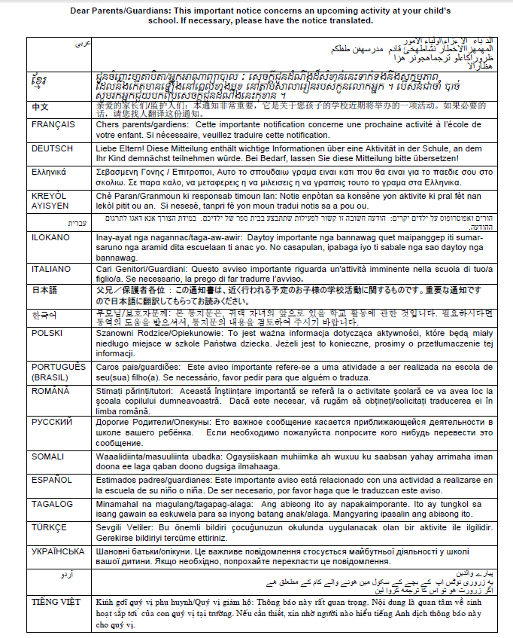

**Appendix A-2: TIMSS 2019 Main Study Recruitment Materials**

**Contents**

State TIMSS Main Study Letter 77

School District TIMSS 2019 Main Study Letter 78

School TIMSS 2019 Main Study Letter 79

Teacher TIMSS 2019 Main Study Letter 80

TIMSS 2019 Main Study Brochure Content: 8 ½ X 11in Tri-fold 81

TIMSS 2019 Main Study FAQ 85

Summary of School Activities 87

Email to School Coordinator (SC) for MyTIMSS Registration and to Provide School Information (PSI) 89

MyTIMSS Registration and Provide School Information (PSI) Guide 91

Automated Email for all MyTIMSS registrants 95

Automated Email for MyTIMSS School Coordinator registrant 96

MyTIMSS Login Page 97

MyTIMSS Home Page 99

MyTIMSS Provide School Information (PSI) Page 100

Email to School Coordinator (SC) to Submit Class and Student Lists—Grade 4 101

Instructions for Submitting Class and Student Lists- Grade 4 102

Submit Class List Page – Grade 4 108

Submit Student List Page – Grade 4 109

TIMSS 2019: Email to School Coordinator (SC) to Submit Class and Student Lists—Grade 8 110

Instructions for Submitting Class and Student Lists—Grade 8 111

Submit Class List Page – Grade 8 117

Submit Student List Page – Grade 8 118

MyTIMSS Prepare for Assessment Page 119

Student-Teacher Linkage Form (STLF) Email 120

Student Tracking Form (STF) and Teacher Tracking Form (TTF) Email 121

Instructions for Student Tracking Form (STF) and Teacher Tracking Form (TTF) 122

Student-Teacher Linkage Form (STLF) Template 124

Student Tracking Form (STF) Template 125

Teacher Tracking Form (TTF) Template 126

MyTIMSS Documents Page 127

MyTIMSS Important Websites and Contact Us Pages 128

School Principal Questionnaire Login Card/Email 129

Teacher Questionnaire Login Card/Email 130

Online Questionnaire Login Screen Text 131

Student Appointment Card for TIMSS 2019 MS: Grade 8 only 132

Student Login Card 134

Student Certificate of Completion 135

School Certificate of Completion 136

# State TIMSS Main Study Letter

[Date]

[Title] [Name First] [Name Last]

[Title/Department]

[State]

[Address 1]

[Address 2]

[City], [State] [Zip code]

Dear [Title] [Name Last]:

The United States is participating in an important international study in 2019: the Trends in International Mathematics and Science Study (TIMSS). TIMSS is the longest ongoing international student assessment. Since 1995, TIMSS has measured trends in academic achievement at grades 4 and 8 in countries around the world, including the United States. Results from TIMSS are used by researchers and policymakers to chart national progress against international standards and other countries around the world, informing national discussions about international competitiveness. For the first time, in 2019 TIMSS will be administered digitally. The electronic version of TIMSS, sometimes called “eTIMSS,” will be on the same scale and comparable to the previous paper versions of TIMSS.

TIMSS is described in more detail in the enclosed materials. In the United States, TIMSS is conducted by the National Center for Education Statistics (NCES), part of the U.S. Department of Education. The U.S. Office of Management and Budget has approved the data collection under OMB#1850-0695. Study findings will not identify participating districts, schools, students, or individual staff. Please see the enclosed FAQ for information about data confidentiality.

NCES is in contact with your state assessment director and NAEP State Coordinator to keep them informed about TIMSS and how it fits in with other NCES data collections, and to facilitate recruitment of sampled schools. While participation in this study is voluntary, your support of school participation in your state is invaluable so that the United States has a representative sample of schools across the country.

If you have questions about the study, please do not hesitate to call Dr. Chris Averett at Westat at (240) 314-2492 or send an email to TIMSS@westat.com. Westat is under contract to NCES to collect the TIMSS data. You may also get more information about this study by contacting Lydia Malley at NCES at (202) 245-7266 or lydia.malley@ed.gov, or by visiting the TIMSS website at <http://nces.ed.gov/timss>.

Thank you for your time and support.

Sincerely,

Peggy Carr, Ph.D.

Acting Commissioner  
National Center for Education Statistics

cc: [State assessment director]

[NAEP State Coordinator]

Enclosures

*NCES is authorized to conduct this study under the Education Sciences Reform Act of 2002 (ESRA 2002, 20 U.S.C. §9543). All of the information provided by school staff and students may be used only for statistical purposes and may not be disclosed, or used, in identifiable form for any other purpose except as required by law (20 U.S.C. §9573 and 6 U.S.C. §151).*

# School District TIMSS 2019 Main Study Letter

Dear [District Superintendent name]:

I am writing to notify you that [number] schools in your district have been randomly selected to participate in an important international study: the Trends in International Mathematics and Science Study (TIMSS). TIMSS is the longest ongoing international student assessment. Since 1995, TIMSS has measured trends in academic achievement at grades 4 and 8 in countries around the world, including the United States. Results from TIMSS are used by researchers and policymakers to chart national progress against international standards and other countries around the world, informing national discussions about international competitiveness. For the first time, in 2019, TIMSS will be administered digitally. The electronic version of TIMSS, sometimes called “eTIMSS,” will be on the same scale and comparable to the previous paper versions of TIMSS.

Selected schools are notified in advance so that principals can place the assessment date on their calendars and incorporate TIMSS into the planned school program. I am writing to ask for your support of the participation of those selected schools. Most selected students will take the TIMSS assessment on supplied tablets. Some students will take a paper and pencil assessment in order to bridge eTIMSS to previous paper versions of TIMSS. Participating schools will receive $200, and each school’s TIMSS school coordinator (the school staff person designated to work with TIMSS staff) will receive $100 as a thank you for his or her time and effort. A school administrator and teachers of the selected students will each be asked to complete a questionnaire. Teachers will receive $20 as a thank you for completing the questionnaire. Each student who participates will receive a small gift as a token of appreciation.

TIMSS is described in more detail in the enclosed materials. In the United States, TIMSS is conducted by the National Center for Education Statistics (NCES), part of the U.S. Department of Education, and its data collection is administered by Westat in Rockville, Maryland. The U.S. Office of Management and Budget has approved the data collection under OMB#1850-0695. For information on the confidentiality of the data collected, please see the enclosed FAQ. While participation in this study is voluntary, your support of school participation in your district is invaluable so that the United States has a representative sample of schools across the country. The schools will be contacted soon with more information about the assessment.

The list of selected schools in your district is attached, along with schools selected for NAEP 2019. Please include the TIMSS assessment window (March to May 2019) on your district test calendar. [Name], our NAEP State Coordinator, will contact your staff with additional information.

If you have any questions, please do not hesitate to contact [Name of NSC] call 1-855-445-5604 or send an email to [TIMSS@westat.com](mailto:TIMSS@westat.com). You may also get more information about this study by contacting Lydia Malley at NCES at (202) 245-7266 or lydia.malley@ed.gov, or by visiting the TIMSS website at <http://nces.ed.gov/timss>.

I know that I can count on you to help accomplish our goal of 100 percent participation. Thank you for your time and support.

[Name of Chief State School Officer]

Enclosures

cc: [State Testing Director]

[District Test Coordinator]

[NAEP State Coordinator]

*NCES is authorized to conduct this study under the Education Sciences Reform Act of 2002 (ESRA 2002, 20 U.S.C. §9543). All of the information provided by school staff and students may be used only for statistical purposes and may not be disclosed, or used, in identifiable form for any other purpose except as required by law (20 U.S.C. §9573 and 6 U.S.C. §151).*

# School TIMSS 2019 Main Study Letter

Dear [Principal name],

I am writing to inform you that [school name] has been randomly selected to represent schools across the United States by participating in an import international study: the Trends in International Mathematics and Science Study (TIMSS). TIMSS is the longest ongoing international student assessment. Since 1995, TIMSS has measured trends in academic achievement at grades 4 and 8 in more than 60 countries around the world, including the United States. Results from these assessments are used by researchers and policymakers to chart national progress against international standards and other countries around the world, informing national discussions about international competitiveness. For the first time, in 2019, TIMSS will be administered digitally. The electronic version of TIMSS, sometimes called “eTIMSS,” will be on the same scale and comparable to the previous paper versions of TIMSS.

NCES recognizes the burden of assessments on schools and works to reduce that burden as much as possible both in terms of time and resources. TIMSS will sample two classes of fourth-graders [or two math classes of eighth-graders] in your school. A school administrator and teachers of the selected students will be asked to complete a questionnaire. As a token of appreciation for participating in TIMSS, your school will receive $200. Your school’s TIMSS school coordinator (a staff person designated to work with TIMSS staff) will receive $100 for his or her time and effort. Teachers of selected students will receive $20 for completing a questionnaire. Students who participate in the test will receive a small token of appreciation.

TIMSS is described in more detail in the enclosed materials. In the United States, TIMSS is conducted by the National Center for Education Statistics (NCES), part of the U.S. Department of Education, and its data collection is administered by Westat in Rockville, Maryland. The U.S. Office of Management and Budget has approved the data collection under OMB#1850-0695. Study findings will not identify participating districts, schools, students, or individual staff. For information on the confidentiality of the data collected, please see the enclosed FAQ. While participation in TIMSS is voluntary, your school’s participation is invaluable in ensuring that the United States has a representative sample of schools across the country.

The assessment window is March to May, 2019. Within the next few weeks I will send you an assessment date. Should there be a conflict on this date, a TIMSS representative will work with you to identify an alternative time. Please put this date on your 2018-2019 school calendar. At the beginning of the school year, I will send you detailed information about the assessment and will ask you to identify a school coordinator. TIMSS representatives will provide significant support to schools, bring all necessary materials, including tablets and all equipment, and administer the assessment.

If you have any questions, please do not hesitate to contact me or call the toll-free TIMSS information hotline 1-855-445-5604, or send an email to [TIMSS@westat.com](mailto:TIMSS@westat.com). You may also get more information about this study by contacting Lydia Malley at NCES at (202) 245-7266 or lydia.malley@ed.gov, or by visiting the TIMSS website at <http://nces.ed.gov/timss>.

Your participation in TIMSS 2019 is very important to its success. We need to ensure that students in schools like yours are represented in our evaluation of assessment items and questionnaires. Thank you for your time and for supporting this important international study.

Name of Coordinator

NAEP State Coordinator

cc: [District Test Coordinator]

Enclosures

*NCES is authorized to conduct this study under the Education Sciences Reform Act of 2002 (ESRA 2002, 20 U.S.C. §9543). All of the information provided by school staff and students may be used only for statistical purposes and may not be disclosed, or used, in identifiable form for any other purpose except as required by law (20 U.S.C. §9573 and 6 U.S.C. §151).*

# Teacher TIMSS 2019 Main Study Letter

[Date] Web Address:

[Title] [Name First] [Name Last] Your Study ID:

[Teacher] Your Password:

[School Name]

[Address 1]

[City], [State] [Zip code]

Dear [Title] [Name Last]:

[School Name] is participating in an important international study in 2019: the Trends in International Mathematics and Science Study (TIMSS). TIMSS is the longest ongoing international student assessment. Since 1995, TIMSS has measured trends in academic achievement at grades 4 and 8 in more than 60 countries around the world, including the United States. Results from these assessments are used by researchers and policymakers to chart national progress against international standards and in comparison to other countries around the world, informing national discussions about international competitiveness. For the first time, in 2019, TIMSS will be administered digitally. The electronic version of TIMSS, sometimes called “eTIMSS,” will be on the same scale and comparable to the previous paper versions of TIMSS.

We are asking you to complete a 30-minute questionnaire to provide insight into school and classroom contexts for mathematics and/or science learning, your teaching experience and available resources and instructional practices at your school. You may complete the questionnaire online using a secure website. To access the questionnaire online, please use the web address and unique study ID and password provided on this letter. If you prefer to complete the questionnaire by hardcopy, please use the enclosed business reply envelope to return the completed questionnaire to us. You may also let your school’s TIMSS coordinator, [school coordinator name], know and a hardcopy questionnaire will be provided for you. You will receive a $20 gift card within a few weeks of completing the questionnaire as a token of our appreciation.

In the United States, TIMSS is conducted by the National Center for Education Statistics (NCES), part of the U.S. Department of Education, and the data are being collected by Westat. The U.S. Office of Management and Budget has approved the data collection under OMB# 1850-0695. For information on the confidentiality of the data collected, please see the enclosed FAQ. While participation in this questionnaire is voluntary, your participation is invaluable.

If you have any questions, please do not hesitate to call 1-(855)-445-5604 or send an email to TIMSS@westat.com. You may also get more information about this study by contacting Lydia Malley at NCES at (202) 245-7266 or lydia.malley@ed.gov, or by visiting the TIMSS website at <http://nces.ed.gov/timss>.

Your participation in TIMSS 2019 is very important to its success. We need to ensure that students in schools like yours are represented in our evaluation of assessment items and questionnaires. Thank you for your time and for supporting this important international study.

Peggy Carr, Ph.D.

Acting Commissioner, NCES

Enclosures

*NCES is authorized to conduct this study under the Education Sciences Reform Act of 2002 (ESRA 2002, 20 U.S.C. §9543). All of the information you provide may be used only for statistical purposes and may not be disclosed, or used, in identifiable form for any other purpose except as required by law (20 U.S.C. §9573 and 6 U.S.C. §151).*

# TIMSS 2019 Main Study Brochure Content: 8 ½ X 11in Tri-fold

***Title page:***

TIMSS USA Logo

Trends in International Mathematics and Science Study (TIMSS)

2019

TIMSS Graphics

IES logo

***Inside panels:***

**What is TIMSS?**

The Trends in International Mathematics and Science Study (TIMSS) is an international assessment and research project designed to measure trends in mathematics and science achievement at the fourth- and eighth-grade levels as well as school and teacher practices related to instruction. Since 1995, TIMSS has been administered every 4 years. TIMSS 2019, the seventh study in the series, will involve students from more than 60 countries, including the United States.

TIMSS is sponsored by the International Association for the Evaluation of Educational Achievement (IEA) and conducted in the United States by the National Center for Education Statistics (NCES), part of the U.S. Department of Education.

**Why is TIMSS important?**

TIMSS provides a unique opportunity to compare U.S. students’ math and science knowledge and skills at the fourth- and eighth-grade levels with that of their peers in countries around the world. TIMSS complements what we learn from national assessments by identifying the strengths and weaknesses of student performance relative to students around the world. The results inform national discussions about education as well as international competitiveness.

TIMSS provides valuable benchmark information on how U.S. students compare to students around the world, allows educators and policymakers to examine other educational systems for practices that could have application to the United States, and contributes to ongoing discussions of ways to improve the quality of education of all students.

**What type of assessment is TIMSS?**

In 2019, for the first time, TIMSS will be a digitally based assessment administered on supplied tablets. A subset of students will take a paper-and-pencil TIMSS in order to bridge the study to TIMSS 2015 and prior TIMSS. The assessment contains a mix of questions; some require students to select appropriate responses, while others require that students solve problems and provide written answers. The TIMSS mathematics and science assessment is developed through an international process involving input from U.S. and international experts in mathematics, science, and measurement. In a final step, the assessment is endorsed as suitable by all participating countries. Examples of released TIMSS items are available at <http://nces.ed.gov/timss/educators.asp>.

**How does the United States compare internationally?**

**Results from TIMSS 2015**

*Mathematics*

* U.S. fourth-graders’ average score in mathematics was 539, which was higher than the average scores of students in 34 education systems and lower than the average scores of students in 10 education systems. U.S. fourth-grade students have, on average, shown long-term improvement on the TIMSS mathematics assessments. At the fourth grade, U.S. students’ average mathematics scores increased from 1995, 2003, and 2007 to 2015. The average mathematics score in 2015, however, was not measurably different from the most recent assessment in 2011. Over 20 years, U.S. fourth graders’ average mathematics score increased from 518 points in 1995 to 539 points in 2015.
* U.S. eighth-graders’ average score in mathematics was 518, which was higher than the average scores of students in 24 education systems and lower than the average scores of students in 8 education systems. At the eighth grade, U.S. students’ average mathematics scores increased from all prior time points (1995, 1999, 2003, 2007, and 2011) to 2015. Over 20 years, U.S. eighth-graders’ mathematics scores increased from 492 points in 1995 to 518 points in 2015.

*Science*

* U.S. fourth-graders’ average score in science was 546, which was higher than the average scores of students in 38 education systems and lower than the average scores of students in 7 education systems. U.S. fourth-grade students have shown improvement on the TIMSS science assessments over some time periods: average scores in 2015 were higher than in 2003 and 2007. However, there was no measurable difference between the average science score in 2015 and the average science score in 1995 or 2011. The apparent difference between the average score in 1995 and in 2015 (542 vs. 546 points) was not statistically significant.
* U.S. eighth-graders’ average score in science was 530, which was higher than the average scores of students in 26 education systems and lower than the average scores of students in 7 education systems. At the eighth grade, U.S. students’ average science scores increased from 1995, 1999, and 2007 to 2015, but there were no measurable differences from 2003 or the most recent time point (2011) to 2015. Over 20 years, U.S. eighth-graders’ science scores increased from 513 points in 1995 to 530 points in 2015.

Additional TIMSS 2015 results can be found at <http://nces.ed.gov/surveys/timss>.

***Back panels:***

**Other information collected by TIMSS**

TIMSS is more than an assessment of student knowledge in mathematics and science. TIMSS also considers the context in which learning occurs. Students, teachers, and schools are asked about a variety of aspects of the environments in which content is taught, learned, practiced, and applied. In this way, TIMSS provides each country with a rich source of information on the factors influencing mathematics and science achievement.

**Participating countries and other education systems in TIMSS 2019**

|  |  |  |
| --- | --- | --- |
| **North and South America**  Canada  Chile  United States  **Europe**  Albania  Austria  Azerbaijan  Belarus  Belgium (Fl.)  Belgium (Fr.)  Bosnia and  Herzegovina  Bulgaria  Croatia  Cyprus  Czech Republic  Denmark  England  Finland  France  Georgia  Germany  Hungary  Ireland  Italy  Kosovo  Lithuania  Macedonia  Malta  Montenegro  Netherlands  Northern Ireland  Norway  Poland  Portugal  Russian Federation  Serbia  Slovak Republic  Spain  Sweden  Turkey | **Asia and Middle East**  Armenia  Bahrain  Chinese Taipei  Hong Kong SAR  Iran, Islamic Rep. of  Israel  Japan  Jordan  Kazakhstan  Korea, Rep. of  Kuwait  Macao SAR  Malaysia  Oman  Pakistan  Philippines  Qatar  Singapore  Thailand  United Arab Emirates | **Africa**  Botswana  Egypt  Morocco  South Africa  **Australia and Oceania**  Australia  New Zealand |
| **Benchmarking participants** | | |
| Abu Dhabi, UAE  Dubai, UAE | Moscow City,  Russian Federation  Ningbo City, China | Ontario, Canada  Quebec, Canada |

NCES is authorized to conduct TIMSS under the Education Sciences Reform Act of 2002 (ESRA 2002, 20 U.S.C. §9543). Information collected will help the U.S. Department of Education’s ongoing efforts to benchmark student achievement in the United States. Participation is voluntary. All of the information provided by school staff and students may be used only for statistical purposes and may not be disclosed, or used, in identifiable form for any other purpose except as required by law (20 U.S.C. §9573 and 6 U.S.C. §151). The U.S. Office of Management and Budget has approved the data collection under OMB# 1850-0695 (Expires 01/31/2021). Individual responses will be combined with those from other participants to produce summary statistics and reports.

TIMSS USA logo

IEA logo

IES / NCES logo

For questions about TIMSS 2019, contact the toll-free TIMSS information hotline at 855-445-5604 or email [TIMSS@westat.com](mailto:TIMSS@westat.com).

# TIMSS 2019 Main Study FAQ

Banner: TIMSS USA logo, Frequently Asked Questions

TIMSS 2019

**What is TIMSS?**

The Trends in International Mathematics and Science Study (TIMSS) is an international assessment and research project designed to measure trends in mathematics and science achievement at the fourth and eighth-grade levels as well as school and teacher practices related to instruction. Since 1995, TIMSS has been administered every 4 years. TIMSS 2019, the seventh study in the series, will involve students from more than 60 countries, including the United States. In 2019, for the first time, TIMSS will be administered digitally. The electronic version of TIMSS, sometimes called “eTIMSS,” will be on the same scale and comparable to the previous paper versions of TIMSS.

**Why was my school selected for participation?**

Schools of varying demographics and locations were randomly selected so that the overall U.S. sample is representative of the overall U.S. school population. The random selection process is important for ensuring that a country’s sample accurately reflects its schools and, therefore, can fairly be compared with samples of schools from other countries.

**Why should my school and students participate?**

TIMSS informs national discussions about student skills, education policy, and international competitiveness. It is important for selected schools to participate because they represent similar U.S. schools across the country. When students participate and give their best effort, TIMSS gets the most accurate measure possible of student achievement in the U.S. to compare with other countries.

**Will all our fourth- or eighth-grade students be asked to participate?**

It depends on the number of fourth- or eighth-grade classrooms in the school. In schools with only one or two such classrooms, all students will be asked to participate. In schools with more than two such classrooms, only students in two randomly selected classrooms will be asked to participate. In addition, some students with special needs or who are English language learners may be excused from the assessment.

**Who conducts the TIMSS assessment?**

The National Center for Education Statistics (NCES), within the U.S. Department of Education, is authorized to conduct this study under the Education Sciences Reform Act of 2002 (ESRA 2002, 20 U.S.C. §9543), and approval of the U.S. Office of Management and Budget under OMB# 1850-0695. The entire assessment process will be administered on behalf of NCES by trained staff from Westat, a research organization under contract with NCES.

**How are the school and teacher questionnaires administered?**

The teacher and school questionnaires are administered online from a secure website. Teacher questionnaires ask teachers about their experience, available resources, and instructional practices and take about 30 minutes to complete. School questionnaires ask about school practices and resources and take about 30 minutes to complete.

**Do teachers need to help administer the assessment?**

No, Westat TIMSS staff will visit the school on the day of the assessment, bringing with them all the materials required. The Westat TIMSS staff will administer the assessments to students.

**Do schools need to provide computer equipment for the test?**

No, Westat TIMSS staff will bring all the equipment needed for the test, including tablets, styluses, and keyboards.

**When will the assessment be conducted?**

TIMSS 2019 will be conducted between March and May 2019. Each school will be notified of its scheduled assessment date in summer/fall 2018. Westat TIMSS staff will work with schools to identify an alternate date should there be a conflict on that date.

**How long does the assessment take?**

The assessment takes 72 minutes at fourth grade and 90 minutes at eighth grade, and there will be breaks between sections and a questionnaire that takes 30 minutes. The two classes will be assessed in sequential sessions, with one class assessed in the morning and the second class assessed in the afternoon.

**What will happen with the collected data?**

The data from the assessment will be used to evaluate how the knowledge and skills of U.S. students compare to those of their peers in other participating countries. All of the information provided by school staff and students may be used only for statistical purposes and may not be disclosed, or used, in identifiable form for any other purpose except as required by law (20 U.S.C. §9573 and 6 U.S.C. §151). Reports of the findings from the assessment will not identify participating districts, schools, students, or individual staff. Individual responses will be combined with those of other participants to produce summary statistics and reports.

**Where can I find more information about TIMSS?**

Visit the TIMSS website at <http://nces.ed.gov/timss>.

For additional information about TIMSS 2019, contact the TIMSS information hotline at 855-445-5604 or email TIMSS@westat.com.

Department of Education logo

IES / NCES logo

IEA logo

OMB# 1850-0695 (Expires 01/31/2021)

# Summary of School Activities

**Front cover**

TIMSS USA Logo

Summary of School Activities

Trends in International Mathematics and Science Study (TIMSS)

2019 Main Study

TIMSS graphic

**Inside**

|  |  |  |  |  |
| --- | --- | --- | --- | --- |
| **Summary of School Activities: TIMSS 2019** | | | | |
|  | **Fall 2018** | **January-March 2019**  **Prior to assessment day** | **March-May 2019**  **Assessment day** | **Benefits** |
| **Principal** | * Designate a school coordinator | * Complete an online school questionnaire on the characteristics of the school, its enrollment, resources, policies, and learning environment * Share the importance of participation in the study with school staff | * Support assessment day activities * Encourage students to participate and do their best on the assessment | * Represent other similar U.S. schools * Receive a $200 check for the school |
| **School coordinator** | * Confirm an assessment date convenient for your school | * Arrange assessment day location * Confirm date and location with Westat TIMSS staff * Provide class lists and student lists through online MyTIMSS portal * Notify teachers, selected students, and students’ parents of the study and benefit of participating * Work with Westat TIMSS staff to identify students with special needs * Collect parental consent forms where required and submit to Westat TIMSS staff * Coordinate the principal’s completion of the school questionnaire * Coordinate the teachers’ completion of teacher questionnaires | * Confirm space is appropriate for the assessment * Collect completed school and teachers questionnaires (if not completed online) and give to Westat TIMSS staff * Ensure all sampled students attend the assessment session * Meet with Westat TIMSS staff and provide feedback about the assessment process | * Receive a $100 personal check |
| **Teachers of students selected for TIMSS** |  | * Complete online teacher questionnaire |  | * Represent U.S. teachers in the international study * Receive $20 |
| **Selected Students** |  |  | * Attend the assessment sessions, complete the assessment and student questionnaire | * Represent the United States in the international study * Receive a small thank-you gift |
| **Westat TIMSS staff** | * Work with the school to set an assessment date * Help school coordinator with assessment details and logistics * Protect school and student information | * Call the school coordinator to discuss assessment day location and student participation * Select classroom sample and notify school of selected classes | * Administer assessment from start to finish * Furnish all assessment equipment or materials, e.g., tablets, styluses, keyboards, pencils, and test booklets * Meet with the school coordinator to debrief at the end of the assessment * Maintain security of all materials | * Ensure quality and uniformity of data collected across the United States |

**Back Cover**

For additional information, go to [http://nces.ed.gov/timss](http://nces.ed.gov/timss%20) or the TIMSS international website at <http://timss.bc.edu>

For questions about TIMSS 2019, contact the toll-free TIMSS information hotline at 855-445-5604 or email TIMSS@westat.com

OMB# 1850-0695 (Expires 01/31/2021)

Department of Education logo

IEA logo

IEA logo

# Email to School Coordinator (SC) for MyTIMSS Registration and to Provide School Information (PSI)

(Yellow highlight for merge data fields; red font for customization)

Dear SC:

We hope that this finds you well and enjoying another terrific school year! We are following up with you to remind you to put the *Trends in International Mathematics and Science Study (TIMSS) 2019* main study assessment date, [date], on your school calendar at [school name]. We appreciate your commitment to TIMSS, and we know your students will be excited and proud to represent U.S. students in this important international assessment. The TIMSS 2019 team looks forward to working with you to coordinate TIMSS in your school.

A sample of your grade [grade 4 or 8] classes will be taking TIMSS. In most schools, TIMSS will randomly select about two [math classes if grade 8] classes to participate in the assessment.

You will have a number of responsibilities critical to making TIMSS a success. Please review the attached *Summary of School Activities: TIMSS 2019* for an overview of these responsibilities. The MyTIMSS website ([www.MyTIMSS.com](http://www.MyTIMSS.com)) will assist you with these responsibilities and provide information about the assessment. You can refer to the attached *MyTIMSS Registration and Provide School Information (PSI) Guide* to assist you through the immediate next steps. Please register on MyTIMSS using this **registration ID**: [MyTIMSS school registration ID].

Once you have registered, please make sure to complete the questions on the **Provide School Information** page on the MyTIMSS website.

The timeline below provides an overview of these activities:

•  **Today** – Register on MyTIMSS and answer the questions on the MyTIMSS **Provide School Information** page.

•  **January** – Prepare and submit a list of classes on the Submit Class List. Once classes are submitted, TIMSS staff will inform you of the selected classes and will email you to submit the list of students in selected classes on the Student List page of MyTIMSS. The TIMSS 2019 team will contact you in January with directions for submitting the class and student lists.

• **January through March** –

* Receive a packet of TIMSS materials, including a TIMSS 2019 Parent FAQ, sample parent/guardian notification letters, and student appointment cards [student appt cards for grade 8 only]. These materials will also be available on the MyTIMSS website.
* Review lists of students and teachers.
* An assigned TIMSS representative will contact you to discuss assessment logistics and accommodations for students with disabilities or English language learners.
* Notify parents/guardians that their children have been selected for the assessment. A sample parent/guardian notification letter will be available on the MyTIMSS website for you to customize and print on your school letterhead.
* **One week before the assessment** – Distribute student appointment cards [student appt cards for grade 8 only] (mailed to you prior to assessment) and notify teachers in advance so they know when to release students, and remind them to complete an online TIMSS Teacher Questionnaire, which should have been emailed to them by the TIMSS Team. Request that the school principal complete the TIMSS School Questionnaire as well.

Thank you in advance for your cooperation and effort in helping to coordinate this important assessment. If you have any questions, please feel free to contact the TIMSS information hotline at 1-(855)-445-5604 or TIMSS@westat.com. You may also get more information about this study by visiting the TIMSS website at <https://nces.ed.gov/timss/>.

Sincerely,

[NAEP State Coordinator]

Attachment: *Summary of School Activities: TIMSS 2019*

*MyTIMSS Registration and PSI Guide*

*NCES is authorized to conduct TIMSS under the Education Sciences Reform Act of 2002 (ESRA 2002, 20 U.S.C. §9543). All of the information provided by school staff and students may be used only for statistical purposes and may not be disclosed, or used, in identifiable form for any other purpose except as required by law (20 U.S.C. §9573 and 6 U.S.C. §151). The U.S. Office of Management and Budget has approved the data collection under OMB# 1850-0695. Individual responses will be combined with those from other participants to produce summary statistics and reports.*

# MyTIMSS Registration and Provide School Information (PSI) Guide

**Registration + Username/Password**

In order to prepare for the TIMSS 2019 main study in grades 4 or 8, you must log in to the MyTIMSS website (www.mytimss.com). If you have never logged in to the website for the 2019 main study and cannot find the registration ID number provided to you by your state coordinator, please contact your state coordinator or the TIMSS Help desk at [TIMSS@westat.com](mailto:TIMSS@westat.com) / 1-855-445-5604.

1. Once you have your registration ID number, go to the [www.mytimss.com](http://www.mytimss.com) website and click “Please register.”
2. Enter your registration ID and click “Continue.”
3. Make sure to confirm the district and school name shown at the top of the page are correct. Then follow the instructions to enter your name and other contact info. If you will be handling most of the TIMSS tasks at your school, make sure to click “Are you the school coordinator for?”



1. Then create a password that meets the password criteria and click **Register.**
2. Once created, your username will be emailed to you. Your username is **not** your email address. Usually the username convention will be LastNameFirstinitialofFirstName, e.g. *JohnsonB*
3. If you check the “Are you the school coordinator for?” box, you will get an additional email with a Summary of upcoming activities.

**Site Home Page**

When you first log in, you will see your school name, grade, and assessment date at the top banner. Please make sure those fields are accurate. If not, contact [TIMSS@westat.com](mailto:TIMSS@westat.com).



The **“What You Need to Do”** menu on the left will guide you through the upcoming TIMSS activities. You will need to visit this website several times throughout the next few months, so remember your MyTIMSS username and password. You will also be asked to update your password every 120 days. The change password link is at the top right of the page.

To get started, use the left-hand menu to complete the tasks listed below.

* Provide School Information—Now
* Submit Class List—January
* Submit Student List—January
* Prepare for Assessment—January-March



**Provide School Information (PSI)**

The first step in MyTIMSS is to complete the **Provide School Information** page. Click the **Provide School Information** link at the left-hand menu to access this page.

On the PSI page, the information on the left is the current information available for your school. Please make updates in the fields on the right if the current information on the left is blank or incorrect. Make sure to complete both the **“School Contact Information**” and **“School Characteristics”** sections. Then click Save.

Note: You will see this red text banner below until all required fields are filled out completely:





**If you are selected for grade 8, then the last two fields will ask about grade 8 (see pic above). For grade 8 schools, count all math classes **with at least one** 8th-grade student.

If you are selected for grade 4, then the last two fields will ask about grade 4. (see pic below).



Once complete, you will see this blue text bar shown below at the top of the page.



In January, 2019, we will email to you instructions for submitting class and student lists.

Thank you for you school’s participation in TIMSS 2019!

The TIMSS 2019 Team

855-445-5604

[TIMSS@westat.com](mailto:TIMSS@westat.com)

# Automated Email for all MyTIMSS registrants

(Yellow highlight for merge data fields)

Thank you for creating a MyTIMSS account for the Trends in International Mathematics and Science Study (TIMSS). To access MyTIMSS, go to <https://www.MyTIMSS.com> and enter your username and password.

**Username: [username]**

**Password information:** You created your own password upon registering. Use the **"Forgot Password"** links on MyTIMSS login page if needed. You will be prompted to change your password after 120 days.

MyTIMSS is a secure site that contains confidential information, so it is important to remember your username and password. If you choose to write down this information, store it in a secure place.

If you have questions or need help accessing the website, please contact the TIMSS Help Desk at [TIMSS@westat.com](mailto:TIMSS@westat.com) or at 1-855-445-5604 Monday through Friday between 9 a.m. and 5:00 p.m. ET.

Sincerely,

The TIMSS Team

*NCES is authorized to conduct TIMSS under the Education Sciences Reform Act of 2002 (ESRA 2002, 20 U.S.C. §9543). All of the information provided by school staff and students may be used only for statistical purposes and may not be disclosed, or used, in identifiable form for any other purpose except as required by law (20 U.S.C. §9573 and 6 U.S.C. §151). The U.S. Office of Management and Budget has approved the data collection under OMB# 1850-0695. Individual responses will be combined with those from other participants to produce summary statistics and reports.*

# Automated Email for MyTIMSS School Coordinator registrant

(Yellow highlight for merge data fields; red font for customization)

Dear [school coordinator],  
  
Thank you for creating a MyTIMSS account for the Trends in International Mathematics and Science Study (TIMSS) on <https://www.MyTIMSS.com>. MyTIMSS is a secure website for sharing information and files related to your school’s participation in the TIMSS 2019 Main study. The website’s **"What You Need to Do"** menu will guide you through the upcoming TIMSS activities.  
  
The first step is to complete the **Provide School Information** page. If you have not already done so, please go to <https://www.MyTIMSS.com/ProvideSchoolInformation.aspx>.   
  
In January, you will need to provide a complete and current list of **all of your school’s fourth-grade/eighth-grade mathematics classes** for the TIMSS team to randomly select two classes to participate in the TIMSS main study. You will then be asked to submit lists of **all students in the selected classes**. TIMSS also needs a list of **all of your school’s eighth-grade science teachers** and the courses they teach to assign teacher questionnaires that will be used to link information about science teachers to the assessed students. We will email you in early January with instructions about how to submit the class list, student list, and teacher list through <https://www.MyTIMSS.com>.   
  
Please see the **attached** Summary of School Activities for a complete list of activities associated with your school’s participation in the TIMSS 2019 main study.  
  
Thank you very much for participating in TIMSS, and for playing a key role in making the assessment a success in [school name]!  
  
Sincerely,  
  
The TIMSS Team  
  
*NCES is authorized to conduct TIMSS under the Education Sciences Reform Act of 2002 (ESRA 2002, 20 U.S.C. §9543). All of the information provided by school staff and students may be used only for statistical purposes and may not be disclosed, or used, in identifiable form for any other purpose except as required by law (20 U.S.C. §9573 and 6 U.S.C. §151). The U.S. Office of Management and Budget has approved the data collection under OMB# 1850-0695. Individual responses will be combined with those from other participants to produce summary statistics and reports.*

# MyTIMSS Login Page

TIMSS USA LOGO

MyTIMSS

**Login**

MyTIMSS is a restricted-use website that contains information on the Trends in International Mathematics and Science Study (TIMSS).

**Existing User Login** First time visiting the MyTIMSS 2019 site?

Schools can register now!

User Name: Please register

Password:

Forgot Password | Having trouble logging in?

Log In

The National Center for Education Statistics (NCES), within the U.S. Department of Education, conducts TIMSS in the United States as authorized by the Education Sciences Reform Act of 2002 (ESRA 2002, 20 U.S.C. §9543). All of the information you provide may be used only for statistical purposes and may not be disclosed, or used, in identifiable form for any other purpose except as required by law (20 U.S.C. §9573 and 6 U.S.C. §151).

According to the Paperwork Reduction Act of 1995, no persons are required to respond to a collection of information unless such collection displays a valid OMB control number. The valid OMB control number for this voluntary information collection is 1850-0695. The time required to complete this information collection and participate in study activities is estimated to average 240 minutes per school coordinator, including the time to review instructions, search existing data resources, gather the data needed, and complete and review the information collection. If you have any comments or concerns regarding the accuracy of the time estimate(s), suggestions for improving the form, or questions about the status of your individual submission of this form, write directly to: Trends in International Mathematics and Science Study (TIMSS), National Center for Education Statistics, Potomac Center Plaza (PCP), 550 12th St., SW, 4th floor, Washington, DC 20202.

OMB No. 1850-0695, Approval Expires 01/31/2021.

**Notice: You are accessing a U.S. Government information system.**

This warning banner provides privacy and security notices consistent with applicable federal laws, directives, and other federal guidance for accessing this Government system, which includes all devices/storage media attached to this system. This system is provided for Government-authorized use only. Unauthorized or improper use of this system is prohibited and may result in disciplinary action and/or civil and criminal penalties.

(MyTIMSS Login Page screenshot of the TIMSS 2019 field test page. The 2019 main study page will replace this one once available)



# MyTIMSS Home Page

Welcome to the TIMSS 2019 main study!

Your school is participating in the TIMSS 2019 main study for the Trends in International Mathematics and Science Study (TIMSS) to be conducted in 2019 at grades 4 and 8. Students in schools selected for grade 4 or grade 8 will take a digitally-based assessment of mathematics and science.

This website will help school coordinators prepare for the upcoming TIMSS main study. Each assessment will be administered by trained TIMSS representatives. Thank you for helping your school participate in this important assessment.

The "What You Need to Do" menu on the left will guide you through these activities. You will need to visit this website several times throughout the next few months, so remember your MyTIMSS username and password. You will be asked to update your password every 120 days. Use the left-hand menu to complete the tasks listed below.

* Provide School Information—Fall, 2018
* Submit Class List—January, 2019
* Submit Student List—January, 2019
* Prepare for Assessment—January-February, 2019

(MyTIMSS Home Page screenshot)



# MyTIMSS Provide School Information (PSI) Page



[Grade 4 schools]



[Grade 8 schools]



# Email to School Coordinator (SC) to Submit Class and Student Lists—Grade 4

Dear [School Coordinator],

TIMSS needs a complete and current list of **all of your school’s fourth-grade classes** and **all the fourth-grade students in those classes** in order to randomly select classes to participate in TIMSS 2019.

Please go to [https://www.mytimss.com](http://www.mytimss.com) to submit your class and student lists. If you have forgotten your login ID please contact the TIMSS hotline at [timss@westat.com](mailto:timss@westat.com) or 1 (855) 445-5604. If you have forgotten your password, you can request a new password on the MyTIMSS login page.

After logging in, select **Submit Class List** from the left hand panel to provide information about your fourth-grade classes. Once you have provided information about all fourth-grade classes, select **Submit Student List** to provide an electronic list of currently enrolled fourth-grade students in your school.

Instructions for **Submit Class List** and **Submit Student List** are attached. These tip sheets and Excel templates can also be found in the **Documents** section of MyTIMSS.

If you have any questions about submitting your list, please email or call the TIMSS Help Desk at TIMSS@westat.com or 1-855-445-5604. ​

Please submit your student E-File by **2/6/19.** TIMSS will process your submission and select the sample of fourth-grade classes to be assessed. You will be informed of the classes selected within a few weeks of submitting your lists.

Thank you very much for participating in TIMSS, and for submitting your school's class and student lists!

Sincerely,

The TIMSS 2019 Team

Attachments: Grade 4 Submit Class List Tip Sheet; Grade 4 Submit Student List Tip Sheet

*NCES is authorized to conduct this study under the Education Sciences Reform Act of 2002 (ESRA 2002, 20 U.S.C. §9543). All of the information you provide may be used only for statistical purposes and may not be disclosed, or used, in identifiable form for any other purpose except as required by law (20 U.S.C. §9573 and 6 U.S.C. §151).*

# Instructions for Submitting Class and Student Lists- Grade 4

**Submit Class List**

When you are ready to submit a class List, click **“Submit Class List”** at the left menu.

TIMSS needs a complete and current list of all of your school’s fourth-grade classes in order to randomly select classes to be assessed. Even if you have a mixed class of different grade students, as long as there is one single 4th-grade student in that class, it will count as a “4th-grade class.”

Typically, two classes are sampled in each school, and all 4th-grade students in the selected classes will be assessed. Enter all 4th-grade classes and we will select 2 classes (sometimes more depending on class size) to be tested.

Enter the data for each class in the form at the bottom of the page. After you have entered information for a class, click on the *Save* button, and another row will appear for you to enter information about another class. Continue until you have entered information for all classes that contain fourth-grade students.

Include the following information for each class:

|  |  |
| --- | --- |
| **Class Name (each class name should be unique)** | Record the class name that is typically used by your school to refer to the class. For example, it may be that your school uses the grade plus a letter for the class name (4a, 4b, etc.), the grade plus a number (4.1, 4.2, etc.), the teacher name, the class period (Period 1, Period 2, etc.), the class location (Room 7, Room 8, etc.), or some other combination of these items. **It is important that unique class names are entered because these names will be used to indicate to the Test Administrator which classes will be tested**. |
| **Class Group or Track (if applicable)** | If your school assigns students to specific classes based on their ability, please indicate the relevant level: Low ability, Average ability, or High ability. |
| **Number of 4th-grade students in the grade (most classes do not have over 30 students)** | Enter the number of fourth-grade students in each class. In the case of *multi-grade classes* (e.g., students from more than one grade level in the same class), only the fourth-grade students should be counted as a class in the list. For example, if three Grade 3 students, five Grade 4 students, and ten Grade 5 students form a multi-grade class, then you should record five students for the number of students in this multi-grade class. |
| **Class Exclusion Status (if applicable; if at least one 4th-grade student in this class is able to be assessed, do not use this field)** | **1** = Students with functional disabilities; i.e., students who have physical disabilities in such a way that they cannot perform in the TIMSS testing situation. Students with functional disabilities who are able to perform should be accommodated in the test situation, within reason, rather than excluded.  **2** = Students with intellectual disabilities; i.e., students who are considered, in the professional opinion of the school principal or by other qualified staff members, to have severe intellectual disabilities or who have been tested as such. This category includes students who are emotionally or mentally unable to follow even the general instructions of the test. Students should not be excluded solely because of poor academic performance or normal disciplinary problems. It should be noted that students with dyslexia, or other such learning disabilities, should be accommodated in the test situation, within reason, rather than excluded.  **3** = Non-native language speakers; i.e., students who are unable to read or speak the language(s) of the test and would be unable to overcome the language barrier in the test situation.  If all students in the excluded class do not belong to the same exclusion category, please identify the category corresponding to the majority of students. |
| **Name of Teacher** | Name of the teacher |

**Tips:**

* Use the *Save* button to save information you have entered for each class.
* If you need to delete a class, click on the http://mytimssdev.westat.com/common/images/tooltip/Critical.png at the beginning of a saved class row.
* Each class name should be unique. Do not just type in “Grade 4 class” several times. We must be able to differentiate between classes, so please use different class names for each class with at least one 4th-grade student.
* Click on the *Finished* button when you have entered all fourth-grade classes in the form.
* If you click Finish, but still need to enter more classes, contact [TIMSS@westat.com](mailto:TIMSS@westat.com) to unlock this page so you can enter more classes.
* Use the *Print* button to print a list of the classes you included for reference. You will need the exact UNIQUE, class name for submitting the student list (next section), so printing is recommended.

***Class Name:*** Record the class name that is typically used by your school to refer to the class. For example, it may be that your school uses the grade plus a letter for the class name (4a, 4b, etc.), the grade plus a number (4.1, 4.2, etc.), the class location (Room 7, Room 8, etc.,) or some other scheme. **This is important because these identifiers will be used to indicate to the Test Administrator which classes will be tested.**

***Class Group or Track*** (If applicable): If your school assigns students to specific classes based on their ability, please indicate the relevant level: Low ability, Average ability, or High ability.

***Number of Students:*** Enter the number of fourth-grade students in each class. In the case of multi-grade classes (e.g., students from more than one grade level in the same class), only the fourth-grade students should be counted as a class in the list. For example, if three Grade 3 students, five Grade 4 students, and ten Grade 5 students form a multi-grade class, then you should record five students for the number of students in this multi-grade class.

***Class Exclusion Status*** (If applicable): As a rule, all classes are to be included. TIMSS 2015 will offer many accommodations that should allow most students to participate. Click on the Documents link on the left panel to see what accommodations are provided or allowed. **All class-level exclusions must be approved.** If you indicate a class-level exclusion, a TIMSS representative will contact you to discuss.

Examples of *potential* class-level exclusions include classes where all students belong to at least one of the following three exclusion status categories, and none of the students can be assessed with TIMSS accommodations:

1. students with functional disabilities (students who have physical disabilities in such a way that they cannot perform in the TIMSS testing situation. Students with functional disabilities who are able to perform should be accommodated in the test situation, within reason, rather than excluded);
2. students with intellectual disabilities (students who are considered, in the professional opinion of the school principal or by other qualified staff members, to have severe intellectual disabilities or who have been tested as such. This includes students who are emotionally or mentally unable to follow even the general instructions of the test. Students should not be excluded solely because of poor academic performance or normal disciplinary problems. It should be noted that students with dyslexia, or other such learning disabilities, should be accommodated in the test situation, within reason, rather than excluded);
3. non-native language speakers (students who are unable to read or speak the language(s) of the test and would be unable to overcome the language barrier in the test situation).

If all students in the excluded class do not belong to the same exclusion category, please identify the category corresponding to the majority of students.

***Name of Teacher:*** Name of the teacher teaching this fourth-grade class.

|  |  |  |  |  |  |  |
| --- | --- | --- | --- | --- | --- | --- |
| **Grade 4** | | | | | | |
|  | [http://mytimssdev.westat.com/common/images/tooltip/info.png](http://mytimssdev.westat.com/SubmitClassList.aspx)**Class Name (enter unique class name in each row)** | [http://mytimssdev.westat.com/common/images/tooltip/info.png](http://mytimssdev.westat.com/SubmitClassList.aspx)**Class Group** | [http://mytimssdev.westat.com/common/images/tooltip/info.png](http://mytimssdev.westat.com/SubmitClassList.aspx)**Number of 4th-grade Students** | [http://mytimssdev.westat.com/common/images/tooltip/info.png](http://mytimssdev.westat.com/SubmitClassList.aspx)**Class Exclusion Status (If applicable)** | [http://mytimssdev.westat.com/common/images/tooltip/info.png](http://mytimssdev.westat.com/SubmitClassList.aspx)**Name of Teacher** | [http://mytimssdev.westat.com/common/images/tooltip/info.png](http://mytimssdev.westat.com/SubmitClassList.aspx) |
|  |  |  | Only Numbers |  |  |  |

**Submit Student List – Part 1 - Upload**

Along with the list of classes, TIMSS needs a complete and current list of **all students** in grade 4 in order to draw a random sample of classes (and therefore students) to participate in the assessment. If you prefer just to submit a list of students for selected classes only, please email [TIMSS@westat.com](mailto:TIMSS@westat.com) after you have submitted you class lists. We will then randomly select 2 (sometimes more) classes and you only need to provide student lists for those 2 to 3 classes.

Your student data electronic file (E-File) must be submitted as a Microsoft Excel file. Click the “Submit Student List” link to get started. You can only do this AFTER you have completed the Submit Class List Page. The class names you entered on that page will need to be reentered exactly when completing student lists.

You may use the eTIMSS E-File Excel Template we provide in the **Documents** section or you may provide an Excel file with the same information. Include the following information for each student:

* Class: The fourth-grade class the student is enrolled in. Please use **the same unique class names** you used in the Submit Class List screen.
* Teacher Name: Teacher of the above named class.
* Student Name: The preferred format is First Name, Middle Name (or Initial), and Last Name in separate columns. However, TIMSS will accept student names in one column.
* Sex: Codes for Male/Female.
* Date of Birth: The preferred format is Month of Birth and Year of Birth in separate columns. However, TIMSS will accept Date of Birth in one column.

It is preferred that you include column headers as the first row in your E-File (see templates for examples in [Documents](http://mytimssdev.westat.com/documents.aspx)). However, E-Files without column headers will be accepted. If you cannot submit your student data with this information in an Excel file, please call or email the TIMSS Help Desk at TIMSS@westat.com or 1-855-445-5604. Please save this file with your school name and district in the file name.

Once finished, click “Yes” or “No” if you do have column headers (first row in file says, “class, teacher name, student name”, etc.). Then click Upload.

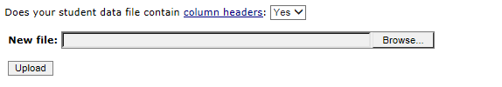  
  
Then click Browse to look for the excel file and then Upload.

Proceed to the next page of this guide.

**Submit Student List – Part 2 – Identifying Columns**

Record Edited

**Identify Your Columns**   
  
We need to know what information is in each column of your student data file (E-File). If you provided column headers in your E-File (preferred), they are displayed in **Column Heading Is** in the table below. If you did not provide column headers, **Column Heading Is** will contain numbers for each column in your submitted E-File. Click on the down arrows in **Your Column Contains** to select descriptions for each column header. If there is no appropriate description in the drop-down list, please select N/A.

Once finished, click Next.

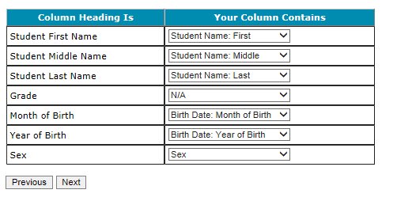

You can always come back to this Identify columns page by clicking here in circled red on the Submit Student List page:

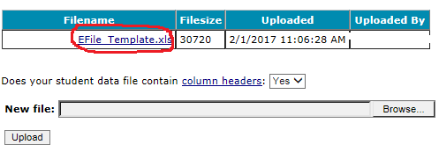

**Submit Student List – Part 3 – Matching Values and Verifying E-file Percentages**

Match Your Values to eTIMSS Codes

Follow the instructions below to verify codes you entered in your excel file, e.g. M means male and F means female student.

TIMSS needs to know the values for each of the columns in your E-File. The tables on the next few web pages contain the following information for each column:

* Your Values: The values in your E-File
* TIMSS Codes: Click on the down arrow and select the TIMSS Code that best matches Your Values
* Number: The number of students in your E-File with that value
* Percentage: The percentage in your E-File with that value

Use the Previous and Next buttons to navigate from column header to column header.

If there is an error in your data file, exit E-File, correct the problem in your Excel file, and upload the file again.

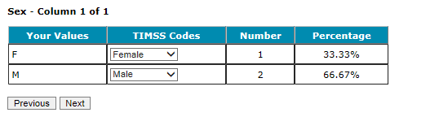

**Verify Your E-File**

Once complete with matching your codes, you can review the percentages to ensure you file looks correct. For example, most schools would have around 50% female and 50% male students.

The table below summarizes the information you have provided on your student list (E-File). Please review this summary and verify that the information is correct. Total Enrollment at the bottom of the table should match the number of students in your E-File, and the total number of students currently enrolled in grade 4.

Record whether the information is correct or incorrect by selecting the appropriate button at the bottom of the page. Then click the Submit button. If you select incorrect, you will need to correct your E-File and resubmit it.

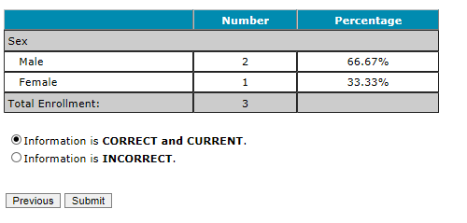Record Edited

**Once you click submit, you will see this message below.**

Thank you for submitting your E-File!

TIMSS will process your submission and select the sample of fourth-grade classes to be assessed. Soon you will receive an email explaining which classes were selected.

A TIMSS representative will contact you to make arrangements for the assessment.

Submit Class List Page – Grade 4

**(Screenshot of the 2018 field test page. Will be updated for 2019)**



Submit Student List Page – Grade 4

**(Screenshot of the 2018 field test page. Will be updated for 2019)**



# TIMSS 2019: Email to School Coordinator (SC) to Submit Class and Student Lists—Grade 8

Dear [School Coordinator],

TIMSS needs a complete and current list of **all of your school’s eighth-grade mathematics classes** and **all the eighth-grade students in those classes** in order to randomly select classes to participate in TIMSS 2019. TIMSS also needs a list of your school’s eighth-grade science teachers and the courses they teach in order to link information about science teachers to the assessed students.

Please go to [https://www.mytimss.com](http://www.mytimss.com/) to submit your class and student lists. If you have forgotten your login ID please contact the TIMSS hotline at [timss@westat.com](mailto:timss@westat.com) or 1-855-445-5604. If you have forgotten your password, you can request a new password on the MyTIMSS login page.

After logging in, select **Submit Class List** from the left hand panel to provide information about your eighth-grade mathematics classes and science teachers. Once you have provided information about all eighth-grade mathematics classes and science teachers, select **Submit Student List** to provide an electronic list of currently enrolled eighth-grade students in your school.

Instructions for **Submit Class List** and **Submit Student List** are attached. These tip sheets and Excel templates can also be found in the **Documents** section of MyTIMSS. An optional webinar will be held on XXXXXXXX to review the Submit Class and Submit Student procedures. Registration information for the webinar will be sent to you in a separate mail. The webinar will be recorded for viewing at a later time as well.

If you have any questions about submitting your list, please email or call the TIMSS Help Desk at TIMSS@westat.com or 1-855-445-5604. ​

Please submit your student E-File by **2/6/19.** TIMSS will process your submission and select the sample of eighth-grade mathematics classes to be assessed. You will be informed of the classes selected within a few weeks of submitting your lists.

Thank you very much for participating in TIMSS, and for submitting your school's class and student lists!

Sincerely,

The TIMSS 2019 Team

Attachments: Grade 8 Submit Class List Tip Sheet; Grade 8 Submit Student List Tip Sheet

*NCES is authorized to conduct this study under the Education Sciences Reform Act of 2002 (ESRA 2002, 20 U.S.C. §9543). All of the information you provide may be used only for statistical purposes and may not be disclosed, or used, in identifiable form for any other purpose except as required by law (20 U.S.C. §9573 and 6 U.S.C. §151).*

# Instructions for Submitting Class and Student Lists—Grade 8

**Submit Class List**

When you are ready to Submit a Class List, click **“Submit Class List”** at the left menu.

TIMSS needs a complete and current list of all of your school’s eighth-grade math classes in order to randomly select classes to be assessed. Even if you have a mixed class of different grade students, as long as there is one single 8th-grade student in that class, it will count as an “8th-grade class.”

Typically, two math classes are sampled in each school, and all students in the selected classes will be assessed. Enter all 8th grade math classes and we will select 2 (sometimes more depending on class size).

Enter the data for each class in the form at the bottom of the page. After you have entered information for a class, click on save, and another row will appear for you to enter information about another class. Continue until you have entered information for all classes that contain eighth-grade students.

Include the following information for each class:

|  |  |
| --- | --- |
| **Class Name (each class name should be unique)** | Record the class name that is typically used by your school to refer to the class. For example, it may be that your school uses the grade plus a letter for the class name (8a, 8b, etc.), the grade plus a number (8.1, 8.2, etc.), the teacher name, the class period (Period 1, Period 2, etc.), the class location (Room 7, Room 8, etc.), or some other combination of these items. **It is important that unique class names are entered because these names will be used to indicate to the Test Administrator which classes will be tested**. |
| **Class Group or Track (if applicable)** | If your school assigns students to specific classes based on their ability, please indicate the relevant level: Low ability, Average ability, or High ability. |
| **Number of 8th-grade students in that 8th-grade math class (most classes do not have more than 30 students).** | Enter the number of eighth-grade students in each class. In the case of *multi-grade classes* (e.g., students from more than one grade level in the same class), only the eighth-grade students should be counted as a class in the list. For example, if three Grade 7 students, five Grade 8 students, and ten Grade 9 students form a multi-grade class, then you should record five students for the number of students in this multi-grade class. |
| **Class Exclusion Status (if applicable; if at least one 8th-grade student in this class is able to be assessed, do not use this field)** | **1** = Students with functional disabilities; i.e., students who have physical disabilities in such a way that they cannot perform in the TIMSS testing situation. Students with functional disabilities who are able to perform should be accommodated in the test situation, within reason, rather than excluded.  **2** = Students with intellectual disabilities; i.e., students who are considered, in the professional opinion of the school principal or by other qualified staff members, to have severe intellectual disabilities or who have been tested as such. This category includes students who are emotionally or mentally unable to follow even the general instructions of the test. Students should not be excluded solely because of poor academic performance or normal disciplinary problems. It should be noted that students with dyslexia, or other such learning disabilities, should be accommodated in the test situation, within reason, rather than excluded.  **3** = Non-native language speakers; i.e., students who are unable to read or speak the language(s) of the test and would be unable to overcome the language barrier in the test situation.  If all students in the excluded class do not belong to the same exclusion category, please identify the category corresponding to the majority of students. |
| **Name of Teacher** | Name of the math teacher |

**Tips:**

* Use the *Save* button to save information you have entered for each class.
* If you need to delete a class, click on the http://mytimssdev.westat.com/common/images/tooltip/Critical.png at the beginning of a saved class row.
* Each class name should be unique. Do not just type in “Grade 8 class” several times. We must be able to differentiate between classes, so please use different class names for each class with at least one 8th-grade student.
* Click on the *Finished* button when you have entered all eighth-grade classes in the form.
* If you click Finish, but still need to enter more classes, contact [TIMSS@westat.com](mailto:TIMSS@westat.com) to unlock this page so you can enter more classes.
* Use the *Print* button to print a list of the classes you included for reference. You will need the exact UNIQUE, class name for submitting the student list (next section), so printing is recommended.

***Class Name:*** Record the class name that is typically used by your school to refer to the class. For example, it may be that your school uses the grade plus a letter for the class name (4a, 4b, etc.), the grade plus a number (4.1, 4.2, etc.), the class location (Room 7, Room 8, etc.,) or some other scheme. **This is important because these identifiers will be used to indicate to the Test Administrator which classes will be tested.**

***Class Group or Track*** (If applicable): If your school assigns students to specific classes based on their ability, please indicate the relevant level: Low ability, Average ability, or High ability.

***Number of Students:*** Enter the number of fourth-grade students in each class. In the case of multi-grade classes (e.g., students from more than one grade level in the same class), only the fourth-grade students should be counted as a class in the list. For example, if three Grade 3 students, five Grade 4 students, and ten Grade 5 students form a multi-grade class, then you should record five students for the number of students in this multi-grade class.

***Class Exclusion Status*** (If applicable): As a rule, all classes are to be included. TIMSS 2015 will offer many accommodations that should allow most students to participate. Click on the Documents link on the left panel to see what accommodations are provided or allowed. **All class-level exclusions must be approved.** If you indicate a class-level exclusion, a TIMSS representative will contact you to discuss.

Examples of *potential* class-level exclusions include classes where all students belong to at least one of the following three exclusion status categories, and none of the students can be assessed with TIMSS accommodations:

1. students with functional disabilities (students who have physical disabilities in such a way that they cannot perform in the TIMSS testing situation. Students with functional disabilities who are able to perform should be accommodated in the test situation, within reason, rather than excluded);
2. students with intellectual disabilities (students who are considered, in the professional opinion of the school principal or by other qualified staff members, to have severe intellectual disabilities or who have been tested as such. This includes students who are emotionally or mentally unable to follow even the general instructions of the test. Students should not be excluded solely because of poor academic performance or normal disciplinary problems. It should be noted that students with dyslexia, or other such learning disabilities, should be accommodated in the test situation, within reason, rather than excluded);
3. non-native language speakers (students who are unable to read or speak the language(s) of the test and would be unable to overcome the language barrier in the test situation).

If all students in the excluded class do not belong to the same exclusion category, please identify the category corresponding to the majority of students.

***Name of Teacher:*** Name of the teacher teaching this fourth-grade class.

|  |  |  |  |  |  |  |
| --- | --- | --- | --- | --- | --- | --- |
| **Grade 8** | | | | | | |
|  | [http://mytimssdev.westat.com/common/images/tooltip/info.png](http://mytimssdev.westat.com/SubmitClassList.aspx)**Class Name (enter unique class name in each row)** | [http://mytimssdev.westat.com/common/images/tooltip/info.png](http://mytimssdev.westat.com/SubmitClassList.aspx)**Class Group** | [http://mytimssdev.westat.com/common/images/tooltip/info.png](http://mytimssdev.westat.com/SubmitClassList.aspx)**Number of 8th-grade Students** | [http://mytimssdev.westat.com/common/images/tooltip/info.png](http://mytimssdev.westat.com/SubmitClassList.aspx)**Class Exclusion Status (If applicable)** | [http://mytimssdev.westat.com/common/images/tooltip/info.png](http://mytimssdev.westat.com/SubmitClassList.aspx)**Name of Teacher** | [http://mytimssdev.westat.com/common/images/tooltip/info.png](http://mytimssdev.westat.com/SubmitClassList.aspx) |
|  |  |  | Only Numbers |  |  |  |

**Submit Student List – Part 1 - Upload**

Along with the list of classes, TIMSS needs a complete and current list of **all students** in grade 8 in order to draw a random sample of classes (and therefore students) to participate in the assessment. If you prefer just to submit a list of students for selected classes only, please email [TIMSS@westat.com](mailto:TIMSS@westat.com) after you have submitted you class lists. We will then randomly select 2 (sometimes more) classes and you only need to provide student lists for those 2 to 3 classes.

Your student data electronic file (E-File) must be submitted as a Microsoft Excel file. Click the “Submit Student List” link to get started. You can only do this AFTER you have completed the Submit Class List Page. The class names you entered on that page will need to be reentered exactly when completing student lists.

You may use the eTIMSS E-File Excel Template we provide in the **Documents** section or you may provide an Excel file with the same information. Include the following information for each student:

* Class: The eighth-grade math class the student is enrolled in. Please use **the same unique class names** you used in the Submit Class List screen.
* Teacher Name: Teacher of the above named class.
* Student Name: The preferred format is First Name, Middle Name (or Initial), and Last Name in separate columns. However, TIMSS will accept student names in one column.
* Sex: Codes for Male/Female.
* Date of Birth: The preferred format is Month of Birth and Year of Birth in separate columns. However, TIMSS will accept Date of Birth in one column.

It is preferred that you include column headers as the first row in your E-File (see templates for examples in [Documents](http://mytimssdev.westat.com/documents.aspx)). However, E-Files without column headers will be accepted. If you cannot submit your student data with this information in an Excel file, please call or email the TIMSS Help Desk at TIMSS@westat.com or 1-855-445-5604. Please save this file with your school name and district in the file name.

Once finished, click “Yes” or “No” if you do have column headers (first row in file says, “class, teacher name, student name”, etc.). Then click Upload.

  
  
Then click Browse to look for the excel file and then Upload.

Proceed to the next page of this guide.

**Submit Student List – Part 2 – Identifying Columns**

Record Edited

**Identify Your Columns**   
  
We need to know what information is in each column of your student data file (E-File). If you provided column headers in your E-File (preferred), they are displayed in **Column Heading Is** in the table below. If you did not provide column headers, **Column Heading Is** will contain numbers for each column in your submitted E-File. Click on the down arrows in **Your Column Contains** to select descriptions for each column header. If there is no appropriate description in the drop-down list, please select N/A.

Once finished, click Next.



You can always come back to this Identify columns page by clicking here in circled red:



**Submit Student List – Part 3 – Matching Values and Verifying E-file Percentages**

Record Edited

**Match Your Values to eTIMSS Codes**

Follow the instructions below to verify codes you entered in your excel file, e.g. M means male and F means female student.

TIMSS needs to know the values for each of the columns in your E-File. The tables on the next few web pages contain the following information for each column:

* Your Values: The values in your E-File
* TIMSS Codes: Click on the down arrow and select the TIMSS Code that best matches Your Values
* Number: The number of students in your E-File with that value
* Percentage: The percentage in your E-File with that value

Use the Previous and Next buttons to navigate from column header to column header.

If there is an error in your data file, exit E-File, correct the problem in your Excel file, and upload the file again.



**Verify Your E-File**

Once complete with matching your codes, you can review the percentages to ensure you file looks correct. For example, most schools would have around 50% female and 50% male students.

The table below summarizes the information you have provided on your student list (E-File). Please review this summary and verify that the information is correct. Total Enrollment at the bottom of the table should match the number of students in your E-File, and the total number of students currently enrolled in grade 8.



Record whether the information is correct or incorrect by selecting the appropriate button at the bottom of the page. Then click the Submit button. If you select incorrect, you will need to correct your E-File and resubmit it.

Record Edited

**Once you click submit, you will see this message below.**

Thank you for submitting your E-File!

TIMSS will process your submission and select the sample of eighth-grade classes to be assessed. Soon you will receive an email explaining which classes were selected.

A TIMSS representative will contact you to make arrangements for the assessment.

Submit Class List Page – Grade 8

**(Screenshot of the 2018 field test page. Will be updated for 2019)**



Submit Student List Page – Grade 8

**(Screenshot of the 2018 field test page. Will be updated for 2019)**



# MyTIMSS Prepare for Assessment Page

(red font is customized depending on grade the school was selected for)

**Prepare For Assessment**

Thank you for providing information about all the fourth-grade classes / eighth-grade math classes in your school! In a few days you will receive an email informing you that your sample of classes has been selected. Return to this webpage when you receive the email from TIMSS@westat.com: “The list of students selected to participate in TIMSS is available in the Student-Teacher Linkage Form (STLF)”

**Please note the following:**

**Student-Teacher Linkage Forms (STLF)** –The forms list the students who have been selected to participate in the assessment at your school. You will get an email when this form is ready.

**Student Tracking Form (STF)–**The forms list the students who have been selected to participate in the assessment at your school. Instructions on how to access and review the forms are in the Documents section on this website. The STF and TTF will become available about a week after the STLF has been posted.

**Teacher Tracking Form (TTF)** –The forms list the teachers who have been selected to participate in the online teacher questionnaire at your school. Instructions on how to access and review the forms are in the Documents section on this website. The STF and TTF will become available about a week after the STLF has been posted.

**Sample Parent Notification Letter and Facts for Parents about TIMSS**. Starting mid-February and after you submit student lists, your school will receive a FedEx packet of TIMSS materials including a TIMSS Parent FAQ, a sample hardy copy parent/guardian notification letter, and student appointment cards.

A sample parent/guardian notification letter is in the Documents section for you to customize and print on your school letterhead. Please distribute the parent notification letter and the Parent FAQ (from our FedEx mailing to you) to the parents of the selected students prior to the assessment. Additionally, a Spanish version of the letter is available in the Documents page. You can also share the Parent FAQ link available here: https://nces.ed.gov/timss/parents/.

As your assessment date approaches, your Test Administrator will be contacting you to finalize the assessment day activities.

Prepare for Assessment page (screenshot)

(Will be updated with text above)



# Student-Teacher Linkage Form (STLF) Email

(yellow highlight for mail merge)

Dear [school coordinator],

The list of students selected to participate in TIMSS is available in the Student-Teacher Linkage Form (STLF)!

The **Student-Teacher Linkage Form (**STLF) lists the students who have been selected to participate in the assessment at your school. This list is based on the class and student information you submitted. To access the STLF, please login at www.mytimss.com, then go to **Prepare for Assessment** and select **“Click here to download the STLF.”** In that one STLF excel file, there is a worksheet for each set of classes or students selected, so please make sure to review each worksheet in the STLF excel file. Most schools will have two worksheets, one for each class.



For the Student-Teacher Linkage Form (STLF), you will only need to make sure the students on that list match the teachers to the selected students in the header of Column 6. If you see any errors, please contact the TIMSS Hotline at [TIMSS@westat.com](mailto:TIMSS@westat.com) or 855-445-5604. Please do not email the list back to us.

In a week of the STLF posting, you will receive an email informing you that the final list of selected students and teachers are available. These lists, called the Student Tracking Forms (STF) and Teacher Tracking Forms (TTF) will be posted on this same **Prepare for Assessment** page.

Thank you very much for participating in TIMSS, and for submitting your school's class and student lists!

Sincerely,

The TIMSS Team

*NCES is authorized to conduct this study under the Education Sciences Reform Act of 2002 (ESRA 2002, 20 U.S.C. §9543). All of the information you provide may be used only for statistical purposes and may not be disclosed, or used, in identifiable form for any other purpose except as required by law (20 U.S.C. §9573 and 6 U.S.C. §151).*

# Student Tracking Form (STF) and Teacher Tracking Form (TTF) Email

(yellow highlight for mail merge; red for customization)

Dear [School Coordinator],

Thank you for providing information about all the fourth-grade/eighth-grade classes in your school! The list of students and teachers selected to participate in TIMSS is now available in the Student Tracking Forms (STF) and Teacher Tracking Forms (TTF) available on the MyTIMSS website. Please see below for more details about the forms and parent notification.

* Student Tracking Form (STF) –The forms list the students who have been selected to participate in the assessment at your school. Instructions on how to access and review the forms are attached.
* Teacher Tracking Form (TTF) –The forms list the teachers who have been selected to participate in the online teacher questionnaire at your school. Instructions on how to access and review the forms are attached.
* Sample Parent Notification Letter and Facts for Parents about TIMSS 2019 (Parent FAQ) – A sample parent/guardian notification letter is attached for you to customize and print on your school letterhead. Please distribute the parent notification letter and the *Facts for Parents about TIMSS 2019* to the parents of the selected students prior to the assessment. A Spanish version of the letter is available on the MyTIMSS site under **Documents.**
* FedEx Shipment
  + Within a week, a FedEx shipment of hard-copies of the *Facts for Parents* *about TIMSS 2019 (Parent FAQ)* will be delivered to you. You can also distribute them electronically or share the Parent FAQ link available here: <https://nces.ed.gov/timss/parents/>
  + Student Appointment/invitations cards to give to selected students will be sent to you as well.

As your assessment date approaches, your Test Administrator will be contacting you to finalize the assessment day activities and discuss accommodations, if necessary.

If you have any questions, please do not hesitate to call 855-445-5604 or send an email to [TIMSS@westat.com](mailto:TIMSS@westat.com). You may also get more information about this study by visiting the TIMSS website at <http://nces.ed.gov/timss>.

Thank you for your assistance with this study!

Sincerely,

The TIMSS Team

Attachments:

Sample Parent Notification Letter

Facts for Parents about TIMSS 2019 (Parent FAQ)

STF and TTF Instructions

*NCES is authorized to conduct this study under the Education Sciences Reform Act of 2002 (ESRA 2002, 20 U.S.C. §9543). All of the information you provide may be used only for statistical purposes and may not be disclosed, or used, in identifiable form for any other purpose except as required by law (20 U.S.C. §9573 and 6 U.S.C. §151).*

# Instructions for Student Tracking Form (STF) and Teacher Tracking Form (TTF)

**Reviewing the Student Tracking Form (STF)**

The **Student Tracking Form** (STF) lists the students who have been selected to participate in the assessment at your school. This list is based on the student information you submitted. You can take notes on this form in preparation for the pre-assessment call in which the Test Administrator will ask you about any updates to this form over the phone. To access the STF, please login at www.mytimss.com, then go to **Prepare for Assessment** and select **“Click here to download the STF.”** Student Appointment/invitations cards to give to selected students will be sent to you in a FedEx delivery.

As the first step in reviewing the Student Tracking Form, please verify the student information for accuracy after you open the excel file you just downloaded. See below for what should be reviewed. Please also make sure the school name and students match what you expect.

* Student’s name is listed in **Column 1**.
* Date of birth is listed in **Column 4.**
* Gender (using codes—1 for female and 2 for male) is listed in **Column 5**.
* Exclusion status in **Column 6.**
* Participation status in **Column 7.**

**Student Exclusions and Accommodations**

If a student is to be excluded from the assessment because he or she requires an accommodation, please make a note in column 6 using the codes at the bottom of the STF.

**Participation Status + Newly-enrolled or no-longer-enrolled students**

If many of the students listed in the STF are not enrolled in the school, please contact TIMSS@westat.com ASAP, but you do not need to contact TIMSS@westat.com if only 1 to 3 students are no longer enrolled or are newly enrolled. These new or no-longer-enrolled students can be discussed with your Test Administrator when they call you for the pre-assessment call (usually 1-2 weeks before assessment date). You can make a note on the form regarding these students in the first column in column 7 using the status codes shown at the bottom of the STF. You can also use status codes 1 through 4 to provide more information about a student.

**Updates and Questions**

If you have updates to the STF, please have the form ready for the pre-assessment call. You can also provide the hardcopy to the Test Administrator when they come to your school on assessment day. If you have any questions about completing this form, please address them with your Test Administrator when they contact you. For urgent questions on the STF, you can also contact the TIMSS Help Desk (TIMSS@westat.com). The STF is just for you to take notes on in preparation for the pre-assessment call so you know parents of which students should be notified. Please do not send the STF or TTF back to us. You can however give it to the Test Administrator in person, if you would like, when they come on the assessment day. Instructions for reviewing the Teacher Tracking Form (TTF) are on the next page.

**Reviewing the Teacher Tracking Form (TTF)**

The **Teacher Tracking Form** (TTF) lists the teachers who have been selected to complete the teacher questionnaire at your school. This list is based on the teacher information you submitted. You can take notes on this form in preparation for the pre-assessment call in which the Test Administrator will ask you about any updates to this form over the phone. To access the TTF, please login at www.mytimss.com, then go to **Prepare for Assessment** and select **“Click here to download the TTF.”**

As the first step in reviewing the TTF, please verify the teacher information for accuracy after you open the excel file you just downloaded. See below for what should be reviewed. Please also make sure the school name and teachers match what you expect.

* Teacher’s name is listed in **Column 1**.
* Year of birth is listed in **Column 3**.
* Gender (using codes—1 for female and 2 for male) is listed in **Column 4**.
* Main subject in **column 5.**
* Questionnaire status is listed in **Column 6.**

**If a selected teacher is no longer at the school, please make a note of this on the TTF. You do not need to contact us about new teachers not already listed on the TTF.**

Teachers will be emailed login access to complete the teacher questionnaire prior to assessment day.

**Updates and Questions**

If you have updates to the TTF, please have the form ready for the pre-assessment call. You can also provide the hardcopy to the Test Administrator when they come to your school on assessment day. If you have any questions with completing this form, please address them with your Test Administrator when they contact you. For urgent questions on the TTF, you can also contact the TIMSS Help Desk (TIMSS@westat.com). The TTF is just for you to take notes on in preparation for the pre-assessment call. Please do not send it back to us. You can however give it to the Test Administrator in person, if you would like, when they come on assessment day.

Thank you for your assistance with this study!

The TIMSS 2019 Team

[TIMSS@westat.com](mailto:ICILS@westat.com);

855-445-5604

# Student-Teacher Linkage Form (STLF) Template

(Template below is an example from 2015. Does not include real names. Will be updated for 2019).



# Student Tracking Form (STF) Template

(Template below is an example from TIMSS 2015. It does not include real names and will be updated for 2019).



# Teacher Tracking Form (TTF) Template

(Template below is an example from 2015. It does not include real names and will be updated for 2019).



# MyTIMSS Documents Page

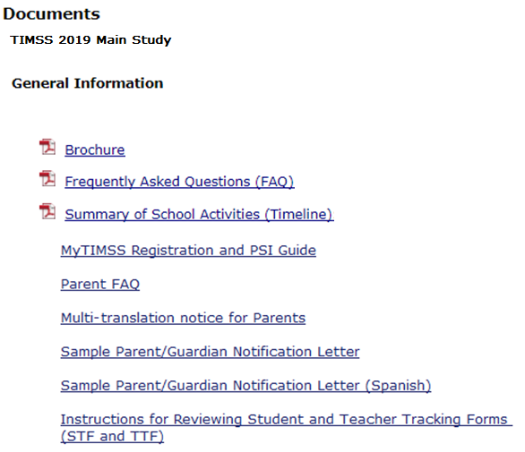

# MyTIMSS Important Websites and Contact Us Pages





# School Principal Questionnaire Login Card/Email

**Front of Card:**

Welcome to TIMSS!

Your school is participating in the main study for Trends in International Mathematics and Science Study (TIMSS) 2019. This online questionnaire seeks information about schools and provides important context to understanding the achievement of students taking the assessment.

Please go to the web address (URL) given below and log in to the online questionnaire with your “School ID” and “Password”, which are printed on the label attached below. Please contact the TIMSS Help Desk (TIMSS@westat.com) if you have problems logging on.

The website link is: <https://portal.myTIMSS.us/>

[Insert Label]

The online questionnaire does NOT require JavaScript or cookies to work. Responses are saved automatically as you go from question to question. The “Table of Contents” link on the bottom of each page provides an overview of all questions and whether you have completed them. You may leave the questionnaire at any time and log in again later. See notes on the back of this card.

OMB# 1850-0695 (expires 01/31/2021).

**Back of Card:**

NOTES

* Please use the Previous and Next buttons to navigate backward and forward
* You may exit the questionnaire at any time and log in again later— all of your responses will be saved automatically.
* The Table of Contents provides an overview of all questions and shows whether you have completed all questions.
* To exit the Table of Contents, click on any question link or section header.
* If you would like a printed copy of the online questionnaire, click on the “Prepare Printer Version” link on the Table of Contents page.
* It is estimated that it will take approximately 20 minutes to complete the questionnaire.
* If you have problems accessing the online questionnaire or need assistance, please contact the TIMSS help desk at 1-855-445-5604 or email TIMSS@westat.com.
* If you would prefer to complete a paper questionnaire, please contact your TIMSS School Coordinator.

Thank you for the thought, time, and effort you have put into completing the questionnaire!

*NCES is authorized to conduct TIMSS under the Education Sciences Reform Act of 2002 (ESRA 2002, 20 U.S.C. §9543). All of the information provided by school staff and students may be used only for statistical purposes and may not be disclosed, or used, in identifiable form for any other purpose except as required by law (20 U.S.C. §9573 and 6 U.S.C. §151). The U.S. Office of Management and Budget has approved the data collection under OMB# 1850-0695. Individual responses will be combined with those from other participants to produce summary statistics and reports.*

# Teacher Questionnaire Login Card/Email

**Front of Card:**

Welcome to TIMSS!

Your school is participating in the main study for Trends in International Mathematics and Science Study (TIMSS) 2019. This online questionnaire seeks information about teachers’ academic and professional backgrounds, classroom resources, instructional practices, and attitudes toward teaching.

Please go to the web address (URL) given below and log in to the online questionnaire with your “Teacher ID” and “Password”, which are printed on the label attached below. Please contact the TIMSS Help Desk (TIMSS@westat.com) if you have problems logging on.

The website link is: <https://portal.myTIMSS.us/>

[Insert Label]

The online questionnaire does NOT require JavaScript or cookies to work. Responses are saved automatically as you go from question to question. The “Table of Contents” link on the bottom of each page provides an overview of all questions and whether you have completed them. You may leave the questionnaire at any time and log in again later. See notes on the back of this card.

OMB# 1850-0695 (expires 01/31/2021).

**Back of Card:**

NOTES

* Please use the Previous and Next buttons to navigate backward and forward
* You may exit the questionnaire at any time and log in again later— all of your responses will be saved automatically.
* The Table of Contents provides an overview of all questions and shows whether you have completed all questions.
* To exit the Table of Contents, click on any question link or section header.
* If you would like a printed copy of the online questionnaire, click on the “Prepare Printer Version” link on the Table of Contents page.
* It is estimated that it will take approximately 30 minutes to complete the questionnaire.
* If you have problems accessing the online questionnaire or need assistance, please contact the TIMSS help desk at 1-855-445-5604 or email TIMSS@westat.com.
* If you would prefer to complete a paper questionnaire, please contact your TIMSS School Coordinator.
* After you complete the questionnaire, please email the TIMSS@westat.com and provide an email address where we can send your $20 Amazon gift card code as a token of appreciation for your participation.

Thank you for the thought, time, and effort you have put into completing the questionnaire!

*NCES is authorized to conduct TIMSS under the Education Sciences Reform Act of 2002 (ESRA 2002, 20 U.S.C. §9543). All of the information provided by school staff and students may be used only for statistical purposes and may not be disclosed, or used, in identifiable form for any other purpose except as required by law (20 U.S.C. §9573 and 6 U.S.C. §151). The U.S. Office of Management and Budget has approved the data collection under OMB# 1850-0695. Individual responses will be combined with those from other participants to produce summary statistics and reports.*

# Online Questionnaire Login Screen Text

(for the Principal, Teachers, and Students)

TIMSS2019MS - English (United States)

You are not logged in.

Welcome to the IEA - DPC SurveySystem

Online Questionnaires

Please enter your user ID and password (Checksum).

User ID:

Password:

The National Center for Education Statistics (NCES), within the U.S. Department of Education, conducts TIMSS in the United States as authorized by the Education Sciences Reform Act of 2002 (ESRA 2002, 20 U.S.C. §9543). All of the information you provide may be used only for statistical purposes and may not be disclosed, or used, in identifiable form for any other purpose except as required by law (20 U.S.C. §9573 and 6 U.S.C. §151).

According to the Paperwork Reduction Act of 1995, no persons are required to respond to a collection of information unless such collection displays a valid OMB control number. The valid OMB control number for this voluntary information collection is 1850-0695. The time required to complete this information collection is estimated to average 20 minutes per principal, 30 minutes per teacher, and 30 minutes per student, including the time to review instructions, search existing data resources, gather the data needed, and complete and review the information collection. If you have any comments or concerns regarding the accuracy of the time estimate(s), suggestions for improving the form, or questions about the status of your individual submission of this form, write directly to: Trends in International Mathematics and Science Study (TIMSS), National Center for Education Statistics, Potomac Center Plaza (PCP), 550 12th St., SW, 4th floor, Washington, DC 20202.

OMB No. 1850-0695, Approval Expires 01/31/2021.

© IEA Online SurveySystem 2019 - Help

# Student Appointment Card for TIMSS 2019 MS: Grade 8 only

**Front**

(TIMSS USA Graphic and Logo)

Welcome to the U.S. TIMSS Team!

___________________________________

(student name)

Congratulations, you have been selected to be part of a special group of students representing the United States in the TIMSS (Trends in International Mathematics and Science Study) 2019 Main Study.

See back for details.

**Back**

This spring, selected students from the United States will participate in the main study in 2019.

Join us on....

TIMSS Date:

TIMSS Time:

TIMSS Location:

Please bring your own scientific or graphic calculator to the TIMSS 2019 main study.

During the assessment, you are not permitted to use devices that can connect to the Internet. Aside from the testing equipment, you cannot use a laptop or other portable computer, pocket organizer, device with a typewriter-style keyboard, electronic writing pad, pen input device, or a cell phone.

See front for details.

(TIMSS USA and IES logos)

(Below is a student appointment card example from the 2017 Pilot. It will be updated for the 2019 main study with the language listed on the previous page of this document.)

**Front**



**Back**



Student Login Card (label with login information will be affixed to the card)



# Student Certificate of Completion

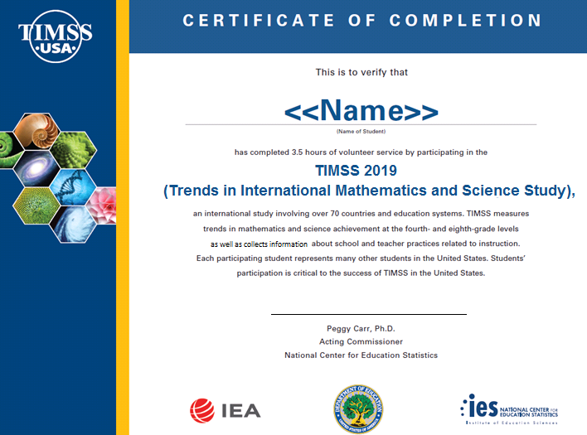

# School Certificate of Completion

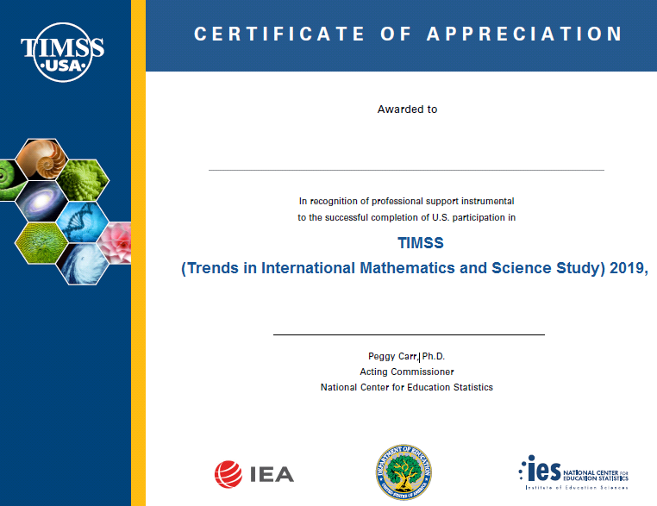

# Appendix B-2: TIMSS 2019 Main Study Notification Letters and Supporting Materials

Contents

TIMSS Main Study Sample Notification Letter: Grade 4 138

TIMSS Main Study Sample Notification Letter: Grade 8 139

TIMSS Main Sample Implicit Consent Letter: Grade 4 140

TIMSS Main Study Sample Implicit Consent Letter: Grade 8 141

TIMSS Implicit Consent Form: Grades 4 and 8 142

TIMSS Main Study Sample Explicit Consent Letter: Grade 4 143

TIMSS Main Study Sample Explicit Consent Letter: Grade 8 144

TIMSS Explicit Consent Form: Grades 4 and 8 145

TIMSS Facts for Parents About the Main Study: Grade 4 146

TIMSS Facts for Parents About the Main Study: Grade 8 147

Multi-translation Notice for Parents 148

## TIMSS Main Study Sample Notification Letter: Grade 4

SCHOOL LETTERHEAD

Dear Parent or Guardian,

This letter is to inform you about an important international study of student learning being conducted in our school this spring. The Trends in International Mathematics and Science Study (TIMSS) provides important information for benchmarking student performance in mathematics and science at grades 4 and 8 in the United States against countries around the world. Since 1995, TIMSS has measured worldwide trends in student knowledge of mathematics and science.

Our school has accepted an invitation from the National Center for Education Statistics (NCES), part of the U.S. Department of Education, to participate in TIMSS 2019. {Insert number} of our 4th-grade classes will take part. {This/One of these} is your child’s class. The enclosed summary sheet provides some background information about TIMSS, explains what is involved for each student selected to participate in the study, and gives a contact phone number and email address where you can find answers to any questions you might have.

To have an accurate picture of what U.S. 4th graders can do in mathematics and science, it is important that each student selected take part in the study. In addition to answering mathematics and science questions, students will be asked to complete a questionnaire about themselves. I urge you to support this effort by encouraging your child to take part; however, participation in this study is entirely voluntary. Previous experience suggests that students actually enjoy taking part, and participating students will receive a small gift, which we think they will like.

All of the information collected is safeguarded, as required by law. NCES is authorized to conduct this study under the Education Sciences Reform Act of 2002 (ESRA 2002, 20 U.S.C. §9543). All of the information provided by school staff and students may be used only for statistical purposes and may not be disclosed, or used, in identifiable form for any other purpose except as required by law (20 U.S.C. §9573 and 6 U.S.C. §151). Students and schools are never identified in any reports. All reported statistics refer to the United States as a whole.

Thank you for taking the time to learn about this important study.

Sincerely,

[School official]

Enclosures:

Facts for Parents about TIMSS 2019

## TIMSS Main Study Sample Notification Letter: Grade 8

SCHOOL LETTERHEAD

Dear Parent or Guardian,

This letter is to inform you about an important international study of student learning being conducted in our school this spring. The Trends in International Mathematics and Science Study (TIMSS) provides important information for benchmarking student performance in mathematics and science at grades 4 and 8 in the United States against countries around the world. Since 1995, TIMSS has measured worldwide trends in student knowledge of mathematics and science.

Our school has accepted an invitation from the National Center for Education Statistics (NCES), part of the U.S. Department of Education, to participate in TIMSS 2019. {Insert number} of our 8th-grade classes will take part. {This/One of these} is your child’s class. The enclosed summary sheet provides some background information about TIMSS, explains what is involved for each student selected to participate in the study, and gives a contact phone number and email address where you can find answers to any questions you might have.

To have an accurate picture of what U.S. 8th graders can do in mathematics and science, it is important that each student selected take part in the study. In addition to answering mathematics and science questions, students will be asked to complete a questionnaire about themselves. I urge you to support this effort by encouraging your child to take part; however, participation in this study is entirely voluntary. Previous experience suggests that students actually enjoy taking part, and participating students will receive a small gift, which we think they will like.

All of the information collected is safeguarded, as required by law. NCES is authorized to conduct this study under the Education Sciences Reform Act of 2002 (ESRA 2002, 20 U.S.C. §9543). All of the information provided by school staff and students may be used only for statistical purposes and may not be disclosed, or used, in identifiable form for any other purpose except as required by law (20 U.S.C. §9573 and 6 U.S.C. §151). Students and schools are never identified in any reports. All reported statistics refer to the United States as a whole.

Thank you for taking the time to learn about this important study.

Sincerely,

[School Official]

Enclosures:

Facts for Parents about TIMSS 2019

## TIMSS Main Sample Implicit Consent Letter: Grade 4

SCHOOL LETTERHEAD

Dear Parent or Guardian,

This letter is to inform you about an important international study of student learning being conducted in our school this spring. The Trends in International Mathematics and Science Study (TIMSS) provides important information for benchmarking student performance in mathematics and science at grades 4 and 8 in the United States against countries around the world. Since 1995, TIMSS has measured worldwide trends in student knowledge of mathematics and science.

Our school has accepted an invitation from the National Center for Education Statistics (NCES), part of the U.S. Department of Education, to participate in TIMSS 2019. {Insert number} of our 4th-grade classes will take part. {This/One of these} is your child’s class. The enclosed summary sheet provides some background information about TIMSS, explains what is involved for each student selected to participate in the study, and gives a contact phone number and email address where you can find answers to any questions you might have.

To have an accurate picture of what U.S. 4th graders can do in mathematics and science, it is important that each student selected take part in the study. In addition to answering mathematics and science questions, students will be asked to complete a questionnaire about themselves. I urge you to support this effort by encouraging your child to take part; however, participation in this study is entirely voluntary. Previous experience suggests that students actually enjoy taking part, and participating students will receive a small gift, which we think they will like.

All of the information collected is safeguarded, as required by law. NCES is authorized to conduct this study under the Education Sciences Reform Act of 2002 (ESRA 2002, 20 U.S.C. §9543). All of the information provided by school staff and students may be used only for statistical purposes and may not be disclosed, or used, in identifiable form for any other purpose except as required by law (20 U.S.C. §9573 and 6 U.S.C. §151). Students and schools are never identified in any reports. All reported statistics refer to the United States as a whole.

If you have any objection to your child joining in the TIMSS activities, please let us know by completing the attached consent form and returning it to the school.

Thank you for taking the time to learn about this important study.

Sincerely,

[School Official]

Enclosures:

Facts for Parents about TIMSS 2019

Parent/Guardian Consent Form

## TIMSS Main Study Sample Implicit Consent Letter: Grade 8

SCHOOL LETTERHEAD

Dear Parent or Guardian,

This letter is to inform you about an important international study of student learning being conducted in our school this spring. The Trends in International Mathematics and Science Study (TIMSS) provides important information for benchmarking student performance in mathematics and science at grades 4 and 8 in the United States against countries around the world. Since 1995, TIMSS has measured worldwide trends in student knowledge of mathematics and science.

Our school has accepted an invitation from the National Center for Education Statistics (NCES), part of the U.S. Department of Education, to participate in TIMSS 2019. {Insert number} of our 8th-grade classes will take part. {This/One of these} is your child’s class. The enclosed summary sheet provides some background information about TIMSS, explains what is involved for each student selected to participate in the study, and gives a contact phone number and email address where you can find answers to any questions you might have.

To have an accurate picture of what U.S. 8th graders can do in mathematics and science, it is important that each student selected take part in the study. In addition to answering mathematics and science questions, students will be asked to complete a questionnaire about themselves. I urge you to support this effort by encouraging your child to take part; however, participation in this study is entirely voluntary. Previous experience suggests that students actually enjoy taking part, and participating students will receive a small gift, which we think they will like.

All of the information collected is safeguarded, as required by law. NCES is authorized to conduct this study under the Education Sciences Reform Act of 2002 (ESRA 2002, 20 U.S.C. §9543). All of the information provided by school staff and students may be used only for statistical purposes and may not be disclosed, or used, in identifiable form for any other purpose except as required by law (20 U.S.C. §9573 and 6 U.S.C. §151). Students and schools are never identified in any reports. All reported statistics refer to the United States as a whole.

If you have any objection to your child joining in the TIMSS activities, please let us know by completing the attached consent form and returning it to the school.

Thank you for taking the time to learn about this important study.

Sincerely,

[School Official]

Enclosures:

Facts for Parents about TIMSS 2019

Parent/Guardian Consent Form

## TIMSS Implicit Consent Form: Grades 4 and 8

**Trends in International Mathematics and Science Study (TIMSS) 2019**

**Parent/Guardian Consent Form**

Your child has been asked to participate in an important international study of student learning called the Trends in International Mathematics and Science Study (TIMSS). Each student who participates will receive a small gift. This assessment will be administered by a team of researchers from Westat, who are operating under contract on behalf of the National Center for Education Statistics (NCES), with the U. S. Department of Education. In spring 2019, 4th and 8th grade questions in electronic formats will be tested on tablet computers in approximately 650 schools in the United States in preparation for the 2019 international study (325 schools that include 4th grade and 325 that include 8th grade).

**If you grant permission for your child to participate in TIMSS 2019, you do not need to return this form.**

**If you do not consent to your child’s participation in TIMSS 2019 please return this form to your child’s school as soon as possible.**

**I do not grant permission** for my child, _______________________________, to participate in the Trends in International Mathematics and Science Study 2019 assessment.

**__________________________________________________________________**

(Signature of parent or guardian)

Date of signature: _______/_______/____________

PLEASE PRINT:

**Student name: _____________________________________________**

School name: ______________________________________________

FOR OFFICE USE ONLY:

Student ID: ________________________________________________

## TIMSS Main Study Sample Explicit Consent Letter: Grade 4

SCHOOL LETTERHEAD

Dear Parent or Guardian,

This letter is to inform you about an important international study of student learning being conducted in our school this spring. The Trends in International Mathematics and Science Study (TIMSS) provides important information for benchmarking student performance in mathematics and science at grades 4 and 8 in the United States against countries around the world. Since 1995, TIMSS has measured worldwide trends in student knowledge of mathematics and science.

Our school has accepted an invitation from the National Center for Education Statistics (NCES), part of the U.S. Department of Education, to participate in TIMSS 2019. {Insert number} of our 4th-grade classes will take part. {This/One of these} is your child’s class. The enclosed summary sheet provides some background information about TIMSS, explains what is involved for each student selected to participate in the study, and gives a contact phone number and email address where you can find answers to any questions you might have.

To have an accurate picture of what U.S. 4th graders can do in mathematics and science, it is important that each student selected take part in the study. In addition to answering mathematics and science questions, students will be asked to complete a questionnaire about themselves. I urge you to support this effort by encouraging your child to take part; however, participation in this study is entirely voluntary. Previous experience suggests that students actually enjoy taking part, and participating students will receive a small gift, which we think they will like.

All of the information collected is safeguarded, as required by law. NCES is authorized to conduct this study under the Education Sciences Reform Act of 2002 (ESRA 2002, 20 U.S.C. §9543). All of the information provided by school staff and students may be used only for statistical purposes and may not be disclosed, or used, in identifiable form for any other purpose except as required by law (20 U.S.C. §9573 and 6 U.S.C. §151). Students and schools are never identified in any reports. All reported statistics refer to the United States as a whole.

Before we can allow your child to join in the TIMSS activities, we must have your written consent. Please let us know by completing the attached form and returning it to the school.

Thank you for taking the time to learn about this important study and to consider your child’s participation in it.

Sincerely,

[School Official]

Enclosures:

Facts for Parents about TIMSS 2019

Parent/Guardian Consent Form

## TIMSS Main Study Sample Explicit Consent Letter: Grade 8

SCHOOL LETTERHEAD

Dear Parent or Guardian,

This letter is to inform you about an important international study of student learning being conducted in our school this spring. The Trends in International Mathematics and Science Study (TIMSS) provides important information for benchmarking student performance in mathematics and science at grades 4 and 8 in the United States against countries around the world. Since 1995, TIMSS has measured worldwide trends in student knowledge of mathematics and science.

Our school has accepted an invitation from the National Center for Education Statistics (NCES), part of the U.S. Department of Education, to participate in TIMSS 2019. {Insert number} of our 8th-grade classes will take part. {This/One of these} is your child’s class. The enclosed summary sheet provides some background information about TIMSS, explains what is involved for each student selected to participate in the study, and gives a contact phone number and email address where you can find answers to any questions you might have.

To have an accurate picture of what U.S. 8th graders can do in mathematics and science, it is important that each student selected take part in the study. In addition to answering mathematics and science questions, students will be asked to complete a questionnaire about themselves. I urge you to support this effort by encouraging your child to take part; however, participation in this study is entirely voluntary. Previous experience suggests that students actually enjoy taking part, and participating students will receive a small gift, which we think they will like.

All of the information collected is safeguarded, as required by law. NCES is authorized to conduct this study under the Education Sciences Reform Act of 2002 (ESRA 2002, 20 U.S.C. §9543). All of the information provided by school staff and students may be used only for statistical purposes and may not be disclosed, or used, in identifiable form for any other purpose except as required by law (20 U.S.C. §9573 and 6 U.S.C. §151). Students and schools are never identified in any reports. All reported statistics refer to the United States as a whole.

Before we can allow your child to join in the TIMSS activities, we must have your written consent. Please let us know by completing the attached form and returning it to the school.

Thank you for taking the time to learn about this important study and to consider your child’s participation in it.

Sincerely,

[School Official]

Enclosures:

Facts for Parents about TIMSS 2019

Parent/Guardian Consent Form

## TIMSS Explicit Consent Form: Grades 4 and 8

**Trends in International Mathematics and Science Study (TIMSS)**

**Parent/Guardian Consent Form**

Your child has been asked to participate in an important international study of student learning called the Trends in International Mathematics and Science Study (TIMSS). Each student who participates will receive a small gift. This assessment will be administered by a team of researchers from Westat, who are operating under contract on behalf of the National Center for Education Statistics (NCES), with the U. S. Department of Education. In spring 2019, 4th and 8th grade questions in electronic formats will be tested on tablet computers in approximately 650 schools in the United States in preparation for the 2019 international study (325 schools that include 4th grade and 325 that include 8th grade).

Yes, I grant permission for my child to participate in TIMSS 2019.

No, I do not grant permission for my child to participate in TIMSS 2019.

**__________________________________________________________________**

(Signature of parent or guardian)

Date of signature: _______/_______/____________

PLEASE PRINT:

**Student name: _____________________________________________**

School name: ______________________________________________

FOR OFFICE USE ONLY:

Student ID: ________________________________________________

## TIMSS Facts for Parents About the Main Study: Grade 4

**Facts for Parents**

**About TIMSS 2019**

Between March and May of this year, your child’s school will be one of about 325 nationwide taking part in a 4th-grade important international assessment: TIMSS 2019. Schools were selected randomly to represent the nation’s schools and, within each school, 4th-grade students were selected randomly to represent the nation’s 4th graders. Your child was among those students selected to take part in the TIMSS assessment.

**What is TIMSS?**

TIMSS (Trends in International Mathematics and Science Study) is an international assessment that measures student learning in mathematics and science. Every four years since 1995, TIMSS documents worldwide trends in the knowledge of 4th graders. The National Center for Education Statistics (NCES), within the U.S. Department of Education, conducts TIMSS in the United States. Along with more than 60 other nations, the U.S. will take part in the 2019 TIMSS cycle as we did in 1995, 1999, 2003, 2007, 2011, and 2015.

**What is involved?**

TIMSS staff will visit the school and administer the assessment on tablet computers that they will bring to the school. In a small number of classes the assessment will be administered on paper. The assessment will take approximately 2 ½ hours. The assessment itself is 72 minutes with breaks between sections. Students will also be asked some questions about themselves and their educational experience. Participation in the study is voluntary.

**What are the benefits?**

The nation as a whole benefits from TIMSS by having a greater understanding of how the knowledge and skills of U.S. 4th graders compare with those of 4th graders in other countries. Schools that participate in TIMSS will receive $200, and students who participates will receive a small gift that we believe they will like.

**Who administers TIMSS?**

The entire assessment is administered by trained staff from Westat, a research organization under contract to the U.S. Department of Education’s National Center for Education Statistics.

All of the information collected is safeguarded, as required by law. NCES is authorized to conduct this study under the Education Sciences Reform Act of 2002 (ESRA 2002, 20 U.S.C. §9543). All of the information provided by school staff and students may be used only for statistical purposes and may not be disclosed, or used, in identifiable form for any other purpose except as required by law (20 U.S.C. §9573 and 6 U.S.C. §151). Students and schools are never identified in any reports. All reported statistics refer to the United States as a whole.

**Where can I find out more about TIMSS?**

More information about TIMSS is available at the TIMSS website at <http://nces.ed.gov/timss> or <http://timss.bc.edu>. Or if you would like to contact a TIMSS staff member directly, please feel free to call the TIMSS hotline at 1-(855)-445-5604 or email us at [TIMSS@westat.com](mailto:TIMSS@westat.com).

## TIMSS Facts for Parents About the Main Study: Grade 8

**Facts for Parents**

**About TIMSS 2019**

Between March and May of this year, your child’s school will be one of about 325 nationwide taking part in an 8th-grade important international assessment: TIMSS 2019. Schools were selected randomly to represent the nation’s schools and, within each school, 8th-grade students were selected randomly to represent the nation’s 8th graders. Your child was among those students selected to take part in the TIMSS assessment.

**What is TIMSS?**

TIMSS (Trends in International Mathematics and Science Study) is an international assessment that measures student learning in mathematics and science. Every four years since 1995, TIMSS documents worldwide trends in the knowledge of 8th graders. The National Center for Education Statistics (NCES), within the U.S. Department of Education, conducts TIMSS in the United States. Along with more than 60 other nations, the U.S. will take part in the 2019 TIMSS cycle as we did in 1995, 1999, 2003, 2007, 2011, and 2015.

**What is involved?**

TIMSS staff will visit the school and administer the assessment on tablet computers that they will bring to the school. In a few classes nationwide, the assessment will be administered on paper. The assessment will take approximately 2½ hours. The assessment itself is 90 minutes with breaks between sections. Students will also be asked some questions about themselves and their educational experience. Participation in the study is voluntary.

**What are the benefits?**

The nation as a whole benefits from TIMSS by having a greater understanding of how the knowledge and skills of U.S. 8th graders compare with those of 8th graders from other countries. Schools that participate in TIMSS will receive $200, and students who participates will receive a small gift that we believe they will like.

**Who administers TIMSS?**

The entire assessment is administered by trained staff from Westat, a research organization under contract to the U.S. Department of Education’s National Center for Education Statistics.

All of the information collected is safeguarded, as required by law. NCES is authorized to conduct this study under the Education Sciences Reform Act of 2002 (ESRA 2002, 20 U.S.C. §9543). All of the information provided by school staff and students may be used only for statistical purposes and may not be disclosed, or used, in identifiable form for any other purpose except as required by law (20 U.S.C. §9573 and 6 U.S.C. §151). Students and schools are never identified in any reports. All reported statistics refer to the United States as a whole.

**Where can I find out more about TIMSS?**

More information about TIMSS is available at the TIMSS website at <http://nces.ed.gov/timss> or <http://timss.bc.edu>. Or if you would like to contact a TIMSS staff member directly, please feel free to call the TIMSS hotline at 1-(855)-445-5604 or email us at TIMSS@westat.com.

## Multi-translation Notice for Parents



1. Another 35 schools nationwide will take part in the TIMSS 2019 Field Test at the 8th-grade level.
2. Another 35 schools nationwide will take part in the TIMSS 2019 Field Test at the 4th grade level.