ATTACHMENT B

Safer Choice Program: Product and Ingredient Submissions in Salesforce

OMB Control No. 2070-0178
Approval expires XX/XX/XX

The public reporting and recordkeeping burden for this collection of information is estimated to average 16 hours per response for formulators of cleaning and non-cleaning products and 8 hours per response for partners wishing to add third-party partners and products, including the time for reviewing instructions, gathering information, and completing and reviewing the application. This is a voluntary collection. EPA cannot collect information without a valid OMB control number. Send comments on the Agency's need for this information, the accuracy of the provided burden estimates, and any suggested methods for minimizing respondent burden, including through the use of automated collection techniques to the Director, Collection Strategies Division, U.S. Environmental Protection Agency (2822T), 1200 Pennsylvania Ave., NW, Washington, D.C. 20460. Include the OMB control number in any correspondence. Do not send the completed application to this address.

Following are screenshots from the Product and Ingredient Submission forms in Safer Choice’s Salesforce data system. Note that the specific details of the screenshots may change over time as the Safer Choice program improves and/or modifies the system. However, the general and fundamental components of the Salesforce system will be similar to what is presented in the following screenshots.

Product Submissions
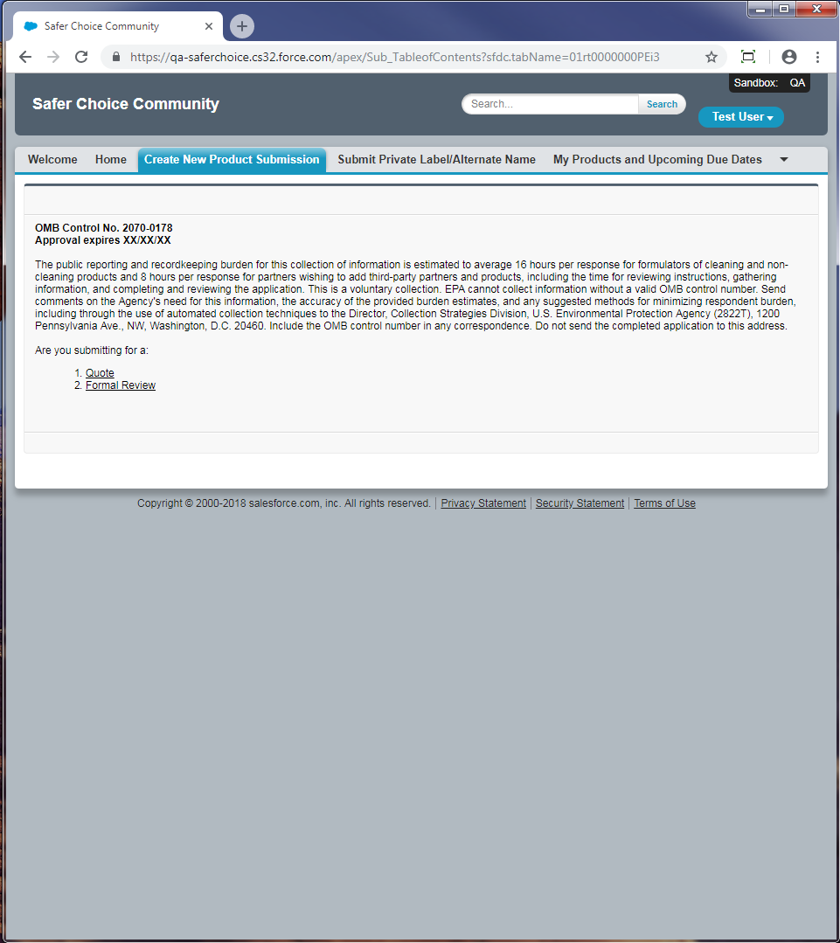
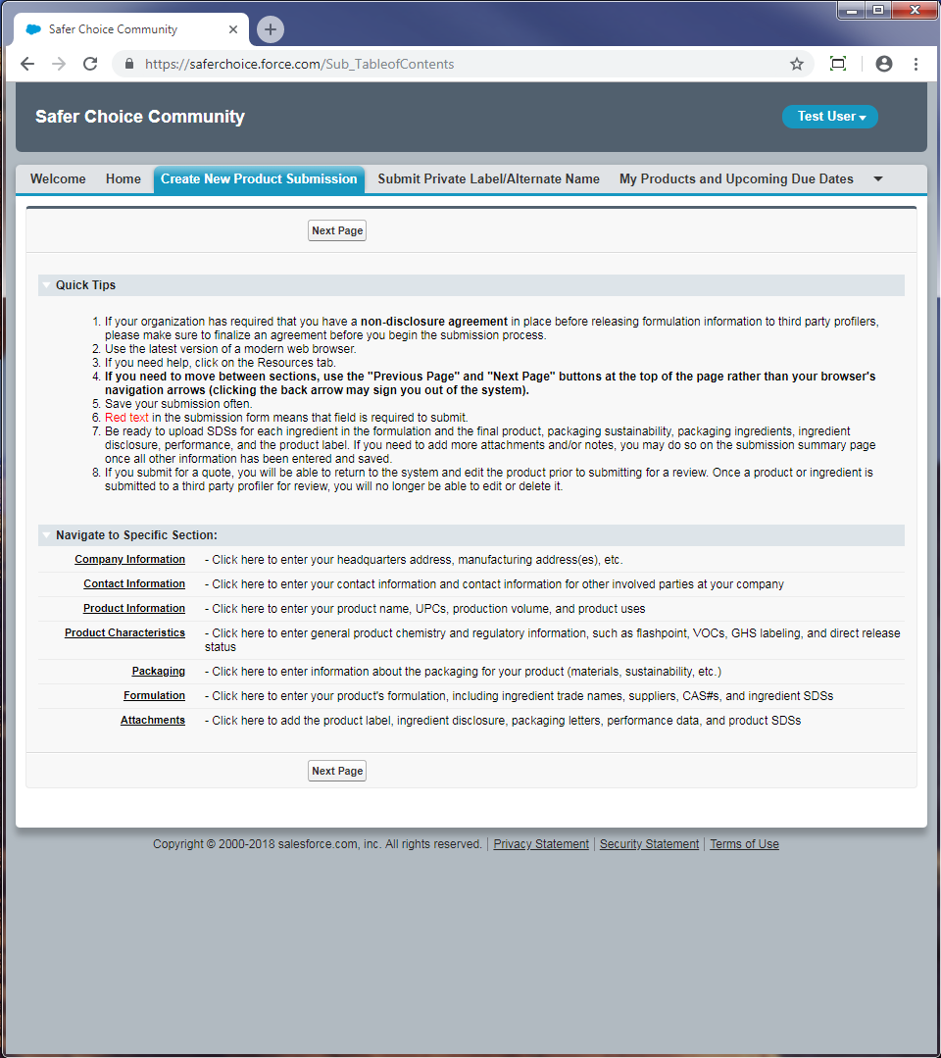

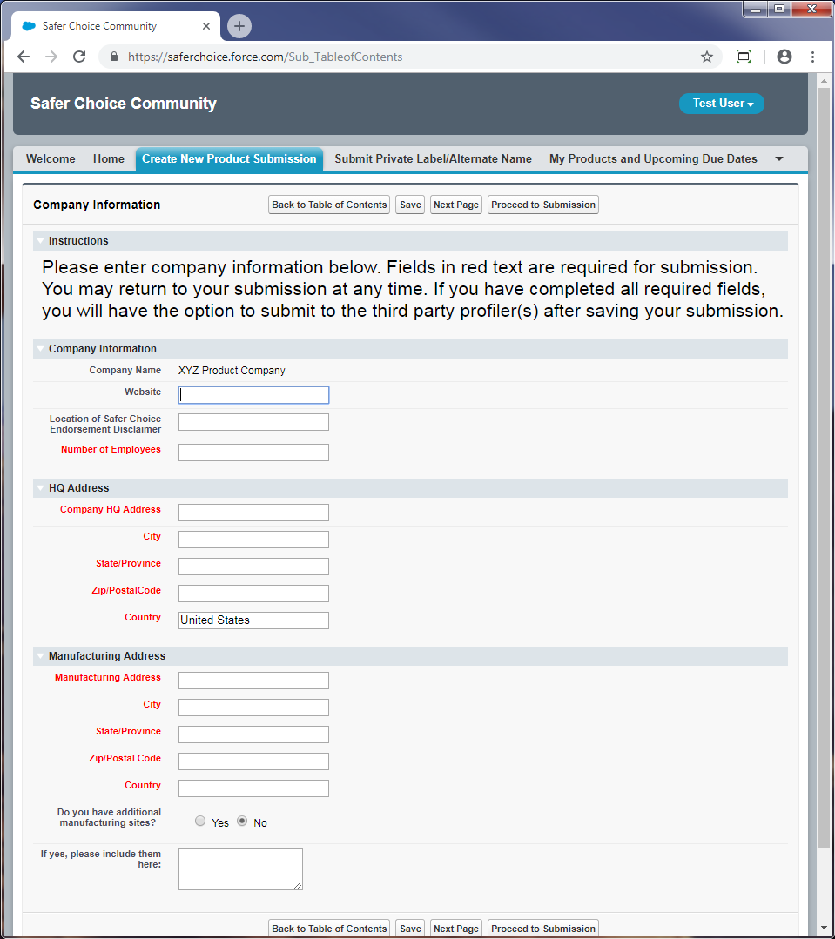
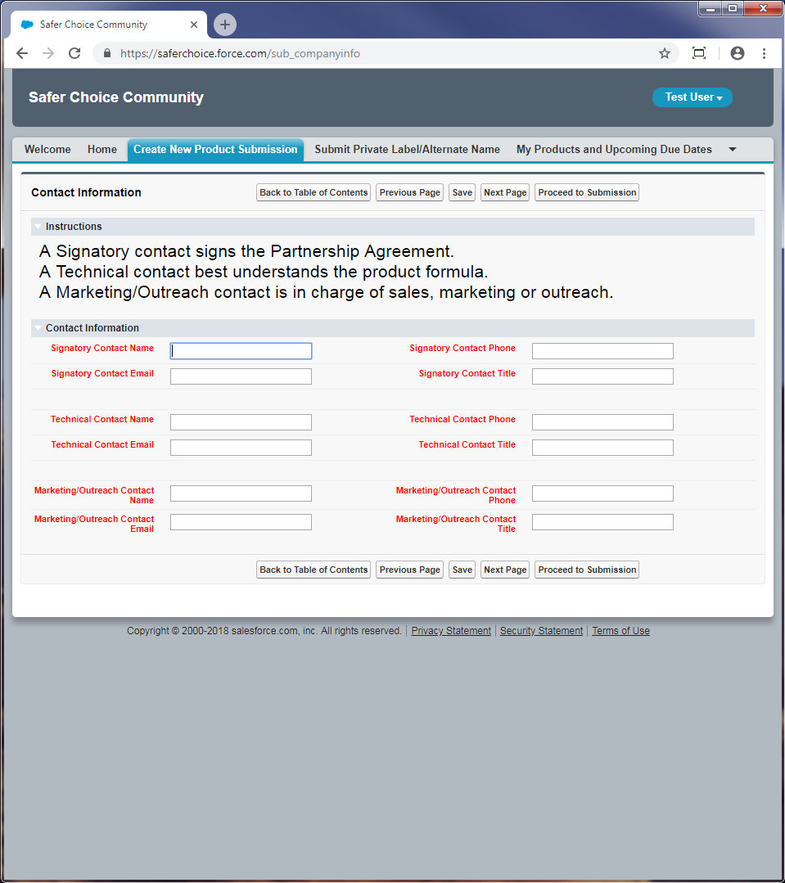
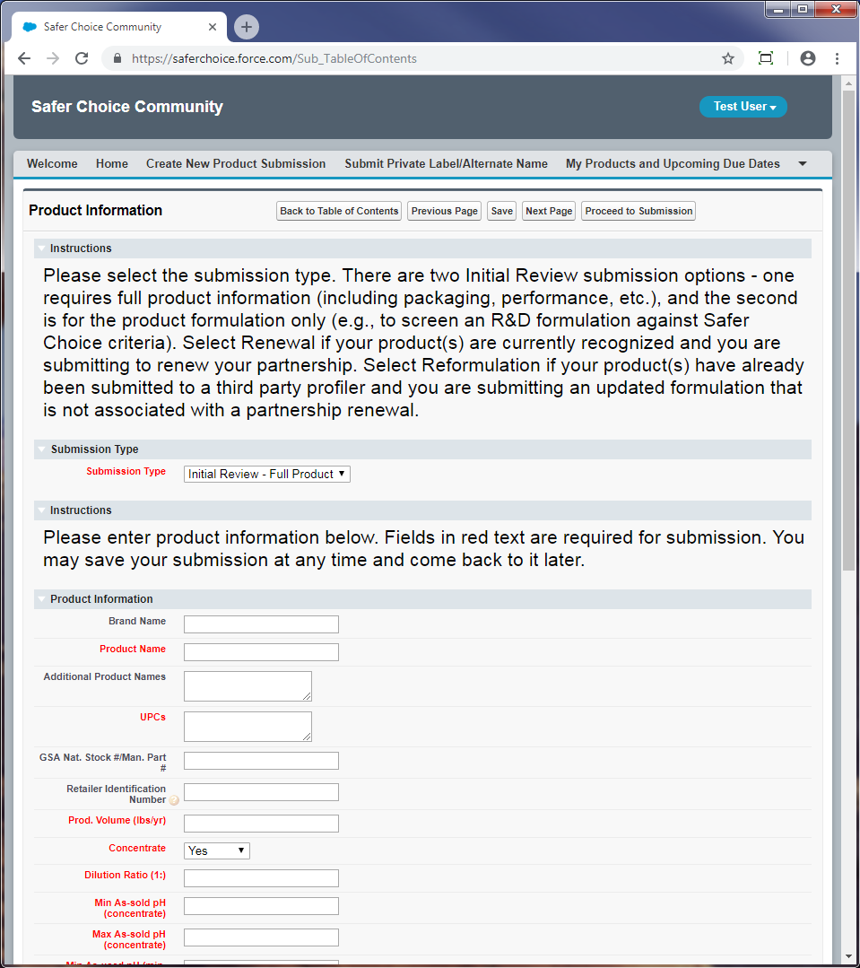
Submission Type: Dropdown options are Renewal, Reformulation, Initial Review – Full Product, Initial Review – Formulation

Concentrate: Dropdown options are Yes, No. If Yes, additional fields appear:
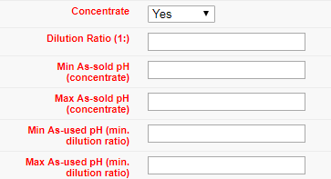
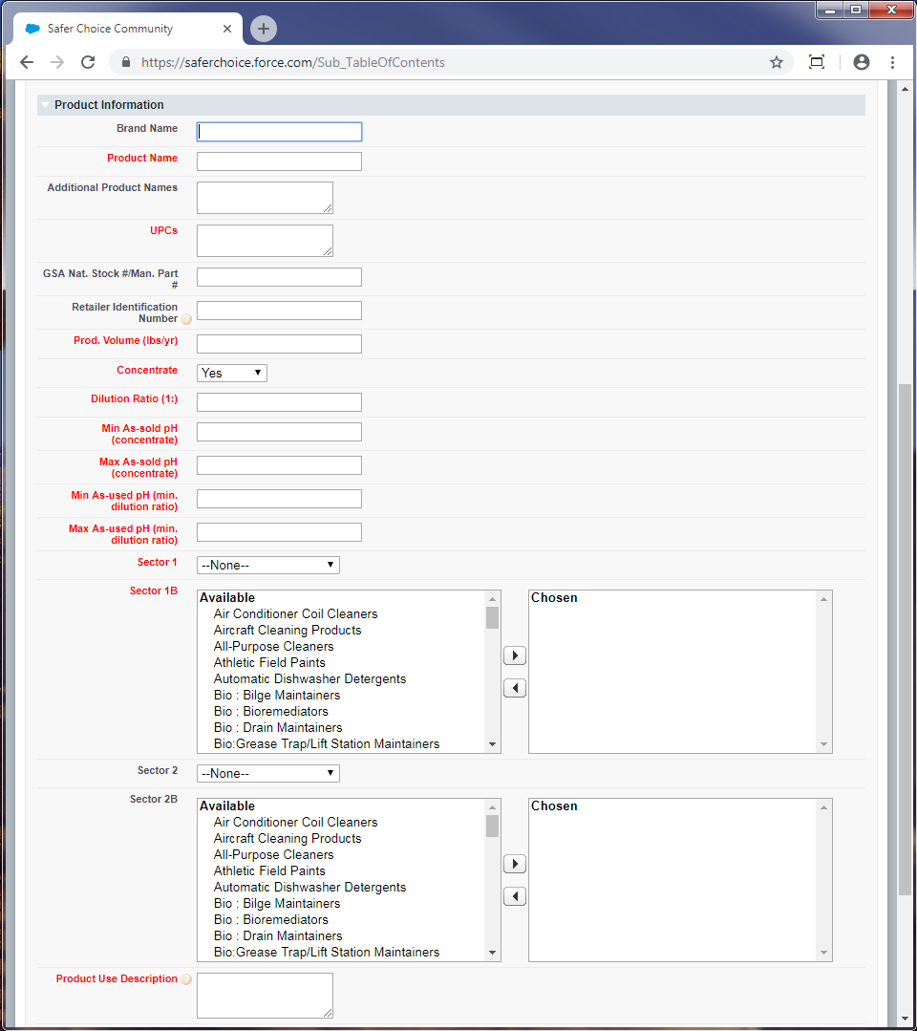
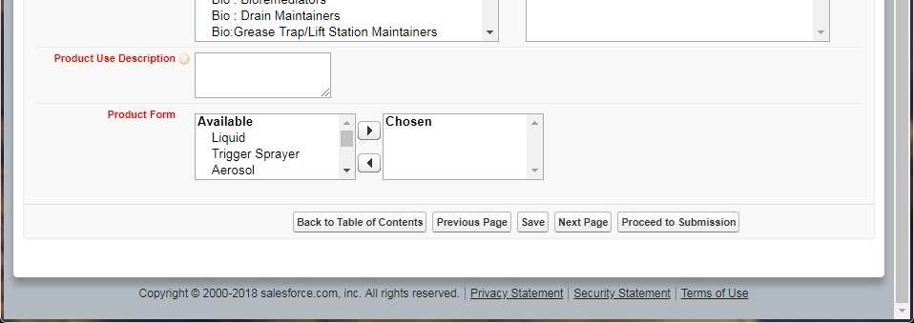
Sector 1 and Sector 2: Dropdown options are Consumer, Industrial/Institutional, Both, N/A
Sector 1B and Sector 2B: Pick list options are Air Conditioner Coil Cleaners, Aircraft Cleaning Products, All-Purpose Cleaners, Athletic Field Paints, Automatic Dishwasher Detergents, Bio : Bilge Maintainers, Bio : Bioremediators, Bio : Drain Maintainers, Bio:Grease Trap/Lift Station Maintainers, Bio : Septic System Treatments, Bio : Vehicle/Parts Wash Additives, Bio : Wastewater Inoculants, Brick and Masonry Cleaners, Car Care Products, Carpet Care Products : Cleaners, Carpet Care Products : Spot Removers, Degreasers, Deicers, Descalers, Dish Soaps, Dry Erase Board Cleaners, Fire-Fighting Products, Floor Care Products : Floor Cleaners, Floor Care Products : Floor Finishes, Floor Care Products : Floor Strippers, Graffiti Removers, Granite/Stone Cleaners, Grease Trap Products, Hand Soaps, HVAC Maintenance, Industrial Coating : Conversion Coatings, Industrial Coating : Pavement Treatments, Inkjet Printing Products, Kitchen/Countertop Cleaners, Laundry Products : Boosters, Laundry Products : Fabric Softeners, Laundry Products : Laundry Detergents, Laundry Products : Pre-Treaters, Leather Cleaners, Marine/RV Cleaners, Medical Instrument Cleaners, Metal Cleaner/Polishes, Odor Removers, Oven/Grill/Barbeque Cleaners, Parts Washers, Pet Care Products, Rinse Aids, Semiconductor/Microelectronics Cleaners, Soluble Films, Stainless Steel Cleaners, Tire Additives, Toilet Bowl Cleaners, Tub/Tile Cleaners, Upholstery Cleaners, Window/Glass Cleaners, Wood Cleaners, Other Industrial/Institutional Products, Other Consumer Products
Product Form: Pick list options are Liquid, Trigger Sprayer, Aerosol, Solid, Powder, Foaming Nozzle, Wipe, Other

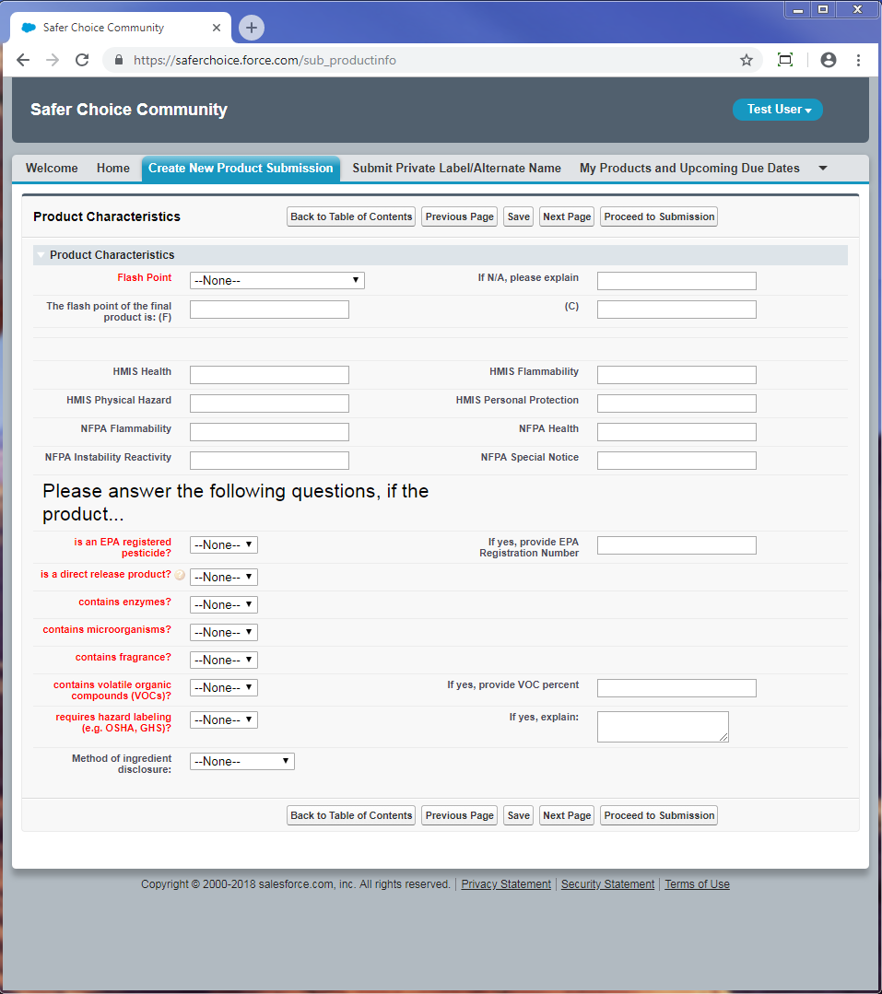
Flash Point: Dropdown options are N/A, <140 F, >140 F, HMIS Flammability Rating 0, HMIS Flammability Rating 1, HMIS Flammability Rating 2, HMIS Flammability Rating 3, HMIS Flammability Rating 4
Is an EPA Registered Pesticide: Dropdown options are Yes, No
Is direct release product: Dropdown options are Yes, No
Contains enzymes: Dropdown options are Yes, No
Contains microorganisms: Dropdown options are Yes, No
Contains fragrance: Dropdown options are Yes, No
Contains volatile organic compounds (VOCs): Dropdown options are Yes, No
Requires hazard labeling (e.g. OSHA, GHS): Dropdown options are Yes, No
Method of ingredient disclosure: Dropdown options are Product Label, Website, Phone Number, SDS, Other
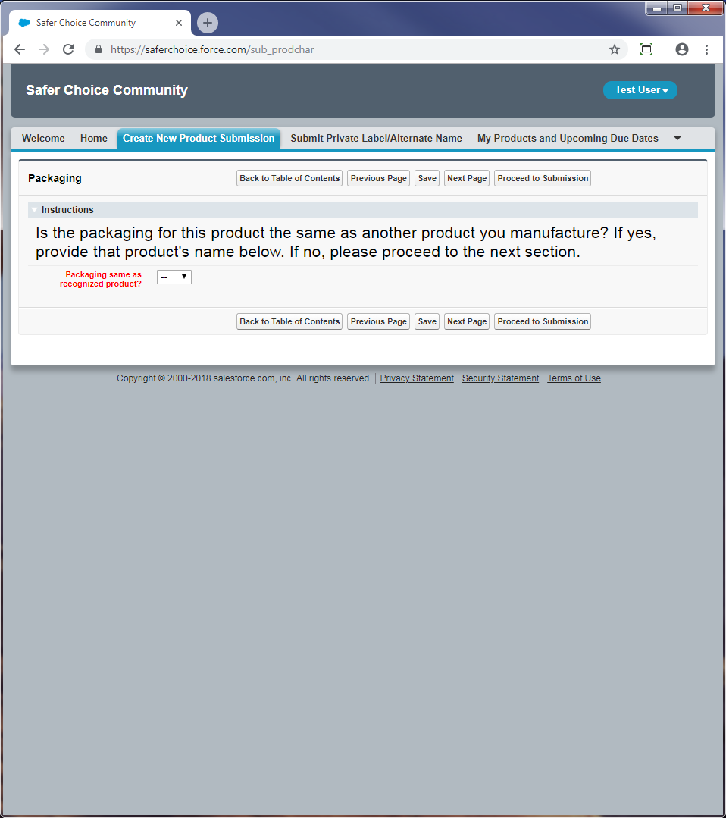

Packaging same as recognized product: Dropdown options are Yes, No. If no, additional instructions appear:
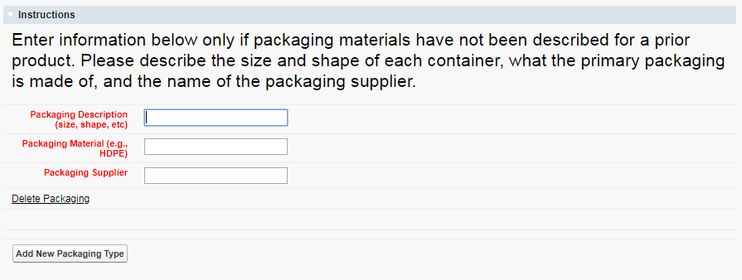

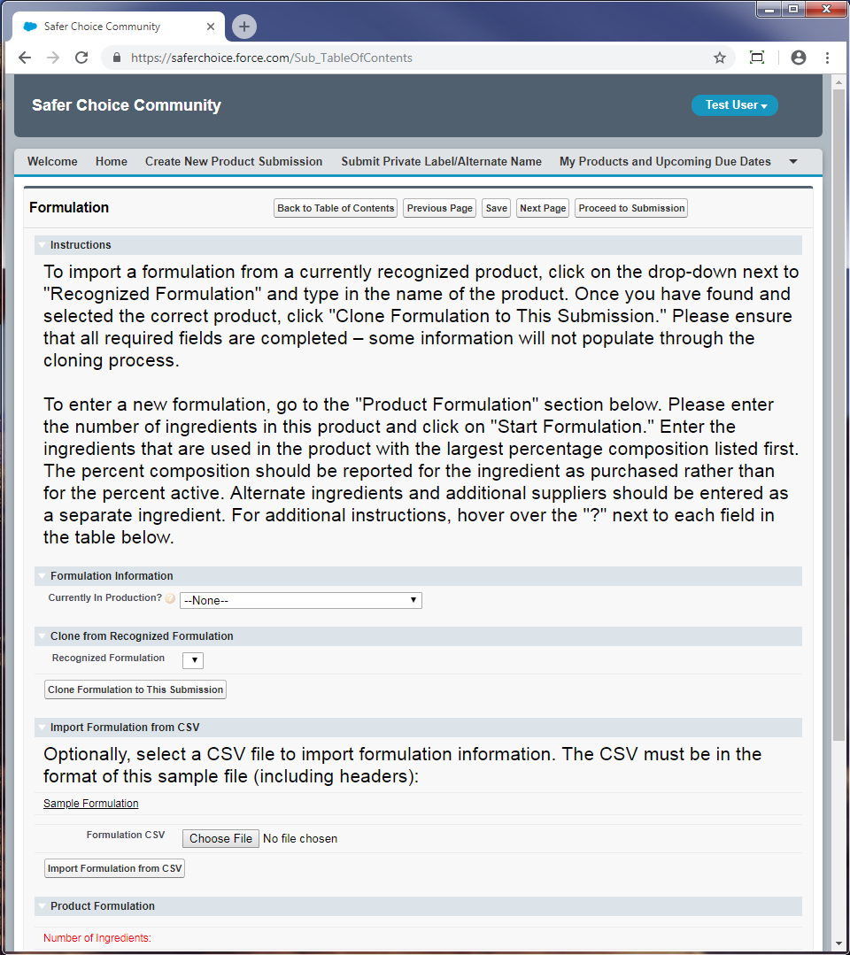
Currently in Production: Dropdown options are Yes, the formulation below is in production; No, this is a proposed formulation
Recognized Formulation: Dropdown options are the currently approved formulations on file with the Safer Choice program for the company

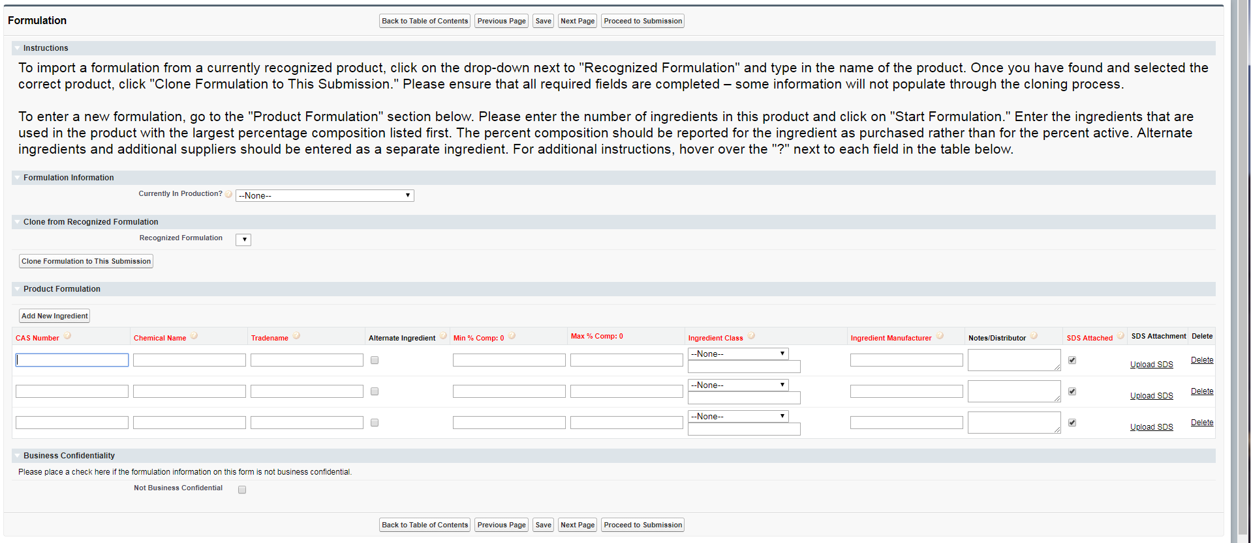
Ingredient Class: Dropdown options are Abrasive, Active, Antifoaming Agent, Antioxidant, Buffer, Builder, Chelant, Colorant, Corrosion Inhibitor, Deicer, Denaturant, Deodorant, Dispersant, Emollient, Enzyme, Fragrance, Hydrotrope, Impurity, Leveling Aid, Microorganism, Optical Brightener, Oxidant, pH Adjuster, Plasticizer, Polymer, Preservative, Propellant, Residual, Sequestrant, Solvent, Stabilizer, Surfactant, Thickener, Wax, Wetting, Other

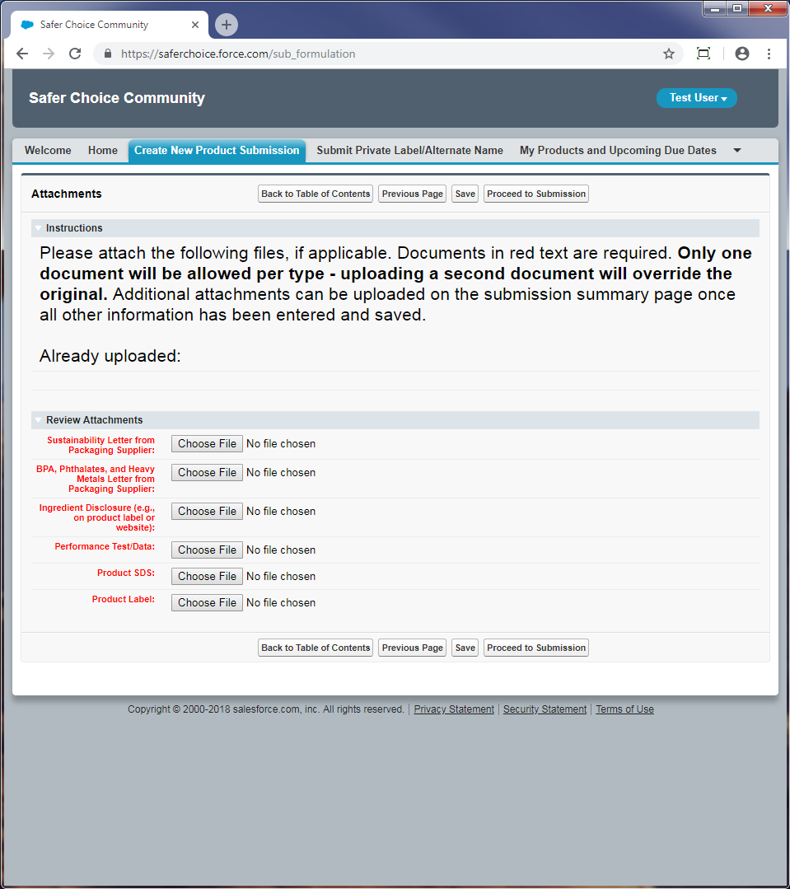

Ingredient Submissions
CleanGredients Submission
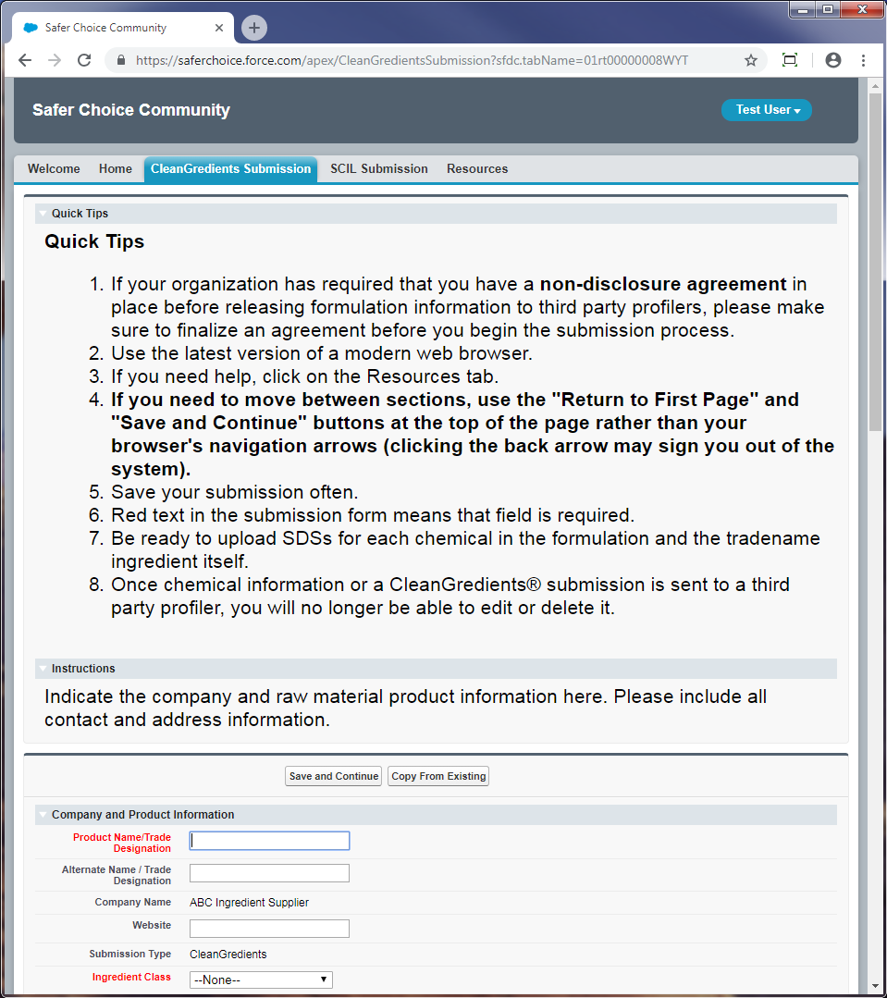
Ingredient Class: Dropdown options are Abrasive, Active, Antifoaming Agent, Antioxidant, Buffer, Builder, Chelant, Colorant, Corrosion Inhibitor, Deicer, Denaturant, Deodorant, Dispersant, Emollient, Enzyme, Fragrance, Hydrotrope, Impurity, Leveling Aid, Microorganism, Optical Brightener, Oxidant, pH Adjuster, Plasticizer, Polymer, Preservative, Propellant, Residual, Sequestrant, Solvent, Stabilizer, Surfactant, Thickener, Wax, Wetting, Other
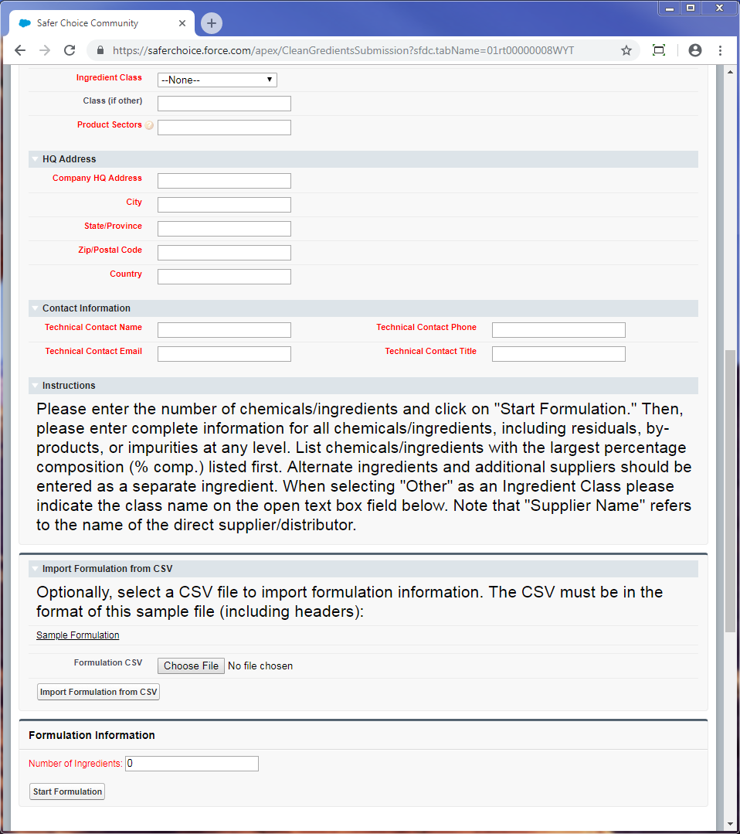

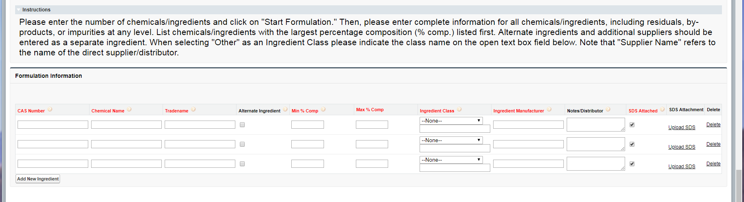
Ingredient Class: Dropdown options are Abrasive, Active, Antifoaming Agent, Antioxidant, Buffer, Builder, Chelant, Colorant, Corrosion Inhibitor, Deicer, Denaturant, Deodorant, Dispersant, Emollient, Enzyme, Fragrance, Hydrotrope, Impurity, Leveling Aid, Microorganism, Optical Brightener, Oxidant, pH Adjuster, Plasticizer, Polymer, Preservative, Propellant, Residual, Sequestrant, Solvent, Stabilizer, Surfactant, Thickener, Wax, Wetting, Other

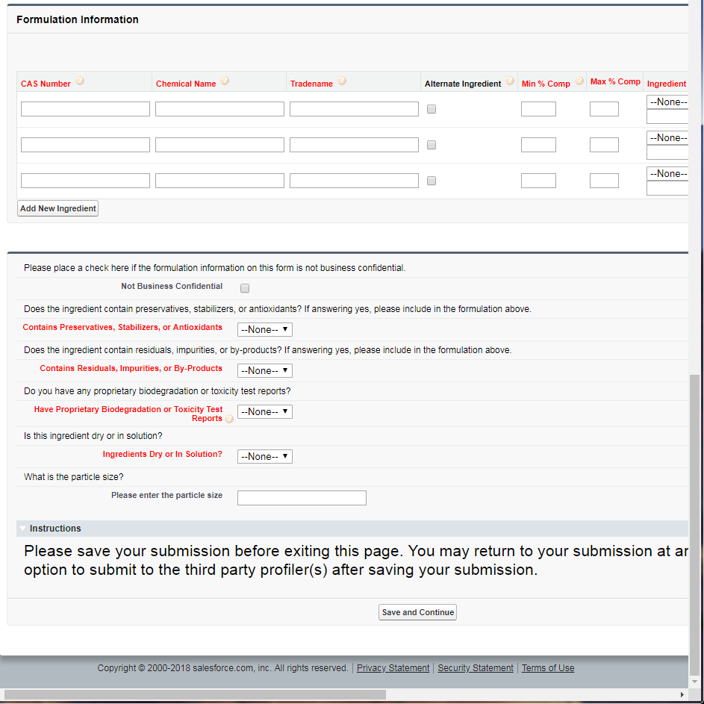
Contains Preservatives, Stabilizers, or Antioxidants: Dropdown options are Yes, No
Contains Residuals, Impurities, or By-Products: Dropdown options are Yes, No
Have Proprietary Biodegradation or Toxicity Test Reports: Dropdown options are Yes, No
Ingredients Dry or In Solution: Dropdown options are Dry, Solution

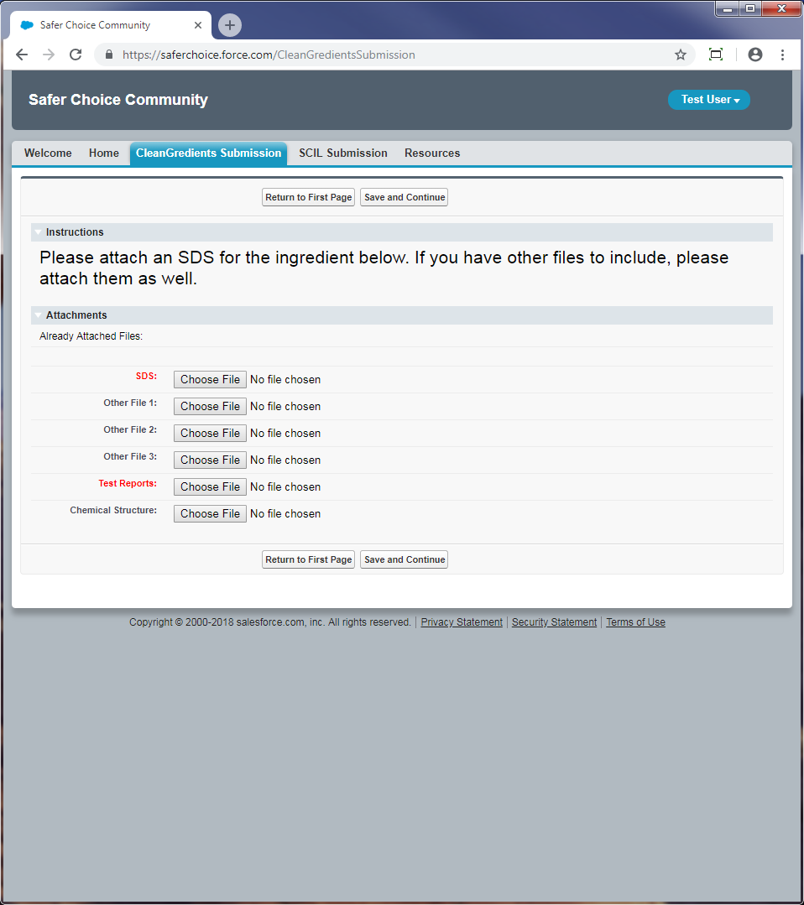
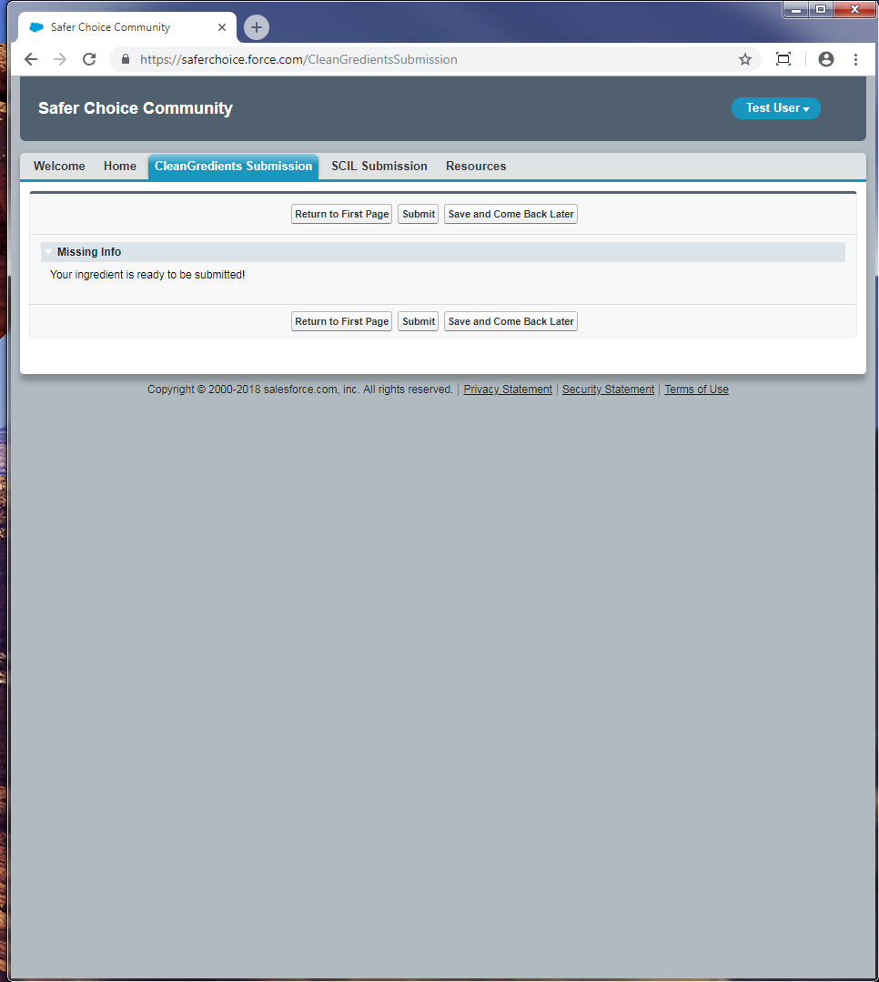

Safer Chemical Ingredients List (SCIL) Submission
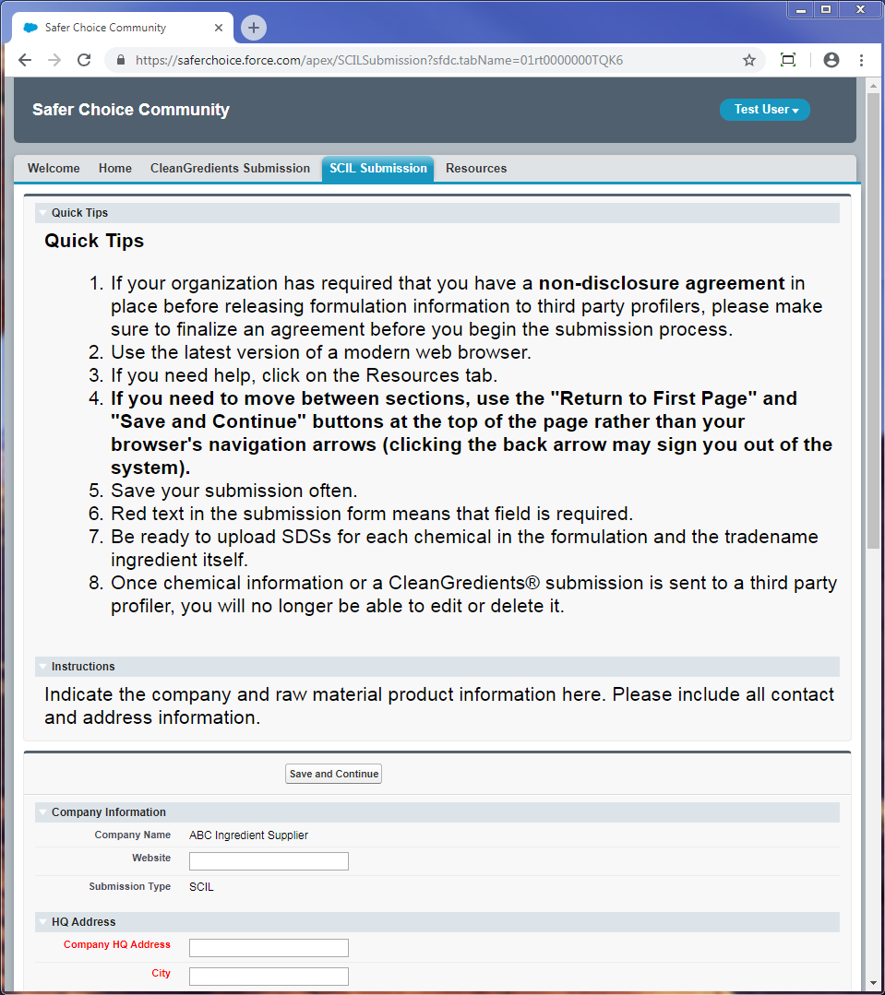
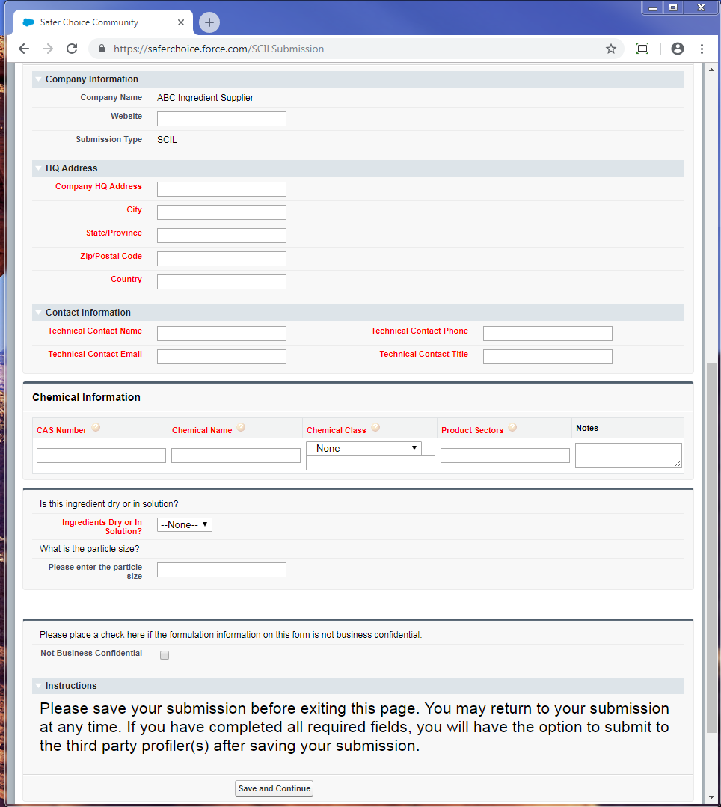
Chemical Class: Dropdown options are Abrasive, Active, Antifoaming Agent, Antioxidant, Buffer, Builder, Chelant, Colorant, Corrosion Inhibitor, Deicer, Denaturant, Deodorant, Dispersant, Emollient, Enzyme, Fragrance, Hydrotrope, Impurity, Leveling Aid, Microorganism, Optical Brightener, Oxidant, pH Adjuster, Plasticizer, Polymer, Preservative, Propellant, Residual, Sequestrant, Solvent, Stabilizer, Surfactant, Thickener, Wax, Wetting, Other (please specify)
Ingredients Dry or In Solution: Dropdown options are Dry, Solution
