ATTACHMENT C

Safer Choice Program: Form for Adding Third-Party Partners and Products
(Private Label Companies, Licensees, or Toll Manufacturers)

OMB Control No. 2070-0178
Approval expires XX/XX/XX

The public reporting and recordkeeping burden for this collection of information is estimated to average 16 hours per response for formulators of cleaning and non-cleaning products and 8 hours per response for partners wishing to add third-party partners and products, including the time for reviewing instructions, gathering information, and completing and reviewing the application. This is a voluntary collection. EPA cannot collect information without a valid OMB control number. Send comments on the Agency's need for this information, the accuracy of the provided burden estimates, and any suggested methods for minimizing respondent burden, including through the use of automated collection techniques to the Director, Collection Strategies Division, U.S. Environmental Protection Agency (2822T), 1200 Pennsylvania Ave., NW, Washington, D.C. 20460. Include the OMB control number in any correspondence. Do not send the completed application to this address.

Following are screenshots from the Form for Adding Third-Party Partners and Products (referred to as Submit Private Label/Alternate Name) in Safer Choice’s Salesforce data system. Note that the specific details of the screenshots may change over time as the Safer Choice program improves and/or modifies the system. However, the general and fundamental components of the Salesforce system will be similar to what is presented in the following screenshots.

Private Label/Alternate Name Submissions

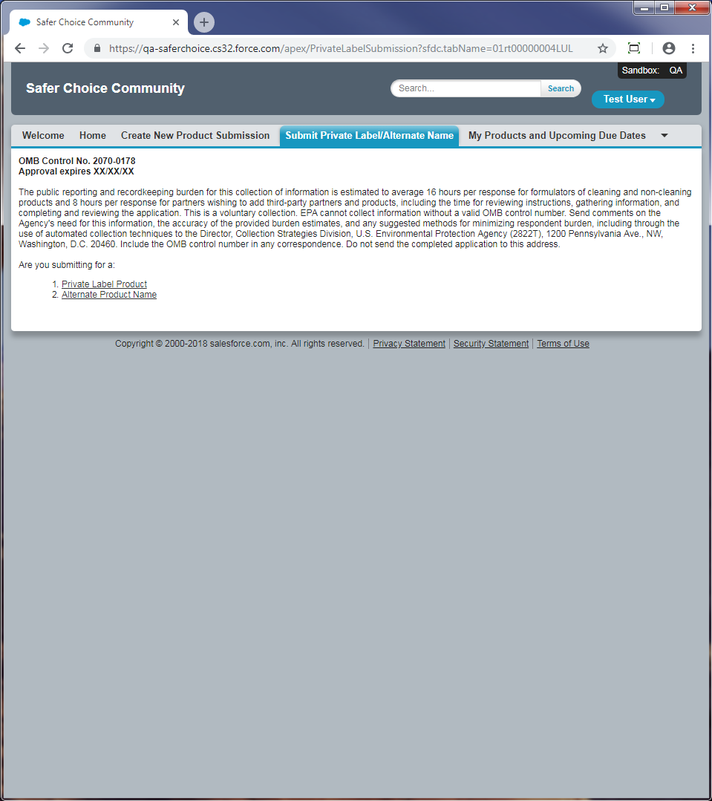

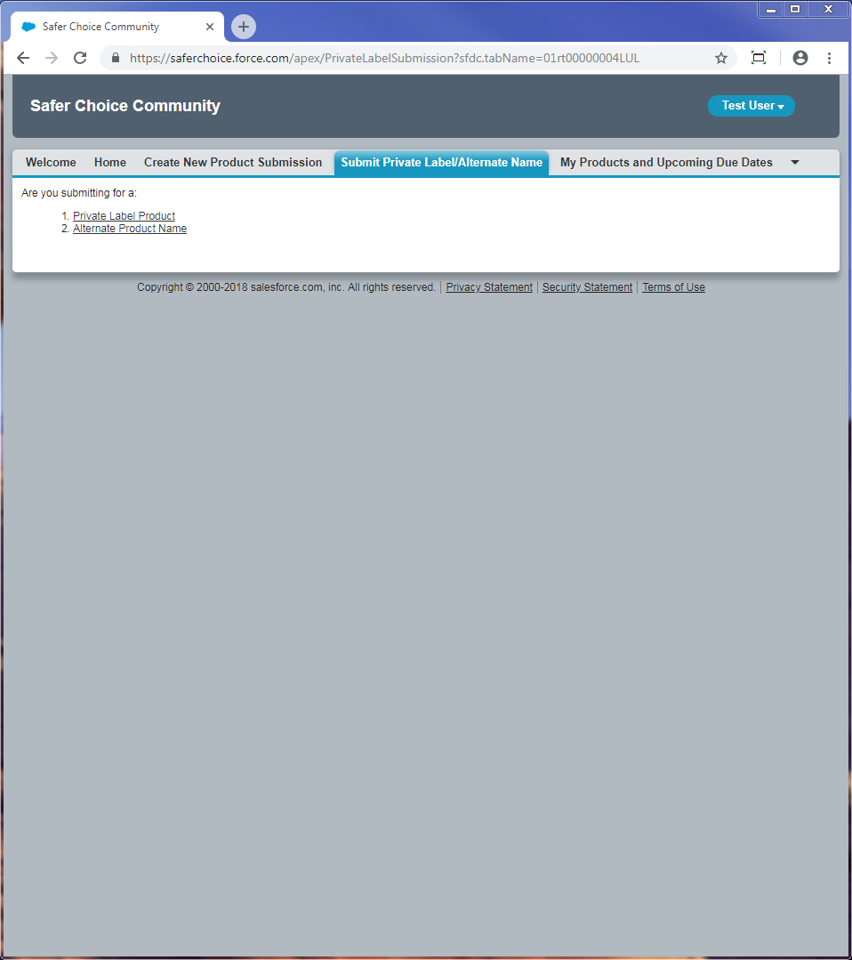

Private Label

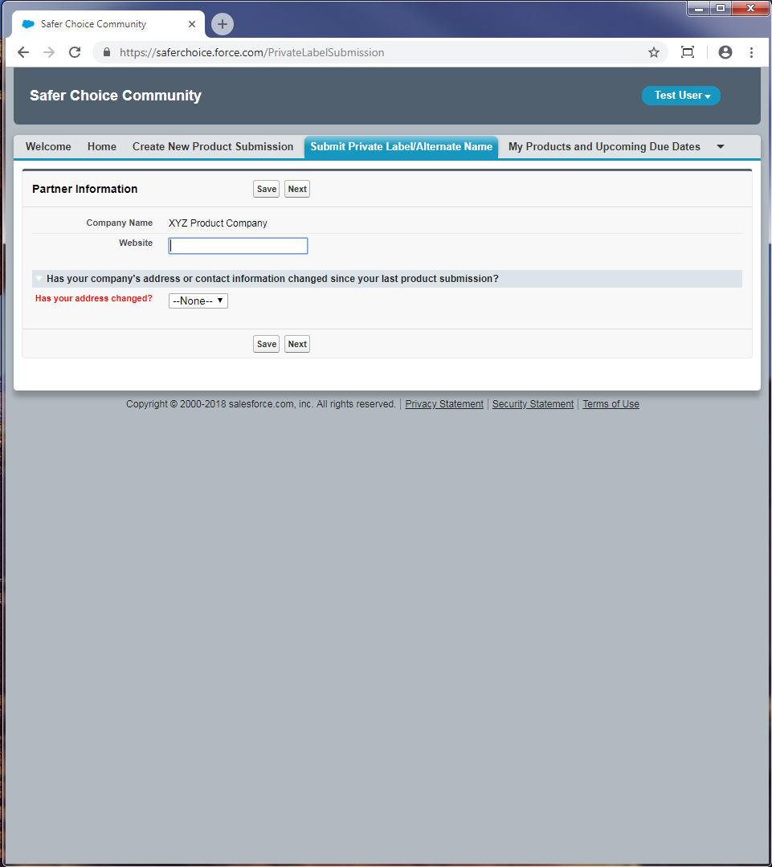

Has your address changed: Dropdown options are Yes, No. If yes, more options appear to update company and contact information.
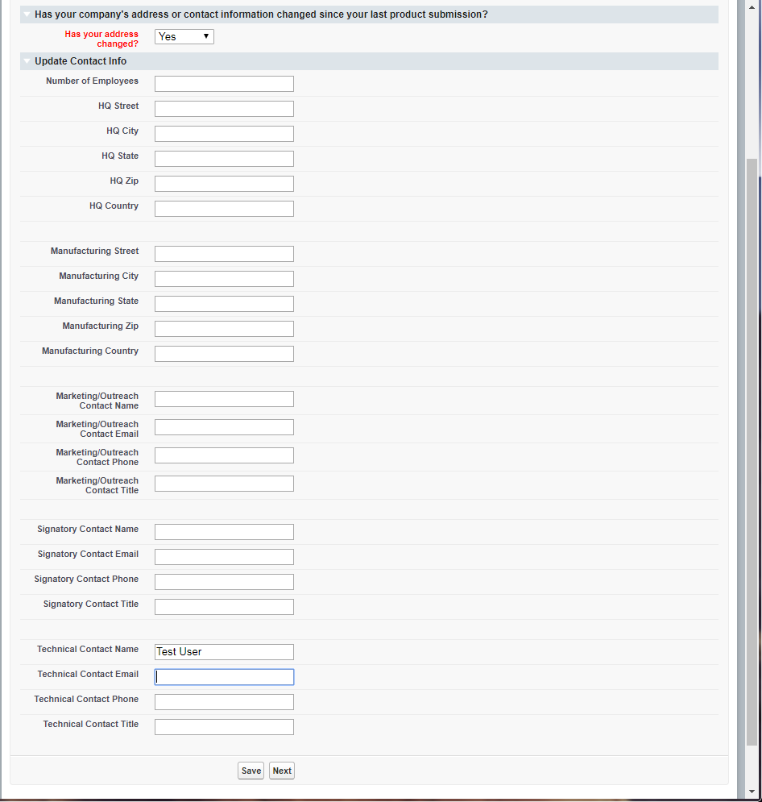

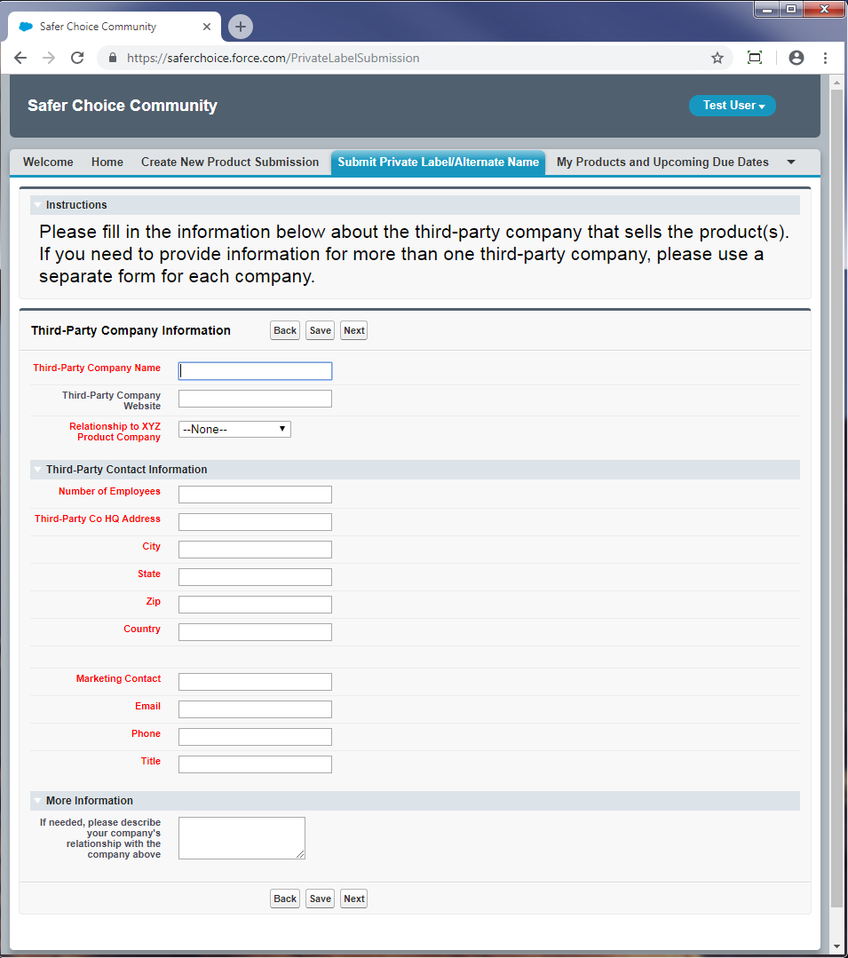

Relationship to Company: Dropdown options are Private Label, Licensee, Toll Manufacturer

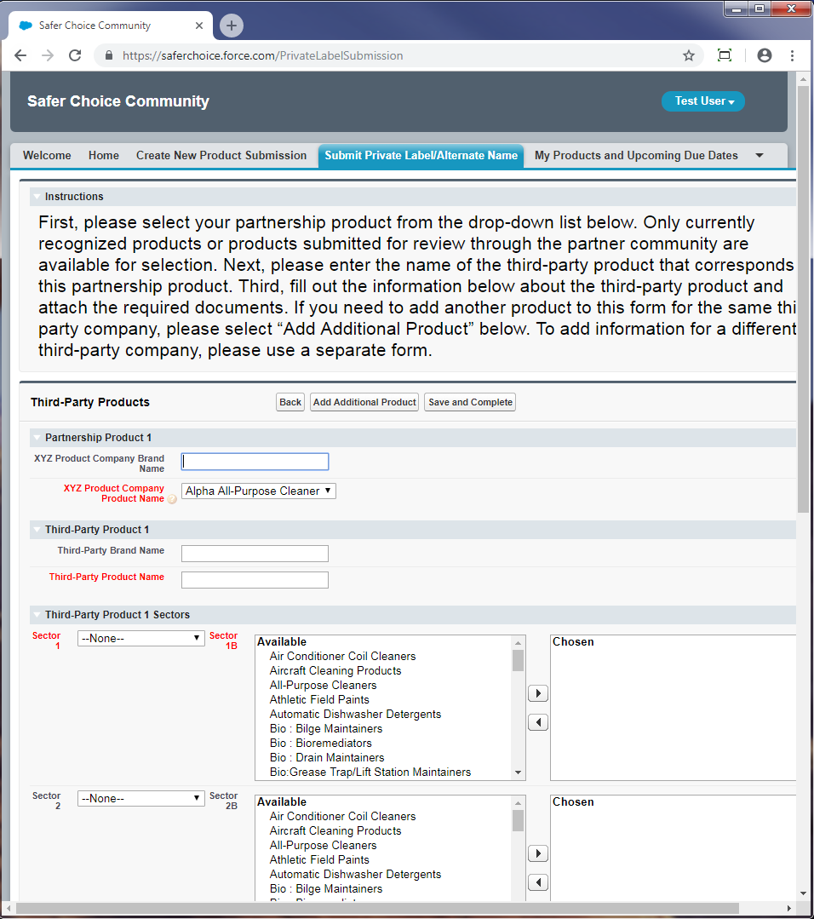

Partner Company Product Name: Dropdown options are the company’s currently Safer Choice-certified products.

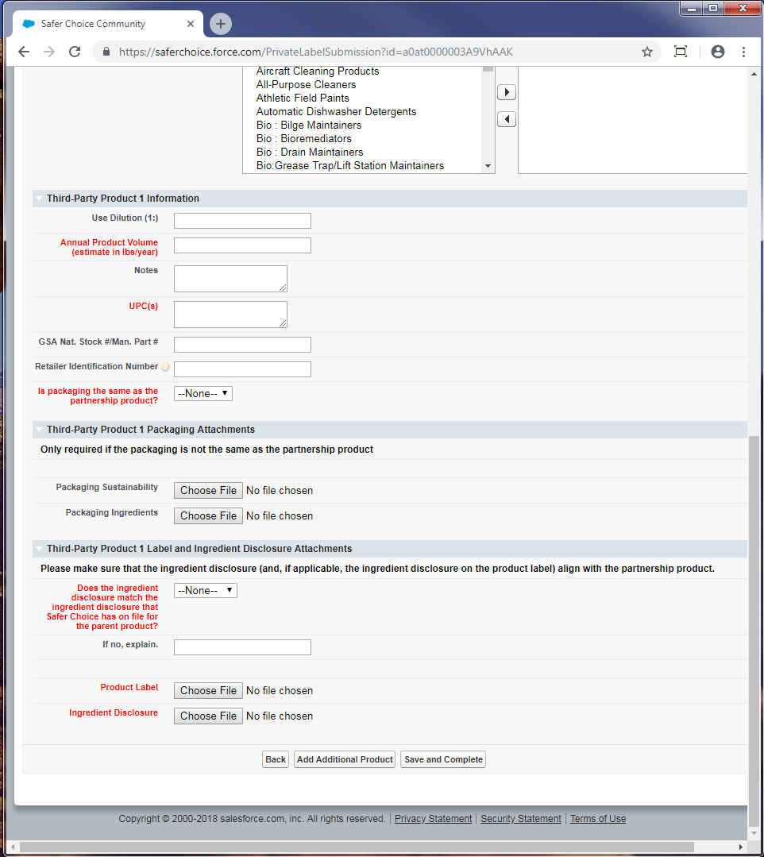

Sector 1 and Sector 2: Dropdown options are Consumer, Industrial/Institutional, Both, N/A
Sector 1B and Sector 2B: Pick list options are Air Conditioner Coil Cleaners, Aircraft Cleaning Products, All-Purpose Cleaners, Athletic Field Paints, Automatic Dishwasher Detergents, Bio : Bilge Maintainers, Bio : Bioremediators, Bio : Drain Maintainers, Bio:Grease Trap/Lift Station Maintainers, Bio : Septic System Treatments, Bio : Vehicle/Parts Wash Additives, Bio : Wastewater Inoculants, Brick and Masonry Cleaners, Car Care Products, Carpet Care Products : Cleaners, Carpet Care Products : Spot Removers, Degreasers, Deicers, Descalers, Dish Soaps, Dry Erase Board Cleaners, Fire-Fighting Products, Floor Care Products : Floor Cleaners, Floor Care Products : Floor Finishes, Floor Care Products : Floor Strippers, Graffiti Removers, Granite/Stone Cleaners, Grease Trap Products, Hand Soaps, HVAC Maintenance, Industrial Coating : Conversion Coatings, Industrial Coating : Pavement Treatments, Inkjet Printing Products, Kitchen/Countertop Cleaners, Laundry Products : Boosters, Laundry Products : Fabric Softeners, Laundry Products : Laundry Detergents, Laundry Products : Pre-Treaters, Leather Cleaners, Marine/RV Cleaners, Medical Instrument Cleaners, Metal Cleaner/Polishes, Odor Removers, Oven/Grill/Barbeque Cleaners, Parts Washers, Pet Care Products, Rinse Aids, Semiconductor/Microelectronics Cleaners, Soluble Films, Stainless Steel Cleaners, Tire Additives, Toilet Bowl Cleaners, Tub/Tile Cleaners, Upholstery Cleaners, Window/Glass Cleaners, Wood Cleaners, Other Industrial/Institutional Products, Other Consumer Products
Is packaging the same as the partnership product: Dropdown options are Yes, No

Does the ingredient disclosure match: Dropdown options are Yes, No, Unknown

Alternate Name

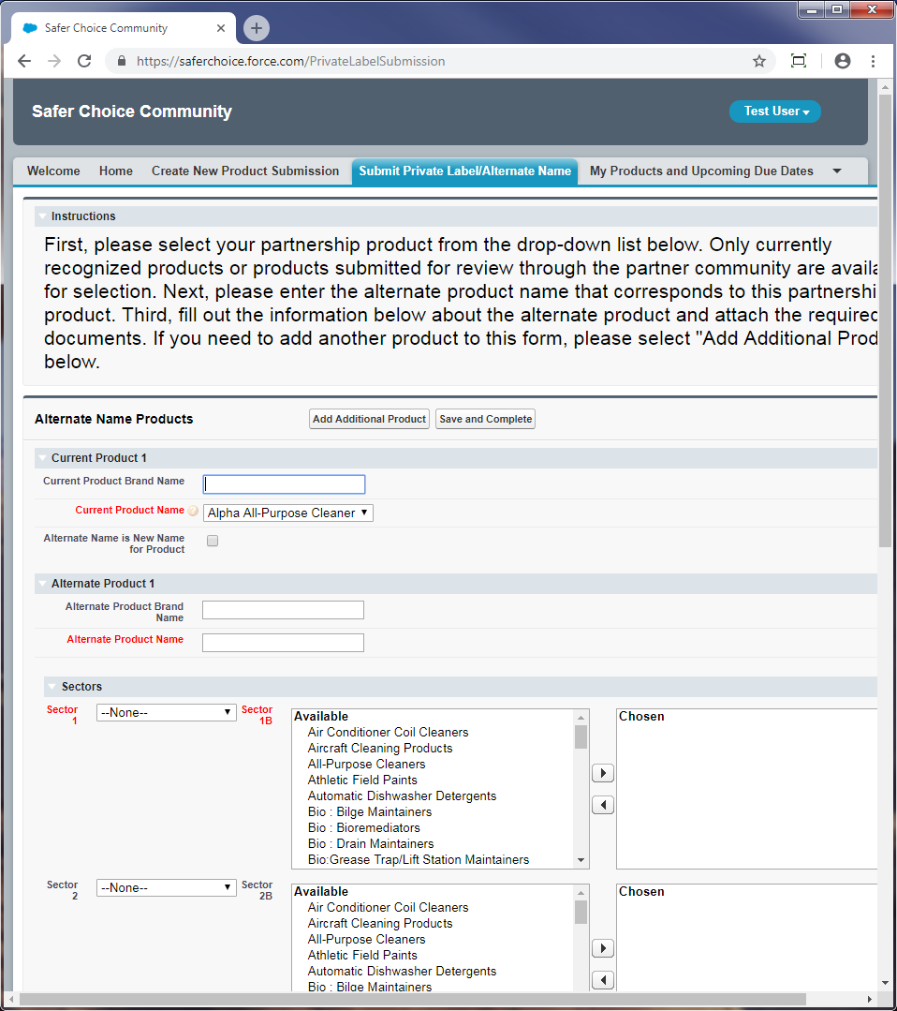

Current Product Name: Dropdown options are the company’s currently Safer Choice-certified products.

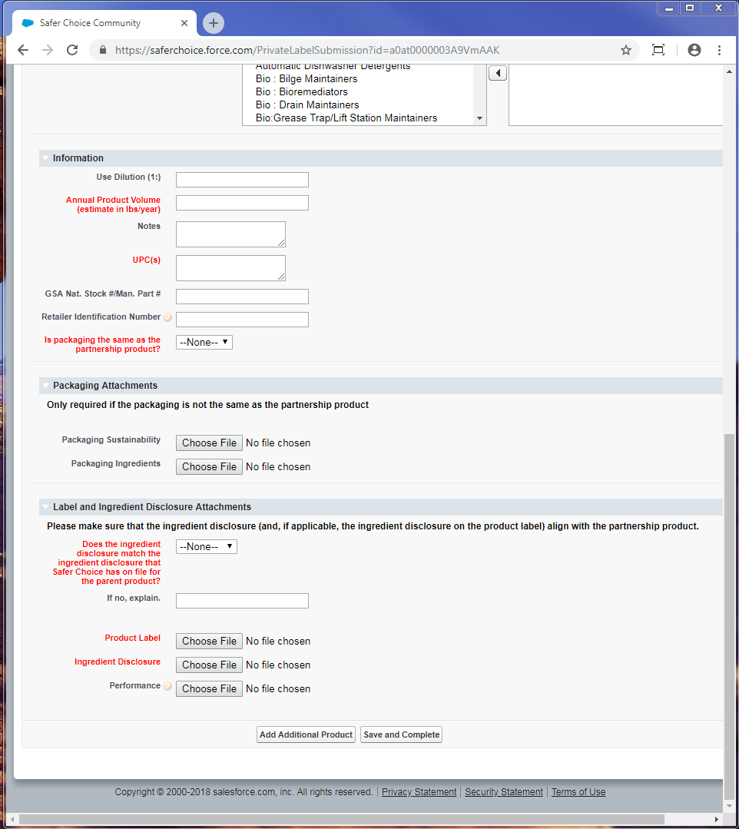

Sector 1 and Sector 2: Dropdown options are Consumer, Industrial/Institutional, Both, N/A
Sector 1B and Sector 2B: Pick list options are Air Conditioner Coil Cleaners, Aircraft Cleaning Products, All-Purpose Cleaners, Athletic Field Paints, Automatic Dishwasher Detergents, Bio : Bilge Maintainers, Bio : Bioremediators, Bio : Drain Maintainers, Bio:Grease Trap/Lift Station Maintainers, Bio : Septic System Treatments, Bio : Vehicle/Parts Wash Additives, Bio : Wastewater Inoculants, Brick and Masonry Cleaners, Car Care Products, Carpet Care Products : Cleaners, Carpet Care Products : Spot Removers, Degreasers, Deicers, Descalers, Dish Soaps, Dry Erase Board Cleaners, Fire-Fighting Products, Floor Care Products : Floor Cleaners, Floor Care Products : Floor Finishes, Floor Care Products : Floor Strippers, Graffiti Removers, Granite/Stone Cleaners, Grease Trap Products, Hand Soaps, HVAC Maintenance, Industrial Coating : Conversion Coatings, Industrial Coating : Pavement Treatments, Inkjet Printing Products, Kitchen/Countertop Cleaners, Laundry Products : Boosters, Laundry Products : Fabric Softeners, Laundry Products : Laundry Detergents, Laundry Products : Pre-Treaters, Leather Cleaners, Marine/RV Cleaners, Medical Instrument Cleaners, Metal Cleaner/Polishes, Odor Removers, Oven/Grill/Barbeque Cleaners, Parts Washers, Pet Care Products, Rinse Aids, Semiconductor/Microelectronics Cleaners, Soluble Films, Stainless Steel Cleaners, Tire Additives, Toilet Bowl Cleaners, Tub/Tile Cleaners, Upholstery Cleaners, Window/Glass Cleaners, Wood Cleaners, Other Industrial/Institutional Products, Other Consumer Products
Is packaging the same as the partnership product: Dropdown options are Yes, No

Does the ingredient disclosure match: Dropdown options are Yes, No, Unknown

