APPENDIX D10.b

PROGRAM EXPERIENCES SURVEY INVITATION POSTCARD - SPANISH

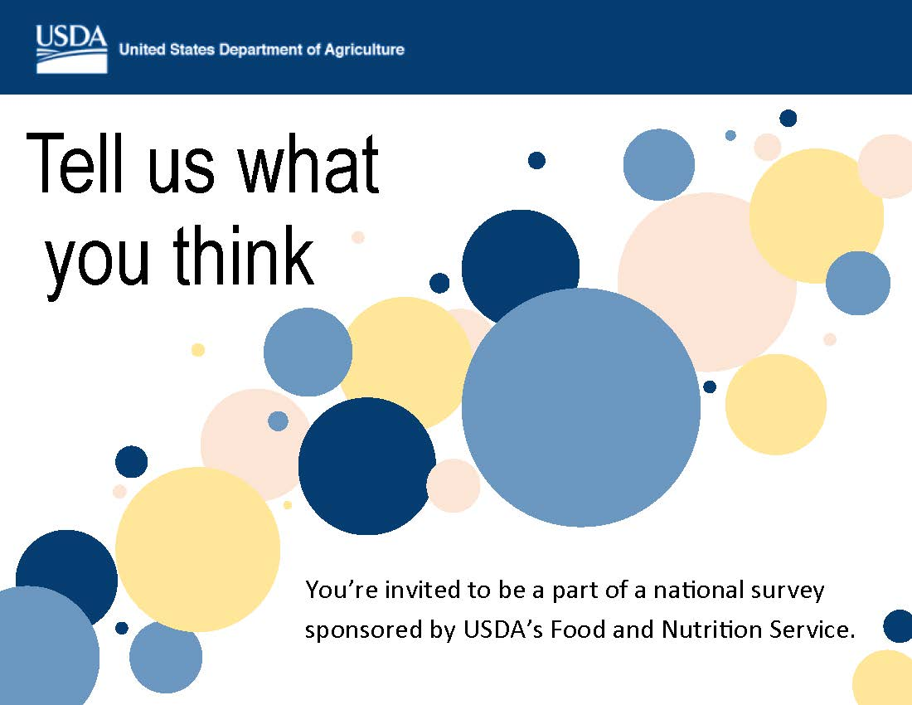

Díganos lo que piensa

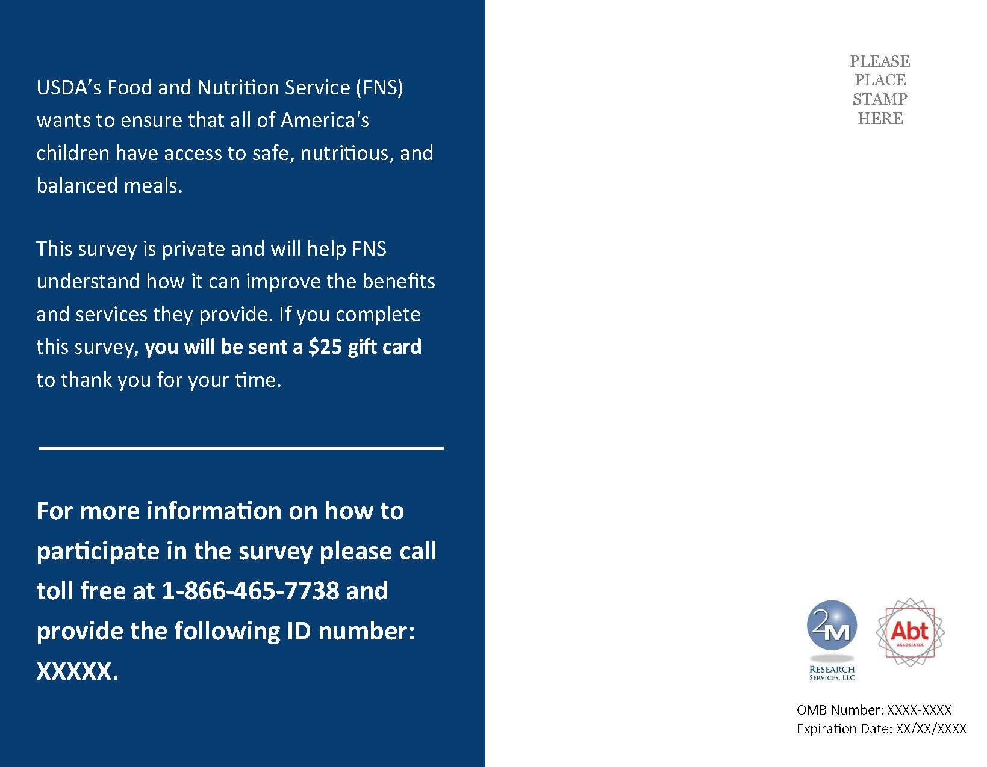
De conformidad con la Ley de reducción del papeleo de 1995 (Paperwork Reduction Act), una agencia no debe llevar a cabo ni patrocinar la colección de datos y ninguna persona está obligada a responder a una recopilación de datos a menos que muestre un número de control válido de la Oficina de Administración y Presupuesto (OMB en inglés). El número de control válido para esta recopilación de datos es 0584-XXXX. Se calcula que el tiempo necesario para completar esta recopilación de datos es un promedio de 1 minuto por respuesta, incluyendo el tiempo requerido para revisar las instrucciones, buscar fuentes de datos existentes, recolectar y mantener los datos necesarios, y completar y revisar la recopilación de datos. Envíe comentarios referentes a la carga estimada o cualquier otro aspecto de esta recopilación de datos, incluyendo sugerencias para reducir esta carga a la siguiente dirección: U.S. Department of Agriculture, Food and Nutrition Services, Office of Policy Support, 3101 Park Center Drive, Room 1014, Alexandria, VA 22302, ATTN: PRA (0584-xxxx*). No envíe el formulario completo a esta dirección.
Esta encuesta es confidencial y le ayudará al FNS de mejor conocer cómo puede mejorar los servicios y beneficios ofrecidos. Si completa la encuesta, recibirá una tarjeta de regalo Visa de $25 para agradecerle su tiempo.
El Servicio de Alimentos y Nutrición del USDA quiere asegurarse que todos los niños de Estados Unidos tengan acceso a comidas balanceadas, saludables y nutritivas.
OMB Number: 0584-XXXX
Expiration Date: XX/XX/XXXX
Para más información sobre como participar en la encuesta, favor de llamar al número gratuito: 1-866-465-7738 y proporcione el siguiente número de identificación: XXXXX.

