APPENDIX B1.b

STATE AGENCY SURVEY - SCREENSHOTS

State Agency Survey
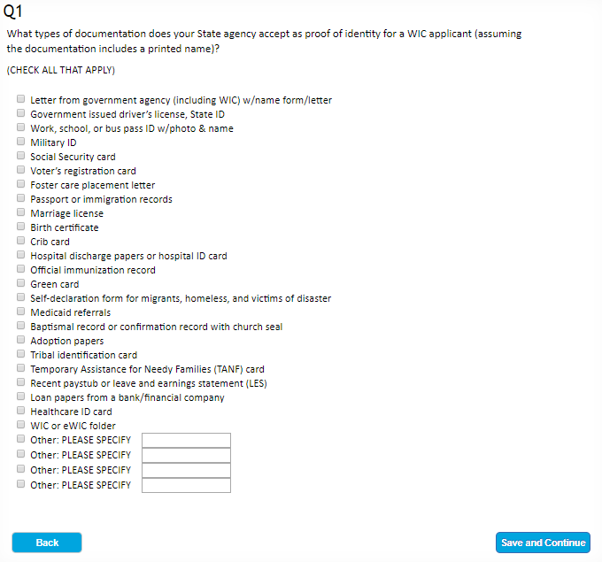

According to the Paperwork Reduction Act of 1995, an agency may not conduct or sponsor, and a person is not required to respond to, a collection of information unless it displays a valid OMB control number. The valid OMB control number for this information collection is 0584-XXXX. The time required to complete this information collection is estimated to average 66 minutes (1.10 hours) per response, including the time for reviewing instructions, searching existing data sources, gathering and maintaining the data needed, and completing and reviewing the collection of information. Send comments regarding this burden estimate or any other aspect of this collection of information, including suggestions for reducing this burden, to: U.S. Department of Agriculture, Food and Nutrition Services, Office of Policy Support, 3101 Park Center Drive, Room 1014, Alexandria, VA 22302, ATTN: PRA (0584-xxxx*). Do not return the completed form to this address.

