**Comprehensive HIV Prevention and Care for Men Who Have Sex with Men of Color**

**0920-New**

**SUPPORTING STATEMENT B**

April 13, 2017

Project Officers

Ken Dominguez, MD, MPH

Phone: 404-639-6129

Fax: 404-639-6127

Email: [KLD0@cdc.gov](mailto:INK4@cdc.gov)

Kashif Iqbal, MPH

Phone: 404-718-2038

Fax: 404-639-6127

Email: [KAI9@cdc.gov](mailto:KAI9@cdc.gov)

Centers of Disease Control and Prevention

National Center for HIV/AIDS, Viral Hepatitis, STD, and TB Prevention

Division of HIV/ AIDS Prevention- Surveillance and Epidemiology  
HIV Epidemiology Branch

1600 Clifton Rd., MS E-45

Atlanta, GA 30333

**TABLE OF CONTENTS**

**B. Statistical Methods**

1. Respondent Universe.
2. Procedures for the Collection of Information
3. Methods to Maximize Response Rates and Deal with Nonresponse
4. Tests of Procedures or Methods to be Undertaken.
5. Individuals Consulted on Statistical Aspects and Individuals Collecting and/or Analyzing Data.

**LIST OF ATTACHMENTS**

Attachment 1 Authorizing Legislation

Attachment 260-DayFederalRegister Notice

Attachment 3 List of THRIVE Awardees

Attachment 4Monitoring and Evaluation (M&E) Variables

Attachment 5 Qualitative Interview: Collaborative Process Evaluation

Attachment 6 Collaborative Assessment Tool

Attachment 7 Funding Allocation Report

Attachment 8 Data Security Guidelines

Attachment 9 Project Determination

**B. Statistical Methods**

This collection does not employ statistical methods.

**1. Respondent Universe**.

The respondents are 7 state and city health departments and their 80 community-based organizations (CBOs), clinics and other health providers, behavioral health and social health providers in their jurisdiction that form a collaborative that are funded by the Division of HIV/AIDS Prevention, NCHHSTP, of CDC (**Attachment 3**: List of THRIVE Awardees). There were no required number of community partners, instead, each health department selected key partners based on the need to deliver all the required services. As a result there are 80 collaborative members. The 7 state and city health departments along with their 80 collaborative members will be required to provide thirteen HIV prevention services for MSM of color at substantial risk for HIV infection and eleven HIV care services for MSM of color living with HIV infection. Data will be collected from the funded 7 state and city health departments grantees. The data will provide CDC local program managers with semiannual information to assess progress towards reaching programmatic goals. These data will identify gaps in services among MSM of color, and inform CDC about needs for technical assistance, training, capacity building, scientific advice, and programmatic advice to health department grantees and their collaborative partners to accelerate progress towards accomplishing programmatic goals.

HIV prevention program data for monitoring and evaluation (M&E) will be collected by grantees for three years (years two through four of the project period). Data collection on THRIVE services is mandatory. Data will be collected for each of the 24 required services. These data will be submitted to CDC semiannually.

The M&E data are used to monitor and evaluate HIV prevention programs, interventions, and activities. Data-driven program monitoring and evaluation better enables CDC, state and city health agencies, and local program managers to provide valuable feedback and assistance to front-line prevention service providers. The value of feedback is increased because counseling and assistance will be categorical at all levels and tailored to correct specific, documented problems and deficiencies. The M&E data are also used to inform stakeholders, including federal and state executive offices and legislative bodies, based on specific information regarding how public health resources are used programmatically, for what purpose, and to what effect.

**2. Procedures for the Collection of Information**

This is a mixed methods information collection request.  Key monitoring and evaluation data will be submitted to CDC electronically two times per year.  These data describe steps in the continuums of HIV prevention services and HIV care services.  In addition, one set of funding allocation variables will be submitted to CDC electronically once per year.  In addition, semi-structured interviews will be conducted in-person or by telephone.

Semi-annual Services Report (**Attachment 4**): Client level data will be transmitted electronically to CDC twice a year. If client level data is not feasible, then aggregate data will be electronically transmitted, stratified by race/ethnicity, current gender, age group, and HIV transmission group.  **Attachment 4** represents guidance for transmitting data and is not a data collection form. The data elements will include:

Population characteristics (Attachment 4, Section A. Population Characteristics, data elements 1-4; see  Attachment 4, Section B, Column “Stratified?” for specification of which data elements will be stratified by population characteristics). Semiannual services reports will be electronically transmitted by health departments and those data will be stratified by race/ethnicity, current gender, age group, and HIV transmission risk group for both persons at risk for acquiring HIV and HIV-positive persons when possible. The data sources for these data elements are from existing health department data collecting systems.

Continuum of HIV prevention services (**Attachment 4**, Section B. Services for Persons at Risk for HIV, data elements 2-3). Semiannual services reports will be submitted by health departments and those data will include data elements describing the steps in the continuum as seen in Figure 1. HIV Prevention Continuum.

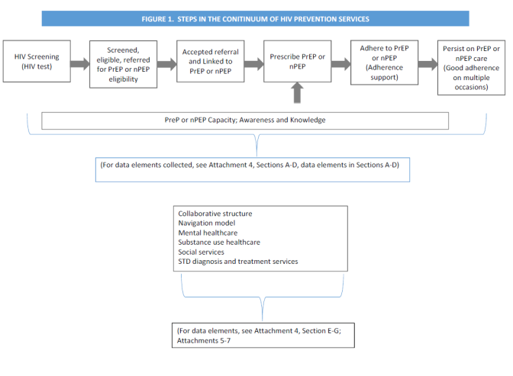

Continuum of HIV care services (**Attachment 4**, Section C. Services for HIV-positive persons, data elements 4-9).Semiannual services reports will be submitted by health departments and those data will include data elements describing the steps in the continuum as seen in Figure 2.

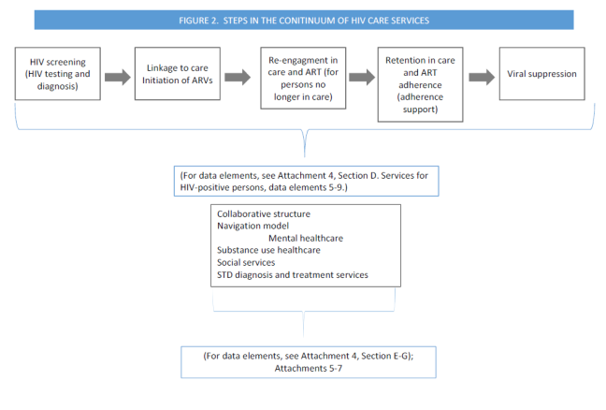Other Integral Services for HIV-positive and HIV-negative persons (**Attachment 4,** Section D. Services for HIV-positive and HIV-negative persons, data elements 10-17).Semiannual services reports will be submitted by health departments and those data will include data elements describing other integral services for both HIV-positive and HIV-negative services (e.g. STD services, partner services, behavioral health screening and linkage, social service screening and linkage, etc.)

Navigation services (Attachment 4, Section E. Navigation Services, data elements 18-19). Semiannual services reports will be submitted by health departments and those data will include data elements describing navigation services for both HIV-positive and HIV-negative services (e.g. navigation for linkage of services [PrEP initiation and ongoing PrEP care, navigation to support retention of HIV-positive persons in HIV care] navigation for assessing health insurance needs and enrolling in a health insurance plan.

Community Collaborative (**Attachment 4,** Section F. Billing/Reimbursement, Capacity Building, and Collaborations, Data element 23). Semiannual services reports will be submitted by health departments and those data will include data elements describing contracts awarded to implement projects, and numbers of CBOs and other organizations.

Billing and Reimbursement and Capacity Building (**Attachment 4**, Section F. Billing/Reimbursement, Capacity Building, and Collaborations, Data elements 20-22).Semiannual services reports will be submitted by health departments and those data will include data elements describing number of HIV tests, STD tests, nPEP health care services, and PrEP health care services that were reimbursed by a third party payer; number of trainings, staff hired, and contracts and partnerships executed for each health department and its collaborative workforce to provide culturally competent services.

Collaboration Assessment and Evaluation (**Attachments 5 and 6**):To assess how successful grantees have been in creating, engaging, and sustaining collaborative partnerships and to understand how these partnerships contributed to achieving the goals of the project, open-ended questions (**Collaborative Process and Outcome Evaluation**), and a survey (**The Collaboration Assessment Tool**) will be used to evaluate.  Health department and collaborative partner staff (e.g., CBOs, healthcare providers, social service providers) will participate annually in the **Collaborative Process and Evaluation** via face-to-face or telephone interviews or in the **Collaborative Assessment Tool** via an interview. We are in the process of developing an online version of the Collaborative Assessment Tool and will upload an amendment as a change request.

Collaborative Process and Outcome Evaluation (Attachment 5, Collaborative Process and Outcome Evaluation, Data Elements CQ01-CQ12.). Process questions include queries about reasons for involvement; clarity of collaborative goals; leadership support; resource input; collaborative activities; and collaborative operational success. Outcome questions include queries about collaborative success in achieving goals; impact on the collaborative; positive, negative, or unintended of the collaboration; benefits from participating in the collaborative barriers to successful collaboration; and lessons learned from participating in the collaborative.

Collaboration Assessment (**Attachment 6**, Collaboration Assessment Tool [CAT], Data Elements A1-H8). To understand the development and function of the collaborative and how they are related to the needs of the collaborators in the communities in which they operate, health department and collaborative staff will be asked to complete a survey that will be administered using an online survey tool. In order to assess collaborative processes and outcomes, several questions will be included in the survey.  These will focus on the cultural, political, and legislative context of the community in which the collaborative is located; collaborative organizational processes including communication, defining goals and objectives, available resources, leadership capacity; and perception of collaborative success

Funding Allocation (**Attachment 7**, Funding Allocation Report, Data Elements FA01-FA18).Annual summary reports of funds allocated for HIV prevention services for MSM of color at substantial risk of acquiring HIV infection; HIV care services for MSM of color living with HIV infection; navigation and linkage services; HIV or STD partner services; behavioral risk reduction counseling or interventions; behavioral health services; social services; program planning; program monitoring and evaluation; capacity building; general operations and administration; CBO contracts; other collaborative activities; and activities to reach MSM of color will be electronically submitted by health departments to CDC.

Data collection and management will be conducted consistent with Attachment 8, which is the “Data Security and Confidentiality Guidelines” plan that has been reviewed by CDC’s Office of the Chief Information Security Officer (OCISO).

The Centers for Disease Control and Prevention, Division of STD, determined this collection does not involve human subjects research and therefore, IRB review and approval is not required (**Attachment** 9).

**3. Methods to Maximize Response Rates and Deal with Nonresponse**

Not applicable.

**4. Tests of Procedures or Methods to be Undertaken.**

Not applicable.

**5. Individuals Consulted on Statistical Aspects and Individuals Collecting and/or Analyzing Data.**

The monitoring and evaluation (NHM&E) variables and values have been developed over the past fourteen years by multiple branches and contractors, as coordinated by the Program Evaluation Branch under the direction of the Division of HIV/AIDS Prevention; National Center for HIV, Viral Hepatitis, STD, and TB Prevention. Additional evaluation variables have been developed by a collaboration between Epidemiology Branch and Program Evaluation Branch staff within the Division of HIV/AIDS prevention. Data will be collected and analyzed by Kashif Iqbal and Ken Dominguez in the Epidemiology Branch. Contact information Ken Dominguez, MD, MPH; Phone: 404-639-6129; Email: [KLD0@cdc.gov](mailto:KLD0@cdc.gov); Kashif Iqbal, MPH; Phone: 404-718-2038; Email: kai9@cdc.gov