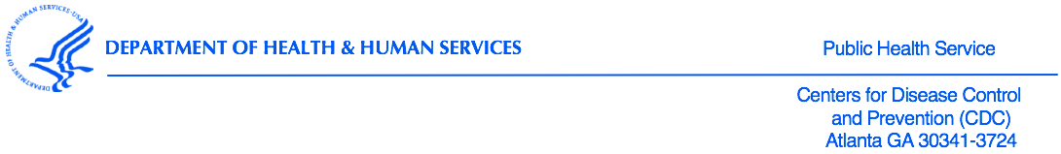
<DATE>

<Name>
<Address>
<Address>

Dear Superintendent <_________>:

I am writing to inform you that one school in your district is among the approximately 250 schools randomly selected across the United States to participate in the 2018 National Youth Tobacco Survey (NYTS), sponsored by the U.S. Centers for Disease Control and Prevention (CDC). As witnessed over the past few decades, youth tobacco use can increase or decrease rapidly, especially with the introduction of new tobacco products that appeal to youth. The CDC reported that from 2011 to 2015, cigarette smoking declined among middle and high school students while the use of electronic cigarettes and hookahs increased among the same population. Efforts such as the NYTS have increased our ability to measure changes in tobacco use behaviors and their influences, thereby enabling states, school districts, schools, and community organizations to adapt their tobacco prevention and control programs to combat the most prevailing issues at hand.

First conducted in 1999, the NYTS is an ongoing survey of students in grades 6 through 12 that gathers information on: (1) prevalence of use (cigarettes, smokeless tobacco, cigars, and other tobacco products), (2) knowledge and attitudes, (3) media and advertising, (4) minors' access and enforcement, (5) school curriculum, (6) secondhand smoke exposure, and (7) cessation. The annual NYTS was designed in cooperation with federal agencies and numerous state and local departments of education and health. Each cycle has produced valuable data regarding students’ knowledge of and attitudes toward tobacco, their exposure to secondhand smoke, and their exposure to influences that promote or discourage tobacco use.

The selected school in your district is shown below, along with the number of anticipated classes at each grade level:

School | Grade (Number of Classes)

The CDC respects the educational mission of schools. For that reason, only a small number of classes in each school, one or two at each selected grade level, are chosen randomly to participate. Data collection will occur during February through May 2018. Questionnaires will be administered during one normal class period by specially trained field staff. Survey administration procedures are designed to protect student privacy and allow for anonymous participation. States, counties, cities, school districts, schools, and students will not be identified in any published reports.

As a symbol of appreciation for contributing their time and support, the CDC will provide each participating school with a monetary award. One option is to use these funds for prevention curriculum and educational materials. However, no restrictions will be placed on how schools can use these funds.

Your support for this survey will help ensure the voluntary participation of the school selected in your district. The NYTS is the most comprehensive, nationally representative source of data regarding tobacco-related behaviors and the only source of such data for middle school students (grades 6-8). In parallel to this national survey, the NYTS questionnaire is used independently by many state and local departments of education and health to conduct their own surveys. Results from the national survey serve as an index against which state- and local-level data can be compared and are used by states to support the design, implementation, and evaluation of effective tobacco use prevention and control programs.

Enclosed are copies of the NYTS questionnaire, sample parental permission forms, a fact sheet, and letters of support from national health and education organizations. Within one week, a representative from <_____> firm contracted by CDC to conduct the NYTS, will contact you to confirm your receipt of this information and answer any questions you may have. If you have any immediate questions, please call <_____>. Your support for this survey, which will help assess and improve efforts to reduce priority health-risk behaviors among adolescents throughout our nation, is appreciated.

Sincerely yours,
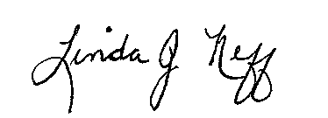

Linda J. Neff, PhD, MSPH
Chief, Epidemiology Branch, Office on Smoking and Health
National Center for Chronic Disease Prevention and Health Promotion
Centers for Disease Control and Prevention

Enclosures

cc: Sean Hu, Centers for Disease Control and Prevention

