Program Contact
Lee Samuel
National Center for Emerging and Zoonotic Infectious Diseases
Office of Policy
1600 Clifton Rd, C-12
Atlanta GA 30333

Submission Date: January 26, 2018

Circumstances of Change Request for OMB 0920-0666
CDC requests approval to replace a recently-approved form with the previously approved version of the same form to OMB Control No. 0920-0666; The National Healthcare Safety Network (NHSN)

Form Name: Denominators for Neonatal Intensive Care Unit (NICU) - CDC 57.116
The most recently approved form includes data collection fields that pertain to an NHSN event titled Pediatric Ventilator-Associated Event (PedVAE). PedVAE was scheduled for release in NHSN in January 2018 but release has been delayed until January 2019. The currently approved form 57.116 has fields that are not available for use given the delay in the PedVAE.
This is a request to re-instate the previously approved version of form CDC 57.116 to minimize confusion to respondents.

Estimates of annualized burden hours for this change request will decrease by 1 hour per response. Because each respondent is expected to respond 12 times per year, the total decrease in burden is expected to be 72,000 hours per year.

 | Form Name | No. of Respondents | No. of responses per respondent | Avg. burden per response (hours) | Total burden (hours)
APPROVED | Denominators for Neonatal Intensive Care Unit (NICU) (2018) | 6,000 | 12 | 4 | 288,000
REQUESTED | Denominators for Neonatal Intensive Care Unit (NICU) (2017) | 6,000 | 12 | 3 | 216,000

For OMB clearance No. 0920-0666, the total burden will decrease from 5,575,470 hours to 5,503,470 hours.

Description of Changes
The previously approved form—Denominators for Neonatal Intensive Care Unit (NICU)—which was in place for calendar year 2017 does not include optional completion of PedVAE Optional Denominator data collection fields , optional completion of Episodes of Mechanical ventilation (EMV) field, or the conditional completion of Ventilator Days (VNT) field.
We are requesting the replacement of the recently approved form (attachment 1) with the previously approved 2017 version (attachment 2).

Current form (highlighted areas would be changed):
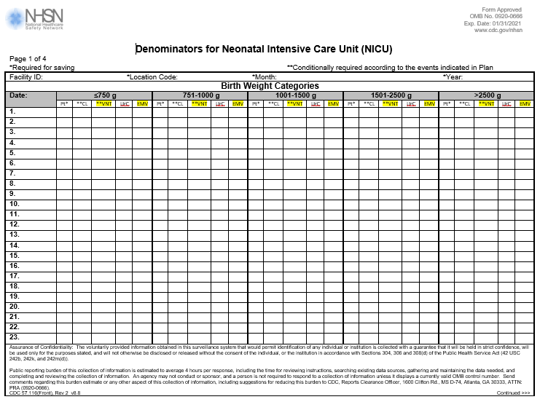
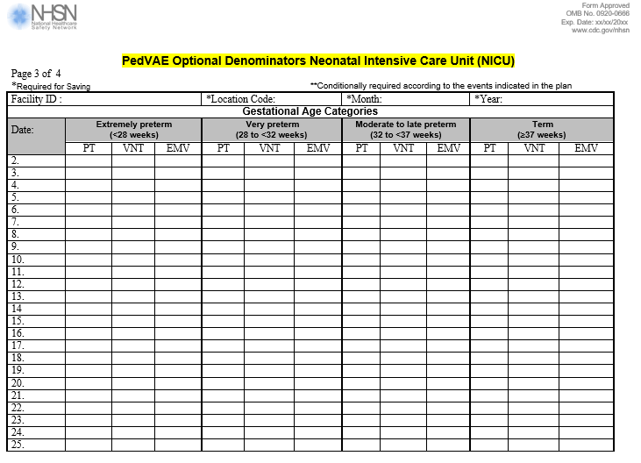

Requested changes:
