ALL RESPONDENTS

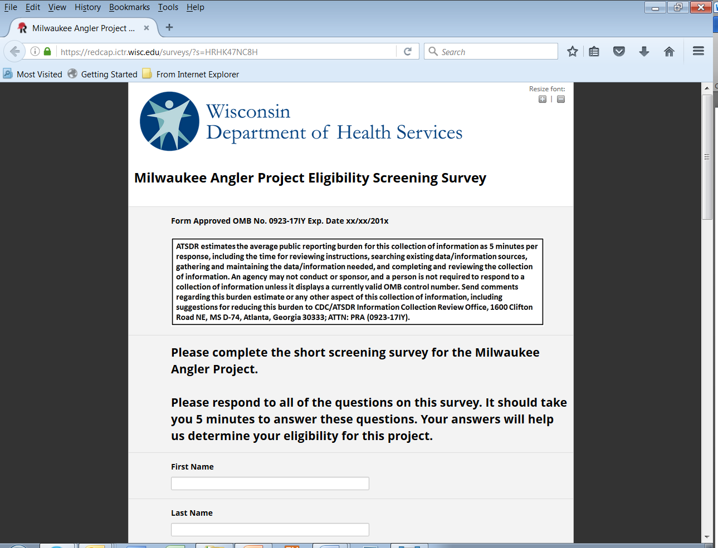

ELIGIBLE RESPONDENTS
If the respondent provides all Name and Address information and answers ‘Yes’ to all of the screening questions:
Page 2 (eligible)
(Follow-up question about text messaging appears if ‘Cell’ is selected)

INELIGIBLE RESPONDENTS
If the respondent answers ‘No’ to one or more of the screening questions:

Page 2 (ineligible)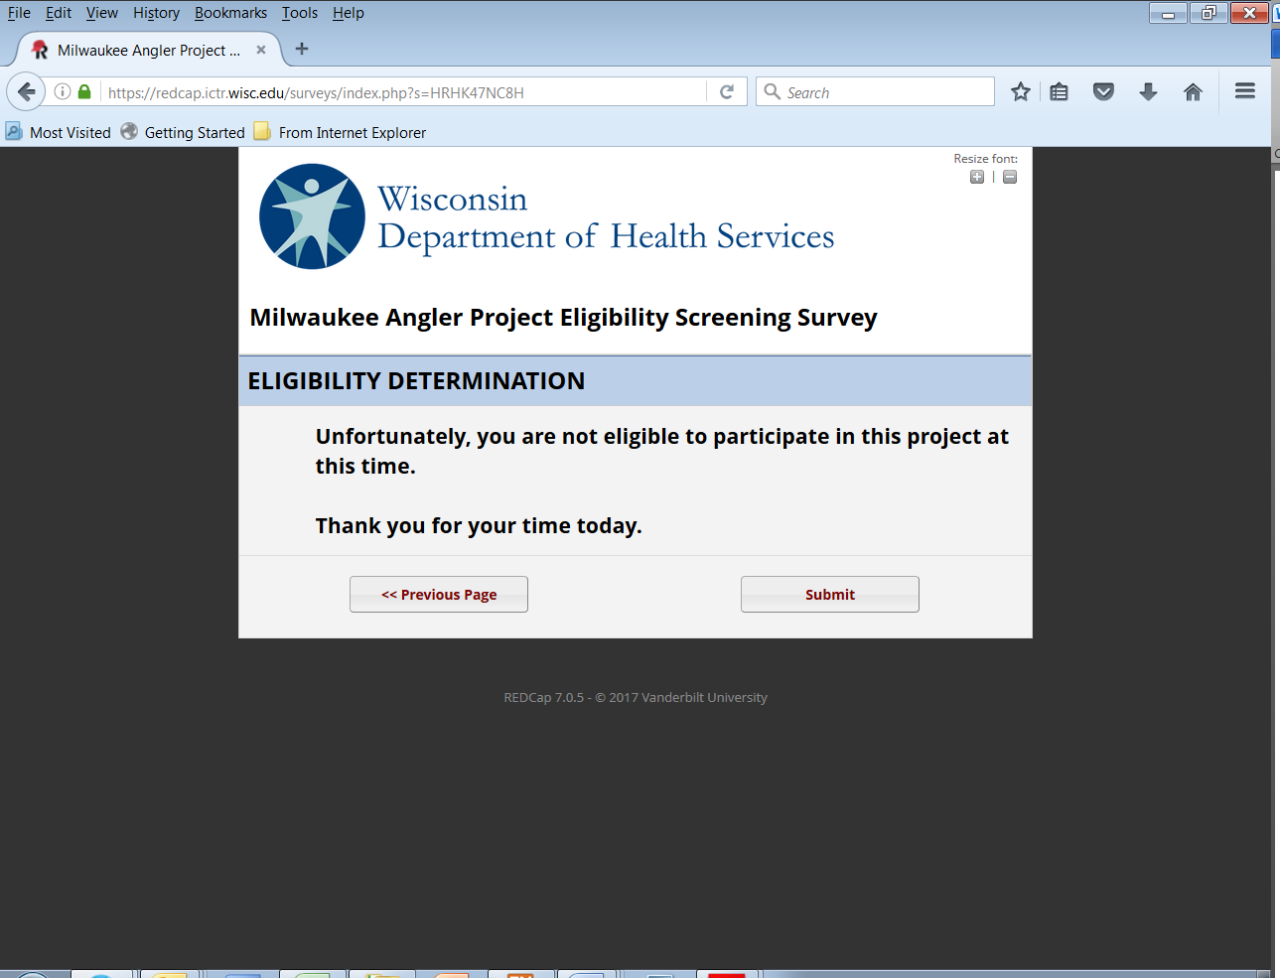

ALL RESPONDENTS
End survey screen
