Attachment 4b. Map of water bodies of interest

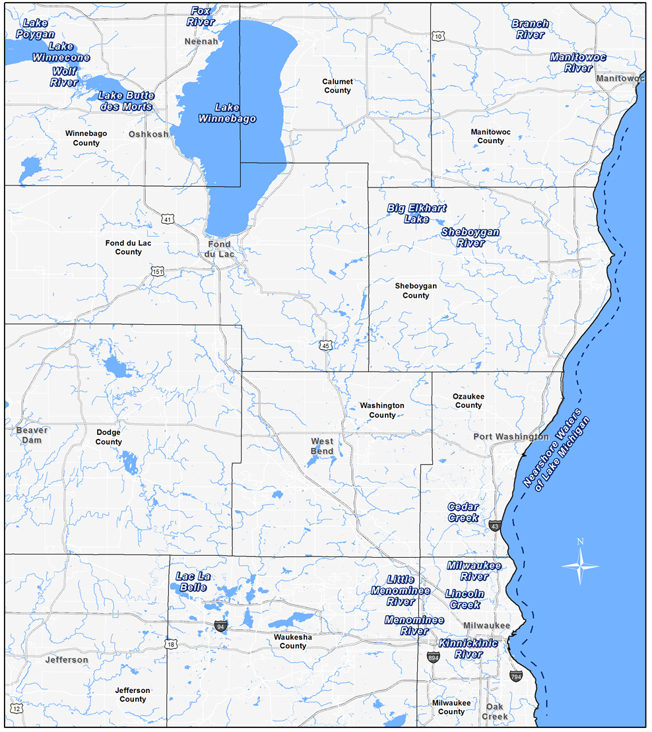
Image 1 in Study Questionnaires

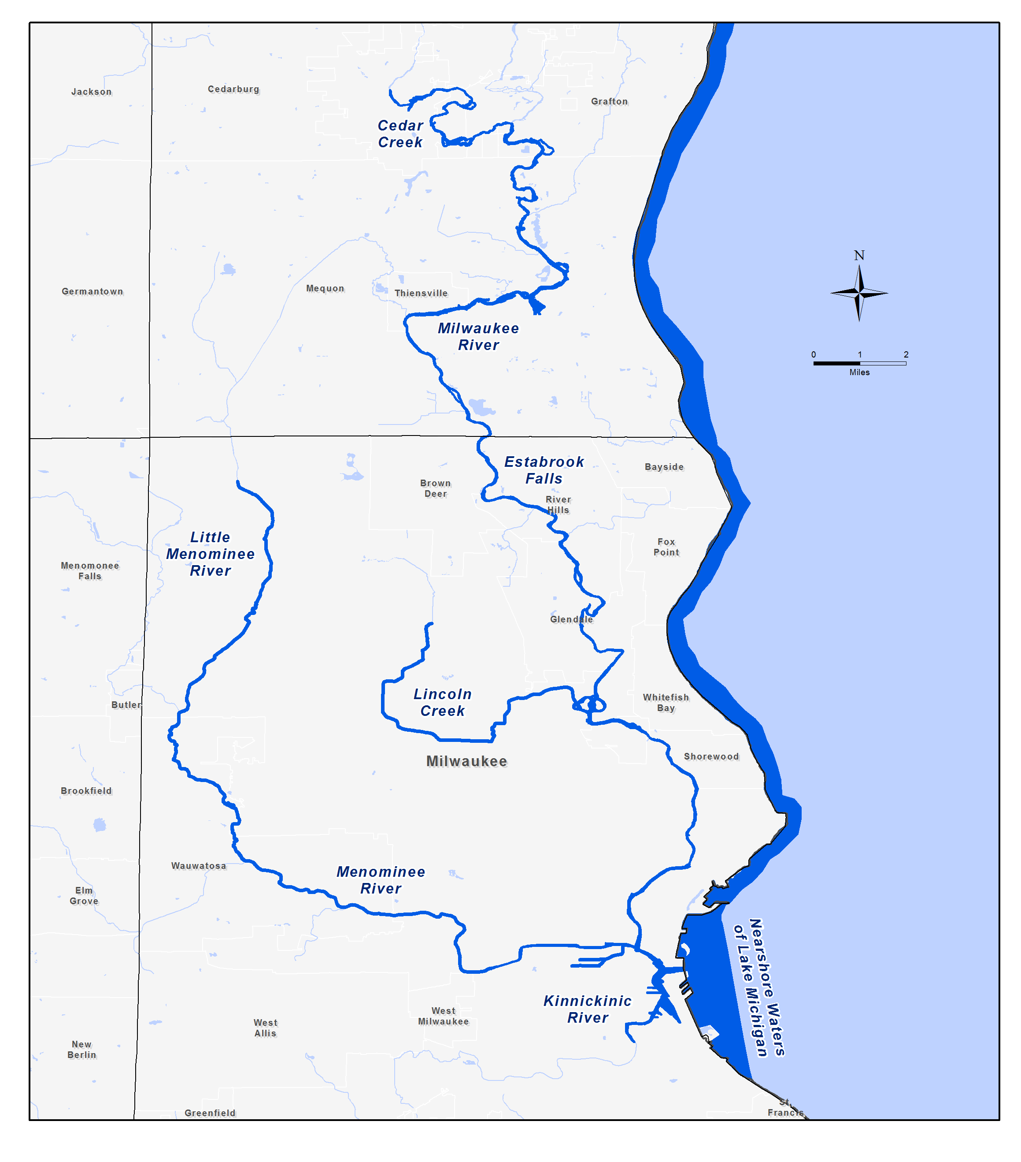
Image 8 in Study Questionnaires

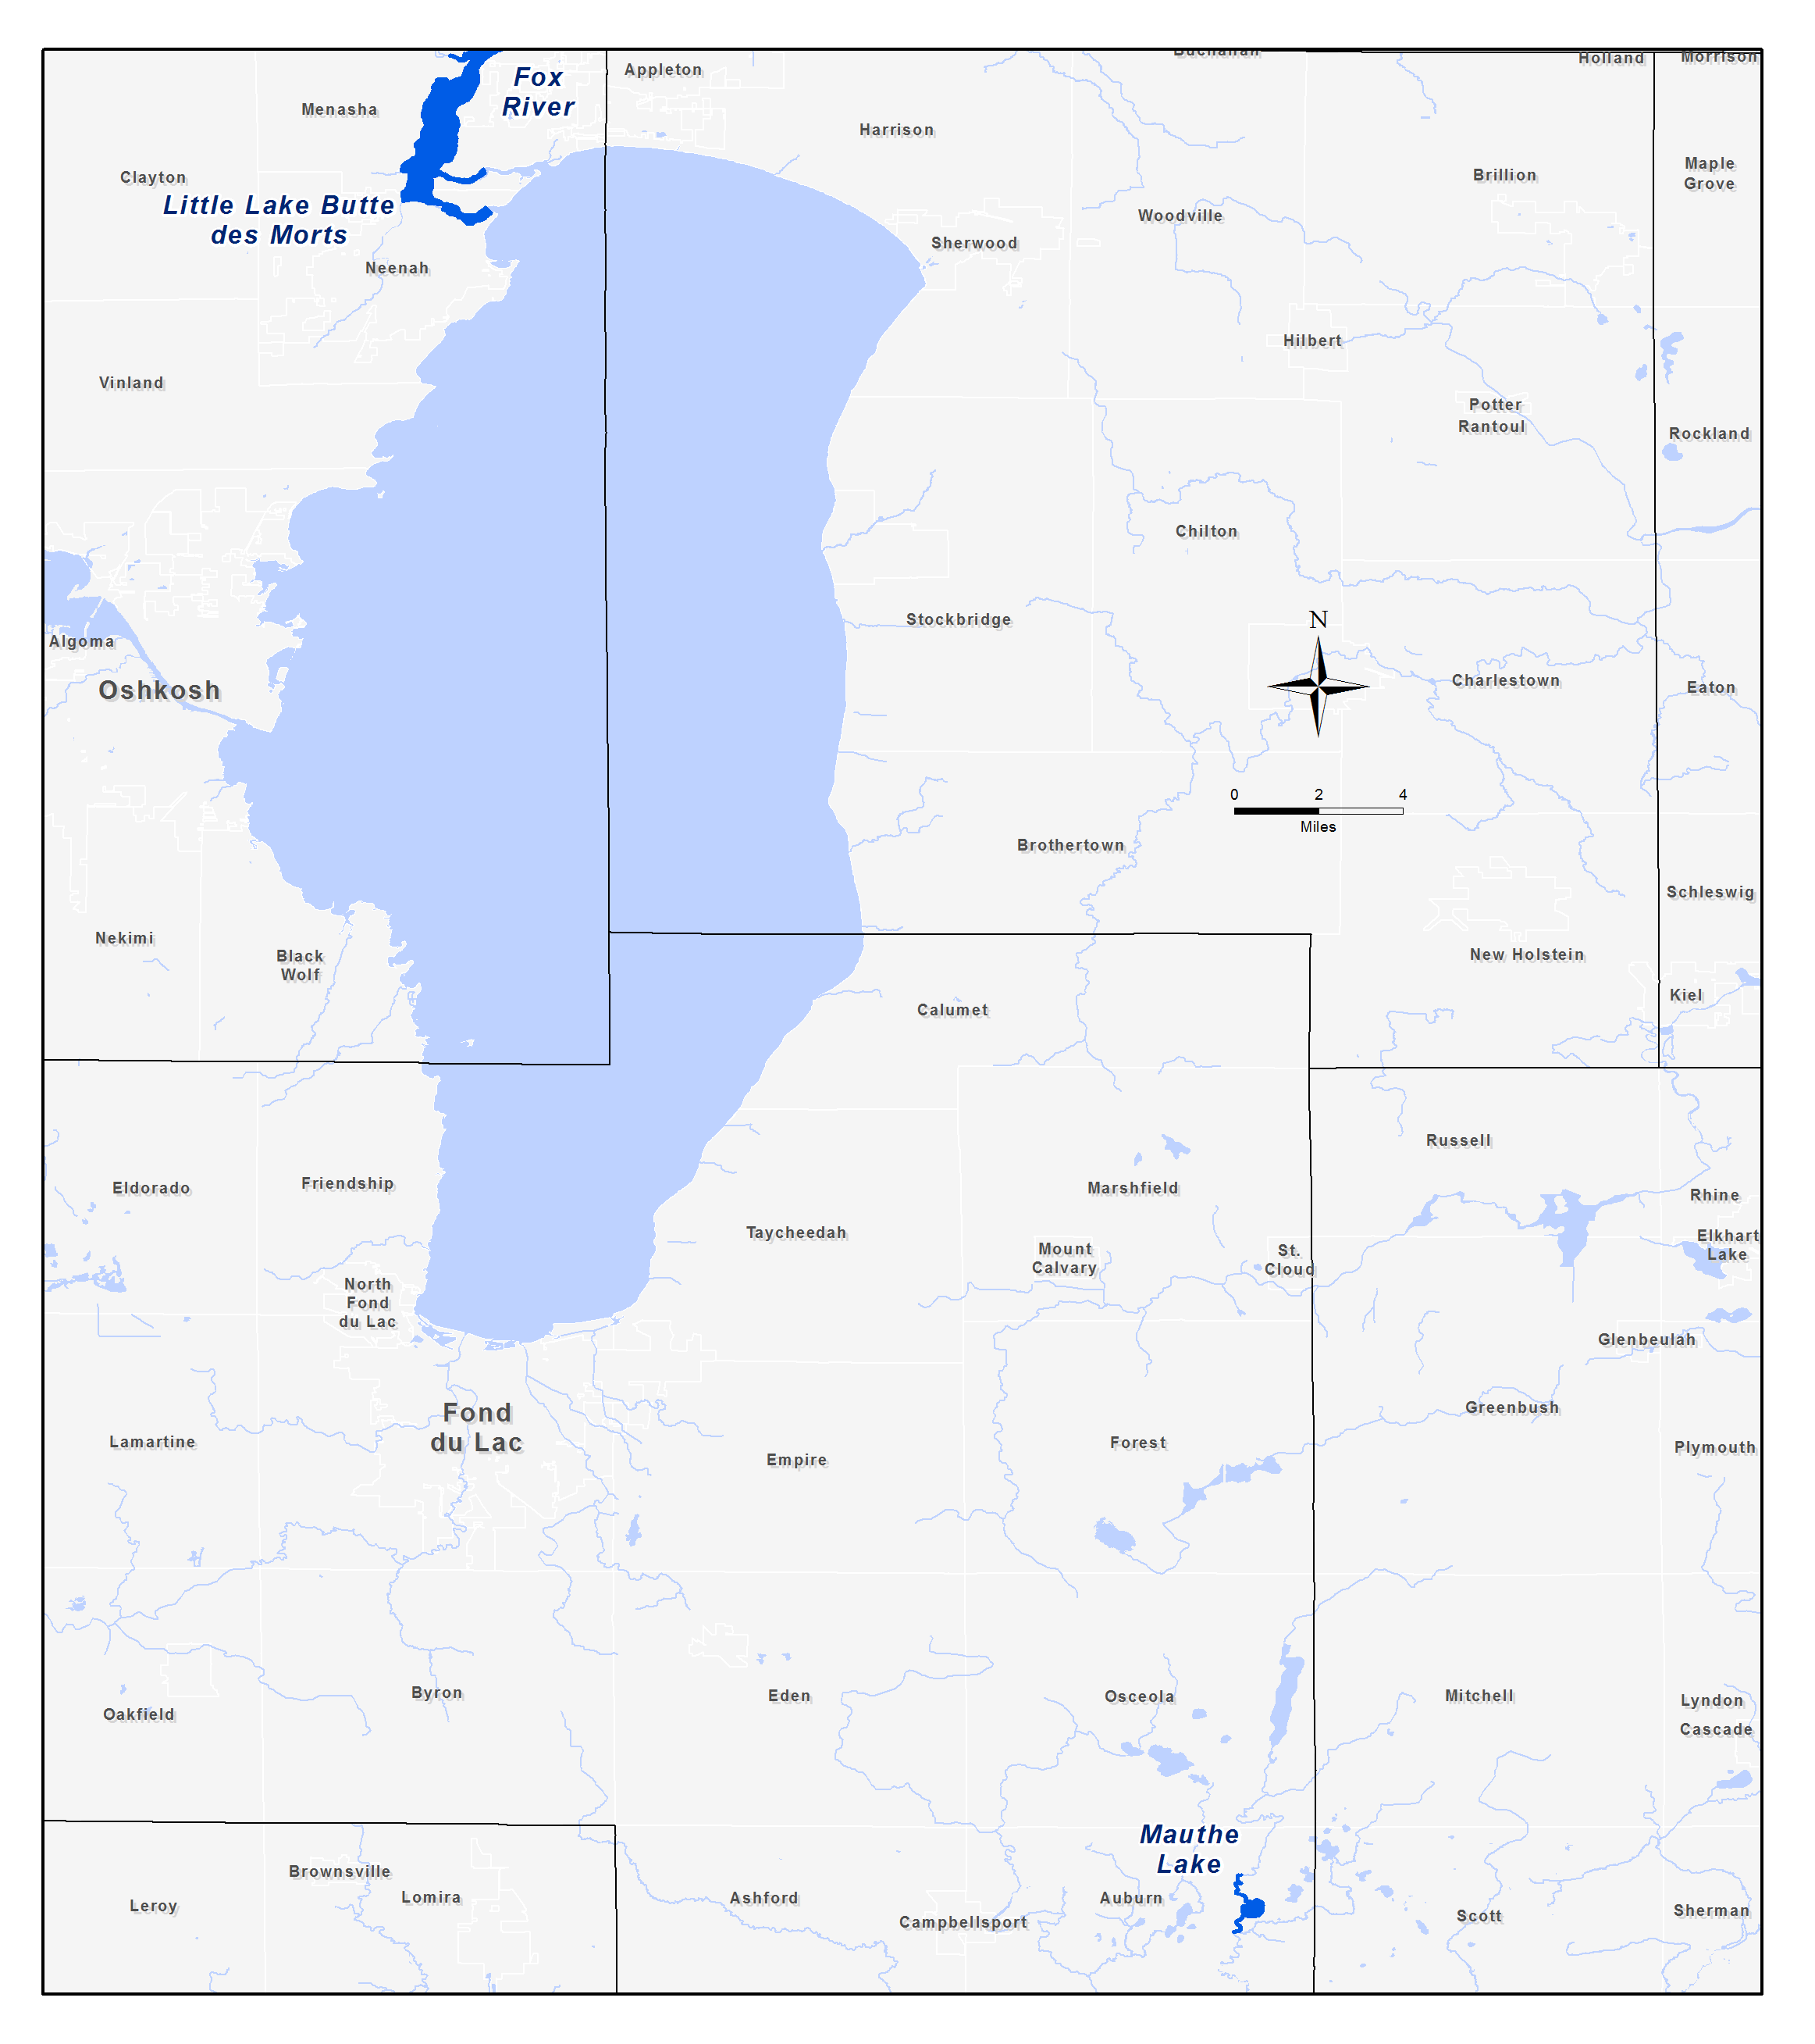

Image 9 in Study Questionnaires

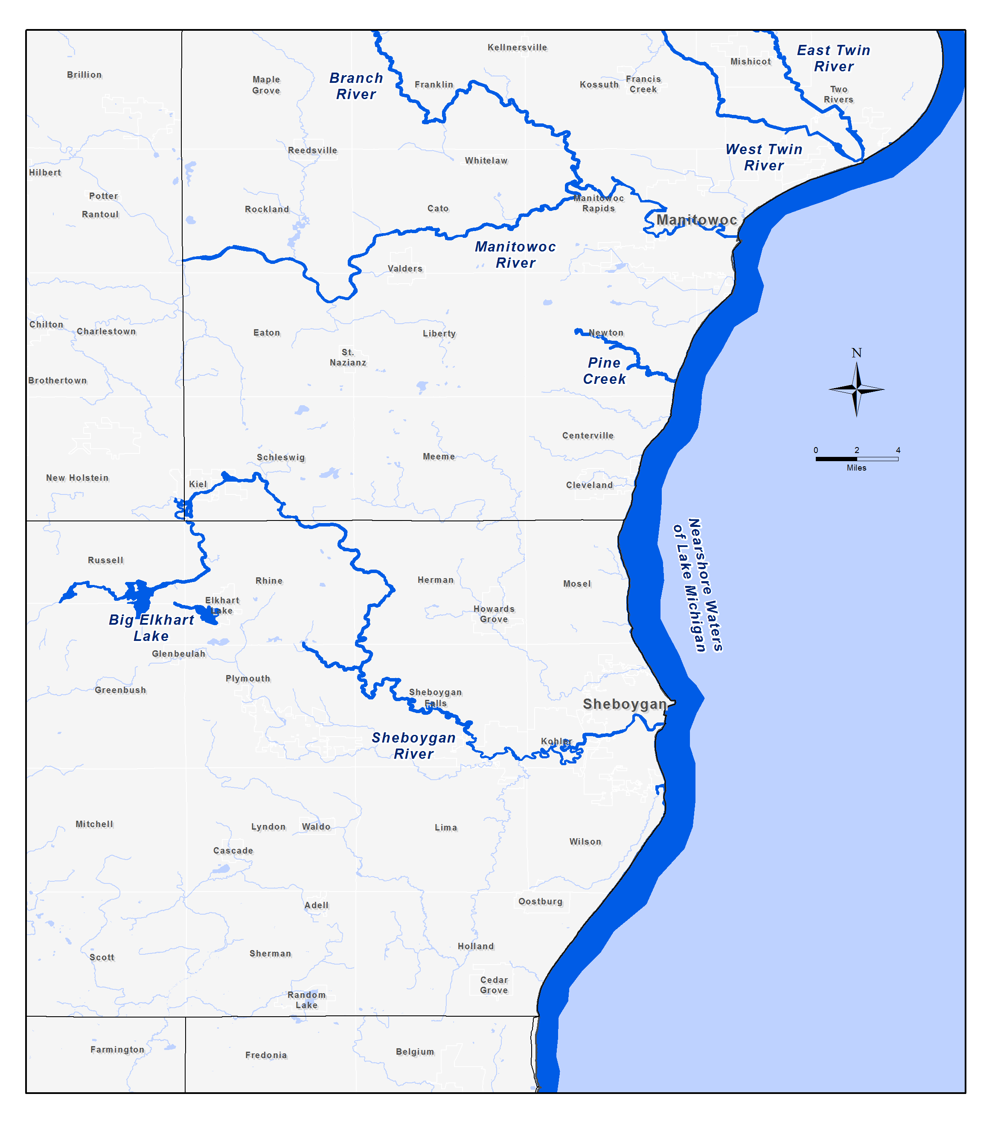

Image 10 in Study Questionnaires

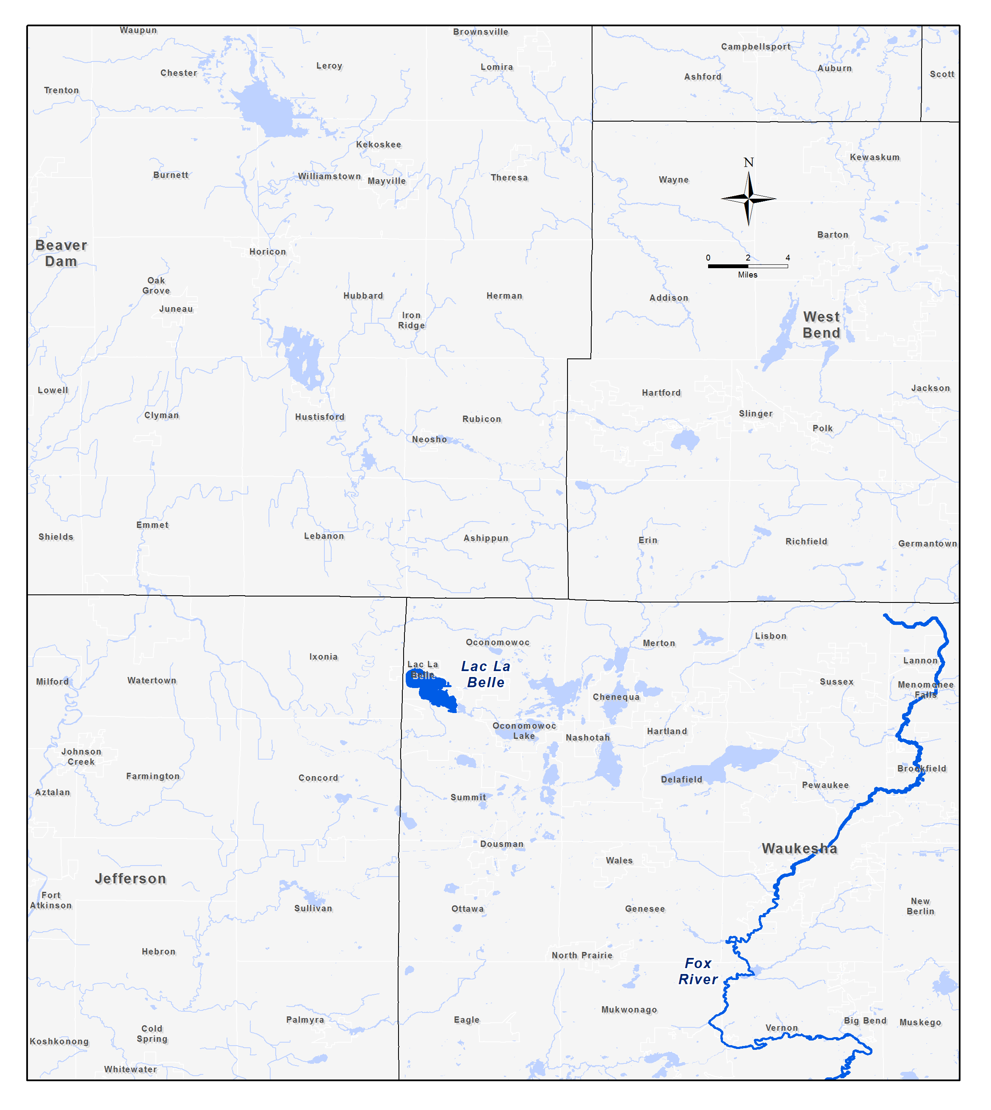

Image 11 in Study Questionnaires

