Addendum to the Supporting Statement for Form SSA-7-F6
Application for Parent’s Insurance Benefits
20 CFR 404.370-404.374 and 404.601-404.603
OMB No. 0960-0012

Revisions to the Collection Instruments

SSA is making the following revisions to Form SSA-7-F6:

- Change #1: On page 4, we will insert new language regarding Medicare Part B Late Enrollment Penalty, as seen below:

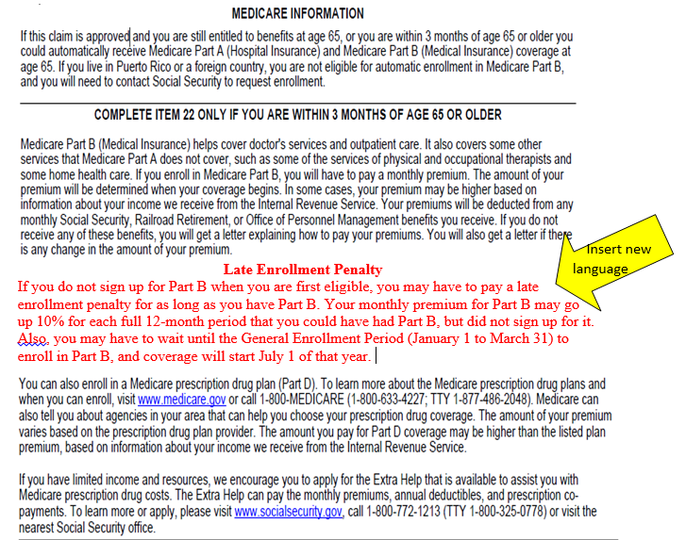

Justification #1: We are adding Medicare Part B late enrollment penalty information to the parent’s insurance benefit application. We ask individuals if they want to enroll in Part B of Medicare, when they are filing for parent’s benefits if they are within four months of age 65 or older. This provides language consistency among applications. We are not adding this information to MCS because the SSA employee who interviews the applicant provides this information verbally.

- Change #2: On Page 6, Bullet 6, we will change the text.
From:
You are confined to jail, prison, penal institution or correctional facility for conviction of a crime or you are confined to a public institution by court order in connection with a crime.

To:
You are confined to jail, prison, penal institution or correctional facility for more than 30 continuous days for conviction of a crime or you are confined for more than 30 continuous days to a public institution by court order in connection with a crime.

Justification #2: These changes conform to the non-payment requirements of the Social Security Act in section 202(x)(1).

- Change #3: On Page 6, Bullet 7, we will change the text.
From:
You have an unsatisfied warrant for your arrest for a crime or attempted crime that is a felony (or, in jurisdictions that do not define crimes as felonies, a crime that is punishable by death or imprisonment for a term exceeding 1 year.)

To:
You have an unsatisfied felony or arrest warrant for more than 30 continuous days for flight to avoid prosecution or confinement, escape from custody, or flight escape.

Justification #3: We are making this change due to the Martinez Settlement. The Martinez Settlement is a nationwide class action settlement that caused us to no longer suspend benefits for an outstanding felony warrant unless the warrant was issued for a crime or attempted crime of flight to avoid prosecution or confinement, or escape from custody and flight-escape. Also, we now use the term “arrest warrant” to cover jurisdictions that do not classify crimes as felonies.

- Change #4: On Page 6, we will remove Bullet 8.

Justification #4: We need to delete this entire bullet. On August 4, 2015, SSA decided we would no longer suspend benefits or stop payments to Title II beneficiaries and Title XVI recipients if the beneficiary or recipient alleged having an unsatisfied violation of probation or parole under Federal or State law. SSA decided we would no longer enforce the Probation or Parole Violation (PPV) non-payment sections of the Social Security Act because the statute, as currently constructed, is flawed and not susceptible to implement given the restrictions placed on the Agency by the Clark Court Order.
- Change #5: We are revising the Privacy Act Statement on this form.

Justification #5: SSA’s Office of the General Counsel is conducting a systematic review of SSA’s Privacy Act Statements on agency forms. As a result, SSA is updating the Privacy Act Statement on the form.

Revisions to the Collection Instrument - Form SSA-7-INST

- Change #1: On Page 1, Bullet 8, we will change the text.
From:
You are confined to jail, prison, penal institution or correctional facility for conviction of a crime or you are confined to a public institution by court order in connection with a crime.

To:
You are confined to jail, prison, penal institution or correctional facility for more than 30 continuous days for conviction of a crime or you are confined for more than 30 continuous days to a public institution by court order in connection with a crime.

Justification #1: These changes conform to the non-payment requirements of the Social Security Act in section 202(x)(1).

- Change #2: On Page 1, Bullet 9, we will change the text.
From:
You have an unsatisfied warrant for your arrest for a crime or attempted crime that is a felony (or, in jurisdictions that do not define crimes as felonies, a crime that is punishable by death or imprisonment for a term exceeding 1 year.)

To:
You have an unsatisfied felony or arrest warrant for more than 30 continuous days for flight to avoid prosecution or confinement, escape from custody, or flight escape.

Justification #2: We are making this change due to the Martinez Settlement. The Martinez Settlement is a nationwide class action settlement that caused us to no longer suspend benefits for an outstanding felony warrant unless the warrant was issued for a crime or attempted crime of flight to avoid prosecution or confinement, escape from custody and flight-escape. Also, we now use the term “arrest warrant” to cover jurisdictions that do not classify crimes as felonies.

- Change #3: On Page 1, we will delete Bullet 10.

Justification #3: We need to delete this entire bullet. On August 4, 2015, SSA decided we would no longer suspend benefits or stop payments to Title II beneficiaries and Title XVI recipients if the beneficiary or recipient alleged having an unsatisfied violation of probation or parole under Federal or State law. SSA decided we would no longer enforce the Probation or Parole Violation (PPV) non-payment sections of the Social Security Act because the statute, as currently constructed, is flawed and not susceptible to implement given the restrictions placed on the Agency by the Clark Court Order.

- Change #4: We are revising the Privacy Act Statement on this form.

Justification #4: SSA’s Office of the General Counsel is conducting a systematic review of SSA’s Privacy Act Statements on agency forms. As a result, SSA is updating the Privacy Act Statement on the form.

SSA will implement the changes above upon OMB approval.

These actions do not affect the public reporting burden.

