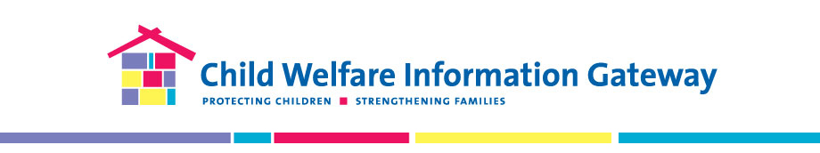
THE PAPERWORK REDUCTION ACT OF 1995 (Pub. L. 104-13) Public reporting burden for this collection of information is estimated to average 3 minutes per response, including the time for reviewing instructions, gathering and maintaining the data needed, and reviewing the collection of information. An agency may not conduct or sponsor, and a person is not required to respond to, a collection of information unless it displays a currently valid OMB control number. The control number for this project is 0970-0401. The control number expires on 05/31/2021.

Child Welfare Information Gateway Subscription Form

Thank you for subscribing!
We want you to receive the most relevant information for your interests and needs. Please let us know how we can best serve you by answering these questions. Your privacy is important to us and your personal information will be kept private.

- First Name
[blank field]

- I am looking for resources to help me with my:
- Work/Professional Development
- Education
- Community/volunteer service
- Family/Personal situation

- What is your primary area of focus or interest? (select all that apply)
- Adoption
- Foster Care
- Child Abuse and Neglect/Prevention
- Youth, or Parent/Family Services and Support
- Child and Family Well-being
- Management and Supervision

- In which State/territory are you located?
[Dropdown]

- Which type of resources would be most useful for you? (select all that apply)
- Mobile phone applications
- Pamphlets or short handouts
- Journal articles
- Online news articles
- Videos
- Virtual trainings
- Conference presentations (e.g. PPT)
- Webinars
- Guidebooks or toolkits
- Online e-books
- Technical reports or briefs
- Infographics
- Podcasts

- If you are looking for resources for work, what is your professional background?
- Not Applicable
- Prevention/family support (outside child welfare agency)
- Prevention/family support (inside child welfare agency)
- Child protective services
- Foster care services
- Adoption services
- Youth services
- Juvenile justice
- Health/mental health
- Substance use
- Legal/courts
- Researcher/evaluator/consultant
- Early childhood educator (0–5yrs)
- Teacher (K–12)
- Professor/faculty (higher education)
- Student/Intern
- Other professional

- If you work for a child welfare agency, please indicate your primary job function:
- N/A
- Child Welfare Leadership (e.g., Director/Deputy Director, Bureau Chief, Regional Director)
- Child Protective Services - Intake
- Child Protective Services – Investigation/Assessment
- In-Home Services (e.g., PSSF, Family Maintenance, and Reunification Services)
- Foster Care – Case Management
- Foster Care – Recruitment/Training/Licensing of Resource Families
- Foster Care – Independent Living/Youth
- Adoption - Case Management, Subsidy, Post-adoption Services
- Continuous Quality Improvement/Quality Assurance/Data Analyst
- CFSR/PIP/CFSP/APSR
- Policy Development
- Training
- Child Welfare Information Systems
- Other Area of Child Welfare-Related Work

- What best describes your professional role?

- Senior Level Management
- Program Manager/Coordinator
- Supervisor
- Front-line staff/worker
- Student Intern
- Family Leader
- Other
- Not Applicable

- We would like your feedback to improve our messaging and service delivery. May we contact you (in 3 to 6 months) to schedule a telephone interview or focus group?

- Yes
- No

