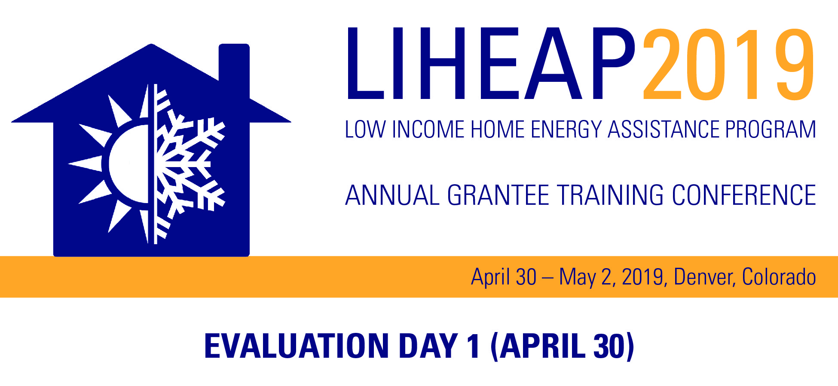
Completion of this form is voluntary and data collected from it will be kept private. The purpose of this data collection is to assist the Administration for Children and Families in improving its training opportunities for LIHEAP grantees. The anticipated time to complete this form is less than 1 minute.

Session: [Insert Title] [Insert Time]
Please rate these sessions from 0 to 4 (4 is the highest) on the following items:
Presenter: Melissa Torgerson | Excellent | Very Good | Fair | Poor | Unsure
Subject Matter Expertise? | 4 ☐ | 3 ☐ | 2 ☐ | 1 ☐ | 0 ☐
Clarify and pacing of presenter’s delivery? | 4 ☐ | 3 ☐ | 2 ☐ | 1 ☐ | 0 ☐
Adequacy of time to cover the subject? | 4 ☐ | 3 ☐ | 2 ☐ | 1 ☐ | 0 ☐
Engagement of the audience? | 4 ☐ | 3 ☐ | 2 ☐ | 1 ☐ | 0 ☐

Facilitation: | Excellent | Very Good | Fair | Poor | Unsure
Did the facilitators introduce the topic clearly? | 4 ☐ | 3 ☐ | 2 ☐ | 1 ☐ | 0 ☐
Did the facilitators manage Q&A effectively? | 4 ☐ | 3 ☐ | 2 ☐ | 1 ☐ | 0 ☐

Topic: | Excellent | Very Good | Fair | Poor | Unsure
Relevance to my work? | 4 ☐ | 3 ☐ | 2 ☐ | 1 ☐ | 0 ☐
Adequacy of time to cover the subject overall? | 4 ☐ | 3 ☐ | 2 ☐ | 1 ☐ | 0 ☐
Additional Comments about Sessions and Speakers:
THE PAPERWORK REDUCTION ACT OF 1995 (Pub. L. 104-13) Public reporting burden for this collection of information is estimated to average 1 minute per response, including the time for reviewing instructions, gathering and maintaining the data needed, and reviewing the collection of information. An agency may not conduct or sponsor, and a person is not required to respond to, a collection of information unless it displays a currently valid OMB control number. The control number for this project is 0970-0401. The control number expires on 5/31/2021.

