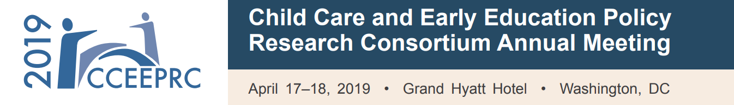

Thank you for attending the CCEEPRC 2019 Annual Meeting! We hope that it was an informative event. We would appreciate receiving your feedback on this year’s meeting, and any suggestions you have for future meetings.

Please complete the meeting evaluation: [INSERT LINK TO SURVEY HERE] by Monday, April 29. The survey should take about 5-10 minutes. We appreciate your input!

Best,
CCEEPRC 2019 Annual Meeting Team

