APPENDIX B1
Email Notification to Regional Offices
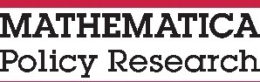

X/X/2017

To: [ALL FNS REGIONAL STUDY LIAISONS]
Subject: CN-OPS II Year 2 Study for SY 2016–2017
Good afternoon!
FNS has contracted with 2M Research Services and its research partner, Mathematica Policy Research, to conduct the Child Nutrition Program Operations Study II (CN-OPS II) Year 2 for SY 2016-2017. The CN-OPS II is being conducted to understand and address the current policy issues related to Child Nutrition Program operations.
Please notify your States about the study and encourage their assistance with any study requests from 2M Research Services and Mathematica Policy Research.
Thank you in advance for your assistance.
[FNS/USDA]

