Attachment H

Department of Commerce
United States Census Bureau
OMB Information Collection Request
2017 Economic Census of Island Areas
OMB Control Number 0607-0937

Electronic Instrument Selected Screen Shots

Welcome Screen
Burden Statement Screen

Welcome Screen

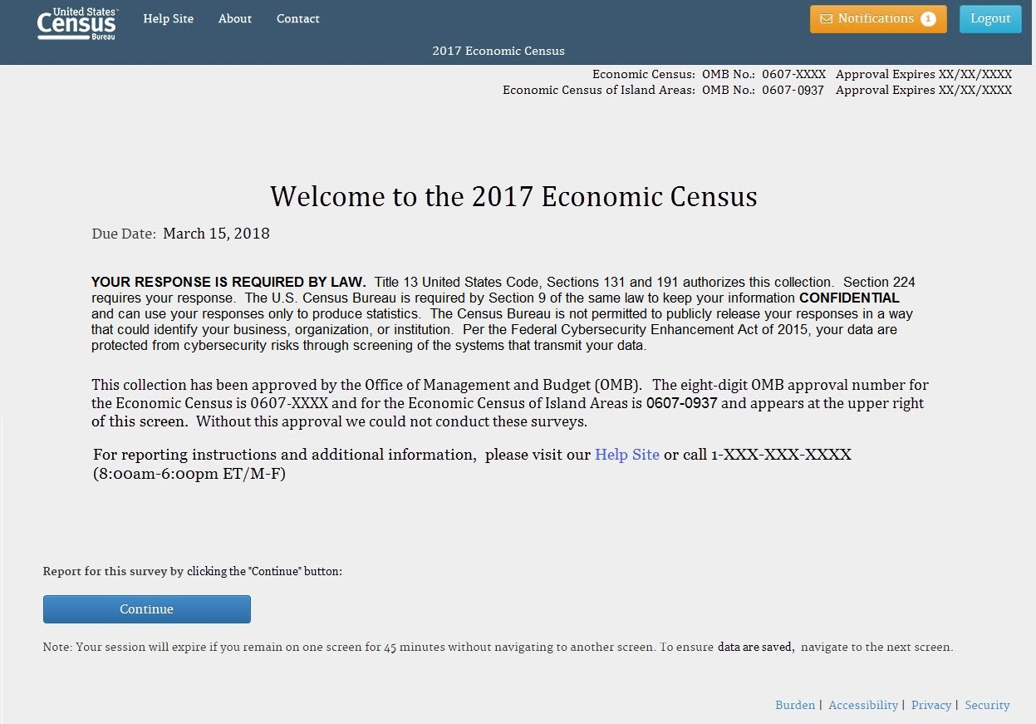

Burden Statement Screen

