Guided Wildlife Viewing Tour Operator Survey
Stellwagen Bank National Marine Sanctuary and New England

This is a voluntary survey.

The public reporting burden for this collection of information is estimated to average 1.75 hours including the time for reviewing instructions, searching for existing data sources, gathering and maintaining the data needed, and completing and reviewing the collection of information. Send comments regarding this burden estimate or any other suggestions for reducing this burden to: Dr. Danielle Schwarzmann, NOAA National Ocean Service, Office of National Marine Sanctuaries, 1305 East-West Highway, Silver Spring, MD 20910. Responses provided for this survey will be anonymous. No personally identifiable information is being collected with this survey; responses will not be attributed to individual businesses. Notwithstanding any other provisions of the law, no person is required to respond to, nor shall any person be subjected to a penalty for failure to comply, with a collection of information subject to the requirements of the Paperwork Reduction Act unless that collection of information displays a currently valid OMB Control Number.

GENERAL INFORMATION

Respondent ID Number_______
(assigned by interviewer)

All questions should be answered by the business owner, unless the owner has specified someone better suited to provide a response.

Questions 1-5 are regarding the business owner.
1. Which of the following includes your age?
2. Are you Hispanic or Latino?
3. What is your race? (Mark one or more)
4. What is your gender?
These four demographic questions will be used to develop profiles of the wildlife viewing tour operators in the Monterey Bay region. The race and ethnicity questions are written per guidelines issued by OMB. The demographics are specifically for the owner of the business to support socioeconomic impacts of regulations on small entities (primarily small businesses) under the Regulatory Flexibility Act.

5. How many family members do you support (including yourself)?
In combination with economic information gathered, this question will provide information on the degree to which operators (business owners) are dependent upon whale watching as their primary source

6. Are you the owner of the business you are representing?
For the next questions it is important to know if it is the owner or an employee answering the questions.

7. What is the businesses primary port/marina/location?
7a. Do you have a secondary port/marina/location from where the business?
7b. If YES, which one?
Question 7 asks about the primary and secondary ports and/or marinas that the wildlife viewing operation utilizes. This information is important for assessing the region of operation as well as travel distance.
8. How many years have you been an ocean recreation business owner?
This information will help determine how established and dependent the operation is in the local whale watching and marine wildlife viewing industry and may explain differences in attitudes and perceptions of management strategies and regulations.

9. How many years have you been an ocean recreation business owner in the New England Region
Question 9 is similar to the prior question in terms of purpose, but collects information regarding the Monterey Bay region, specifically.

10. Do you visit federal, state and/or local marine protected area (reserves/conservation areas) specifically during your tours? (Interviewer—please show state MPA map to identify specific quadrants)
10a. Why or why not?
10b. How often?
10c. If YES, how many years have you conducted guided wildlife tours in state marine protected areas?
This information is important for understanding visitation rates to, as well as the importance of, the state marine protected areas and sanctuaries to business operations. Also asked is why and how often they visit the state MPAs. This qualitative information is important to ascertain their reasons for visiting the state MPAs, which will be of use to sanctuary managers.

Question 11 is for whale watching operators only:
11. Do you currently have a dedicated naturalist on board during whale watching trips?
11a. If NO, would you be interested in having one on board if you had more information about the role they play with whale watching operators?
11b. If NO to question 11, would you be interested in having a sanctuary certified naturalist on board?
In some cases, naturalists will often come aboard for whale watching trips to talk with customers and collect data on the location and species of whales seen per trip. Question 11 asks if operators participate in this naturalist program, meaning that they allow naturalists on board during whale watching trips. This question will help researchers and sanctuary workers better understand the participation rate of operators in the naturalist program, as well as interest among operators for program expansion.

12. Are customers expecting particular wildlife species when they go on a guided tour?
12a. If YES, please list
This information will allow researchers to roughly ascertain the species of viewing preference among whale/marine wildlife watching customers in the region.
13. How would you describe the wildlife viewing operation? (Mark one or more)
13a. If part time or seasonal, which months?

14. Number of boats/vessels at the operation:
____ (number of vessels)

Questions 13 and 14 ascertain the type and size of the operation. This information will be used to develop a profile of the business and the types of businesses operating within the sanctuary.

Question 15-20 are for specific types of operators:
15. Average number of whale watching participants per vessel in operation:

16. Average number of seal watching participants per vessel in operation:

17. Average number of participants per vessel in recreational fishing cruise operation:

18. Average number of kayakers and kayaks per guided tour:

19. Average number of divers/snorkelers per vessel in operation:

20. Average number of wildlife observers (seabirds and other) per vessel in operation (capacity):

Questions 15-19 ask about the capacity of vessels in terms of the number of participants for each of the operator’s different vessels for each activity. This information will help assess supply capacity and will be used in cost/earnings calculations.

21. Number of employees at the operation:
Question 21 will gather data on the number of employees at the operation. Employee numbers and status will help determine the size of the operation.

22. Number of vessel trips/guided tours per day (primary purpose):
Question 22 gathers information on the number of trips per day and will help researchers understand the magnitude of participants/customers in the area, as well as the percentage of business that is dedicated to wildlife viewing, as opposed to other services.

Question 23 should be answered only if the person responding has been in the guided wildlife tour industry for 10 years or more.
23. In your opinion, on a scale of 1 to 5, how has the quality of the guided wildlife tour industry changed in the last 10 years?

23a. If you believe that the quality of guided tours has changed, could you tell us how it’s changed?
This series of questions asks the operations to indicate if the quality of wildlife viewing has changed in the last 10 years. This information will be helpful in gauging the status of the industry from an “insider’s” point of view. This information will allow researchers to understand what factors are believed to be most associated with changes in quality in the industry.

24. Are you aware that wildlife in the region are sometimes unintentionally harassed?

24a. If YES, how concerned are you that harassment to wildlife (whales, dolphins, seals, and seabirds) may be having a negative impact on your business, with 1 being not concerned and 5 being extremely concerned?

24b. Please explain your answer
24c. Are you concerned about vessel speeds impact on wildlife?
24d. If yes to 24c, please explain your answer

Question 24 queries the operation on the issue of wildlife disturbance in the region. Gauging awareness of the issue would help local resource managers plan future education and outreach efforts among guided tours. This question also gathers information on the level of concern among wildlife viewing operations about the impact of wildlife harassment on their businesses. This question will help managers to understand how interested stakeholders from this group are about wildlife conservation issues relative to wildlife disturbance.

25 With the exception of Right Whales, there are no regulations in SBNMS that require an "approach distance" to whales. However, there are official NOAA Fisheries voluntary guidelines that recommend wildlife-viewing vessels maintain a minimum distance of 100 feet from whales. Does your operation have any kind of established policy regarding a minimum distance your vessels maintain from whales?

25a. If YES, what is your company's approach distance policy for whales?

This question helps to understand what companies are currently doing to mitigate whale strikes within the region. This will provide a baseline of how companies respond and interact with whales and other wildlife.

26. Any sighting of an entangled whale should be reported to the NOAA’s Greater Atlantic Marine Animal Reporting Hotline HOTLINE 1-866-7555 NOAA (6622) or call on VHF CH-16 to USCG.

26a. Have you ever heard of the Reporting HOTLINE?
26b. Have you/any of your employees ever called the Disentanglement HOTLINE?
26c. Please explain your response (i.e. reason why you called, did not call because you were not aware of program, did not call because you never encountered an entangled whale, etc.)
26d. Have you/any of your employees ever called another number or organization about entangled whales?
26e. If yes to 26d, which organization or number did you call?
26f. Does your company have a policy about responding to injured or entangled wildlife?
26g. If YES, what is your company’s policy about responding to injured or entangled wildlife?

27. Would you be interested in learning more about how your company can report injured or entangled wildlife?
27a. If YES, how would you like to receive information? (Check all options that apply)

28. Have you heard of Whale Alert?
28a. Have you ever used Whale Alert?
28b. How have you used Whale Alert?

Questions 26 -28 are regarding whale and marine wildlife entanglement, injury and awareness. It is beneficial to know if wildlife viewing tour operators are already aware of programs in place to assist injured marine animals, as well as to understand what operators may or may not be doing about it. The information collected also has potential to be used by resource managers for future outreach and education purposes. Question 27 will help resource managers to understand how best to communicate information to business operators regarding marine wildlife entanglement

29. Have you heard of Whale SENSE?
29a. Have you ever used Whale SENSE?
29b. Please tell us what you think about Whale SENSE
29c. Please tell us why you have not used Whale SENSE

Whale SENSE is a program to promote responsible whale watching. It is a voluntary program, but understanding why people use or do not use the program could help to improve future outreach and educational efforts of the program.
30. If you have been operating a wildlife viewing business in or around SBNMS for at least 10 years, please answer the following questions. To the best of your knowledge, please rank the how the status/condition of the following resources in Stellwagen Bank National Marine Sanctuary has changed over the past 10 years, where 1 is much better and 5 is much worse.

RESOURCE Better Not Much Change Worse

a. Water Quality 1 2 3 4 5 N/A Unsure
b. Marine Debris/Ocean Pollution 1 2 3 4 5 N/ A Unsure
c. Marine Mammals whales, turtles,
seals) 1 2 3 4 5 N/ A Unsure
d. Habitats 1 2 3 4 5 N/ A Unsure
e. Introduced Species 1 2 3 4 5 N/ A Unsure
f.. Seabirds 1 2 3 4 5 N/ A Unsure
g. Recreational Fish 1 2 3 4 5 N/ A Unsure
h. Forage Fish 1 2 3 4 5 N/ A Unsure

31. If you have been operating a wildlife viewing business in or around SBNMS for at least 5 years, please answer the following questions. To the best of your knowledge, please rank the how the status/condition of the following items in Stellwagen Bank National Marine Sanctuary have improved over the past five years as a result of sanctuary management. 1 is strongly agree and 5 is strongly disagree

Strongly Agree Neutral Strongly Disagree

a. Enforcement 1 2 3 4 5 N/A Unsure
b. Research 1 2 3 4 5 N/ A Unsure
c. Natural Resource Protection 1 2 3 4 5 N/ A Unsure
d. Maritime Heritage Resource Protection 1 2 3 4 5 N/ A Unsure
e. Education 1 2 3 4 5 N/ A Unsure
f.. Community Engagement 1 2 3 4 5 N/ A Unsure

Questions 30 and 31 are designed to understand how the respondent feels the sanctuary has changed over the past 5 years. This information will help resources managers identify which areas need more attention in regards to regulation or research, as well as understand the opinions and perceptions of the general public. Question 31 provides information to better understand the public’s perception of the role and responsibility of the Sanctuary.

32. In this section, we want to learn the best ways that SBNMS can communicate with you by understanding the sources of information you use and which sources of your information you trust.

For each of the following potential sources of information please indicate your level of trust for each one that use.

No Trust Very little Neutral Very much Completely Do not
at all trust trust trust use

- SBNMS Staff 1 2 3 4 5 N/A
- SBNMS Website 1 2 3 4 5 N/A
- SBNMS Advisory Council 1 2 3 4 5 N/A
- National Marine Sanctuary
Foundation 1 2 3 4 5 N/A
- NOAA’s National Marine
Fisheries Service 1 2 3 4 5 N/A
- State of Massachusetts
(Coastal Zone Management,
Division of Marine Fisheries) 1 2 3 4 5 N/A
- Newspaper 1 2 3 4 5 N/A
- Radio 1 2 3 4 5 N/A
- Television 1 2 3 4 5 N/A
- Internet 1 2 3 4 5 N/A
- SBNMS Facebook Page 1 2 3 4 5 N/A
- SBNMS Twitter Feed 1 2 3 4 5 N/A
- Other Social Media (YouTube,
Flickr, Instagram, etc.) 1 2 3 4 5 N/A
- Word of Mouth 1 2 3 4 5 N/A
- Whale SENSE 1 2 3 4 5 N/A
- SBNMS Events 1 2 3 4 5 N/A
- Sanctuary Publications 1 2 3 4 5 N/A

This question will help the sanctuary to better understand how to maximize education and outreach efforts within the sanctuary for wildlife viewing operations in the area.

33. Use by activity in the sanctuary:
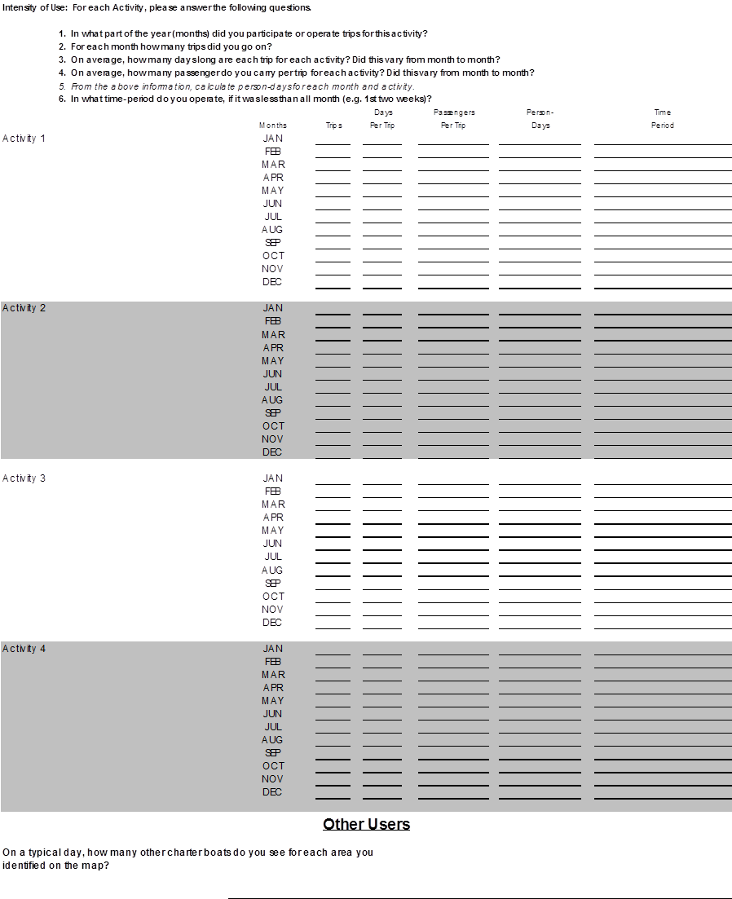

Question 33 collects information on the person-days by activity type for the business over a twelve-month period. A person-day is one person doing an activity for a whole day or any part of the day. This measurement corresponds generally to what the operations record in their logbooks as the number of passengers taken to a specific location on a specific day. There is some potential for double-counting across activities, so totals across activities is asked and it is not required that the sum by activity equal the total. This type of information has been collected previously by ONMS to ascertain the spatialized recreational value of marine protected areas in the CINMS and the Florida Keys National Marine Sanctuary.

34. Mapping Exercise: Map the Distribution of Each Activity
Respondents will be advised to provide information on their anticipated spatial use of the New England region. This anticipated spatial use may be the same as their current use or it may be different. Respondents will be given a 100 penny budget, meaning one penny equals one percent of passenger activity. The respondent will allocate his or her budget across all map cells. Codes will be recorded on the coding sheet. The map cells will be referenced by column and row: For example, C1R1 1% means 1% of activity is in cell Column 1 Row 1. The percent of each activity must add up to 100.

35. Does this map reflect where you presently operate?
___YES ___NO

35a. If NO, please explain why future operations may be different than where you have historically operated.
________________________________________________________________________________________________________________________________________________________________________________________________________________________

Question 34 is needed to obtain a detailed spatial resolution of “expected person-days”. The purpose of this information is to assess the potential impacts of alternative management scenarios on the wildlife viewing industry. This evaluation is by its nature forward looking, thus past spatial distribution of effort may not be a good representation of future impact. Wildlife viewing tour operators will be asked to provide the percent distribution of where they expect to undertake their future effort (i.e., their anticipated spatial use area) by type of activity at spatial resolutions of 1-minute by 1-minute of one nautical square mile grid cells. It is important to note that a respondent’s future anticipated spatial use area might be similar or identical to their current or past use area. Detailed maps will be provided with NOAA nautical chart layers with latitude and longitude lines, as well as key reference points such as benthic structure and depth contours. The person-day totals provided in Question 41 will provide the information to weight percentage distributions across operations when extrapolating to population totals by spatial unit. A copy of the map that will be used for data collection is included with this package. This type of information has been collected previously by ONMS to ascertain the influence of a marine protected area designation on the economic condition of commercial fishermen and recreational boat operators in CINMS and the Florida Keys National Marine Sanctuary. Additionally, similar data have been collected for the Flower Garden Banks National Marine Sanctuary in the Gulf of Mexico, although data from this report have not been published to date.
Questions 35 and35a clarify if the distribution is for current or future movements.

ECONOMIC INFORMATION

36. What approximate percentage of the TOTAL business income is derived from guided wildlife viewing operations? ____%

Question 36 will provide information about how much of a respondent’s business income is dependent solely on wildlife viewing services, as opposed to other goods or services offered as a part of their business (e.g., the operation may offer fishing tours as well). This information will allow researchers to assess the degree of dependency of these businesses on wildlife viewing ventures.

37. What approximate percentage of your TOTAL household income is derived from guided wildlife viewing operations? ____%

Question 37 will be used, in combination with other information gathered, to determine the degree of dependency of the business owners on wildlife viewing tourism for their household support. This question will help researchers to understand the economic vulnerability of owners’ households should management options or other factors impact the industry. This will help us meet the needs of socioeconomic impact analysis of regulations under the Regulatory Flexibility Act, which applies to small entities (primarily small businesses).
38. Please list any outstanding balance on loan amounts for vessels and equipment.
$______________

39. Please provide your best estimate for the following expenses last year:
Permits/licenses $ ______________
Docking fees $ ______________
Interest payments on vessel(s) $ ______________
P&I insurance on vessel(s) $ ______________
Maintenance/repair on vessel/electronic equipment $ ______________
Maintenance/repair on dive/snorkel gear $ ______________
Maintenance/repair on rods/reels $ ______________
Maintenance/repair on compressors $ ______________
Maintenance/repair on other equipment $ ______________
Other dive equipment costs $ ______________
Advertising $ ______________
Office rent/mortgage $ ______________
Office utilities (electric, water, telephone, Internet) $ ______________
Depreciation of vessels and equipment $ ______________
Business taxes $ ______________
Other (specify):
_______________________________________ $ ______________
_______________________________________ $ ______________
_______________________________________ $ ______________

39a. Please provide your best estimate of the replacement value of the following items that you used last year (fill in year _____):
Vessel(s) and electronic equipment $ ______________
Diving and snorkeling gear $ ______________
Compressors $ ______________
Rods/reels $ ______________
Other gear (specify):
_______________________________________ $ ______________
_______________________________________ $ ______________
_______________________________________ $ ______________

The previous two questions will be used with revenues to assess the profitability of the operation that can be used to assess the impacts of management options or other factors on individual businesses and the industry as a whole.

40. Please provide your best estimate for the following trip related expenses last year:
Dive equipment costs $ ______________
Fuel/oil $ ______________
Ice $ ______________
Food/supplies $ ______________
Bait $ ______________
Captain wages & salaries (if not owner-captain) $ ______________
Crew wages & salaries Number ______ $ ______________
Other (specify):
_______________________________________ $ ______________
_______________________________________ $ ______________
_______________________________________ $ ______________

This question asks about additional annual expenses from the previous year. This information will help researchers to calculate the operation’s total operating costs.

41. Please provide your best estimate of total business revenues last year.
$ ______________

Question 41 asks about the operation’s total revenue from last year. Revenue information is essential for understanding profits and the size of the local industry.
42. Please provide your best estimate of total revenues and/or percent of total revenues last year in Stellwagen Bank National Marine Sanctuary.
$ ______________ % _____

Question 42 focuses on total whale watching and marine wildlife observation operation revenues for the past year in MBNMS.

Questions 43-45 pertain to whale watching operators only:
43. Does the number of whales seen per trip affect the profitability of that trip?
___YES ___NO

If you answered ‘yes’ to question 43, then
What is the minimum number of whales that need to be seen per trip in order to make the
trip profitable? ______________

44. What is the minimum number of customers/attendants that need to be booked per trip in order to make the trip profitable? _______________

45. If you do not see any whales on a trip, do you reimburse customers? ___YES ___NO

45a. If YES, how do you reimburse customers?
________________________________________________________________________
The previous 3 questions gather information on the threshold of probable success before a vessel operator agrees to go out, as well as the impact of unsuccessful trips, meaning trips made when no whales are spotted. The latter information is useful in determining how much loss is associated if whales are not encountered during a whale watching trip.

Leeworthy, V.R. and P Wiley. 2003. Socioeconomic Impact Analysis of Marine Reserve Alternatives for the Channel Islands National Marine Sanctuary. Silver Spring, MD: U.S. Department of Commerce, NOAA.; Jeffrey, C.F.G., V.R. Leeworthy, M.E. Monaco, G. Piniak, M. Fonseca (eds.). 2012. An Integrated Biogeographic Assessment of Reef Fish
Leeworthy, V.R. and P Wiley. (2003); Jeffrey, et al. (2012). Populations and Fisheries in Dry Tortugas: Effects of No-take Reserves. NOAA Technical Memorandum NOS NCCOS 111. Prepared by the NCCOS Center for Coastal Monitoring and Assessment Biogeography Branch. Silver Spring, MD. 147 pp.

