Fresh Empire Campaign: Wave 2 Quantitative Study of Reactions to Rough-Cut Advertising
Designed to Prevent Youth Tobacco Use
OMB# 0910-0810
Exp. Date: 11/30/18
Social Media Electronic Screener

WELCOME PAGE

[TEXT TO PRESENT TO PARTICIPANT]: “We are looking for teens to be part of a survey about teen culture and health. In order to be selected, you must answer this short screener survey to see if you qualify. You will find out if you have been selected at the end of this screener survey. If you are selected, you will be asked to provide contact information, and we will send you a $5 electronic gift card as a thank you. We will then send you a link to the full survey about 24 hours later. You can click on that link and complete and submit the full survey to receive a $20 electronic gift card.

Only the researchers will know how you answer. We will not share the answers you give with anyone outside of the research study. There are no right or wrong answers to these questions.”

[Each item will be presented in a separate page, separated by a “NEXT” button.]

DEMOGRAPHICS AND TOBACCO USE

B1. How old are you?
- 11 years old or younger
- 12 years old
- 13 years old
- 14 years old
- 15 years old
- 16 years old
- 17 years old
- 18 years old or older

B2. During the past 7 days, did you drink a can, bottle, or glass of soda or pop, such as Coke, Pepsi, or Sprite? (Do not count diet soda or diet pop.)
- Yes [CONTINUE TO B3]
- No [SKIP TO B4]

B3. During the past 7 days, how many times did you drink a can, bottle, or glass of soda or pop, such as Coke, Pepsi, or Sprite? Your best guess is fine. (Do not count diet soda or diet pop.)
- I did not drink soda or pop during the past 7 days
- 1 to 3 times during the past 7 days
- 4 to 6 times during the past 7 days
- 1 time per day
- 2 times per day
- 3 times per day
- 4 times or more per day

B4. Have you ever tried cigarette smoking, even one or two puffs?
- Yes [CONTINUE TO B5]
- No [SKIP TO B6]

B5. About how many cigarettes have you smoked in your entire life? Your best guess is fine.
- I have never smoked cigarettes, not even one or two puffs
- 1 or more puffs but never a whole cigarette
- 1 cigarette
- 2 to 5 cigarettes
- 6 to 15 cigarettes (about 1/2 pack total)
- 16 to 25 cigarettes (about 1 pack total)
- 26 to 99 cigarettes (more than 1 pack, but less than 5 packs)
- 100 or more cigarettes (5 or more packs)

B6. Do you think that you will smoke a cigarette soon?
- Definitely yes
- Probably yes
- Probably not
- Definitely not

B7. Do you think that you will drink a can, bottle, or glass of soda or pop, such as Coke, Pepsi, or Sprite, in the next week? (Do not count diet soda or diet pop.)
- Definitely yes
- Probably yes
- Probably not
- Definitely not

B8. Do you think you will smoke a cigarette in the next year?
- Definitely yes
- Probably yes
- Probably not
- Definitely not

B9. If one of your best friends were to offer you a cigarette, would you smoke it?
- Definitely yes
- Probably yes
- Probably not
- Definitely not

B10. Have you ever been curious about smoking a cigarette?
- Definitely yes
- Probably yes
- Probably not
- Definitely not

B11. What is your sex?
- Female
- Male

B12. What is the 5-digit zip code where you CURRENTLY live?
___ ___ ___ ___ ___

B13. Are you Hispanic, Latino/a, or Spanish origin? (You can choose one answer or more than one answer)
- No, not of Hispanic, Latino/a, or Spanish origin
- Yes, Mexican, Mexican American, Chicano or Chicana
- Yes, Puerto Rican
- Yes, Cuban
- Yes, another Hispanic, Latino/a, or Spanish origin

B14. What race or races do you consider yourself to be? (Mark one or more answers)
- American Indian or Alaska Native
- Asian
- Black or African American
- Native Hawaiian or Other Pacific Islander
- White
- Other

MARKETING AND RESEARCH

C1. Do you or any member of your immediate family or a close friend work for...? (Select all that apply)
- A market research company
- A tobacco company (manufacturer or importer of tobacco products)
- An advertising agency or public relations firm
- The media (TV/radio/newspapers/magazines)
- A healthcare professional (doctor, nurse, pharmacist, dietician, etc.)
- None of these

C2. Have you ever received money or gift cards from a company for sharing your opinions in a discussion group, interview or survey?
- Yes, within the past 6 months
- Yes, more than 6 months ago
- No
- I’m not sure

PICTURE SELECTION EXERCISE

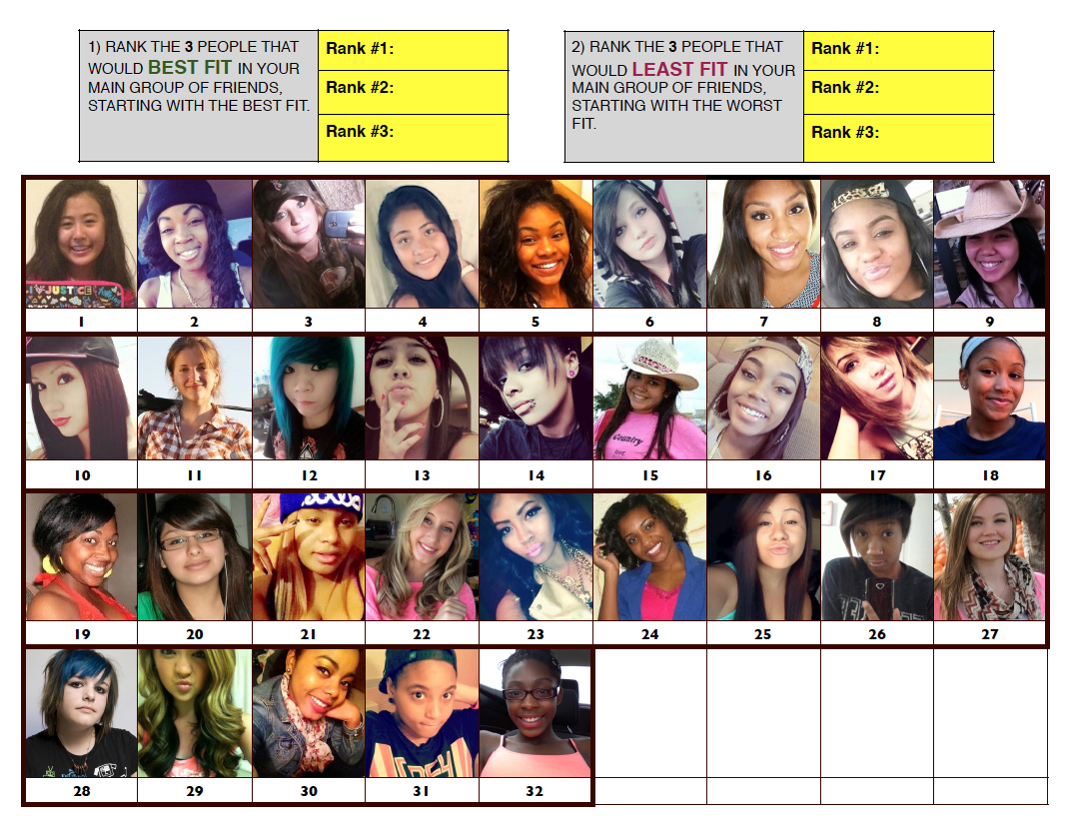
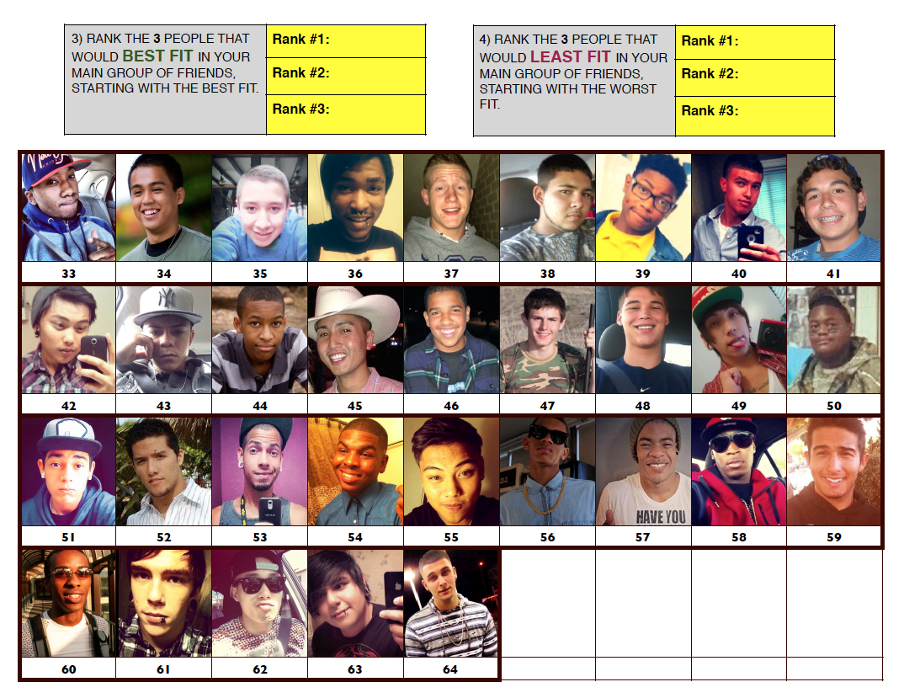

EMAIL ADDRESS
C3. What is your email address? (to receive main survey link): ______________
Please confirm the email address above: ___________

[IF BOTH EMAILS PROVIDED IN C3 DO NOT MATCH, PROVIDE ERROR MESSAGE]

[SCREEN OUT DISQUALIFYING YOUTH BEFORE PROCEEDING TO NEXT PAGE.]

[IF B1 = A OR B OR H, DISQUALIFY]
[IF B4 = B AND B6 = D AND B8 = D AND B9 = D AND B10 = D, DISQUALIFY]
[IF B4 = A AND B5 = A AND B6 = D AND B8 = D AND B9 = D AND B10 = D, DISQUALIFY]
[IF B4 = A AND B5 = H, DISQUALIFY]
[IF B12 IS NOT ZIP CODE WITHIN 50 MILES OF DESIGNATED DMA, DISQUALIFY]

[IF C1 = B, DISQUALIFY]
[IF C2 = A, DISQUALIFY]

[IF HIP HOP I-BASE SCORE < 4, DISQUALIFY.]

[IF C3 MATCHES EMAIL ADDRESS ALREADY IN DATASET, DISQUALIFY]

[ELSE, QUALIFY]

[TEXT PRESENTED TO DISQUALIFIED PARTICIPANTS]: “Thank you for answering our questions! Unfortunately, you will not be invited to take part in the full survey. Have a great day!”

[TEXT PRESENTED TO QUALIFIED PARTICIPANTS]: “Congrats! You qualify to complete the full survey! Please provide the following information so that we can send you a link to complete the survey!”

CONTACT INFO PAGE

A1. We will send you a link by email to complete the full survey in about 24 hours. If you would also like to receive the link by text message, please provide a phone number that we can text the link to.

- Cell Phone Number: (__) ___ - ____
- I do not have a cell phone number

[ANSWER REQUIRED TO PROCEED]

A2. Before we can send you the full survey, we need to email a copy of our Opt Out Form to your parent or guardian. This form explains what you will be doing, and provides them with a way to contact us only if they do NOT want you to complete the survey.

Parent or guardian’s email address: ___________________

As a reminder, your answers will only be known to the researchers and we will not share them with anyone outside the study, including your parents.

[TEXT PRESENTED TO QUALIFIED PARTICIPANTS]: “Thank you! Keep an eye out for your $5 gift card. We will email you the link to the full survey in about 24 hours. After you submit the full survey, you will receive your $20 gift card. Don’t forget to check your SPAM if you do not see the survey link after 24 hours.

Paperwork Reduction Act Statement: The public reporting burden for this information collection has been estimated to average 4 minutes per response to complete this survey (the time estimated to read and complete). Send comments regarding this burden estimate or any other aspects of this information collection, including suggestions for reducing burden, to PRAStaff@fda.hhs.gov.”

