Fresh Empire Campaign: Wave 2 Quantitative Study of Reactions to Rough-Cut Advertising Designed to Prevent Youth Tobacco Use
Attachment L: Video Ad Stimuli

The following video ads will be tested as part of the Copy Testing exercise. Video ads will reflect the content represented below.

Video Ad #1

Screenshot:

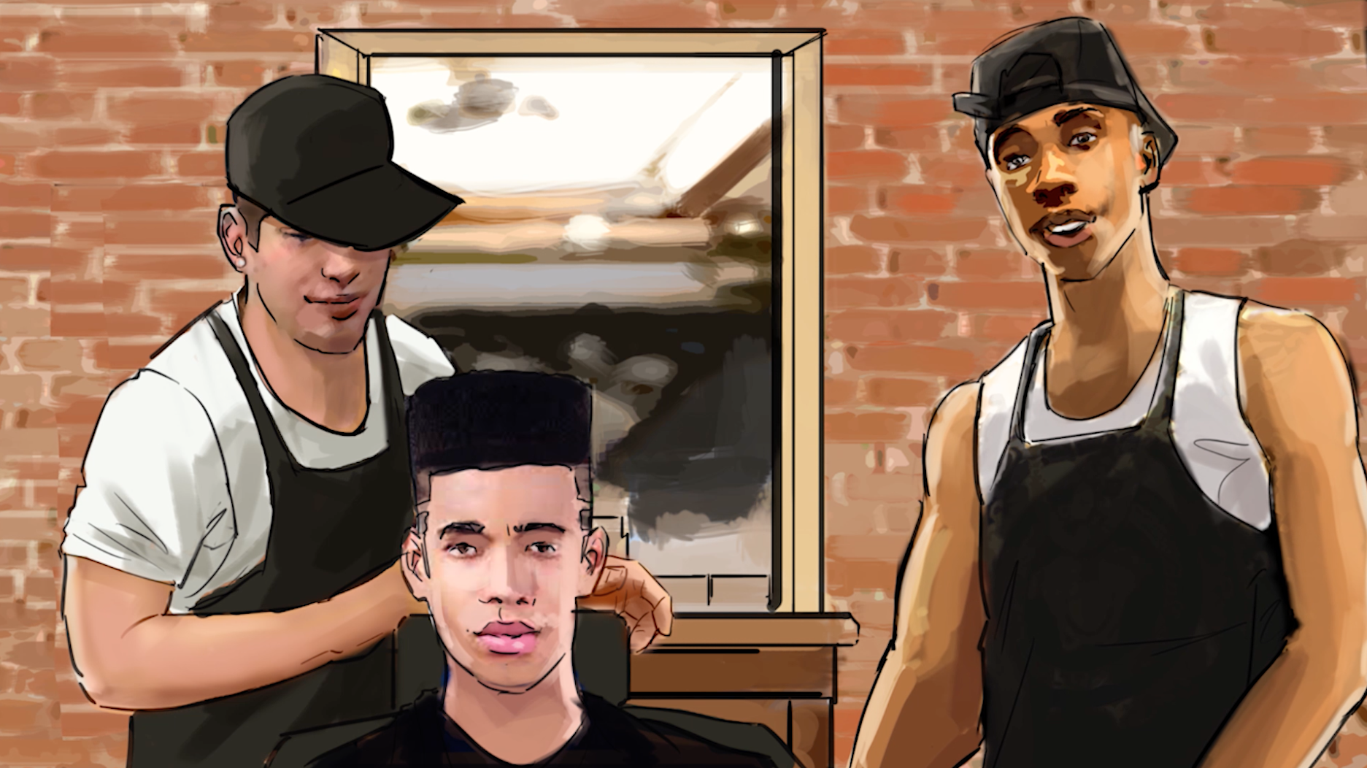

Script:
Inside of a busy urban barbershop. The pace is quick. An African American male young adult barber is showing off different elements of the shop. There are also other barbers of different ethnicities. Intentionally, the ad looks like it could be an ad for a really cool barbershop to get youth’s attention.

VISUAL: Inside of a busy urban barbershop. The pace is quick. An African American male young adult barber is showing off different elements of the shop. There are also other barbers of different ethnicities. Intentionally, the ad looks like it could be an ad for a really cool barbershop to get youth’s attention.

YOUNG BARBER VOICE OVER:
Out here at the freshest shop in the city. We hook it up.
VISUAL: Rapid shots of haircuts and barbers posing together.
YOUNG BARBER VOICE OVER:
High tops...

VISUAL: African American patron getting a “fade” haircut by a barber.
YOUNG BARBER VOICE OVER:
Temp fades...

VISUAL: Hispanic patron getting his wavy hair brushed.
YOUNG BARBER VOICE OVER:
Shape-ups...

VISUAL: Barber positively acknowledges an African American patron with outrageous hair who is smiling. Patron’s teeth clearly show.
YOUNG BARBER VOICE OVER:
And whatever this guy has.

VISUAL: Barber looking into camera.
YOUNG BARBER VOICE OVER:
All of it.

VISUAL: Cuts through various haircuts:
Asian patron with a nice clean cut.
Caucasian patron with a nice clean cut.
YOUNG BARBER VOICE OVER:
But no matter how fresh your cut is, tobacco can ruin it. Like losing your teeth or making your breath smell like an ashtray.

YOUNG BARBER VOICE OVER:
Real talk. Smoking cigs will mess with your look.

VISUAL: As the barber is talking to the camera, you see a patron about to walk out. He sprays some sort of hair spray.
YOUNG BARBER VOICE OVER:
So I guarantee you’ll leave here looking and SMELLING fresh.

VISUAL: The patron is listening to the barber as he walks out, but before he leaves he is greeted by an attractive female outside, he nods in agreement to what the barber just said. The barber is still talking to the camera.
YOUNG BARBER VOICE OVER:
Whether or not you KEEP it fresh, is up to you.

VISUAL: ENDCARD WITH LOGO LOCKUP
YOUNG BARBER VOICE OVER:
Keep it fresh. Live tobacco-free.
Video Ad #2

Screenshot:

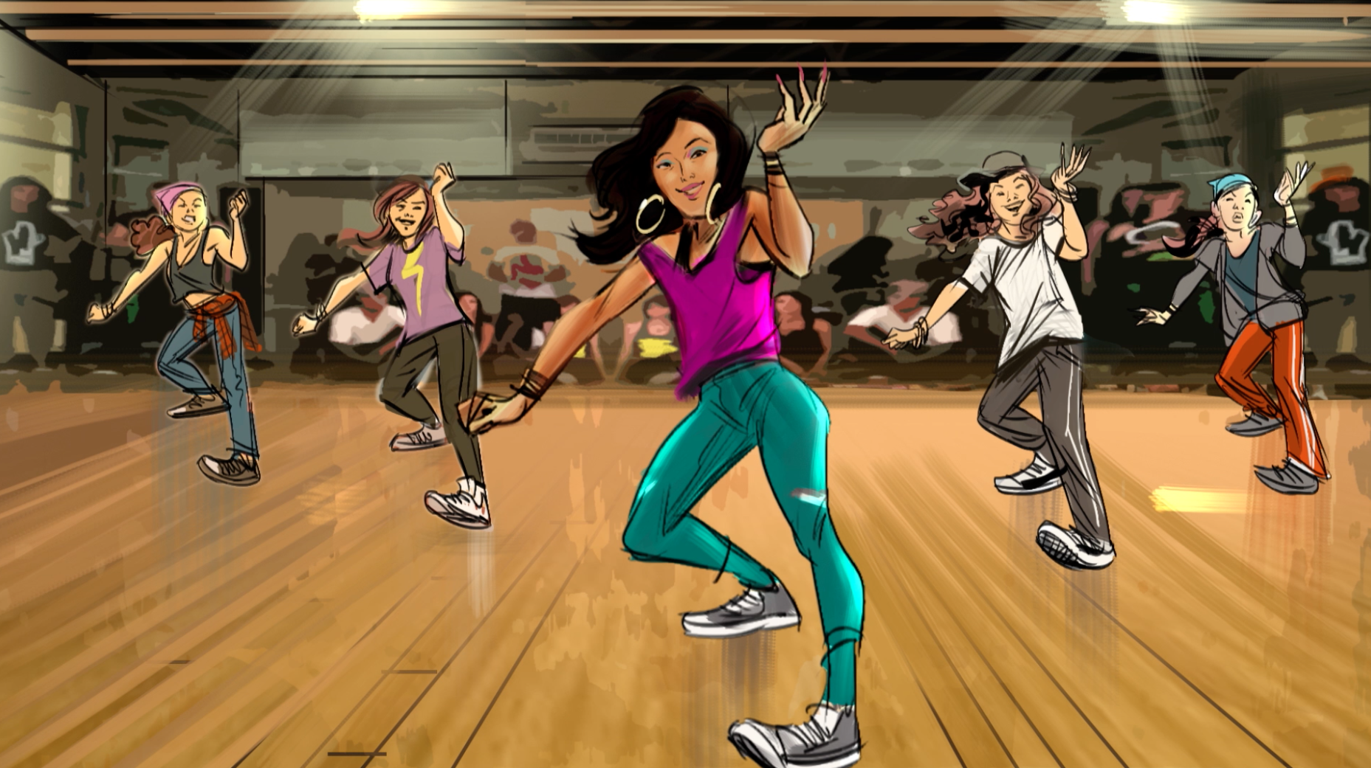

Script:
This execution features a Hispanic teen who describes how her parents worked hard to build up their successful business. As she walks out of the bakery and onto the dance floor, she explains that she lives tobacco-free so that she can give her all to being a successful hip-hop dancer, the same way her parents gave their all to achieve their success.

VISUAL: Hispanic female teen is in the back office of a business. You don’t yet know what kind of business it is. As she starts to talk, she gets up, grabs her backpack and puts her jacket on.
TEEN VOICE OVER:
When my parents first left home, they didn’t have much.

VISUAL: She walks out of the back office, you realize the business is a nice bakery. She walks toward the front door as she talks.
TEEN VOICE OVER:
So they made their own way and built their own shop.

VISUAL: The shot continues as she leaves the bakery, waving goodbye to her mother working.
TEEN VOICE OVER:
You have to respect that.

VISUAL: The shot continues as she walks out the front door of the bakery. But instead of opening up into the street, it is the entrance to the dance studio.
TEEN VOICE OVER
I guess you can say I got their drive.
SFX: (In background) 5 - 6 - 7 – 8

VISUAL: VO begins and she starts to dance a routine with friends.
TEEN VOICE OVER:
Day in and day out I put my mind and body into my own thing.

VISUAL: FACT ON SCREEN:
Smoking cigarettes can damage nearly every part of your body (USDHHS Consumer Booklet 2010, p. 2-3).
TEEN VOICE OVER:
So I live tobacco-free because it’s a fact that smoking cigarettes can damage nearly every part of your body (USDHHS Consumer Booklet 2010, p. 2-3).

VISUAL: Her friends successfully perform a complex routine.
TEEN VOICE OVER:
Nah I need to get 100% out of this body to get where I’m going.

VISUAL: ENDCARD WITH LOGO LOCKUP
TEEN VOICE OVER:
I keep it fresh, I live tobacco-free.

Video Ad #3

Screenshot:

Script:
This execution couples a bold script with subtly abstract imagery to encourage the target demographic to empower themselves through self-expression. Tobacco use is framed as something that quells their voices, as it takes the lives of 1,300 Americans every day (USDHHS, 2014).

SFX: MUSIC THROUGHOUT ENTIRE SPOT

VISUAL: An Asian male teen against a brick wall.
Text on screen: HE

VISUAL: A Hispanic male teen popping his collar in an urban setting.
Text on screen: HE

VISUAL: An Asian female teen stands facing the camera wearing a Hip Hop outfit
Text on screen: HER

VISUAL: A Hispanic female teen stands wearing a Hip Hop outfit
Text on screen: HER

VISUAL: Back/Up shot of a crowd of people going up dual escalators
Text on screen: HERD?

VISUAL: Text on screen: NO

VISUAL: Shot of an African American female teen’s profile as she shouts.
Text on screen: HEARD

VISUAL: FRESH EMPIRE green liquid vibrates/splashes on a horizontal subwoofer
Text on screen: HEARD

VISUAL: A stereo explodes into pieces
Text on screen: NEVER SILENCED

VISUAL: Ambiguous smoke blows across a black background from the side of the screen
Text on screen: BY CIGARETTES

VISUAL: Black and gold skull in front of a black background
Text on screen: CIGARETTES KILL MORE THAN 1,300 PEOPLE EVERY DAY (USDHHS 2014).

VISUAL: An African American male teen performing Hip Hop rap/dance
Text on screen: MORE THAN 1,300 PEOPLE THAT WON’T BE HEARD

VISUAL: Close up of an African American male teen
Text on screen: IF HE IS YOU
TEEN VOICE OVER:
IF HE IS YOU

VISUAL: Close up of a Hispanic female teen
Text on screen: IF YOU ARE HER
TEEN VOICE OVER:
IF YOU ARE HER

VISUAL: Wide shot of teens together representing multiple races/ethnicities.
TEEN VOICE OVER:
KEEP YOUR LIFE

VISUAL: Text on screen: KEEP YOUR LIFE

VISUAL: Close up of a Hispanic male teen
Text on screen: YOUR VOICE, TOBACCO-FREE.
TEEN VOICE OVER:
YOUR VOICE, TOBACCO-FREE.

VISUAL: Stereo exploding into pieces.
Text on screen: SPEAK UP AND BE HEARD

TEEN VOICE OVER:
SPEAK UP AND BE HEARD

VISUAL: ENDCARD WITH LOGO LOCKUP
ANNOUNCER VOICE OVER:
KEEP IT FRESH. LIVE TOBACCO-FREE.

Video Ad #4

Screenshot:

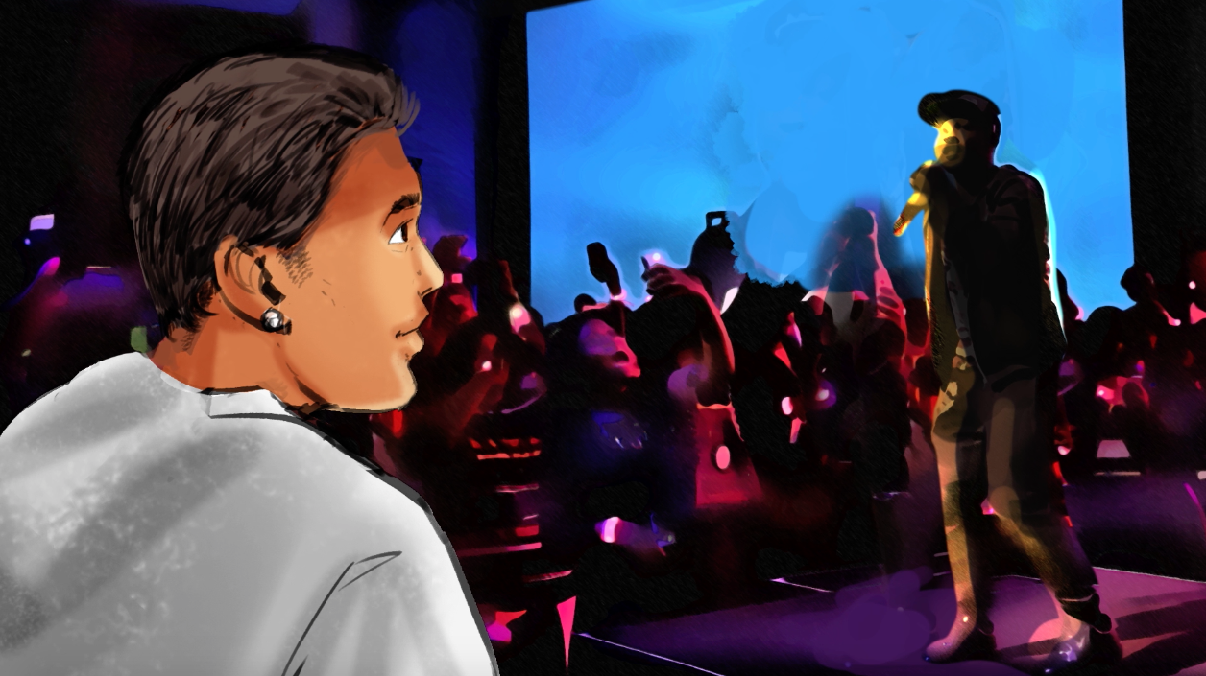

Script:
This execution follows a Hispanic teen who describes how his father worked hard to move his family forward, and now it is his turn to do the same. Words and images on the screen depict his story as he explains why he stays tobacco-free so he can keep moving forward.

VISUAL: A Hispanic male teen gets ready to go out.
TEEN VOICE OVER:
When my family came here I was just 5.

VISUAL: He waves goodbye to his father.
TEEN VOICE OVER:
My pops has always been trying to make life better for us.

VISUAL: He starts to walk and we see a close-up of his phone as he writes lyrics on a notepad app.
TEEN VOICE OVER:
When I started spittin’ with a few friends, I saw that as MY chance to keep it moving. Forward.

VISUAL: He continues walking, rapping to himself like he is rehearsing.
TEEN VOICE OVER:
And knowing there’s only a few MC’s like me, won’t stop me. I’ve come too far.

VISUAL: He arrives to a venue.
TEEN VOICE OVER:
My pops was always looking out for US...

VISUAL: He enters the backstage area and greets a few friends.
TEEN VOICE OVER:
Now it’s MY turn. That’s why I stay tobacco-free.

VISUAL: FACT ON SCREEN: Every cigarette can damage your body (USDHHS Fact Sheet 2010).
TEEN VOICE OVER:
‘Cause you’re not moving forward...when every pack is pulling you back.

VISUAL: He steps on stage and begins rapping.

VISUAL: ENDCARD WITH LOGO LOCKUP
ANNOUNCER VOICE OVER:
Keep it Fresh. Live Tobacco-Free.

