Multicultural Campaign: Wave 3 Online Quantitative Study of Reactions to Rough-Cut Advertising Designed to Prevent Multicultural Youth Tobacco Use
Screener

DEMOGRAPHICS AND TOBACCO USE

A1. How old are you?
- 12 years old or younger
- 13 years old
- 14 years old
- 15 years old
- 16 years old
- 17 years old
- 18 years old or older

[Tobacco use and openness to tobacco use questions will be grouped into sets by tobacco product. The order of the tobacco product sets will be randomized by participant.]

[Set 1, page 1: Cigarettes]

A2. Have you ever tried cigarette smoking, even one or two puffs?
- Yes [CONTINUE TO A3]
- No [SKIP TO A4]

[Set 1, page 2a: Cigarettes]

A3. About how many cigarettes have you smoked in your entire life? Your best guess is fine.
- I have never smoked cigarettes, not even one or two puffs
- 1 or more puffs but never a whole cigarette
- 1 cigarette
- 2 to 5 cigarettes
- 6 to 15 cigarettes (about 1/2 pack total)
- 16 to 25 cigarettes (about 1 pack total)
- 26 to 99 cigarettes (more than 1 pack, but less than 5 packs)
- 100 or more cigarettes (5 or more packs)

[CONTINUE TO NEXT RANDOMIZED TOBACCO PRODUCT SET]

[Set 1, page 2b: Cigarettes]

[RANDOMIZE ORDER]

A4. Do you think you will smoke a cigarette in the next year?
- Definitely yes
- Probably yes
- Probably not
- Definitely not

A5. Do you think you will try a cigarette soon?
- Definitely yes
- Probably yes
- Probably not
- Definitely not

[CONTINUE TO NEXT RANDOMIZED TOBACCO PRODUCT SET]

[Set 2, page 1: Cigar products]

A6. Have you ever tried smoking cigars, cigarillos, or little cigars, such as Black and Milds, Swisher Sweets, Dutch Masters, White Owl, or Phillies Blunts, even one or two puffs?
- Yes [SKIP TO NEXT RANDOMIZED TOBACCO PRODUCT SET]
- No [CONTINUE TO A7]

[Set 2, page 2: Cigar products]

[RANDOMIZE ORDER]

A7. Do you think you will smoke a cigar, cigarillo, or little cigar, such as Black and Milds, Swisher Sweets, Dutch Masters, White Owl, or Phillies Blunts, in the next year?
- Definitely yes
- Probably yes
- Probably not
- Definitely not

A8. Do you think you will try a cigar, cigarillo, or little cigar, such as Black and Milds, Swisher Sweets, Dutch Masters, White Owl, or Phillies Blunts, soon?
- Definitely yes
- Probably yes
- Probably not
- Definitely not

[CONTINUE TO NEXT RANDOMIZED TOBACCO PRODUCT SET]

[Set 3, page 1: Hookah]

A9. Have you ever tried smoking tobacco in a hookah or waterpipe, even one or two puffs?
- Yes [SKIP TO NEXT RANDOMIZED TOBACCO PRODUCT SET]
- No [CONTINUE TO A10]

[Set 3, page 2: Hookah]

[RANDOMIZE ORDER]

A10. Do you think you will smoke tobacco in a hookah or waterpipe in the next year?
- Definitely yes
- Probably yes
- Probably not
- Definitely not

A11. Do you think you will try smoking tobacco in a hookah or waterpipe soon?
- Definitely yes
- Probably yes
- Probably not
- Definitely not

[CONTINUE TO NEXT RANDOMIZED TOBACCO PRODUCT SET]

[Set 4, page 1: E-Cigarettes]

A12. Have you ever tried smoking electronic cigarettes, e-cigarettes, vape pens, or hookah pens, such as Fin, NJOY, JUUL, Blu, e-Go, or Vuse, even one or two puffs?
- Yes [SKIP TO NEXT RANDOMIZED TOBACCO PRODUCT SET]
- No [CONTINUE TO A13]

[Set 4, page 2: E-Cigarettes]

[RANDOMIZE ORDER]

A13. Do you think you will smoke an electronic cigarette, e-cigarette, vape pen, or hookah pen, such as Fin, NJOY, JUUL, Blu, e-Go, or Vuse, in the next year?
- Definitely yes
- Probably yes
- Probably not
- Definitely not

A14. Do you think you will try an electronic cigarette, e-cigarette, vape pen, or hookah pen, such as Fin, NJOY, JUUL, Blu, e-Go, or Vuse, soon?
- Definitely yes
- Probably yes
- Probably not
- Definitely not

[Each of the following items will be presented on a separate page, separated by a “NEXT” button.]

A15. What is your sex?
- Female
- Male

A16. What is the 5-digit zip code where you CURRENTLY live?
___ ___ ___ ___ ___

A17. Are you of Hispanic, Latino/a, or Spanish origin? (You can choose one answer or more than one answer)
- No, not of Hispanic, Latino/a, or Spanish origin
- Yes, Mexican, Mexican American, Chicano or Chicana
- Yes, Puerto Rican
- Yes, Cuban
- Yes, another Hispanic, Latino/a, or Spanish origin

A18. What race or races do you consider yourself to be? (You can choose one answer or more than one answer)
- American Indian or Alaska Native
- Asian
- Black or African American
- Native Hawaiian or Other Pacific Islander
- White
- Other

MARKETING AND RESEARCH

B1. Do you or any member of your immediate family or a close friend work for...? (Select all that apply)
- A market research company
- A tobacco company (manufacturer or importer of tobacco products)
- An advertising agency or public relations firm
- The media (TV/radio/newspapers/magazines)
- A healthcare professional (doctor, nurse, pharmacist, dietician, etc.)
- None of these

B2. Have you ever received money or gift cards from a company for sharing your opinions about tobacco in a discussion group, interview or survey?
- Yes, within the past 6 months
- Yes, more than 6 months ago
- No
- I’m not sure

PICTURE SELECTION EXERCISE

B3. Rank the 3 people that would BEST FIT in your main group of friends by clicking on the pictures. The first picture you select by clicking on it will be the best fit overall.

B4. Rank the 3 people that would LEAST FIT in your main group of friends by clicking on the pictures. The first picture you select by clicking on it will be the least fit overall.
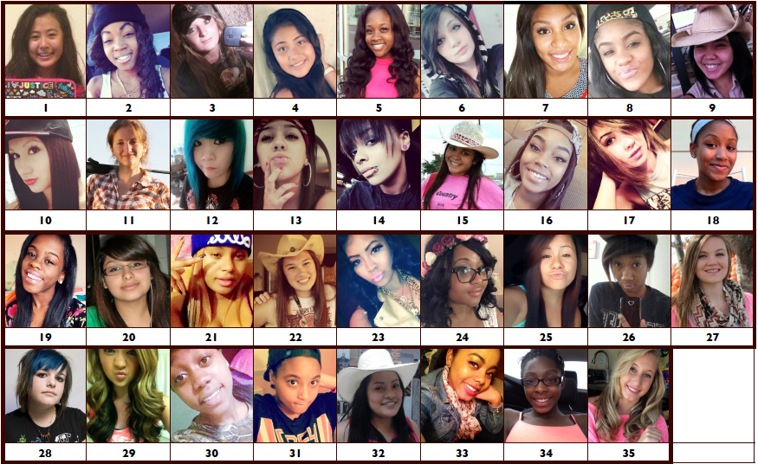

B5. Rank the 3 people that would BEST FIT in your main group of friends by clicking on the pictures. The first picture you select by clicking on it will be the best fit overall.

B6. Rank the 3 people that would LEAST FIT in your main group of friends by clicking on the pictures. The first picture you select by clicking on it will be the least fit overall.
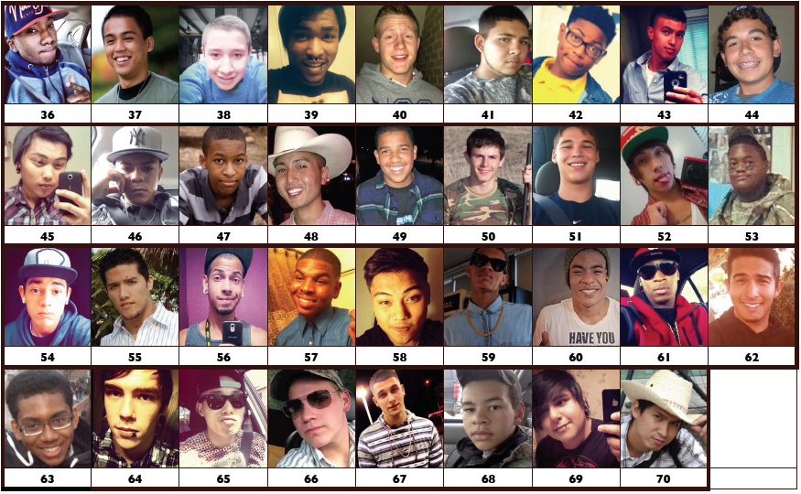

EMAIL ADDRESS

C1. What is your email address? (to receive the main survey link): ______________
Please confirm the email address above: ___________

[IF EMAILS PROVIDED IN C1 DO NOT MATCH, PROVIDE ERROR MESSAGE]

[SCREEN OUT DISQUALIFYING YOUTH BEFORE PROCEEDING TO NEXT PAGE.]

[IF A1 = A OR G, DISQUALIFY]
[IF A2 = B AND A4 = D AND A5 = D AND A6 = B AND A7 = D AND A8 = D AND A9 = B AND A10 = D AND A11 = D, DISQUALIFY]
[IF A16 IS NOT ZIP CODE WITHIN 48 CONTIGUOUS STATES OR DC, DISQUALIFY]
[IF B1 = B, DISQUALIFY]
[IF B2 = A, DISQUALIFY]
[IF HIP HOP I-BASE SCORE < 4, DISQUALIFY]
[IF C1 MATCHES EMAIL ADDRESS ALREADY IN DATASET, DISQUALIFY]

[ELSE, QUALIFY]

[TEXT PRESENTED TO DISQUALIFIED PARTICIPANTS]: “Thank you for answering our questions! Unfortunately, you will not be invited to take part in the full survey.

Please note that you can only submit this survey once.

Form Approved
OMB No. 0910-0810
Exp. Date 11/30/2018
RIHSC #17-093CTP

Paperwork Reduction Act Statement: The public reporting burden for this information collection has been estimated to average 7 minutes per response to complete this screener (the time estimated to read and complete). Send comments regarding this burden estimate or any other aspects of this information collection, including suggestions for reducing burden, to PRAStaff@fda.hhs.gov.”

[TEXT PRESENTED TO QUALIFIED PARTICIPANTS]: “Congrats! You qualify to complete the full survey! We just need a little more info so we can send you the link tomorrow. After you finish the full survey, you’ll receive a $10 gift card at the email address you provided!

CONTACT INFO PAGE
D1. If you would also like to receive the survey link by text message, please provide a phone number that we can text the link to.

- Cell Phone Number: (__) ___ - ____
- I do not have a cell phone number

[ANSWER REQUIRED TO PROCEED]

D2. Just one last thing. Before we can send you the full survey, we need to email a copy of our Opt-Out Form to your parent or guardian. This form explains what you will be doing, and provides them with a way to contact us only if they do NOT want you to complete the survey.

Parent or guardian’s email address: ___________________
Please confirm parent or guardian’s email address: ___________

[IF EMAILS PROVIDED IN D2 DO NOT MATCH, PROVIDE ERROR MESSAGE]

As a reminder, we will not share your answers with anyone outside the study, including your parents.

[TEXT PRESENTED TO QUALIFIED PARTICIPANTS]: “Thank you! We will also email you the link to the full survey in about 24 hours – I know it seems like a long time, but we are good for it -- after you submit the full survey, you will get your $10 gift card! Don’t forget to check your SPAM tomorrow, just in case.

Please note that you can only submit this survey once and receive one gift card. Fraudulent or duplicate surveys will not be eligible to receive a gift card.

Form Approved
OMB No. 0910-0810
Exp. Date 11/30/2018
RIHSC #17-093CTP

Paperwork Reduction Act Statement: The public reporting burden for this information collection has been estimated to average 7 minutes per response to complete this screener (the time estimated to read and complete). Send comments regarding this burden estimate or any other aspects of this information collection, including suggestions for reducing burden, to PRAStaff@fda.hhs.gov.”

