**The Real Cost Campaign: Online Quantitative Study of Reactions to Rough-Cut Advertising Designed to Prevent Youth Tobacco Use**

***Stimuli***

**Infected/Health Threat**

**Key Frame**



**Script**

VO: There’s a health threat spreading.

VO: Scientists say it can change your brain.

VO: It can release dangerous chemicals, like formaldehyde, into your bloodstream…

VO: …and acrolein into your lungs, which can cause irreversible damage.

VO: It’s not a parasite. Not a virus. Not an infection.

VO: It’s vaping.

VO: Know the Real Cost of vaping.

**Hacked**

**Key Frame**

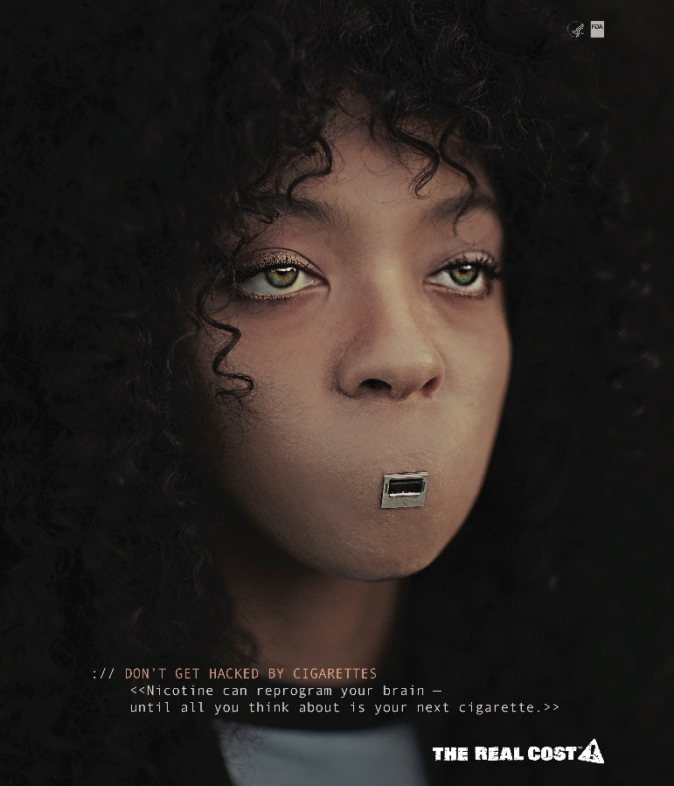

**Script**

VO: Vaping can deliver nicotine to your brain

VO: Reprogramming you to crave more and more

VO: Don’t get hacked

**The Real Cost Smokeless Campaign: Creative Concepts Designed to Prevent Smokeless Tobacco Use Among Rural Youth.**

*Creative Concept Stimuli*

1. Addiction is Tougher
2. Travis Cup
3. The Other Tooth Fairy
4. Tools of Mouth Cancer

**CREATIVE CONCEPT #1: Addiction is Tougher**

**Key Frame**

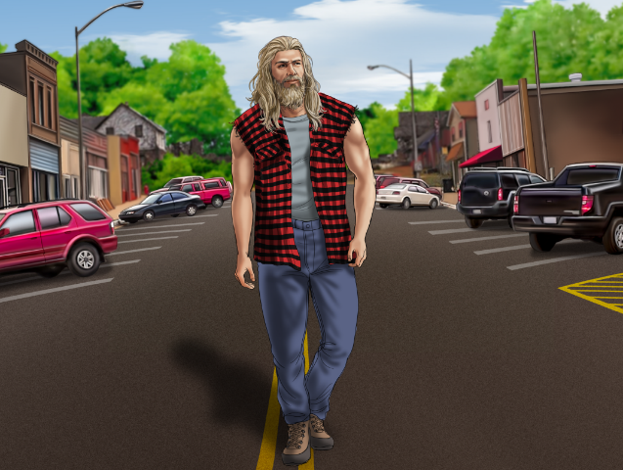

**Concept Overview**

This concept follows “Big Tim Timberfist,” a strong and tough character, through a series of outlandish vignettes that highlight his ruggedness, culminating with a vignette that demonstrates how an addiction to dip can be tougher than even Big Tim. A singing narrator will walk the viewer through the events being shown on screen.

**Concept Script**

NARRATOR: This commercial tells the story of Big Tim Timberfist — a massive mountain of a man, strong and tough. First we see him stride through the town with an intimidating swagger. A country singer playing guitar stands by the side of the road and sings big Tim’s theme song.

SINGER: **Well, gather round you people. Let me tell you this**

**About the man, the myth, the legend of Big Tim Timberfist**

NARRATOR: We see a close up of a sign being posted to a tree in the woods. The sign says, “WARNING: BIG TIM TIMBERFIST TERRITORY” and shows an artist’s rendering of Big Tim. We pull back and see it’s a grizzly bear hanging the sign.

SINGER: **He had the meanest demeanor and the strength to match it**

**He was tougher than a rhino in a biker jacket**

NARRATOR: Then, we see the drawing of Big Tim on the sign crossfade into Big Tim himself. We see Big Tim Timberfist using the blade of a big hunting knife as a mirror as he trims his beard with a chainsaw, one-handed.

SINGER: **Well, he always did things his way. Never gave a damn**

35

**He didn’t answer to no one. He was his own man.**

VISUAL: BIG TIM TAKING A SHOWER IN A FREEZING WATERFALL. HE USES A PORCUPINE AS A SPONGE.

SINGER: **The ultimate tough guy – to cross him was frightening**

NARRATOR: Now Big Tim is standing on top of a barn, holding a knife and fork. He tucks a napkin into his shirt collar, tilts his head to the sky and opens his mouth.

SINGER: **He ate tree bark for breakfast for lunch he ate lightning**

NARRATOR: Suddenly, lightning strikes Big Tim’s open mouth. He devours it hungrily.

NARRATOR: We jump to see Big Tim wrestling a pair of bears in the woods. He seems completely in control, as he has them both in a headlock

SINGER: **He was hair as a bear. All his shirts were sleeveless.   
But despite all his machismo, he had one weakness**

NARRATOR: We see Big Tim frantically searching for something in his truck. He appears nervous and in a panic. He finally finds what he’s looking for — his can of dip. He opens it and discovers it’s empty. He starts whimpering.

SINGER: **His dark little secret. His awful affliction**

**He had no control over his dip addiction**

NARRATOR: We see a convenience store. A giant shadow is cast over the clerk. He looks up, in awe as he sees Big Tim standing before him. But Big Tim appears forlorn.

SINGER: **That dip addiction has him, it’s plain to see**

**It won’t let him go – it won’t let him free**

NARRATOR: Big Tim points to a can of dip on the wall behind the counter. He looks defeated. The country singer enters to sing a final chorus.

SINGER: **He was a dip-dip-dip-dip-dip-dip-dip-dip dippin’ that dip**

**Now he’s a- d-d-d-d-d-d-d-d-dicted to it**

NARRATOR: The singer strums the final chord and gives Big Tim a sad, sympathetic look.

VO: **Dip contains nicotine, which is highly addictive. Even if you’re tough, addiction may be tougher.**

THE REAL COST LOGO APPEARS

VO: **Smokeless doesn’t mean harmless.**

**CREATIVE CONCEPT #3: Travis Cup**

**Key Frame**

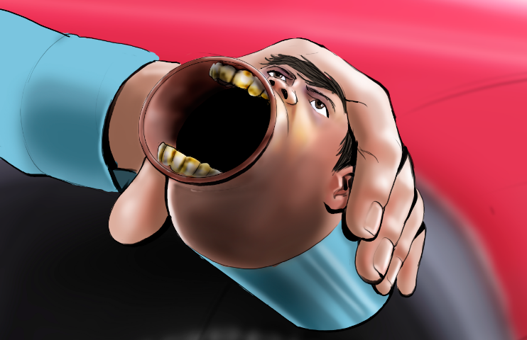

**Concept Overview**

This concept shows a teen boy who is dipping, and spits into what we reveal to be a spit jug that looks like his own face. Bizarrely, he then has a conversation with his doppelganger spit jug about the harms of dip and the chemicals in it.

**Concept Script**

NARRATOR: This commercial shows a teenage boy, Travis, hanging out by his pickup. He has a dip in his mouth.

NARRATOR: He spits. He jumps when he hears his own voice.

VOICE: (gagging) **Really, man?!**

NARRATOR: Travis looks down and sees the voice is coming from the cup he’s holding – which is a cup-size version of his own face.

TRAVIS CUP: **You just spit in our mouth.**

TRAVIS: **What the –**

TRAVIS CUP: **Yeah. Thanks for that. Keep it up – maybe we can get some gross gum disease, lose a tooth or even get mouth cancer.**

TRAVIS: **But when I spit, all the bad stuff gets out, right?**

TRAVIS CUP: **Doesn’t work that way. Some of it gets absorbed. So those chemicals, now they’re in us. Spit all you want, it’s still not safe.**

NARRATOR: Travis looks at his face cup, unsure of what to do. The cup meets his gaze.

TRAVIS CUP: **We have pretty eyes.**

VO: No matter how much you spit, up to 30 cancer-causing chemicals may find their way into your body.

THE REAL COST LOGO APPEARS

VO: Smokeless doesn’t mean harmless.

**CREATIVE CONCEPT #4: The Other Tooth Fairy**

**Key Frame**

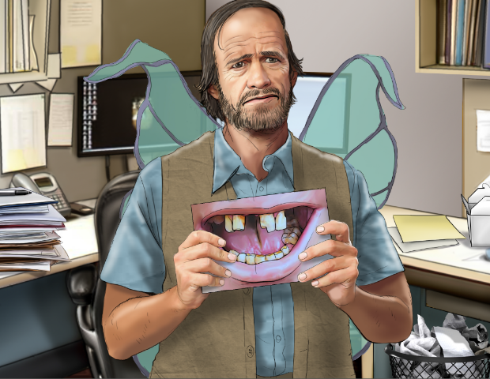

**Concept Overview**

This concept depicts a day in the life of the “other tooth fairy,” the disheveled fairy whose unpleasant job it is to collect teeth dip users lose to gum disease.

**Concept Script**

NARRATOR: This commercial starts with a middle-aged man dressed in a worn-down fairy outfit, talking to camera. He is sitting in an office cubicle being interviewed.

OTHER TOOTH FAIRY: **You probably know my colleague. She comes for your baby teeth.**

NARRATOR: We see him glance over to a shiny, all-white corner office. It’s the office of the real tooth fairy. We see her giggling with joy and throwing sparkly glitter around with her magic wand.

OTHER TOOTH FAIRY: **She’s got a sweet gig.**

OTHER TOOTH FAIRY: **I’m the Other Tooth Fairy. The guy you don’t want to see. I come to collect teeth that fall out because of gum disease.**

NARRATOR: He holds up a picture of rotten teeth.

OTHER TOOTH FAIRY: **Nobody puts these under their pillow. I gotta yank ’em right outta their mouth.**

NARRATOR: We see him getting coffee at a run-down gas station and fuels up his worn down car.

OTHER TOOTH FAIRY: **This is what keeps me in business.** (Holds up a can of dip.) **Dip can cause gum disease, yet these kids keep on chewing.**

NARRATOR: Now we see him out in the town, doing his job. He is walking up to a teen examining his diseased gums in the mirror. He reaches into the kid’s mouth.

OTHER TOOTH FAIRY: **Hold still, son, I don’t like this any more than you do.**

NARRATOR: He pulls out the tooth with his bare hands. The tooth comes out pretty easily.

NARRATOR: He offers a buck to the kid, who reaches out to take it, but he yanks it away.

OTHER TOOTH FAIRY: **C’mon.**

NARRATOR: He returns to his car.

OTHER TOOTH FAIRY: **Another day, another tooth... they think brushing their teeth can save them from this.**

NARRATOR: Now we see him back at the office of the tooth fairies. The regular tooth fairy is dusting her collection of cute pearly-white baby teeth.

NARRATOR: Meanwhile, the Other Tooth Fairy places his freshly collected tooth into an envelope and then into an old cabinet.

NARRATOR: He makes a face at the regular tooth fairy when she turns her back.

OTHER TOOTH FAIRY: **Another great day at the office.**

**SUPER: Dip can cause painful gum disease and tooth loss.**

**SUPER: Know The Real Cost of Dip.**

***CREATIVE CONCEPT #5: Tools of Mouth Cancer***

**Key Frame**

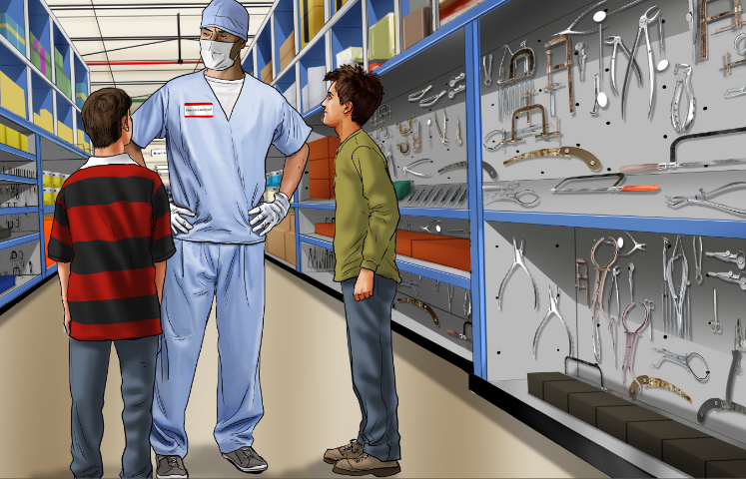

**Concept Overview**

This concept illustrates the unpleasant but very real details of mouth cancer surgery, specifically the type and number of tools involved in performing a mandibulectomy.

**Concept Script**

SUPER: **SMOKELESS TOBACCO CAN CAUSE MOUTH CANCER, WHICH CAN REQUIRE THE REMOVAL OF YOUR JAW.**

NARRATOR: An empty aisle in a hardware store is restocked with scary-looking medical instruments and tools. A sign that says “FOR DIPPERS ONLY” is hung above the aisle.

SUPER: **A GRUELING OPERATION INVOLVING UP TO 87 TOOLS. WE PUT THEM ALL HERE...IN THE TOOL AISLE.**

NARRATOR: A group of teens walk up and read the aisle sign. Curious, they walk in.

NARRATOR: They see a man wearing a surgeon’s outfit and a hardware store nametag.

The surgeon says, **“Can I help you?”**

One of the teens looks around at all of the scary-looking tools and says, **“Um, what are these for?”**

The surgeon says, **“These? This is what I use on patients that get mouth cancer from dipping.”**

The teen says, **“Mouth cancer?”**

The surgeon says, **“Yep, dip contains up to 30 cancer-causing chemicals. Do you want to know more about the process?”**

We see the surgeon explaining the procedure in detail to the terrified teens. He says things like “**I use this screw to hold down your jaw,**” “**this is a new bone plate,**” and “**this is the feeding tube that will feed you for the first two weeks.**”

NARRATOR: The teens are shocked and terrified. Some of them even walk away, not wanting to hear any more.

The surgeon says, “**What, you’re not the do-it-yourself type?**”