The Real Cost Campaign: Online Quantitative Study of Reactions to Rough-Cut Advertising Designed to Prevent Youth Tobacco Use
Stimuli

Infected/Health Threat

Key Frame

Script

VO: There’s a health threat spreading.
VO: Scientists say it can change your brain.
VO: It can release dangerous chemicals, like formaldehyde, into your bloodstream…
VO: …and acrolein into your lungs, which can cause irreversible damage.
VO: It’s not a parasite. Not a virus. Not an infection.
VO: It’s vaping.
VO: Know the Real Cost of vaping.

Hacked

Key Frame

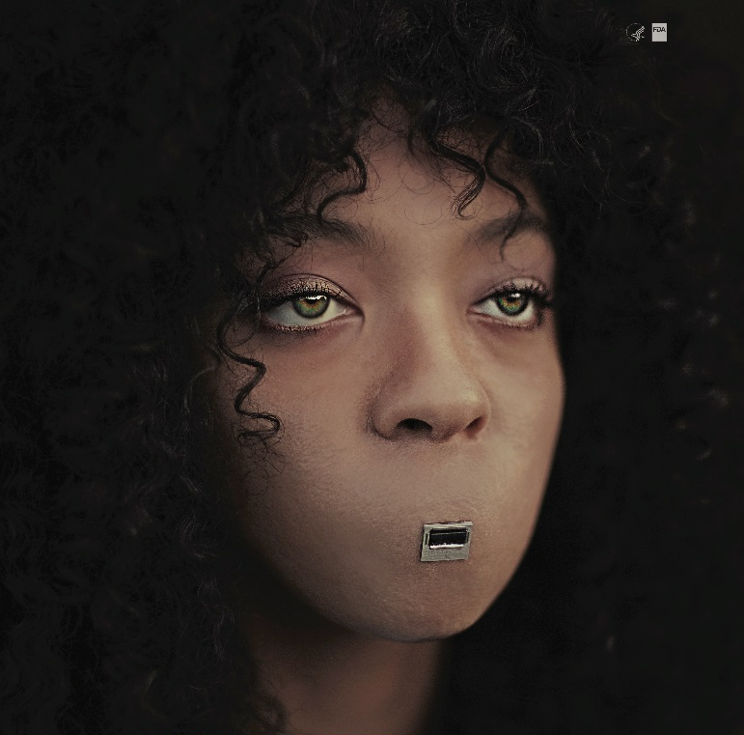

Script
VO: Vaping can deliver nicotine to your brain
VO: Reprogramming you to crave more and more
VO: Don’t get hacked

The Real Cost Smokeless Campaign: Creative Concepts Designed to Prevent Smokeless Tobacco Use Among Rural Youth.
Creative Concept Stimuli

- Addiction is Tougher
- Travis Cup
- The Other Tooth Fairy
- Tools of Mouth Cancer

CREATIVE CONCEPT #1: Addiction is Tougher

Key Frame

Concept Overview
This concept follows “Big Tim Timberfist,” a strong and tough character, through a series of outlandish vignettes that highlight his ruggedness, culminating with a vignette that demonstrates how an addiction to dip can be tougher than even Big Tim. A singing narrator will walk the viewer through the events being shown on screen.
Concept Script
NARRATOR: This commercial tells the story of Big Tim Timberfist — a massive mountain of a man, strong and tough. First we see him stride through the town with an intimidating swagger. A country singer playing guitar stands by the side of the road and sings big Tim’s theme song.
SINGER: Well, gather round you people. Let me tell you this
About the man, the myth, the legend of Big Tim Timberfist
NARRATOR: We see a close up of a sign being posted to a tree in the woods. The sign says, “WARNING: BIG TIM TIMBERFIST TERRITORY” and shows an artist’s rendering of Big Tim. We pull back and see it’s a grizzly bear hanging the sign.
SINGER: He had the meanest demeanor and the strength to match it
He was tougher than a rhino in a biker jacket
NARRATOR: Then, we see the drawing of Big Tim on the sign crossfade into Big Tim himself. We see Big Tim Timberfist using the blade of a big hunting knife as a mirror as he trims his beard with a chainsaw, one-handed.
SINGER: Well, he always did things his way. Never gave a damn
35
He didn’t answer to no one. He was his own man.
VISUAL: BIG TIM TAKING A SHOWER IN A FREEZING WATERFALL. HE USES A PORCUPINE AS A SPONGE.
SINGER: The ultimate tough guy – to cross him was frightening
NARRATOR: Now Big Tim is standing on top of a barn, holding a knife and fork. He tucks a napkin into his shirt collar, tilts his head to the sky and opens his mouth.
SINGER: He ate tree bark for breakfast for lunch he ate lightning
NARRATOR: Suddenly, lightning strikes Big Tim’s open mouth. He devours it hungrily.
NARRATOR: We jump to see Big Tim wrestling a pair of bears in the woods. He seems completely in control, as he has them both in a headlock
SINGER: He was hair as a bear. All his shirts were sleeveless.
But despite all his machismo, he had one weakness
NARRATOR: We see Big Tim frantically searching for something in his truck. He appears nervous and in a panic. He finally finds what he’s looking for — his can of dip. He opens it and discovers it’s empty. He starts whimpering.
SINGER: His dark little secret. His awful affliction
He had no control over his dip addiction
NARRATOR: We see a convenience store. A giant shadow is cast over the clerk. He looks up, in awe as he sees Big Tim standing before him. But Big Tim appears forlorn.
SINGER: That dip addiction has him, it’s plain to see
It won’t let him go – it won’t let him free
NARRATOR: Big Tim points to a can of dip on the wall behind the counter. He looks defeated. The country singer enters to sing a final chorus.
SINGER: He was a dip-dip-dip-dip-dip-dip-dip-dip dippin’ that dip
Now he’s a- d-d-d-d-d-d-d-d-dicted to it
NARRATOR: The singer strums the final chord and gives Big Tim a sad, sympathetic look.
VO: Dip contains nicotine, which is highly addictive. Even if you’re tough, addiction may be tougher.
THE REAL COST LOGO APPEARS
VO: Smokeless doesn’t mean harmless.

CREATIVE CONCEPT #3: Travis Cup

Key Frame

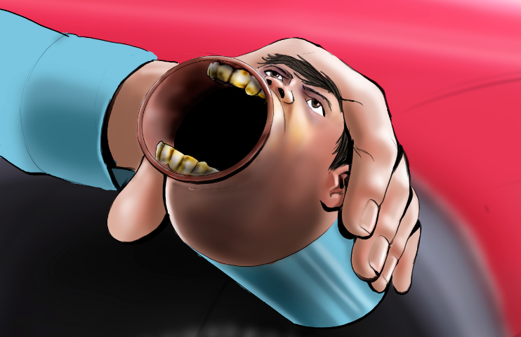

Concept Overview
This concept shows a teen boy who is dipping, and spits into what we reveal to be a spit jug that looks like his own face. Bizarrely, he then has a conversation with his doppelganger spit jug about the harms of dip and the chemicals in it.
Concept Script
NARRATOR: This commercial shows a teenage boy, Travis, hanging out by his pickup. He has a dip in his mouth.
NARRATOR: He spits. He jumps when he hears his own voice.
VOICE: (gagging) Really, man?!
NARRATOR: Travis looks down and sees the voice is coming from the cup he’s holding – which is a cup-size version of his own face.
TRAVIS CUP: You just spit in our mouth.
TRAVIS: What the –
TRAVIS CUP: Yeah. Thanks for that. Keep it up – maybe we can get some gross gum disease, lose a tooth or even get mouth cancer.
TRAVIS: But when I spit, all the bad stuff gets out, right?
TRAVIS CUP: Doesn’t work that way. Some of it gets absorbed. So those chemicals, now they’re in us. Spit all you want, it’s still not safe.
NARRATOR: Travis looks at his face cup, unsure of what to do. The cup meets his gaze.
TRAVIS CUP: We have pretty eyes.
VO: No matter how much you spit, up to 30 cancer-causing chemicals may find their way into your body.

THE REAL COST LOGO APPEARS
VO: Smokeless doesn’t mean harmless.

CREATIVE CONCEPT #4: The Other Tooth Fairy

Key Frame
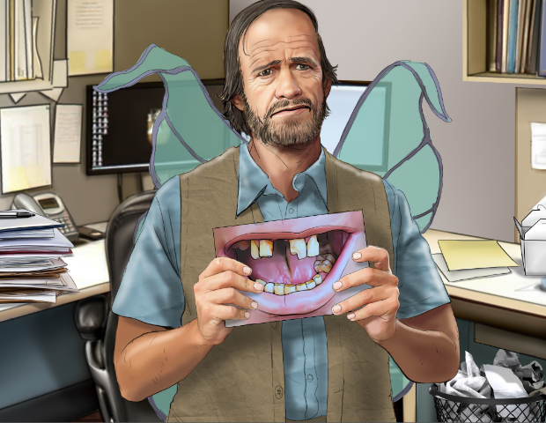

Concept Overview
This concept depicts a day in the life of the “other tooth fairy,” the disheveled fairy whose unpleasant job it is to collect teeth dip users lose to gum disease.
Concept Script

NARRATOR: This commercial starts with a middle-aged man dressed in a worn-down fairy outfit, talking to camera. He is sitting in an office cubicle being interviewed.
OTHER TOOTH FAIRY: You probably know my colleague. She comes for your baby teeth.
NARRATOR: We see him glance over to a shiny, all-white corner office. It’s the office of the real tooth fairy. We see her giggling with joy and throwing sparkly glitter around with her magic wand.
OTHER TOOTH FAIRY: She’s got a sweet gig.
OTHER TOOTH FAIRY: I’m the Other Tooth Fairy. The guy you don’t want to see. I come to collect teeth that fall out because of gum disease.
NARRATOR: He holds up a picture of rotten teeth.
OTHER TOOTH FAIRY: Nobody puts these under their pillow. I gotta yank ’em right outta their mouth.
NARRATOR: We see him getting coffee at a run-down gas station and fuels up his worn down car.
OTHER TOOTH FAIRY: This is what keeps me in business. (Holds up a can of dip.) Dip can cause gum disease, yet these kids keep on chewing.
NARRATOR: Now we see him out in the town, doing his job. He is walking up to a teen examining his diseased gums in the mirror. He reaches into the kid’s mouth.
OTHER TOOTH FAIRY: Hold still, son, I don’t like this any more than you do.
NARRATOR: He pulls out the tooth with his bare hands. The tooth comes out pretty easily.
NARRATOR: He offers a buck to the kid, who reaches out to take it, but he yanks it away.
OTHER TOOTH FAIRY: C’mon.
NARRATOR: He returns to his car.
OTHER TOOTH FAIRY: Another day, another tooth... they think brushing their teeth can save them from this.
NARRATOR: Now we see him back at the office of the tooth fairies. The regular tooth fairy is dusting her collection of cute pearly-white baby teeth.
NARRATOR: Meanwhile, the Other Tooth Fairy places his freshly collected tooth into an envelope and then into an old cabinet.
NARRATOR: He makes a face at the regular tooth fairy when she turns her back.
OTHER TOOTH FAIRY: Another great day at the office.
SUPER: Dip can cause painful gum disease and tooth loss.
SUPER: Know The Real Cost of Dip.

CREATIVE CONCEPT #5: Tools of Mouth Cancer
Key Frame

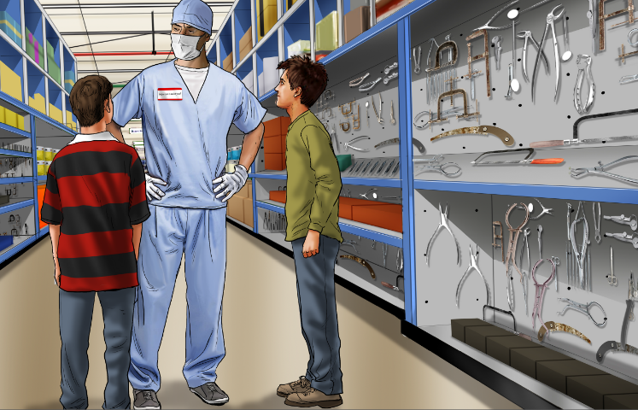

Concept Overview
This concept illustrates the unpleasant but very real details of mouth cancer surgery, specifically the type and number of tools involved in performing a mandibulectomy.
Concept Script
SUPER: SMOKELESS TOBACCO CAN CAUSE MOUTH CANCER, WHICH CAN REQUIRE THE REMOVAL OF YOUR JAW.

NARRATOR: An empty aisle in a hardware store is restocked with scary-looking medical instruments and tools. A sign that says “FOR DIPPERS ONLY” is hung above the aisle.

SUPER: A GRUELING OPERATION INVOLVING UP TO 87 TOOLS. WE PUT THEM ALL HERE...IN THE TOOL AISLE.

NARRATOR: A group of teens walk up and read the aisle sign. Curious, they walk in.

NARRATOR: They see a man wearing a surgeon’s outfit and a hardware store nametag.

The surgeon says, “Can I help you?”

One of the teens looks around at all of the scary-looking tools and says, “Um, what are these for?”

The surgeon says, “These? This is what I use on patients that get mouth cancer from dipping.”

The teen says, “Mouth cancer?”

The surgeon says, “Yep, dip contains up to 30 cancer-causing chemicals. Do you want to know more about the process?”

We see the surgeon explaining the procedure in detail to the terrified teens. He says things like “I use this screw to hold down your jaw,” “this is a new bone plate,” and “this is the feeding tube that will feed you for the first two weeks.”

NARRATOR: The teens are shocked and terrified. Some of them even walk away, not wanting to hear any more.

The surgeon says, “What, you’re not the do-it-yourself type?”

