ATTACHMENT 2: LGBT YOUNG ADULT FOLLOW-UP INSTRUMENT
Form Approved
OMB No. 0910-0808
Exp. Date 01/31/2019

Research and Evaluation Survey for the Public Education Campaign on Tobacco among Lesbian Gay Bisexual Transgender (LGBT) (RESPECT)

Programming conventions and specifications notes
- Abbreviations used include ‘R’ for ‘respondent’ and ‘PNTA’ for ‘prefer not to answer.’
- Prefer Not To Answer/Don’t Know/Refused/None of these are not allowed in combination with other responses.
- Variable names and section headings are not displayed on screen.
- Response options should not be labeled with numbers.
- A back button will not be offered to respondents.
- Bolding conveys emphasis while capital letters convey instructions for programmers or interviewers.
- Questionnaire will include a progress bar.
- All items are required.
- “Next” buttons will be displayed on every survey screen as appropriate.
- All images should be arranged in such a way that focus on usability and layout. Images should be aligned and of similar sizes as one another.

PROGRAMMER: Insert Longitudinal Screener Informed Consent (Attachment 14)

PROGRAMMER: Insert Longitudinal Screener (Attachment 13)

PROGRAMMER: Insert Cross-sectional Survey Informed Consent (Attachment 6a)

PROGRAMMER: Insert Longitudinal Survey Informed Consent (Attachment 6b)
_________________________________________________________________________
Y_video Please try to view this video to make sure you can see it.
PROGRAMMER: DISPLAY OCEAN VIDEO
ASK: All respondents
Y_video1 Are you able to view and hear this video?
1 Yes
2 No

PROGRAMMER: IF Y_video1=2, display this message: ‘Viewing and hearing the videos in this survey is important. Please turn up on the volume on your device. If you cannot view the video, try logging into the survey using a different computer or browser. If that doesn’t work, you will not be able to take the survey online.’ If the respondent answers ‘No’ the instrument should resume at this screen.
ASK: All respondents
_________________________________________________________________________

Section A: Demographic Items
A1. The first part of the survey asks you some general questions about yourself.
What is your date of birth?
Please Select: Month Year
PROGRAMMER: CALCULATE MINIMUM AGE. FOR EXAMPLE, IF MONTH IS CURRENT MONTH AND R CAN BE EITHER 17 OR 18 BASED ON DATE, CALCULATE 17. INCLUDE DROP DOWN MENUS FOR MONTH AND YEAR. THE RANGE OF YEARS SHOULD INCLUDE 1985 TO 2005.
ASK: All respondents
_________________________________________________________________________
ROUTE [IF MINIMUM AGE <18] Thank you for your responses. Based on your responses, you are not eligible to participate in the study.
NEXT
PROGRAMMER: EXIT INTERVIEW
ASK: Respondents whose month and year of birth could make them 17 years old.
_________________________________________________________________________
A2. [IF LONGITUDINAL (LC_W5 NE 1)]
Are you Hispanic, Latino/a, or of Spanish origin? Check all that apply.
PROGRAMMER: PROGRAM SO THAT RESPONDENTS CAN SELECT MORE THAN ONE RESPONSE ON 2-5
1 No, not of Hispanic, Latino/a, or Spanish origin
2 Yes, Mexican American, Chicano/a
3 Yes, Puerto Rican
4 Yes, Cuban
5 Yes, another Hispanic, Latino/a, or Spanish origin
9 Prefer not to answer

ASK: All new cohort respondents
_________________________________________________________________________
A3. [IF LONGITUDINAL (LC_W5 NE 1)]
What race or races do you consider yourself to be? You can choose one answer or more than one answer or you may skip this question.
PROGRAMMER: PREFER NOT TO ANSWER SHOULD NOT BE COMBINABLE WITH OTHER RESPONSE OPTIONS
1 American Indian or Alaska Native
2 Asian
3 Black or African American
4 Native Hawaiian or Other Pacific Islander
5 White
5 Other
9 Prefer not to answer
ASK: All new cohort respondents
_________________________________________________________________________
A4. Which best describes your current job or paid employment status?
1 Work full-time at least 35 hours per week
2 Work part-time 15 to 34 hours per week
3 Work part-time less than 15 hours per week
4 I don't currently work for pay
5 Don’t know
9 Prefer not to answer

ASK: All respondents
_________________________________________________________________________
A5. What is the highest grade or level of school you have completed?
1 Less than high school
2 Some high school, no diploma
3 GED
4 High school graduate—diploma
5 Some college but no degree
6 Associate degree—occupational/vocational
7 Associate degree—academic program
8 Bachelor’s degree (ex: BA, AB, BS)
9 Master’s degree (ex: MA, MS, MEng, Med, MSW)
10 Professional school degree (ex: MD, DDS, DVM, JD)
11 Doctorate degree (ex: PhD, EdD)
12 Don’t know
99 Prefer not to answer

ASK: All respondents
_________________________________________________________________________
A6. Are you currently enrolled in a degree program?
1 Yes
2 No
3 Don’t know
9 Prefer not to answer

ASK: All respondents
_________________________________________________________________________
A7. Which of the following categories best describes your total household income in the past 12 months?
This is the total income before taxes of all persons in your household combined. Please include money from jobs, relatives, pensions, dividends, interest, social security payments or retirement benefits, net income from business, farm or rent, and any other money received by household members.
1 Less than $10,000
2 $10,000 to $14,999
3 $15,000 to $24,999
4 $25,000 to $34,999
5 $35,000 to $49,999
6 $50,000 to $74,999
7 $75,000 to $99,999
8 $100,000 to $149,999
9 $150,000 to $199,999
10 $200,000 or more
11 Don’t know
99 Prefer not to answer

ASK: All respondents
_________________________________________________________________________

Section B: Tobacco Use Behavior
The next section asks about your experiences with tobacco products.
Cigarette Use
B1. Have you ever tried cigarette smoking, even one or two puffs?
1 Yes
2 No – GO TO B9
9 Prefer not to answer

ASK: All respondents
_________________________________________________________________________
B2. [IF B1=1 or 9]
During the past 30 days, on how many days did you smoke cigarettes? Enter 99 if you prefer not to answer.
|_|_| days [RANGE: 0-30, 99]
ASK: Respondents who have ever smoked cigarettes or preferred not to answer whether they smoked cigarettes
_________________________________________________________________________
B3. [IF B2=1 to 30]
During the past 30 days, on the days you smoked, how many cigarettes did you smoke per day?
1 Fewer than 5 cigarettes
2 5-9 cigarettes
3 10 cigarettes (1/2 a pack)
4 11-19 cigarettes (more than 1/2 pack but less than 1 pack)
5 20 cigarettes (1 pack)
6 30 cigarettes (1 ½ packs)
7 40 cigarettes (2 packs)
8 More than 40 cigarettes (more than 2 packs)
9 Prefer not to answer

ASK: Respondents who smoked between 1 and 30 days in the past 30 days
_________________________________________________________________________
B4. [IF B2=1 to 30]
On the days that you smoke, how soon after you wake up do you have your first cigarette? Would you say…
1 Within 5 minutes
2 6-30 minutes
3 31-60 minutes
4 After 60 minutes
9 Prefer not to answer

ASK: Respondents who smoked between 1 and 30 days in the past 30 days
_________________________________________________________________________
B5. [IF B2=1 to 30]
Do you consider yourself a smoker?
1 Yes
2 No
9 Prefer not to answer

ASK: Respondents who smoked between 1 and 30 days in the past 30 days
_________________________________________________________________________
B6. [IF B2=1 to 30]
Do you consider yourself a social smoker?
1 Yes
2 No
9 Prefer not to answer

ASK: Respondents who smoked between 1 and 30 days in the past 30 days
_________________________________________________________________________
B7. [IF B1=1]
About how many cigarettes have you smoked in your entire life? Your best guess is fine.
1 1 or more puffs but never a whole cigarette
2 1 cigarette
3 2 to 5 cigarettes
4 6 to 15 cigarettes (about 1/2 a pack total)
5 16 to 25 cigarettes (about 1 pack total)
6 26 to 99 cigarettes (more than 1 pack, but less than 5 packs)
7 100 or more cigarettes (5 or more packs)
9 Prefer not to answer

ASK: Respondents who have ever smoked a cigarette
_________________________________________________________________________
B8. [IF B1=1 AND B2=0 OR 99]
About how long has it been since you last smoked cigarettes?

1 More than 30 days ago but within the past 3 months
2 More than 3 months ago but within the past 12 months
3 More than 12 months ago but within the past 3 years
4 More than 3 years ago
9 Prefer not to answer

ASK: Respondents who have ever smoked but have not smoked in the past 30 days or refuse to answer whether they have smoked in the past 30 days
_________________________________________________________________________
B9. Have you ever used smokeless tobacco, such as chewing tobacco, snuff, snus (rhymes with goose) or dip, such as Copenhagen, Skoal, Grizzly, Kodiak, and Red Seal even just a small amount?
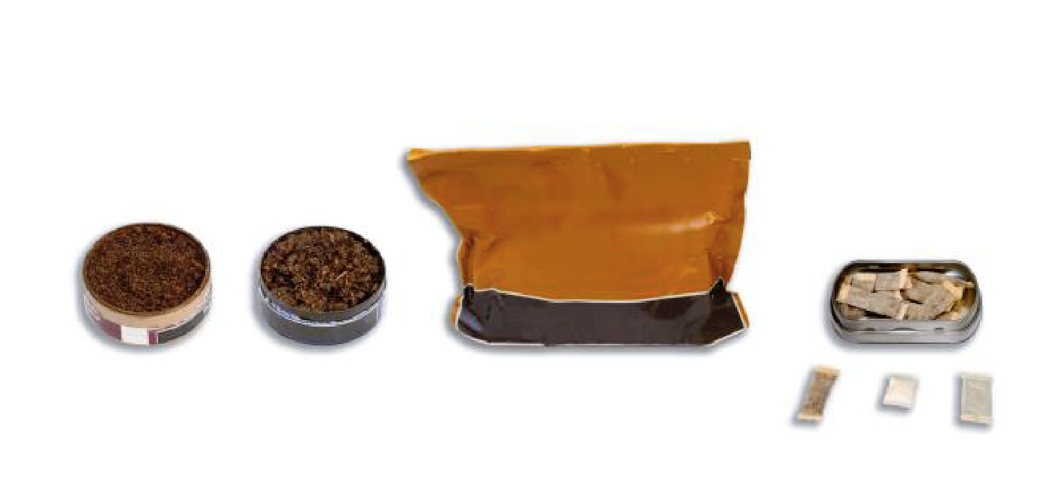
1 Yes
2 No – GO TO B11
9 Prefer not to answer – GO TO B11

ASK: All respondents
_________________________________________________________________________
B10. [IF B9=1]
During the past 30 days, on how many days did you use chewing tobacco, snuff, snus or dip?
1 0 days
2 1 or 2 days
3 3 to 5 days
4 6 to 9 days
5 10 to 19 days
6 20 to 29 days or
7 All 30 days
9 Prefer not to answer

ASK: Respondents who report ever having used chewing tobacco
_________________________________________________________________________
B11. Have you ever smoked cigars, cigarillos, or little cigars such as Swisher Sweets, White Owl, Cheyenne, Dutch Masters, Garcia Y Vega or Middleton’s, even one or two puffs?
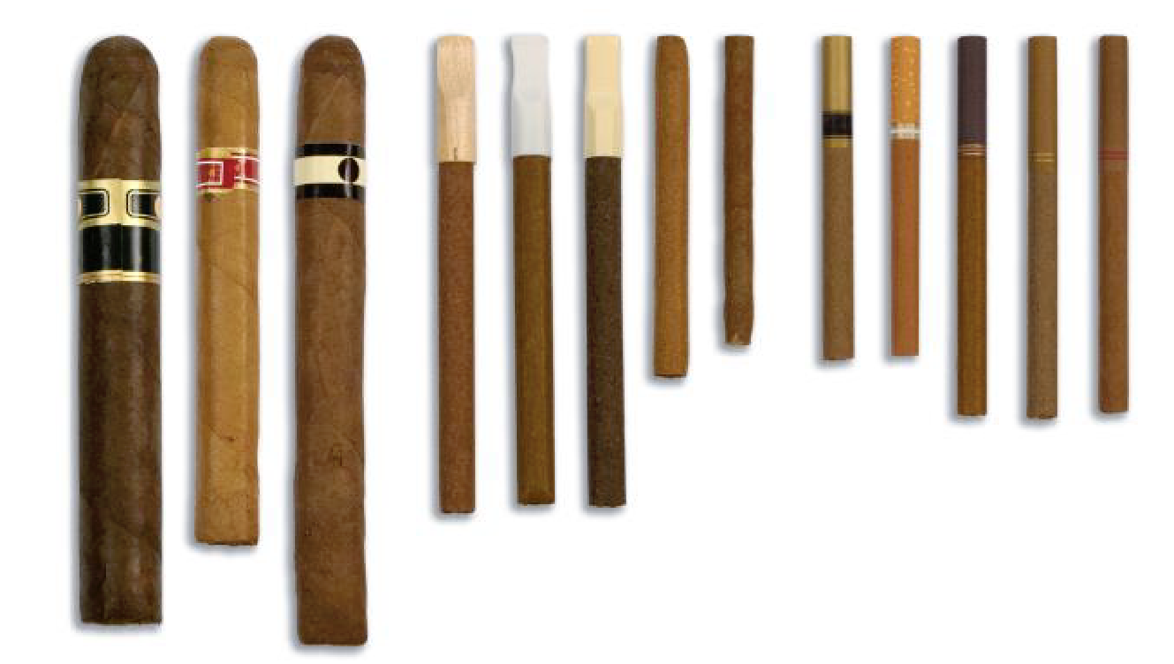
1 Yes
2 No – GO TO B13
9 Prefer not to answer – GO TO B13

ASK: All respondents
_________________________________________________________________________
B12. [IF B11=1]
During the past 30 days, on how many days did you smoke cigars, cigarillos, or little cigars such as Swisher Sweets, White Owl, Cheyenne, Dutch Masters, Garcia Y Vega or Middleton’s?
1 0 days
2 1 or 2 days
3 3 to 5 days
4 6 to 9 days
5 10 to 19 days
6 20 to 29 days or
7 All 30 days
9 Prefer not to answer

ASK: Respondents who report ever smoking cigars
_________________________________________________________________________
B13. Have you ever tried smoking tobacco out of a water pipe (also called “hookah”)?
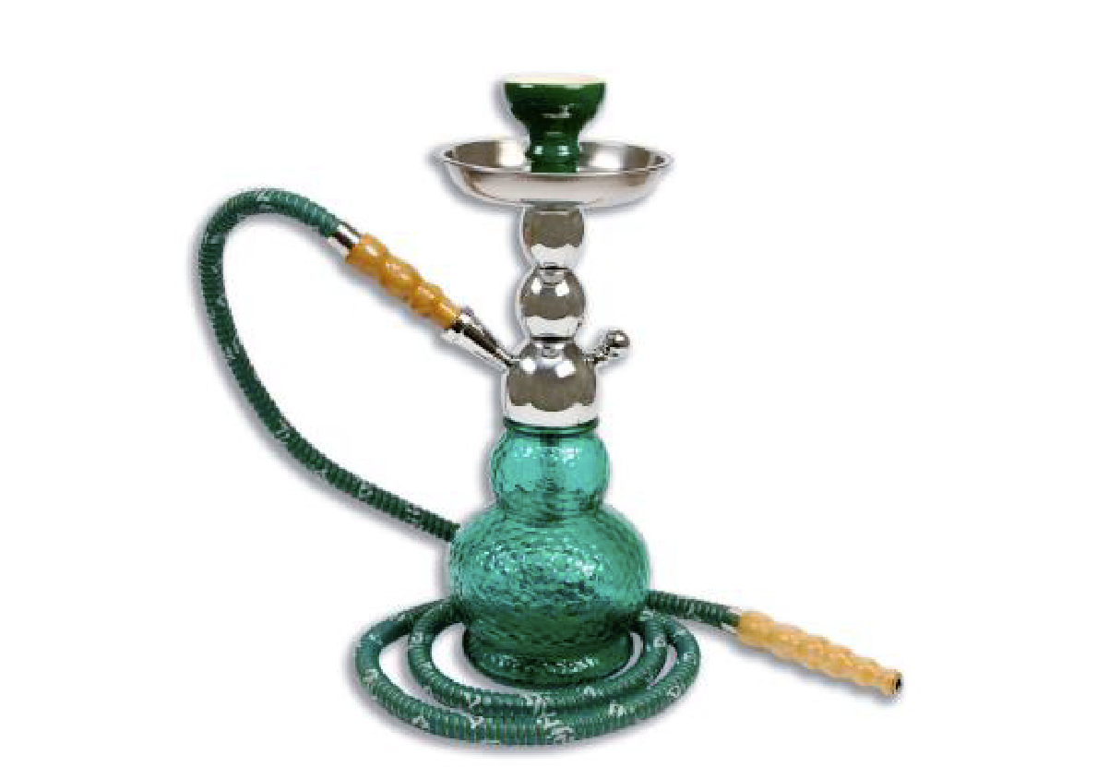
1 Yes
2 No - GO TO B15
9 Prefer not to answer – GO TO B15

ASK: All respondents
_________________________________________________________________________
B14. [IF B13=1]
During the past 30 days, on how many days did you smoke tobacco out of a water pipe (also called “hookah”)?
1 0 days
2 1 or 2 days
3 3 to 5 days
4 6 to 9 days
5 10 to 19 days
6 20 to 29 days or
7 All 30 days
9 Prefer not to answer

ASK: Respondents who have ever used a hookah
_________________________________________________________________________
B15. These are examples of electronic nicotine products: e-cigarettes, e-cigars, e-hookahs, epipes, vape pens, hookah pens, mods, and personal vaporizers. These products are battery-powered, usually use nicotine fluid, and produce vapor instead of smoke. Some common brands include Fin, NJOY, Blu, e-Go and Vuse. Have you ever tried these products, even once or twice?
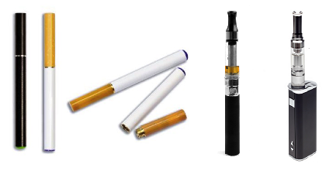

1 Yes
2 No – GO TO B17
9 Prefer not to answer – GO TO B17

ASK: All respondents
_________________________________________________________________________
B16. [IF B15=1]
During the past 30 days, on how many days did you use electronic nicotine products, such as “e-cigarettes”, “e-cigs”, “vapor pens”, or “e-hookahs”?
1 0 days
2 1 or 2 days
3 3 to 5 days
4 6 to 9 days
5 10 to 19 days
6 20 to 29 days or
7 All 30 days
9 Prefer not to answer

ASK: Respondents who report ever using electronic nicotine products
________________________________________________________________________
B17. During the past 30 days, on how many days did you drink one or more drinks of an alcoholic beverage?
1 0 days
2 1 or 2 days
3 3 to 5 days
4 6 to 9 days
5 10 to 19 days
6 20 to 29 days
7 All 30 days
9 Prefer not to answer

ASK: All respondents
_________________________________________________________________________
BBKO. Your opinions are vital to this study. Thank you for sharing your responses. Click the forward arrow to go on to the next question.
ASK: All respondents
_________________________________________________________________________

Section C: Tobacco Use Intentions and Self-Efficacy
C1. [IF B1=2 OR B2= 0]
Thinking about the future…
 |  | Definitely Yes | Probably Yes | Probably Not | Definitely Not | Prefer not to answer
C1_1 | Do you think that you will try a cigarette soon? | ☐1 | ☐2 | ☐3 | ☐4 | ☐9
C1_2 | Do you think you will smoke a cigarette at any time in the next year? | ☐1 | ☐2 | ☐3 | ☐4 | ☐9
C1_3 | If one of your best friends were to offer you a cigarette, would you smoke it? | ☐1 | ☐2 | ☐3 | ☐4 | ☐9
ASK: Respondents who have either not ever smoked or have not smoked in the past 30 days.
________________________________________________________________________
C2. How sure are you that, if you really wanted to, you could avoid smoking cigarettes if…
PROGRAMMER: RANDOMIZE C2_1-C2_5
 |  | Not at all sure | Slightly sure | Somewhat sure | Mostly sure | Completely sure | Prefer not to answer
C2_1 | You are at a party, bar or club? | ☐1 | ☐2 | ☐3 | ☐4 | ☐5 | ☐9
C2_2 | You are in a place where most people are smoking? | ☐1 | ☐2 | ☐3 | ☐4 | ☐5 | ☐9
C2_3 | Someone you know offers it? | ☐1 | ☐2 | ☐3 | ☐4 | ☐5 | ☐9
C2_4 | Someone you want to get to know offers it? | ☐1 | ☐2 | ☐3 | ☐4 | ☐5 | ☐9
C2_5 | Someone offers it to take a break? | ☐1 | ☐2 | ☐3 | ☐4 | ☐5 | ☐9

ASK: All respondents
_________________________________________________________________________

Section D: Cessation (Intention, Behavior, Motivation)
Cigarette Use
D1. [IF B2=1-30]
How much do you want to stop smoking for good? Would you say…?
1 Not at all
2 A little
3 Somewhat
4 A lot
9 Prefer not to answer
ASK: Respondents who have smoked between 1 and 30 days in the past 30 days.
_________________________________________________________________________
D2. [IF B2=1-30]
How much do you think your health would improve if you were to stop smoking for good?
1 Not at all
2 A little
3 Somewhat
4 A lot
9 Prefer not to answer
ASK: Respondents who have smoked between 1 and 30 days in the past 30. ________________________________________________________________________

D3. [IF B2=1-30] How worried are you that smoking will damage your health in the future?
1 Not at all worried
2 A little worried
3 Somewhat worried
4 Very worried
9 Prefer not to answer

ASK: Respondents who have smoked between 1 and 30 days in the past 30.
________________________________________________________________________
D4. [IF B2=1-30] How worried are you that smoking will damage your physical appearance or attractiveness?
1 Not at all worried
2 A little worried
3 Somewhat worried
4 Very worried
9 Prefer not to answer
ASK: Respondents who have smoked between 1 and 30 days in the past 30.
_________________________________________________________________________

Section E: Attitudes, Beliefs & Risk Perceptions, Social Norms
The next set of questions asks for your opinions on cigarette use and other tobacco products.
Attitude
E1. How much do you agree or disagree with the following statements about people who are tobacco-free?
PROGRAMMER: RANDOMIZE ALL ROWS
 |  | Strongly Disagree | Disagree | Neither Agree or Disagree | Agree | Strongly Agree | Prefer not to answer
E1_1. | People who are tobacco-free are confident. | ☐1 | ☐2 | ☐3 | ☐4 | ☐5 | ☐9
E1_2. | People who are tobacco-free are trendsetting. | ☐1 | ☐2 | ☐3 | ☐4 | ☐5 | ☐9
E1_3. | People who are tobacco-free are happy. | ☐1 | ☐2 | ☐3 | ☐4 | ☐5 | ☐9
E1_4. | People who are tobacco-free are judgmental. | ☐1 | ☐2 | ☐3 | ☐4 | ☐5 | ☐9
E1_5. | People who are tobacco-free are attractive. | ☐1 | ☐2 | ☐3 | ☐4 | ☐5 | ☐9
E1_6. | People who are tobacco-free are basic. | ☐1 | ☐2 | ☐3 | ☐4 | ☐5 | ☐9
E1_7. | People who are tobacco-free are boring. | ☐1 | ☐2 | ☐3 | ☐4 | ☐5 | ☐9
E1_8. | People who are tobacco-free are predictable. | ☐1 | ☐2 | ☐3 | ☐4 | ☐5 | ☐9
ASK: All respondents
_________________________________________________________________________
E2. Smoking cigarettes is…
[RANDOMIZE E2_1-E2_2]
E2_1. | Bad | ☐ | ☐ | ☐ | ☐ | ☐ | ☐ | ☐ | Good
E2_2. | Unenjoyable | ☐ | ☐ | ☐ | ☐ | ☐ | ☐ | ☐ | Enjoyable
PROGRAMMER: DETERMINE HOW TO HAVE AN OVERT PREFER NOT TO ANSWER OPTION
ASK: All respondents
_________________________________________________________________________
E3A. [IF B1= 2 OR B2= 0 AND B9=2 OR B10= 1 AND B11= 2 OR B12= 1 AND B13= 2 OR B14= 1 AND B15= 2 OR B16= 1]
How much do you agree or disagree with the following statements?
PROGRAMMER: RANDOMIZE E3A_1- E3A_5
 |  | Strongly Disagree | Disagree | Neither Agree or Disagree | Agree | Strongly Agree | Prefer not to answer
E3A_1. | I am proud to live tobacco-free. | ☐1 | ☐2 | ☐3 | ☐4 | ☐5 | ☐9
E3A_2. | Living tobacco-free is important to me. | ☐1 | ☐2 | ☐3 | ☐4 | ☐5 | ☐9
E3A_3. | Tobacco use is harmful to the LGBT community. | ☐1 | ☐2 | ☐3 | ☐4 | ☐5 | ☐9
E3A_4. | Being tobacco free when I go out makes me feel excluded. | ☐1 | ☐2 | ☐3 | ☐4 | ☐5 | ☐9
E3A_5. | Using tobacco makes life harder. | ☐1 | ☐2 | ☐3 | ☐4 | ☐5 | ☐9

ASK: Any respondents who have either never used any of the tobacco products in Section B or have not used any of them in the past 30 days.
_________________________________________________________________________
E3B. [IF B2 NE 0 OR B10 NE 1 OR B12 NE 1 OR B14 NE 1 OR B16 NE 1]
How much do you agree or disagree with the following statements?
PROGRAMMER: RANDOMIZE E3B_1-E3B_7
 |  | Strongly Disagree | Disagree | Neither Agree or Disagree | Agree | Strongly Agree | Prefer not to answer
E3B_1. | I would be proud to live tobacco-free. | ☐1 | ☐2 | ☐3 | ☐4 | ☐5 | ☐9
E3B_2. | Living tobacco-free is important to me. | ☐1 | ☐2 | ☐3 | ☐4 | ☐5 | ☐9
E3B_3. | If I lived tobacco-free I would be proud to tell other people. | ☐1 | ☐2 | ☐3 | ☐4 | ☐5 | ☐9
E3B_4. | Using tobacco interferes with my life. | ☐1 | ☐2 | ☐3 | ☐4 | ☐5 | ☐9
E3B_5. | Tobacco use is harmful to the LGBT community. | ☐1 | ☐2 | ☐3 | ☐4 | ☐5 | ☐9
E3B_6. | If I was tobacco free I would feel excluded when I go out. | ☐1 | ☐2 | ☐3 | ☐4 | ☐5 | ☐9
E3B_7. | Using tobacco makes life harder. | ☐1 | ☐2 | ☐3 | ☐4 | ☐5 | ☐9
ASK: Respondents who have used any type of tobacco in the past 30 days
_________________________________________________________________________

E4. How much do you agree or disagree with the following statements? If I smoke cigarettes every day, I will…
PROGRAMMER: RANDOMIZE ROWS
 |  | Strongly Disagree | Disagree | Neither Agree or Disagree | Agree | Strongly Agree | Prefer not to answer
E4_1. | Shorten my life | ☐1 | ☐2 | ☐3 | ☐4 | ☐5 | ☐9
E4_2. | Be able to stop smoking when I want to | ☐1 | ☐2 | ☐3 | ☐4 | ☐5 | ☐9
E4_3. | Damage my immune system | ☐1 | ☐2 | ☐3 | ☐4 | ☐5 | ☐9
E4_4. | Turn off potential partners | ☐1 | ☐2 | ☐3 | ☐4 | ☐5 | ☐9
E4_5. | Damage my teeth | ☐1 | ☐2 | ☐3 | ☐4 | ☐5 | ☐9
E4_6. | Damage my skin | ☐1 | ☐2 | ☐3 | ☐4 | ☐5 | ☐9
E4_7. | Develop lung cancer | ☐1 | ☐2 | ☐3 | ☐4 | ☐5 | ☐9

ASK: All respondents
_________________________________________________________________________

Social Norms
E5. How many of your four closest friends…
 |  | None | One | Two | Three | Four | Prefer not to answer
E5_1. | Smoke cigarettes? | ☐0 | ☐1 | ☐2 | ☐3 | ☐4 | ☐9
E5_4. | Smoke cigars, cigarillos, or little cigars?  Common brands are Swisher Sweets, Black & Mild, White Owl, Cheyenne, Dutch Masters, Garcia Y Vega or Middleton’s. | ☐0 | ☐1 | ☐2 | ☐3 | ☐4 | ☐9
E5_2. | Use a hookah or water pipe to smoke tobacco? | ☐0 | ☐1 | ☐2 | ☐3 | ☐4 | ☐9
E5_3. | Use electronic nicotine products such as “e-cigarettes”, “e-cigs”, “vapor pens”, or “e-hookahs”?  Common brands are Blu, Njoy, Logic, Fin, Swisher, 21st Century Smoke, Vuse, Markten, V2 Cigs, Nicotek or Vapin Plus. | ☐0 | ☐1 | ☐2 | ☐3 | ☐4 | ☐9

ASK: All respondents
_________________________________________________________________________
E6. How many LGBT people who are your age...
 |  | None | A few | Some | Most | All | Prefer not to answer
E6_1. | Smoke cigarettes? | ☐0 | ☐1 | ☐2 | ☐3 | ☐4 | ☐9
E6_4. | Smoke cigars, cigarillos, or little cigars?  Common brands are Swisher Sweets, Black & Mild, White Owl, Cheyenne, Dutch Masters, Garcia Y Vega or Middleton’s. | ☐0 | ☐1 | ☐2 | ☐3 | ☐4 | ☐9
E6_2. | Use a hookah or water pipe to smoke tobacco? | ☐0 | ☐1 | ☐2 | ☐3 | ☐4 | ☐9
E6_3. | Use electronic nicotine products such as “e-cigarettes”, “e-cigs”, “vapor pens”, or “e-hookahs”?  Common brands are Blu, Njoy, Logic, Fin, Swisher, 21st Century Smoke, Vuse, Markten, V2 Cigs, Nicotek or Vapin Plus. | ☐0 | ☐1 | ☐2 | ☐3 | ☐4 | ☐9

ASK: All respondents
_________________________________________________________________________
E7. How do LGBT people your age feel about cigarette smoking? Would you say most LGBT people your age...

1 Strongly disapprove
2 Somewhat disapprove
3 Neither approve nor disapprove
4 Somewhat approve
5 Strongly approve
9 Prefer not to answer

ASK: All respondents
_________________________________________________________________________
E8. Compared to 3 months ago, people my age at LGBT bars, clubs and events are smoking...
1 More often
2 Less often
3 About the same
4 Not sure
9 Prefer not to answer

ASK: All respondents
_________________________________________________________________________
EBKO. Thank you for thinking so carefully about your responses so far. Click the forward arrow to move on.
ASK: All respondents
_________________________________________________________________________
Perceived Approval
E9. How much do you agree or disagree with the following statements?
PROGRAMMER: RANDOMIZE E9_1-E9_3
 |  | Strongly Disagree | Disagree | Neither Agree or Disagree | Agree | Strongly Agree | Prefer not to answer
E9_1. | According to my friends, it is very important for me to not smoke cigarettes. | ☐1 | ☐2 | ☐3 | ☐4 | ☐5 | ☐9
E9_2. | According to most people who hang out where I hang out, it is very important for me to not smoke cigarettes. | ☐1 | ☐2 | ☐3 | ☐4 | ☐5 | ☐9
E9_3. | According to people my age in LGBT communities it is very important for me to not smoke cigarettes. | ☐1 | ☐2 | ☐3 | ☐4 | ☐5 | ☐9

ASK: All respondents
_________________________________________________________________________
E10. How much do you agree or disagree with the following statements? If I only smoke cigarettes on some days (for example, smoking only when I go out), I will…
PROGRAMMER: RANDOMIZE ROWS IN TABLE
 |  | Strongly Disagree | Disagree | Neither Agree or Disagree | Agree | Strongly Agree | Prefer not to answer
E10_1 | Shorten my life | ☐1 | ☐2 | ☐3 | ☐4 | ☐5 | ☐9
E10_2 | Be able to stop smoking when I want to | ☐1 | ☐2 | ☐3 | ☐4 | ☐5 | ☐9
E10_3 | Damage my immune system | ☐1 | ☐2 | ☐3 | ☐4 | ☐5 | ☐9
E10_4 | Turn off potential partners | ☐1 | ☐2 | ☐3 | ☐4 | ☐5 | ☐9
E10_5 | Damage my teeth | ☐1 | ☐2 | ☐3 | ☐4 | ☐5 | ☐9
E10_6 | Damage my skin | ☐1 | ☐2 | ☐3 | ☐4 | ☐5 | ☐9
E10_7 | Develop lung cancer | ☐1 | ☐2 | ☐3 | ☐4 | ☐5 | ☐9

ASK: All respondents
_________________________________________________________________________
Approval of Smoking
E11. This next set of questions asks about how willing or unwilling you are to do things with people who smoke cigarettes. Would you:
 |  | Definitely Yes | Probably Yes | Probably Not | Definitely Not | Prefer not to answer
E11_1 | Go to a bar, club, party, concert or event where people are smoking cigarettes? | ☐1 | ☐2 | ☐3 | ☐4 | ☐9
E11_2 | Hang out with someone who smokes cigarettes? | ☐1 | ☐2 | ☐3 | ☐4 | ☐9
E11_3 | Dance with someone who smokes cigarettes? | ☐1 | ☐2 | ☐3 | ☐4 | ☐9
E11_4 | Kiss someone who smokes cigarettes? | ☐1 | ☐2 | ☐3 | ☐4 | ☐9
E11_5 | Date someone who smokes cigarettes? | ☐1 | ☐2 | ☐3 | ☐4 | ☐9

ASK: All respondents
_________________________________________________________________________
E12. How much do you agree or disagree with the following statements about smoking cigarettes?
 |  | Strongly Disagree | Disagree | Neither Agree or Disagree | Agree | Strongly Agree | Prefer not to answer
E12_1. | It is safe for me to smoke for only a year or two, as long as I quit after that. | ☐1 | ☐2 | ☐3 | ☐4 | ☐5 | ☐9
E12_2. | If I started to smoke occasionally I would not become addicted. | ☐1 | ☐2 | ☐3 | ☐4 | ☐5 | ☐9
E12_3. | Smoking cigarettes helps people relieve stress. | ☐1 | ☐2 | ☐3 | ☐4 | ☐5 | ☐9
E12_4 | Cigarette ingredients are harmful. | ☐1 | ☐2 | ☐3 | ☐4 | ☐5 | ☐9
E12_5 | Cigarette ingredients are dangerous. | ☐1 | ☐2 | ☐3 | ☐4 | ☐5 | ☐9
E12_6. | Smoking is a way to show my identity to others. | ☐1 | ☐2 | ☐3 | ☐4 | ☐5 | ☐9
E12_7. | Smoking cigarettes can help keep your weight down. | ☐1 | ☐2 | ☐3 | ☐4 | ☐5 | ☐9
E12_8. | Smoking can cause damage to nearly every part of your body. | ☐1 | ☐2 | ☐3 | ☐4 | ☐5 | ☐9
E12_9. | Smoking weakens your immune system. | ☐1 | ☐2 | ☐3 | ☐4 | ☐5 | ☐9
E12_10. | Please select the option labeled ‘Disagree’ as your answer. | ☐1 | ☐2 | ☐3 | ☐4 | ☐5 | ☐9

ASK: All respondents
________________________________________________________________________
Section F: Media Use and Awareness
F1. Next, we’d like to ask you about your use of TV and other media.
How often do you…
 | Several times a day | About Once a Day | 3-5 days a week | 1-2 days a week | Every few weeks | Less often | Never | Prefer not to answer
F1_1. Watch TV shows or movies on any platform including a TV set, a computer, laptop or tablet, a smartphone or an iPod or MP3 player? | ☐1 | ☐2 | ☐3 | ☐4 | ☐5 | ☐6 | ☐7 | ☐9
F1_2. Watch videos on YouTube? | ☐1 | ☐2 | ☐3 | ☐4 | ☐5 | ☐6 | ☐7 | ☐9
F1_3. Listen to streaming radio? | ☐1 | ☐2 | ☐3 | ☐4 | ☐5 | ☐6 | ☐7 | ☐9

ASK: All respondents
_________________________________________________________________________
F2. Thinking about the social media sites you use, about how often do you visit or use …
[RANDOMIZE ALL]
 | Several times a day | About Once a Day | 3-5 days a week | 1-2 days a week | Every few weeks | Less often | Never | Prefer not to answer
F2_1. Facebook | ☐1 | ☐2 | ☐3 | ☐4 | ☐5 | ☐6 | ☐7 | ☐9
F2_2. Instagram | ☐1 | ☐2 | ☐3 | ☐4 | ☐5 | ☐6 | ☐7 | ☐9
F2_3. Twitter | ☐1 | ☐2 | ☐3 | ☐4 | ☐5 | ☐6 | ☐7 | ☐9
F2_4. Tumblr | ☐1 | ☐2 | ☐3 | ☐4 | ☐5 | ☐6 | ☐7 | ☐9
F2_5. Snapchat | ☐1 | ☐2 | ☐3 | ☐4 | ☐5 | ☐6 | ☐7 | ☐9

ASK: All respondents
_________________________________________________________________________

F3. Think about the following websites. About how often do you visit or use…
[RANDOMIZE ALL]
 | Several times a day | About Once a Day | 3-5 days a week | 1-2 days a week | Every few weeks | Less often | Never | Prefer not to answer
F3_1. Queerty http://www.queerty.com/ | ☐1 | ☐2 | ☐3 | ☐4 | ☐5 | ☐6 | ☐7 | ☐9
F3_2. Logo TV http://www.logotv.com/ | ☐1 | ☐2 | ☐3 | ☐4 | ☐5 | ☐6 | ☐7 | ☐9
F3_4. Autostraddle http://www.autostraddle.com/ | ☐1 | ☐2 | ☐3 | ☐4 | ☐5 | ☐6 | ☐7 | ☐9
F3_5. After Ellen http://www.afterellen.com/ | ☐1 | ☐2 | ☐3 | ☐4 | ☐5 | ☐6 | ☐7 | ☐9
F3_7. GayCities.com http://www.gaycities.com/ | ☐1 | ☐2 | ☐3 | ☐4 | ☐5 | ☐6 | ☐7 | ☐9
ASK: All respondents
_________________________________________________________________________
F4. How often do you go to concerts, live shows, or other events at a store, local stage, community center, or music venue?
1 Once a week or more often
2 One or two times a month
3 Once every two or three months
4 One or two times a year
5 I do not attend concerts, live shows, or other events
9 Prefer not to answer

ASK: All respondents
_________________________________________________________________________
F5. In the past 30 days, on how many days did you go to an LGBT party, night, bar, club, or event?
1 0 days
2 1-3 days
3 4-6 days
4 7 or more days
5 Don’t remember how many days
9 Prefer not to answer

ASK: All respondents
_________________________________________________________________________
F6. How many LGBT celebrities, athletes, musicians, or artists do you follow on social media (e.g.,[IF Z3= 2 OR 4 AND Z6= 1 OR 3; IF A3= 2 OR 4 AND A6= 1 OR 3 THEN FILL ‘Ingrid Nilsen, Tegan & Sara, Ruby Rose, Angel Haze’
IF Z3= 1 OR 3 AND Z5= 1 OR 3; IF A3= 1 OR 3 AND A5= 1 OR 3; THEN FILL Adore Delano, Bretman Rock, Colton Hayes, Tom Daley
ELSE FILL ‘Laverne Cox, Ingrid Nilsen, Tom Daley, Adore Delano’])?
1 0
2 1-2
3 3-4
4 5 or more
9 Prefer not to answer

ASK: All respondents
_________________________________________________________________________
Brand Awareness
F7. We want to ask you about some brands that might or might not have appeared in the media around here, as part of ads or videos about tobacco or at concerts, live shows, or other events.
_________________________________________________________________________

F7_2. In the past 3 months, that is since [FILL DATE], have you seen or heard the following brand?

The Real Cost
1 Yes
2 No
3 Not Sure
9 Prefer not to answer

ASK: All respondents
DISPLAY: FILL DATE will calculate the date 3 months prior to the current date.
_________________________________________________________________________
F7_3. In the past 3 months, that is since [FILL DATE], have you seen or heard the following brand?
This Free Life
1 Yes
2 No
3 Not Sure
9 Prefer not to answer
ASK: All respondents
DISPLAY: FILL DATE will calculate the date 3 months prior to the current date.
_________________________________________________________________________
F7_5. In the past 3 months, that is since [FILL DATE], have you seen or heard the following brand?
Digital Young Adults Against Tobacco

1 Yes
2 No
3 Not Sure
9 Prefer not to answer

ASK: All respondents
DISPLAY: FILL DATE will calculate the date 3 months prior to the current date.
_________________________________________________________________________
Ad Awareness Other TC Campaigns (To Use As Controls)
F8. The next set of questions asks whether or not you’ve seen any of the following ads.
ASK: All respondents
_________________________________________________________________________
PROGRAMMER: RANDOMIZE F8_1-F8_3
_________________________________________________________________________
F8_1. In the past 3 months, that is since [FILL DATE], have you seen a Tips from Former Smokers (Tips) ad? Examples of some Tips from Former Smokers ads are shown below.
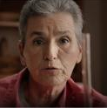
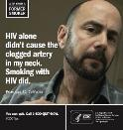
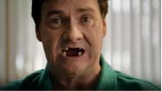
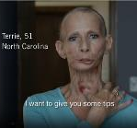

1 Yes
2 No
3 Not Sure
9 Prefer not to answer
ASK: All respondents
DISPLAY: FILL DATE will calculate the date 3 months prior to the current date.
_________________________________________________________________________
F8_2. In the past 3 months, that is since [FILL DATE], have you seen a truth® campaign ad? Examples of some truth® campaign ads are shown below.
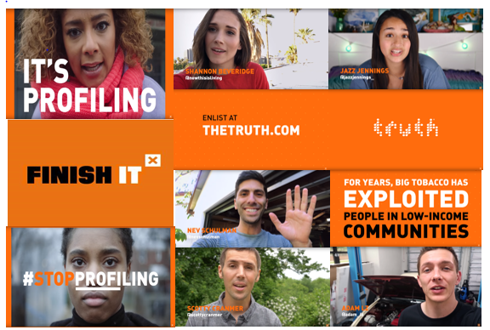
1 Yes
2 No
3 Not Sure
9 Prefer not to answer
ASK: All respondents
DISPLAY: FILL DATE will calculate the date 3 months prior to the current date.
_________________________________________________________________________
F8_3. In the past 3 months, that is since [FILL DATE], have you seen a The Real Cost campaign ad? Examples of some The Real Cost campaign ads are shown below.
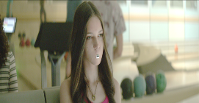

1 Yes
2 No
3 Not Sure
9 Prefer not to answer
ASK: All respondents
DISPLAY: FILL DATE will calculate the date 3 months prior to the current date.
_________________________________________________________________________
Channels of This Free Life Awareness
F9. [IF F7_3= 1 or 3]
Where have you seen or heard about This Free Life? Check all that apply.
PROGRAMMER: RANDOMIZE RESPONSE OPTIONS. KEEP ‘OTHER’ AND ‘PNTA’ AT THE END
F9_1 On TV
F9_2 On the Internet or anywhere online
F9_3 Outdoor ads like billboards, bus shelters, subways, or posters at bars or nightclubs
F9_4 At a bar, nightclub, or other event (e.g. Pride festival)
F9_5 LGBT nightlife magazine or bar photo book (Boi Magazine, Gay City News, LGBT Weekly, etc.)
F9_6 National LGBT magazines (e.g., OUT Magazine, Curve, FTM Magazine)
F9_7 Some other place (please specify____________)
F9_9 Prefer not to answer
ASK: Respondents who have heard of This Free Life or are not sure
_________________________________________________________________________
F10. [IF F7_3= 1 or 3]
This Free Life is online. In the past 3 months, have you seen This Free Life on… Check all that apply
[RANDOMIZE; ALL APPEAR ON SCREEN AT ONCE]
F10_1 Twitter?
F10_2 Instagram?
F10_3 Facebook?
F10_4 YouTube?
F10_5 Pandora?
F10_6 Tumblr?
F10_7 LGBT websites (e.g., Autostraddle, After Ellen, Queerty, Gay Cities, etc.)?
F10_8 Other websites with LGBT content (e.g., Buzzfeed)?
F10_10 Other (please specify____________)?
F10_11 I have not seen This Free Life online
F10_99 Prefer not to answer
ASK: All respondents
_________________________________________________________________________
F10b. [IF ANY RESPONSES TO F10_1 to F10_10 ARE YES] Have you ‘liked’, shared, or commented on any social media posts about This Free Life?
1 Yes
2 No
3 Not Sure
9 Prefer not to answer
ASK: Respondents who have seen This Free Life on social media in F10
_________________________________________________________________________
F10c. [IF F7_3= 1 or 3] Do you know or know of anyone who is part of This Free Life?
1 Yes
2 No
3 Not Sure
9 Prefer not to answer
ASK: Respondents who have heard of This Free Life or are not sure
_________________________________________________________________________
Events Awareness, Channel of Awareness
F34_1. In the past 3 months, that is since [FILL DATE], have you seen This Free Life at an event, club, concert, or nightclub??
This Free Life video online
1 Yes
2 No
3 Not Sure
9 Prefer not to answer
ASK: All respondents
DISPLAY: FILL DATE will calculate the date 3 months prior to the current date.
_________________________________________________________________________
F13_3. [IF F34_1=1 OR 3 OR 9] Did you talk to anyone from This Free Life at the event?
1 Yes
2 No
9 Prefer not to answer
ASK: Respondents who have either seen This Free Life at an event, weren’t sure or preferred not to answer
_________________________________________________________________________
F15. [IF F34_1=1 OR 3 OR 9] How much do you agree or disagree with the following statements?
 |  | Strongly Disagree | Disagree | Neither Agree or Disagree | Agree | Strongly Agree | Prefer Not to Answer
F15_7. | I would go to another This Free Life event in the future | ☐1 | ☐2 | ☐3 | ☐4 | ☐5 | ☐9
F15_8. | The event was fun | ☐1 | ☐2 | ☐3 | ☐4 | ☐5 | ☐9

ASK: Respondents who have either attended a This Free Life event, weren’t sure or preferred not to answer
_________________________________________________________________________
Video Awareness
F11_2. In the past 3 months, that is since [FILL DATE], have you seen a This Free Life video online?
1 Yes
2 No
3 Not Sure
9 Prefer not to answer

ASK: All respondents
_________________________________________________________________________
DISPLAY: FILL DATE will calculate the date 3 months prior to the current date.
_________________________________________________________________________
F18a_2. To show us that you are paying attention, please select Never as your response to this item.
1 Never
2 Rarely
3 Sometimes
4 Often
5 Very Often
9 Prefer not to answer

ASK: All respondents
_________________________________________________________________________
F17. Now we would like to show you some videos that have been shown in the U.S. Once you have viewed the video, please click on the forward arrow below to continue with the survey.
NEXT
ASK: All respondents
_________________________________________________________________________
PROGRAMMER: RANDOMIZE BLOCKS OF QUESTIONS ABOUT EACH VIDEO (F18_1 – F32_1) AND (F18_2 – F32_2) AND {F18_5 – F23_5_f)) AND (F18_6 – F32_6) ALL RESPONDENTS RECEIVE ALL BLOCKS.
_________________________________________________________________________
F18_1. PROGRAMMER: DISPLAY OUR STORY VIDEO
Apart from this survey, how frequently have you seen this video in the past 3 months, that is since [FILL DATE]?
PROGRAMMER: ALLOW ANSWER TO BE MADE ONLY AFTER VIDEO PLAYS FOR 15 SECONDS.
1 Never
2 Rarely
3 Sometimes
4 Often
5 Very Often
9 Prefer not to answer
ASK: All respondents
_________________________________________________________________________
DISPLAY: FILL DATE will calculate the date 3 months prior to the current date.
_________________________________________________________________________
Reactions to Videos
F21_1. How much do you agree or disagree with the following statements?
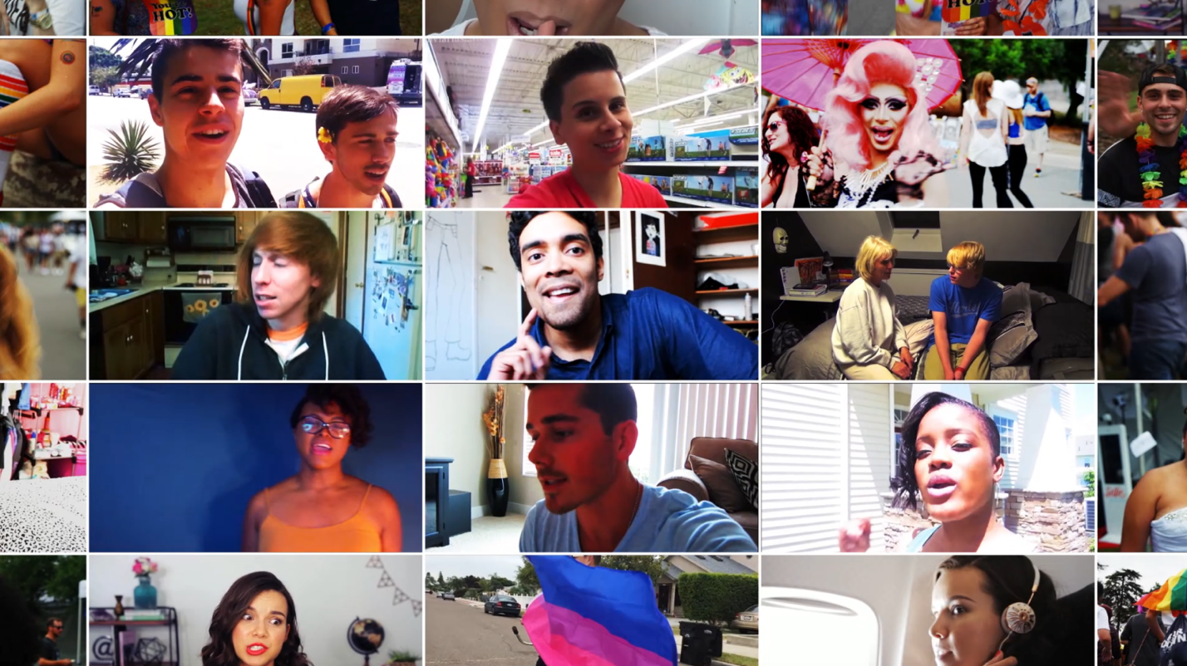
 |  | Strongly Disagree | Disagree | Neither Agree or Disagree | Agree | Strongly Agree | Prefer Not to Answer
F21_1_a. | This video is worth  remembering | ☐1 | ☐2 | ☐3 | ☐4 | ☐5 | ☐9
F21_1_b. | This video grabbed my attention | ☐1 | ☐2 | ☐3 | ☐4 | ☐5 | ☐9
F21_1_c. | This video is powerful | ☐1 | ☐2 | ☐3 | ☐4 | ☐5 | ☐9
F21_1_d. | This video is informative | ☐1 | ☐2 | ☐3 | ☐4 | ☐5 | ☐9
F21_1_e. | This video is meaningful to me | ☐1 | ☐2 | ☐3 | ☐4 | ☐5 | ☐9
F21_1_f. | This video is convincing | ☐1 | ☐2 | ☐3 | ☐4 | ☐5 | ☐9

ASK: All respondents
_________________________________________________________________________
F32_1. [IF F18_1=2 - 5] Have you ‘liked’, shared, or commented on any social media posts about this video?
1 Yes
2 No
3 Not sure
9 Prefer not to answer

ASK: All respondents
_________________________________________________________________________

F18_2. PROGRAMMER: DISPLAY FLAWLESS VIDEO
Apart from this survey, how frequently have you seen this video in the past 3 months, that is since [FILL DATE]?
PROGRAMMER: ALLOW ANSWER TO BE MADE ONLY AFTER VIDEO PLAYS FOR 15 SECONDS.
1 Never
2 Rarely
3 Sometimes
4 Often
5 Very Often
9 Prefer not to answer
ASK: All respondents
DISPLAY: FILL DATE will calculate the date 3 months prior to the current date.
_________________________________________________________________________
F21_2. How much do you agree or disagree with the following statements?
 |  | Strongly Disagree | Disagree | Neither Agree or Disagree | Agree | Strongly Agree | Prefer Not to Answer
F21_2_a. | This video is worth  remembering | ☐1 | ☐2 | ☐3 | ☐4 | ☐5 | ☐9
F21_2_b. | This video grabbed my attention | ☐1 | ☐2 | ☐3 | ☐4 | ☐5 | ☐9
F21_2_c. | This video is powerful | ☐1 | ☐2 | ☐3 | ☐4 | ☐5 | ☐9
F21_2_d. | This video is informative | ☐1 | ☐2 | ☐3 | ☐4 | ☐5 | ☐9
F21_2_e. | This video is meaningful to me | ☐1 | ☐2 | ☐3 | ☐4 | ☐5 | ☐9
F21_2_f. | This video is convincing | ☐1 | ☐2 | ☐3 | ☐4 | ☐5 | ☐9

ASK: All respondents

_________________________________________________________________________

F32_2. [IF F18_2=2-5] Have you ‘liked’, shared, or commented on any social media posts about this video?
1 Yes
2 No
3 Not sure
9 Prefer not to answer

ASK: All respondents
_________________________________________________________________________
F18_5. [DISPLAY LET LOVE IN VIDEO] Apart from this survey, how frequently have you seen this video in the past 3 months, that is since [FILL DATE]?
PROGRAMMER: ALLOW ANSWER TO BE MADE ONLY AFTER VIDEO PLAY FOR 15 SECONDS.
1 Never
2 Rarely
3 Sometimes
4 Often
5 Very Often
9 Prefer not to answer

ASK: All respondents
_________________________________________________________________________
REACTIONS TO VIDEOS
F19_5. What is the main message of this video?
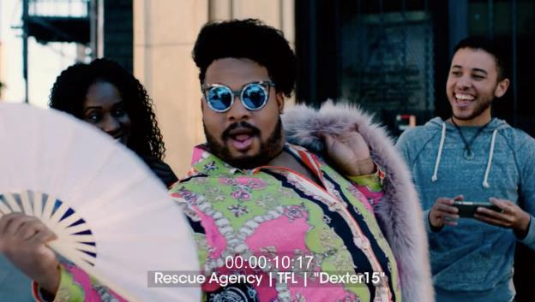

[RANDOMIZE ORDER OF CHECKBOX LIST KEEPING NOT SURE AND PNTA LAST]
1 Smoking can hurt nearly every part of you
2 3 out of 4 people who start smoking as teens will continue smoking as adults
3 Tobacco gets in the way of your health and happiness
4 Life is better when you’re tobacco-free
5 You don’t need tobacco to express who you are
6 Smoking tobacco puts poisons in your body
98 Not sure
99 Prefer not to answer
_________________________________________________________________________
F21_5. How much do you agree or disagree with the following statements?
 |  | Strongly Disagree | Disagree | Neither Agree or Disagree | Agree | Strongly Agree | Prefer Not to Answer
F21_5_a. | This video is worth  remembering | ☐₁ | ☐₂ | ☐₃ | ☐₄ | ☐₅ | ☐₉
F21_5_b. | This video grabbed my attention | ☐₁ | ☐₂ | ☐₃ | ☐₄ | ☐₅ | ☐₉
F21_5_c. | This video is powerful | ☐₁ | ☐₂ | ☐₃ | ☐₄ | ☐₅ | ☐₉
F21_5_d. | This video is informative | ☐₁ | ☐₂ | ☐₃ | ☐₄ | ☐₅ | ☐₉
F21_5_e. | This video is meaningful to me | ☐₁ | ☐₂ | ☐₃ | ☐₄ | ☐₅ | ☐₉
F21_5_f. | This video is convincing | ☐₁ | ☐₂ | ☐₃ | ☐₄ | ☐₅ | ☐₉
F21_5_g. | This video is terrible | ☐₁ | ☐₂ | ☐₃ | ☐₄ | ☐₅ | ☐₉
F21_5_h. | This video told me things I never knew before about tobacco | ☐₁ | ☐₂ | ☐₃ | ☐₄ | ☐₅ | ☐₉
F21_5_i | This video gave me good reasons not to smoke cigarettes | ☐1 | ☐2 | ☐3 | ☐4 | ☐5 | ☐9
F21_5_j. | This video gave me good reasons not to use tobacco | ☐₁ | ☐₂ | ☐₃ | ☐₄ | ☐₅ | ☐₉

F32_5. [IF F18_5=2-5] Have you ‘liked’, shared, or commented on any social media posts about this video?
1 Yes
2 No
3 Not sure
9 Prefer not to answer

ASK: All respondents
_________________________________________________________________________

F23_5. On scale of 1 to 5, where 1 means ‘not at all’ and 5 means ‘very’, please indicate how much this video made you feel…
 | 1 Not at all | 2 | 3 | 4 | 5 Very | Prefer not to answer
F23_5_a. Afraid | ☐1 | ☐2 | ☐3 | ☐4 | ☐5 | ☐9
F23_5_b. Irritated | ☐1 | ☐2 | ☐3 | ☐4 | ☐5 | ☐9
F23_5_c. Understood | ☐1 | ☐2 | ☐3 | ☐4 | ☐5 | ☐9
F23_5_d. Uneasy | ☐1 | ☐2 | ☐3 | ☐4 | ☐5 | ☐9
F23_5_e. Happy | ☐1 | ☐2 | ☐3 | ☐4 | ☐5 | ☐9
F23_5_f. Accepted | ☐1 | ☐2 | ☐3 | ☐4 | ☐5 | ☐9
F23_5_g. Inspired | ☐1 | ☐2 | ☐3 | ☐4 | ☐5 | ☐9
F23_5_h. Confident | ☐1 | ☐2 | ☐3 | ☐4 | ☐5 | ☐9

ASK: All respondents
_________________________________________________________________________
F18_6. [DISPLAY COMPILATION VIDEO] Apart from this survey, how frequently have you seen content from this video in the past 3 months, that is since [FILL DATE]?
PROGRAMMER: ALLOW ANSWER TO BE MADE ONLY AFTER VIDEO PLAY FOR 15 SECONDS.
1 Never
2 Rarely
3 Sometimes
4 Often
5 Very Often
9 Prefer not to answer

ASK: All respondents
_________________________________________________________________________
REACTIONS TO VIDEOS
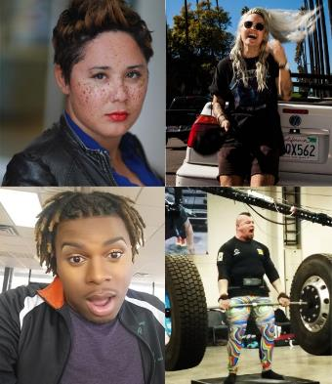
F19_6. What is the main message of this video?
[RANDOMIZE ORDER OF CHECKBOX LIST KEEPING NOT SURE AND PNTA LAST]
- Tobacco gets in the way of your health and happiness
- Cigarette smoke contains more than 7,000 chemicals
- Life is better when you’re tobacco-free
- Addiction to cigarettes is expensive
- You don’t need tobacco to express who you are
98 Not sure
99 Prefer not to answer

ASK: All respondents
_________________________________________________________________________
F21_6. How much do you agree or disagree with the following statements?
 |  | Strongly Disagree | Disagree | Neither Agree or Disagree | Agree | Strongly Agree | Prefer Not to Answer
F21_6_a. | This video is worth  remembering | ☐₁ | ☐₂ | ☐₃ | ☐₄ | ☐₅ | ☐₉
F21_6_b. | This video grabbed my attention | ☐₁ | ☐₂ | ☐₃ | ☐₄ | ☐₅ | ☐₉
F21_6_c. | This video is powerful | ☐₁ | ☐₂ | ☐₃ | ☐₄ | ☐₅ | ☐₉
F21_6_d. | This video is informative | ☐₁ | ☐₂ | ☐₃ | ☐₄ | ☐₅ | ☐₉
F21_6_e. | This video is meaningful to me | ☐₁ | ☐₂ | ☐₃ | ☐₄ | ☐₅ | ☐₉
F21_6_f. | This video is convincing | ☐₁ | ☐₂ | ☐₃ | ☐₄ | ☐₅ | ☐₉
F21_6_g. | This video is terrible | ☐₁ | ☐₂ | ☐₃ | ☐₄ | ☐₅ | ☐₉
F21_6_h. | This video told me things I never knew before about tobacco | ☐₁ | ☐₂ | ☐₃ | ☐₄ | ☐₅ | ☐₉
F21_6_i. | This video gave me good reasons not to smoke cigarettes | ☐1 | ☐2 | ☐3 | ☐4 | ☐5 | ☐9
F21_6_j. | This video gave me good reasons not to use tobacco | ☐₁ | ☐₂ | ☐₃ | ☐₄ | ☐₅ | ☐₉

ASK: All respondents

F32_6. [IF F18_6=2-5] Have you ‘liked’, shared, or commented on any social media posts about any of the content from this video?
1 Yes
2 No
3 Not sure
9 Prefer not to answer

ASK: All respondents
_________________________________________________________________________
OTHER CONTENT AWARENESS
F33. Now we would like to show you some digital content you may have seen online.

DISPLAY LLI BRAND CONTENT - OTHER CONTENT 1

Apart from this survey, how frequently have you seen ads with similar content in the past 3 months, that is since [FILL DATE]?
1 Never
2 Rarely
3 Sometimes
4 Often
5 Very Often
9 Prefer not to answer
ASK: All respondents
DISPLAY: FILL DATE will calculate the date 3 months prior to the current date.
_________________________________________________________________________
Brand Equity
F29. [IF F7_3 = 1 OR 3 OR 9]
How much do you agree or disagree with the following statements about This Free Life?
[RANDOMIZE F29_1- F29_3]
 |  | Strongly Disagree | Disagree | Neither Agree or Disagree | Agree | Strongly Agree | Prefer Not to Answer
F29_1. | I want to help promote This Free Life | ☐1 | ☐2 | ☐3 | ☐4 | ☐5 | ☐9
F29_2 . | I’d defend This Free Life if someone was making fun of it | ☐1 | ☐2 | ☐3 | ☐4 | ☐5 | ☐9
F29_3. | I’d wear a This Free Life T-shirt | ☐1 | ☐2 | ☐3 | ☐4 | ☐5 | ☐9
ASK: Respondents who have heard of This Free Life, or those who are not sure or who preferred not to answer
_________________________________________________________________________
[IF F7_3 = 1 OR 3 OR 9]
PROGRAMMER: RANDOMIZE ITEMS BELOW WITH F29_5/ F29_6 ASKED TOGETHER IN THAT ORDER
F29_4. | I talk to my friends about This Free Life | ☐1 | ☐2 | ☐3 | ☐4 | ☐5 | ☐9
F29_5. | If I had the chance, I would tell people I know to watch This Free Life videos | ☐1 | ☐2 | ☐3 | ☐4 | ☐5 | ☐9
F29_6. | If I had the chance, I would tell people I know to check out This Free Life at events | ☐1 | ☐2 | ☐3 | ☐4 | ☐5 | ☐9
F29_7. | If I see anything from This Free Life, I check it out | ☐1 | ☐2 | ☐3 | ☐4 | ☐5 | ☐9
ASK: Respondents who have heard of This Free Life, or those who are not sure or who preferred not to answer
_________________________________________________________________________
[IF F7_3 = 1 OR 3 OR 9]
PROGRAMMER: RANDOMIZE ITEMS BELOW WITH F29_10/ F29_11 AND F29_12/ F29_13 ASKED TOGETHER IN THAT ORDER
F29_8. | This Free Life is popular with people like me | ☐1 | ☐2 | ☐3 | ☐4 | ☐5 | ☐9
F29_9. | People are talking about This Free Life | ☐1 | ☐2 | ☐3 | ☐4 | ☐5 | ☐9
F29_10. | This Free Life videos are becoming more popular with the people who hang out where I hang out | ☐1 | ☐2 | ☐3 | ☐4 | ☐5 | ☐9
F29_11. | Checking out This Free Life at events is becoming more popular with the people who hang out where I hang out | ☐1 | ☐2 | ☐3 | ☐4 | ☐5 | ☐9
F29_12. | This Free Life videos are for people like me | ☐1 | ☐2 | ☐3 | ☐4 | ☐5 | ☐9
F29_13. | This Free Life events are for people like me | ☐1 | ☐2 | ☐3 | ☐4 | ☐5 | ☐9
ASK: Respondents who have heard of This Free Life, or those who are not sure or who preferred not to answer
_________________________________________________________________________
F30. [IF F7_3 = 1 OR 3 OR 9]
To what extent do you agree that each of the traits or statements listed below describe This Free Life?
PROGRAMMER: RANDOMIZE RESPONSE OPTIONS
 |  | Strongly Disagree | Disagree | Neither Agree or Disagree | Agree | Strongly Agree | Prefer Not to Answer
F30_1. | Trendsetting | ☐1 | ☐2 | ☐3 | ☐4 | ☐5 | ☐9
F30_2. | Motivating | ☐1 | ☐2 | ☐3 | ☐4 | ☐5 | ☐9
F30_3. | Confident | ☐1 | ☐2 | ☐3 | ☐4 | ☐5 | ☐9
F30_4. | Outgoing | ☐1 | ☐2 | ☐3 | ☐4 | ☐5 | ☐9
F30_5. | Hosts the best parties | ☐1 | ☐2 | ☐3 | ☐4 | ☐5 | ☐9
F30_6. | Always looks good | ☐1 | ☐2 | ☐3 | ☐4 | ☐5 | ☐9
ASK: Respondents who have heard of This Free Life, or those who are not sure or who preferred not to answer
_________________________________________________________________________
F31. [IF F7_3 = 1 OR 3 OR 9]
How much do you agree or disagree with the following statements?
When I think of This Free Life, I think…
 |  | Strongly Disagree | Disagree | Neither Agree or Disagree | Agree | Strongly Agree | Prefer Not to Answer
F31_1 | I have the freedom to be tobacco-free | ☐1 | ☐2 | ☐3 | ☐4 | ☐5 | ☐9
F31_2 | Using tobacco can undo some of the progress I have made | ☐1 | ☐2 | ☐3 | ☐4 | ☐5 | ☐9
F31_3 | Tobacco use is not attractive | ☐1 | ☐2 | ☐3 | ☐4 | ☐5 | ☐9
ASK: Respondents who have heard of This Free Life, or those who are not sure or who preferred not to answer
_________________________________________________________________________

Section G: Environment
G1. Your survey is almost complete. The next section asks some questions about your household and peers.
Other than you, has anyone who lives with you used any of the following during the past 30 days? Check all that apply.
1 Cigarettes
2 Cigars, cigarillos, or little cigars such as Swisher Sweets, White Owl, Cheyenne, Dutch Masters, Garcia Y Vega or Middleton’s
3 Tobacco out of a water pipe (also called “hookah”)
5 Electronic nicotine products, also called ‘e-cigarettes’, ‘e-cigs’, ‘vapor pens’, or ‘e-hookahs’
4 No, no one who lives with me has used any form of tobacco during the past 30 days
9 Prefer not to answer

PROGRAMMER: DO NOT ALLOW A RESPONSE OF 4 IN COMBINATION WITH OTHER RESPONSES.
ASK: All respondents
_________________________________________________________________________
G2. How often do you attend church or religious services? Would you say…
1 Never
2 Less than once a month
3 About once a month
4 About 2 or 3 times a month
5 Once a week
6 More than once a week
9 Prefer not to answer

ASK: All respondents
_________________________________________________________________________
G3. Please tell us if you strongly disagree, disagree, neither agree nor disagree, agree, or strongly agree with the following statements.
I would like to explore strange places. Would you say you…
1 Strongly Disagree
2 Disagree
3 Neither agree nor disagree
4 Agree
5 Strongly Agree
9 Prefer not to answer
ASK: All respondents
_________________________________________________________________________
G4. I like to do frightening things. Would you say you…
1 Strongly Disagree
2 Disagree
3 Neither agree nor disagree
4 Agree
5 Strongly Agree
9 Prefer not to answer
ASK: All respondents
_________________________________________________________________________
G5. I like new and exciting experiences, even if I have to break the rules. Would you say you…
1 Strongly Disagree
2 Disagree
3 Neither agree nor disagree
4 Agree
5 Strongly Agree
9 Prefer not to answer
ASK: All respondents
_________________________________________________________________________
G6. I prefer friends who are exciting and unpredictable. Would you say you…
1 Strongly Disagree
2 Disagree
3 Neither agree nor disagree
4 Agree
5 Strongly Agree
9 Prefer not to answer
ASK: All respondents
_________________________________________________________________________
G7. Thinking about your mental health, which includes stress, depression, and problems with emotions, for how many days during the past 30 days was your mental health not good?
_____ Number of days (Range: 1-30)
None
Don’t know
Prefer not to answer
ASK: All respondents
_________________________________________________________________________
G8. In the last month, how often have you…
 |  | Never | Almost never | Some-times | Fairly often | Very often | Prefer not to answer
G8_1. | Felt that you were unable to control the important things in your life? | ☐1 | ☐2 | ☐3 | ☐4 | ☐5 | ☐9
G8_2. | Felt confident about your ability to handle your personal problems? | ☐1 | ☐2 | ☐3 | ☐4 | ☐5 | ☐9
G8_3. | Felt that things were going your way? | ☐1 | ☐2 | ☐3 | ☐4 | ☐5 | ☐9
G8_4. | Felt difficulties were piling up so high that you could not overcome them? | ☐1 | ☐2 | ☐3 | ☐4 | ☐5 | ☐9
ASK: All respondents
_________________________________________________________________________

Section H: LGBT Identity and Community
Discrimination
H1. You have reached the final questions in the survey.
Have you ever experienced discrimination, been prevented from doing something, or been hassled or made to feel inferior in any of the following seven situations because of your sexual identity (lesbian, gay, bisexual, transgender)?
 |  | Yes | No | Prefer not to answer
H1_1. | In your family | ☐1 | ☐2 | ☐9
H1_2. | At school | ☐1 | ☐2 | ☐9
H1_3. | Getting a job | ☐1 | ☐2 | ☐9
H1_4. | At work | ☐1 | ☐2 | ☐9
H1_5. | At home | ☐1 | ☐2 | ☐9
H1_6. | Getting medical care | ☐1 | ☐2 | ☐9
H1_7 | On the street or in a public setting | ☐1 | ☐2 | ☐9
ASK: All respondents
_________________________________________________________________________
LGBT Community Involvement
H2_1. Have you ever attended an LGBT pride event?
1 Yes
2 No
9 Prefer not to answer
ASK: All respondents
________________________________________________________________________

H2_2. [IF H2_1= 1]
Have you attended an LGBT pride event in the past 12 months?
1 Yes
2 No
9 Prefer not to answer

ASK: Respondents who have attended an LGBT pride event
_________________________________________________________________________
LGBT Identity Development
H3. For each of the following questions, please mark the response that best indicates your current experience as an LGBT person. Please be as honest as possible. Indicate how you really feel now, not how you think you should feel. There is no need to think too much about any one question. Answer each question according to your initial reaction and then move on to the next.
 |  | Strongly Disagree | Disagree | Neither Agree or Disagree | Agree | Strongly Agree | Prefer Not to Answer
H3_1 | I am glad to be an LGBT person. | ☐1 | ☐2 | ☐3 | ☐4 | ☐5 | ☐9
H3_2 | My sexual identity is an insignificant part of who I am. | ☐1 | ☐2 | ☐3 | ☐4 | ☐5 | ☐9
H3_3 | I’m proud to be part of the LGBT community. | ☐1 | ☐2 | ☐3 | ☐4 | ☐5 | ☐9
H3_4 | My sexual identity is a central part of my identity. | ☐1 | ☐2 | ☐3 | ☐4 | ☐5 | ☐9
H3_5 | To understand who I am as a person, you have to know that I’m LGBT. | ☐1 | ☐2 | ☐3 | ☐4 | ☐5 | ☐9
H3_6 | Being an LGBT person is a very important aspect of my life. | ☐1 | ☐2 | ☐3 | ☐4 | ☐5 | ☐9
H3_7 | I believe being LGBT is an important part of me. | ☐1 | ☐2 | ☐3 | ☐4 | ☐5 | ☐9
H3_8 | I am proud to be LGBT. | ☐1 | ☐2 | ☐3 | ☐4 | ☐5 | ☐9
H3_9 | I feel part of the LGBT community. | ☐1 | ☐2 | ☐3 | ☐4 | ☐5 | ☐9
H3_10 | I feel accepted by the LGBT community. | ☐1 | ☐2 | ☐3 | ☐4 | ☐5 | ☐9
ASK: All respondents
_______________________________________________________________________
PROGRAMMER: CALCULATE A VARIABLE CALLED COMPLETED THAT EQUALS 1 ONCE A RESPONDENT ANSWERS H3_10. ELSE VARIABLE EQUALS 0.
_________________________________________________________________________
Please indicate how much you agree or disagree with the following statements about the RESPECT study.

 |  | Strongly Disagree | Disagree | Neither Agree or Disagree | Agree | Strongly Agree | Prefer Not to Answer
SSAT1 | This survey took too long to complete. | ☐1 | ☐2 | ☐3 | ☐4 | ☐5 | ☐9
SSAT2 | Researchers value my participation in the RESPECT study. | ☐1 | ☐2 | ☐3 | ☐4 | ☐5 | ☐9
SSAT3 | The questions in this survey are repetitive. | ☐1 | ☐2 | ☐3 | ☐4 | ☐5 | ☐9
SSAT4 | If I am invited, I will participate in another RESPECT study. | ☐1 | ☐2 | ☐3 | ☐4 | ☐5 | ☐9
SSAT5 | The questions in the survey are interesting. | ☐1 | ☐2 | ☐3 | ☐4 | ☐5 | ☐9
SSAT6 | This research doesn’t benefit people like me. | ☐1 | ☐2 | ☐3 | ☐4 | ☐5 | ☐9

ASK: All respondents

_________________________________________________________________________

WEBTH Thank you! Click the ‘Finish’ button below and within the next 3 days, we will send an email containing information about how to access and redeem your digital gift card.
This information must be sent via email to the email address you supplied before starting this survey. Check your spam, junk or clutter folder(s) if you don’t see our email in your email inbox. The study team is available to assist you at respect@rti.org if you are unable to locate the message in your inbox, junk, or clutter folders.

_________________________________________________________________________

RECON
We may contact you again to complete another survey and offer you the same digital gift card as a reward, so please be on the lookout for that invitation email. If you have any questions about the study, please email us at respect@rti.org.
Should we contact you, you will be able to decide if you want to take part in the survey at that time, and you can change your mind at any point.

OMB No. 0910-0808 Expiration Date: 01/31/2019
Paperwork Reduction Act Statement: The public reporting burden for this collection of information has been estimated to average 30 minutes per response. Send comments regarding this burden estimate or any other aspects of this collection of information, including suggestions for reducing burden to PRAStaff@fda.hhs.gov.

FINISH
ASK: All respondents
_________________________________________________________________________
END Thank you for taking time to complete this survey. You may close this window now.
ASK: All respondents
_________________________________________________________________________

