Food and Drug Administration
Non-Substantive Change Request
OMB Control No. 0910-0338

Purpose: FDA is requesting a non-substantive change to Form FDA 356h, General Licensing Provisions: Biologics License Application, Changes to an Approved Application, Labeling, Revocation and Suspension, Postmarketing Studies Status Reports, Form FDA 356h, currently approved under OMB Control No. 0910-0338.

Background: Regulations in 21 CFR Parts 314 (Applications for FDA Approval to Market a
New Drug) and 601 (Biologics/Licensing) govern the submission of new drug applications and
biologics, respectively. FDA’s Center for Drug Evaluation and Research (CDER) and Center for
Biologics Evaluation and Research (CBER) review these submissions, where the agency has developed Form FDA 356h to assist respondents in this regard. The application form serves primarily as a checklist for firms to gather and submit certain information to FDA. As such, the form helps to ensure that the application is complete and contains all the necessary information, so that delays due to lack of information may be eliminated. In addition, the form provides key information to FDA for efficient handling and distribution to the appropriate staff for review. The form is available electronically and may be submitted electronically. We are currently proposing to revise Form FDA 356h to add the following two fields:

Field 15B: SNOMED CT
SNOMED CT (Systematized Nomenclature of Medicine -- Clinical Terms) is a standardized, multilingual vocabulary of clinical terminology that is used by physicians and other health care providers for the electronic exchange of clinical health information. SNOMED CT currently contains more than 300,000 medical concepts, divided into hierarchies as diverse as body structure, clinical findings, geographic location and pharmaceutical/biological product. Each concept is represented by an individual number and several concepts can be used simultaneously to describe a complex condition.

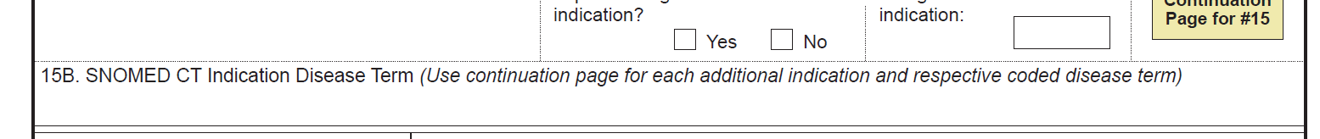
Field 24: Combination Product
21st Century Cures Legislation requires that Sponsors identify combination products.
Justification: SNOMED CT provides a standard by which medical conditions and symptoms can be referred, eliminating the confusion that may result from the use of regional or colloquial terms.
The inclusion of Combination Products on the form helps meet the 21st Century Cures Legislation requirement.
We hope to release the revised form in early May 2018.

