Attachment 4
Why is it Important for 3-5 Year Olds to Provide Urine in NHANES?

- Children between the ages of 3 and 5 can be exposed to environmental chemicals through drinking water, bug sprays, exhaust fumes, grilled meats, cigarette smoke, and paint. Some of these chemicals may be harmful to your child’s health and affect their growth and development.
- The Centers for Disease Control and Prevention (CDC) intends to create safe exposure limits and guidelines for normal kidney functions among children aged 3-5 by measuring the levels of environmental chemicals found in your child’s urine as well as in the urine of thousands of children of the same age throughout the United States.
- The urine collection is safe. Your child will empty his/her bladder in a container. You and your child will be shown how to provide the urine sample during your child’s exam in the NHANES mobile examination center.
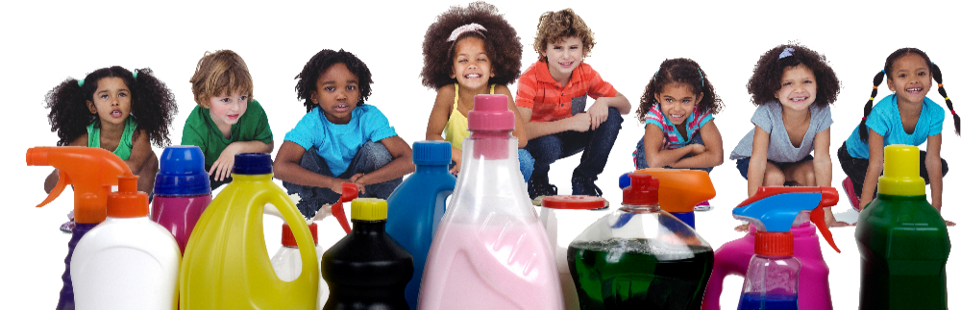
- You will receive a report providing details about your child’s kidney function, and a report indicating high urine arsenic, if elevated.

